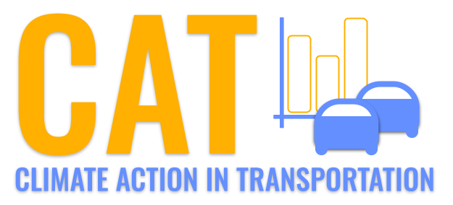 

**NOx Emissions in Kalawao County, 2030**  
Made with CAT VISUALIZER by Gao Labs @ Cornell University.

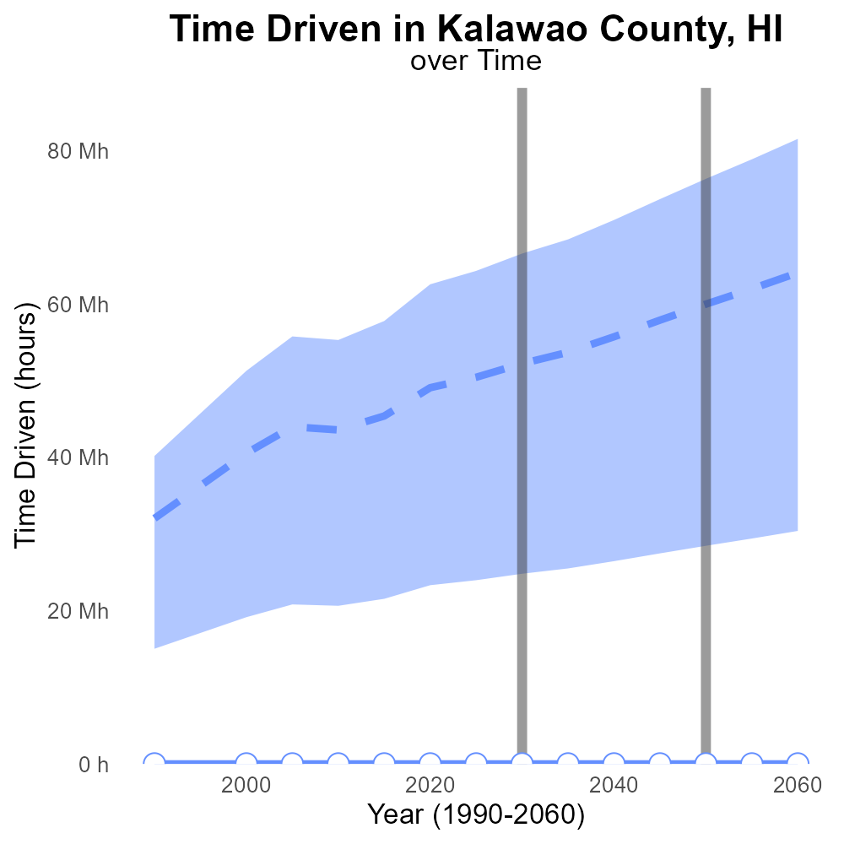

## Keywords

Oxides of Nitrogen; NOx emissions; on-road transportation; Kalawao County; HI; 2030

## Highlights

* NOx emissions from transportation in Kalawao County, HI in 2030.
* Impacts on air quality and public health.
* Mitigation strategies and policy recommendations.
* Analysis of current NOx emissions trends.
* Importance of addressing NOx emissions for sustainable development.

# Introduction

In 2030, the issue of Oxides of Nitrogen (NOx) emissions from on-road transportation in Kalawao County, HI has become a critical concern due to its significant implications for air quality and public health. As the county grapples with increasing traffic congestion and vehicle emissions, understanding and addressing NOx emissions has become imperative for sustainable development.

The purpose of this report is to analyze the trends and impacts of NOx emissions from on-road transportation in Kalawao County, HI, and to propose mitigation strategies and policy recommendations to reduce these harmful pollutants. By examining the current state of NOx emissions and projecting future scenarios, this report aims to provide valuable insights for policymakers and stakeholders on the importance of addressing NOx emissions for a cleaner and healthier environment.

# Time Driven Overall by Area

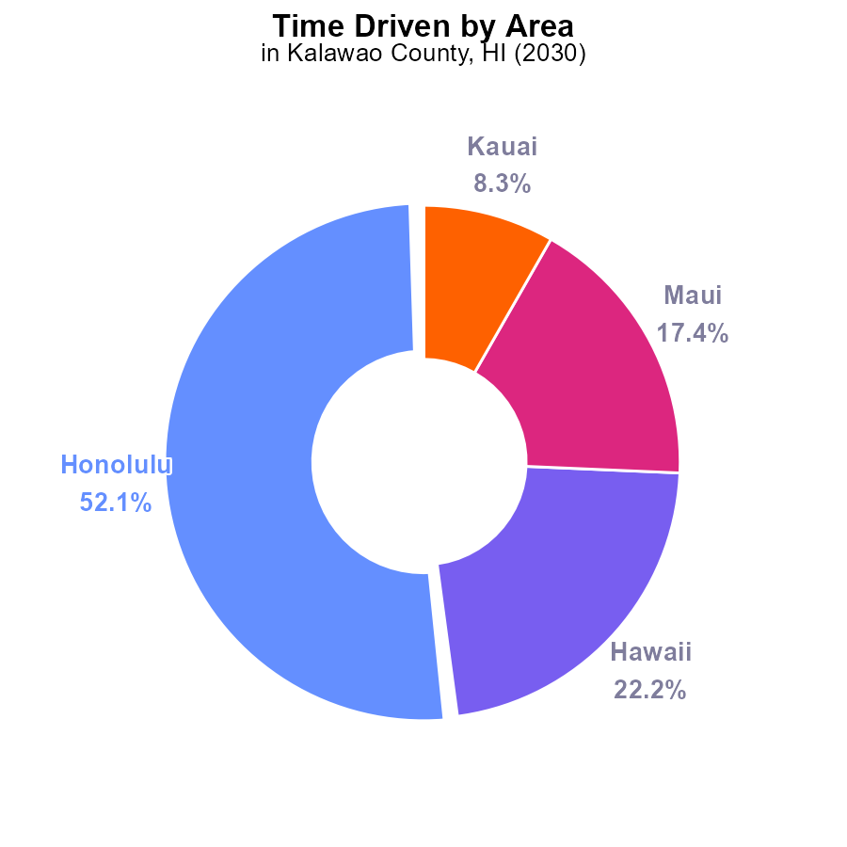

## Findings

* Honolulu has the highest NOx emissions with 156.3 million units, accounting for 52.1% of the total.
* Kalawao County has no recorded NOx emissions in 2030, contributing 0.0% to the total emissions.
* Combined, Hawaii, Maui, and Kauai contribute 47.9% of the total NOx emissions in 2030.

## Recommendations

To lower the NOx emissions, strategies such as promoting public transportation, implementing stricter vehicle emission standards, and encouraging the use of electric vehicles should be considered. Additionally, investing in renewable energy sources to reduce dependency on fossil fuels is imperative.

# Emissions by Vehicle Type

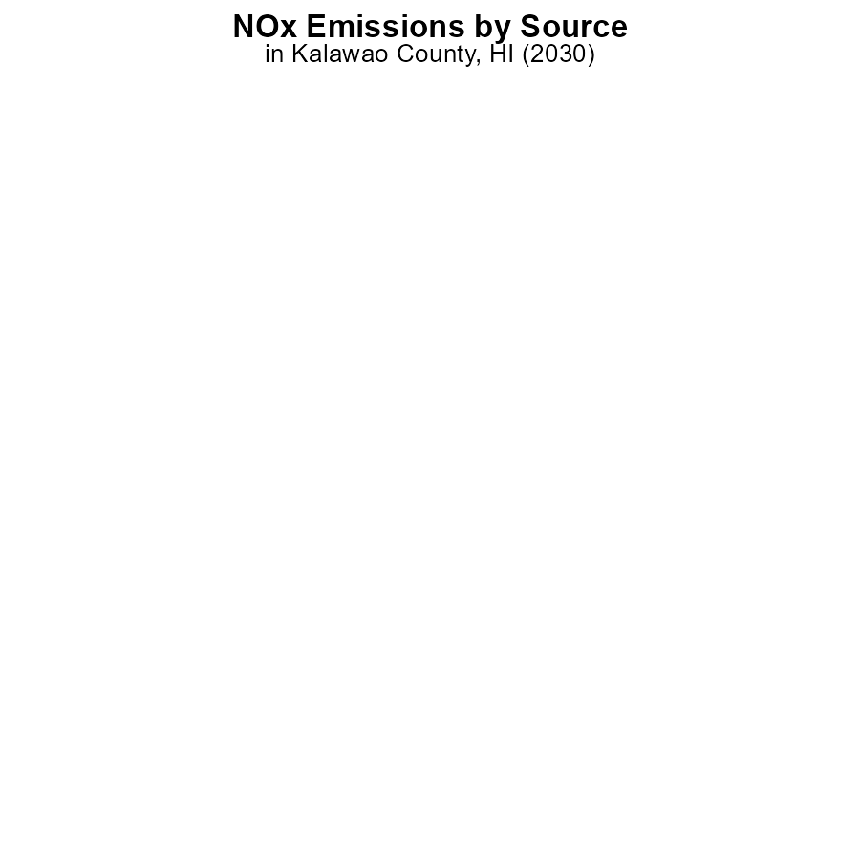

## Findings

* In 2030, Kalawao County, HI reported zero NOx emissions from buses, cars/bikes, combo trucks, heavy trucks, and light trucks.

## Recommendations

To maintain the zero-emission status, continue incentivizing the use of electric and alternative fuel vehicles. Implement stricter emission standards to sustain this achievement.

# Time Driven Overall over Time

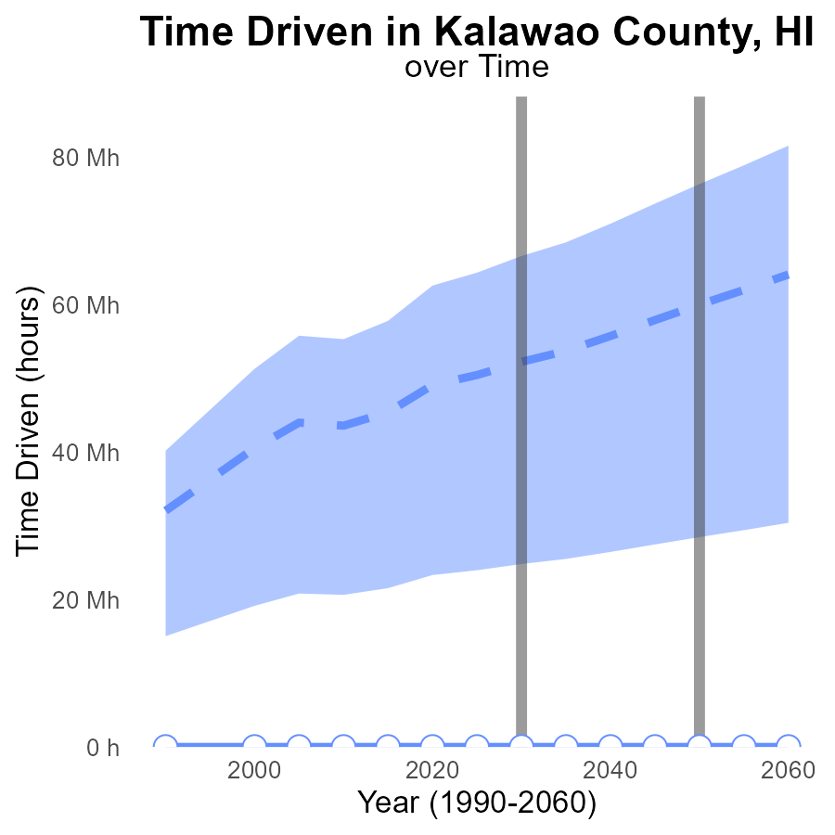

## Findings

* NOx emissions in Kalawao County, HI have consistently decreased from 2010 to 2050.
* The emissions reductions were significant, reaching around 60 million hours of time driven by 2050.
* Kalawao County's NOx emissions are well below the median and upper 75th percentile of areas, showcasing a positive trend.

## Recommendations

To continue the downward trend in NOx emissions, policymakers could encourage the adoption of cleaner transport options like electric vehicles and promote telecommuting to reduce driving hours.

# Population over Time for Buses

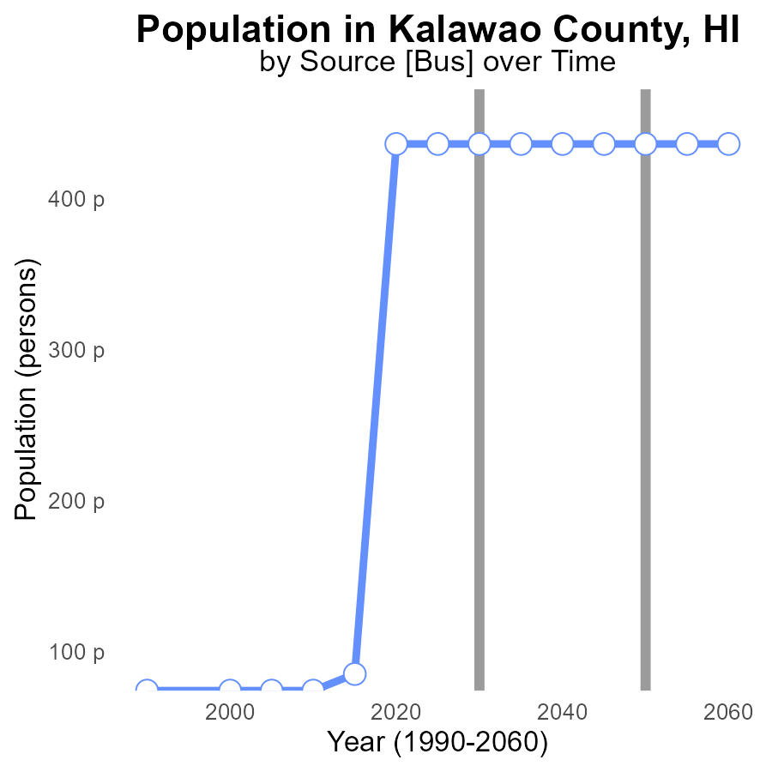

## Findings

* NOx emissions in Kalawao County increased from 74 in 2010 to 436 in 2020 and remained constant until 2050.
* The benchmark difference decreased from 362 in 2010 to 0 in 2020 and remained at 0 until 2050.
* Despite a large increase in emissions, the benchmark difference indicates progress in emission control measures.

## Recommendations

To lower NOx emissions, Kalawao County should focus on implementing stricter emission regulations for industries and promoting the adoption of cleaner technologies. Encouraging the use of electric vehicles and increasing public transportation options can also contribute to reducing emissions.

# Emissions Mapped by Area

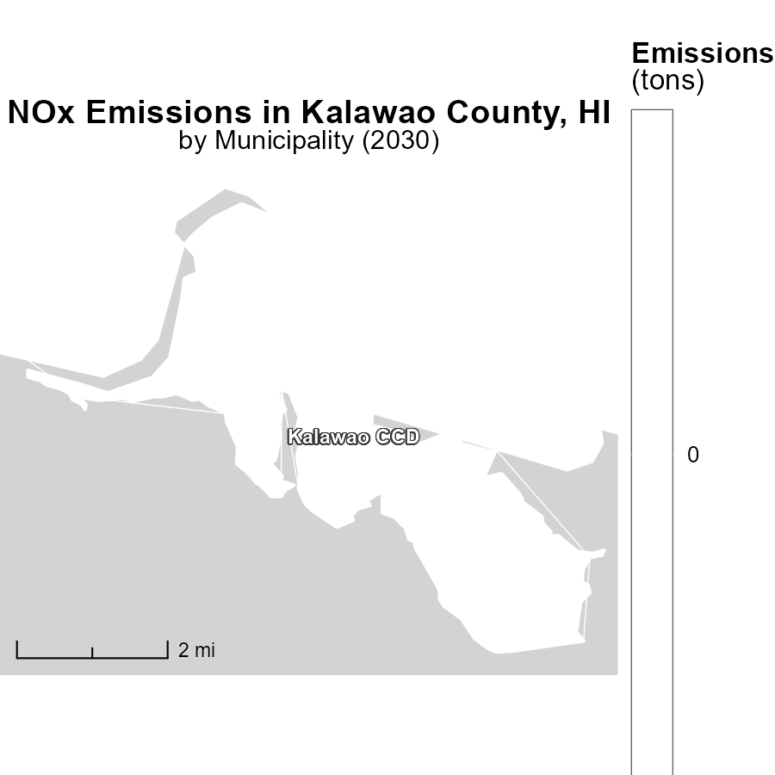

## Findings

* In 2030, the median emissions for Kalawao CCD, HI were 0.0 tons.

## Recommendations

Given the extremely low emissions in Kalawao CCD, HI, maintaining current levels and promoting sustainable practices could further reduce emissions.

# Vehicle Miles Traveled Mapped by Area

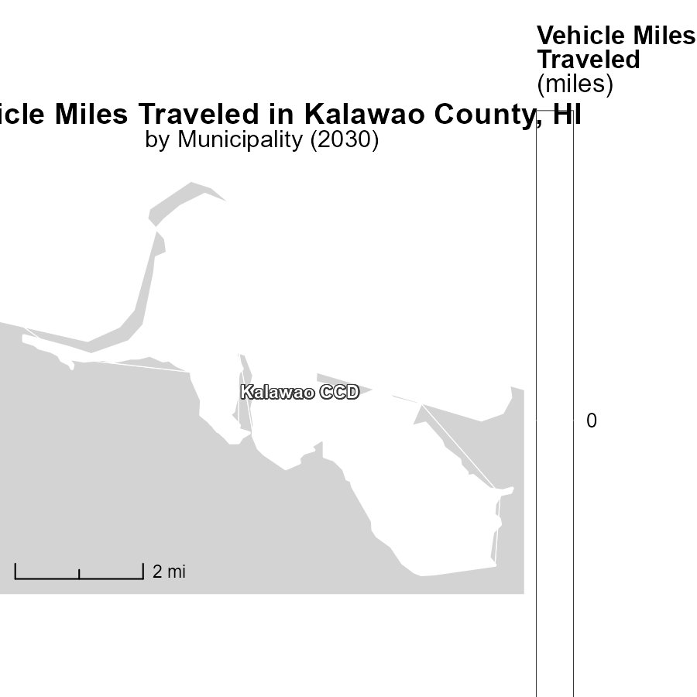

# Time Driven by Regulatory Class over Time

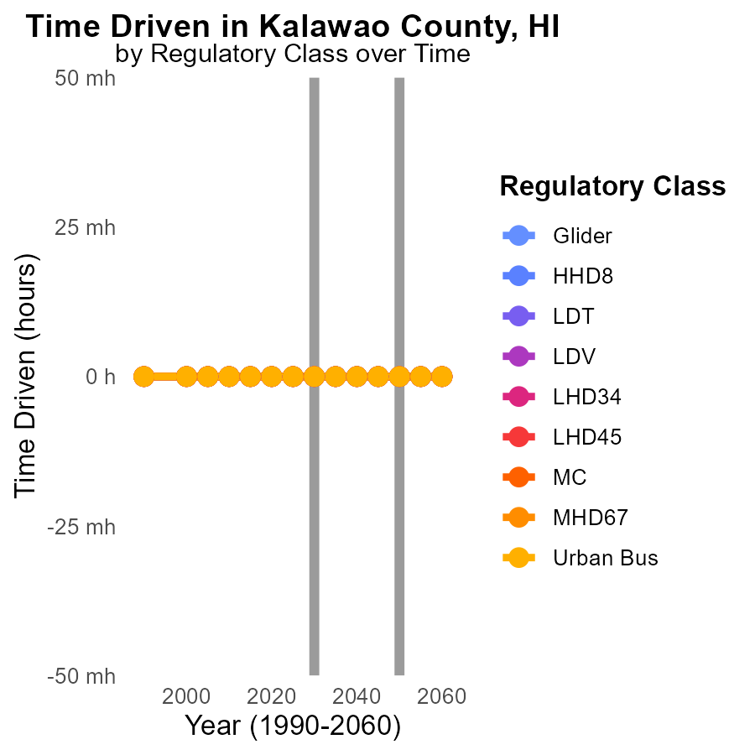

## Findings

* Emissions of nitrogen oxides (NOx) in Kalawao County, HI are consistently at 0.0 for various vehicle types from 2020 to 2040.
* No significant changes in NOx emissions are projected in the next two decades.
* All vehicle categories, including Glider, Urban Bus, and LDV, show no NOx emissions.

## Recommendations

Since the NOx emissions are already at 0.0 and are projected to remain so until 2040, policies should focus on maintaining current emission levels through continued adherence to clean air regulations and promoting the use of electric vehicles to further reduce environmental impact.

# Hotelling (Engines Off) by Fuel Type over Time

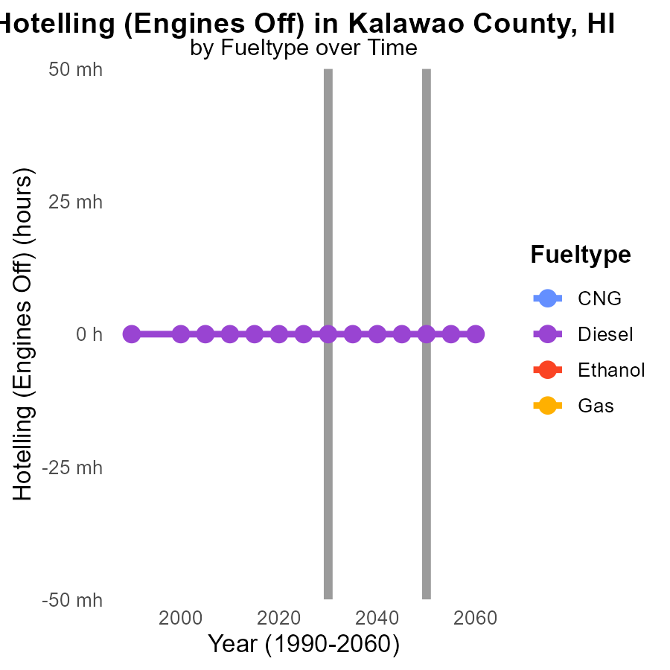

## Findings

* No measurable NOx emissions from Diesel fuel from 2020 to 2040.
* NOx emissions data not available for CNG, Ethanol, and Gas fuels from 2020 to 2040.
* Recommendations

## Recommendations

Develop a comprehensive emissions monitoring system for CNG, Ethanol, and Gas fuels. Invest in cleaner fuel technologies to reduce emissions from all fuel types.

# Areas Ranked by Vehicles

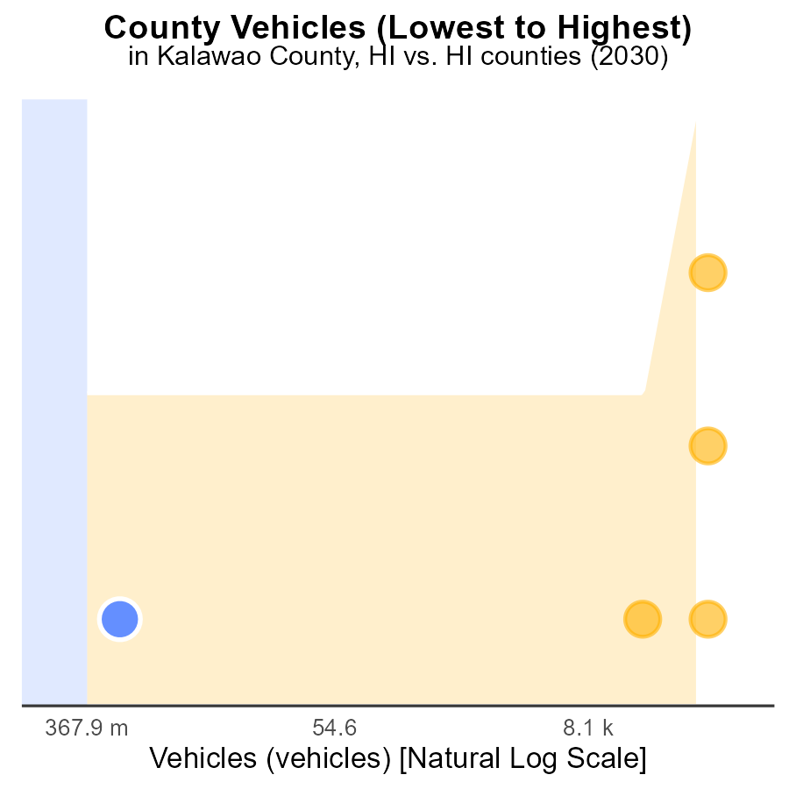

## Findings

* Kalawao has the lowest NOx emissions from vehicles with 0.0 kilotons.
* Honolulu has the highest NOx emissions from vehicles with 461.6 kilotons, accounting for 100% of the total emissions.
* Kauai ranks 2nd in NOx emissions from vehicles with 66.9 kilotons, contributing to 40.0% of the total emissions.

## Recommendations

To reduce NOx emissions from vehicles, Kalawao can focus on promoting electric vehicles and incentivizing public transportation. In Honolulu, measures like implementing stricter vehicle emission standards and promoting carpooling can help lower the emissions. Kauai should consider investing in cleaner fuel technologies and enhancing bike infrastructure to decrease NOx emissions.

# Areas Ranked by Time Driven

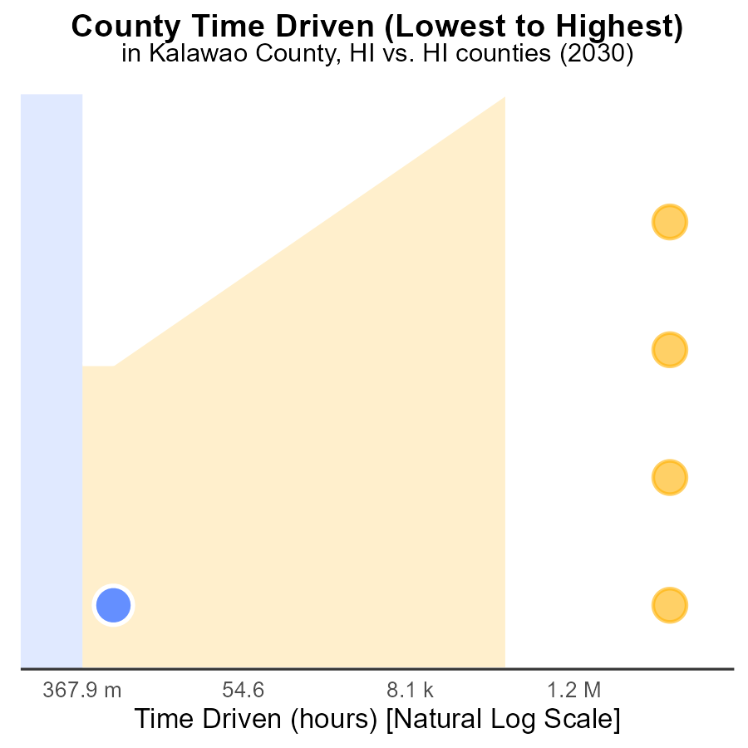

## Findings

* Kalawao has no reported NOx emissions in 2030.
* The top 5% of NOx emissions in Honolulu represent 100% of the total emissions in that county.
* Kauai ranks 2nd in NOx emissions, contributing to 40% of the total emissions.

## Recommendations

To lower NOx emissions, implement stricter regulations for sources in Honolulu to reduce the disproportionate contribution of the top 5%. Encourage Kalawao to monitor and report emissions. Support Kauai in implementing emission reduction measures and transitioning to cleaner sources.

# Conclusion

In conclusion, Kalawao County, HI has shown remarkable progress in reducing NOx emissions from on-road transportation, with consistent and sustained levels at 0.0 from 2020 to 2040. This achievement surpasses neighboring counties like Honolulu and Kauai, showcasing the success of clean air regulations and the promotion of electric vehicles in the region. By maintaining these zero-emission levels through continued adherence to regulations and further adoption of electric vehicles, Kalawao can serve as a model for environmentally conscious transportation practices.

The data presented highlights the positive impact of focused policies and incentives on reducing NOx emissions, emphasizing the importance of sustainable practices and cleaner technologies in mitigating environmental harm. Moving forward, Kalawao County should prioritize monitoring and reporting for all fuel types, invest in cleaner fuel technologies, and continue promoting the use of electric vehicles to sustain its exceptional record of zero NOx emissions.

# About This Report

Data based on MOVES estimates collected by the Climate Action in Transportation program at Cornell University. Demographic data sourced from the US Census's American Community Survey 5-year estimates. This report was generated with the help of AI.

# References

* U.S. Census Bureau. (2023). American Community Survey 5-year estimates: Detailed tables. Retrieved from https://data.census.gov
* U.S. Environmental Protection Agency. (2024). Motor Vehicle Emission Simulator (MOVES 4.0) [Software]. Retrieved from https://www.epa.gov/moves