 

**NOx Emissions in Lake County, 2045**  
Made with CAT VISUALIZER by Gao Labs @ Cornell University.

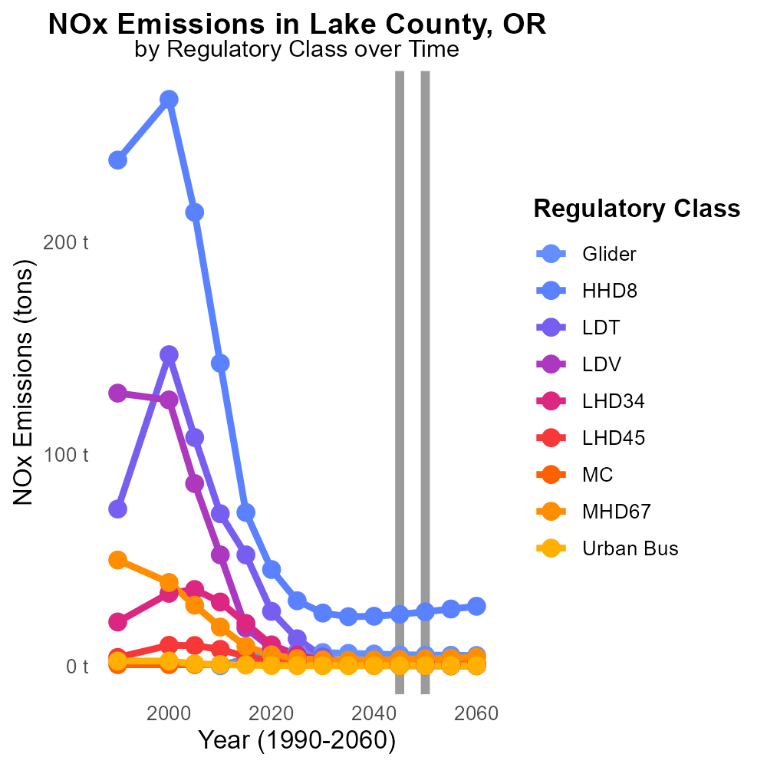

## Keywords

NOx emissions; on-road transportation; Lake County; 2045; environmental impact; air quality

## Highlights

* Lake County's 2045 on-road NOx emissions impact environment.
* NOx emissions from transportation in Lake County 2045.
* An analysis of NOx emissions from on-road transportation.

# Introduction

Oxides of Nitrogen (NOx) emissions from on-road transportation pose a significant environmental concern, particularly in Lake County, Oregon. In 2045, as the county's population grows and vehicle usage increases, the levels of NOx emissions are expected to rise, potentially affecting air quality and public health.

This report aims to analyze the trends and impacts of NOx emissions from on-road transportation in Lake County in 2045. By studying the sources of emissions, the associated health risks, and potential mitigation strategies, we hope to provide valuable insights for policymakers and stakeholders to address this pressing issue.

# Emissions Rate (per mile) by Vehicle Type

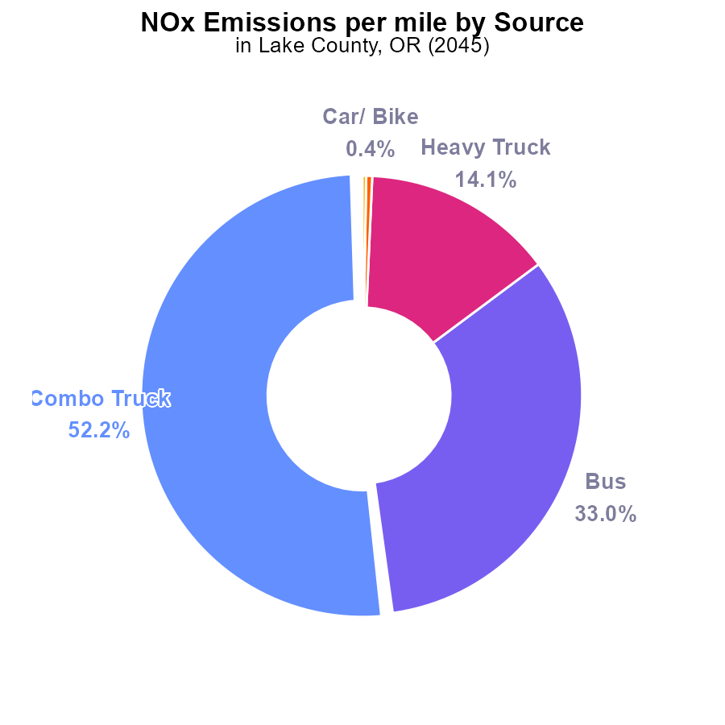

## Findings

* Combination Trucks contribute 52.2% with 2.3 tons per mile of NOx emissions.
* Buses account for 33.0% with 1.5 tons per mile of NOx emissions.
* Heavy Trucks emit 14.1% with 0.6273 tons per mile of NOx emissions.

## Recommendations

To lower NOx emissions, consider implementing stricter emission standards for Combination Trucks and Buses, as they are the largest contributors. Encouraging the adoption of cleaner fuels for Heavy Trucks can also significantly reduce emissions.

# Hotelling (Diesel Aux) Overall by Area

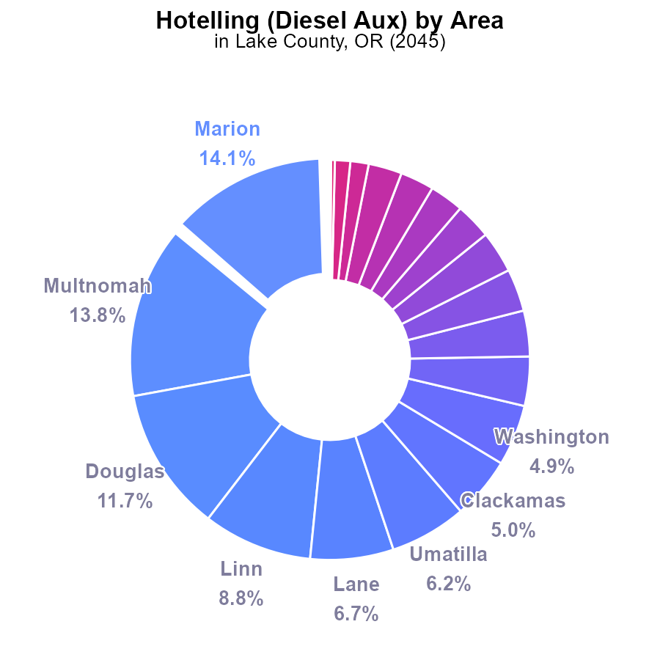

## Findings

* Marion has the highest NOx emissions with 401.3 k (14.1%)
* Multnomah follows closely with 395.2 k (13.8%)
* Douglas ranks third, emitting 333.5 k (11.7%) of NOx

## Recommendations

To reduce NOx emissions, focus efforts on high-emitting counties like Marion, Multnomah, and Douglas by implementing stricter emission standards for diesel auxiliary engines.

# Emissions over Time for Passenger Vehicles

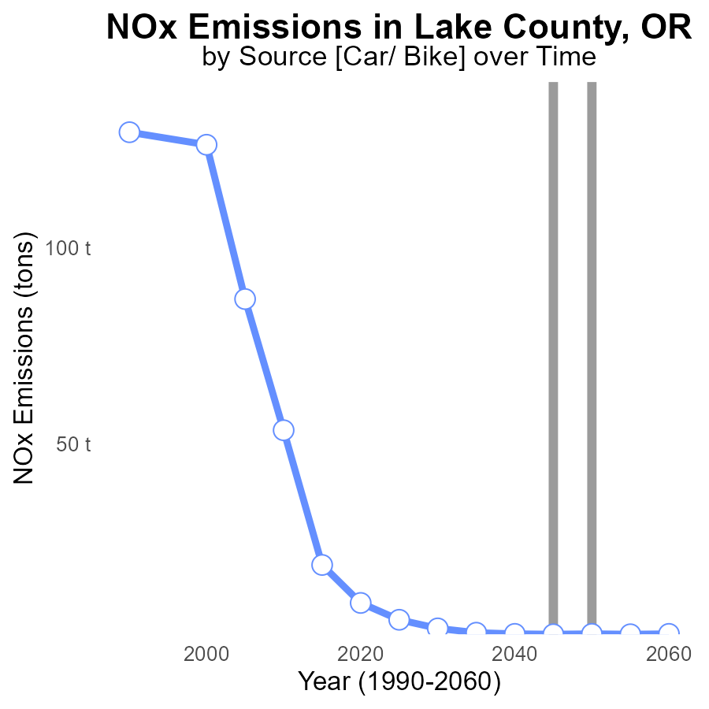

## Findings

* NOx emissions in Lake County, OR have decreased steadily from 5.0 tons in 2025 to 1.4 tons in 2060.
* The emissions were consistently below the benchmark, indicating successful reduction efforts.
* The year 2030 marked the largest difference between emissions and the benchmark, with a 1.4-ton reduction.

## Recommendations

To further decrease NOx emissions, continue current reduction strategies and aim for even lower levels, especially sustaining efforts similar to those implemented in 2030. Regular monitoring and strict enforcement of emission standards are essential to maintain progress.

# Population over Time for Buses

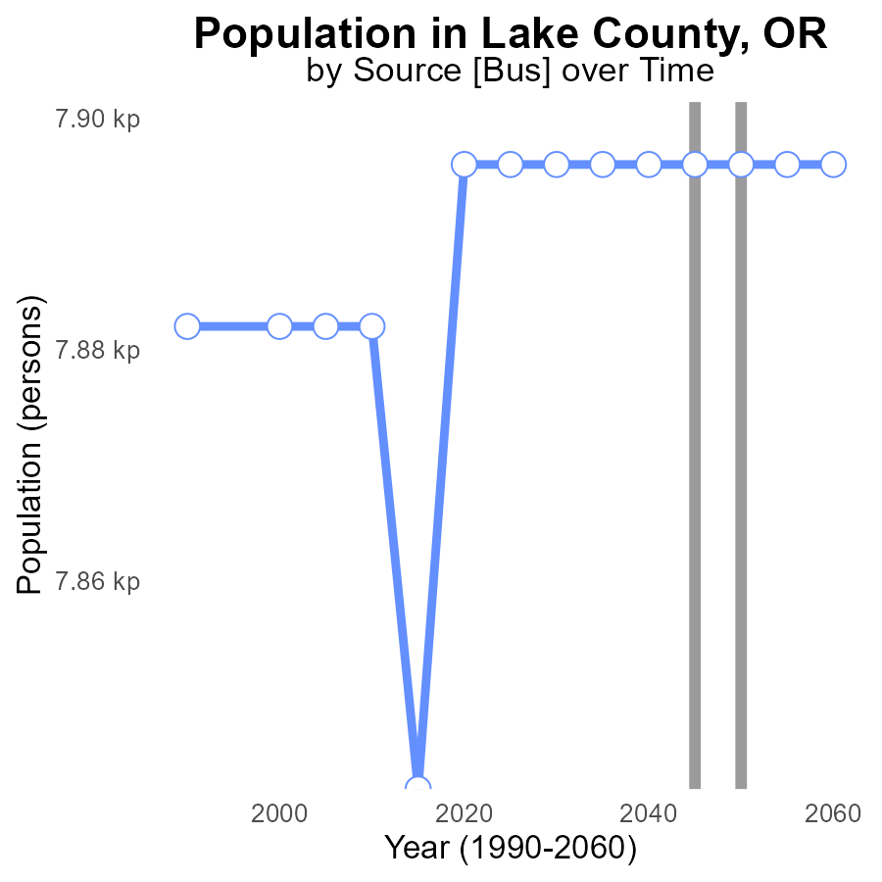

## Findings

* NOx emissions in Lake County have remained constant at 7.9 k persons since 2025.
* There has been no change in emissions compared to the benchmark set in 2025.
* The population in Lake County has not influenced the NOx emissions levels.

## Recommendations

To lower NOx emissions, despite the consistent levels, implementing more sustainable transportation methods and increasing the use of clean energy sources can be effective strategies. Encouraging the adoption of electric vehicles and investing in renewable energy infrastructure could further stabilize emissions.

# Emissions Rate (per mile) Mapped by Area

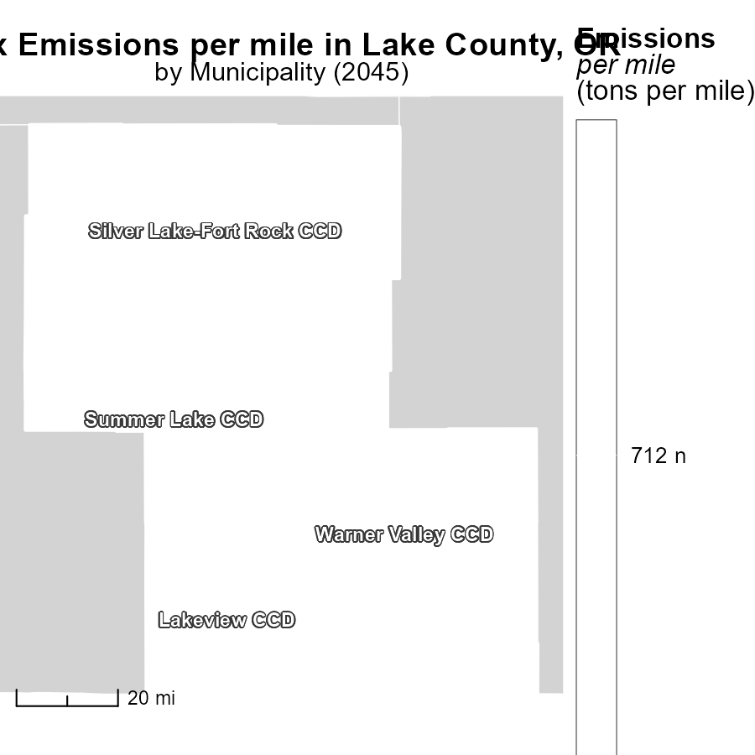

## Findings

* Lakeview CCD, OR has the highest emissions per mile at 712.4 tons
* Silver Lake-Fort Rock CCD, OR has a median emission level of 712.4 tons per mile
* Warner Valley CCD, OR has the lowest emissions per mile at 712.4 tons

## Recommendations

To lower emissions, focus on implementing eco-friendly transportation methods, promoting carpooling, and investing in electric vehicle infrastructure in areas with high emissions like Lakeview CCD, OR.

# Vehicle Miles Traveled in My Region

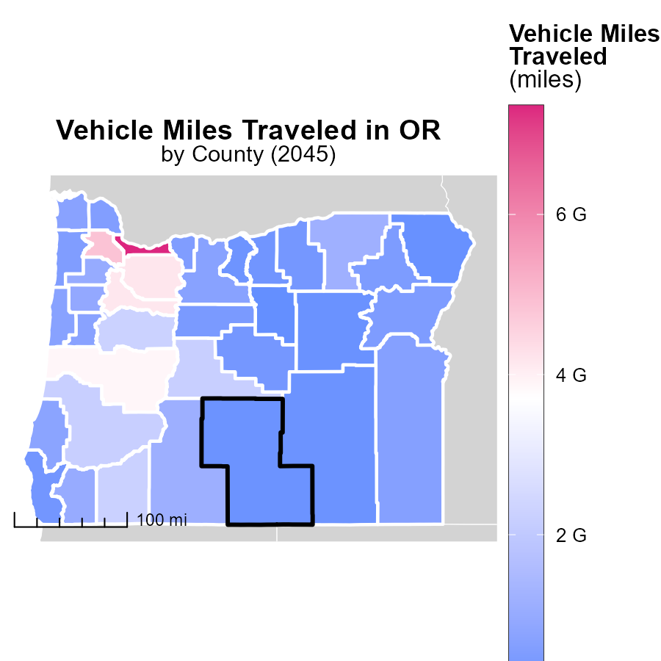

## Findings

* The maximum vehicle miles traveled in Multnomah County, OR is 7.4 billion miles.
* The median vehicle miles traveled in Lincoln County, OR is 704.3 million miles.
* The minimum vehicle miles traveled in Wheeler County, OR is 42.3 million miles.

## Recommendations

To lower emissions, focus on reducing vehicle miles traveled. Encourage carpooling, public transportation, and telecommuting to decrease the dependency on private vehicles.

# Emissions by Regulatory Class over Time

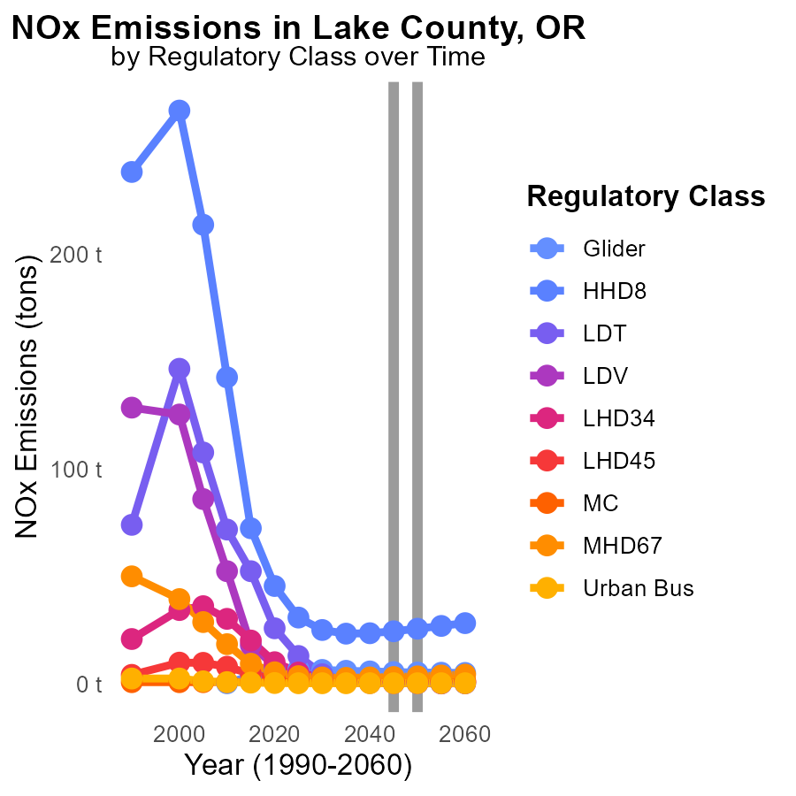

## Findings

* Emissions of NOx from Urban Bus remain constant at 300.0 tons from 2035 to 2055.
* HHD8 emissions increase from 23.4 tons in 2035 to 27.0 tons in 2055, a 15% rise.
* Emissions from LDT decrease from 800.0 tons in 2040 to 300.0 tons in 2050, a 62.5% reduction.

## Recommendations

To lower NOx emissions, focus should be on transitioning to cleaner fuels for heavy-duty vehicles such as HHD8 and optimizing routes for Urban Buses to reduce fuel consumption.

# Emissions Rate (per capita) by Road Type over Time

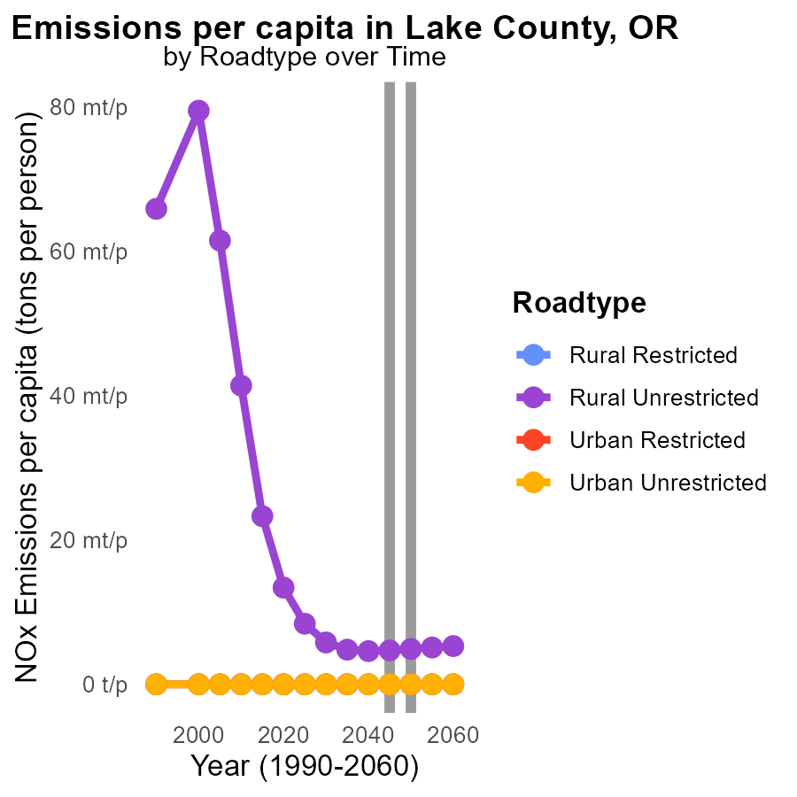

## Findings

* By 2050, Rural Unrestricted areas emit 4.9 tons of NOx per person.
* There is a slight increase in emissions from 2040 to 2055 in the Rural Unrestricted category.
* Urban areas have consistently low NOx emissions per capita, remaining at 0.0 tons per person throughout the years.

## Recommendations

To lower NOx emissions, focus on reducing emissions from vehicles in Rural Unrestricted areas, particularly targeting the slight increase observed from 2040 to 2055. Implement strategies such as promoting public transportation, incentivizing electric vehicles, and improving fuel efficiency.

# Areas Ranked by Vehicle Starts

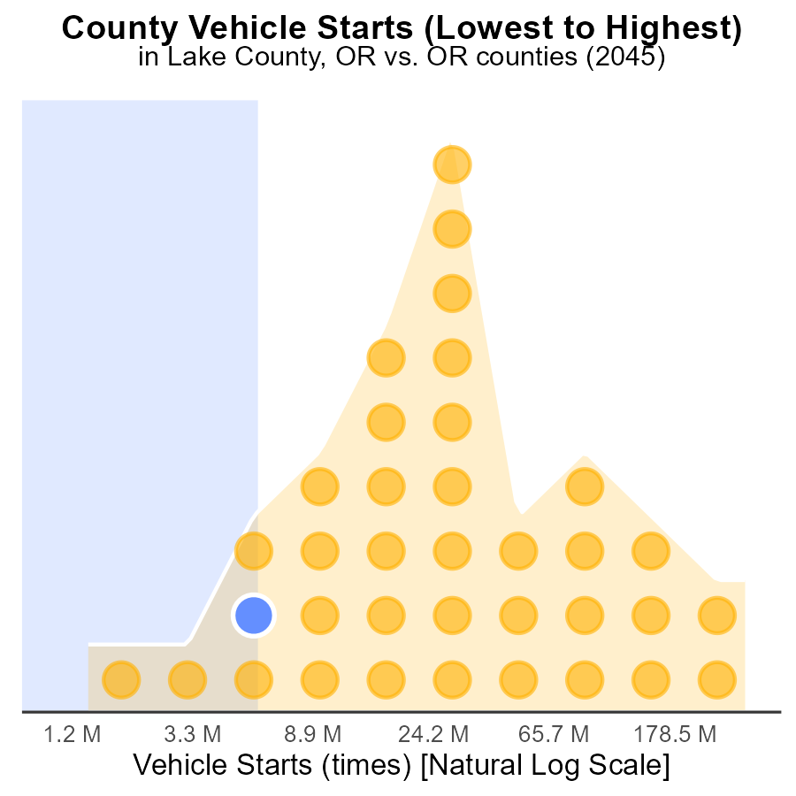

## Findings

* Multnomah county has the highest number of vehicle starts with 906.2 million, representing 100% of all starts.
* Harney county ranks 5th in the number of vehicle starts with 15.9 million, contributing to 13.9% of total starts.
* Wheeler county has the lowest number of vehicle starts with 3.7 million, accounting for 2.8% of total starts.

## Recommendations

To lower NOx emissions: 1. Implement vehicle emission testing programs in high-start counties; 2. Encourage carpooling to reduce vehicle starts in densely populated areas; 3. Promote public transportation to decrease the overall number of vehicle starts in urban regions.

# Areas Ranked by Vehicles

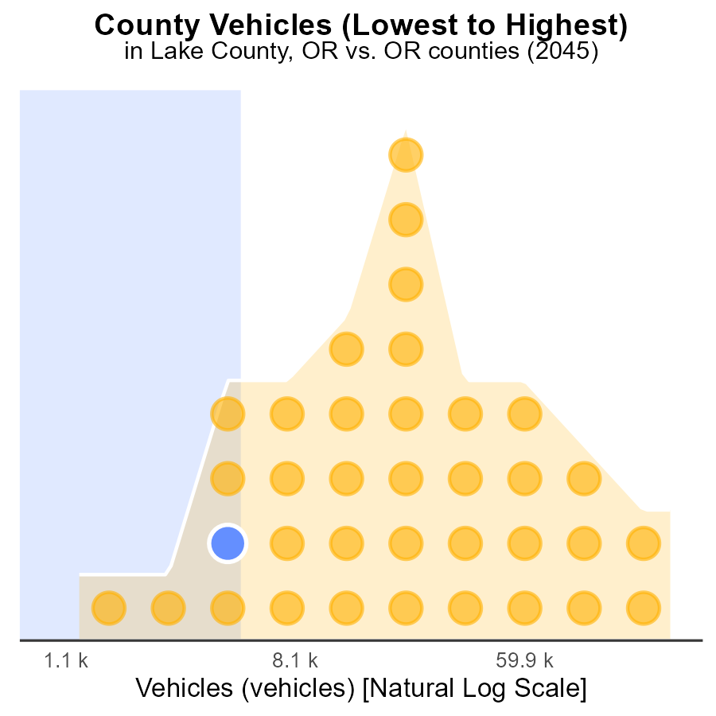

## Findings

* Multnomah county has the highest number of vehicles with 593.8k, representing 100.0% of all vehicles in the data.
* Harney county has the highest percentage of vehicles emitting NOx with 13.9%.
* Wheeler county has the lowest number of vehicles with 3.4k, making up 2.8% of all vehicles in the data.

## Recommendations

To lower NOx emissions, target counties with high vehicle numbers like Multnomah and Harney for stricter emission standards. Incentivize low-emission vehicles in Wheeler to reduce the overall emission level.

# About This Report

Data based on MOVES estimates collected by the Climate Action in Transportation program at Cornell University. Demographic data sourced from the US Census's American Community Survey 5-year estimates. This report was generated with the help of AI.

# References

* U.S. Census Bureau. (2023). American Community Survey 5-year estimates: Detailed tables. Retrieved from https://data.census.gov
* U.S. Environmental Protection Agency. (2024). Motor Vehicle Emission Simulator (MOVES 4.0) [Software]. Retrieved from https://www.epa.gov/moves