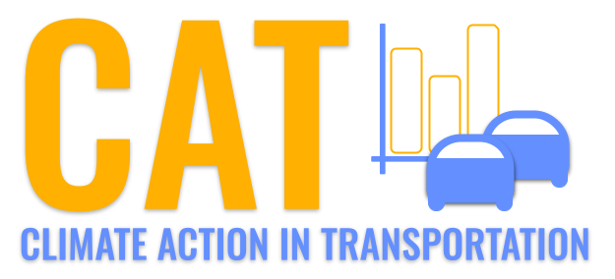 

**NOx Emissions in Monona County, 2055**  
Made with CAT VISUALIZER by Gao Labs @ Cornell University.

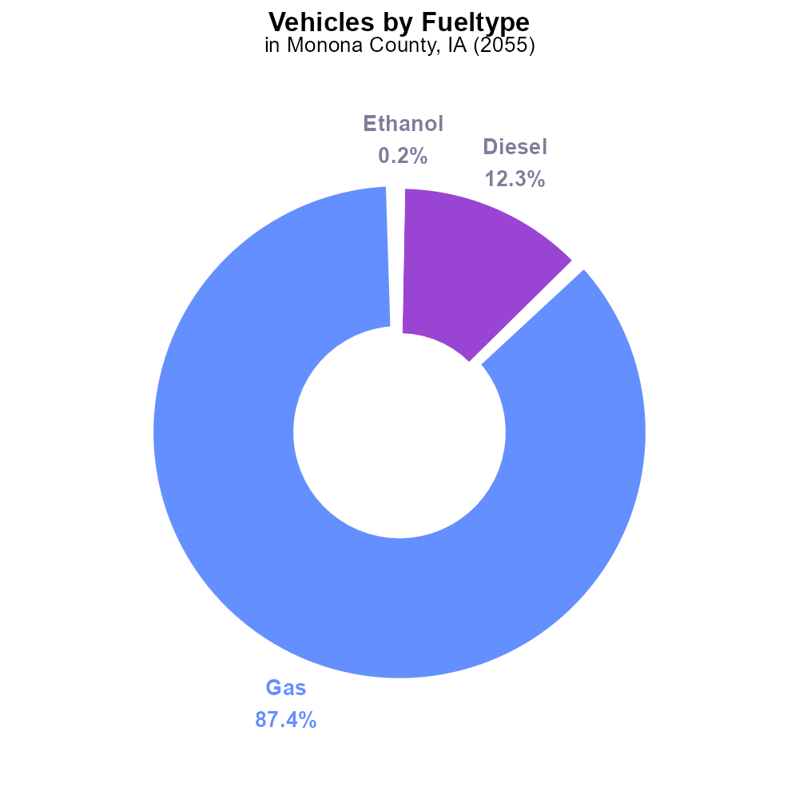

## Keywords

Oxides of Nitrogen; NOx emissions; on-road transportation; Monona County; IA; 2055

## Highlights

* NOx emissions from on-road transport in Monona County, IA in 2055.
* Analyzing the impact of transportation on air quality.
* Exploring measures to reduce NOx emissions for a cleaner environment.
* Investigating the trends and levels of NOx emissions.
* Addressing the environmental concerns of NOx in transportation.

# Introduction

The report focuses on the Oxides of Nitrogen (NOx) emissions resulting from on-road transportation activities in Monona County, IA, projected for the year 2055. With increasing concerns about air quality and environmental sustainability, understanding and addressing NOx emissions have become crucial. The study aims to analyze the specific sources and levels of NOx emissions originating from on-road vehicles, and their implications for the local environment and public health.

By examining the trends and patterns of NOx emissions in Monona County, IA, in 2055, this report seeks to provide valuable insights into the current state of air quality and the potential risks posed by elevated NOx levels. Additionally, the report will explore possible mitigation strategies and policy interventions to reduce NOx emissions from on-road transportation, promoting a cleaner and healthier environment for residents of Monona County and beyond.

# Vehicles by Fuel Type

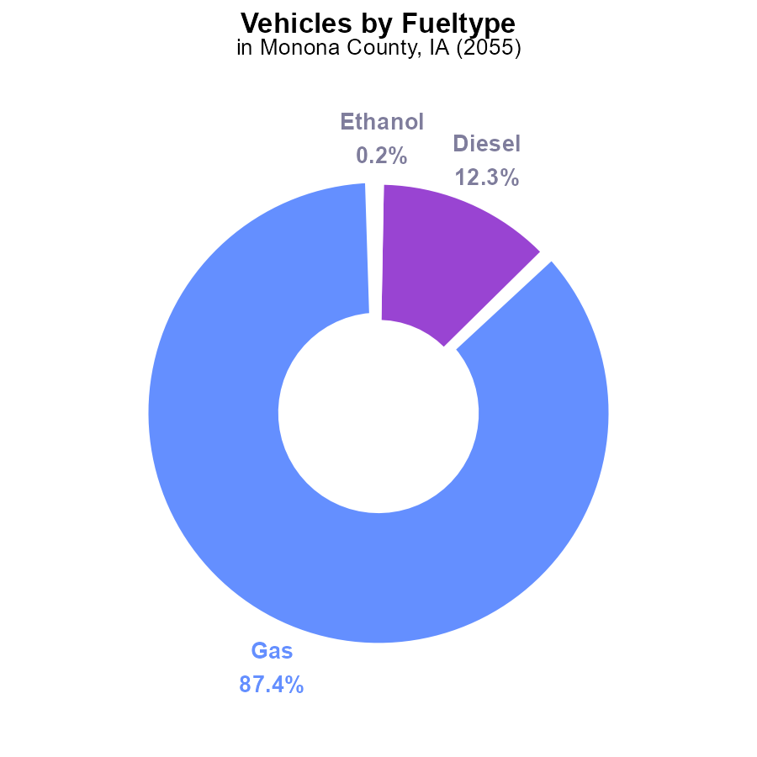

## Findings

* Gasoline vehicles are the main source of NOx emissions in Monona County, IA, accounting for 87.4%.
* Diesel vehicles contribute to 12.3% of NOx emissions in the county.
* Alternative fuel sources like ethanol and CNG have a negligible impact, contributing only 0.2% and 0.1% respectively.

## Recommendations

To lower NOx emissions in Monona County, IA, there should be a focus on reducing emissions from gasoline and diesel vehicles through measures such as promoting electric vehicles, improving public transportation, and enforcing stricter emission standards for traditional vehicles.

# Idling Overall by Area

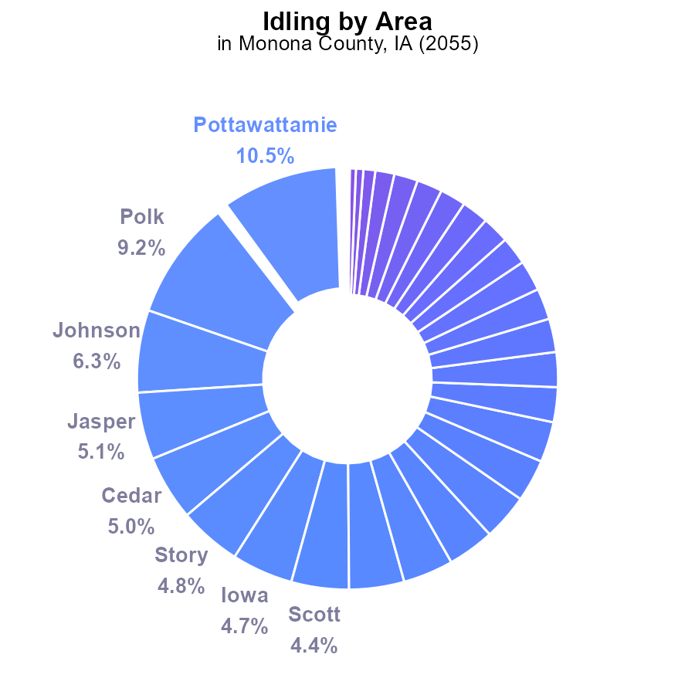

## Findings

* The top five counties with the highest NOx emissions from idling in Monona County, IA are Pottawattamie with 10.5%, Polk with 9.2%, Johnson with 6.3%, Jasper with 5.1%, and Cedar with 5.0%.
* The top ten counties in terms of NOx emissions collectively account for about 51.8% of the total emissions from idling in Monona County.
* A significant number of counties, including Madison, Wright, and many others, reported negligible to zero NOx emissions from idling in Monona County.

## Recommendations

To lower NOx emissions from idling in Monona County, a targeted approach focusing on high-emission counties like Pottawattamie, Polk, Johnson, Jasper, and Cedar is crucial. Implementing idling reduction campaigns and promoting the use of emission-reducing technologies in these areas can substantially decrease overall emissions.

# Population Overall over Time

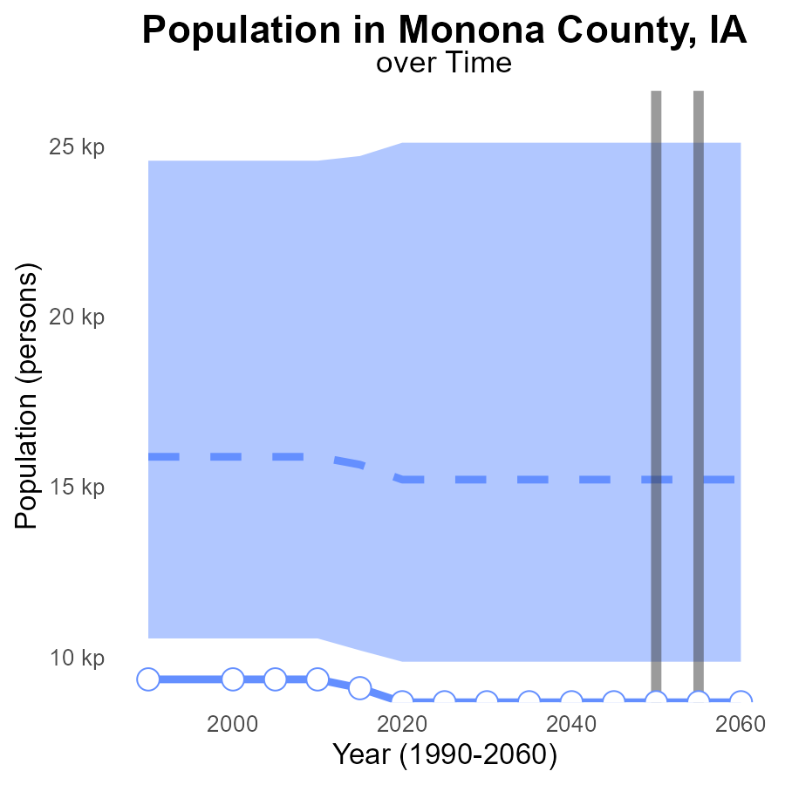

## Findings

* NOx emissions in Monona County, IA are consistently at 8.7 k over the years 2035 to 2060.
* The emissions in this area are lower by 6.5 k compared to the median area of 15205 persons.
* Monona County falls within the lower 25% of areas in terms of NOx emissions.

## Recommendations

To lower NOx emissions in Monona County, IA, measures should be implemented to target industries or activities that are the primary sources of NOx. Encouraging the adoption of cleaner technologies and regular monitoring can help in reducing emissions further.

# Hotelling (Diesel Aux) over Time for Passenger Vehicles

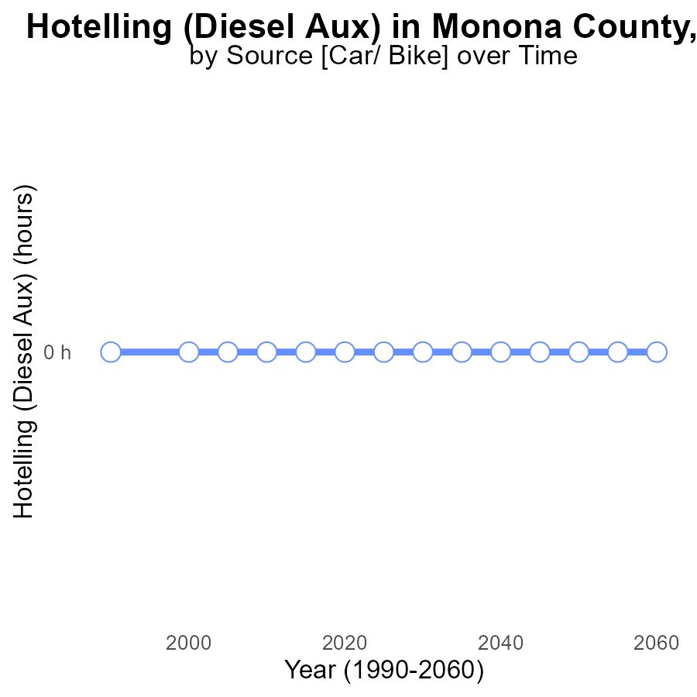

## Findings

* There has been no NOx emissions from Hotelling (Diesel Aux) in Monona County, IA from 2035 to 2060.

## Recommendations

Given the absence of NOx emissions from Hotelling (Diesel Aux), it is crucial to continue monitoring and enforcing strict regulations to maintain this zero-emission trend in the future.

# Population in My Region

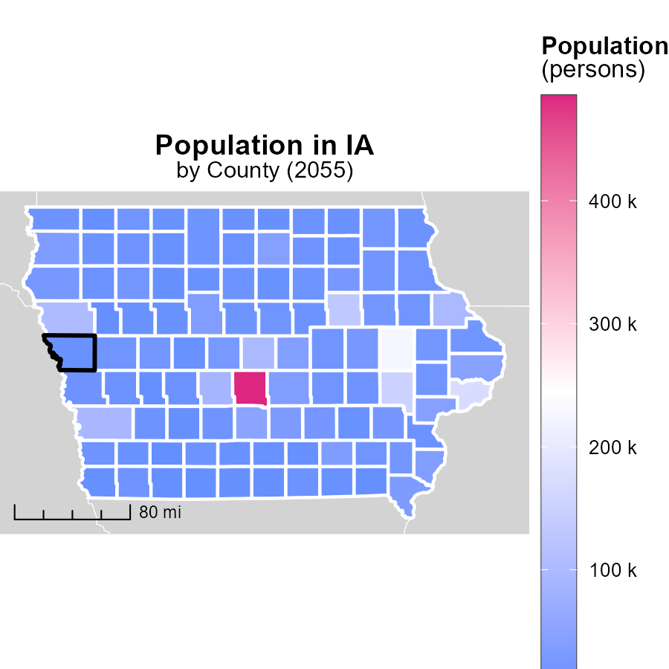

## Findings

* Polk County, IA has the highest population with 485.4k persons.
* Adams County, IA has the lowest population with 3.6k persons.
* Page County, IA has a median population of 15.2k persons.

## Recommendations

To lower emissions, focus on high-population areas like Polk County by promoting public transport and carpooling. In low-population areas like Adams County, encourage the use of energy-efficient technologies.

# Population Mapped by Area

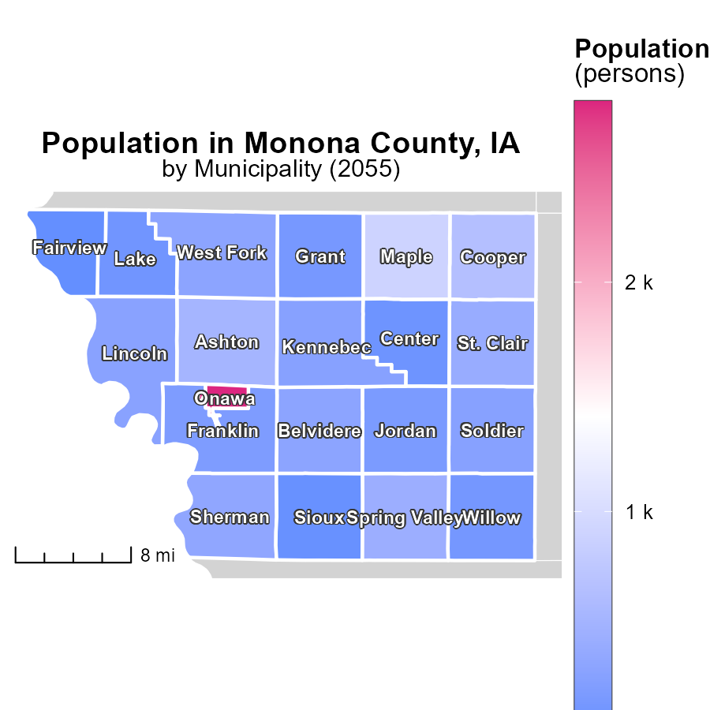

## Findings

* The maximum population emission of Onawa, IA is 2.8k persons.
* The median population emission of Lincoln, IA is 297.0 persons.
* The minimum population emission of Fairview, IA is 45.0 persons.

## Recommendations

To reduce emissions, focus on areas with high population emissions like Onawa, IA by implementing energy-efficient infrastructure. Consider incentivizing sustainable transportation options in Lincoln, IA. Encourage community initiatives for emission reduction in Fairview, IA.

# Emissions Rate (per mile) by Vehicle Type over Time

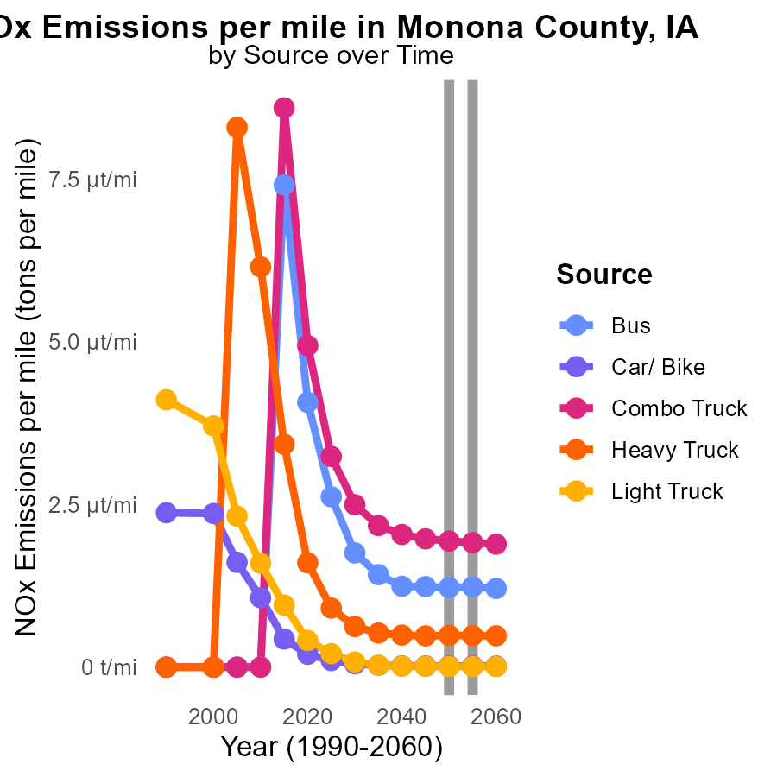

## Findings

* In 2055, there was a decrease in NOx emissions per mile for Car/Bike compared to 2050.
* Heavy Trucks had the highest NOx emissions per mile across all vehicle types in 2050.
* Light Trucks showed a significant reduction in NOx emissions per mile from 2050 to 2060.

## Recommendations

To reduce NOx emissions in Monona County, IA, focus should be on implementing more stringent emission standards for Heavy Trucks, promoting the adoption of cleaner fuel technologies for Light Trucks, and incentivizing the use of public transportation or carpooling to decrease Car/Bike emissions further.

# Hotelling (Diesel Aux) by Regulatory Class over Time

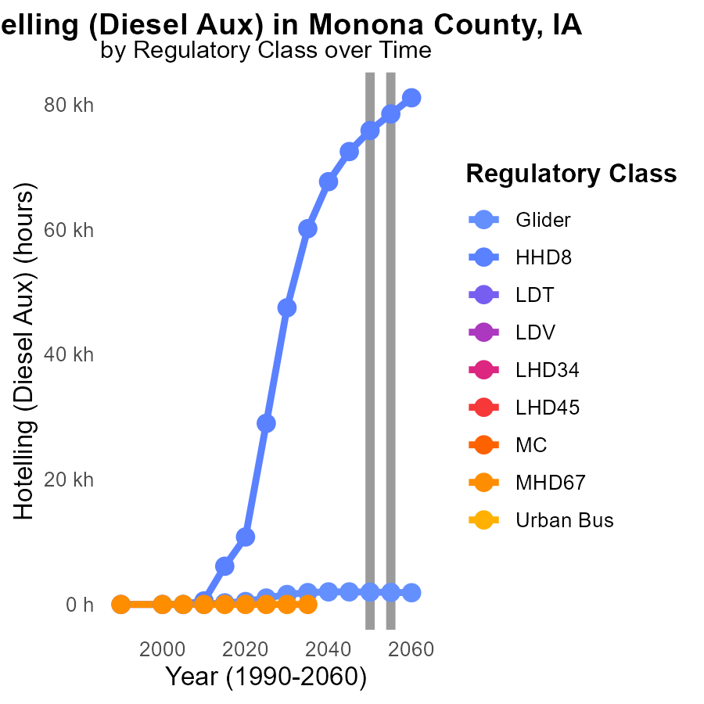

## Findings

* NOx emissions from Glider engines are expected to decrease by 35.4% by 2045 and then remain stable until 2060.
* NOx emissions from HHD8 engines will increase by 3369.2% by 2045 and decrease by 5229.3% by 2060 compared to 2050 levels.
* Other vehicle types such as LDT, LDV, LHD34, LHD45, MC, MHD67, and Urban Bus show no available data for NOx emissions from 2045 to 2060.

## Recommendations

To lower NOx emissions, focus on implementing stricter regulations on HHD8 engines to ensure the drastic reduction observed by 2060. For Glider engines, continue monitoring and enforcing measures that maintain the initial 35.4% reduction achieved by 2045.

# Areas Ranked by Vehicle Miles Traveled

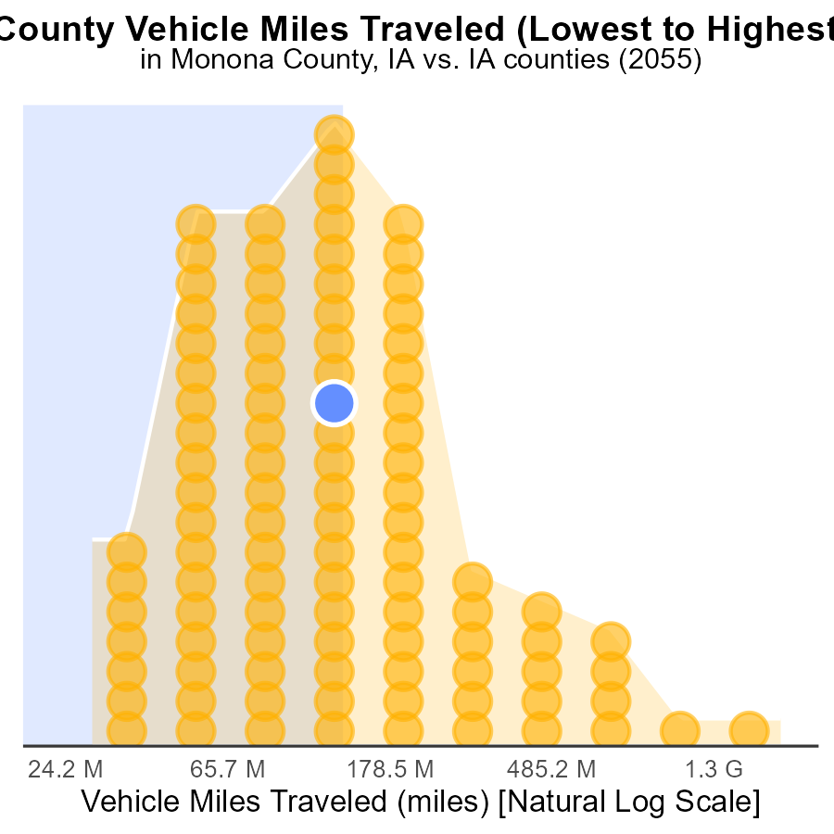

## Findings

* Polk county has the highest VMT with 5.5 billion miles, ranking 99th nationally.
* Most counties, such as Monona, Tama, and Jones, have VMT in the range of 333-366 million miles.
* Taylor county has the lowest VMT with only 77.2 million miles, ranking 1st on the percentile scale.

## Recommendations

To lower NOx emissions, focus on reducing VMT in counties with high mileage like Polk. Encourage carpooling, public transportation, and telecommuting to decrease vehicle usage.

# Areas Ranked by Population

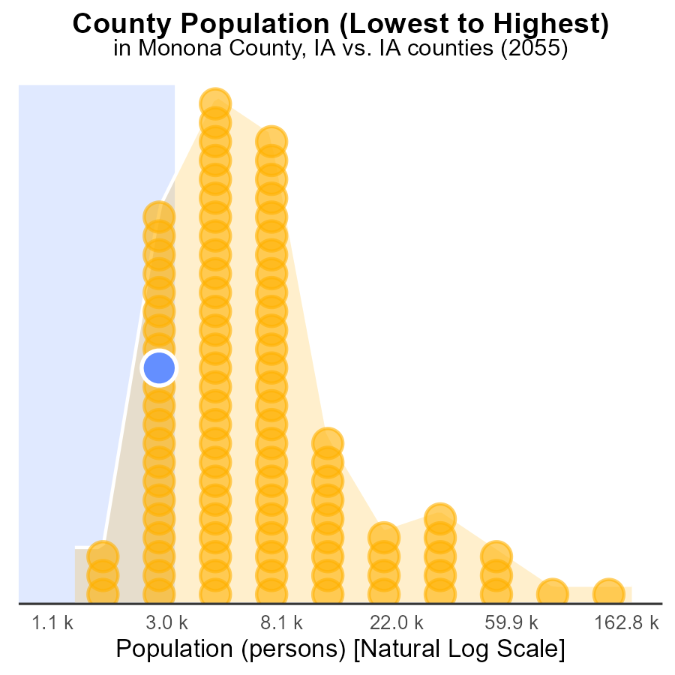

## Findings

* Polk county has the highest NOx emissions in 2055.
* Polk county has the highest population among the three counties.
* Monona county has the lowest NOx emissions and population percentage.

## Recommendations

To lower NOx emissions, focus on reducing emissions from high-ranking areas like Polk county through stricter regulations. Implement clean energy initiatives in densely populated areas to reduce overall emissions.

# Conclusion

In conclusion, the analysis of Oxides of Nitrogen (NOx) emissions from on-road transportation in Monona County, IA in 2055 reveals some key insights. Gasoline vehicles remain the primary contributor to NOx emissions in the county, while diesel vehicles also play a significant role. Alternative fuel sources like ethanol and CNG have a minimal impact on overall emissions. To effectively reduce NOx emissions, there should be a concerted effort to promote electric vehicles, enhance public transportation infrastructure, and enforce stricter emission standards for traditional vehicles.

Additionally, targeting high-emission counties such as Pottawattamie, Polk, Johnson, Jasper, and Cedar for idling reduction campaigns can lead to a substantial decrease in emissions. It is also essential to focus on industries and activities that are major sources of NOx emissions in Monona County and encourage the adoption of cleaner technologies. By closely monitoring emissions and implementing appropriate measures, significant progress can be made towards reducing NOx emissions from on-road transportation in the county.

# About This Report

Data based on MOVES estimates collected by the Climate Action in Transportation program at Cornell University. Demographic data sourced from the US Census's American Community Survey 5-year estimates. This report was generated with the help of AI.

# References

* U.S. Census Bureau. (2023). American Community Survey 5-year estimates: Detailed tables. Retrieved from https://data.census.gov
* U.S. Environmental Protection Agency. (2024). Motor Vehicle Emission Simulator (MOVES 4.0) [Software]. Retrieved from https://www.epa.gov/moves