 

**Carbon Emissions in Hutchinson County, 2050**  
Made with CAT VISUALIZER by Gao Labs @ Cornell University.

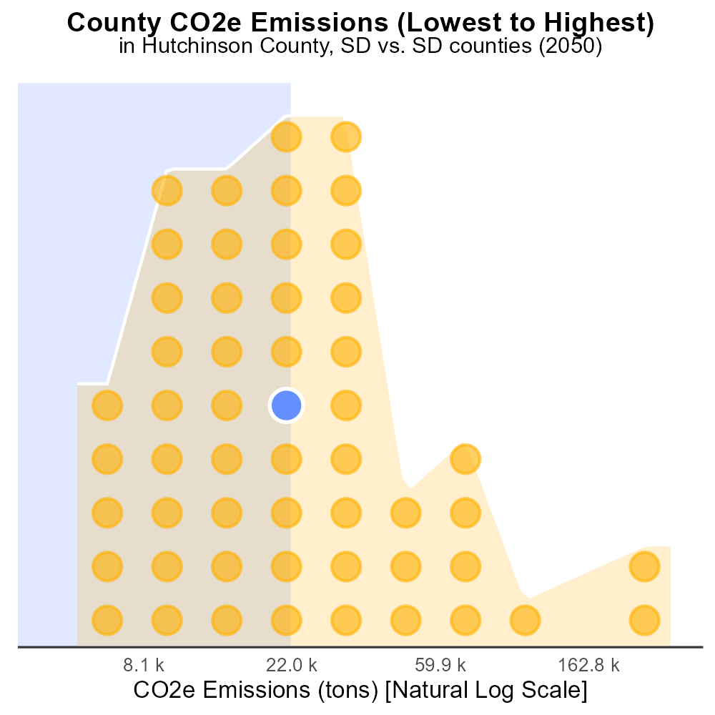

## Keywords

CO2 emissions; on-road transportation; Hutchinson County; SD; 2050

## Highlights

* Examining on-road CO2 emissions in Hutchinson County, SD in 2050.
* Understanding the impact of transportation on greenhouse gas levels.
* Analyzing trends and forecasting future emissions for policy planning.
* Addressing environmental implications of transportation practices.
* Proposing strategies for reducing CO2 equivalent emissions in the county.

# Introduction

In the year 2050, Hutchinson County, located in South Dakota, is facing a critical challenge in reducing CO2 equivalent emissions from on-road transportation. This report aims to investigate the current emission levels, trends, and potential forecasts for the future. The transportation sector plays a significant role in contributing to greenhouse gas levels, and understanding these dynamics is essential for effective policy planning and environmental management.

By examining on-road transportation emissions in Hutchinson County, we can assess the environmental impact of current practices and propose strategies for mitigating these emissions. This report will delve into the data, analyze patterns, and offer recommendations to address the pressing issue of reducing CO2 equivalent emissions in the county for a more sustainable future.

# Hotelling (Diesel Aux) by Fuel Type



## Findings

* In 2050, diesel emissions accounted for 0.0% of the total CO2e emissions in Hutchinson County, SD.
* There were no emissions data available for CNG, ethanol, and gas for the same time period.
* The majority of emissions came from Diesel (Hotelling) with auxiliary power, indicating potential areas for emission reduction.

## Recommendations

To lower emissions in Hutchinson County, SD, it is recommended to focus on reducing emissions from Diesel (Hotelling) sources by implementing cleaner technologies or alternative fuels, given their significant contribution to the total emissions in 2050.

# Vehicle Starts by Road Type

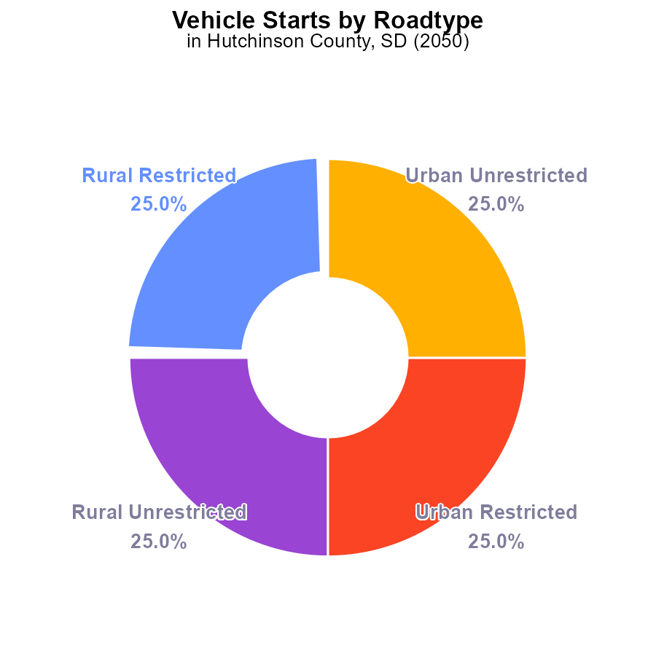

## Findings

* Hutchinson County emitted 54.8 million tons of CO2e in 2050.
* Vehicle starts were evenly distributed across all categories, with 25% each.
* There is no significant difference in emissions between rural and urban areas.

## Recommendations

To lower emissions, focus on transitioning to electric vehicles, promoting public transportation, and investing in infrastructure to support walking and cycling.

# Vehicles over Time for Passenger Vehicles

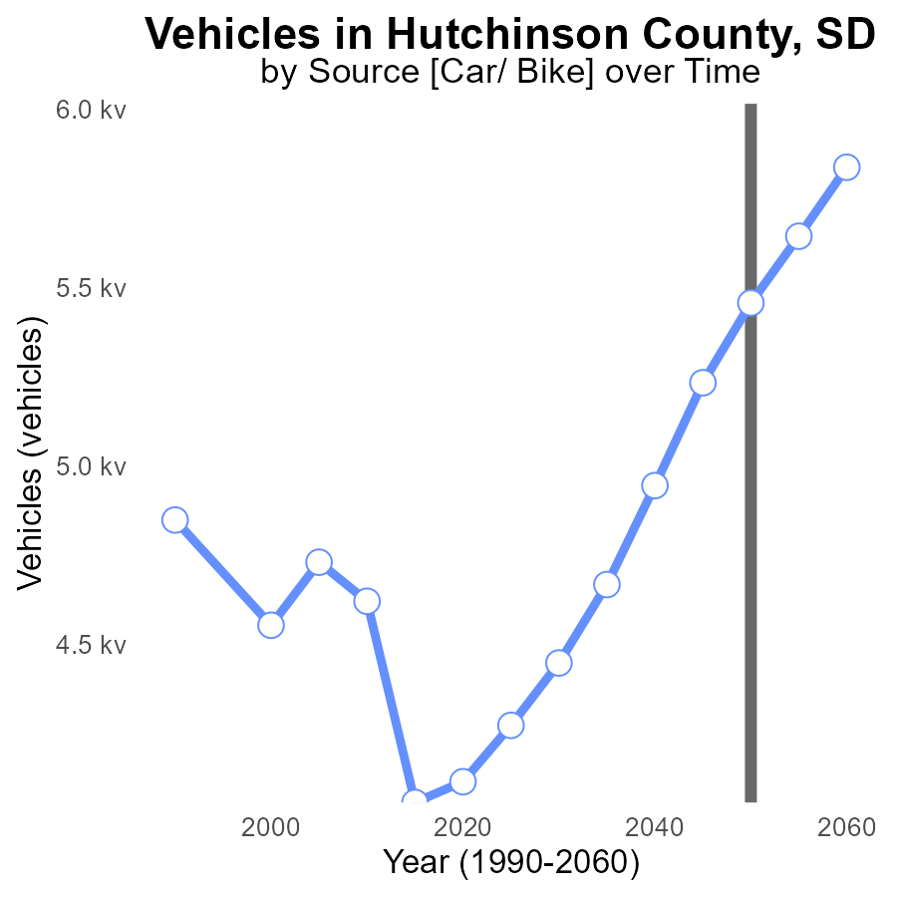

## Findings

* CO2e emissions from vehicles in Hutchinson County are projected to increase steadily until 2050, reaching 5.5 k tonnes.
* By 2060, emissions are projected to decrease to 5.8 k tonnes, showing a net decrease of 380.2 tonnes compared to 2050 levels.
* Over the 30-year period from 2030 to 2060, CO2e emissions from vehicles are expected to decrease by 9.7%.

## Recommendations

To lower emissions, Hutchinson County should focus on investments in sustainable transportation infrastructure, promote the adoption of electric vehicles, and implement policies to incentivize carpooling and public transportation usage.

# Time Driven Overall over Time

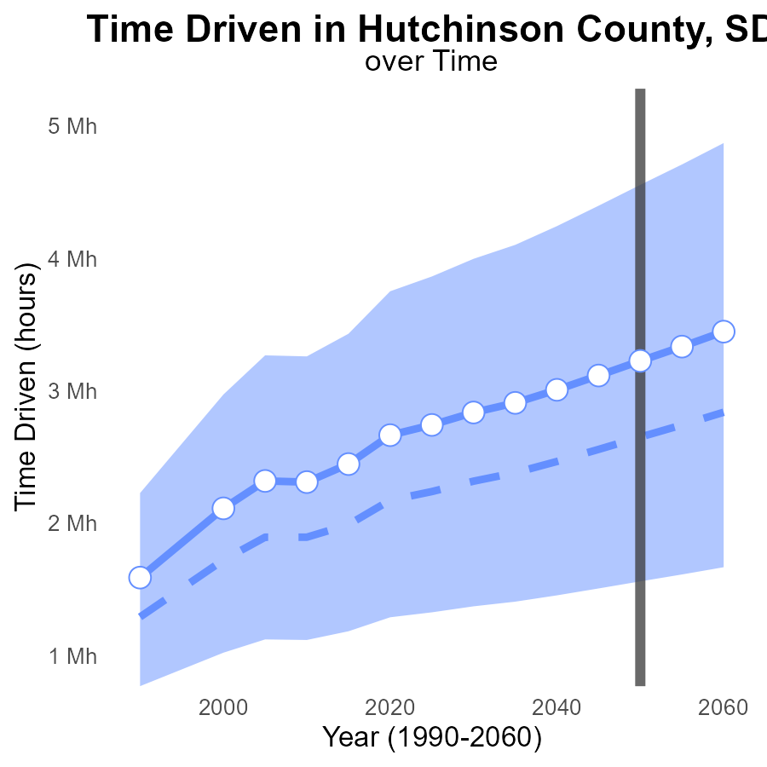

## Findings

* Emissions in Hutchinson County are projected to increase steadily, from 2.8M in 2030 to 3.4M in 2060.
* Area emissions consistently remain above the median, by as much as 592.0k in 2055.
* Benchmark differences fluctuate, from +389.9k in 2030 to -221.2k in 2060.

## Recommendations

To lower emissions, Hutchinson County should focus on transitioning to renewable energy sources, incentivizing energy-efficient technologies, and implementing stricter emissions regulations on industries.

# Time Driven Mapped by Area

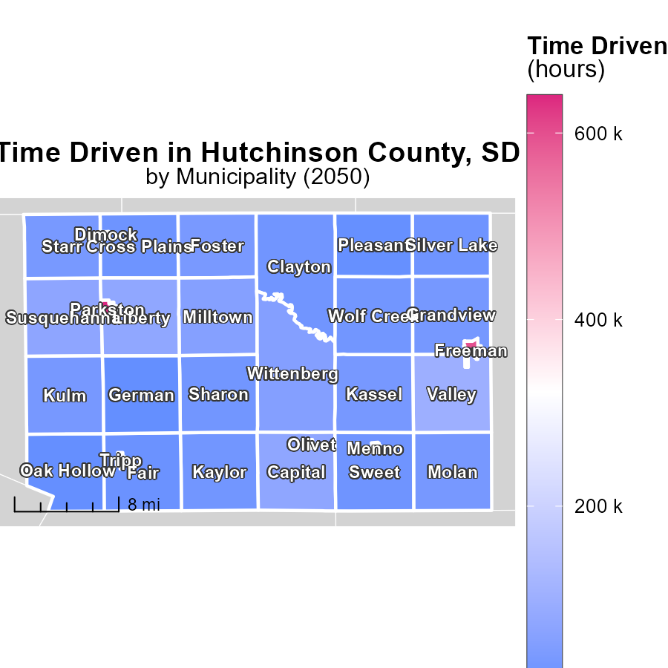

## Findings

* Parkston, SD has the highest maximum emissions of 640.2 k hours.
* Kulm, SD has a median emission level of 33.9 k hours.
* German, SD shows the lowest minimum emissions of 5.8 k hours.

## Recommendations

To lower emissions, focus on reducing usage in locations with high levels like Parkston, while improving efficiency in median areas like Kulm. Implement renewable energy sources across all locations for sustainable reduction.

# Vehicles Mapped by Area

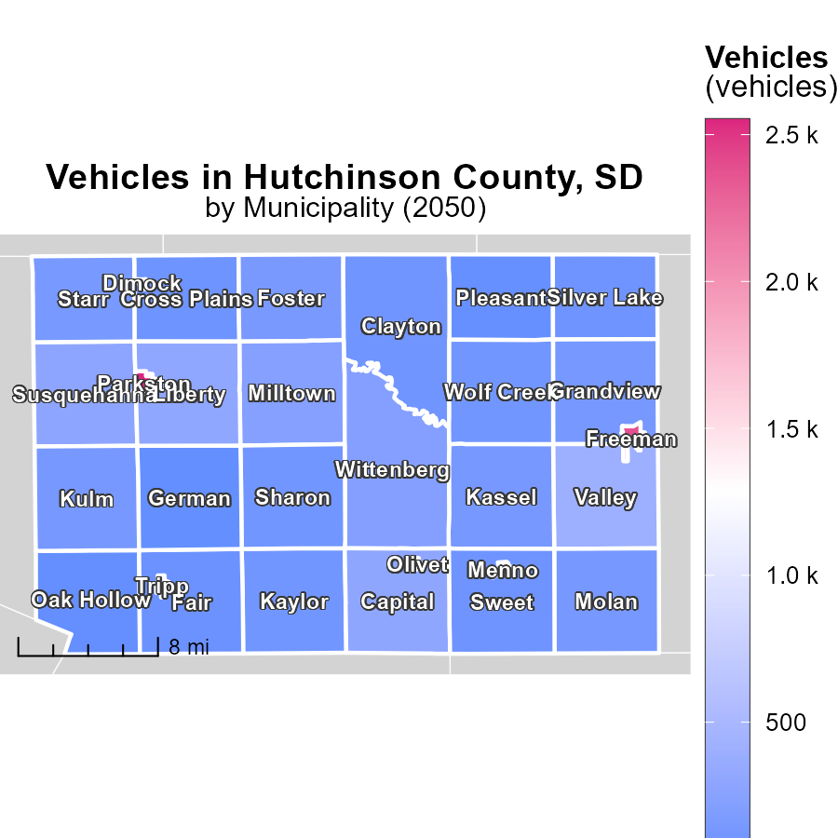

## Findings

* Parkston, SD has the highest maximum vehicle emissions at 2.6k
* Kulm, SD has a median vehicle emission level of 135.1
* German, SD has the lowest minimum vehicle emissions at 23.2

## Recommendations

To lower vehicle emissions, focus on areas with higher values like Parkston, SD by promoting the use of electric vehicles and public transportation. Implement stricter emission regulations in these areas.

# Vehicle Miles Traveled by Area over Time

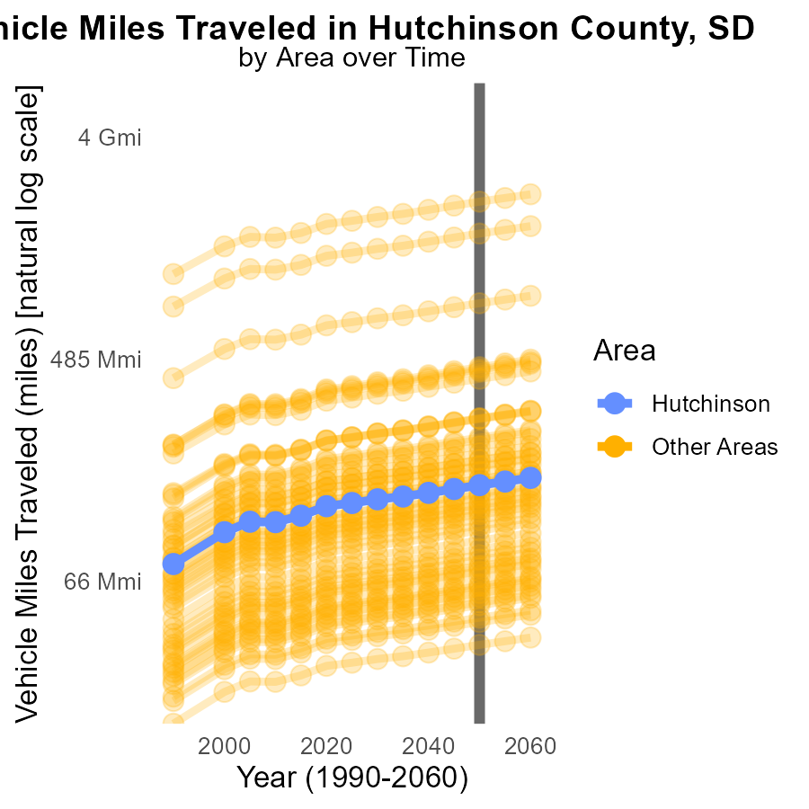

## Findings

* In 2050, minimum county had 36.9 million vehicle miles traveled (VMT).
* In 2050, target county had 155.6 million VMT.
* In 2050, maximum county had 2.0 billion VMT.

## Recommendations

To reduce emissions from transportation, focus on promoting public transportation, carpooling, and cycling to decrease VMT. Implement policies to incentivize the use of electric vehicles to lower carbon emissions.

# Vehicle Miles Traveled by Regulatory Class over Time

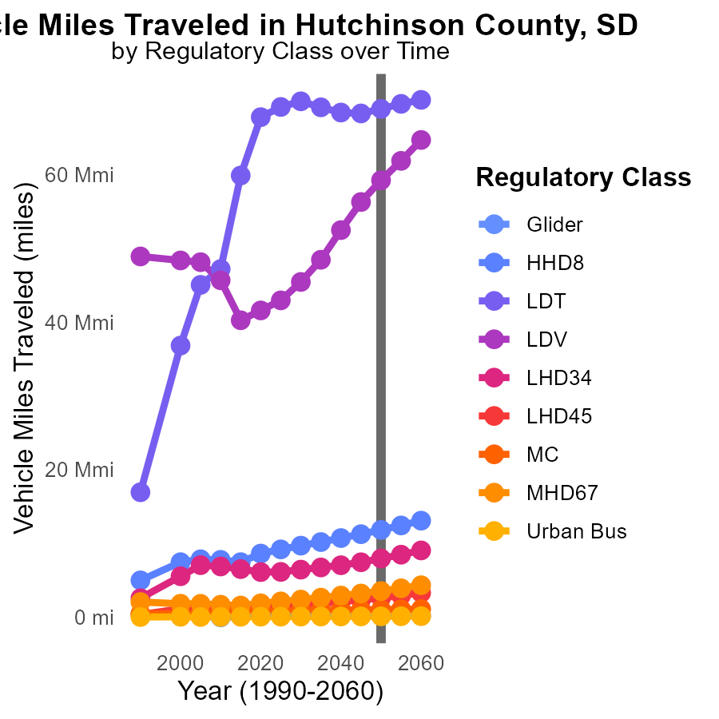

## Findings

* The number of vehicle miles traveled in Hutchinson County, SD, is projected to decrease by 6.1% by 2060 compared to 2050 levels.
* Light-duty trucks (LDT) are expected to have a 17.6% increase in miles traveled by 2045 compared to 2050 levels.
* Urban bus emissions are forecasted to decrease by 8.4% in 2060 relative to 2050, potentially due to shifts in public transportation usage.

## Recommendations

To reduce emissions, encourage the use of public transportation and invest in urban bus infrastructure. Incentivize the adoption of electric vehicles to mitigate the forecasted increase in light-duty truck miles traveled.

# Areas Ranked by Time Driven

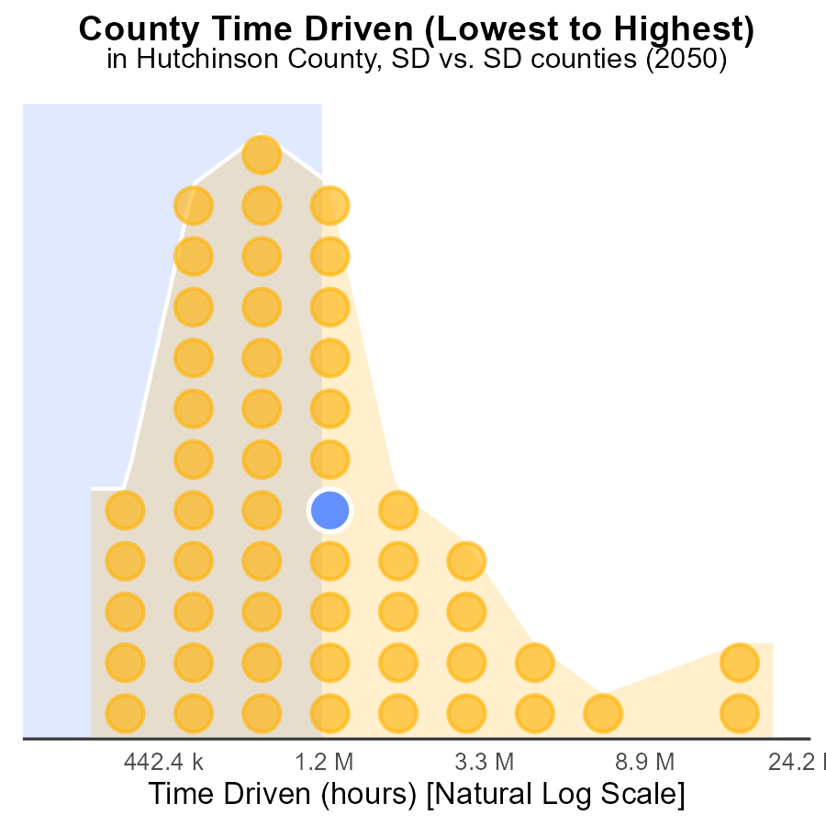

## Findings

* Minnehaha county has the highest source hours and contributes 100.0% to the emissions.
* Buffalo county has the lowest source hours, contributing only 1.9% to the emissions.
* Hutchinson, Lake, and Spink counties collectively contribute 187.7% to the emissions.

## Recommendations

To lower emissions, allocate resources from Minnehaha to Buffalo county to reduce the overall emissions. Implement efficiency measures in Hutchinson, Lake, and Spink counties to optimize emissions output.

# Areas Ranked by Emissions

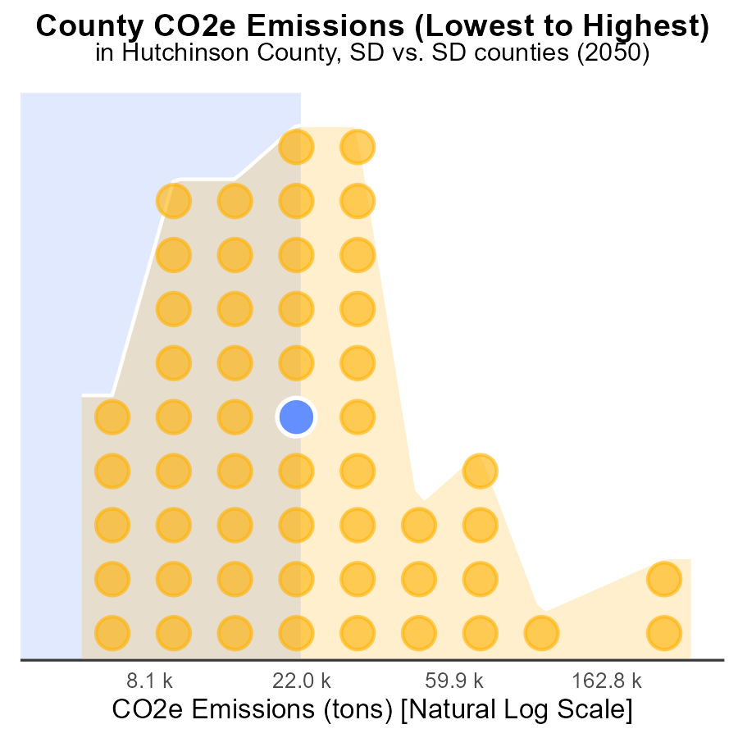

## Findings

* Minnehaha county has the highest emissions with 789.9k tons of CO2e.
* Buffalo county has the lowest emissions with 14.1k tons of CO2e.
* Minnehaha county ranks 53rd and represents 100% of emissions among the listed counties.

## Recommendations

To lower emissions, encourage Minnehaha county to adopt renewable energy sources and implement energy efficiency measures. Work with Buffalo county to maintain their low emissions level through sustainable practices.

# Conclusion

In conclusion, the data from Hutchinson County, SD, in 2050 paint a clear picture of the significant role transportation emissions play in the county's overall carbon footprint. With diesel emissions being the primary contributor to CO2e emissions, a targeted approach to reducing emissions from Diesel (Hotelling) sources is crucial for mitigating environmental impact. The projected increase in CO2e emissions from vehicles until 2050 underscores the urgency in implementing sustainable transportation solutions.

To effectively lower emissions, a strategic focus on transitioning to electric vehicles, enhancing public transportation, and investing in infrastructure to support alternative modes of transportation like walking and cycling is necessary. Additionally, the disparities in emissions levels across different areas within the county highlight the importance of tailored approaches to emission reduction efforts. By prioritizing investments in sustainable transportation infrastructure, promoting cleaner technologies, and implementing policies to incentivize greener transportation choices, Hutchinson County can work towards a more sustainable and eco-friendly future.

# About This Report

Data based on MOVES estimates collected by the Climate Action in Transportation program at Cornell University. Demographic data sourced from the US Census's American Community Survey 5-year estimates. This report was generated with the help of AI.

# References

* U.S. Census Bureau. (2023). American Community Survey 5-year estimates: Detailed tables. Retrieved from https://data.census.gov
* U.S. Environmental Protection Agency. (2024). Motor Vehicle Emission Simulator (MOVES 4.0) [Software]. Retrieved from https://www.epa.gov/moves