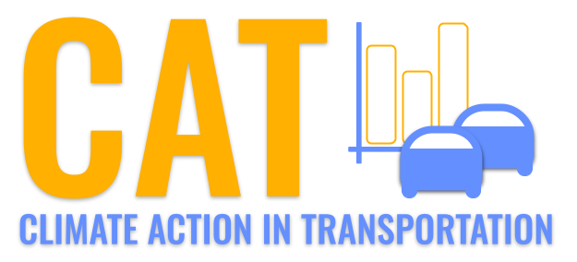 

**CO Emissions in Wood County, 2000**  
Made with CAT VISUALIZER by Gao Labs @ Cornell University.

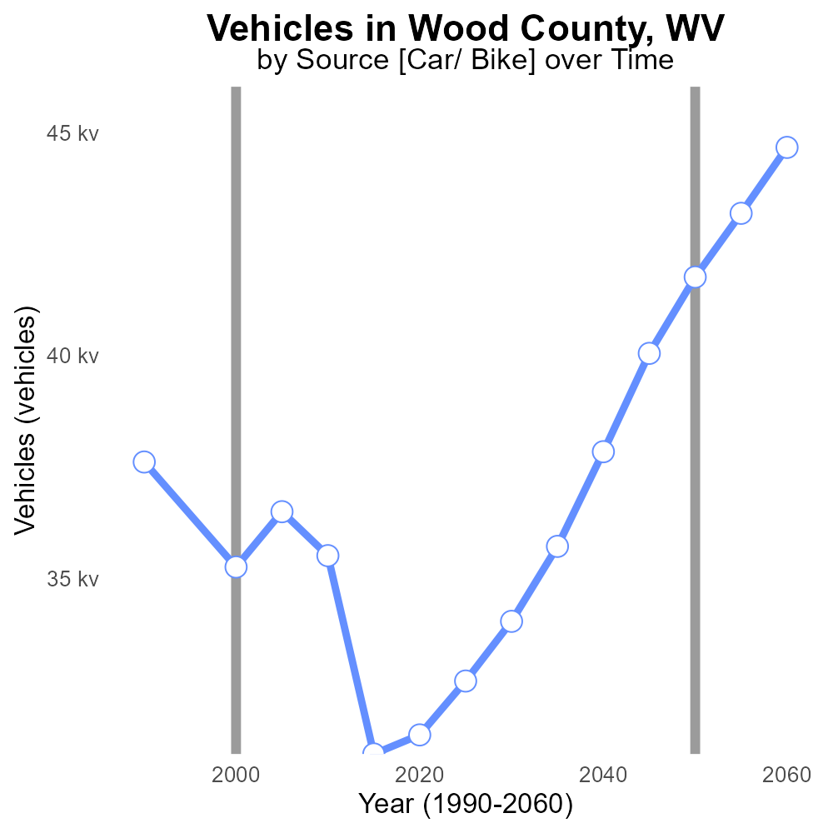

## Keywords

Carbon Monoxide emissions; on-road transportation; Wood County; West Virginia; 2000

## Highlights

* Research on CO emissions from transportation in Wood County, WV in 2000.
* Focus on impact of on-road vehicles on air quality in a specific region.
* Analysis of CO levels to understand environmental health risks.
* Policy implications for reducing CO emissions in transportation sector.
* Importance of monitoring and addressing CO emissions for public health.

# Introduction

In 2000, Wood County, West Virginia, experienced significant levels of Carbon Monoxide (CO) emissions from on-road transportation. This report delves into the impact of vehicle emissions on air quality in the region and the environmental health risks associated with high CO levels.

The study aims to analyze the data on CO emissions specifically from on-road transportation to provide insights into the extent of pollution caused by vehicles. By examining the trends in CO levels in Wood County in 2000, this report seeks to inform policymakers on the urgent need to address and mitigate CO emissions from the transportation sector to safeguard public health and improve air quality.

# Hotelling (Diesel Aux) by Regulatory Class

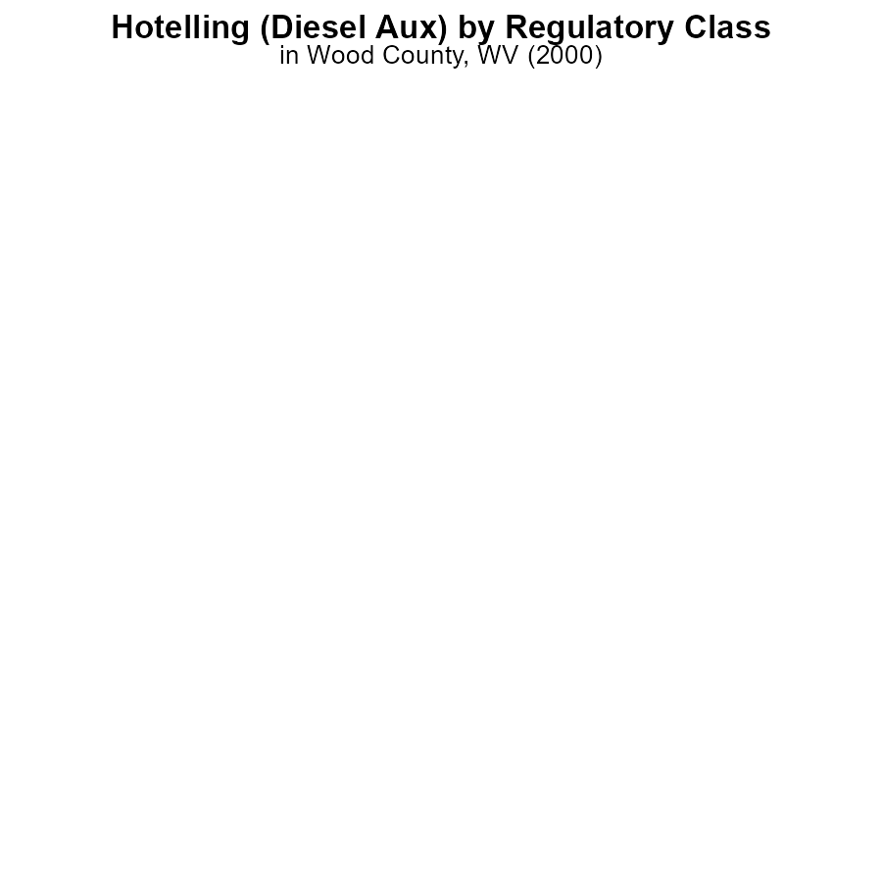

## Findings

* CO emissions from HHD8 and MHD67 in Wood County, WV in 2000 were 0.0.
* Label_percent data is unavailable for LDT, LDV, LHD34, LHD45, MC, and Urban Bus.

## Recommendations

Further investigation is needed to determine the CO emissions from vehicles with unavailable label_percent data. Policies should be implemented to reduce emissions from vehicles with recorded emissions, such as HHD8 and MHD67.

# Idling Overall by Area

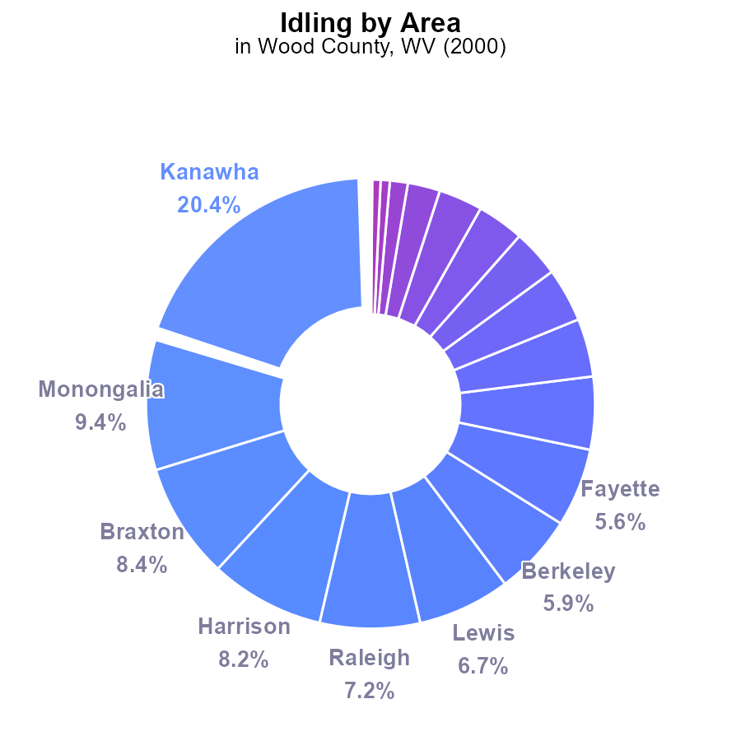

## Findings

* Top 5 counties emit 50.6% of CO from idling in Wood County, WV in 2000.
* 16 counties show minimal to no emissions from idling, comprising less than 2% of total CO emissions.
* Boone and Clay show no data on CO emissions from idling in 2000.

## Recommendations

To lower CO emissions, focus efforts on the top 5 emitting counties. Implement idling reduction programs in Kanawha, Monongalia, Braxton, Harrison, and Raleigh. Consider policies to promote idling-free zones and educate residents on the environmental impact of idling.

# Vehicles over Time for Passenger Vehicles

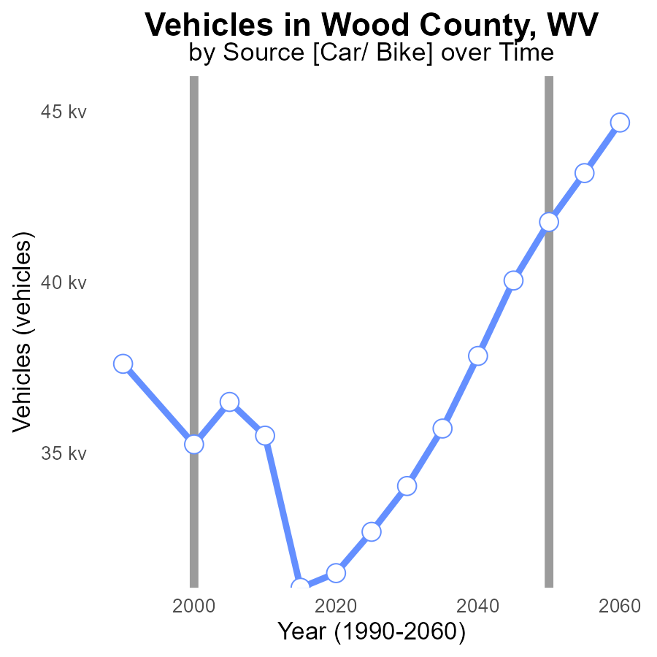

## Findings

* CO emissions from vehicles decreased by 11.0% from 1990 to 2020 in Wood County, WV.
* The largest decrease in CO emissions (25.0%) occurred between 2015 and 2020.
* The benchmark difference increased over the years, peaking at 10701.4 in 2015.

## Recommendations

To further reduce CO emissions from vehicles in Wood County, WV, policy changes promoting carpooling, public transportation use, and adoption of electric vehicles should be considered.

# Time Driven Overall over Time

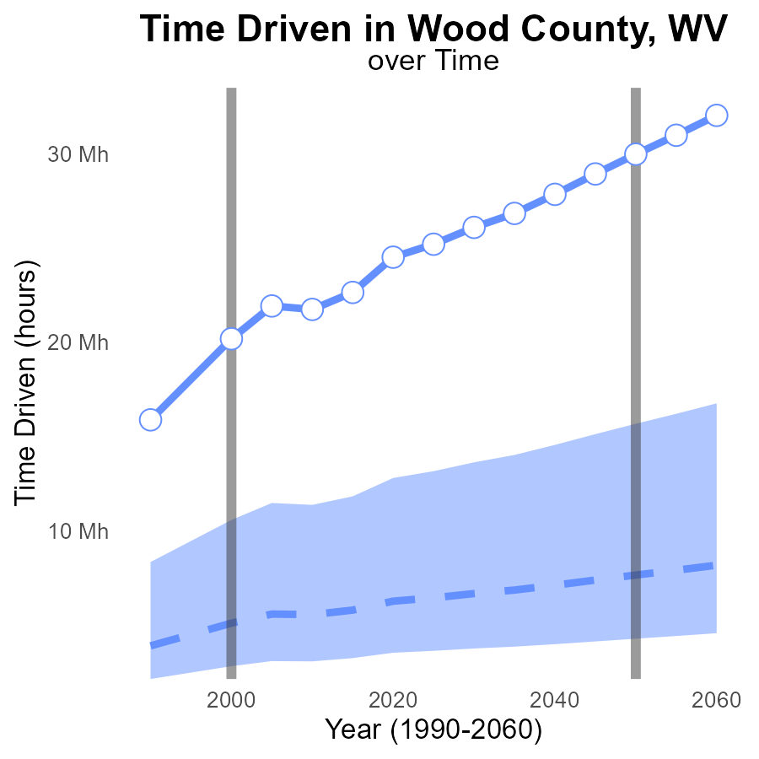

## Findings

* Emissions in Wood County, WV have consistently been above the median area since 1990, with a significant increase over time.
* In 2020, emissions were 18.3 million above the median area level of 6.25 million, representing a concerning trend.
* The difference between Wood County and the benchmark has been reducing, suggesting a slight improvement in emission control measures.

## Recommendations

To reduce emissions in Wood County, WV, immediate action is necessary. Implement stricter regulations on industrial emissions. Invest in renewable energy sources to decrease reliance on high-emission energy production. Promote public transportation and carpooling to reduce individual carbon footprints.

# Idling Mapped by Area

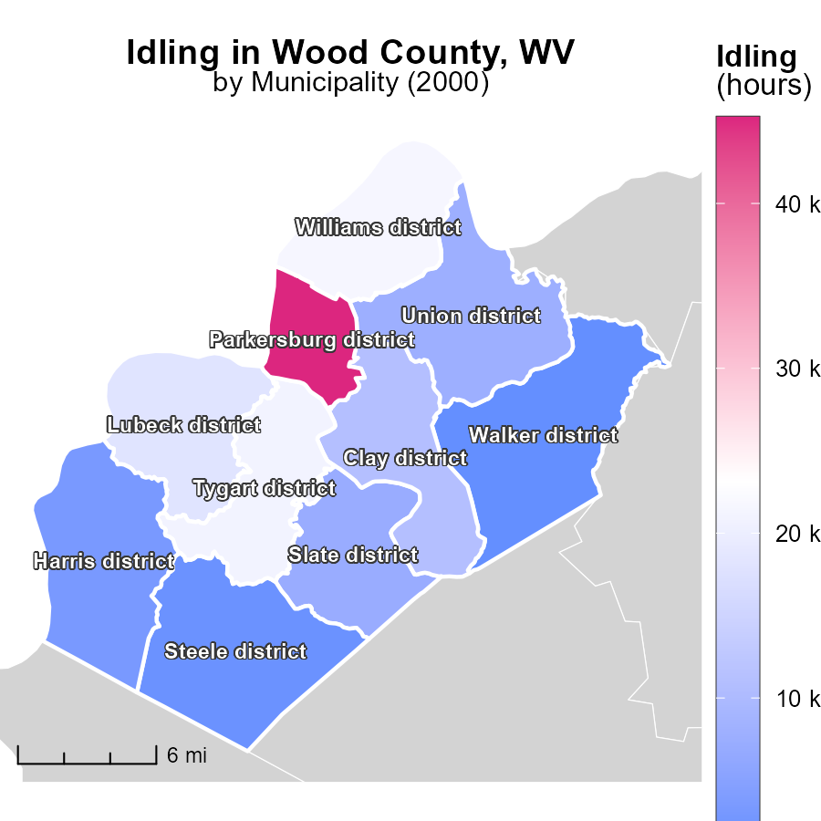

## Findings

* Parkersburg district, WV has the highest idling emissions at 45.2 k hours.
* Union district, WV reported a median idling emissions of 7.7 k hours.
* Walker district, WV has the lowest idling emissions at 1.1 k hours.

## Recommendations

To lower emissions, encourage Parkersburg district to reduce idling time through awareness campaigns. Union district could implement idling reduction policies. Walker district should continue their low idling practices.

# Vehicle Starts in My Region

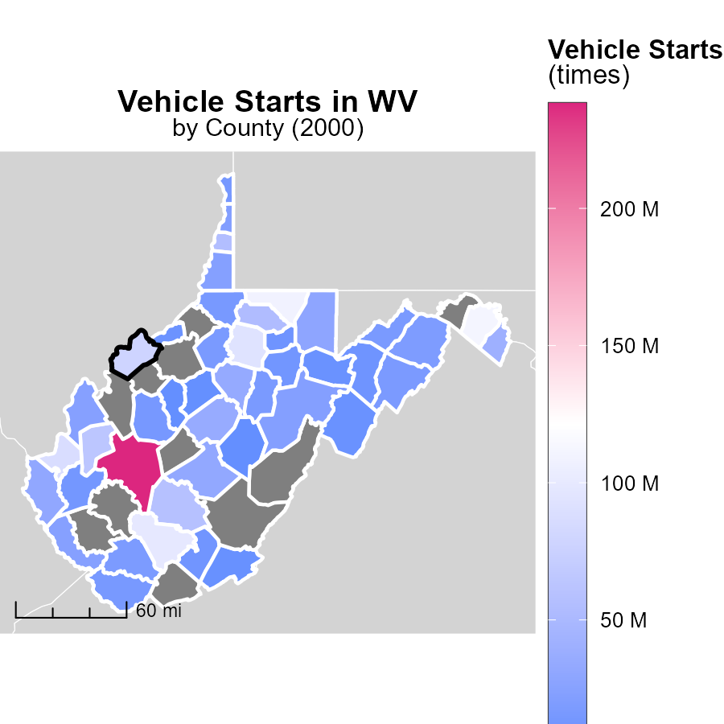

## Findings

* Kanawha County, WV has the highest number of vehicle starts with 238.2 million times.
* Wyoming County, WV has a median number of vehicle starts at 17.9 million times.
* No data available for Clay County, WV on vehicle starts.

## Recommendations

To decrease emissions from vehicle starts, initiatives such as promoting carpooling, using public transportation, and investing in electric vehicles can be implemented. Additionally, encouraging telecommuting and improving infrastructure for biking and walking can help reduce the overall number of vehicle starts.

# Emissions Rate (per mile) by Regulatory Class over Time

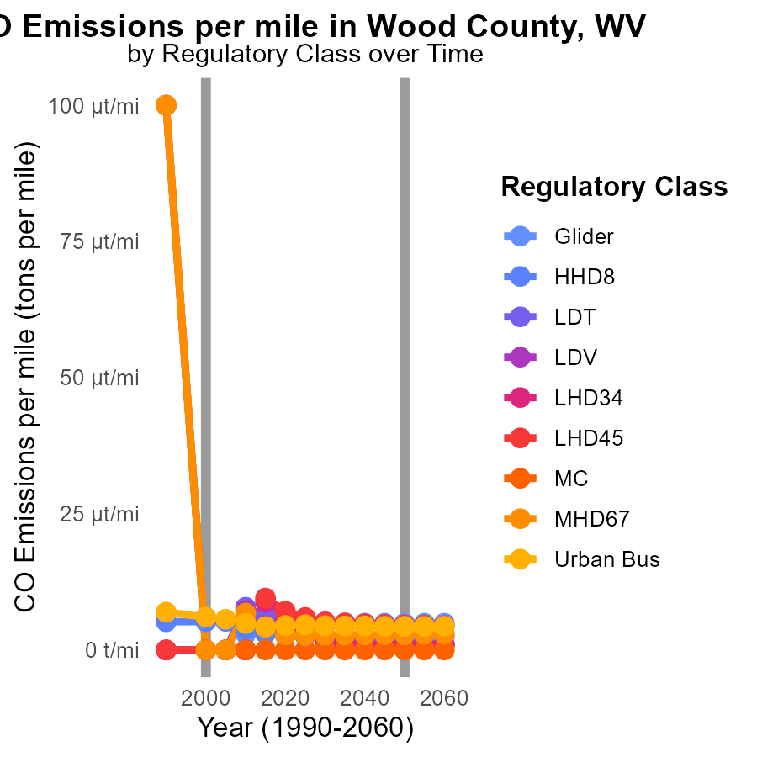

## Findings

* In 1990, LDV emissions were 32.0 tons per mile, decreasing to 7.2 tons per mile in 2010.
* In 1990, LDT emissions were 65.1 tons per mile, decreasing to 7.8 tons per mile in 2010.
* In 1990, MC emissions were 62.6 tons per mile, decreasing to 20.7 tons per mile in 2010.

## Recommendations

To lower emissions, focus on reducing LDV, LDT, and MC emissions through stricter regulations on vehicle emissions, promoting the adoption of electric vehicles, and incentivizing public transportation use.

# Emissions Rate (per vehicle) by Area over Time

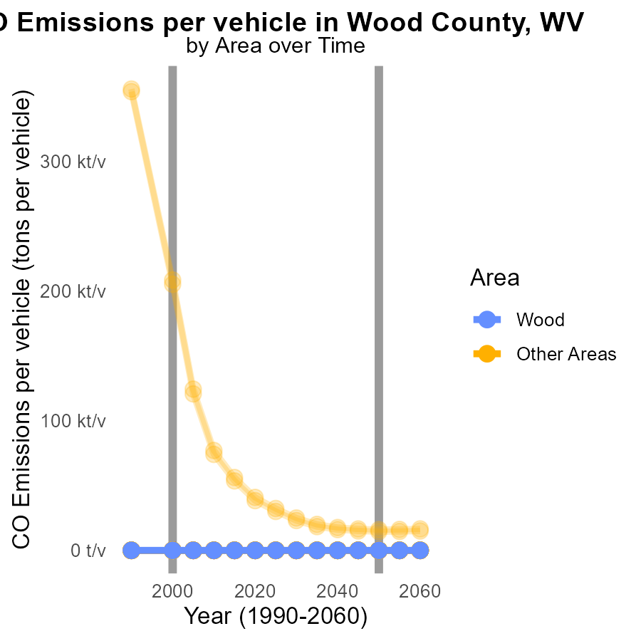

## Findings

* The highest CO emissions per vehicle were in max_county in 2000 at 208.7 tons per vehicle.
* There is a small variation in emissions between the different locations in 2000, with a difference of less than a ton per vehicle.
* The target_county had relatively higher emissions per vehicle in 2000 compared to other locations, at 246.9 tons per vehicle.

## Recommendations

To lower emissions, focus on max_county to reduce the significant emissions per vehicle. Implement stricter vehicle emission standards. Analyze factors causing higher emissions in target_county for targeted reductions.

# Areas Ranked by Vehicle Starts

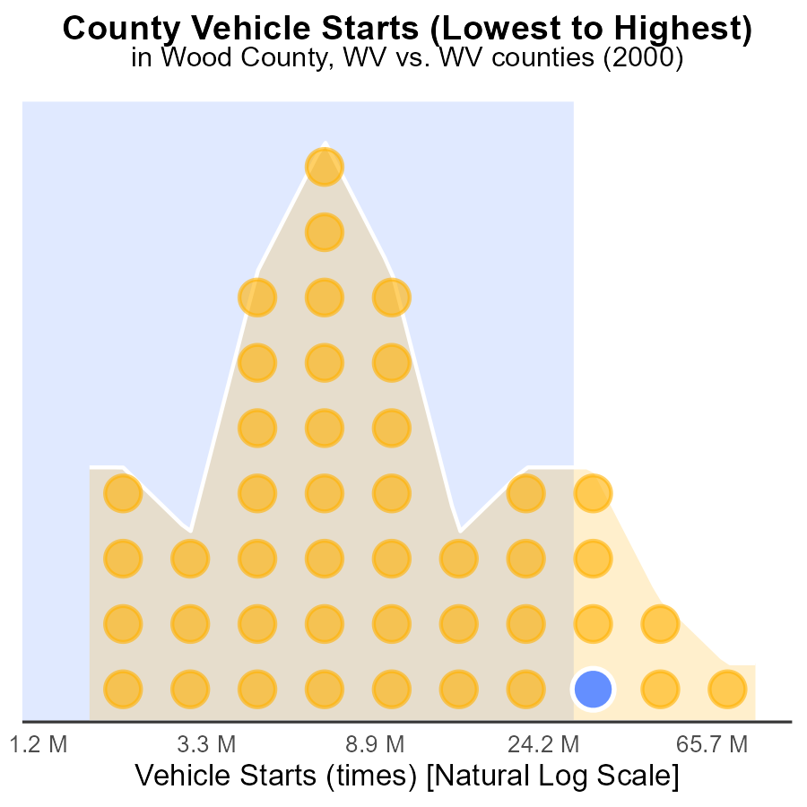

## Findings

* Wood County had 78.4 million vehicle starts accounting for 86.4% of total starts.
* Putnam County had 63.5 million vehicle starts constituting 84.1% of total starts.
* Cabell County had 87.7 million vehicle starts making up 88.6% of total starts.

## Recommendations

To decrease vehicle emissions, incentivize carpooling or public transportation use in Wood, Putnam, and Cabell counties to reduce the number of individual vehicle starts.

# Areas Ranked by Emissions

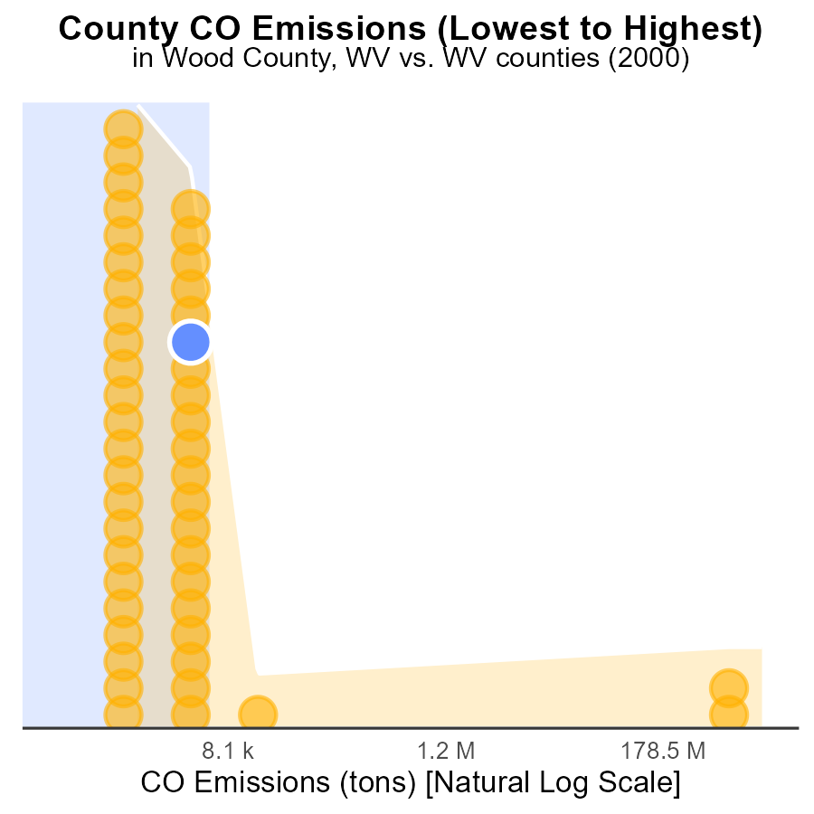

## Findings

* Boone county emitted the highest amount of CO with 4.8 G tons, ranking 46th in emissions.
* Calhoun county emitted the lowest amount of CO with 913.2 tons, ranking 1st in emissions.
* Cabell county had the highest percentile of CO emissions at 84.8%.

## Recommendations

To reduce emissions, Boone county should implement stricter emission control measures. Calhoun county can focus on promoting cleaner energy sources like solar and wind power. Cabell county should invest in sustainable transportation and energy-efficient infrastructure.

# Conclusion

In conclusion, the data from Wood County, WV in 2000 regarding Carbon Monoxide (CO) emissions from on-road transportation paints a concerning picture of elevated emissions and areas that require immediate attention. While some vehicles like HHD8 and MHD67 showed no CO emissions, there is a lack of data for several vehicle types, necessitating further investigation and regulation. Efforts should be directed towards the top 5 counties emitting the majority of CO from idling, with a focus on implementing idling reduction programs and educating residents on the environmental impact of idling.

To combat the increasing trend in CO emissions in Wood County, WV, policy changes promoting carpooling, public transportation, and adoption of electric vehicles are recommended. Additionally, the county should consider stricter regulations on industrial emissions and invest in renewable energy sources. By addressing these key areas, Wood County can work towards reducing its emissions and improving air quality for its residents.

# About This Report

Data based on MOVES estimates collected by the Climate Action in Transportation program at Cornell University. Demographic data sourced from the US Census's American Community Survey 5-year estimates. This report was generated with the help of AI.

# References

* U.S. Census Bureau. (2023). American Community Survey 5-year estimates: Detailed tables. Retrieved from https://data.census.gov
* U.S. Environmental Protection Agency. (2024). Motor Vehicle Emission Simulator (MOVES 4.0) [Software]. Retrieved from https://www.epa.gov/moves