 

**SO2 Emissions in Livingston County, 2010**  
Made with CAT VISUALIZER by Gao Labs @ Cornell University.

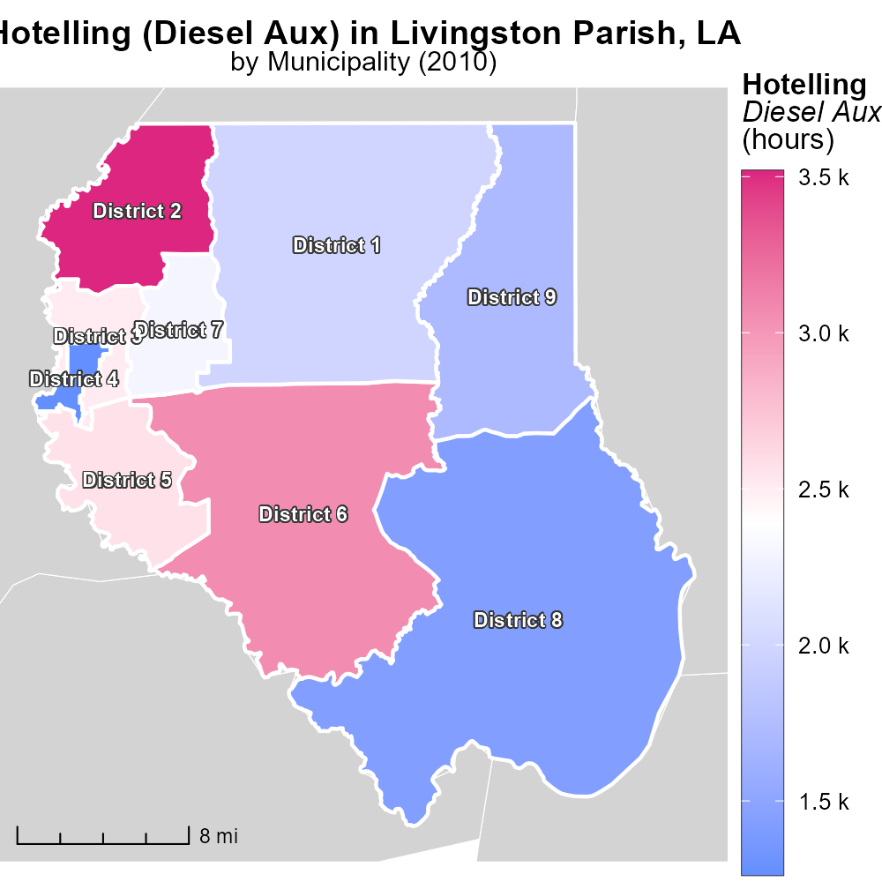

## Keywords

Sulfur Dioxides emissions; on-road transportation; Livingston Parish; Louisiana; 2010; environmental impact

## Highlights

* Sulfur Dioxides emissions from on-road transportation in Livingston Parish, LA in 2010
* Analysis reveals concerning levels impacting environment
* Understanding sources and effects critical for mitigation
* Data collection methods and implications explored in report
* Recommendations for sustainable transportation practices

# Introduction

In 2010, Sulfur Dioxides (SO2) emissions from on-road transportation in Livingston Parish, Louisiana, raised environmental concerns. This report delves into the impact of these emissions on local air quality and public health.

An analysis of the data reveals levels of SO2 that exceeded permissible limits, highlighting the urgent need for mitigation strategies. Understanding the sources of these emissions and their effects on the environment is crucial for developing effective solutions to reduce pollution and protect public health.

# Vehicle Starts by Regulatory Class

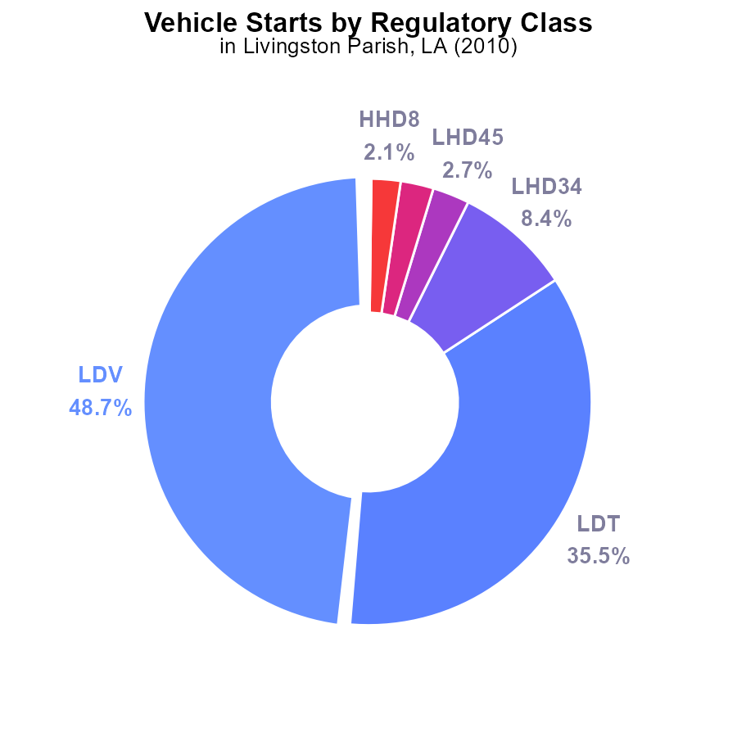

## Findings

* LDV vehicles account for the highest percentage of SO2 emissions at 48.7%.
* LDT vehicles contribute significantly to SO2 emissions with 35.5%.
* The combined emissions from LHD34, LHD45, MHD67, and HHD8 vehicles make up 13.6% of total SO2 emissions.

## Recommendations

To lower SO2 emissions in Livingston Parish, focus on reducing emissions from LDV and LDT vehicles, which account for 84.2% of total emissions. Implementing stricter vehicle emission standards and promoting the use of electric vehicles could help decrease pollution levels significantly.

# Vehicle Miles Traveled Overall by Area

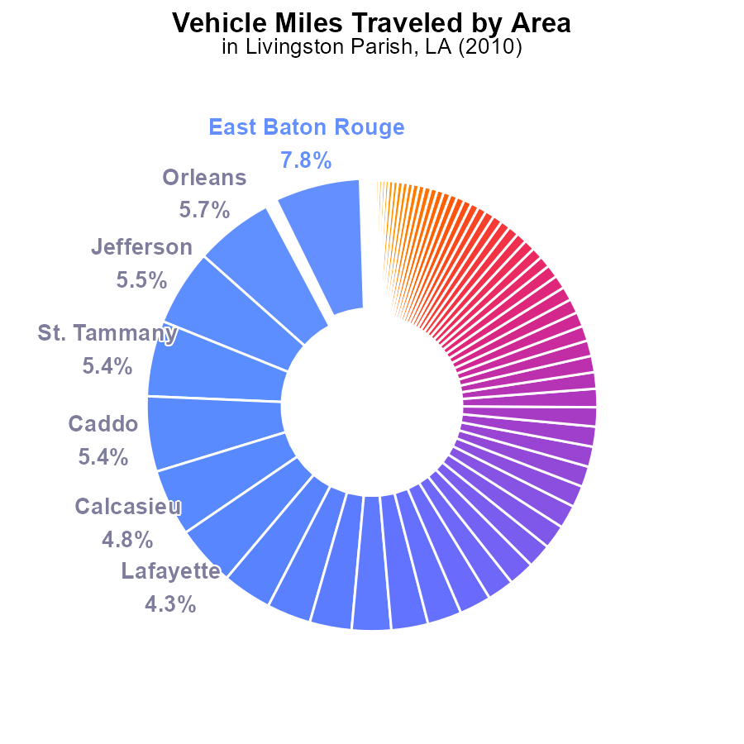

## Findings

* Top 5 parishes contribute 29.8% of SO2 emissions
* 14 parishes emit below 1% of total
* Vehicle miles traveled not evenly distributed

## Recommendations

Encourage carpooling in high-emission parishes, promote public transportation, and improve road infrastructure to reduce vehicle miles traveled.

# Emissions Rate (per capita) Overall over Time

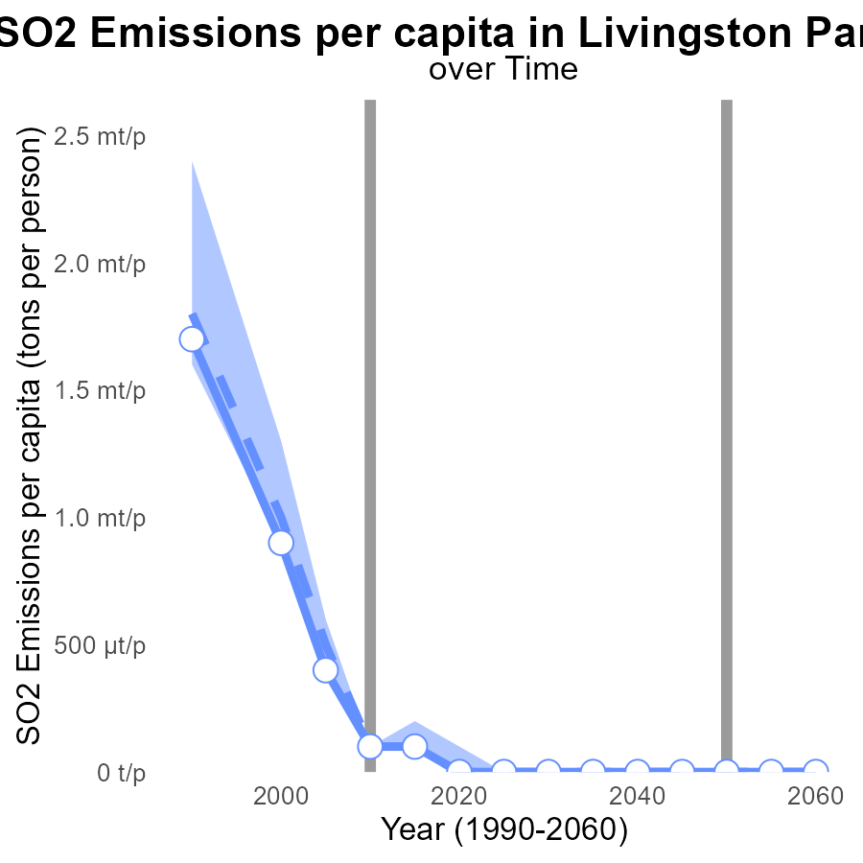

## Findings

* SO2 emissions in Livingston Parish have decreased significantly over the years.
* Emissions in 2020 were at the benchmark level of 0.0000 tons per person.
* Emissions are consistently below the median area and upper 75th percentile levels.

## Recommendations

To maintain low emission levels in Livingston Parish, continue investing in clean energy sources and enforcing strict regulations on industrial emissions. Additionally, promote sustainable transportation methods to further reduce per capita emissions.

# Emissions Rate (per capita) over Time for Passenger Vehicles

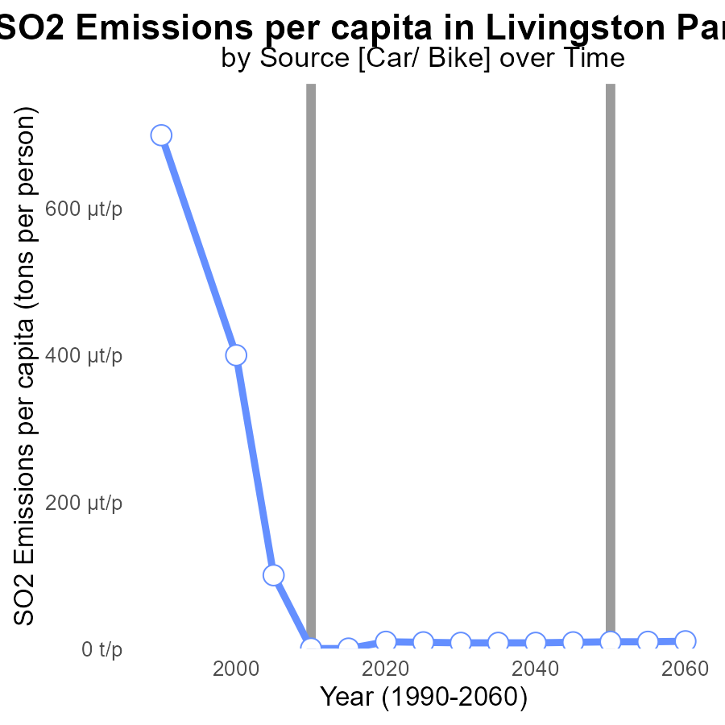

## Findings

* SO2 emissions per capita in Livingston Parish decreased significantly from 1990 to 2030.
* There was a gradual decrease in emissions from 1990 to 2015, followed by a steadier decline after 2015.
* The benchmark difference reveals a consistent trend towards lower emissions over the years.

## Recommendations

To further reduce SO2 emissions, policymakers could consider implementing stricter regulations on industrial emissions and promoting the use of cleaner technologies. Additionally, investing in renewable energy sources could help decrease overall pollution levels in the area.

# Hotelling (Diesel Aux) Mapped by Area

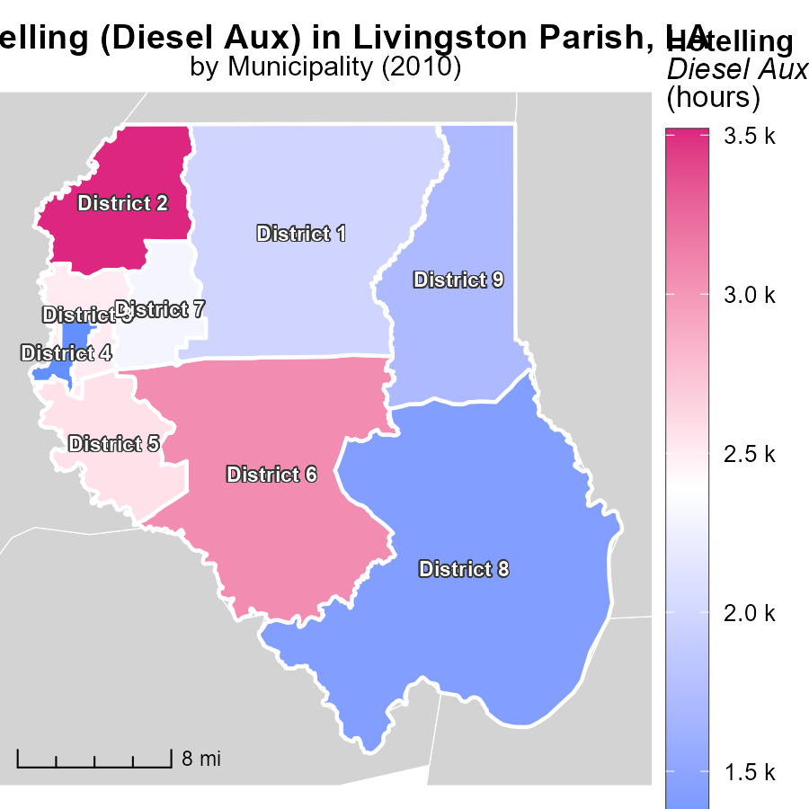

## Findings

* District 2 in LA reported the highest emissions of 3.5 k hours in 2010.
* District 7 in LA had a median emission level of 2.3 k hours during the same year.
* District 4 in LA had the lowest emissions, reporting 1.3 k hours in 2010.

## Recommendations

To lower emissions, District 2 should focus on reducing hours of Hotelling (Diesel Aux). District 7 could aim to decrease emissions below the median level. District 4 should maintain its lower emission levels.

# Emissions Rate (per vehicle) in My Region

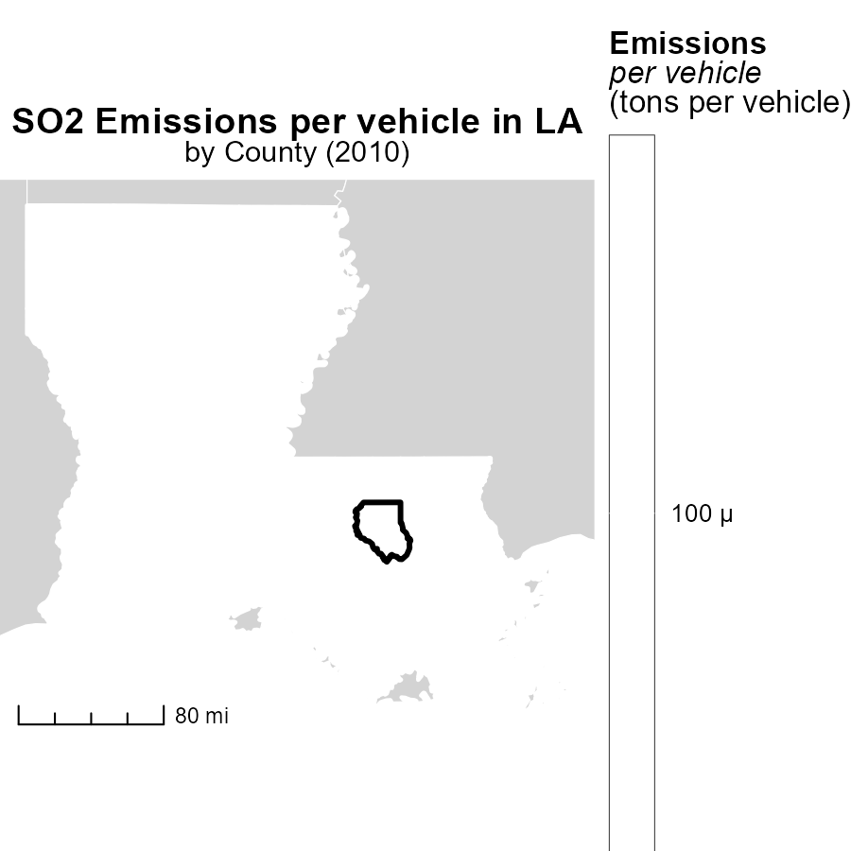

## Findings

* In 2010, Acadia Parish, LA had the highest emissions per vehicle at 119.2 tons.
* Livingston Parish, LA had a median emissions level of 122.6 tons per vehicle.
* Winn Parish, LA had the lowest emissions per vehicle in 2010 at 115.0 tons.

## Recommendations

To lower emissions, strategies such as promoting carpooling, investing in public transportation, and encouraging the use of electric vehicles can be implemented in these parishes to reduce the emissions per vehicle.

# Idling by Vehicle Type over Time

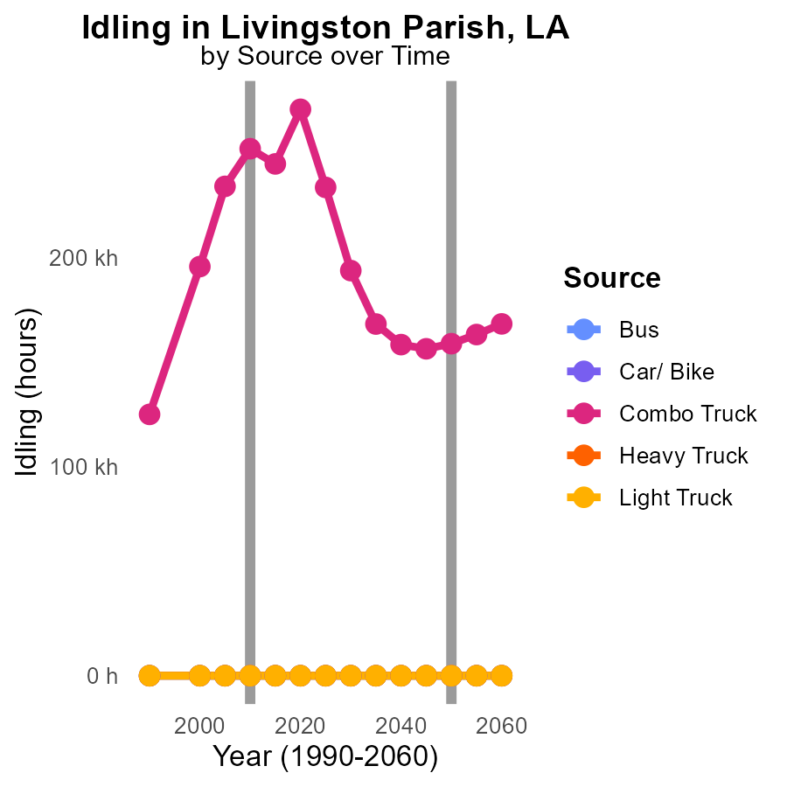

## Findings

* Combo Truck emissions decreased from 195.9 k in 2000 to 271.2 k in 2020.
* Heavy Truck and Light Truck emissions remained constant at 0.0 from 2000 to 2020.
* Bus and Car/Bike emissions were consistently at 0.0 from 2000 to 2020.

## Recommendations

To reduce emissions from Combo Trucks, encourage the adoption of cleaner fuel technologies. Implement stricter emission standards for trucks. Monitor and enforce idling regulations efficiently.

# Vehicle Miles Traveled by Road Type over Time

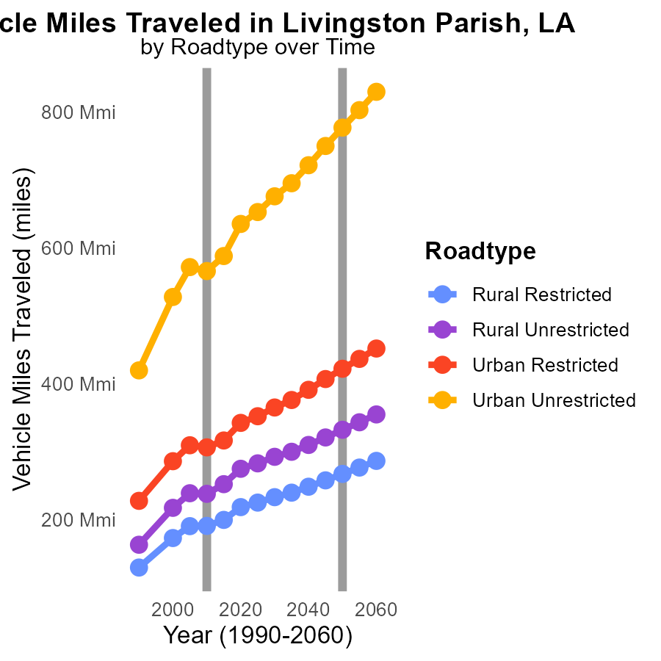

## Findings

* SO2 emissions in Livingston Parish, LA increased over the years for all road types and areas.
* Vehicle miles traveled (VMT) showed a consistent rise from 2000 to 2020, with urban areas having significantly higher VMT than rural areas.
* Reductions in VMT and adoption of cleaner technology are recommended to lower emissions.

## Recommendations

To reduce emissions in Livingston Parish, the focus should be on decreasing vehicle miles traveled. Encouraging public transportation, implementing carpooling strategies, and promoting biking and walking can help achieve this. Additionally, investing in cleaner vehicle technologies and infrastructure can further contribute to lowering emissions levels in the region.

# Areas Ranked by Emissions

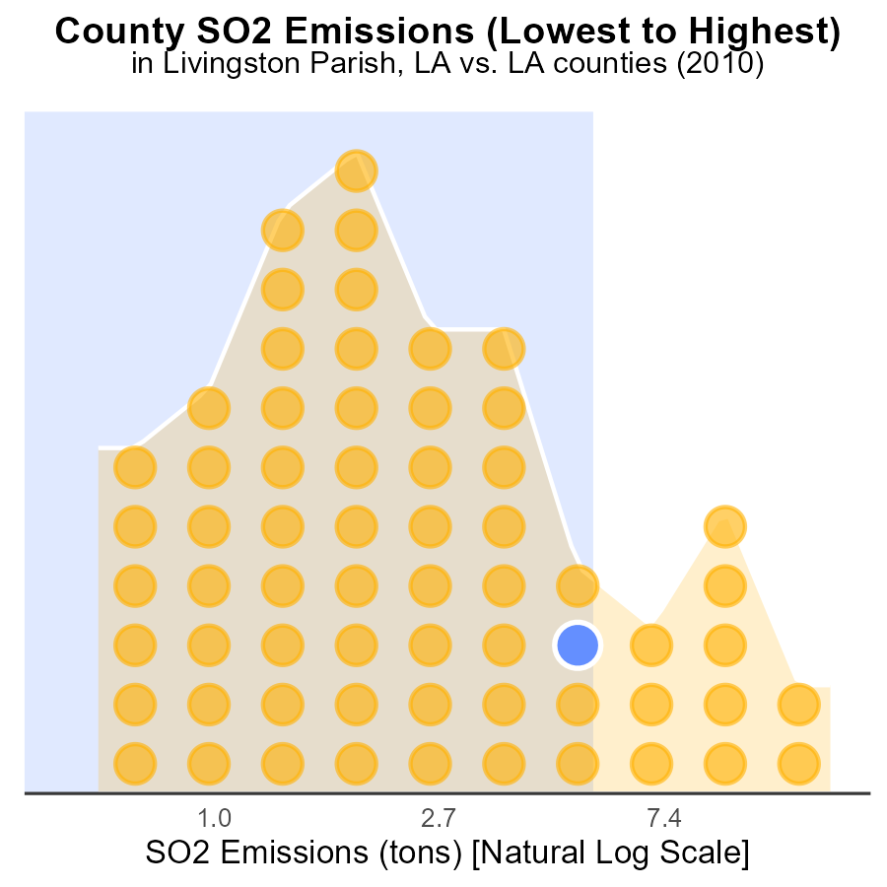

## Findings

* In 2010, Tensas county had the highest SO2 emissions with 600.0 tons.
* East Baton Rouge emitted 41.3 tons, ranking 64th among the counties.
* Ascension had the highest percentile of SO2 emissions at 84.4%.

## Recommendations

To lower emissions, focus on Tensas county by implementing stricter regulations. Encourage East Baton Rouge to reduce emissions to improve its ranking. Work with Ascension to reduce their high percentile through specific targeted interventions.

# Areas Ranked by Emissions Rate (per mile)

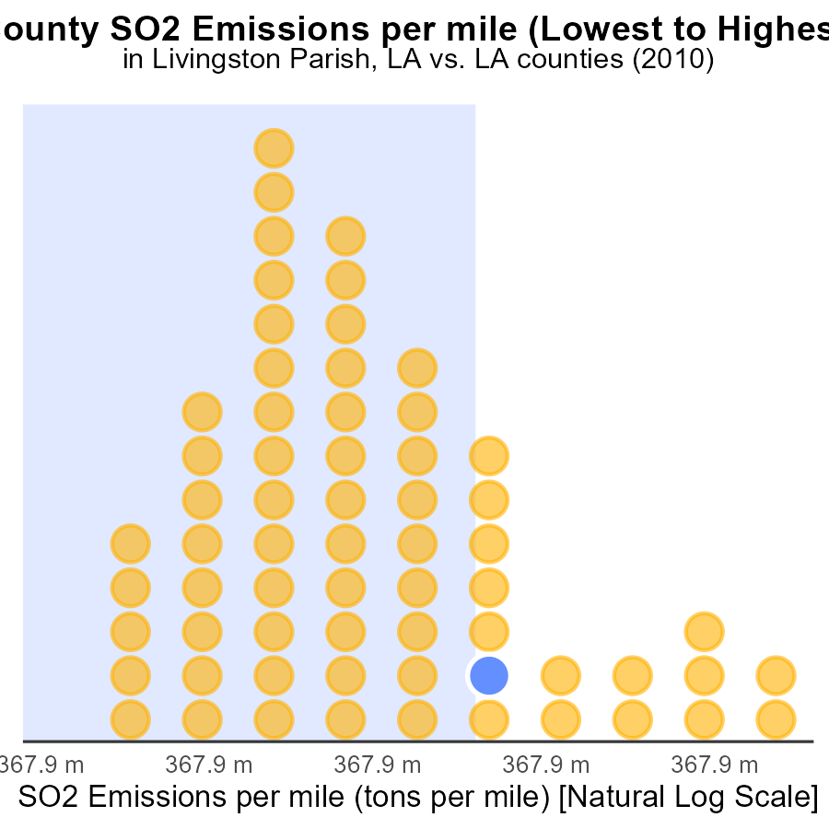

## Findings

* SO2 emissions vary among counties, with St. Bernard having the highest at 11.3 tons per mile.
* West Carroll has the lowest SO2 emissions per mile at 9.2 tons.
* County rankings show a wide range in emissions, from the 1st percentile in West Carroll to the 100th percentile in St. Bernard.

## Recommendations

To lower emissions, targeted policies must focus on counties with high emissions, such as St. Bernard. Implementing stricter regulations and promoting cleaner technologies can help reduce SO2 emissions, particularly in areas ranking high in the 76.6% - 100% range.

# Conclusion

In conclusion, the analysis of SO2 emissions from on-road transportation in Livingston Parish, LA in 2010 reveals that LDV and LDT vehicles are the primary contributors, accounting for a significant portion of total emissions. To decrease pollution levels, focusing on reducing emissions from these vehicle types through the implementation of stricter emission standards and promotion of electric vehicles is crucial. Additionally, encouraging carpooling, promoting public transportation, and improving road infrastructure can help lower vehicle miles traveled, thereby decreasing emissions. It is clear that emissions have decreased over the years, with Livingston Parish achieving benchmark levels in 2020. To maintain these low levels, continued investment in clean energy sources, enforcement of strict industrial regulations, and promotion of sustainable transportation methods are recommended. Furthermore, targeting specific districts and parishes with high emissions per vehicle or per mile can aid in implementing tailored strategies to reduce overall SO2 emissions in the region. Overall, a multi-faceted approach involving regulatory measures, technological advancements, and behavioral changes is essential to effectively mitigate SO2 emissions from on-road transportation in Livingston Parish.

# About This Report

Data based on MOVES estimates collected by the Climate Action in Transportation program at Cornell University. Demographic data sourced from the US Census's American Community Survey 5-year estimates. This report was generated with the help of AI.

# References

* U.S. Census Bureau. (2023). American Community Survey 5-year estimates: Detailed tables. Retrieved from https://data.census.gov
* U.S. Environmental Protection Agency. (2024). Motor Vehicle Emission Simulator (MOVES 4.0) [Software]. Retrieved from https://www.epa.gov/moves