 

**NOx Emissions in Creek County, 2060**  
Made with CAT VISUALIZER by Gao Labs @ Cornell University.

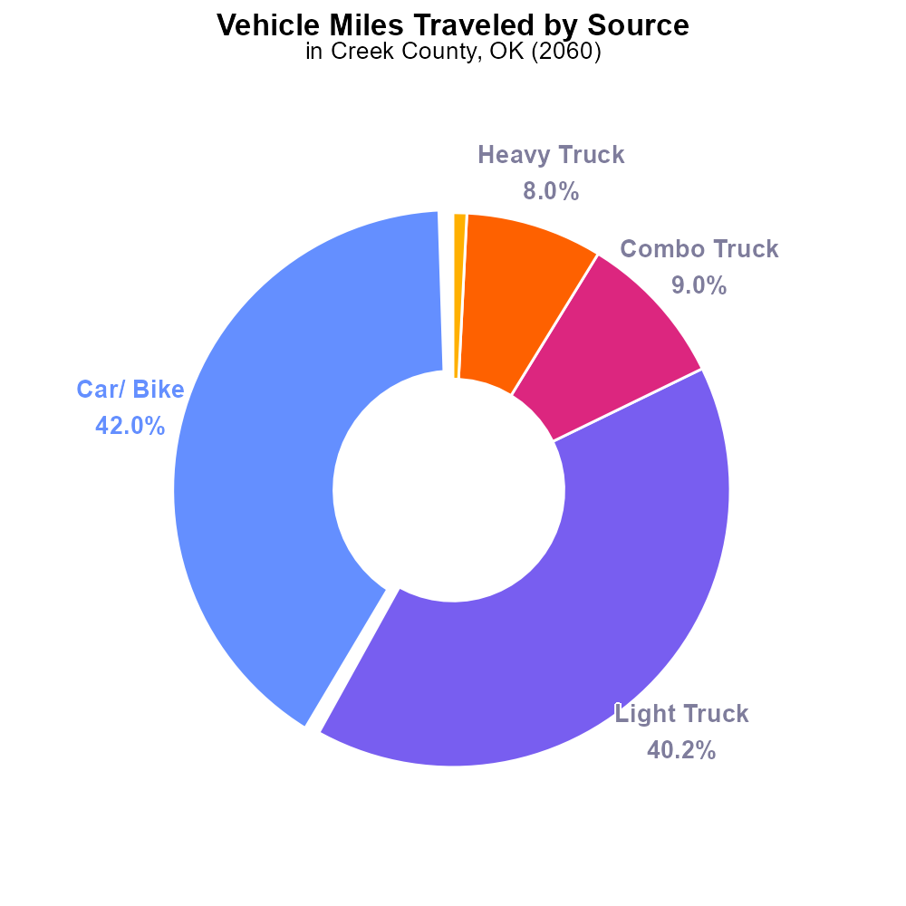

## Keywords

Oxides of Nitrogen; NOx emissions; on-road transportation; Creek County, OK; 2060

## Highlights

* Investigation of NOx emissions from on-road transportation in Creek County, OK in 2060.
* Analysis to understand the impact of NOx emissions on air quality and public health.
* Identification of potential strategies to reduce NOx emissions in on-road vehicles.
* Assessment of legislative and technological interventions to mitigate NOx emissions.
* Recommendations for sustainable transportation practices to combat NOx pollution.

# Introduction

The following report delves into the concerning issue of Oxides of Nitrogen (NOx) emissions stemming from on-road transportation in Creek County, Oklahoma, projected to affect the region in the year 2060. This investigation aims to examine the sources, impact, and potential mitigation strategies for NOx emissions within the county.

With the continuous growth of vehicular traffic and industrial activities in Creek County, the levels of NOx emissions are expected to rise significantly by 2060, posing a serious threat to air quality and public health. By analyzing the current state of NOx emissions and studying the trends, this report seeks to provide valuable insights into the environmental implications and recommend sustainable measures to address the pressing issue.

# Time Driven by Fuel Type

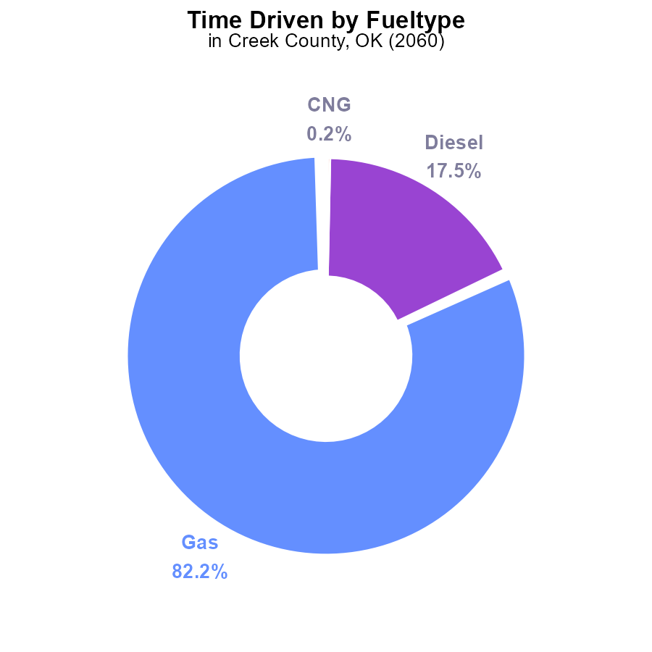

## Findings

* Gasoline vehicles emit 27.9 M units, accounting for 82.2% of NOx emissions in Creek County, OK.
* Diesel vehicles emit 5.9 M units, contributing to 17.5% of NOx emissions.
* CNG and Ethanol vehicles emit minimal NOx, with 64.2 k (0.2%) and 48.5 k (0.1%) units, respectively.

## Recommendations

To reduce NOx emissions, policies should focus on reducing gasoline and diesel vehicle usage through incentives for electric or hybrid vehicles and improving public transportation.

# Vehicle Miles Traveled by Vehicle Type

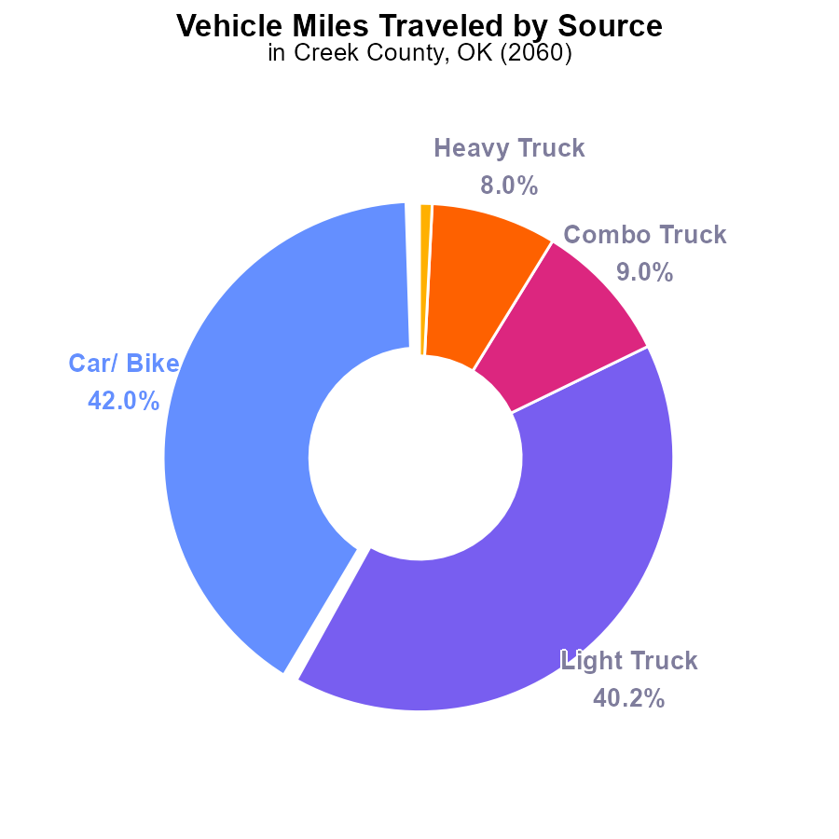

## Findings

* Cars/ Bikes contribute 42.0% of NOx emissions from vehicle miles traveled.
* Light trucks account for 40.2% of NOx emissions in the same category.
* Heavy trucks and buses contribute a combined total of 8.8% of NOx emissions.

## Recommendations

To lower NOx emissions from vehicle miles traveled in Creek County, OK, strategies should focus on transitioning to cleaner fuel technologies for cars and light trucks, such as electric vehicles. Encouraging public transportation use and optimizing truck routes can also help reduce emissions from heavy trucks and buses.

# Emissions over Time for Buses

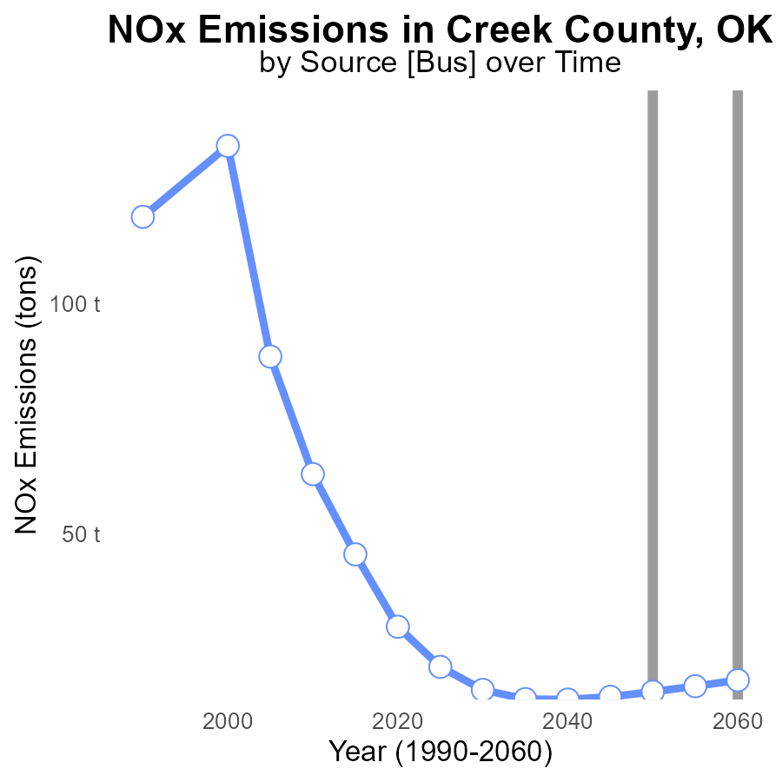

## Findings

* NOx emissions in Creek County are projected to increase from 14.1 tons in 2040 to 18.3 tons in 2060.
* The benchmark difference shows a decreasing trend over time, with emissions surpassing the benchmark by 1.7 tons in 2040 and falling to -2.5 tons in 2060.
* Emissions are anticipated to exceed the benchmark by a larger margin in the upcoming years.

## Recommendations

To lower NOx emissions in Creek County, immediate actions should focus on implementing stricter emission standards for industries and promoting the adoption of cleaner technologies. Regular monitoring and enforcement of these standards are essential. Additionally, investing in renewable energy sources like solar and wind power can help reduce the reliance on fossil fuels, further decreasing emissions over time.

# Idling over Time for Passenger Idling

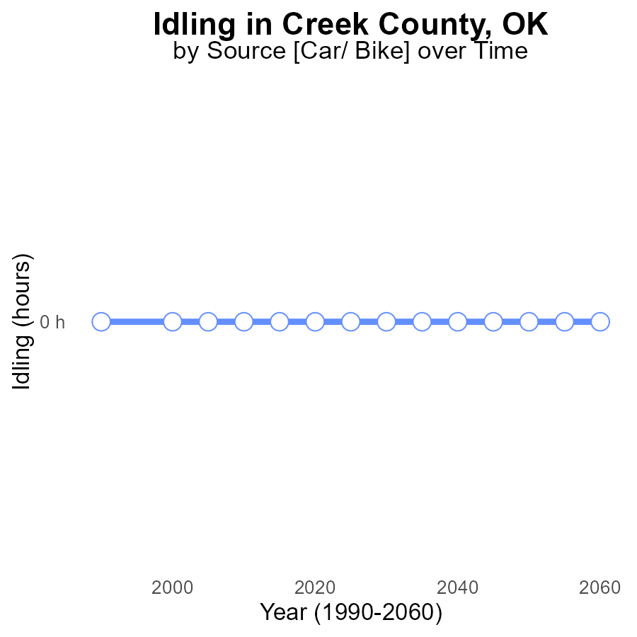

## Findings

* NOx emissions from idling in Creek County, OK have been consistently at 0.0 units from 2040 to 2060.
* There is no difference compared to the benchmark for NOx emissions from idling in the area.
* Idling activities in Creek County, OK are not contributing to NOx emissions based on the data provided.

## Recommendations

Given the clean track record of NOx emissions from idling in Creek County, no specific recommendations are needed at this time. Continuous monitoring is advised to ensure emissions remain at negligible levels.

# Population Mapped by Area

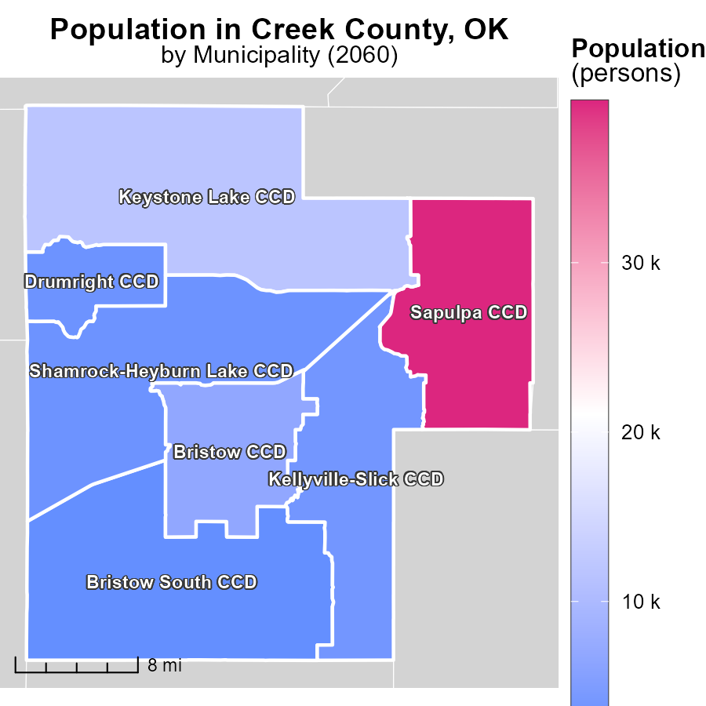

## Findings

* The highest population in 2060 was in Sapulpa CCD, OK with 39.6k persons.
* The median population was 3.9k in Kellyville-Slick CCD, OK.
* The lowest population was 2.6k in Bristow South CCD, OK.

## Recommendations

To lower emissions, focus on highly populated areas like Sapulpa CCD by implementing energy-efficient measures. Encourage sustainable practices in Kellyville-Slick and Bristow South CCDs to reduce emissions proportionally.

# Emissions Rate (per mile) Mapped by Area

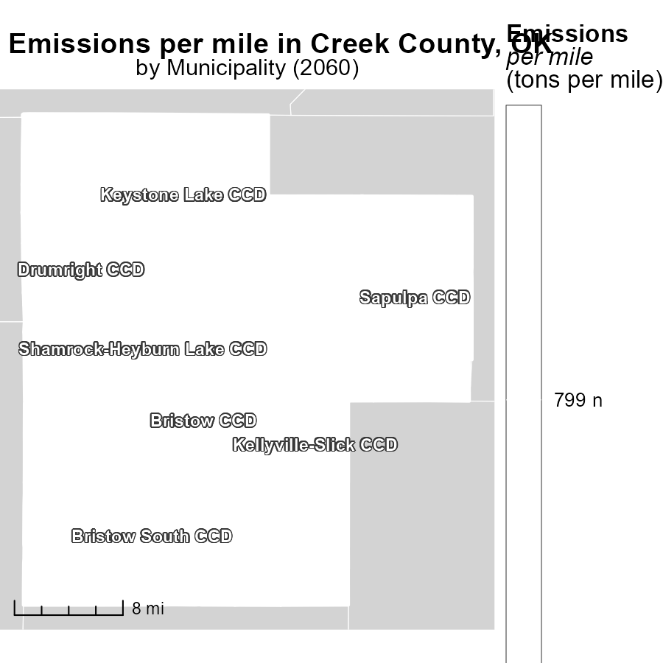

## Findings

* Bristow CCD, OK has the highest emissions per mile at 798.8 tons per mile.
* Kellyville-Slick CCD, OK has a median emissions per mile at 798.8 tons per mile.
* Shamrock-Heyburn Lake CCD, OK has the lowest emissions per mile at 798.8 tons per mile.

## Recommendations

To reduce emissions, focus on areas with high emissions, like Bristow CCD, by promoting public transportation and exploring options for cleaner energy sources.

# Emissions Rate (per mile) by Area over Time

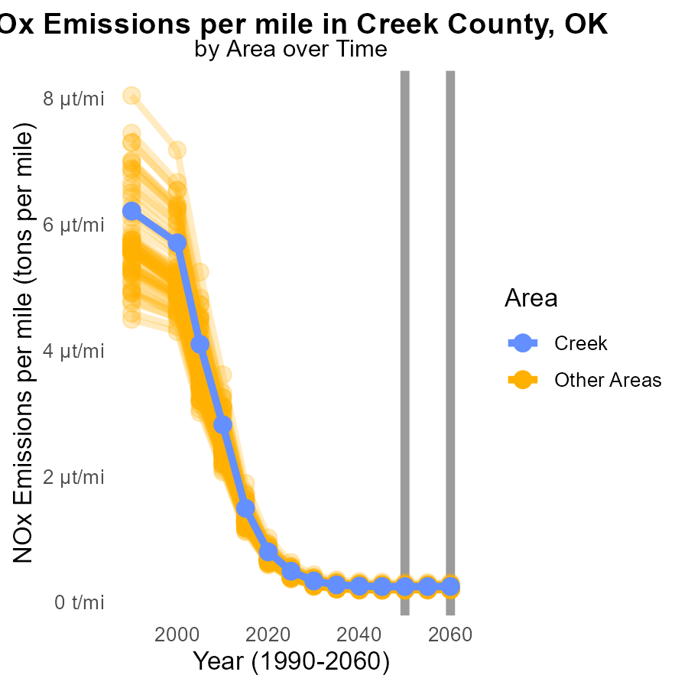

## Findings

* In 2060, the target county emitted 249.3 tons of NOx per mile.
* The county with the highest emissions in 2060 released 313.3 tons of NOx per mile.
* The county with the lowest emissions in 2060 produced 189.6 tons of NOx per mile.

## Recommendations

To reduce NOx emissions, focus on areas with higher emissions like the county with 313.3 tons per mile by implementing stricter emission regulations and promoting the use of cleaner technologies in transportation and industrial sectors. Encouraging public transportation and carpooling can also help reduce emissions in areas with lower levels like the county emitting 189.6 tons per mile.

# Emissions Rate (per vehicle) by Fuel Type over Time

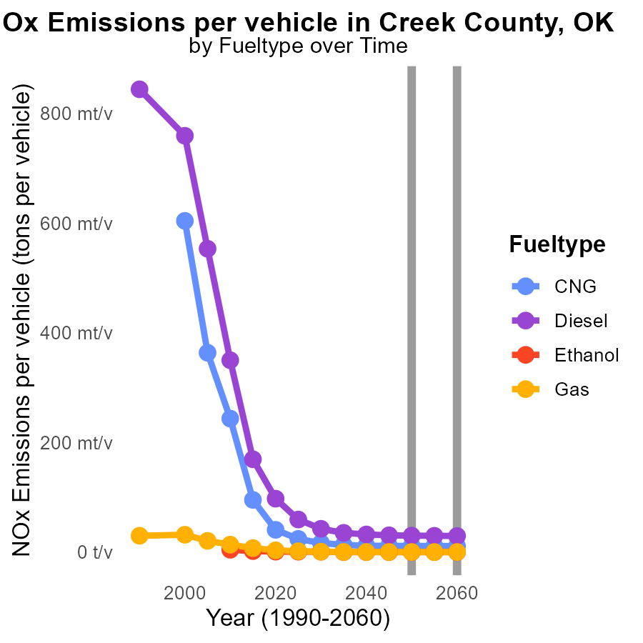

## Findings

* From 2050 to 2060, NOx emissions per vehicle decreased for all fuel types.
* Diesel vehicles had the highest NOx emissions in 2050 with 30.0 tons per vehicle.
* Gas vehicles showed fluctuation in emissions, reaching 135.4 tons per vehicle in 2055.

## Recommendations

To further reduce NOx emissions in Creek County, OK, policymakers should focus on promoting the use of CNG and Ethanol vehicles that showed a consistent decline in emissions. Implementing stricter regulations on Diesel and Gas vehicles can help maintain the decreasing trend.

# Areas Ranked by Idling

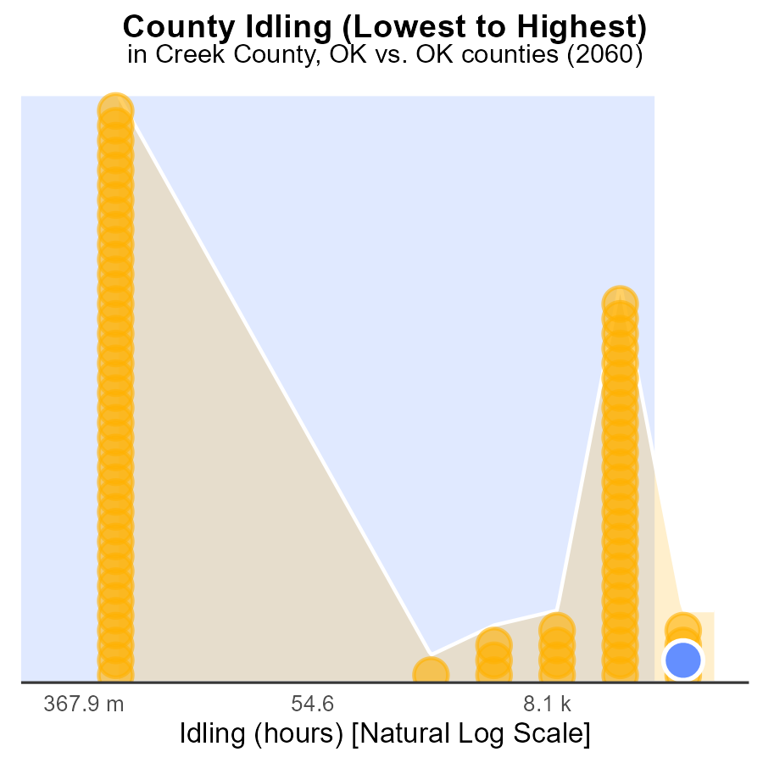

## Findings

* Oklahoma county has the highest idling hours at 814.6k, ranking at 77th and in the 100th percentile for NOx emissions.
* Tulsa county follows with 442.0k idling hours, ranking 76th, and in the 98.7th percentile for NOx emissions.
* Adair county has the lowest idling hours with 0.0, ranking at 1st, but still contributes to 50.6% of NOx emissions.

## Recommendations

To reduce NOx emissions caused by idling, targeted measures should focus on high-ranking counties like Oklahoma and Tulsa, promoting anti-idling campaigns and enforcing idling regulations. Additionally, Adair county should implement idling reduction initiatives to address its contribution to emissions.

# Areas Ranked by Population

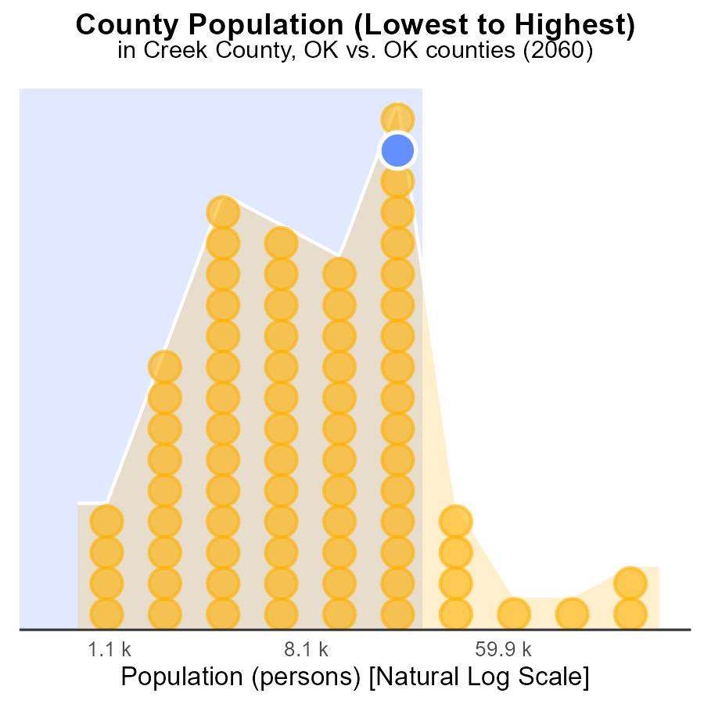

## Findings

* Oklahoma county has the highest NOx emissions.
* Creek county ranks 136th in population but is responsible for 88.3% of NOx emissions.
* Cimarron county, with a population of 2.2k, accounts for 1.3% of NOx emissions.

## Recommendations

To reduce emissions, focus on implementing stricter regulations in high-emission counties like Creek. Encourage the use of cleaner technologies to decrease NOx levels while considering population size for targeted policies.

# Conclusion

In conclusion, the data reveals a concerning trend of increasing NOx emissions from on-road transportation in Creek County, OK by 2060. Gasoline and diesel vehicles remain the primary contributors to NOx emissions, despite the minimal impact of CNG and Ethanol vehicles. To combat this issue, policies should prioritize incentivizing the adoption of electric or hybrid vehicles and enhancing public transportation.

Moreover, the data underscores the importance of focusing on highly populated areas like Sapulpa CCD for energy-efficient measures and promoting sustainable practices in less populated regions like Bristow South CCD. Areas with high emissions per mile, such as Bristow CCD, require targeted strategies like promoting public transportation and cleaner energy sources. Additionally, implementing stricter emission regulations and cleaner technologies in transportation and industrial sectors can help reduce NOx emissions in areas with differing emission levels per mile.

# About This Report

Data based on MOVES estimates collected by the Climate Action in Transportation program at Cornell University. Demographic data sourced from the US Census's American Community Survey 5-year estimates. This report was generated with the help of AI.

# References

* U.S. Census Bureau. (2023). American Community Survey 5-year estimates: Detailed tables. Retrieved from https://data.census.gov
* U.S. Environmental Protection Agency. (2024). Motor Vehicle Emission Simulator (MOVES 4.0) [Software]. Retrieved from https://www.epa.gov/moves