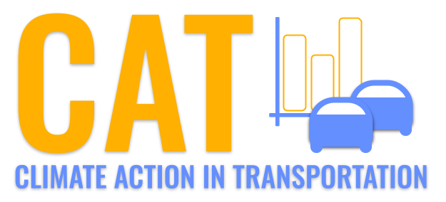 

**SO2 Emissions in Tolland County, 2025**  
Made with CAT VISUALIZER by Gao Labs @ Cornell University.

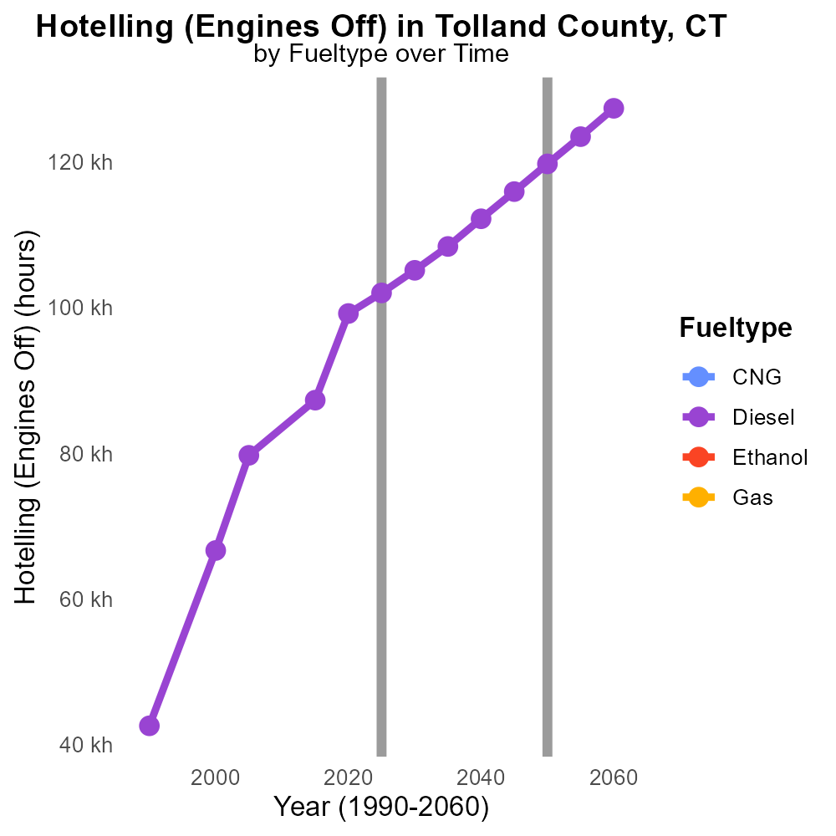

## Keywords

sulfur dioxide emissions; on-road transportation; Tolland County; CT; 2025; air pollution

## Highlights

* Sulfur dioxide from on-road transport in Tolland Co. in 2025
* Implications of high SO2 emissions on air quality
* Analysis of sources of sulfur dioxide emissions
* Proposed measures to reduce sulfur dioxide levels
* Importance of monitoring and addressing air pollution

# Introduction

Sulfur dioxide (SO2) emissions from on-road transportation pose a significant environmental concern in Tolland County, CT, particularly in the year 2025. Rapid urbanization and increased vehicular traffic have contributed to elevated levels of this harmful pollutant in the region.

The presence of sulfur dioxide in the air can lead to a myriad of health issues and environmental problems. Understanding the sources and impact of SO2 emissions from on-road transportation is crucial for devising effective mitigation strategies to improve air quality in Tolland County. This report aims to analyze the trends, sources, and implications of sulfur dioxide emissions specifically attributed to on-road transportation in the region in 2025, as well as propose recommendations for reducing these emissions and safeguarding public health and the environment.

# Hotelling (Diesel Aux) by Regulatory Class

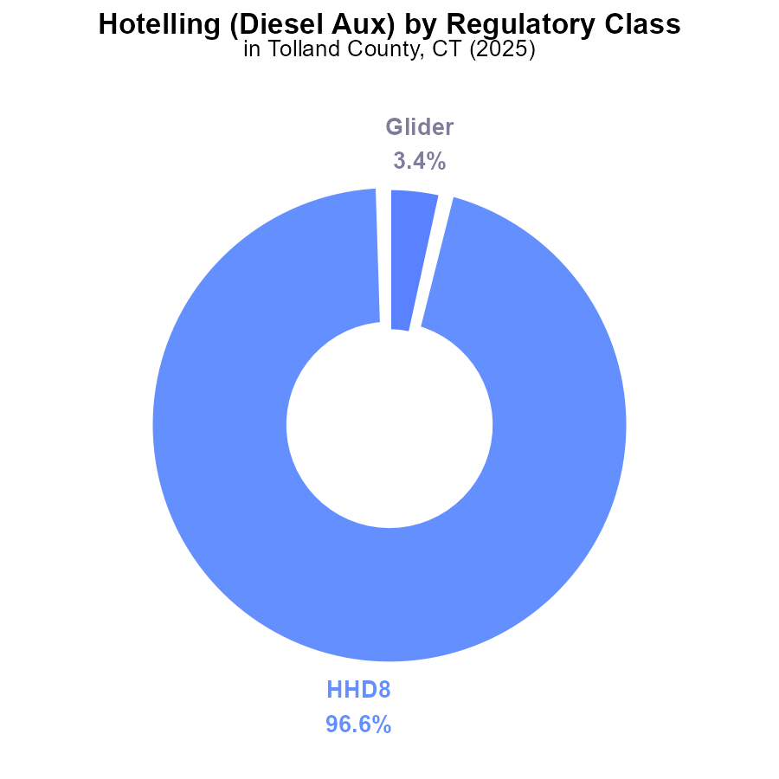

## Findings

* Almost all emissions (96.6%) come from HHD8 vehicles with a total of 71.2 k hours.
* Glider vehicles contribute a marginal 3.4% with 2.5 k hours.
* Other vehicle types like MHD67, LDT, LDV, LHD34, LHD45, MC, and Urban Bus have negligible to no emissions.

## Recommendations

To lower SO2 emissions in Tolland County, focus on reducing emissions from HHD8 vehicles, which account for the majority. Implement stricter emissions standards for these vehicles and incentivize the transition to cleaner alternatives. Consider investing in technology that can reduce emissions from diesel auxiliary engines.

# Vehicles by Vehicle Type

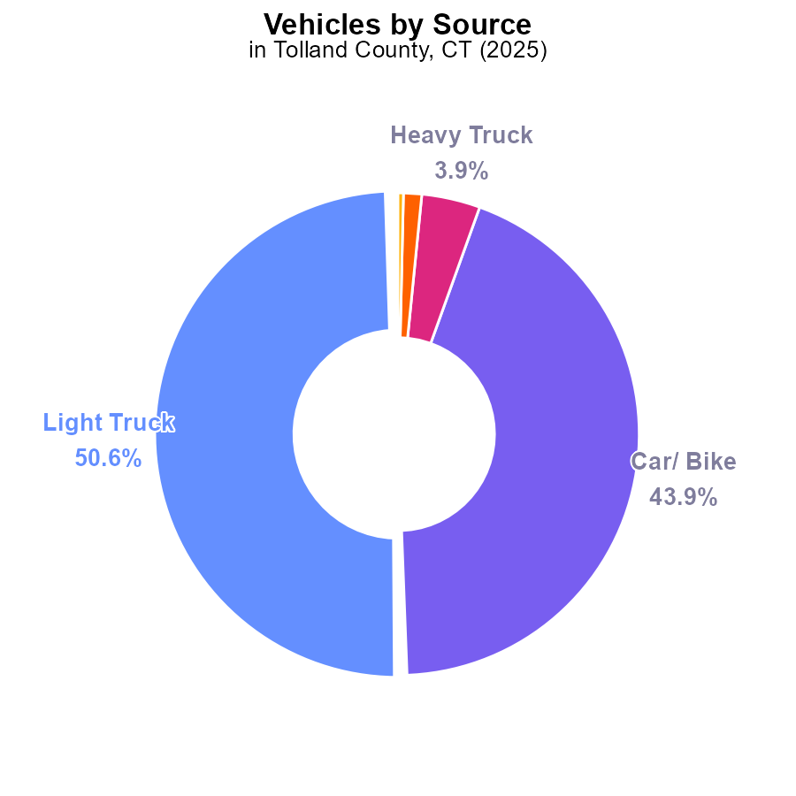

## Findings

* Light trucks contribute to over 50% of SO2 emissions from vehicles in Tolland County, CT in 2025.
* Cars/bikes are the second-largest contributors, accounting for nearly 44% of vehicle-related SO2 emissions.
* Heavy trucks, combo trucks, and buses combined contribute less than 6% of the total SO2 emissions from vehicles.

## Recommendations

To reduce SO2 emissions from vehicles in Tolland County, CT, policies should focus on reducing emissions from light trucks and cars/bikes. Implementing stricter emissions standards, promoting electric vehicles, and incentivizing public transportation can help lower overall emissions.

# Vehicle Miles Traveled over Time for Buses

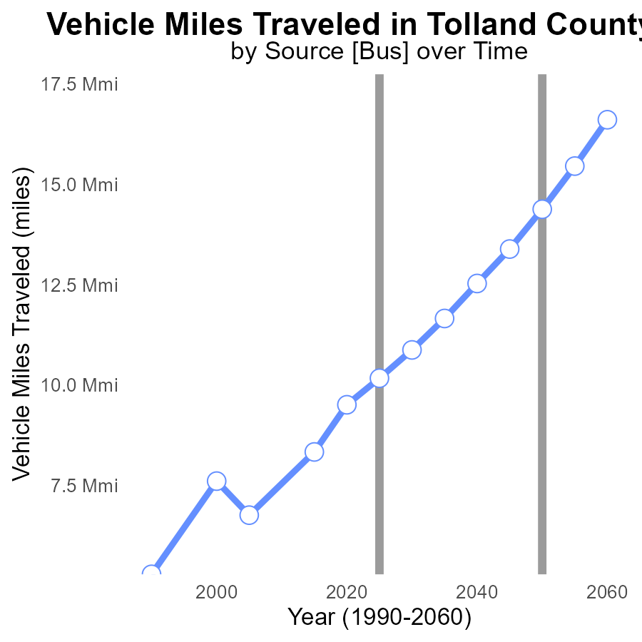

## Findings

* SO2 emissions in Tolland County, CT have consistently increased from 2005 to 2045.
* The benchmark_difference has decreased steadily over the years, indicating a positive trend.
* Vehicle miles traveled have shown a steady upward trend from 2005 to 2045 in Tolland County, CT.

## Recommendations

To lower SO2 emissions in Tolland County, CT, policymakers should consider implementing stricter vehicle emission standards and promoting the use of electric vehicles to reduce the environmental impact of transportation. Investing in public transportation infrastructure can also help decrease the reliance on individual vehicles, ultimately lowering emissions.

# Hotelling (Engines Off) over Time for Passenger Vehicles

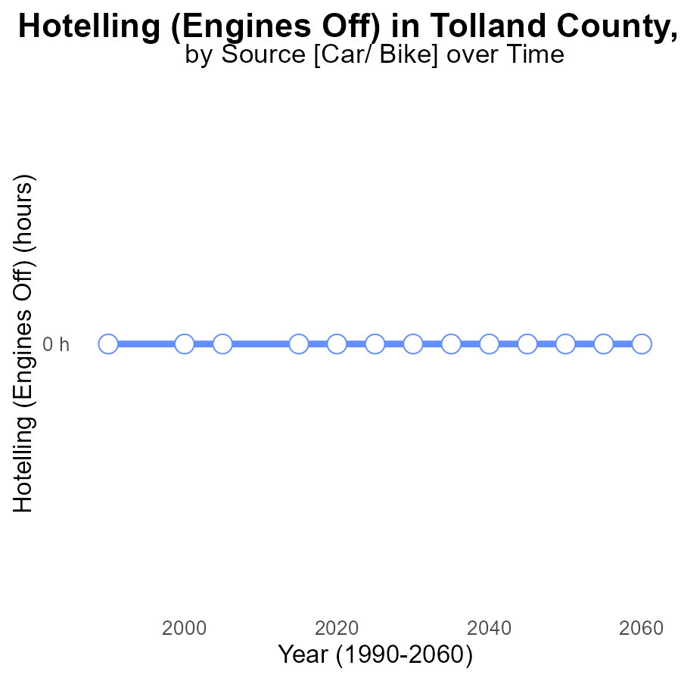

## Findings

* Between 2005 and 2045, there were no SO2 emissions from Hotelling in Tolland County, CT.

## Recommendations

Continued monitoring and enforcement of regulations to maintain zero SO2 emissions from Hotelling in Tolland County, CT.

# Time Driven Mapped by Area

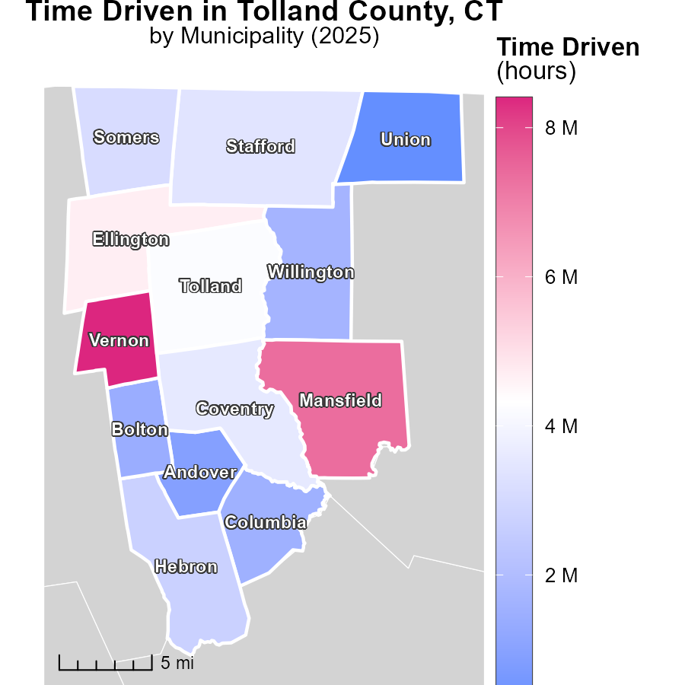

## Findings

* Vernon, CT emitted 8.4 million tons of emissions, the highest among the three locations.
* Somers, CT emitted 3.1 million tons, placing it in the middle in terms of emissions.
* Union, CT had the lowest emissions with 258.9 thousand tons emitted.

## Recommendations

To lower emissions, focus on developing sustainable transportation options in Vernon, CT, incentivize energy-efficient practices in Somers, CT, and implement green initiatives in Union, CT to further reduce emissions.

# Emissions Rate (per mile) Mapped by Area

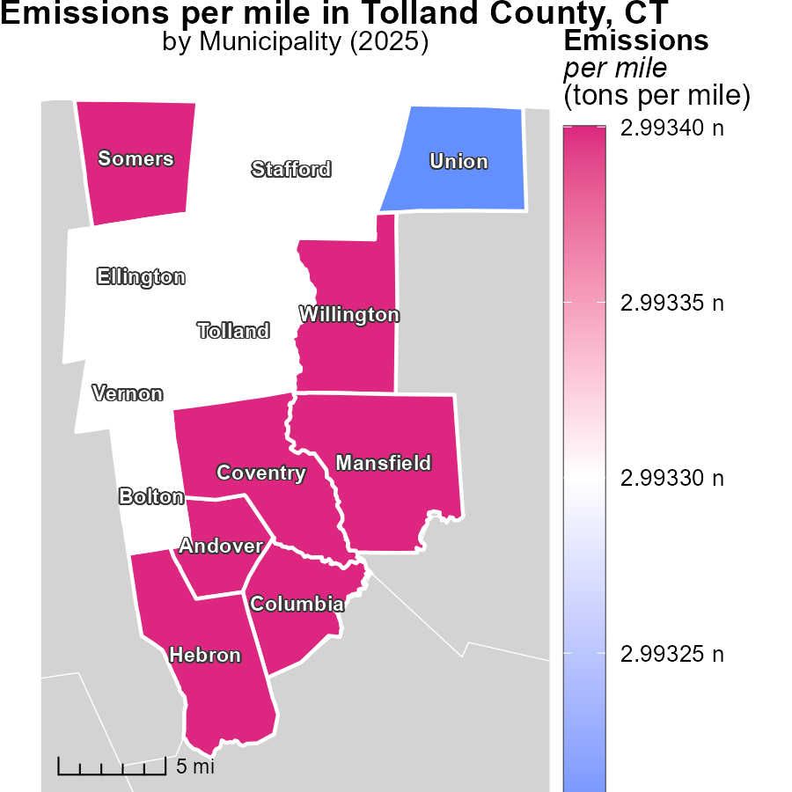

## Findings

* Andover, CT has the highest emissions per mile at 3.0 tons per mile.
* Willington, CT shows median emissions per mile at 3.0 tons per mile.
* Union, CT demonstrates the lowest emissions per mile at 3.0 tons per mile.

## Recommendations

To lower emissions, focus on reducing emissions from vehicles in Andover, CT, which is the highest contributor. Implement green transportation initiatives in these areas.

# Emissions Rate (per mile) by Road Type over Time

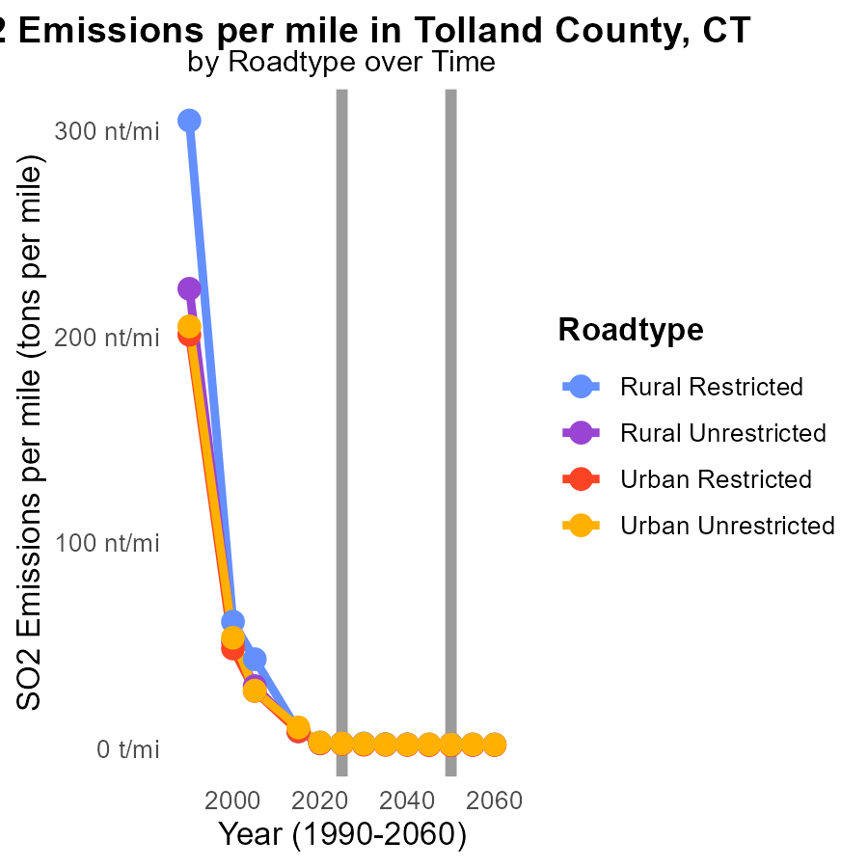

## Findings

* SO2 emissions reduced across all road types from 2015 to 2035.
* The greatest reduction occurred in Urban Unrestricted areas.
* Emissions decreased by 71.8% in Urban Unrestricted zones.

## Recommendations

To further decrease emissions, focus on urban unrestricted areas by implementing stricter emission standards for vehicles and promoting public transportation.

# Hotelling (Engines Off) by Fuel Type over Time

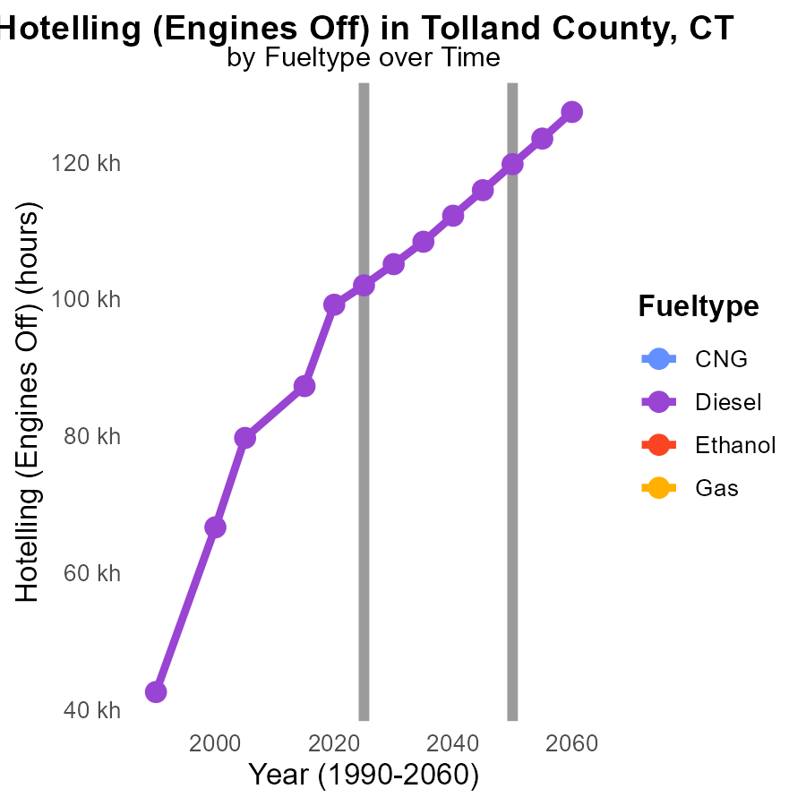

## Findings

* Diesel emissions in Tolland County decreased by 31.8% from 2015 to 2035.
* There was no data available for SO2 emissions from CNG, Ethanol, and Gas in the region from 2015 to 2035.
* Diesel emissions reductions slowed over time, with a 16.1% decrease from 2030 to 2035.

## Recommendations

To further reduce emissions, policymakers could consider promoting alternatives to diesel fuels, such as CNG, Ethanol, or Gas. Investing in infrastructure for supporting these alternative fuels can help achieve significant emission reductions in the long term.

# Areas Ranked by Time Driven

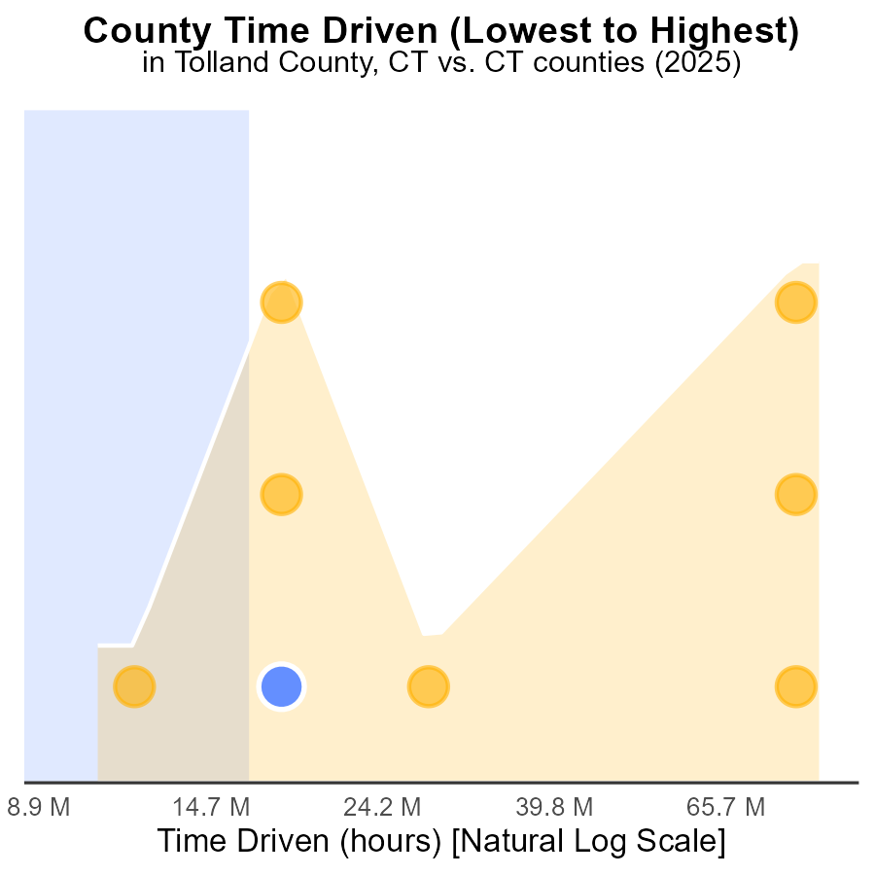

## Findings

* Hartford county has the highest SO2 emissions with 243.5 M source-hours in 2025.
* Tolland county ranked 2nd with 44.5 M source-hours, representing 25.0% of emissions.
* Windham county had the lowest emissions at 28.6 M source-hours, accounting for 12.5%.

## Recommendations

To lower emissions, focus on more sustainable energy sources in Hartford county to reduce the 100% percentile. Implement stricter regulations in Tolland and Litchfield counties to decrease their high emission percentages. Encourage Windham county to maintain their low emission levels through continued monitoring and incentives.

# Areas Ranked by Hotelling (Engines Off)

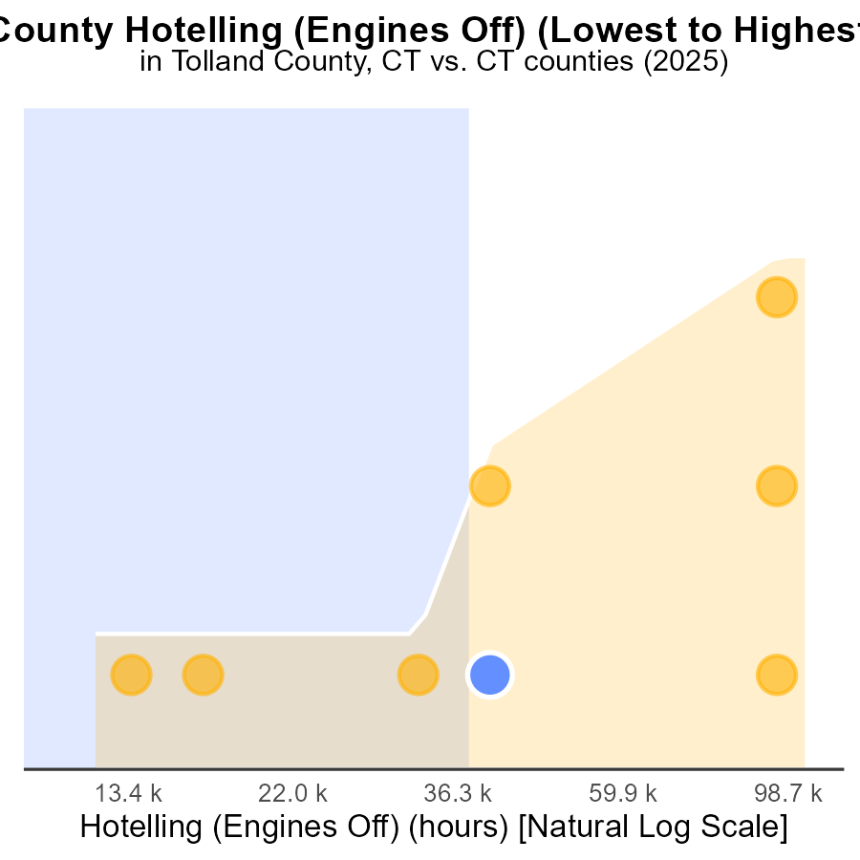

## Findings

* New Haven county has the highest SO2 emissions with 289.1 k hours.
* Litchfield county has the lowest SO2 emissions with 32.9 k hours.
* SO2 emissions in Tolland, Middlesex, and New London counties are 102.0 k, 81.5 k, and 115.3 k hours respectively.

## Recommendations

To lower SO2 emissions, focus on reducing emissions in New Haven county by implementing stricter regulations and incentivizing cleaner technologies. Encourage Tolland, Middlesex, and New London counties to maintain their current emission levels.

# About This Report

Data based on MOVES estimates collected by the Climate Action in Transportation program at Cornell University. Demographic data sourced from the US Census's American Community Survey 5-year estimates. This report was generated with the help of AI.

# References

* U.S. Census Bureau. (2023). American Community Survey 5-year estimates: Detailed tables. Retrieved from https://data.census.gov
* U.S. Environmental Protection Agency. (2024). Motor Vehicle Emission Simulator (MOVES 4.0) [Software]. Retrieved from https://www.epa.gov/moves