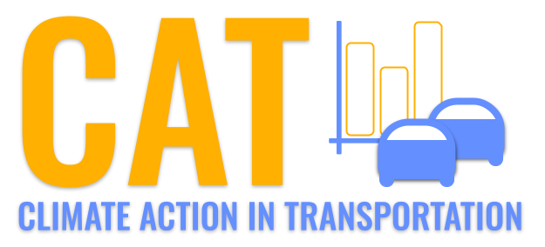 

**NOx Emissions in DeKalb County, 2035**  
Made with CAT VISUALIZER by Gao Labs @ Cornell University.

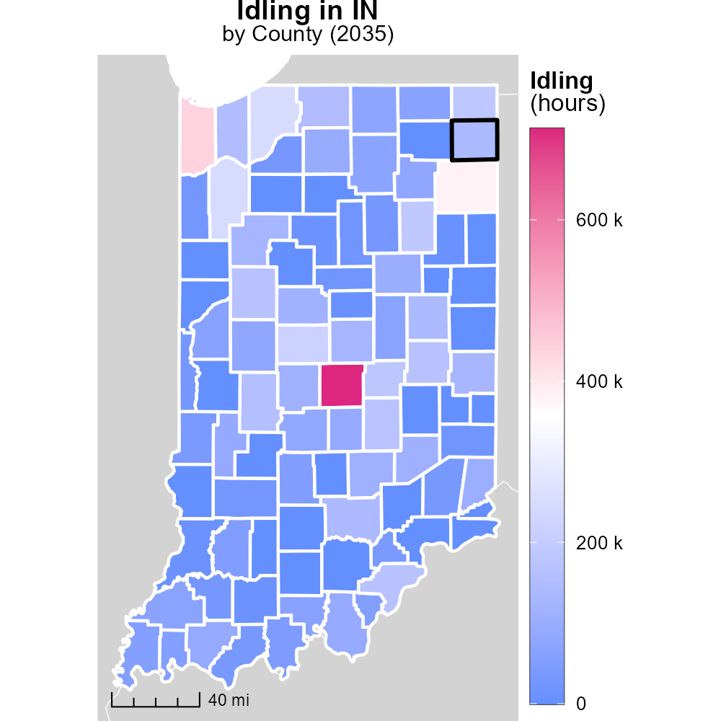

## Keywords

Oxides of Nitrogen; NOx emissions; on-road transportation; DeKalb County; 2035; environmental impact

## Highlights

* Study on NOx emissions from DeKalb County transportation.
* Impact of emissions on air quality in 2035.
* Assessing long-term effects on the environment.
* Data analysis of NOx levels from on-road vehicles.
* Recommendations for reducing emissions in the county.

# Introduction

The report presents an in-depth analysis of Oxides of Nitrogen (NOx) emissions from on-road transportation in DeKalb County, IN in the year 2035. This study aims to investigate the environmental impact of NOx emissions from various vehicles operating within the county.

By examining the trends and levels of NOx emissions, the report will provide insights into the air quality challenges faced by DeKalb County in the future. Additionally, the long-term effects of these emissions on public health and the environment will be assessed, informing potential mitigation strategies for policymakers and stakeholders. Recommendations for reducing NOx emissions from on-road transportation will also be discussed to promote sustainable and environmentally conscious practices within the county.

# Vehicles by Road Type

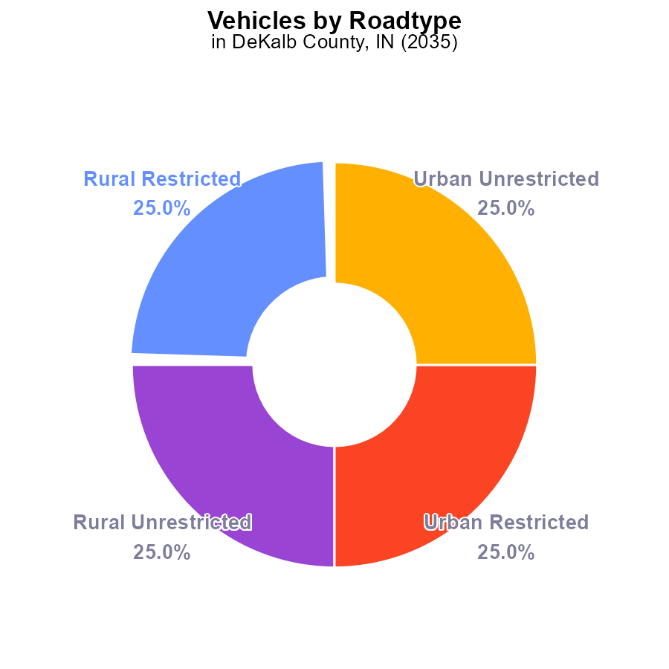

## Findings

* NOx emissions from vehicles in 2035 are 243.6 k.
* Rural and urban areas contribute equally, each at 50% to the total emissions.
* There is a balance within rural and urban areas due to equal contributions from restricted and unrestricted zones.

## Recommendations

To lower NOx emissions, implement vehicle emission testing in both rural and urban areas. Encourage the use of electric vehicles to reduce pollution further in all categories.

# Hotelling (Engines Off) Overall by Area

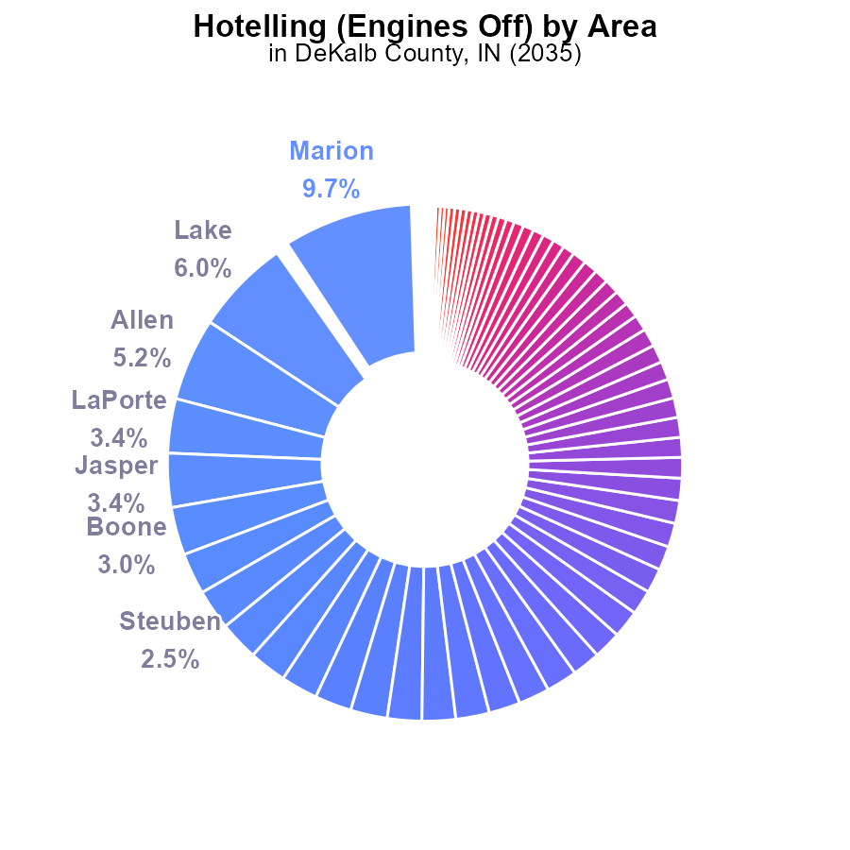

## Findings

* The top 5 emitters, Marion, Lake, Allen, LaPorte, and Jasper counties, contribute to 25.7% of the total emissions.
* 94 out of 92 counties emit NOx, with 48 counties emitting less than 0.5% each.
* 51.8% of counties emit less than 1% of the total emissions, indicating a long tail distribution.

## Recommendations

To reduce NOx emissions, focus on implementing stricter emission standards for high emitters like Marion, Lake, Allen, LaPorte, and Jasper counties, which contribute significantly. Additionally, incentivize low emitting counties to maintain their low emission levels.

# Population over Time for Buses

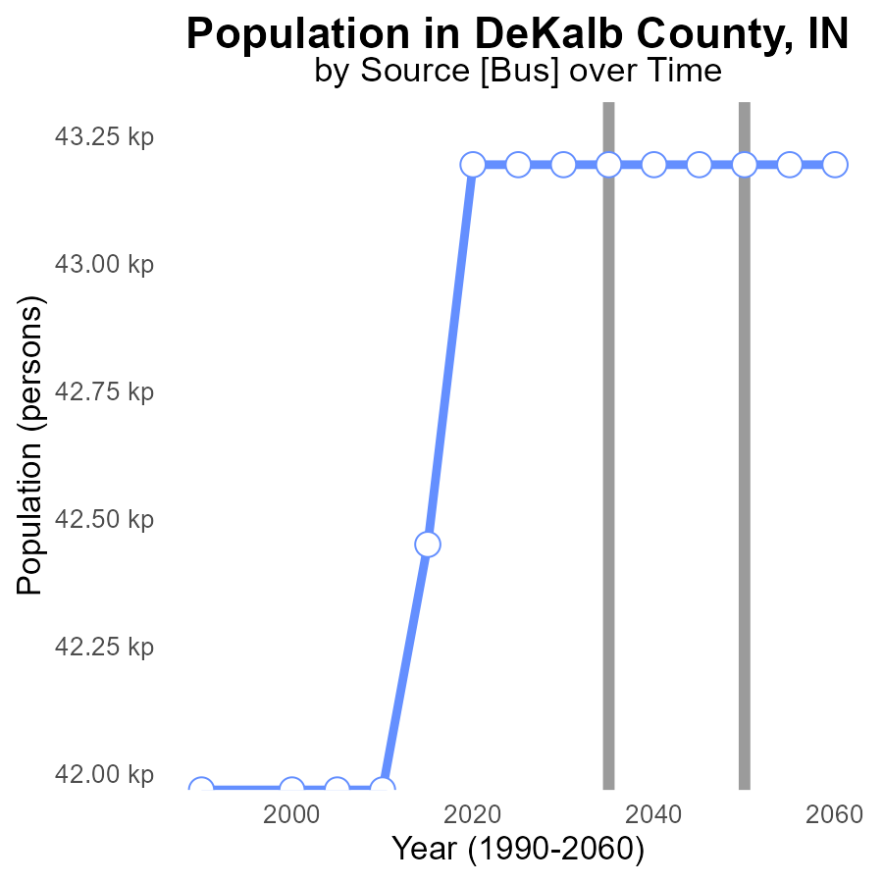

## Findings

* NOx emissions in DeKalb County remained relatively stable from 2020 to 2055, at around 43.2 k persons.
* There was a notable decrease in NOx emissions between 2015 and 2020, with a reduction of 744 persons.
* From 2020 to 2055, the county maintained the same level of NOx emissions, showing no further improvements.

## Recommendations

To further reduce NOx emissions in DeKalb County, initiatives such as promoting the use of electric vehicles, implementing stricter emission standards for industries, and supporting public transportation systems should be considered. Continuous monitoring and enforcement of regulations are crucial to ensure sustained improvements in air quality.

# Vehicle Starts Overall over Time

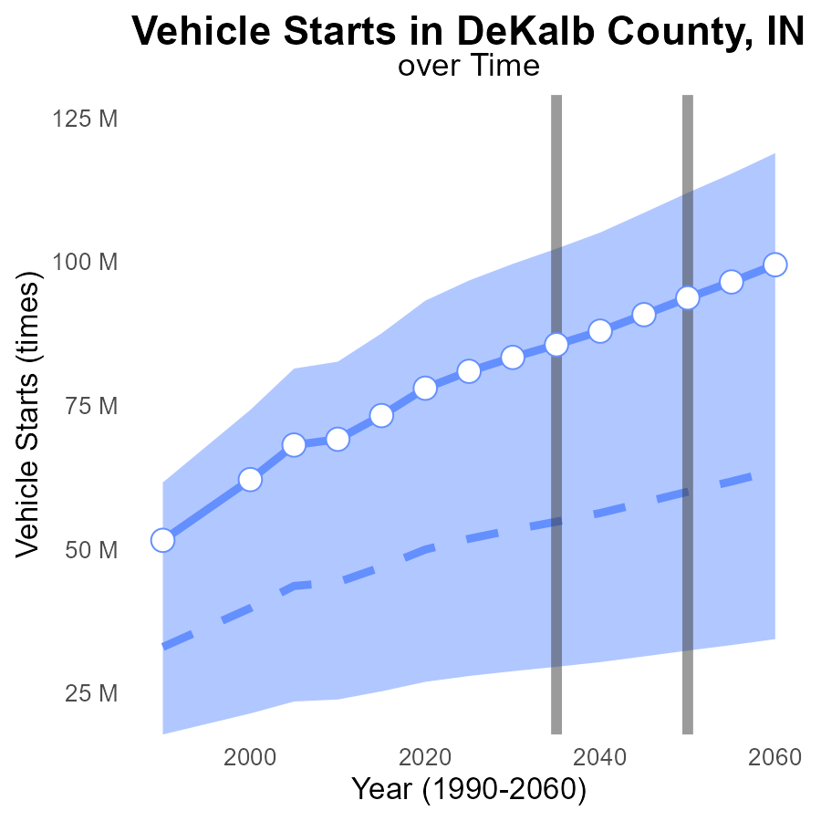

## Findings

* NOx emissions in DeKalb County are projected to increase steadily over the next few decades, with a significant difference from the median area.
* NOx emissions from vehicle starts are expected to rise by around 34.7 million times in 2055 compared to the benchmark difference.
* DeKalb County is set to surpass the upper 75th percentile of areas in NOx emissions from vehicle starts by 2050.

## Recommendations

To address the increasing NOx emissions, DeKalb County should focus on promoting electric vehicles, improving public transportation, and implementing stricter emission standards for vehicles in the area.

# Vehicle Miles Traveled in My Region

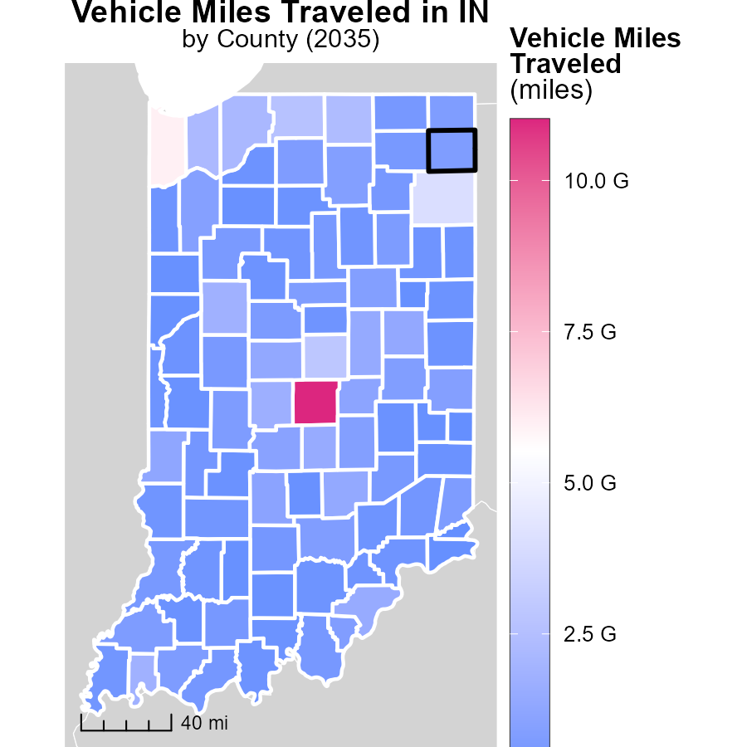

## Findings

* Marion County, IN has the highest vehicle miles traveled at 11.0 billion miles.
* Whitley County, IN has a median vehicle miles traveled of 543.0 million miles.
* Ohio County, IN has the lowest vehicle miles traveled at 59.7 million miles.

## Recommendations

To reduce emissions from transportation in Marion County, IN, explore implementing carpooling incentives or expanding public transportation. In Whitley County, focus on promoting biking or walking infrastructure to decrease vehicle miles traveled. For Ohio County, consider investing in telecommuting options to help lower emissions from reduced travel.

# Idling in My Region

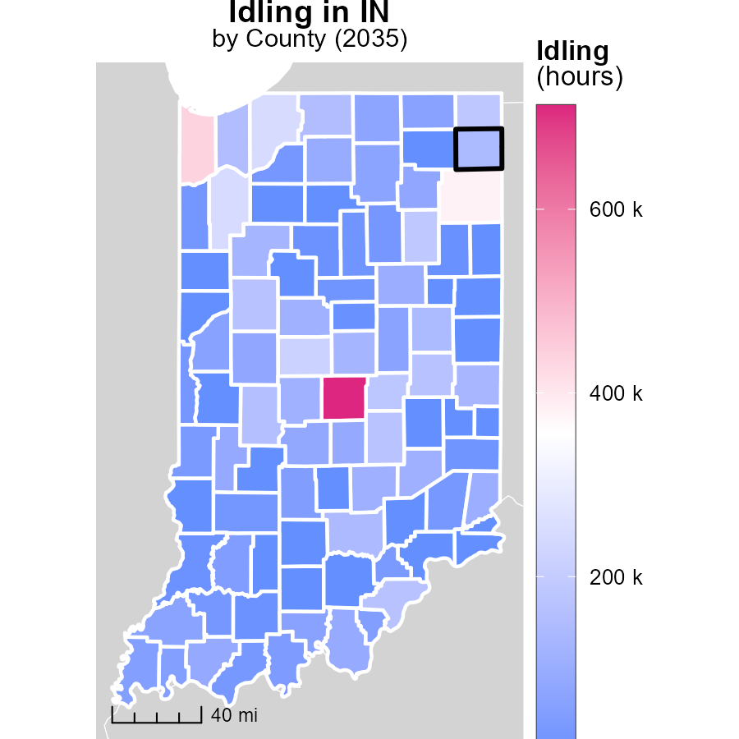

## Findings

* Marion County, IN has the highest idling hours with 712.8 thousand hours.
* Floyd County, IN has a median idling hours with 52.1 thousand hours.
* Washington County, IN has the lowest idling hours with 0 hours.

## Recommendations

To lower emissions, policymakers should implement idling reduction initiatives, especially in Marion County, focusing on high idling areas to reduce overall emissions.

# Vehicle Starts by Fuel Type over Time

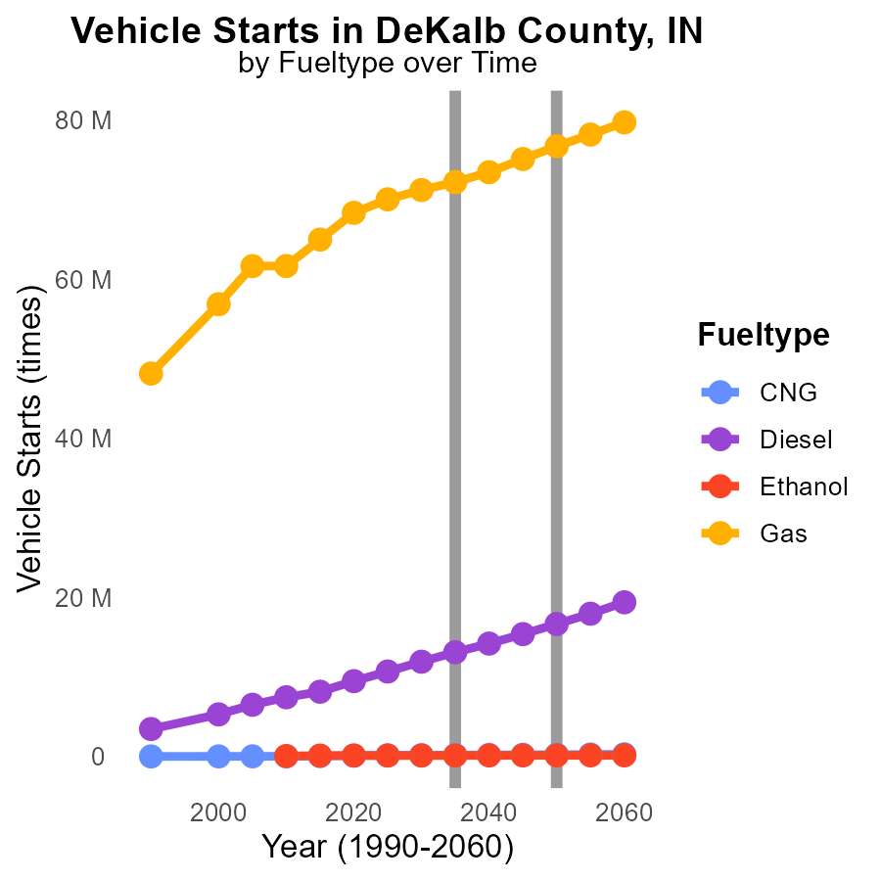

## Findings

* By 2045, CNG vehicle starts will decrease by 80.1% compared to 2025.
* Diesel vehicle starts will reduce by 74.6% by 2045 compared to 2025.
* Gasoline vehicle starts show a decrease of 77.1% by 2045 compared to 2025.

## Recommendations

To lower NOx emissions, it is crucial to shift towards cleaner fuel alternatives like ethanol and CNG. Implementing policies that incentivize the adoption of these cleaner fuels can significantly reduce emissions in DeKalb County.

# Time Driven by Vehicle Type over Time

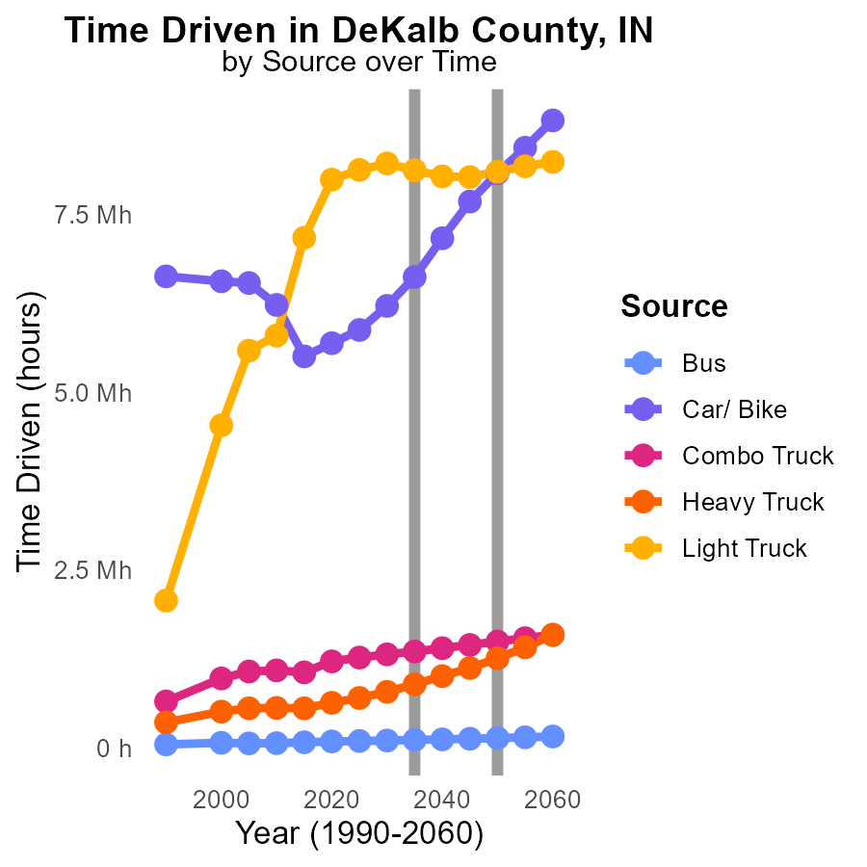

## Findings

* NOx emissions are projected to decrease for all vehicle types from 2025 to 2045.
* The largest reduction in NOx emissions is expected in the Car/ Bike category, with a decrease of 7.7 million units by 2045.
* Despite reductions in other categories, Light Trucks show a fluctuating trend in NOx emissions, ending with a slight increase by 2045.

## Recommendations

To lower NOx emissions further, policymakers should incentivize the transition to cleaner fuel technologies for heavy-duty vehicles, like buses and trucks. Encouraging the adoption of electric or hybrid vehicles can significantly reduce emissions in the long term.

# Areas Ranked by Idling

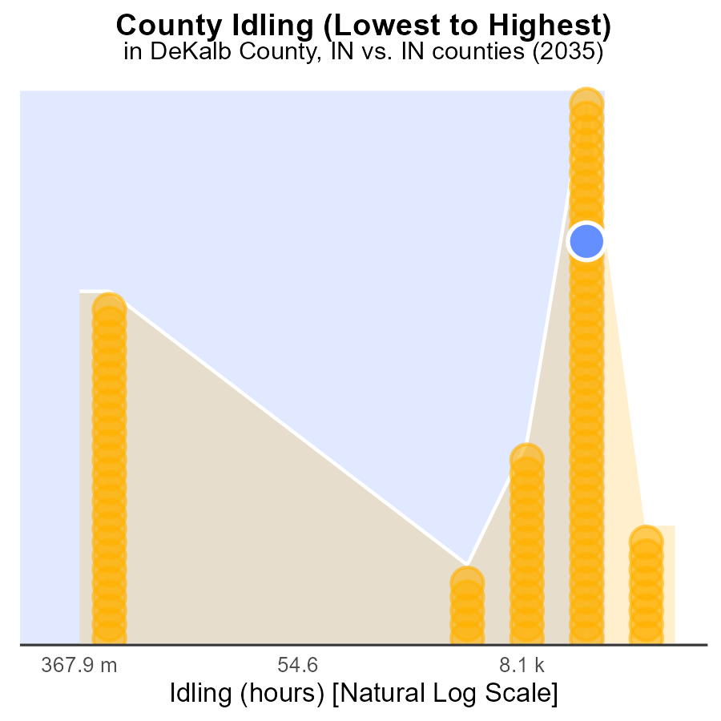

## Findings

* Marion county has the highest idling hours at 712.8k, ranking 92nd nationally.
* Adams county has the lowest idling hours at 0.0, ranking 1st nationally.
* Highest idling hours percentage are in Delaware county at 81.5%.

## Recommendations

To reduce emissions, prioritize reducing idling times in Marion and Delaware counties where levels are the highest. Implement idling reduction campaigns and incentivize alternative transportation.

# Areas Ranked by Vehicle Starts

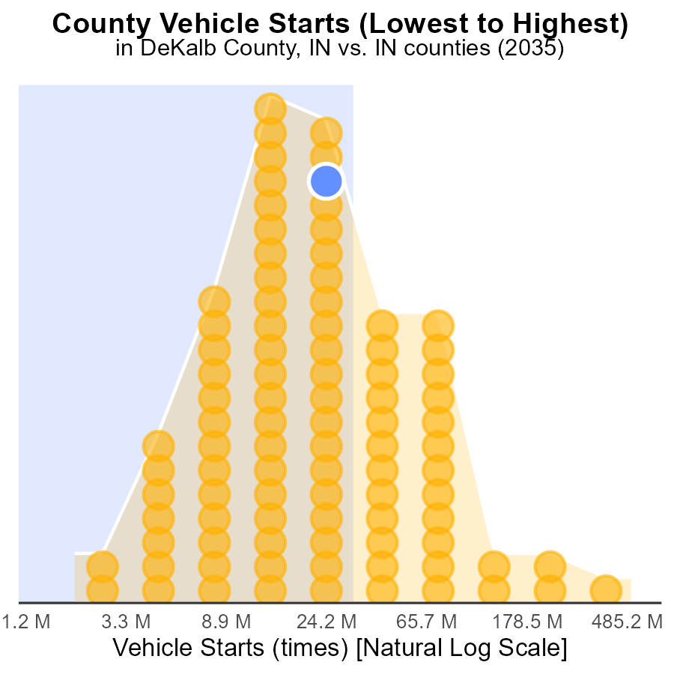

## Findings

* DeKalb had 85.6 million vehicle starts, ranking 61st with 66.3% of the total starts.
* Marion county had the highest number of starts at 1.4 billion, ranking 92nd and constituting 100% of the total starts.
* Ohio had the lowest number of starts at 5.3 million, being the first rank with only 1.1% of the total starts.

## Recommendations

To lower NOx emissions, DeKalb and Dearborn counties should focus on reducing vehicle starts by optimizing traffic flow and promoting carpooling. Marion county could benefit from upgrading vehicles to cleaner options to reduce its significant NOx contribution.

# Conclusion

In conclusion, the analysis of Oxides of Nitrogen (NOx) emissions from on-road transportation in DeKalb County, IN in 2035 reveals several key insights. The data shows that NOx emissions are evenly split between rural and urban areas, with the top 5 emitters accounting for a significant portion of the total emissions. While DeKalb County has maintained relatively stable NOx emissions over the years, there is room for improvement by promoting the use of electric vehicles, implementing stricter emission standards, and supporting public transportation systems.

To address the projected increase in NOx emissions, DeKalb County should focus on initiatives like promoting cleaner fuel alternatives, implementing stricter emission standards for vehicles, and encouraging the transition to electric or hybrid vehicles. Additionally, targeting high-emitting counties and incentivizing low-emitting counties can help in achieving a more sustainable reduction in NOx emissions. Continuous monitoring and enforcement of regulations will be essential to ensure long-term improvements in air quality.

# About This Report

Data based on MOVES estimates collected by the Climate Action in Transportation program at Cornell University. Demographic data sourced from the US Census's American Community Survey 5-year estimates. This report was generated with the help of AI.

# References

* U.S. Census Bureau. (2023). American Community Survey 5-year estimates: Detailed tables. Retrieved from https://data.census.gov
* U.S. Environmental Protection Agency. (2024). Motor Vehicle Emission Simulator (MOVES 4.0) [Software]. Retrieved from https://www.epa.gov/moves