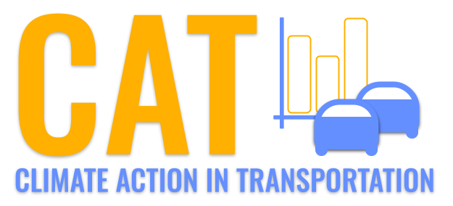 

**NOx Emissions in Valley County, 2010**  
Made with CAT VISUALIZER by Gao Labs @ Cornell University.

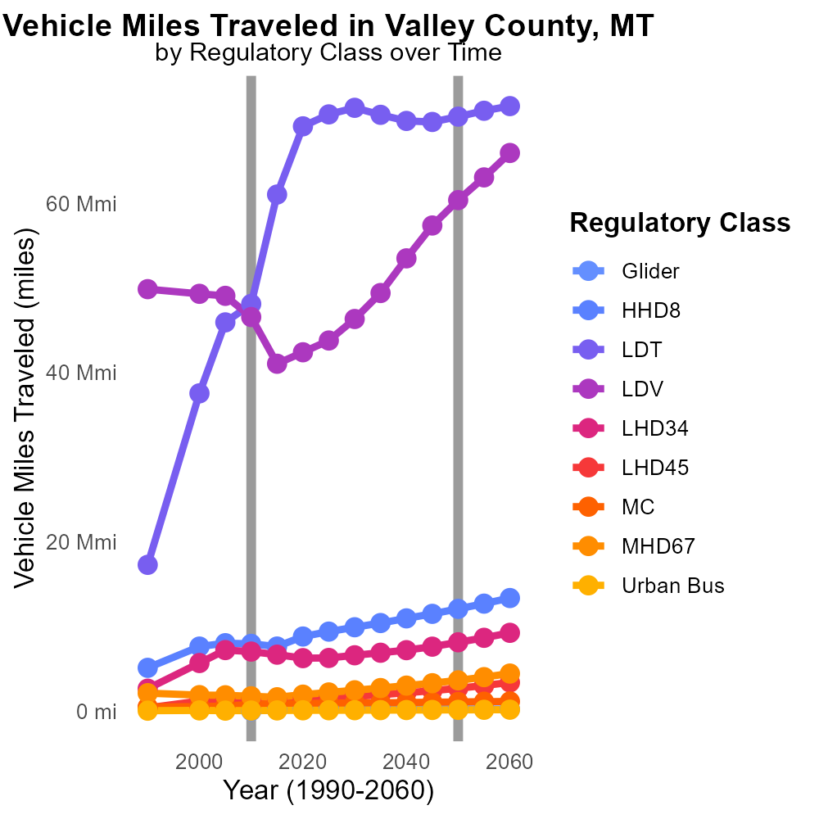

## Keywords

Oxides of Nitrogen; NOx emissions; on-road transportation; Valley County; MT; 2010

## Highlights

* Study on NOx emissions from transportation in Valley County, MT.
* Analysis of 2010 data reveals significant impact on air quality.
* Efforts to mitigate NOx emissions crucial for environmental health.
* Findings to inform policy decisions in Valley County.
* Importance of understanding on-road transportation emissions for local communities.

# Introduction

The report examines the Oxides of Nitrogen (NOx) emissions stemming from on-road transportation activities in Valley County, Montana, during the year 2010. NOx emissions are a significant environmental concern due to their role in air pollution and impact on public health.

By analyzing the data specific to Valley County, insights can be gained into the extent of NOx emissions from on-road transportation and their contribution to the overall air quality in the region. The findings of this study are crucial in guiding mitigation strategies and policy decisions aimed at reducing NOx emissions and improving the environmental health of Valley County.

# Population by Fuel Type

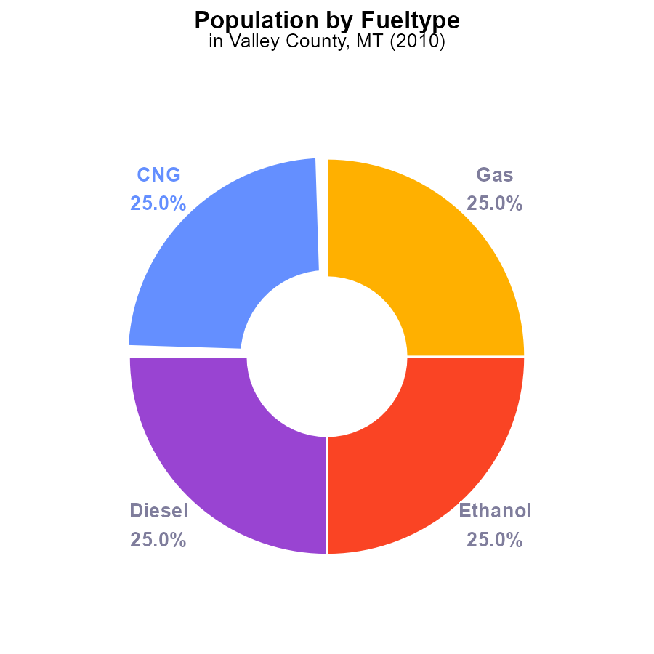

## Findings

* In 2010, NOx emissions in Valley County, MT were 29.2 k tons.
* Each fuel type - CNG, Diesel, Ethanol, and Gas - contributed equally to NOx emissions with 7.3 k tons each.
* NOx emissions were evenly distributed at 25.0% for each fuel type.

## Recommendations

To lower NOx emissions, policymakers should consider promoting cleaner alternative fuels and strict emission standards to reduce the impact from each fuel type equally.

# Population by Vehicle Type

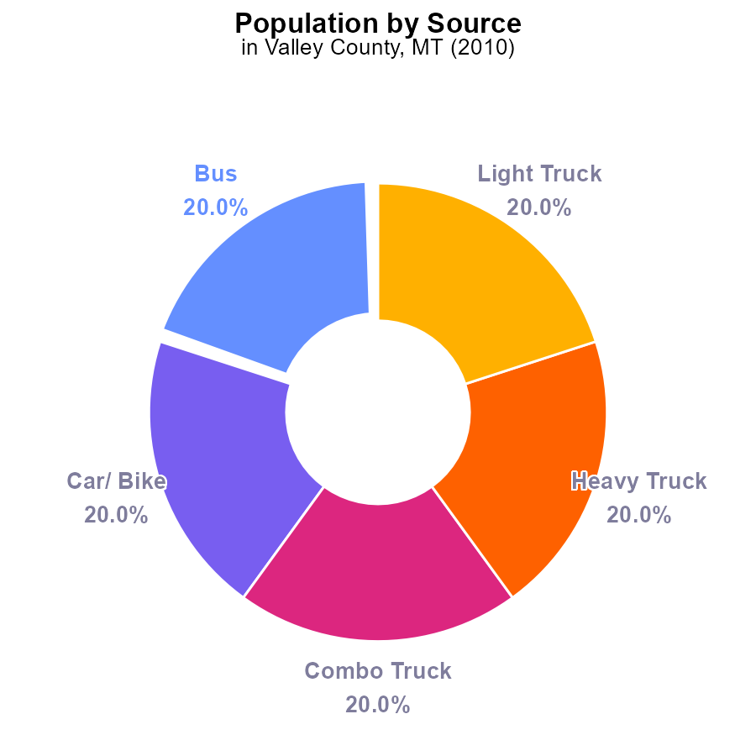

## Findings

* NOx emissions in Valley County, MT in 2010 were 36.5 k
* Buses, cars/bikes, combo trucks, heavy trucks, and light trucks contributed equally to NOx emissions.
* All vehicle types individually accounted for 20.0% of the total NOx emissions.

## Recommendations

To lower NOx emissions, policymakers should consider implementing strategies that target all vehicle types equally to ensure a balanced reduction in emissions. This could involve promoting cleaner fuels, enhancing vehicle maintenance programs, and investing in public transportation to reduce reliance on individual vehicles.

# Emissions Rate (per vehicle) Overall over Time

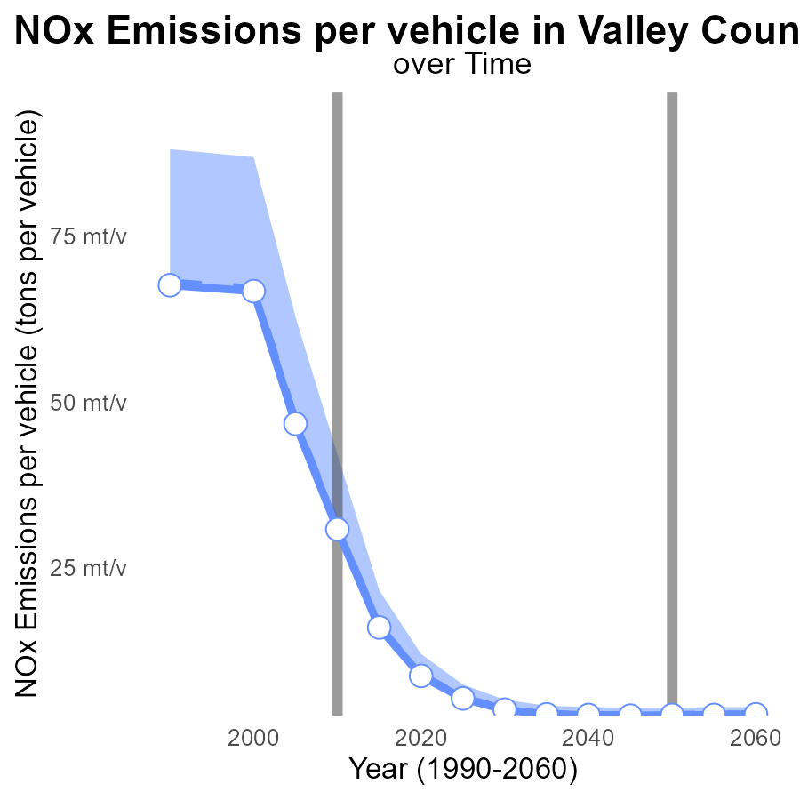

## Findings

* NOx emissions per vehicle in Valley County have steadily decreased from 67.6 tons in 1990 to 3.6 tons in 2030.
* Valley County's NOx emissions per vehicle consistently remain below the upper 75th percentile of areas and above the lower 25th percentile.
* Valley County's NOx emissions per vehicle are significantly lower than the median area across all recorded years.

## Recommendations

To further reduce NOx emissions per vehicle in Valley County, policies should focus on promoting the adoption of low-emission vehicles, improving public transportation systems, and implementing stricter emission regulations for industries.

# Emissions Rate (per capita) over Time for Passenger Vehicles

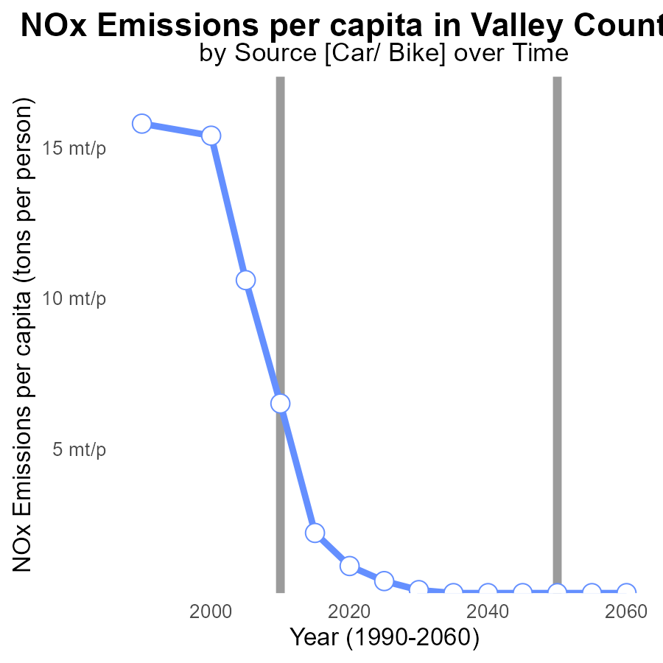

## Findings

* From 1990 to 2030, NOx emissions per capita in Valley County decreased by 15.1 tons per person.
* The most significant reduction occurred between 2015 and 2020 when emissions dropped from 2.2 m tons to 1.1 m tons per person.
* By 2030, emissions are projected to decrease to 336.7 µ tons per person, showing a continued downward trend.

## Recommendations

To further reduce NOx emissions, Valley County should focus on promoting the adoption of cleaner technologies in industries and transportation. Implementing stricter emission regulations and investing in renewable energy sources can help sustain the current decrease in emissions.

# Hotelling (Engines Off) in My Region

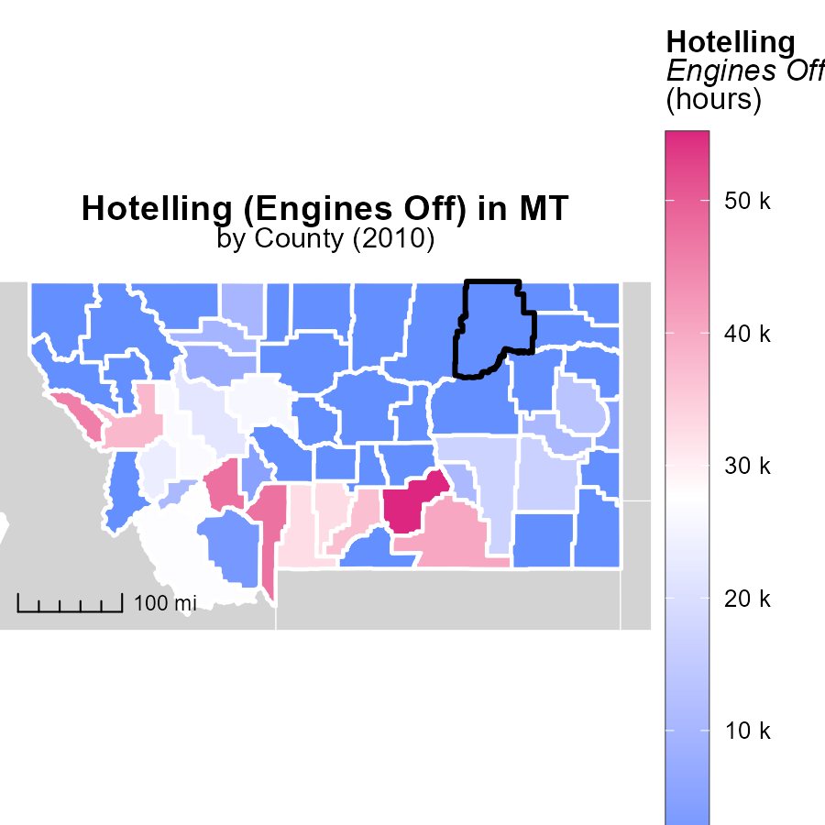

## Findings

* Yellowstone County, MT had the highest hotelling emissions in 2010 at 55.2k hours.
* Blaine County, MT had no hotelling emissions in 2010, making it the median emission level.
* Wheatland County, MT also had no hotelling emissions in 2010, placing it at the minimum emission level.

## Recommendations

To lower hotelling emissions, focus on reducing idle time in Yellowstone County, MT, while maintaining the no-emission levels in Blaine and Wheatland Counties, MT.

# Emissions Mapped by Area

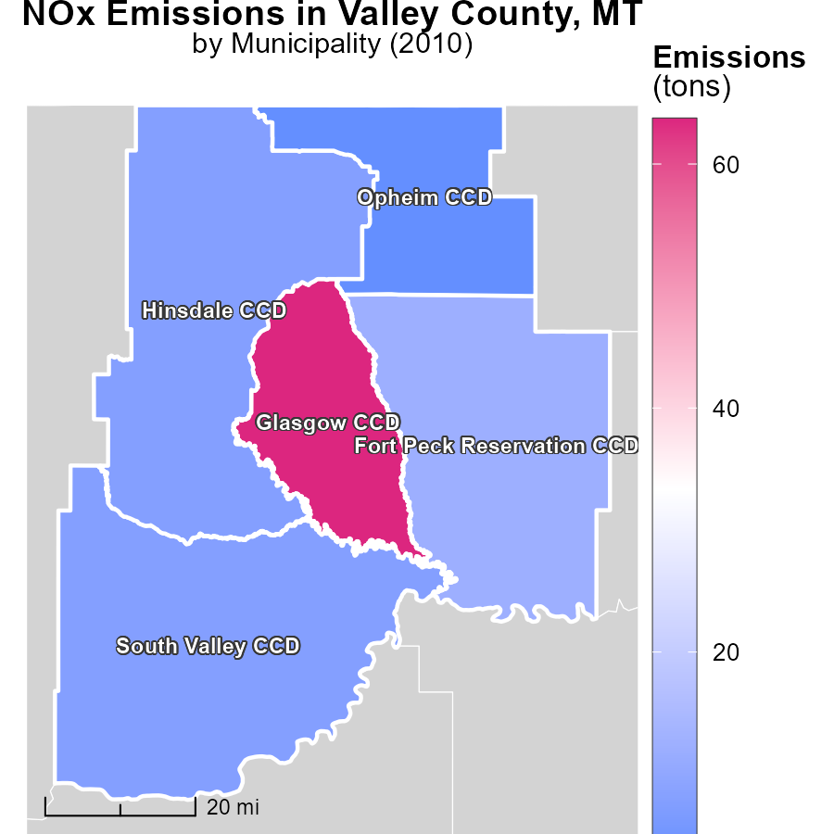

## Findings

* The maximum emissions in 2010 were 63.7 tons in Glasgow CCD, MT.
* Hinsdale CCD, MT had median emissions of 7.8 tons in 2010.
* Opheim CCD, MT had the lowest emissions in 2010, with 3.1 tons.

## Recommendations

To reduce emissions, focus on areas with higher emissions like Glasgow CCD, MT. Implement stricter emission control measures across all regions.

# Vehicle Miles Traveled by Regulatory Class over Time

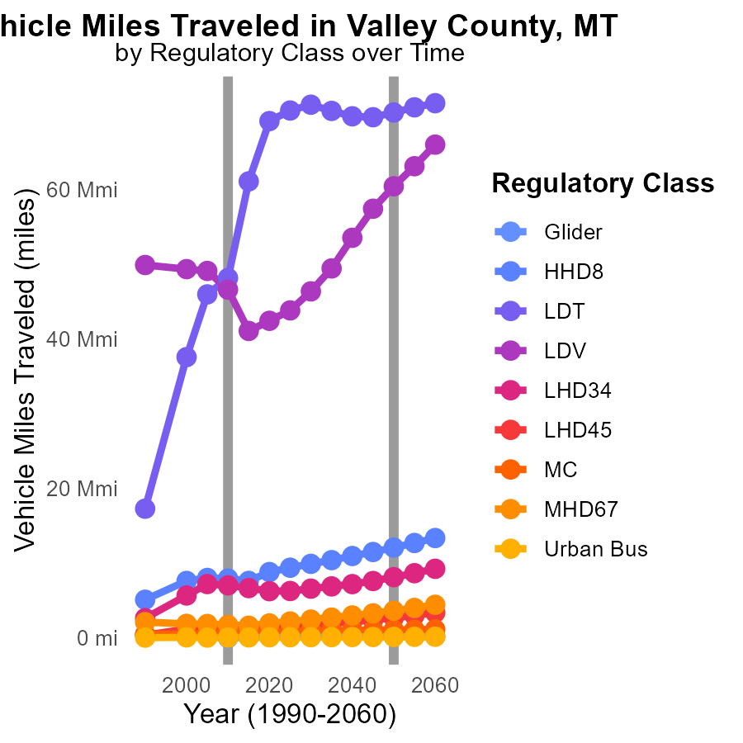

## Findings

* NOx emissions from Glider vehicles decreased by 17574.0 miles from 2015 to 2020.
* Vehicle miles traveled by LDT increased by 1143748.3 miles from 2015 to 2020.
* MC emissions reduced by 742.2 k from 2010 to 2020, with an overall decrease of 81.3% from 2000.

## Recommendations

To further reduce NOx emissions, incentivize the transition to cleaner vehicle technologies like electric or hydrogen-powered vehicles. Implement stricter emission standards for heavy-duty vehicles to curb the increase in LDT emissions. Continue promoting policies that encourage the use of low-emission transport modes for urban buses.

# Population by Regulatory Class over Time

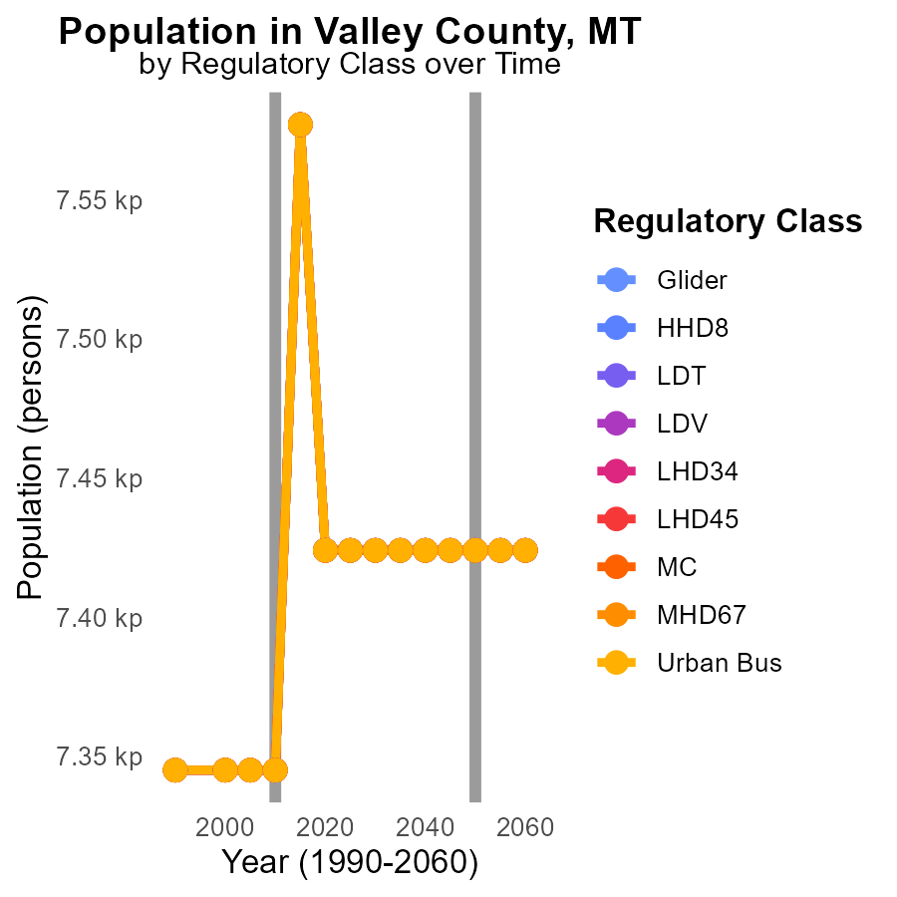

## Findings

* NOx emissions in Valley County, MT have remained relatively stable from 2000 to 2020, with minor fluctuations.
* In 2015, there was a significant decrease of 153 in NOx emissions compared to 2020, representing a 2% reduction.
* Across all vehicle types in Valley County, there was a consistent trend of NOx emissions decreasing by 153 units from 2015 to 2020.

## Recommendations

To further reduce NOx emissions in Valley County, targeted measures should be implemented to maintain the decreasing trend observed post-2015. Strategies could include incentivizing the adoption of low-emission vehicles, improving public transportation infrastructure, and enforcing stricter emission standards for vehicles.

# Areas Ranked by Hotelling (Engines Off)

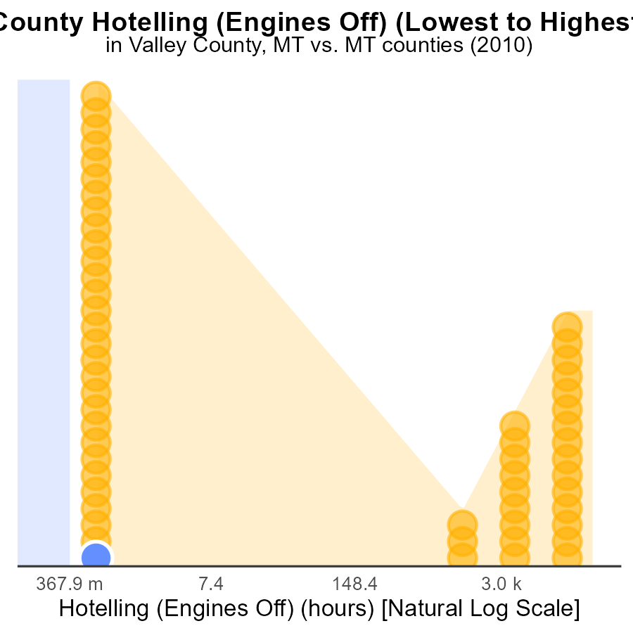

## Findings

* Valley had 51.8% of NOx emissions from Hotelling with engines off.
* Blaine had 0.0 NOx emissions from Hotelling with engines off.
* Yellowstone had the highest NOx emissions with 55.2k hours from Hotelling at 100.0%.

## Recommendations

To reduce NOx emissions from Hotelling activities, Valley should assess the need for engine-off time, Blaine should maintain their current emissions level, and Yellowstone should explore engine efficiency improvements.

# Areas Ranked by Emissions

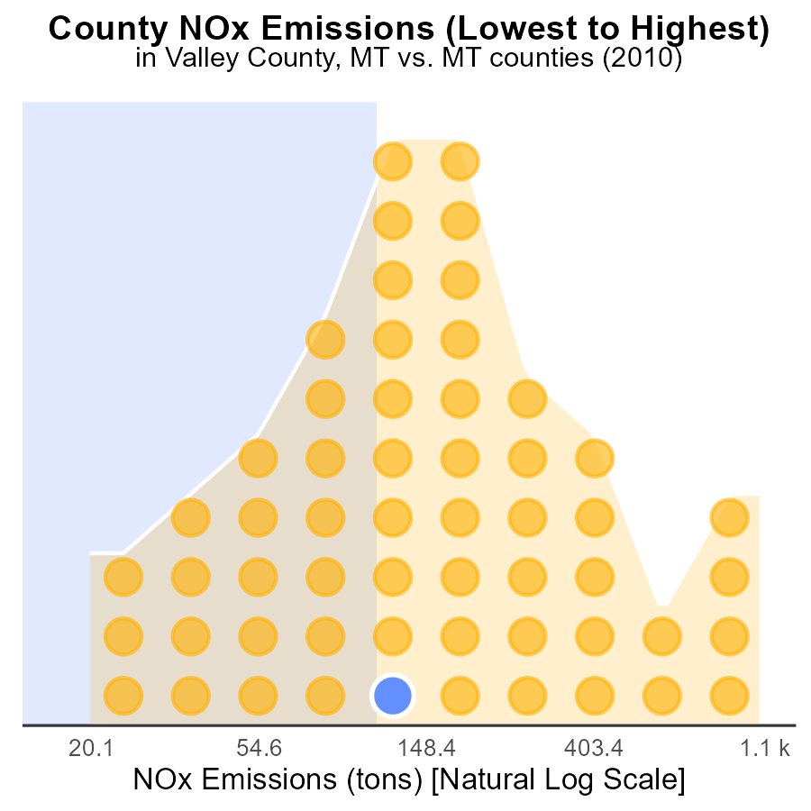

## Findings

* Yellowstone county has the highest NOx emissions in 2010.
* Yellowstone county accounts for 100% of the emissions percentile among the listed counties.
* Valley county has the lowest emissions among the listed counties.

## Recommendations

To lower emissions, focus on reducing NOx sources in Yellowstone county through stricter regulations and incentive programs. Encourage cleaner technologies to decrease NOx levels.

# About This Report

Data based on MOVES estimates collected by the Climate Action in Transportation program at Cornell University. Demographic data sourced from the US Census's American Community Survey 5-year estimates. This report was generated with the help of AI.

# References

* U.S. Census Bureau. (2023). American Community Survey 5-year estimates: Detailed tables. Retrieved from https://data.census.gov
* U.S. Environmental Protection Agency. (2024). Motor Vehicle Emission Simulator (MOVES 4.0) [Software]. Retrieved from https://www.epa.gov/moves