 

**SO2 Emissions in Benson County, 2045**  
Made with CAT VISUALIZER by Gao Labs @ Cornell University.

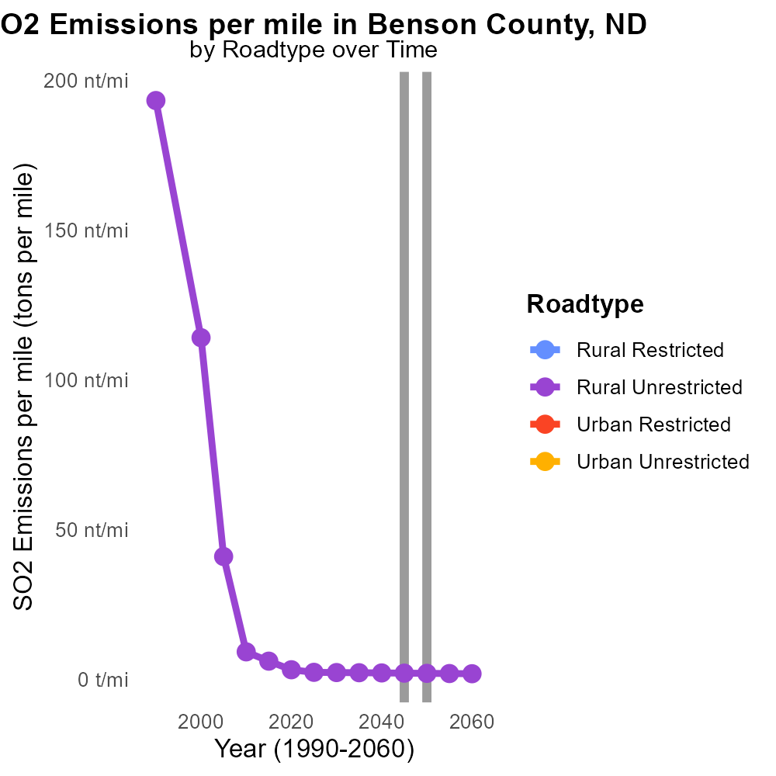

## Keywords

Sulfur Dioxides; SO2 emissions; on-road transportation; Benson County; North Dakota; 2045

## Highlights

* SO2 emissions in Benson County from transportation in 2045.
* Impact on air quality and public health.
* Regulatory measures and mitigation strategies needed.
* Potential implications for future emission trends.
* Call for collaborative efforts to address the issue.

# Introduction

In 2045, the levels of sulfur dioxide (SO2) emissions from on-road transportation in Benson County, North Dakota, have become a significant concern due to their detrimental impact on air quality and public health. The increasing reliance on vehicles powered by fossil fuels has contributed to the rising SO2 emissions in the region.

As a result, there is a pressing need for regulatory measures and mitigation strategies to address the issue and prevent further environmental degradation. Understanding the sources and patterns of SO2 emissions from transportation in Benson County is crucial for developing effective policies to reduce air pollution and protect public health. Collaborative efforts between government agencies, industries, and communities are essential in achieving sustainable solutions to control SO2 emissions and ensure a cleaner and healthier environment for all residents.

# Hotelling (Diesel Aux) Overall by Area

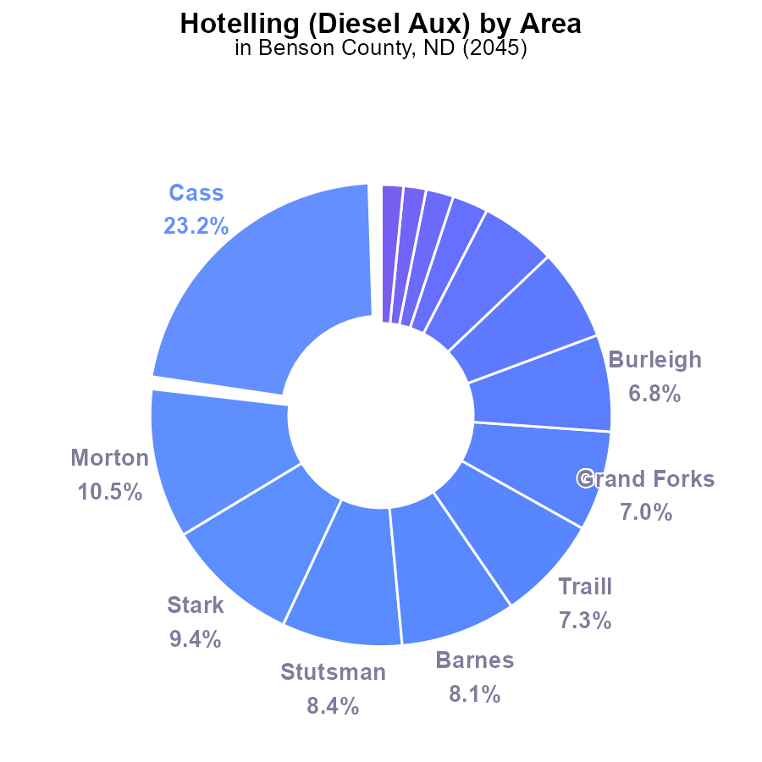

# Population by Fuel Type

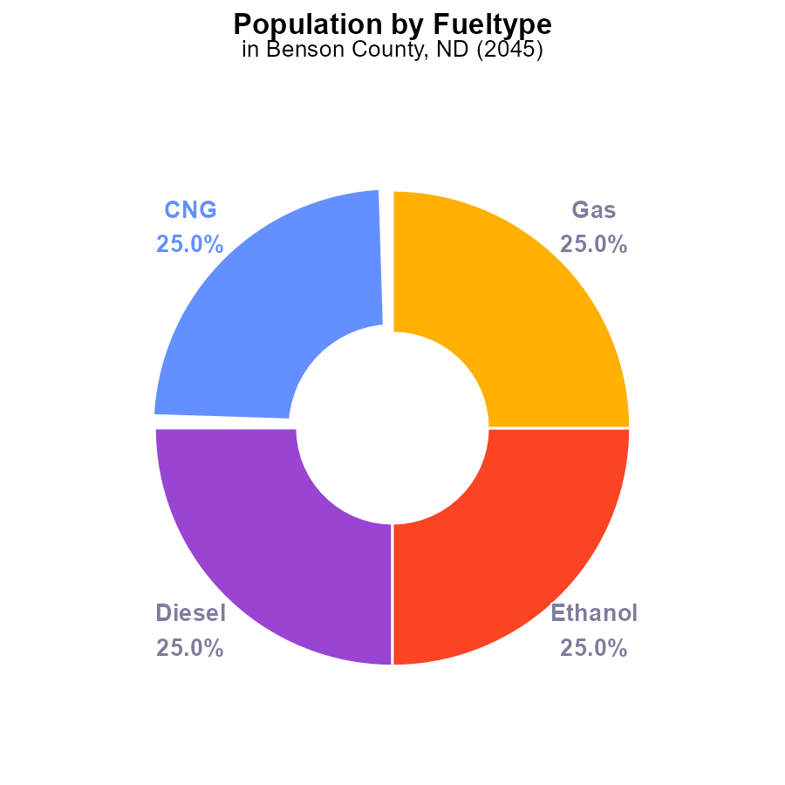

## Findings

* In 2045, Benson County, ND emitted 27.6 k of SO2 in total.
* The breakdown of emissions by type shows that each CNG, Diesel, Ethanol, and Gas contributed equally with 6.9 k (25.0%) of SO2 emissions.
* These emissions are based on the entire population of Benson County, which is not provided in the data.

## Recommendations

To lower SO2 emissions in Benson County, strategies should focus on transitioning to cleaner fuel sources such as renewable energy and promoting electric vehicles. Additionally, implementing stricter emissions standards for vehicles and industries could help reduce overall pollution levels.

# Emissions Rate (per capita) over Time for Passenger Vehicles

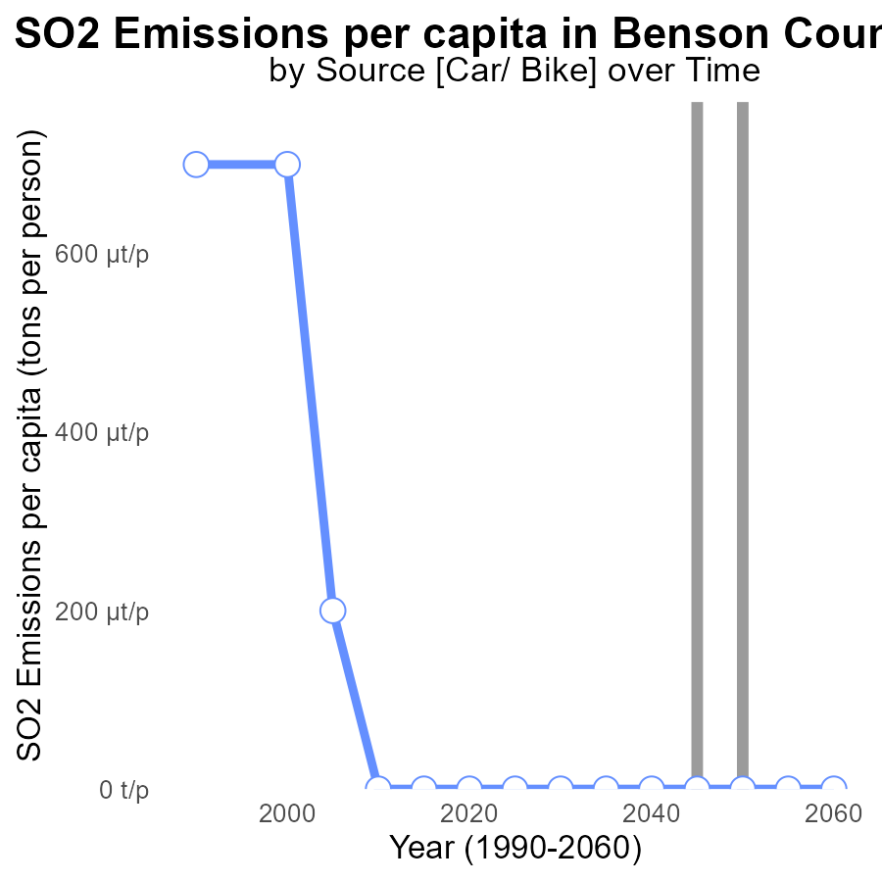

## Findings

* SO2 emissions per capita in Benson County, ND have remained constant at 14.6 tons per person from 2025 to 2060.

## Recommendations

To lower the SO2 emissions per capita, focus on implementing stricter regulations on industries, investing in cleaner energy sources, and promoting energy efficiency in residential and commercial buildings.

# Emissions Rate (per mile) over Time for Buses

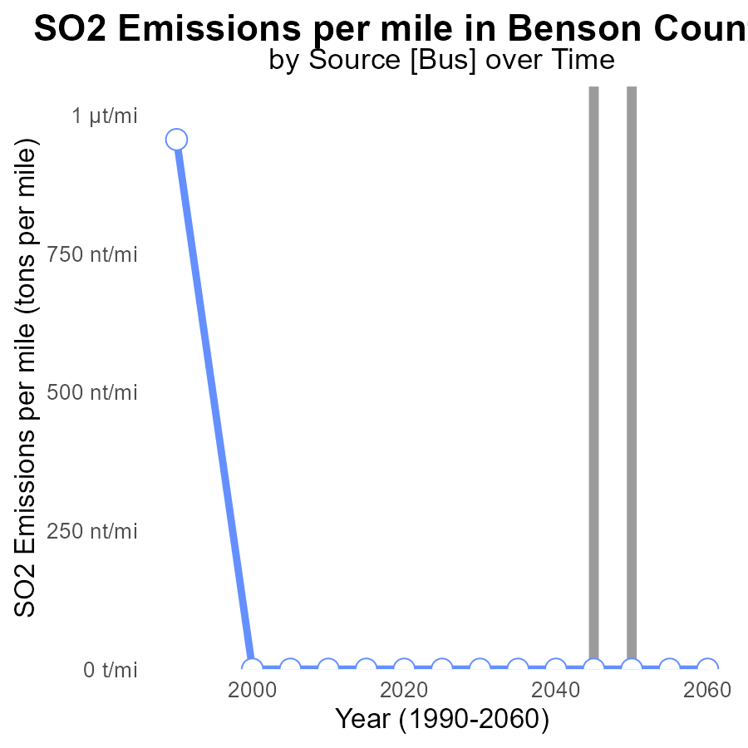

## Findings

* There have been no sulfur dioxide (SO2) emissions per mile in Benson County, ND from 2025 to 2060.
* The emissions remain consistently at 0 tons per mile throughout the years.
* The data indicates a stable trend of zero SO2 emissions, showing no change over the 35-year period.

## Recommendations

Given the consistent zero SO2 emissions per mile in Benson County, ND, it is recommended to continue implementing and enforcing strict emission control measures on industries and vehicles in the area to maintain the current clean air quality levels.

# Time Driven in My Region

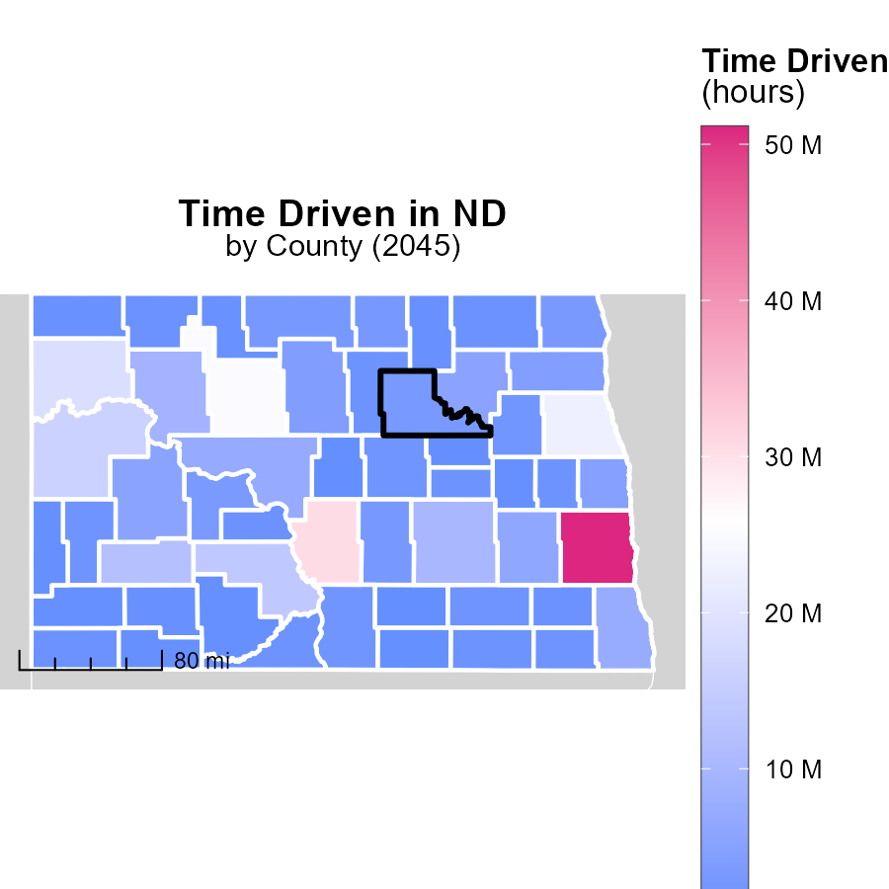

## Findings

* Cass County, ND emitted 51.1 million units, the highest among the three counties.
* Emmons County, ND had median emissions of 2.2 million units.
* Sheridan County, ND had the lowest emissions at 654.1 thousand units.

## Recommendations

To lower emissions, Cass County should focus on strategies to reduce the emissions from activities that contribute to the majority of the 51.1 million units. Emmons County and Sheridan County should also continue efforts to minimize emissions to move towards sustainability.

# Vehicles in My Region

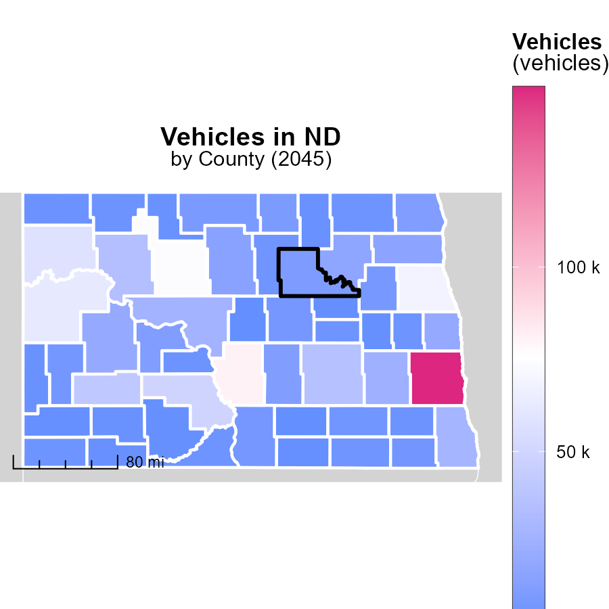

## Findings

* In Cass County, ND, vehicle emissions are at 148.8 thousand tons.
* Emmons County, ND has a median vehicle emission of 8.3 thousand tons.
* Sheridan County, ND has the lowest vehicle emissions at 2.5 thousand tons.

## Recommendations

To lower vehicle emissions, encourage the adoption of electric vehicles, boost public transportation, and promote carpooling in these counties.

# Vehicle Miles Traveled by Road Type over Time

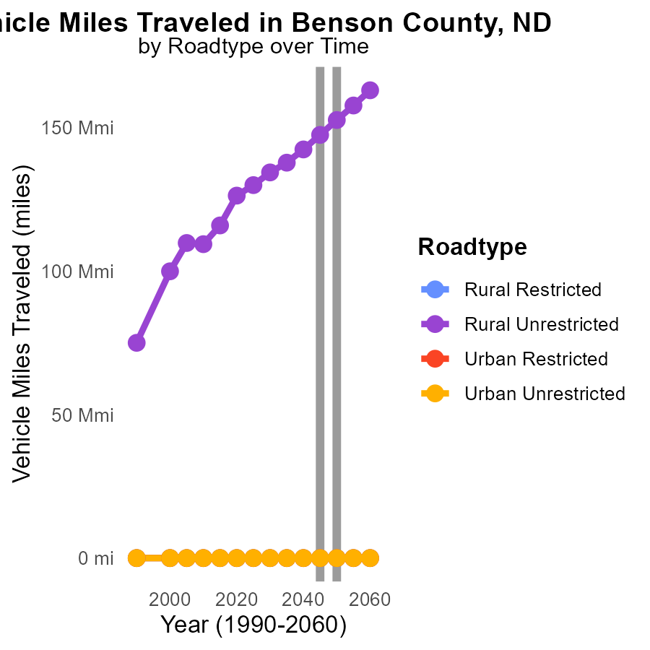

## Findings

* Rural Unrestricted area had a significant increase in SO2 emissions from 2035 to 2050.
* Urban areas and Rural Restricted areas showed no emissions of SO2 from vehicle miles traveled during the period.
* By 2055, Rural Unrestricted emissions reduced compared to 2050.

## Recommendations

To lower SO2 emissions, focus on Urban and Rural Restricted areas with zero emissions. Implement clean transportation policies and promote the use of electric vehicles in Rural Unrestricted areas to maintain the decreasing trend.

# Emissions Rate (per mile) by Road Type over Time

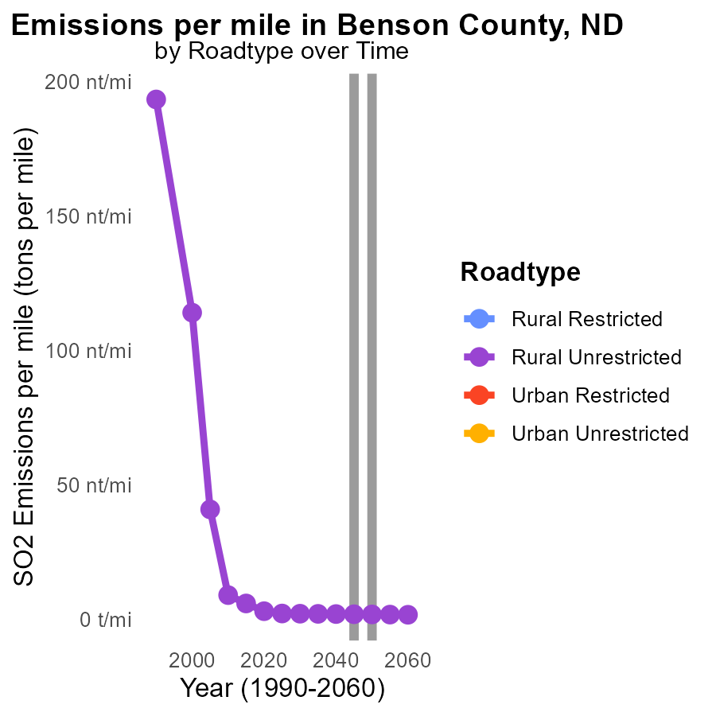

## Findings

* SO2 emissions per mile in Benson County decrease from 2.2 tons in 2035 to 1.9 tons in 2055 for Rural Unrestricted road type.
* Urban areas data is unavailable for all road types in the emission report from 2035 to 2055.
* Emissions for Rural Unrestricted roads stay consistent at 2.0 tons per year from 2045 to 2050.

## Recommendations

To reduce SO2 emissions further in Benson County, focus on improving emission controls and technology for vehicles and industries on Rural Unrestricted roads. Monitor and regulate emissions in urban areas to fill the data gap.

# Areas Ranked by Hotelling (Diesel Aux)

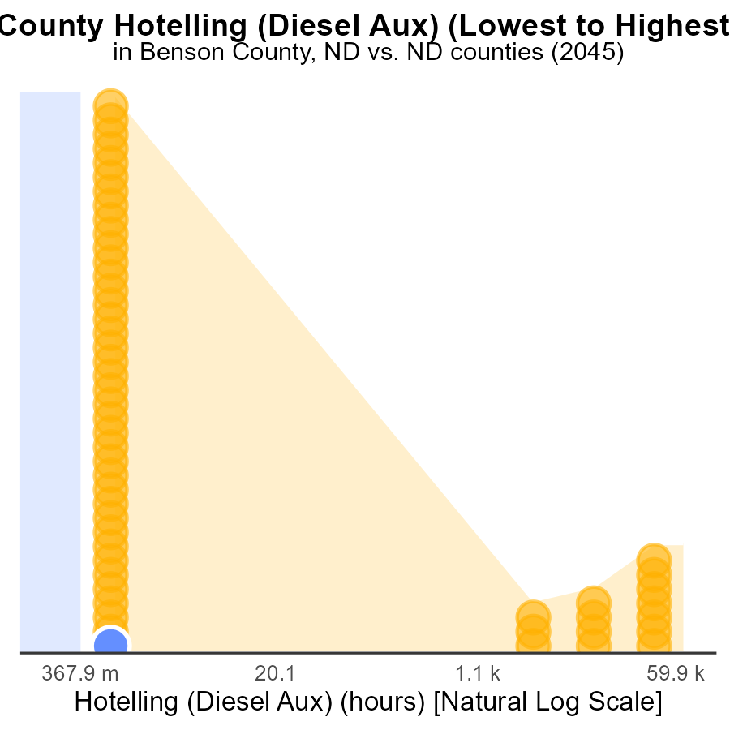

## Findings

* Benson County has the lowest SO2 emissions at 0.0 hours, ranking 1st.
* Cass County records the highest SO2 emissions with 192.9 k hours, placing it 53rd.
* SO2 emissions in Adams County are also low, standing at 0.0 hours, ranking 2nd.

## Recommendations

To lower SO2 emissions, Benson and Adams counties could share best practices with higher-ranking counties. Cass County should prioritize reducing emissions through technological upgrades and stricter regulations.

# Areas Ranked by Population

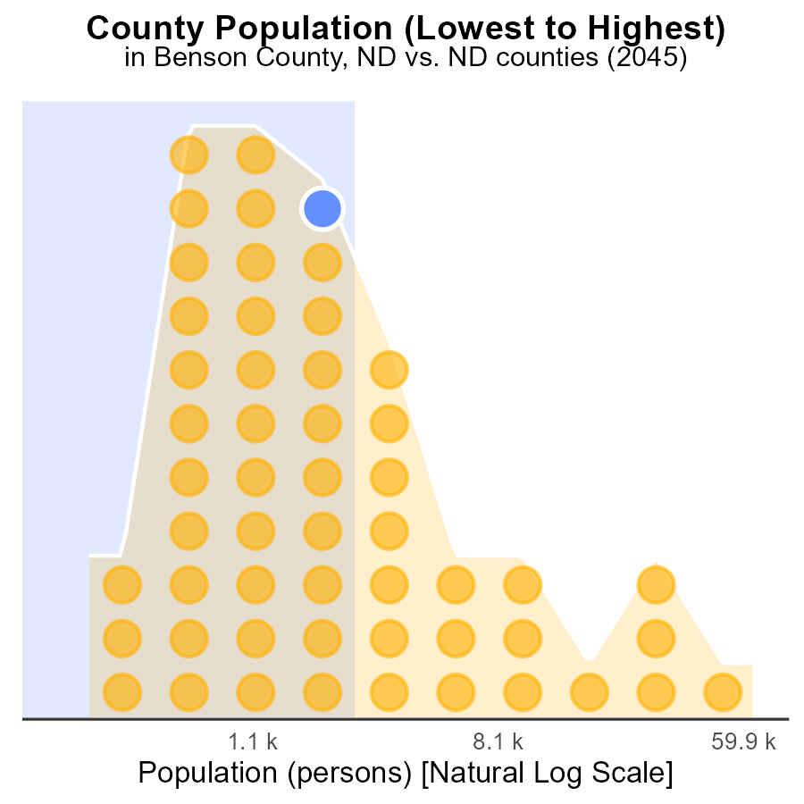

## Findings

* Benson county emitted 6.9 kilotons of SO2 in 2045, ranking 70th nationwide.
* Slope county emitted 788.0 tons of SO2, the lowest among the counties analyzed, at the 2nd percentile.
* Cass county emitted 179.9 kilotons of SO2, ranking 106th nationwide with the highest emissions among the counties studied.

## Recommendations

To lower the SO2 emissions, Benson county could focus on implementing stricter emission control measures for industries and vehicles. Slope county should continue its efforts to maintain its low emissions level. Cass county should invest in cleaner energy sources and industrial emissions controls to reduce its emissions drastically.

# Conclusion

In conclusion, the data reveals that in 2045, Benson County, ND emitted a total of 27.6 kilotons of SO2, with each CNG, Diesel, Ethanol, and Gas contributing equally to emissions. Strategies to lower SO2 emissions should focus on transitioning to cleaner fuel sources, stricter emissions standards, and promoting electric vehicles. Despite the stable trend of zero SO2 emissions per mile in Benson County from 2025 to 2060, efforts should be made to maintain clean air quality levels by enforcing strict emission control measures on industries and vehicles. In comparison to Cass County's highest emissions and Slope County's lowest emissions, Benson County ranked 70th nationwide, suggesting the need for stricter emission control measures to reduce SO2 emissions further.

To mitigate SO2 emissions, Benson County could learn from counties with lower emissions like Slope County and implement similar measures. Encouraging the adoption of electric vehicles, investing in cleaner energy sources, and implementing stringent emission regulations are critical steps for Benson County to improve air quality and reduce its overall environmental impact.

# About This Report

Data based on MOVES estimates collected by the Climate Action in Transportation program at Cornell University. Demographic data sourced from the US Census's American Community Survey 5-year estimates. This report was generated with the help of AI.

# References

* U.S. Census Bureau. (2023). American Community Survey 5-year estimates: Detailed tables. Retrieved from https://data.census.gov
* U.S. Environmental Protection Agency. (2024). Motor Vehicle Emission Simulator (MOVES 4.0) [Software]. Retrieved from https://www.epa.gov/moves