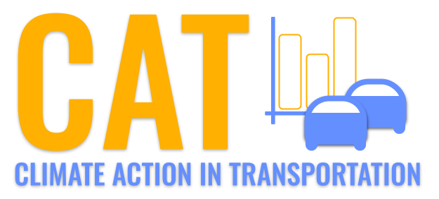 

**VOC Emissions in Green County, 2015**  
Made with CAT VISUALIZER by Gao Labs @ Cornell University.

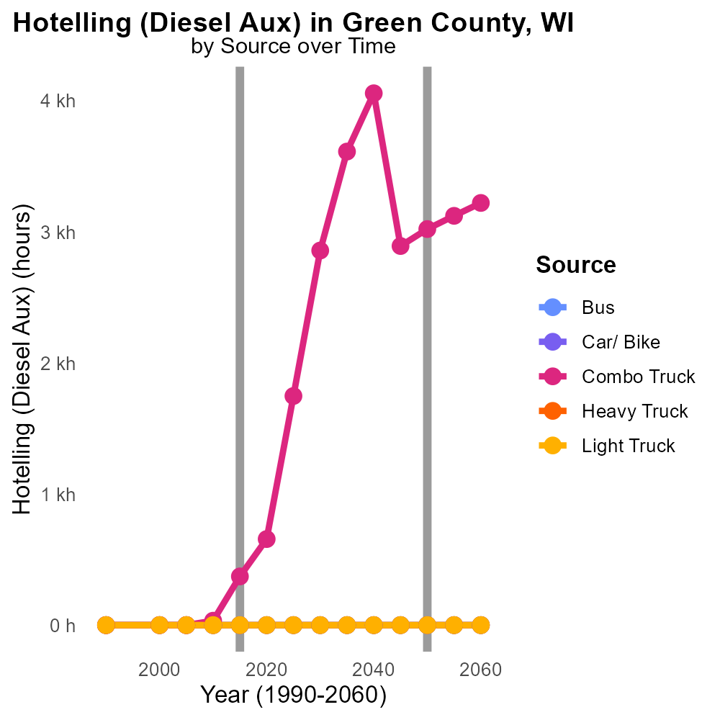

## Keywords

Volatile Organic Compounds; on-road transportation; Green County WI; emissions; 2015

## Highlights

* Volatile Organic Compounds pose a significant threat to air quality.
* On-road transportation is a major source of these emissions.
* Understanding local emissions is crucial for mitigation strategies.
* The report focuses on VOC emissions in Green County, WI in 2015.
* Data from this study can inform policies for cleaner transportation.

# Introduction

Volatile Organic Compounds (VOCs) are compounds that significantly contribute to air pollution and the formation of ground-level ozone, posing a serious threat to public health and the environment. On-road transportation is a known major source of VOC emissions, releasing these harmful compounds into the atmosphere through vehicle exhaust and fuel evaporation. In order to address this pressing issue, it is essential to understand the specific emissions profile of VOCs from on-road transportation in local areas.

The following report focuses on the analysis of VOC emissions from on-road transportation in Green County, Wisconsin during the year 2015. By examining the data collected, policymakers and environmental agencies can gain valuable insights into the extent of VOC emissions in the region and develop targeted strategies to reduce the impact of transportation-related pollutants on air quality and public health.

# Vehicle Miles Traveled Overall by Area

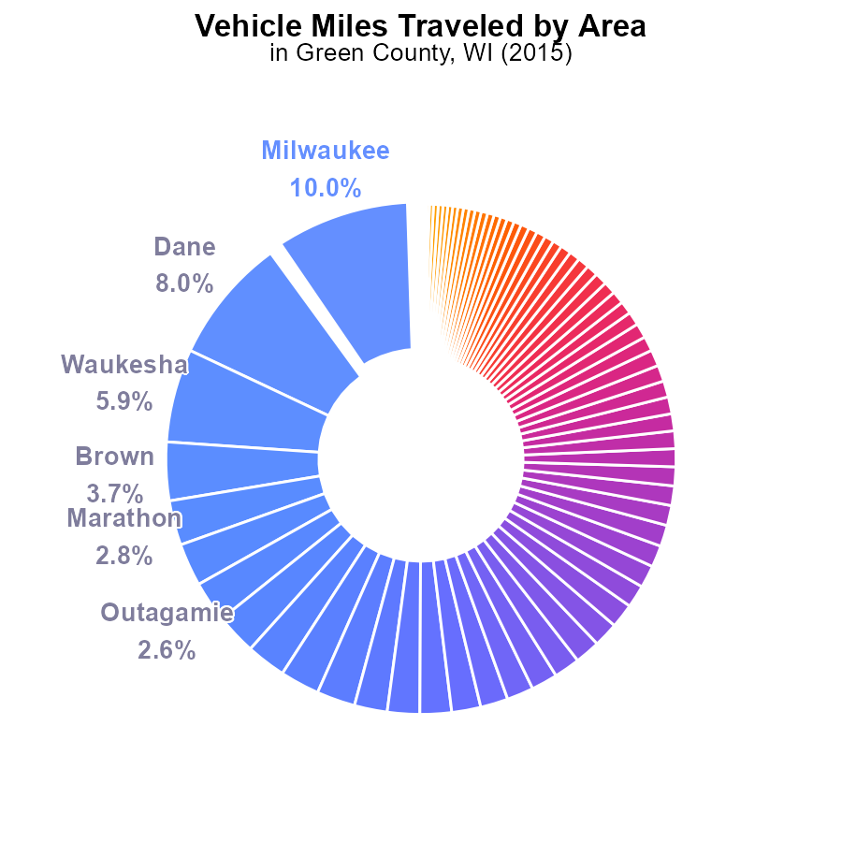

# Hotelling (Diesel Aux) Overall by Area

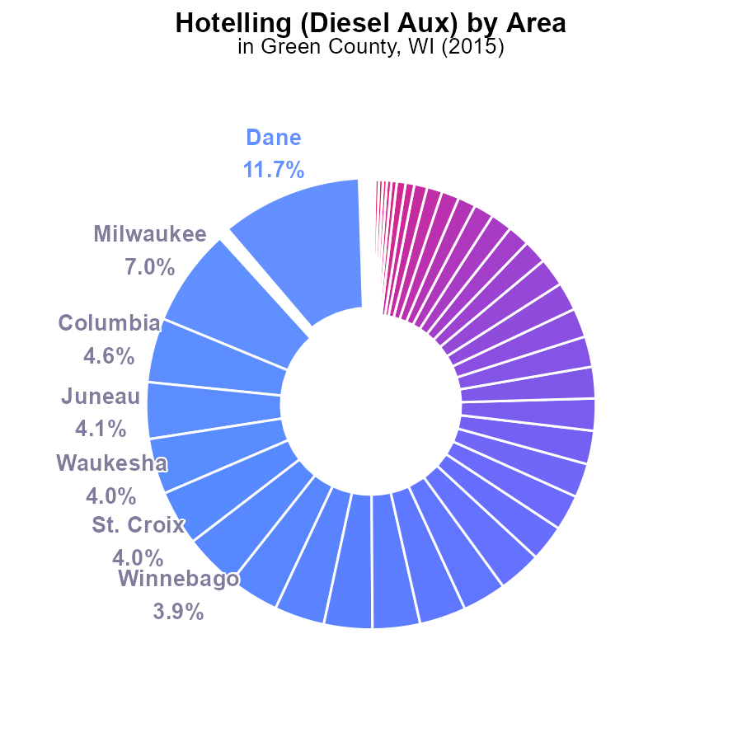

## Findings

* Top 5 counties (Dane, Milwaukee, Columbia, Juneau, Waukesha) contribute to 30.4% of emissions.
* 30 least emitting counties collectively contribute only 0.4% of emissions.
* Wide variation in emissions with some counties contributing significantly more than others.

## Recommendations

Focus efforts on top counties to reduce emissions. Provide incentives for emissions reduction programs in these areas. Consider stricter regulations for high-emitting counties.

Support low-emitting counties to maintain their levels and incentivize further reductions. Encourage sharing of best practices between counties to improve overall emissions performance.

# Idling over Time for Buses

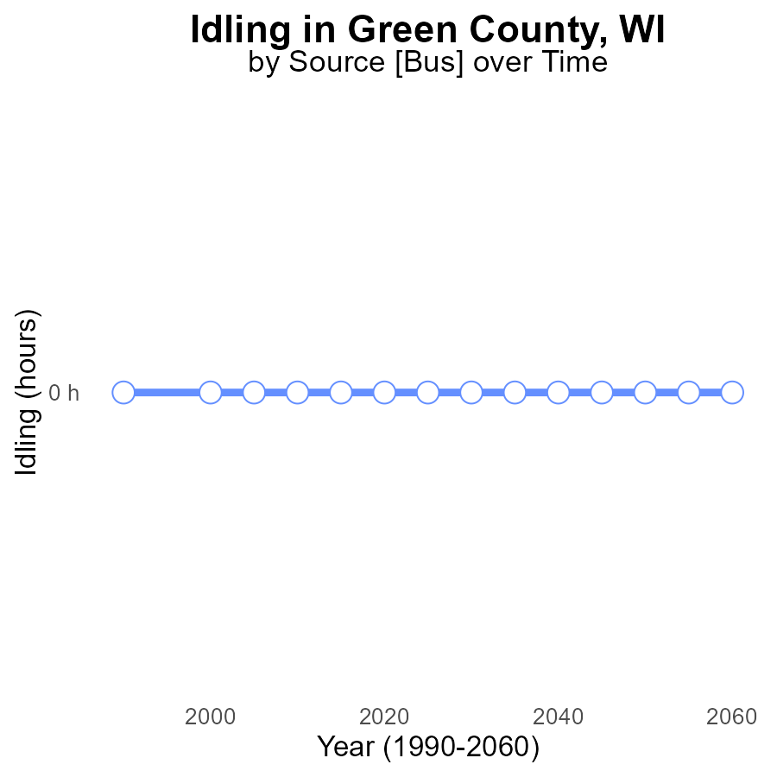

## Findings

* No idling emissions from VOCs in Green County, WI from 2000 to 2035.

## Recommendations

Since there are no idling emissions from VOCs in Green County, WI, it is important to continue monitoring and enforcing anti-idling regulations to maintain this zero-emission level.

# Time Driven Overall over Time

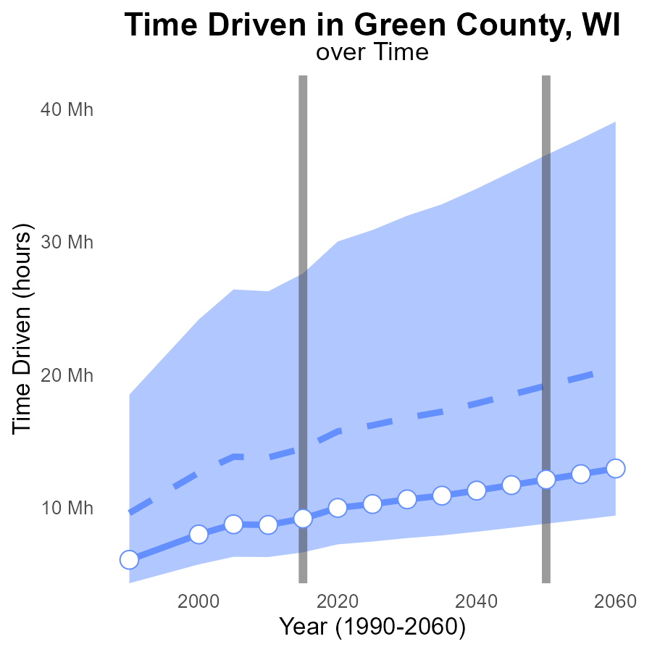

## Findings

* Emissions in Green County, WI, have consistently been below the median area from 2000 to 2035.
* The gap between Green County's emissions and the upper 75th percentile of areas has been narrowing over time.
* Despite reductions, Green County's emissions still exceed the lower 25th percentile of areas.

## Recommendations

To lower emissions in Green County, actions should focus on further reducing VOC emissions in industrial processes, incentivizing the adoption of cleaner technologies, and enhancing enforcement of air quality regulations.

# Emissions Rate (per capita) Mapped by Area

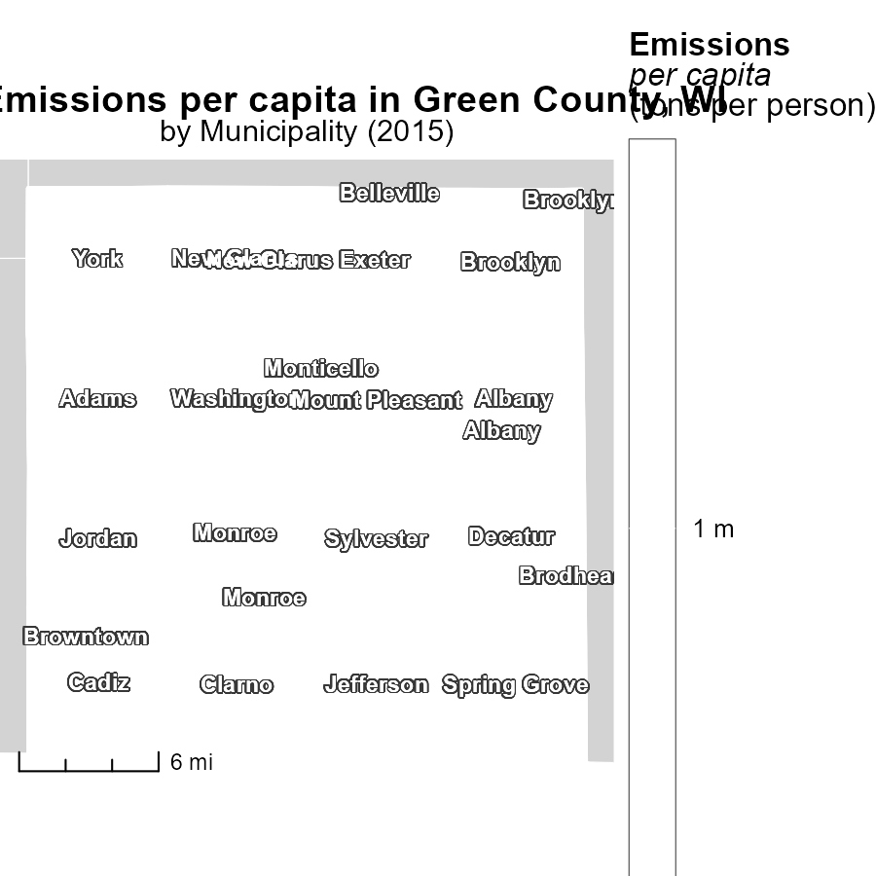

## Findings

* Adams, WI had the highest emissions per capita at 1.3 tons per person.
* Exeter, WI had the median emissions per capita at 1.3 tons per person.
* York, WI had the lowest emissions per capita at 1.3 tons per person.

## Recommendations

To lower emissions, focus on reducing per capita emissions in Adams and Exeter, which are currently at the median and above. Implement strategies to decrease emissions from transportation and energy consumption.

# Idling Mapped by Area

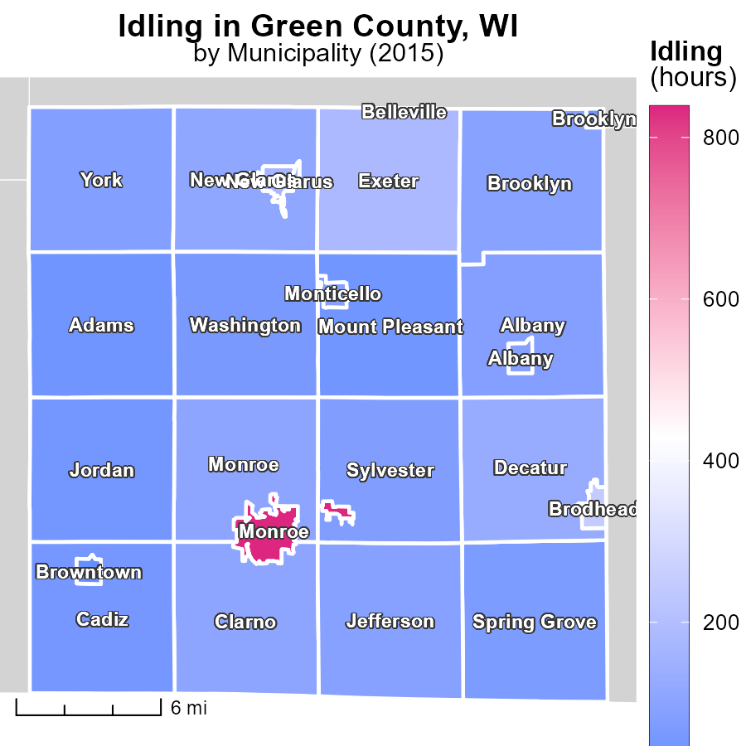

## Findings

* Monroe, WI had the highest idling hours in 2015 with 838.1 hours.
* Albany, WI had a median idling duration of 85.9 hours.
* The lowest idling hours in 2015 were in Browntown, WI, with 20.2 hours.

## Recommendations

To lower emissions, implement idling reduction programs in high idling areas such as Monroe, WI, and promote awareness among drivers in locations like Browntown, WI.

# Hotelling (Diesel Aux) by Vehicle Type over Time

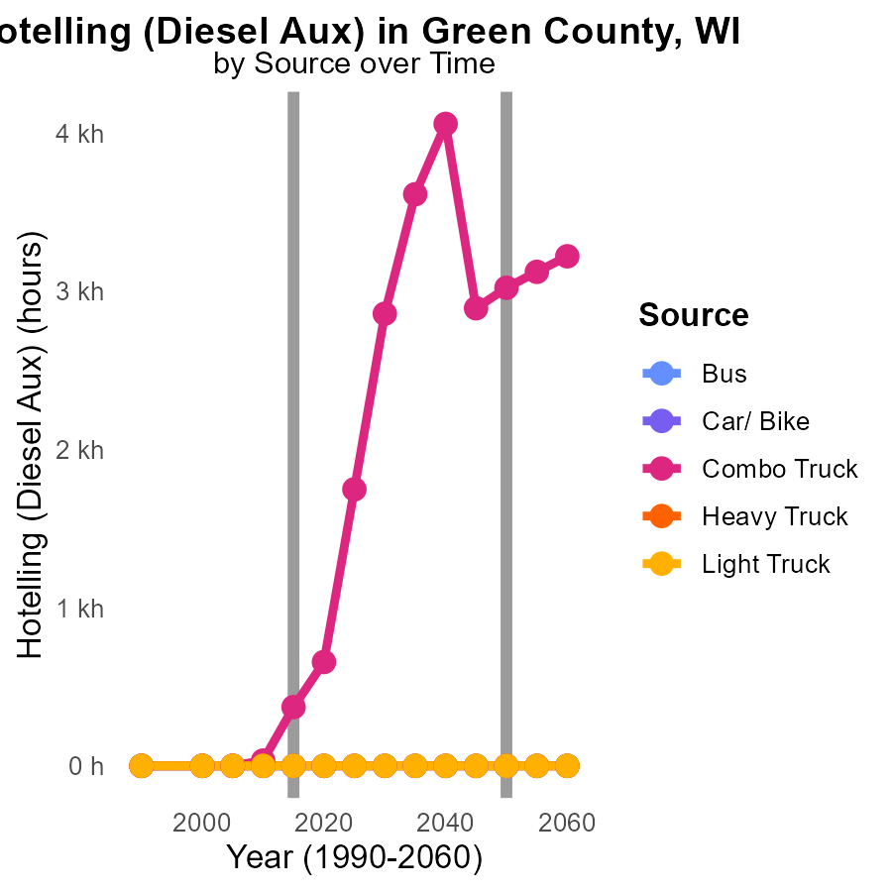

## Findings

* Combo Truck emissions decreased from 2005 to 2025, showing a 57.9% reduction.
* No emissions were recorded for Bus, Car/ Bike, Heavy Truck, and Light Truck from 2005 to 2025.
* The highest emissions in 2025 were from Combo Trucks, with 1.7 k units, compared to other vehicle types.

## Recommendations

To maintain the declining trend in Combo Truck emissions, policymakers could incentivize the adoption of cleaner fuel technologies or promote the use of electric vehicles in the transportation sector. For other vehicle types, further monitoring and implementation of emission control measures are advised.

# Population by Vehicle Type over Time

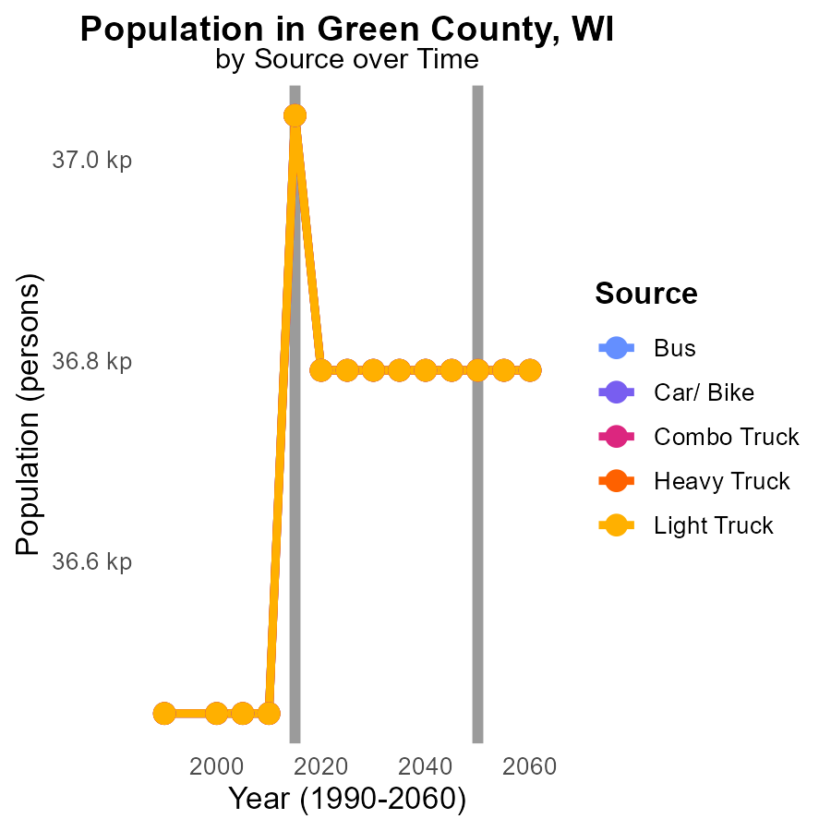

## Findings

* Emissions for all vehicle types remained consistent from 2020 to 2025.
* VOC emissions decreased in 2015 across all vehicle types by an average of 254 units compared to 2020.
* In 2015, the most significant VOC reduction was observed in Combo Trucks at -254 units.

## Recommendations

To lower emissions, efforts should focus on maintaining the 2015 VOC reduction levels across vehicle types through stricter emission standards, improved vehicle maintenance, and promotion of public transportation.

# Areas Ranked by Emissions Rate (per vehicle)

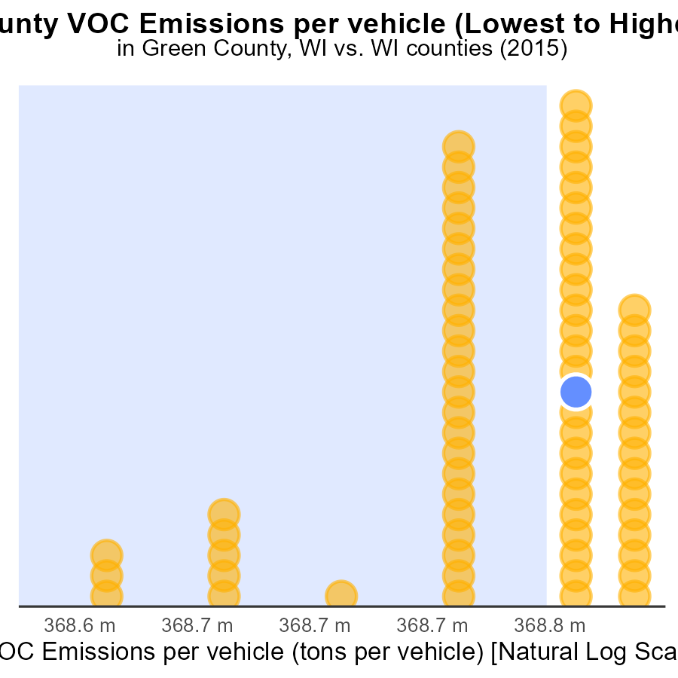

## Findings

* In 2015, La Crosse County had the highest VOC emissions per vehicle, at 2.5 tons per vehicle.
* Ozaukee County had the lowest VOC emissions per vehicle, at 2.0 tons per vehicle in 2015.
* The majority of counties (58.3% - 61.1%) had VOC emissions per vehicle of 2.4 tons in 2015.

## Recommendations

To lower VOC emissions, targeted policies promoting the adoption of electric or hybrid vehicles in counties with higher emissions per vehicle could be effective. Additionally, investing in public transport and incentivizing carpooling can help reduce overall emissions.

# Areas Ranked by Emissions Rate (per capita)

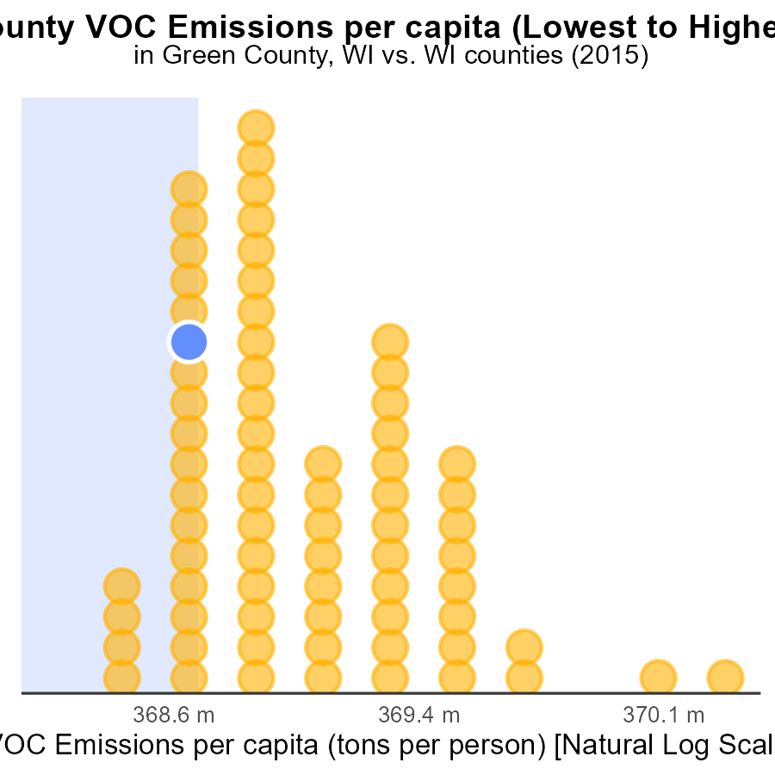

## Findings

* Jackson county has the highest VOC emissions per capita at 6.8 tons per person.
* Milwaukee county has the lowest VOC emissions per capita at 1.3 tons per person.
* Dane county ranks 17th with VOC emissions per capita of 2.3 tons per person.

## Recommendations

To lower the emission levels, Jackson county should focus on implementing stricter regulations on VOC-producing industries. Milwaukee county should continue its sustainable practices. Dane county should invest in public transportation to reduce individual vehicle emissions.

# Conclusion

In conclusion, the analysis of Volatile Organic Compounds (VOC) emissions from on-road transportation in Green County, WI, in 2015 reveals a relatively positive outlook. With no idling emissions reported and consistently below-median emissions levels from 2000 to 2035, Green County sets a commendable example in emissions control. However, there is still room for improvement as the county's emissions continue to surpass the lower 25th percentile of areas. To address this, targeted actions should concentrate on further reducing VOC emissions in industrial processes, pushing for the adoption of cleaner technologies, and enforcing stringent air quality regulations.

Moreover, the data underscores the importance of monitoring per capita emissions, as seen in Adams and Exeter, which have higher emissions compared to the median level. By implementing strategies to reduce per capita emissions and focusing on transportation and energy consumption, significant progress can be made. Additionally, the decreasing trend in Combo Truck emissions highlights the effectiveness of cleaner fuel technologies, suggesting that similar initiatives could be beneficial for other vehicle types.

Overall, the findings suggest that a multi-faceted approach is necessary to lower VOC emissions effectively. By leveraging best practices from low-emitting counties, implementing targeted reduction programs in high-emitting areas, and promoting sustainable transportation solutions, Green County and other regions can work towards a greener and healthier environment.

# About This Report

Data based on MOVES estimates collected by the Climate Action in Transportation program at Cornell University. Demographic data sourced from the US Census's American Community Survey 5-year estimates. This report was generated with the help of AI.

# References

* U.S. Census Bureau. (2023). American Community Survey 5-year estimates: Detailed tables. Retrieved from https://data.census.gov
* U.S. Environmental Protection Agency. (2024). Motor Vehicle Emission Simulator (MOVES 4.0) [Software]. Retrieved from https://www.epa.gov/moves