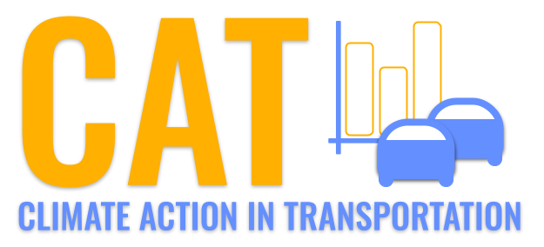 

**CO Emissions in Manassas city, Virginia County, 2045**  
Made with CAT VISUALIZER by Gao Labs @ Cornell University.

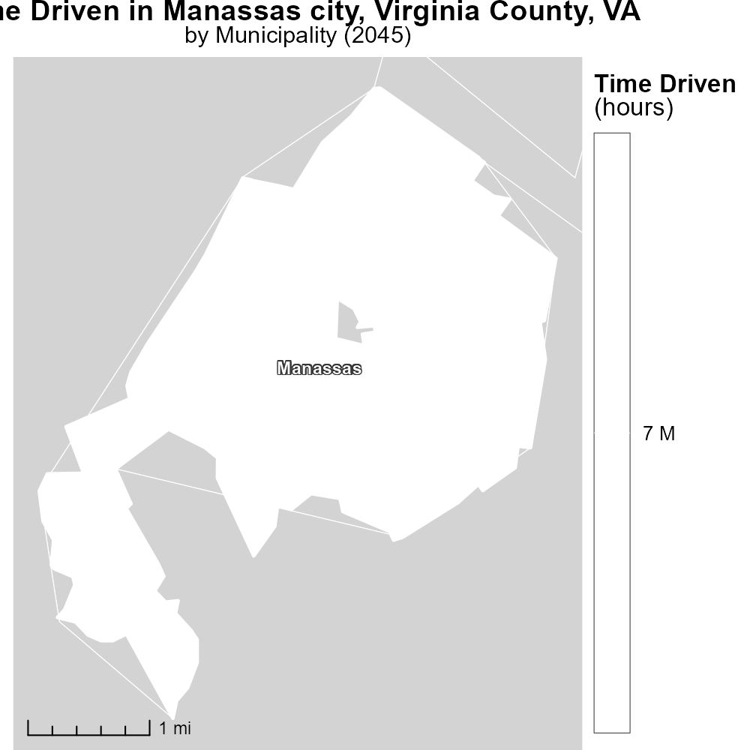

## Keywords

Carbon Monoxide emissions; on-road transportation; Manassas city; Virginia County; VA; 2045

## Highlights

* Study examines CO emissions from on-road transport in Manassas City, VA in 2045.
* Focus on environmental impact and public health consequences of CO pollutants.
* Trends in transportation-related CO emissions reveal insights for future policy actions.
* Findings aim to inform strategies to reduce CO emissions and improve air quality.
* Report discusses implications for sustainable transportation planning in the region.

# Introduction

In 2045, a comprehensive study was conducted to investigate Carbon Monoxide (CO) emissions arising from on-road transportation in Manassas city, Virginia County, VA. The report seeks to shed light on the environmental impact and public health consequences associated with CO pollutants, offering insights into the contributions of transportation activities to air quality degradation. By analyzing trends in CO emissions from on-road vehicles, the study aims to provide valuable data for crafting effective policy interventions to curb emissions and enhance air quality standards in the region.

The findings of this report are crucial for guiding future strategies aimed at mitigating the adverse effects of CO emissions from transportation, with a particular focus on sustainable urban planning and transportation management. By understanding the dynamics of CO pollution in the context of on-road transport in Manassas City, VA in 2045, policymakers can make informed decisions to promote cleaner and healthier environments for the residents of the region.

# Hotelling (Diesel Aux) Overall by Area

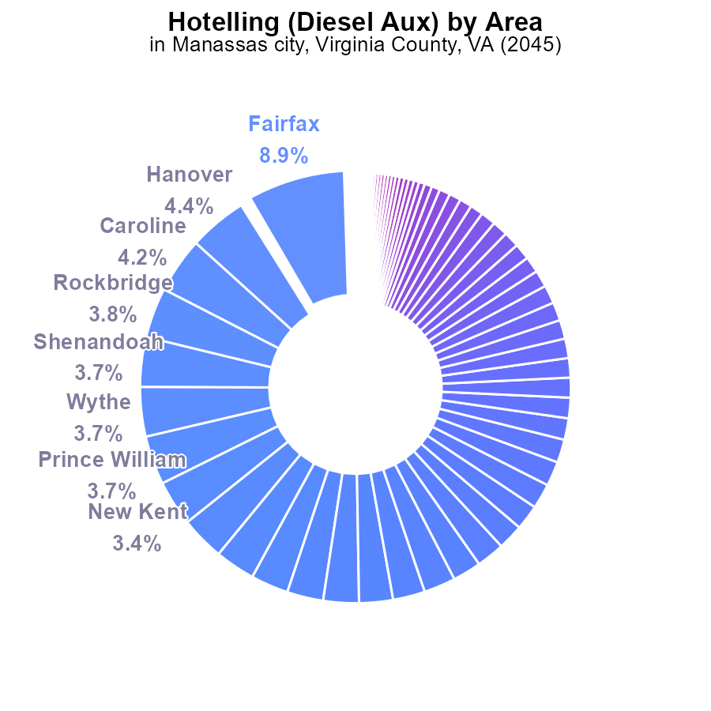

## Findings

* Top emissions by Fairfax at 8.9%, Hanover at 4.4%, and Caroline at 4.2%.
* Many counties have minimal emissions, e.g., Norton at 0%.
* Major cities generally show low emissions percentages, like Richmond at 0%.

## Recommendations

Given the concentration of emissions in few counties, focus efforts on Fairfax, Hanover, and Caroline. Engage low-emission counties. Assess reasons for zero emissions in certain locations to set emission reduction goals.

# Vehicles by Vehicle Type

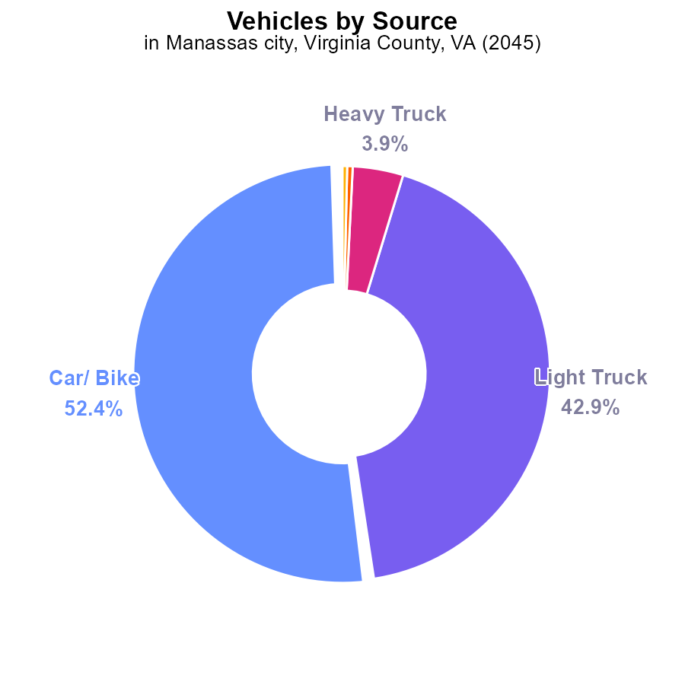

## Findings

* Car/ Bike emissions account for 52.4% of total vehicle emissions in Manassas City, VA in 2045.
* Light Trucks contribute 42.9% to the total vehicle emissions in the area.
* Heavy Trucks, Combo Trucks, and Buses collectively contribute only 4.7% to the total emissions.

## Recommendations

To reduce emissions in Manassas City, focus on reducing emissions from cars and light trucks which account for the majority, by implementing stricter emissions standards, promoting electric vehicles, and investing in public transportation.

# Emissions over Time for Passenger Vehicles

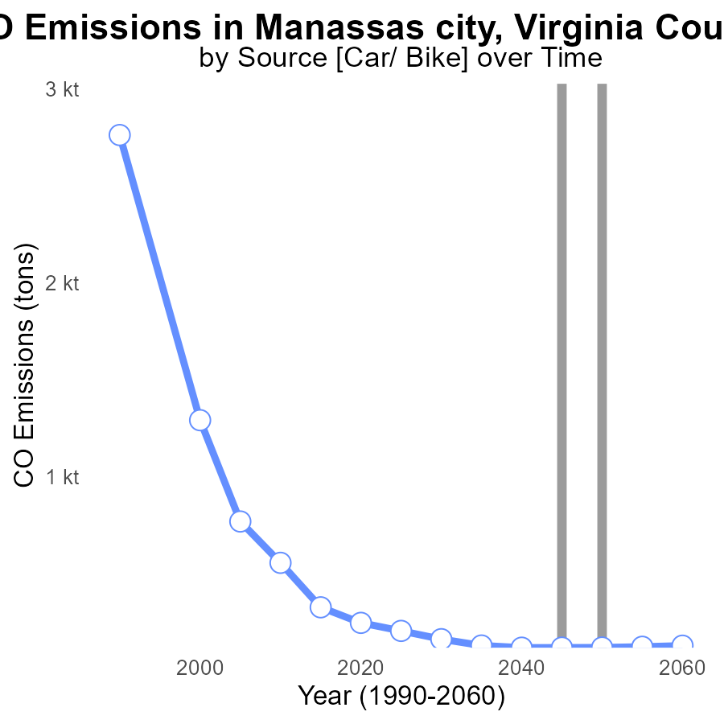

## Findings

* Emissions decreased consistently from 204.7 tons in 2025 to 128.4 tons in 2060.
* By 2060, emissions were only 0.9 tons above the benchmark set in 2040.
* A significant reduction of 43.0 tons in emissions was observed from 2025 to 2030.

## Recommendations

To maintain this decreasing trend towards emissions reduction, focus on implementing stricter regulations for industries, promoting the usage of renewable energy sources, and incentivizing public transportation to reduce individual carbon footprints.

# Vehicle Starts over Time for Buses

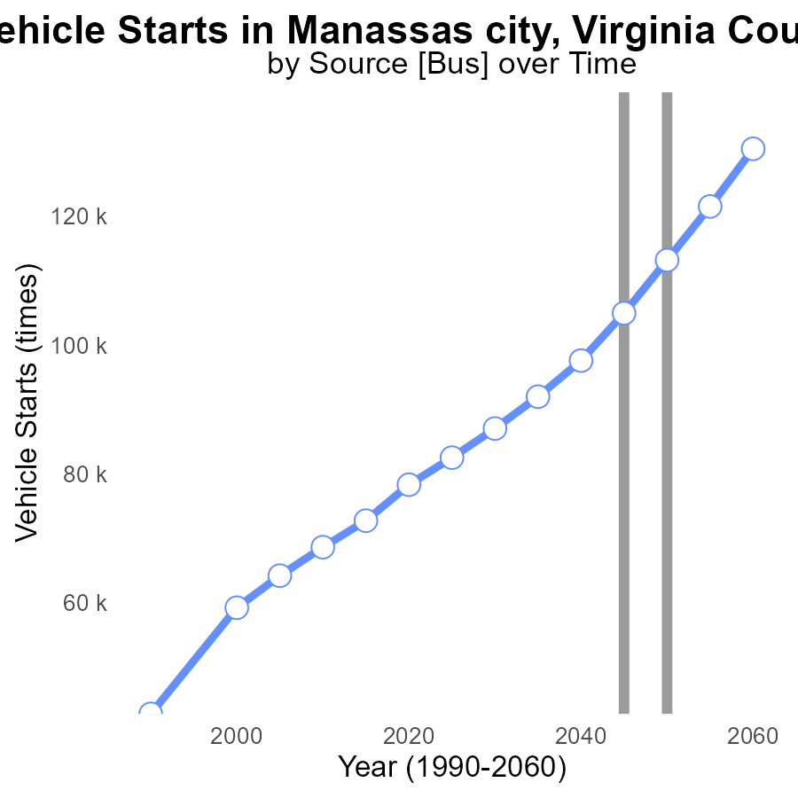

## Findings

* Vehicle starts in Manassas City, VA are projected to increase by 56.1% from 2025 to 2060.
* Emissions reductions have been achieved through 2050, with a decrease in vehicle starts by 8337.4 times from 2050 to 2055.
* Despite initial reductions, there is an upward trend in vehicle starts from 2055 to 2060, showing a 13.3% increase.

## Recommendations

To lower emissions, Manassas City should focus on implementing stricter vehicle emission standards, promoting public transportation, and encouraging the adoption of electric vehicles. Additionally, investing in infrastructure for cycling and walking can reduce the reliance on private vehicles.

# Time Driven Mapped by Area

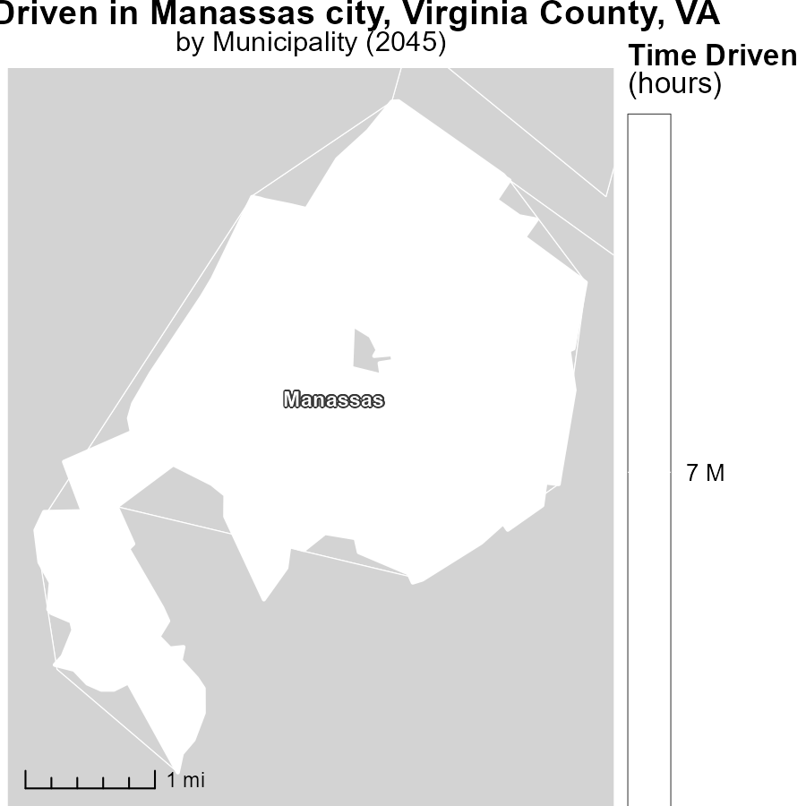

# Vehicle Miles Traveled Mapped by Area

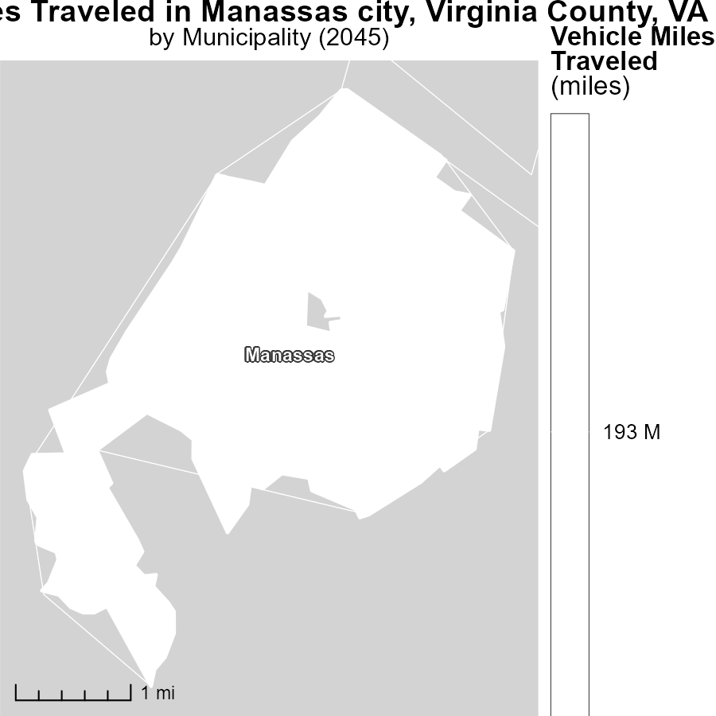

## Findings

* The median vehicle miles traveled in Manassas, VA was 193.2 million miles in 2045.

## Recommendations

To reduce emissions from transportation in Manassas, VA, initiatives such as promoting public transportation, carpooling, biking, and walking should be encouraged to lower the number of vehicle miles traveled.

# Emissions Rate (per capita) by Fuel Type over Time

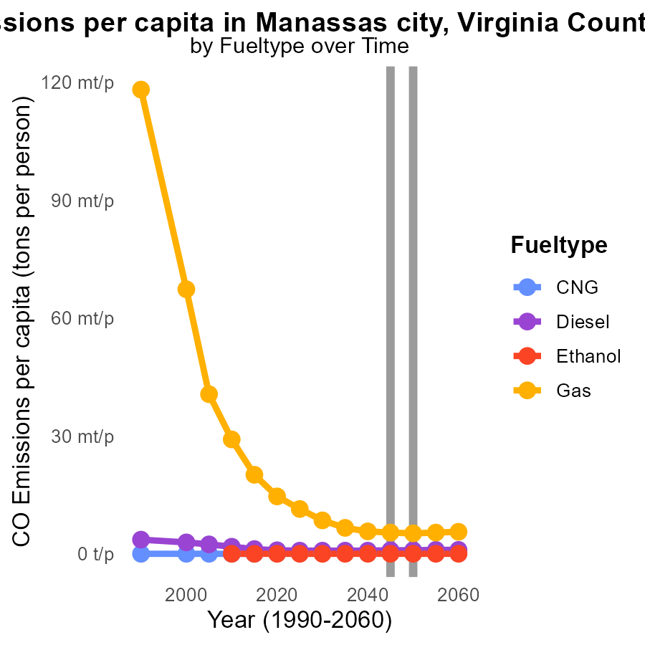

## Findings

* CNG emissions per capita are projected to increase from 260.7 µ in 2050 to 285.1 µ in 2055.
* Diesel emissions per capita will decrease from 906.5 µ in 2050 to 957.6 µ in 2055.
* Gas emissions per capita are expected to slightly decrease from 5.2 m in 2050 to 5.4 m in 2055.

## Recommendations

To reduce emissions, consider investing in cleaner alternative fuels for transportation, such as promoting the use of electric vehicles and increasing public transportation options. Additionally, implementing stricter emission standards for vehicles can help limit the environmental impact.

# Emissions Rate (per vehicle) by Regulatory Class over Time

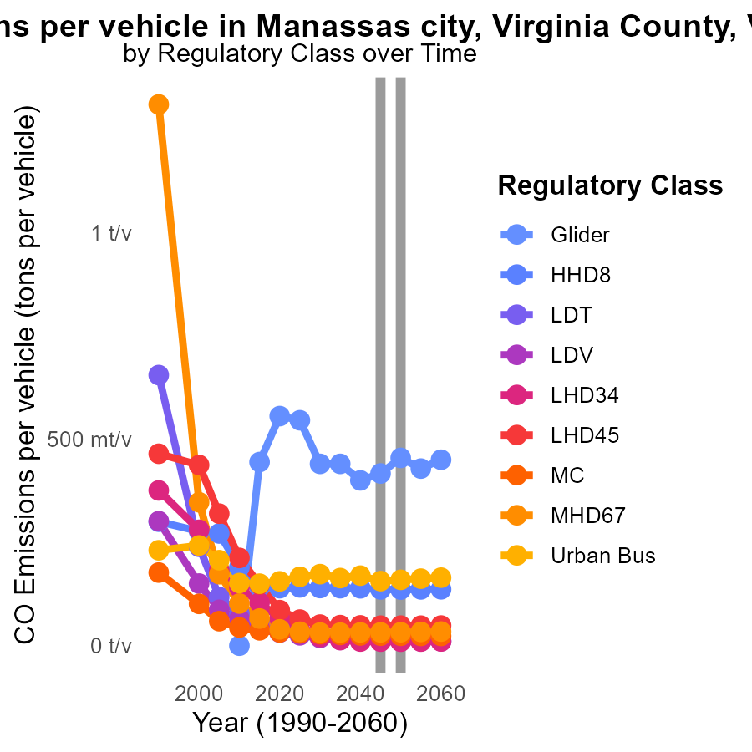

## Findings

* Emissions per vehicle are decreasing across all vehicle types from 2035 to 2055.
* The highest emissions in 2050 are from Glider vehicles with 454.5 m tons per vehicle.
* Urban Bus emissions show a fluctuating trend, with a decrease from 2035 to 2040 and then an increase by 2045.

## Recommendations

Based on the data, policymakers should continue to promote the use of vehicles with lower emissions. Implementing stricter emissions standards and investing in public transportation infrastructure would aid in reducing emissions further, especially from Urban Buses.

# Areas Ranked by Emissions Rate (per vehicle)

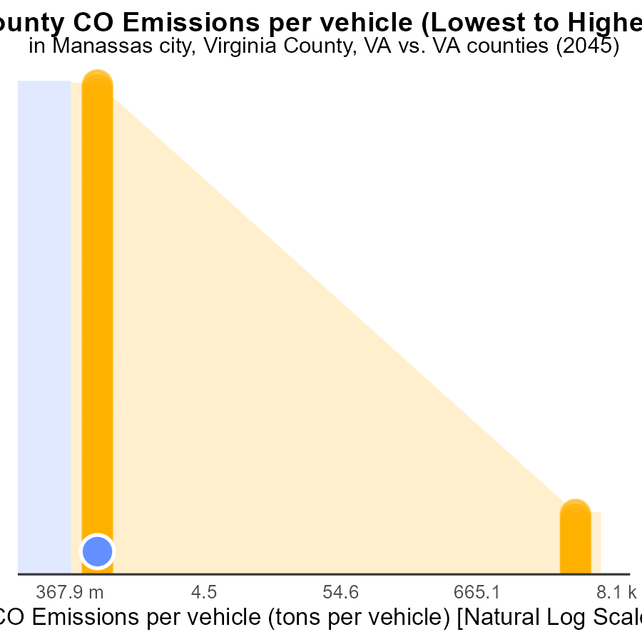

## Findings

* Arlington has the lowest CO emissions per vehicle at 13.9 tons.
* Manassas city, Virginia, Prince William, and Fairfax city have similar CO emissions per vehicle around 14.2 tons.
* Augusta has the highest CO emissions per vehicle at 16.9 tons, ranking 134th nationally.

## Recommendations

To lower emission levels, focus on reducing vehicle miles traveled through promoting public transportation, carpooling, and bike lanes. Implement stricter vehicle emission standards and encourage the adoption of electric vehicles in high-emission areas.

# Areas Ranked by Emissions Rate (per mile)

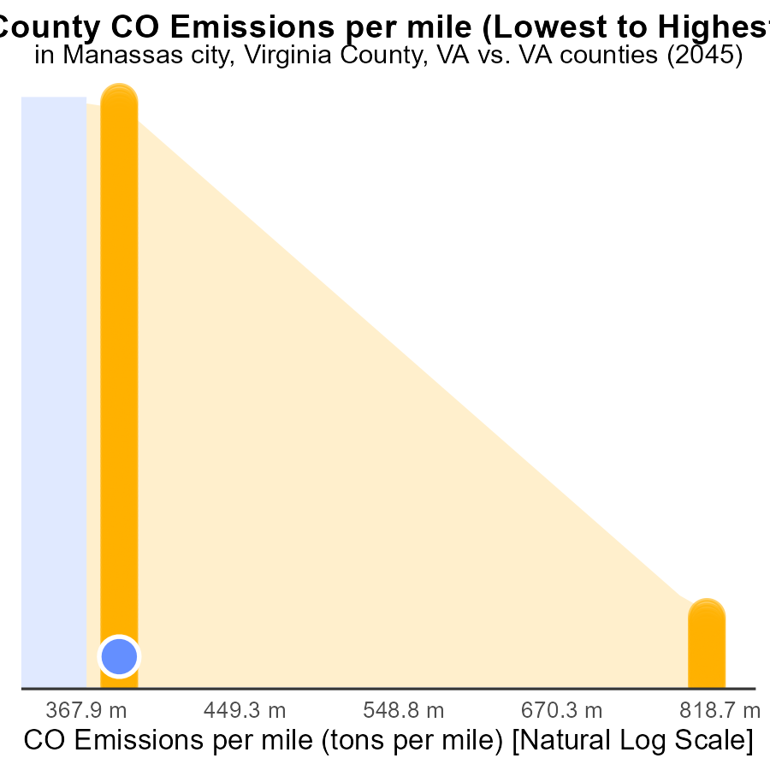

## Findings

* Lexington city, Virginia has the highest CO emissions per mile at 1.3 tons.
* Arlington has the lowest CO emissions per mile at 1.1 tons.
* Fairfax city and Manassas city, Virginia, have equal CO emissions per mile at 1.2 tons.

## Recommendations

To lower emissions, focus on reducing vehicle miles traveled (VMT) in Lexington city. Encourage the use of public transportation, cycling, and walking. In areas with high emissions like Fairfax city and Manassas city, improve infrastructure for electric vehicles.

# Conclusion

In conclusion, the data reveals key insights into CO emissions from on-road transportation in Manassas City, Virginia, in 2045. With car and bike emissions contributing significantly to the total vehicle emissions, focusing on reducing emissions from these sources through stricter standards and promoting electric vehicles is imperative. The data also highlights a decreasing trend in emissions over the years, showcasing the effectiveness of current emission reduction strategies. To maintain this trend, continued efforts such as implementing stricter regulations for industries, promoting renewable energy, and incentivizing public transportation are crucial.

Furthermore, the projected increase in vehicle starts necessitates proactive measures to address rising emissions, including stricter vehicle emission standards and investments in public transportation infrastructure. Encouraging alternatives to private vehicle usage, such as public transportation, carpooling, biking, and walking, can help reduce the median vehicle miles traveled. Additionally, focusing on cleaner alternative fuels and promoting the adoption of electric vehicles can contribute to lowering emissions per capita. By analyzing and acting upon the data trends, Manassas City can work towards a more sustainable and eco-friendly transportation system.

# About This Report

Data based on MOVES estimates collected by the Climate Action in Transportation program at Cornell University. Demographic data sourced from the US Census's American Community Survey 5-year estimates. This report was generated with the help of AI.

# References

* U.S. Census Bureau. (2023). American Community Survey 5-year estimates: Detailed tables. Retrieved from https://data.census.gov
* U.S. Environmental Protection Agency. (2024). Motor Vehicle Emission Simulator (MOVES 4.0) [Software]. Retrieved from https://www.epa.gov/moves