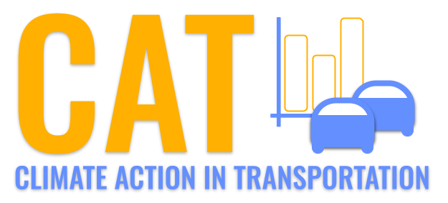 

**SO2 Emissions in New Castle County, 2035**  
Made with CAT VISUALIZER by Gao Labs @ Cornell University.

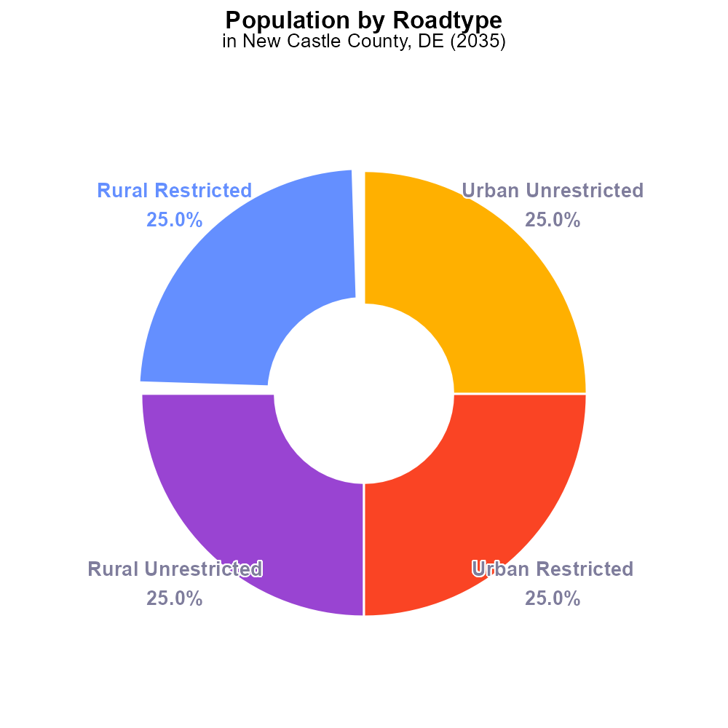

## Keywords

Sulfur Dioxides; SO2 emissions; on-road transportation; New Castle County; 2035; environmental impact

## Highlights

* Sulfur Dioxides (SO2) emissions from on-road transportation in New Castle County, DE are a growing concern.
* The study aims to analyze the projected emissions for 2035 and their potential impact on the environment.
* Findings will provide valuable insight for policy-makers to develop strategies for reducing emissions in the future.

# Introduction

In 2035, the issue of Sulfur Dioxides (SO2) emissions from on-road transportation in New Castle County, DE has become a pressing environmental concern. This report presents a comprehensive analysis of the projected emissions for the given year, examining the sources, trends, and potential impacts on air quality and public health. By focusing on the transportation sector, this study aims to provide insights into the contribution of vehicles to the overall SO2 emissions in the county.

The findings of this research will serve as a crucial foundation for policy-makers and stakeholders to devise effective strategies and regulations aimed at curbing the escalating levels of SO2 emissions from on-road transportation. By understanding the current trajectory of emissions and their implications, decision-makers can implement targeted measures to mitigate the environmental and health risks associated with high levels of SO2 in the region.

# Emissions Rate (per vehicle) Overall by Area

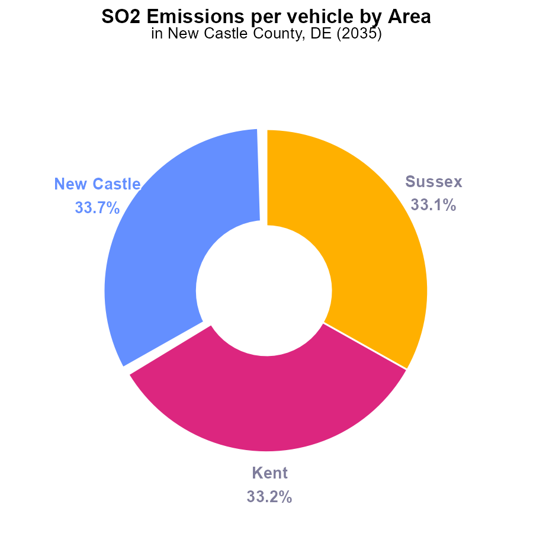

## Findings

* New Castle County has the highest SO2 emissions per vehicle at 27.1 tons.
* Kent and Sussex counties have similar SO2 emissions per vehicle, both at around 26.7 tons.
* New Castle County contributes to 33.7% of the total SO2 emissions per vehicle in the region.

## Recommendations

To lower SO2 emissions, focus on reducing vehicle emissions in New Castle County, which has the highest contribution. Implement stricter emission standards and promote the use of cleaner transportation methods.

# Population by Road Type

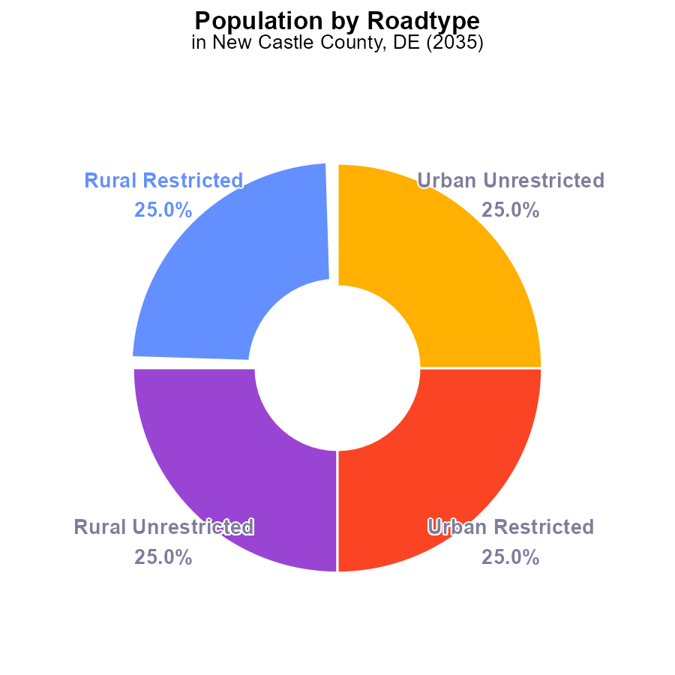

## Findings

* SO2 emissions in New Castle County, DE in 2035 total 2233.2 k
* Rural and Urban areas contribute equally to SO2 emissions, each at 50%
* Restricted and Unrestricted areas emit the same amount of SO2, each at 50%

## Recommendations

To lower SO2 emissions in New Castle County, focus on implementing emission control technologies in both rural and urban areas, particularly targeting unrestricted zones to achieve a balanced reduction.

# Vehicle Miles Traveled Overall over Time

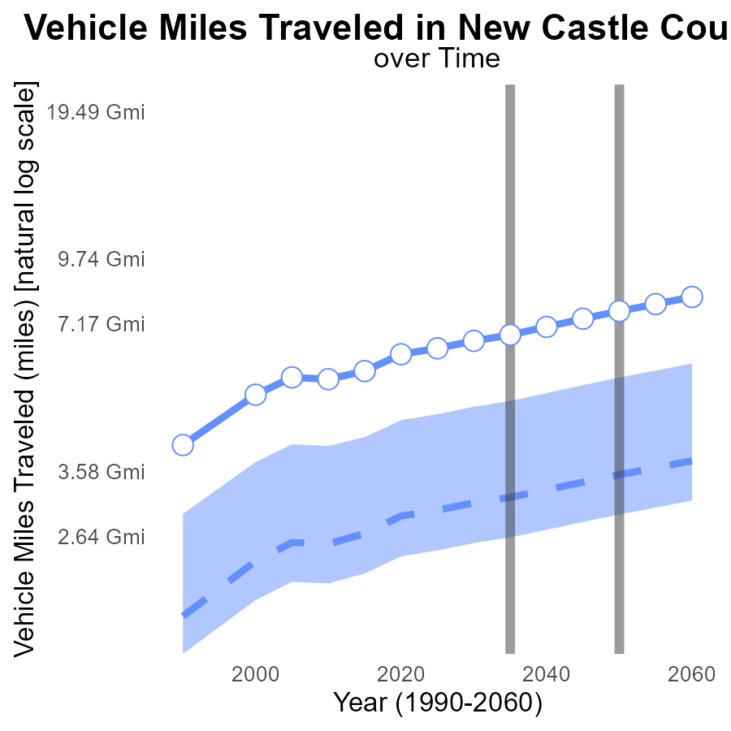

## Findings

* Vehicle miles traveled in New Castle County, DE are projected to steadily increase over the next few decades.
* The benchmark difference decreases over time, indicating lower emissions compared to the upper 75% of areas.
* Despite the increase in vehicle miles traveled, efforts should be made to reduce emissions to below the upper 75% of areas.

## Recommendations

To lower emissions levels despite the projected increase in vehicle miles traveled, New Castle County should prioritize investing in public transportation infrastructure, promoting carpooling and ridesharing initiatives, encouraging the adoption of electric vehicles, and implementing policies to reduce traffic congestion.

# Vehicles over Time for Buses

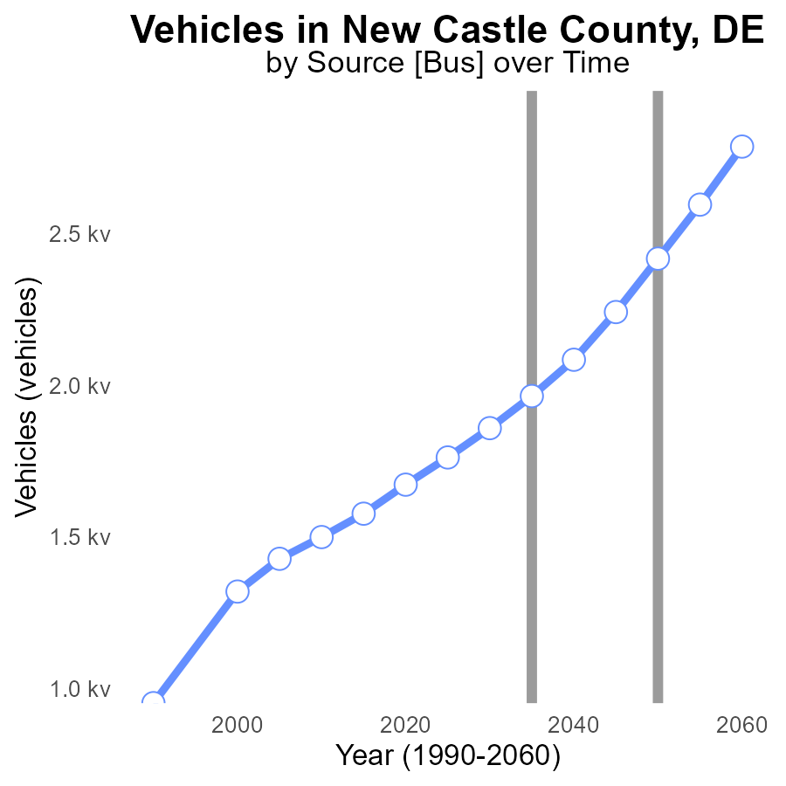

## Findings

* SO2 emissions from vehicles in New Castle County, DE have been decreasing over time.
* By 2050, SO2 emissions are projected to reduce by 31.7% compared to 2015 levels.
* A significant reduction of 178.0 units in SO2 emissions is expected from 2050 to 2055.

## Recommendations

To further decrease SO2 emissions from vehicles, policymakers should continue to invest in promoting the use of electric vehicles, improve public transportation infrastructure, and incentivize carpooling and telecommuting.

# Idling in My Region

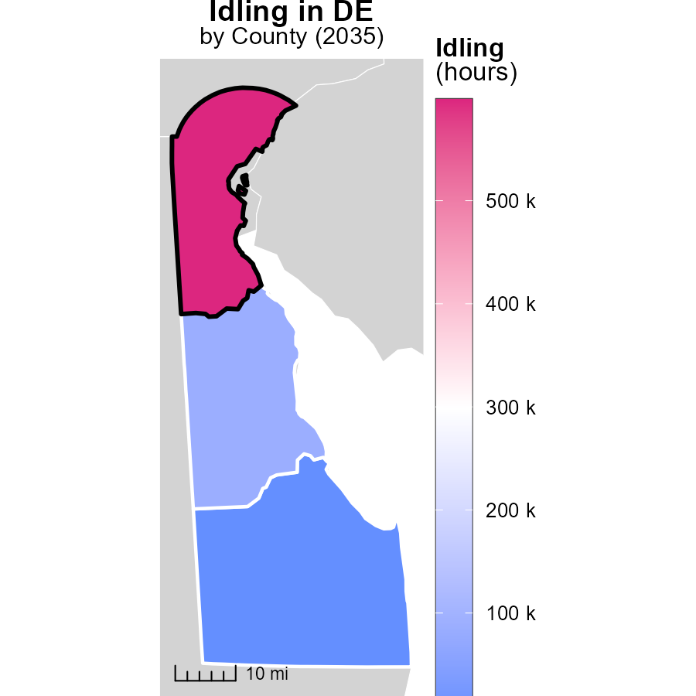

## Findings

* New Castle County, DE had the highest idling emissions with 598.2 thousand hours.
* Kent County, DE reported a median idling emissions of 87.0 thousand hours.
* Sussex County, DE had no reported idling emissions.

## Recommendations

To lower idling emissions, New Castle County should enforce anti-idling policies for vehicles, while Kent County could invest in promoting idling reduction programs. Sussex County should monitor and report any potential idling activities.

# Emissions Rate (per capita) Mapped by Area

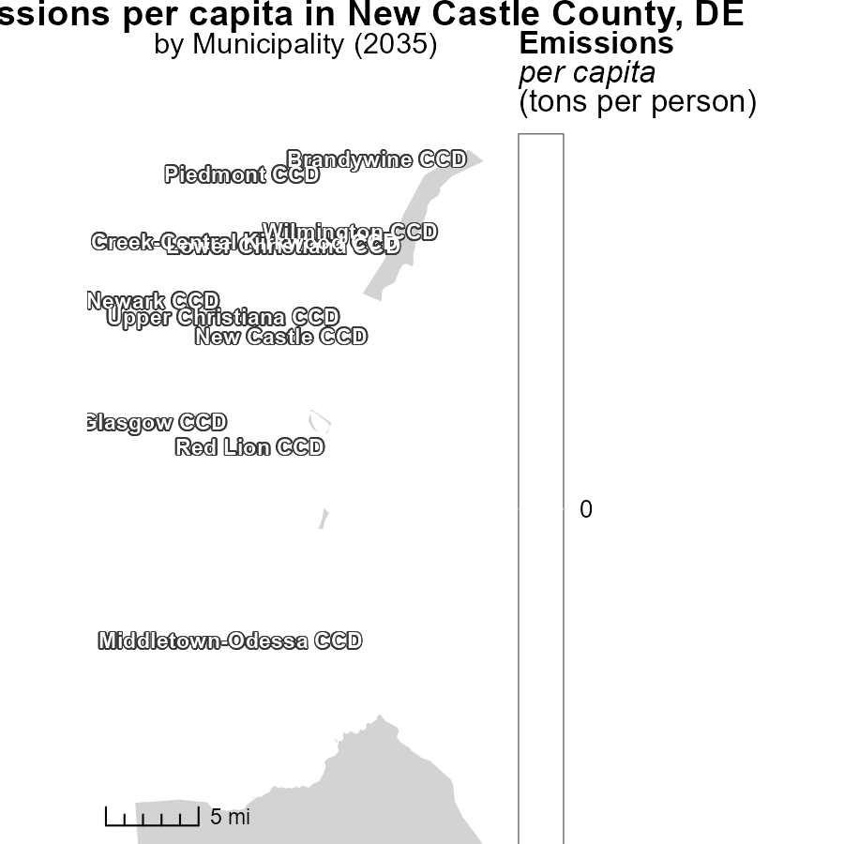

## Findings

* The maximum emissions per capita in Brandywine CCD, DE is 32.8 tons per person.
* The median emissions per capita in New Castle CCD, DE is 32.8 tons per person.
* The minimum emissions per capita in Wilmington CCD, DE is 32.8 tons per person.

## Recommendations

Local policymakers should focus on reducing emissions in areas with high per capita emissions like Brandywine CCD, DE by promoting sustainable transportation and energy-efficient practices. Additionally, implementing community-wide initiatives to reduce overall carbon emissions can help lower the median levels seen in New Castle CCD, DE.

# Vehicles by Vehicle Type over Time

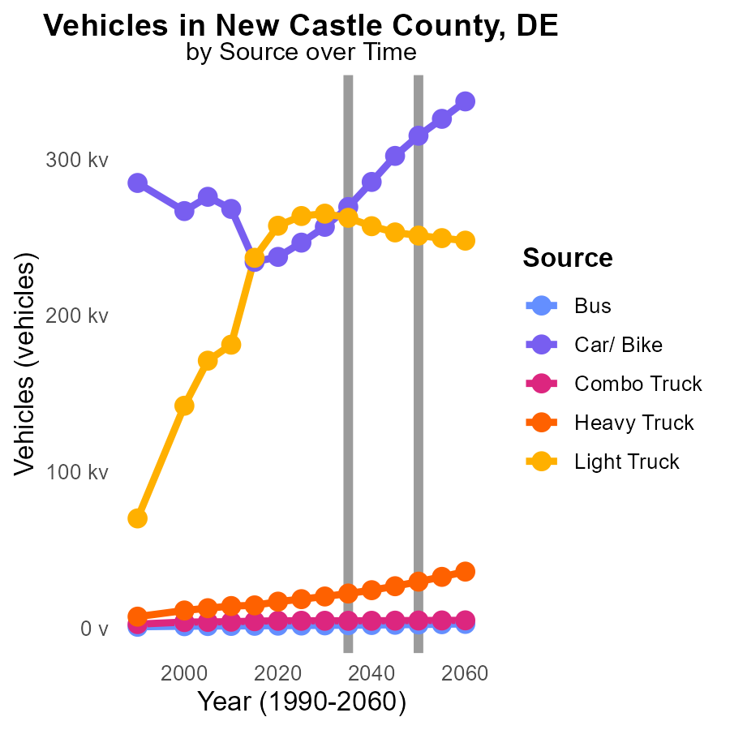

## Findings

* The emissions of SO2 from vehicles in New Castle County are projected to decrease significantly by 2045.
* The highest reduction in SO2 emissions is expected in the Heavy Truck category, with a 75.6% decrease by 2045.
* In contrast, Light Trucks are projected to have a reduction of only 7.7% in SO2 emissions by 2045.

## Recommendations

To further reduce emissions, policymakers should incentivize the transition to cleaner fuel technologies for Heavy Trucks, which have the highest emissions, to achieve a larger reduction by 2045. Additionally, promoting the use of electric vehicles in the Light Truck category can help accelerate the decrease in emissions in this segment.

# Hotelling (Engines Off) by Area over Time

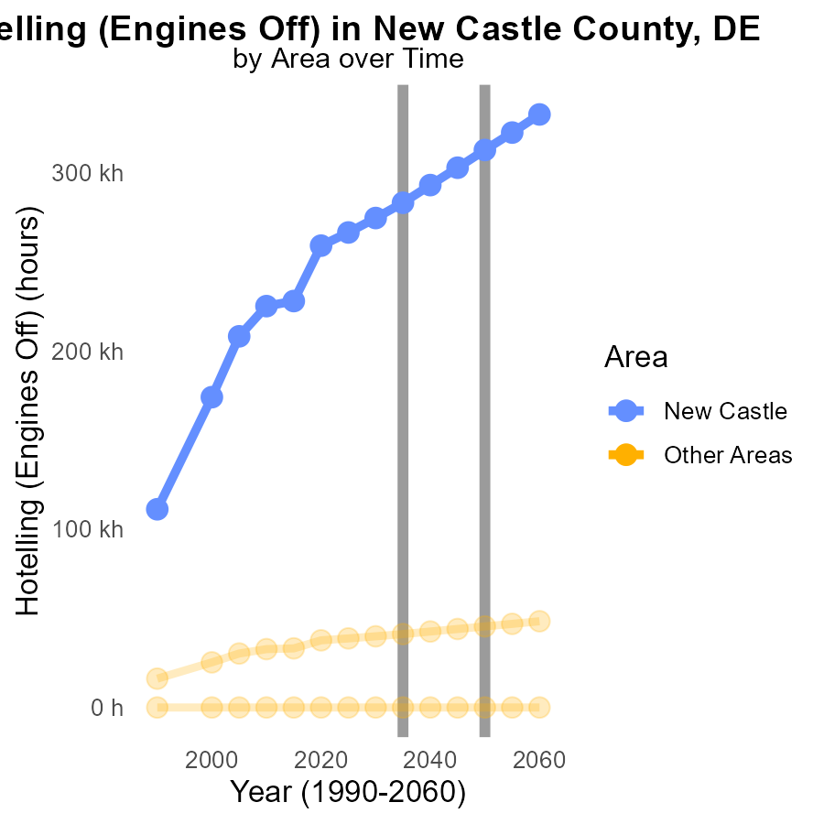

## Findings

* In 2035, max_county emitted 283.0 k tons of SO2 with a reduction of 29599.2 tons compared to the projected 2050 levels.
* In 2035, min_county emitted 0.0 tons of SO2, showing no change in emissions compared to the projected 2050 levels.

## Recommendations

To lower SO2 emissions, focus on further reducing emissions in max_county by implementing stricter regulations and cleaner technologies. Encourage min_county to maintain its emissions at zero levels through sustainable practices.

# Areas Ranked by Population

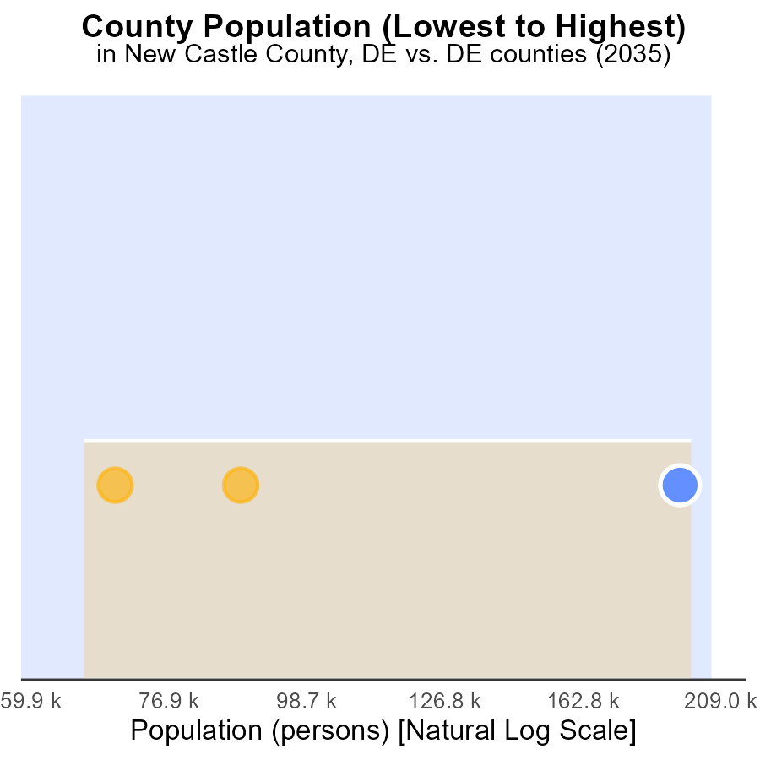

## Findings

* New Castle county emits the most SO2 with 100.0% of the population.
* Kent county ranks 2nd in SO2 emissions, with 33.3% of the population.
* SO2 emissions in New Castle county are disproportionately high compared to Kent county.

## Recommendations

To reduce SO2 emissions, focus on targeted policies in New Castle county where emission levels are highest. Implement stricter regulations and promote cleaner energy sources to bring down pollution levels.

# Areas Ranked by Emissions

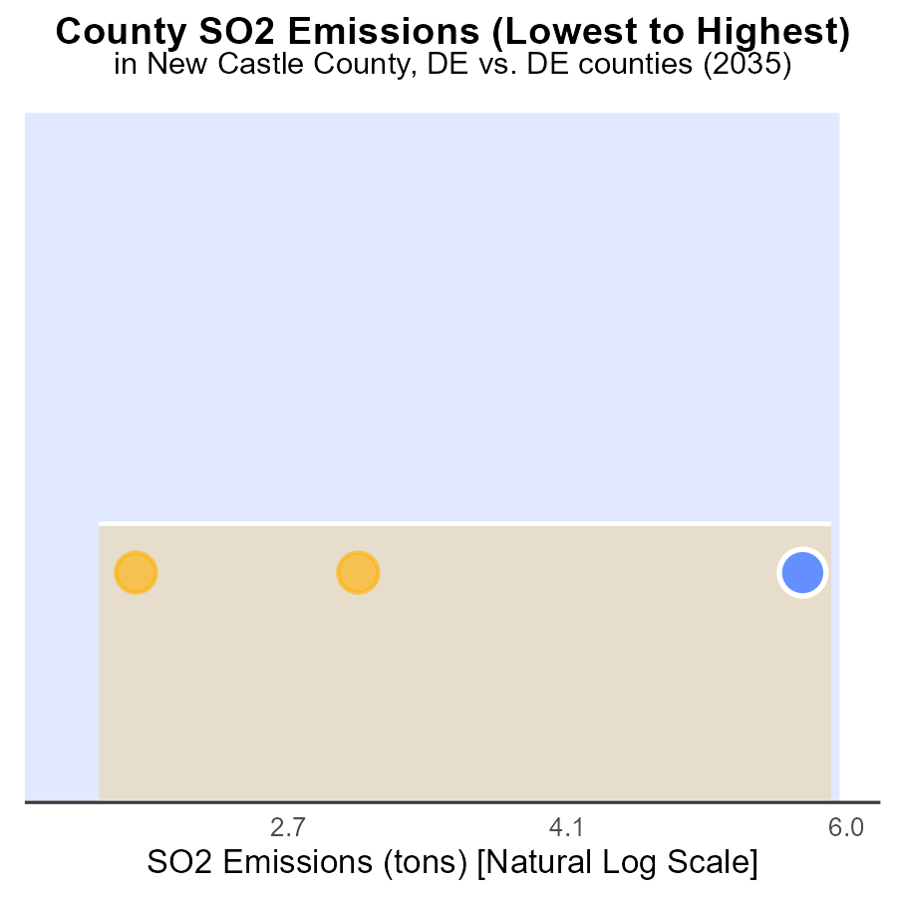

## Findings

* New Castle County has the highest SO2 emissions at 15.2 tons, ranking 3rd with 100.0% percentile.
* Kent County has the lowest SO2 emissions at 4.6 tons, ranking 1st with 33.3% percentile.
* Sussex County has SO2 emissions of 7.0 tons, ranking 2nd with 66.7% percentile.

## Recommendations

To lower SO2 emissions, focus on reducing industrial and transportation sources in New Castle County to decrease its high emissions. Implement clean energy initiatives. Provide incentives for industries in Kent County to maintain its low emissions. Improve monitoring and regulations in Sussex County to further reduce emissions.

# Conclusion

In conclusion, the data illustrates that New Castle County in Delaware has the highest SO2 emissions per vehicle, contributing significantly to the region's total emissions. To combat this, it is imperative to focus on implementing stricter emission standards and promoting cleaner transportation methods in the county. Efforts should be directed towards reducing emissions in both rural and urban areas, particularly targeting unrestricted zones to achieve a balanced reduction. Despite the projected increase in vehicle miles traveled, emphasis should be placed on investing in public transportation infrastructure, promoting carpooling, adopting electric vehicles, and implementing policies to reduce traffic congestion to lower emissions levels. Policymakers should continue to invest in promoting electric vehicles, improving public transportation infrastructure, and incentivizing carpooling and telecommuting to further decrease SO2 emissions. Moreover, the data emphasizes the importance of enforcing anti-idling policies, reducing idling emissions, and focusing on areas with high per capita emissions to promote sustainable transportation practices.

# About This Report

Data based on MOVES estimates collected by the Climate Action in Transportation program at Cornell University. Demographic data sourced from the US Census's American Community Survey 5-year estimates. This report was generated with the help of AI.

# References

* U.S. Census Bureau. (2023). American Community Survey 5-year estimates: Detailed tables. Retrieved from https://data.census.gov
* U.S. Environmental Protection Agency. (2024). Motor Vehicle Emission Simulator (MOVES 4.0) [Software]. Retrieved from https://www.epa.gov/moves