 

**SO2 Emissions in Rock Island County, 2005**  
Made with CAT VISUALIZER by Gao Labs @ Cornell University.

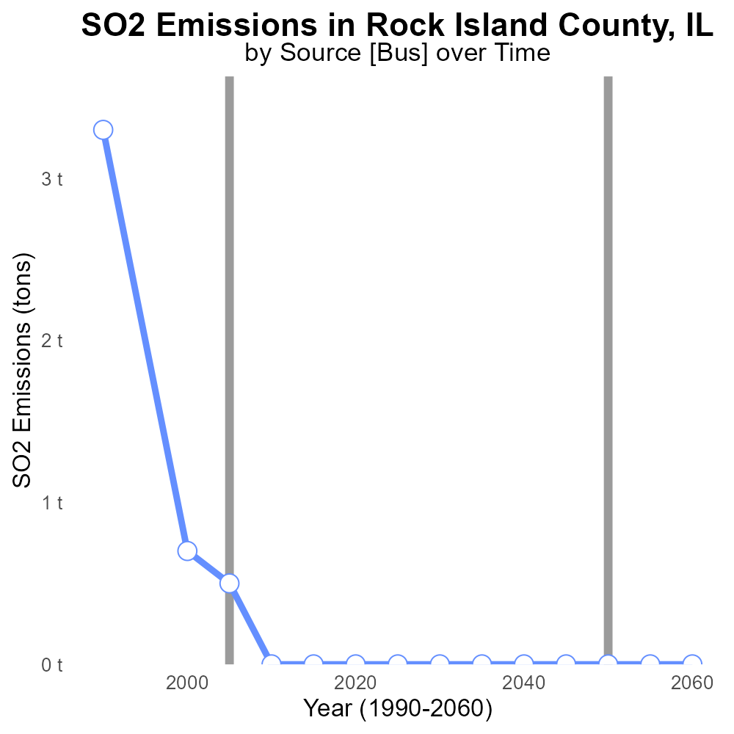

## Keywords

Sulfur Dioxide emissions; on-road transportation; Rock Island County; Illinois; 2005

## Highlights

* Identification and analysis of SO2 emissions from on-road transportation in Rock Island County, IL.
* Insights into the impact of transportation on air quality and public health in the region.
* Comparison of SO2 emissions in 2005 with current levels for trend analysis.
* Recommendations for mitigating the harmful effects of sulfur dioxide emissions.
* Implications of the study for environmental policy and public health initiatives.

# Introduction

The report focuses on the assessment of Sulfur Dioxide (SO2) emissions originating from on-road transportation in Rock Island County, Illinois, during the year 2005.

This study aims to provide a comprehensive analysis of the sources, levels, and impact of SO2 emissions on air quality and public health in the region. By examining the data from 2005, we can compare the emission levels to current statistics to identify any trends or changes over time. The findings of this report will offer valuable insights for policymakers, environmental agencies, and public health officials in devising strategies to reduce and mitigate the detrimental effects of sulfur dioxide emissions on the environment and human health.

# Vehicle Starts by Road Type

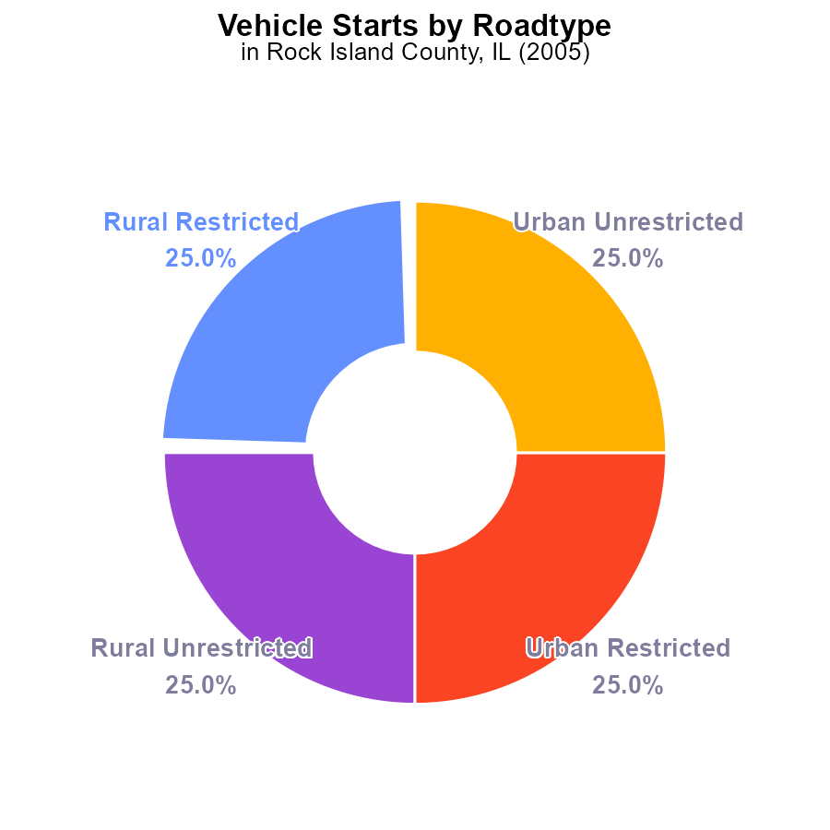

## Findings

* SO2 emissions in Rock Island County, IL in 2005 were 127.1 M times for each vehicle start for all four categories.
* Rural areas contributed 50% (25% Rural Restricted and 25% Rural Unrestricted) to the total SO2 emissions.
* Urban areas also contributed 50% (25% Urban Restricted and 25% Urban Unrestricted) to the total SO2 emissions.

## Recommendations

To lower SO2 emissions in Rock Island County, IL, policies should focus on improving vehicle emission standards, promoting public transportation, and implementing stricter regulations on industrial emissions.

# Time Driven by Regulatory Class

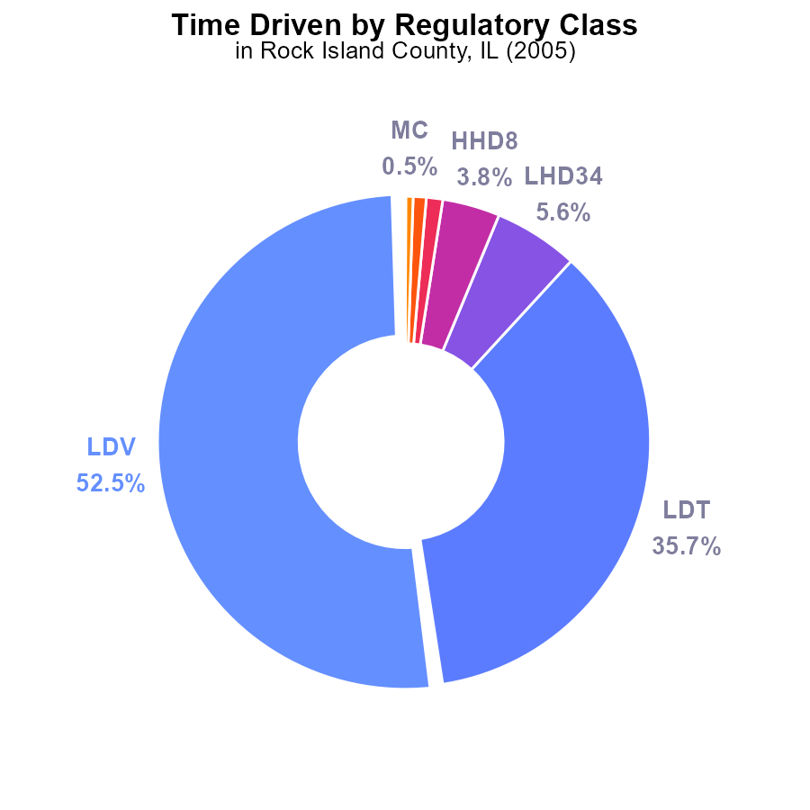

## Findings

* In 2005, LDV contributed to 52.5% of SO2 emissions in Rock Island County, IL.
* LDT accounted for 35.7% of total SO2 emissions during the same year.
* Together, LDV and LDT were responsible for over 88% of SO2 emissions in 2005 in the county.

## Recommendations

To reduce SO2 emissions, focus on regulating LDV and LDT emissions through stricter emission standards and promoting alternative transportation methods. Collaboration with industries and implementing clean technologies is essential.

# Hotelling (Diesel Aux) over Time for Passenger Vehicles

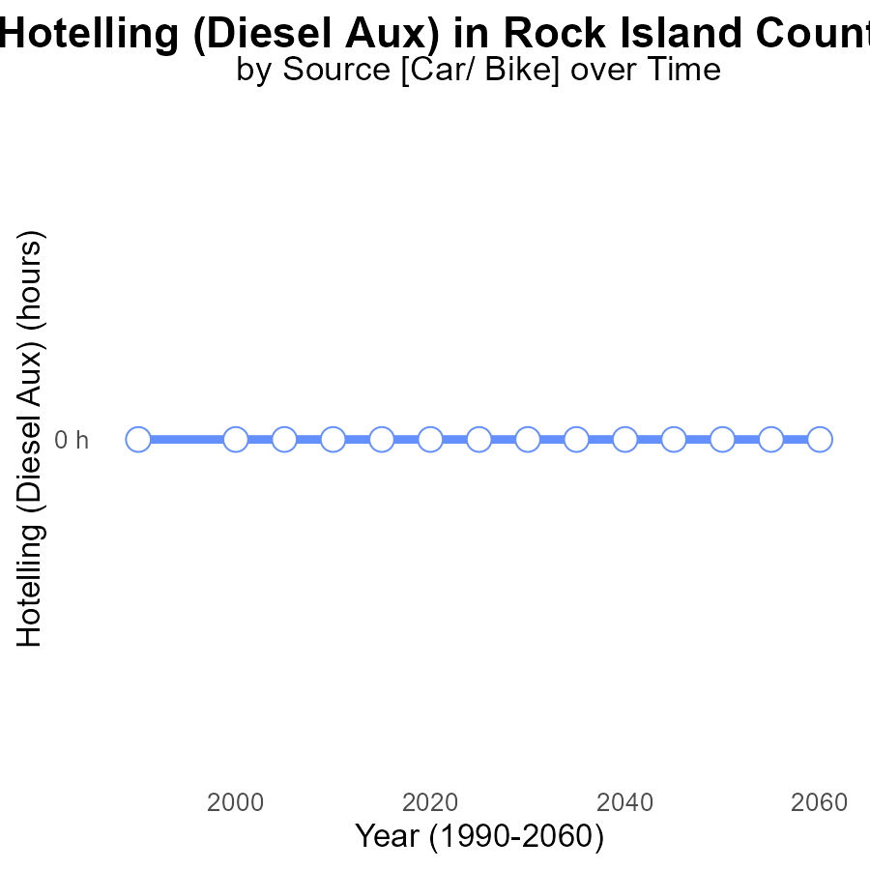

## Findings

* There have been zero emissions of sulfur dioxide (SO2) from Hotelling (Diesel Aux) in Rock Island County, IL from 1990 to 2025.
* The emissions have consistently stayed at 0.0 hours, indicating no presence of SO2 in the area.
* The benchmark difference has remained at 0 throughout the years, showing no deviation in emission levels.

## Recommendations

Considering the consistently low emissions of sulfur dioxide from Hotelling (Diesel Aux) in Rock Island County, IL, it is important to continue monitoring and enforcing stringent emission control measures to maintain the clean air quality. Additionally, investing in renewable energy sources to replace diesel auxiliaries can help further reduce emissions.

# Emissions over Time for Buses

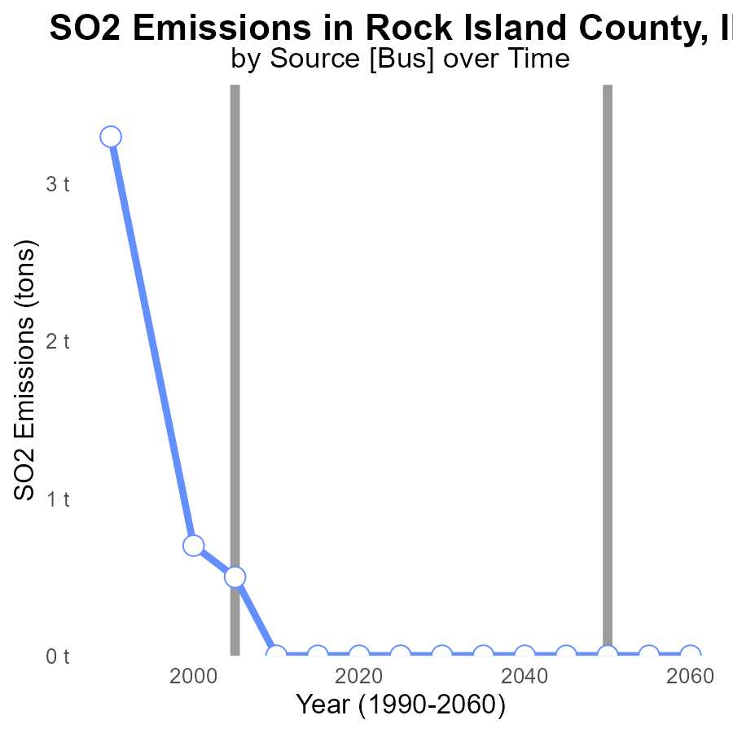

## Findings

* SO2 emissions in Rock Island County decreased significantly from 1990 to 2000 by 3.3 tons.
* There was a slight decrease in SO2 emissions from 2000 to 2005 by 0.2 tons.
* From 2010 to the projected 2025, SO2 emissions remained at 0 tons.

## Recommendations

To maintain the decreasing trend observed in SO2 emissions, policymakers should continue implementing and enforcing stringent emission control measures on industrial activities in Rock Island County.

# Vehicle Starts Mapped by Area

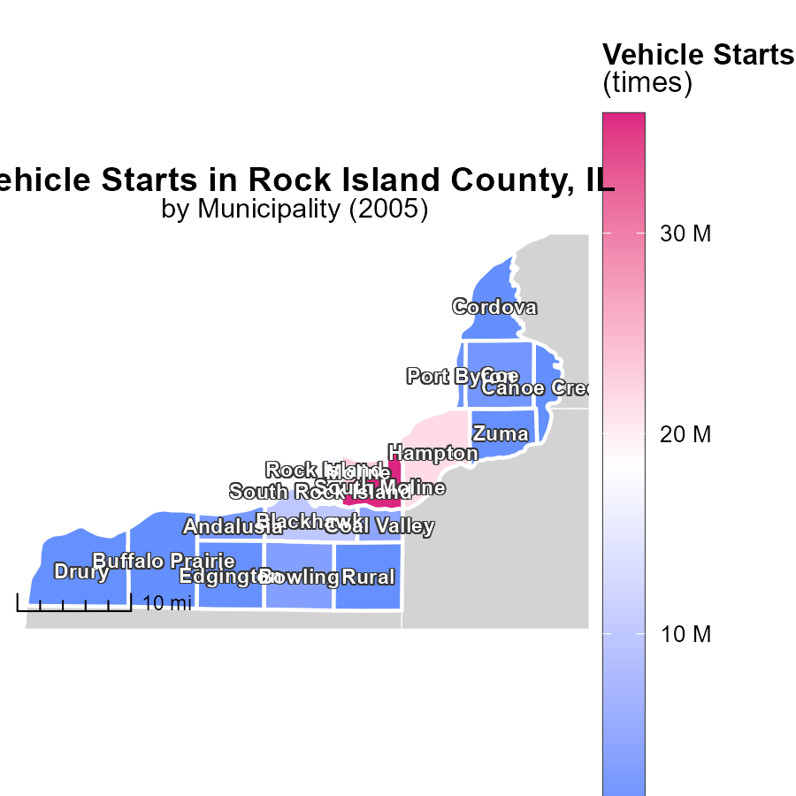

## Findings

* In 2005, South Moline, IL had the highest vehicle starts at 36.0 million.
* The median number of vehicle starts in 2005 was 2.0 million in Coe, IL.
* Canoe Creek, IL had the lowest number of vehicle starts in 2005 at 756.1 thousand.

## Recommendations

To lower emissions, incentivize carpooling or promote the use of public transportation in high-start areas like South Moline. Encourage efficient transport methods in Coe and Canoe Creek to reduce emission levels further.

# Vehicles in My Region

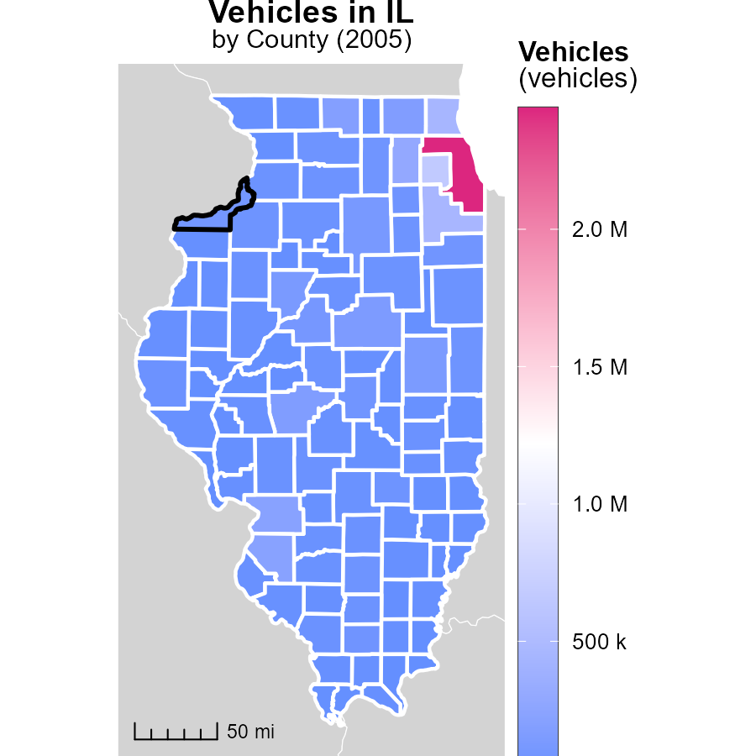

## Findings

* Cook County, IL had the highest vehicle emissions in 2005 with 2.4 million tons.
* Cumberland County, IL had a median level of vehicle emissions with 27.4 thousand tons.
* Hardin County, IL had the lowest vehicle emissions in 2005 at 2.9 thousand tons.

## Recommendations

To lower vehicle emissions, strategies should focus on Cook County, IL, by improving public transportation infrastructure and promoting electric vehicles. In Cumberland County, IL, enhancing carpooling initiatives can help reduce emissions. Hardin County, IL needs support for transitioning to greener transportation options.

# Vehicle Starts by Fuel Type over Time

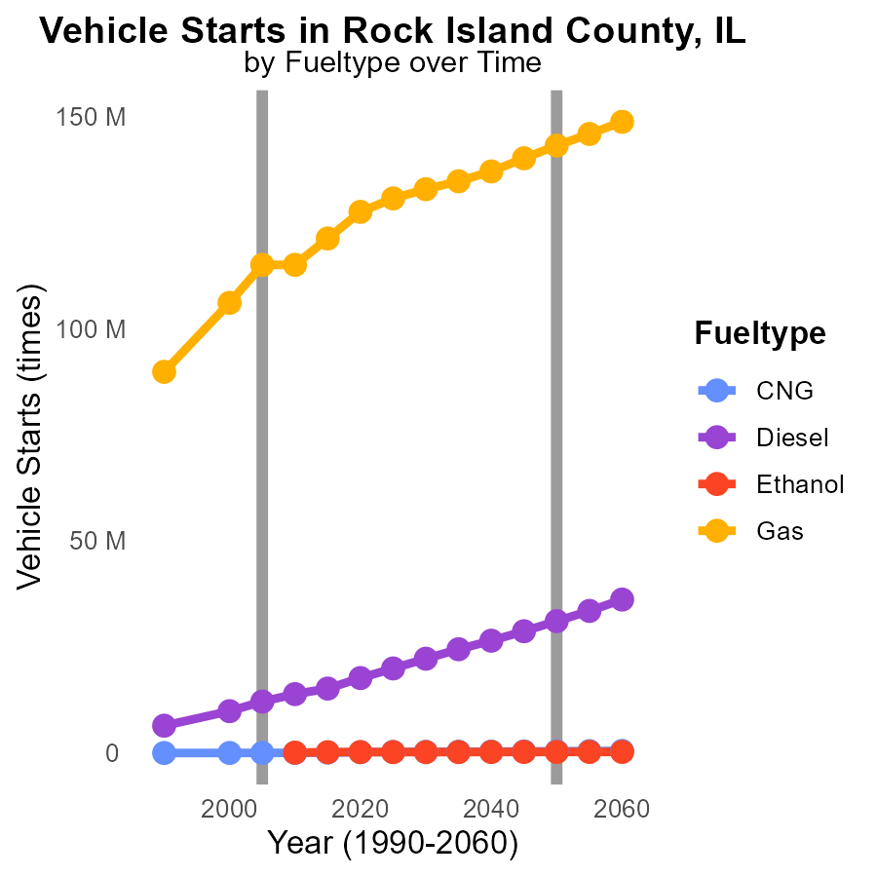

## Findings

* By 2015, CNG vehicle starts saw a 69% increase from 2000 to 100,000 kilos.
* Diesel vehicle starts increased by 54% from 2000 to 2015, reaching 15.2 million.
* Gasoline vehicle starts remained relatively stable, with a minimal increase of 14% from 2000 to 2015.

## Recommendations

To reduce SO2 emissions in Rock Island County, IL, policymakers should incentivize a transition to cleaner fuel types such as CNG and Ethanol, which have shown significant emission reductions compared to Diesel and Gasoline. Implementing stricter emissions standards for vehicles and promoting the use of public transportation or carpooling could also help lower overall emissions in the county.

# Population by Fuel Type over Time

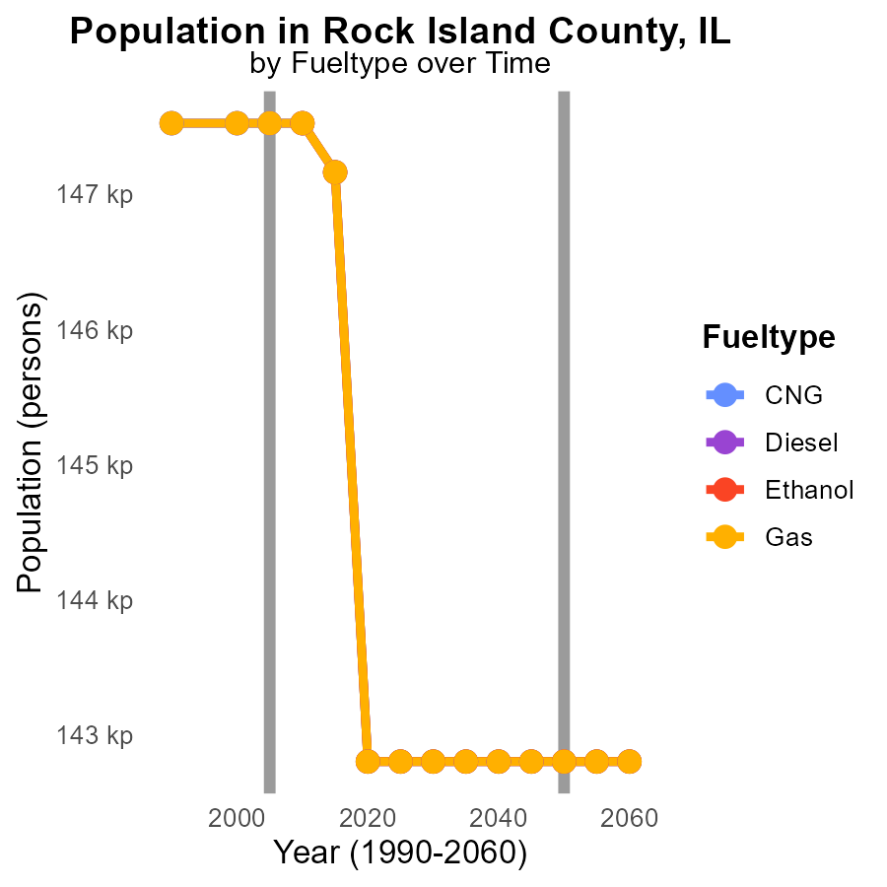

## Findings

* SO2 emissions in Rock Island County, IL have remained relatively stable from 2000 to 2015, with values around 147.5k - 147.2k.
* The highest emissions were observed in 2000 across all fuel types, with a reduction in emissions for all fuel types by 2015 ranging from -4360 to -4723 compared to projections for 2050.
* Overall, there was a consistent decrease in SO2 emissions for CNG, Diesel, Ethanol, and Gas in Rock Island County, IL from 2000 to 2015.

## Recommendations

To further reduce SO2 emissions in Rock Island County, IL, policies should focus on promoting the use of cleaner fuel types like CNG, Diesel, Ethanol, and Gas, which have shown a consistent decrease in emissions over the years. Additionally, incentivizing the adoption of renewable energy sources and implementing stricter emission standards for industries could help achieve a more significant reduction in emissions.

# Areas Ranked by Vehicle Miles Traveled

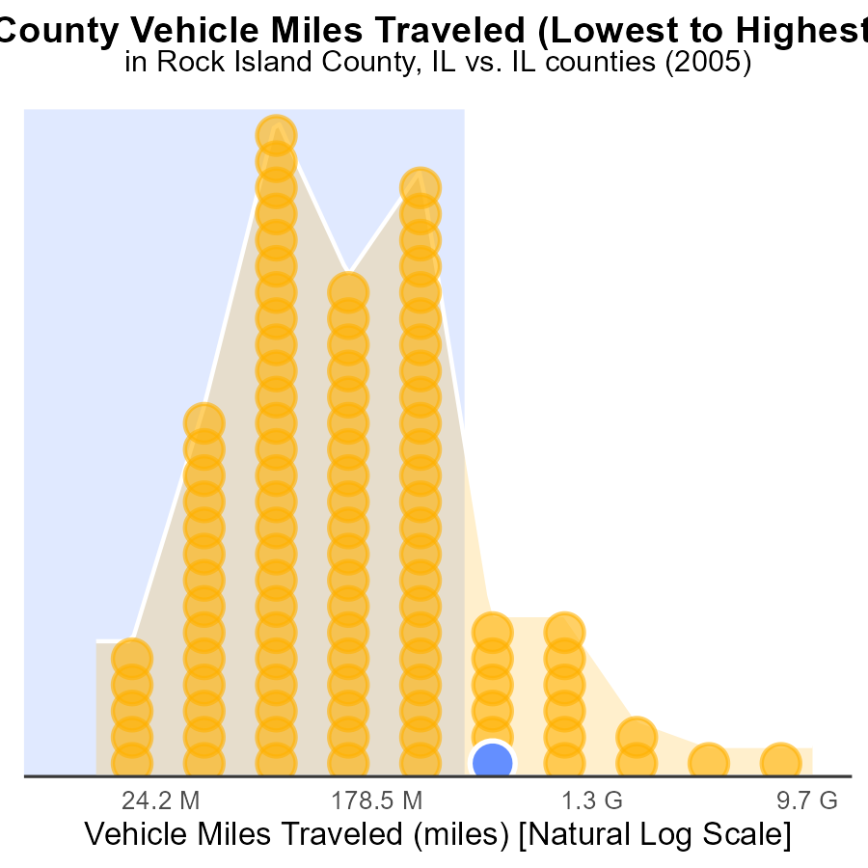

## Findings

* Cook County has the highest vehicle miles traveled (VMT) in 2005, accounting for 100.0% of all counties.
* Hardin County has the lowest VMT in 2005, representing only 1.0% of the total VMT.
* The top five counties with the highest VMT in 2005 contribute to 356.8 billion miles, making a significant impact on SO2 emissions.

## Recommendations

To reduce SO2 emissions from vehicle miles traveled, policymakers should focus on promoting public transportation, carpooling initiatives, and implementing stricter vehicle emission standards to lessen the environmental impact.

# Areas Ranked by Emissions Rate (per mile)

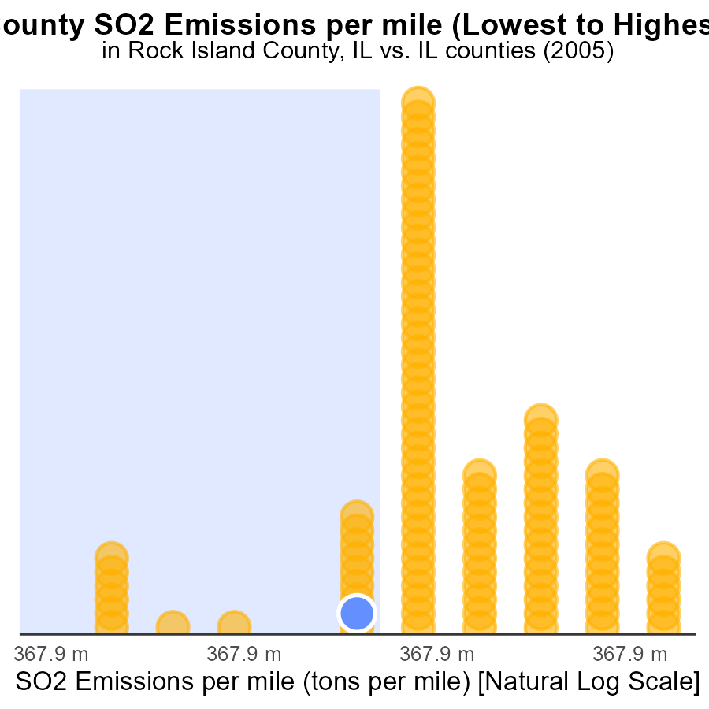

## Findings

* Highest SO2 emissions per mile in Cumberland county (51.7 tons per mile).
* Cook county with the lowest SO2 emissions per mile (35.8 tons per mile).
* Rock Island and Hamilton counties have similar SO2 emissions per mile (43.5 tons per mile).

## Recommendations

To lower emissions: focus on reducing ton per mile output by implementing cleaner technologies and promoting sustainable transportation methods, particularly in high emission counties like Cumberland.

# About This Report

Data based on MOVES estimates collected by the Climate Action in Transportation program at Cornell University. Demographic data sourced from the US Census's American Community Survey 5-year estimates. This report was generated with the help of AI.

# References

* U.S. Census Bureau. (2023). American Community Survey 5-year estimates: Detailed tables. Retrieved from https://data.census.gov
* U.S. Environmental Protection Agency. (2024). Motor Vehicle Emission Simulator (MOVES 4.0) [Software]. Retrieved from https://www.epa.gov/moves