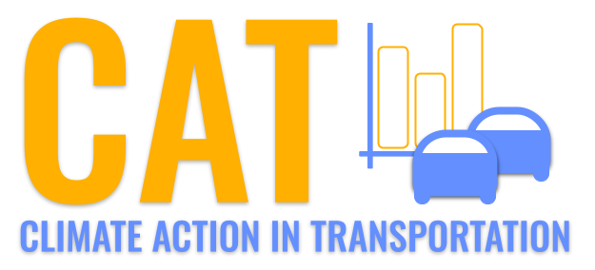 

**Carbon Emissions in Kalawao County, 2040**  
Made with CAT VISUALIZER by Gao Labs @ Cornell University.

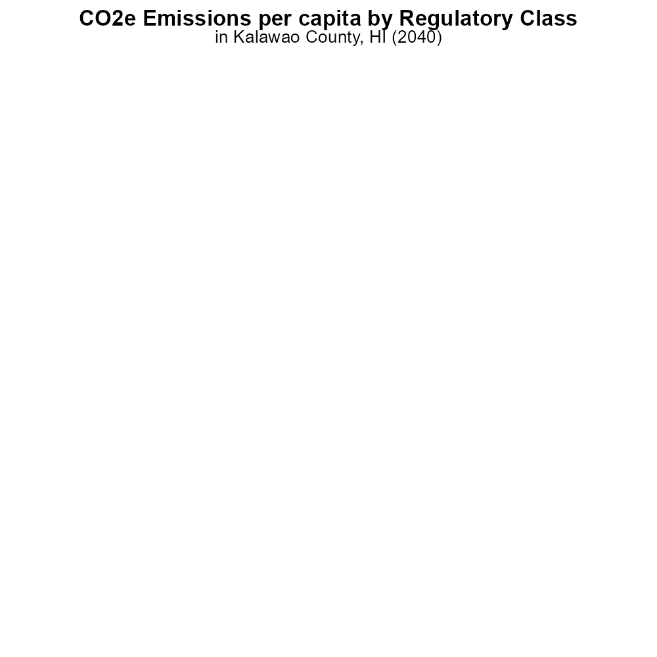

## Keywords

CO2 Equivalent emissions; on-road transportation; Kalawao County; HI; 2040; report

## Highlights

* Analysis of on-road transportation CO2 emissions in Kalawao County, HI in 2040.
* Impact of transportation trends on CO2 emissions in a rural county.
* Exploring strategies to reduce on-road transportation emissions in Kalawao County.
* Forecasting future CO2 Equivalent emissions from on-road vehicles in 2040.
* Investigating the carbon footprint of transportation in a unique Hawaiian county.

# Introduction

In 2040, the issue of CO2 Equivalent emissions from on-road transportation in Kalawao County, Hawaii, is of critical concern. As the county grapples with the effects of climate change, understanding and mitigating these emissions is essential for sustainable development. This report aims to provide an in-depth analysis of the current state and projected trends of on-road transportation emissions in Kalawao County.

By examining the contributing factors and exploring potential solutions, valuable insights can be gained to guide policymakers and stakeholders in implementing effective strategies to reduce CO2 emissions from transportation. Through forecasting future emissions and evaluating the impact of transportation policies, this report seeks to inform decision-making processes for a greener and more sustainable future.

# Idling by Vehicle Type

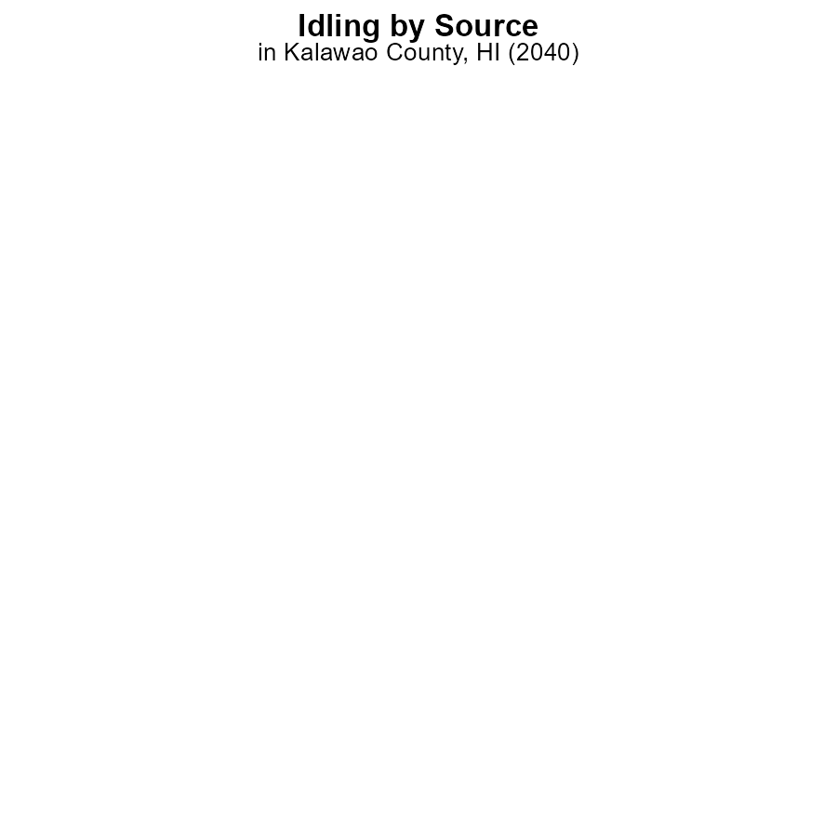

## Findings

* In 2040, Kalawao County, HI had no CO2e emissions from idling vehicles.
* All vehicle types - Bus, Car/Bike, Combo Truck, Heavy Truck, Light Truck - had zero emissions from idling in 2040.

## Recommendations

To maintain the zero-emission level from idling vehicles, policymakers should continue to promote the use of clean energy vehicles and implement strict idling regulations.

# Emissions Rate (per capita) by Regulatory Class

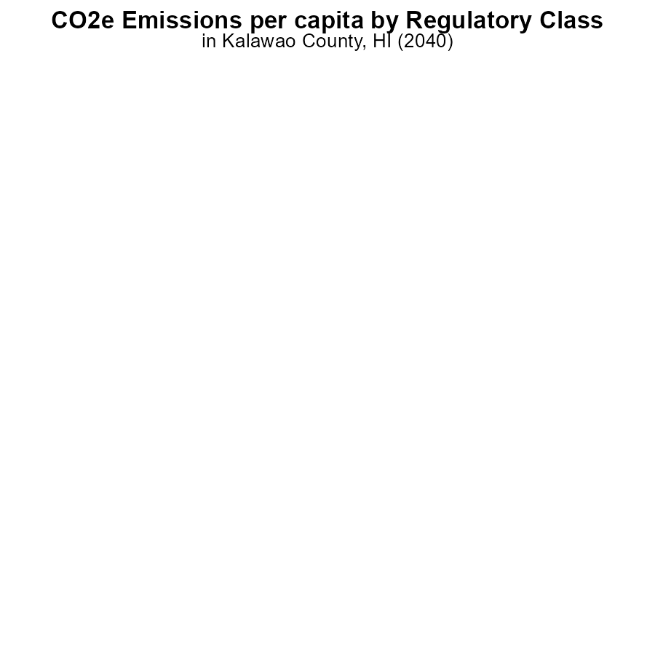

## Findings

* All transportation types in Kalawao County, HI emitted 0 tons of CO2e per capita in 2040.

## Recommendations

Considering the zero emissions from transportation, policymakers could focus on sustainable energy production and waste management to further reduce overall emissions in Kalawao County, HI.

# Emissions Rate (per capita) over Time for Buses

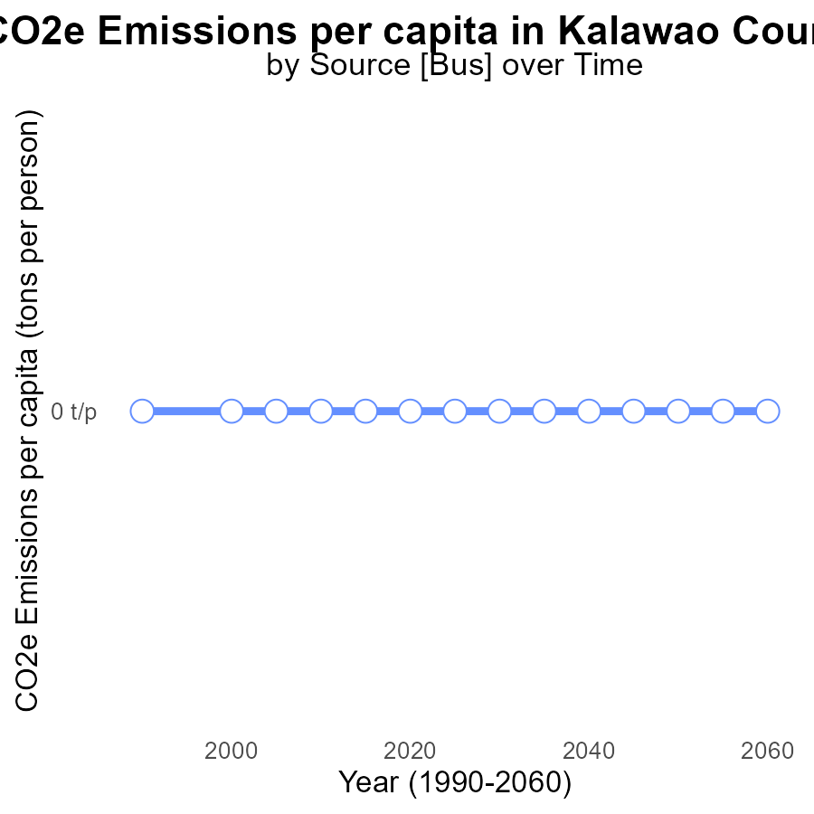

## Findings

* Kalawao County, HI had zero CO2e emissions per capita from 2020 to 2060.

## Recommendations

Given the consistently low emissions, continue to invest in renewable energy sources. Implement public awareness campaigns to maintain and increase sustainability efforts.

# Emissions Rate (per mile) Overall over Time

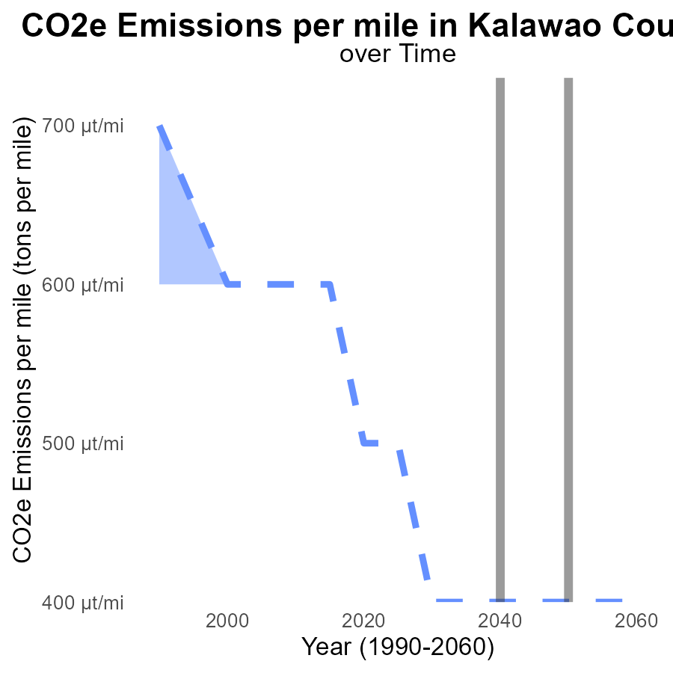

## Findings

* Emissions in Kalawao County, HI per mile are consistently at 0.0005 tons from 2020 to 2060.
* Comparison shows this area is in line with the median area and upper 75th percentile of areas.
* There is no significant difference in emissions between Kalawao County and the benchmark.

## Recommendations

Since emissions in Kalawao County are already in line with the median and upper 75th percentile of areas, continued efforts to maintain current levels should be prioritized. Investments in sustainable transportation and energy-efficient infrastructures can help sustain these low emission levels over the coming years.

# Hotelling (Engines Off) in My Region

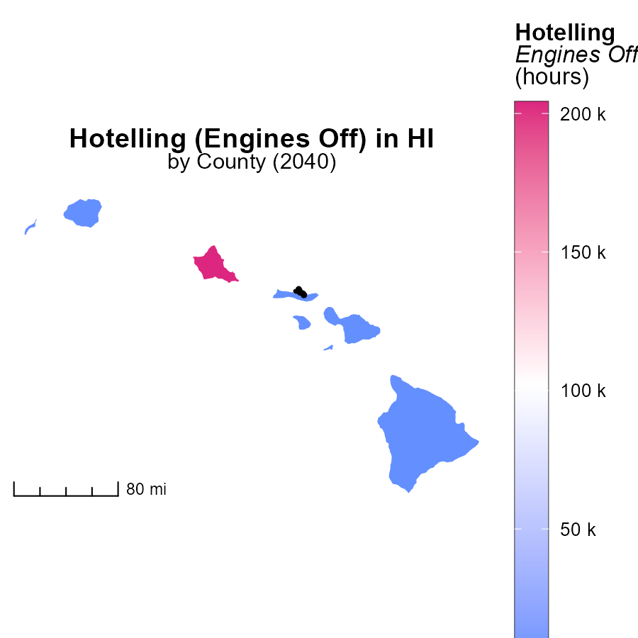

## Findings

* Honolulu County, HI has the highest emissions at 204.1k hours.
* Kalawao County, HI has the median emissions at 0.0 hours.
* Maui County, HI has the lowest emissions at 0.0 hours.

## Recommendations

To reduce emissions, focus on Honolulu County, HI, by implementing policies to minimize engine usage during specific times, thereby potentially decreasing emissions by a significant number.

# Time Driven in My Region

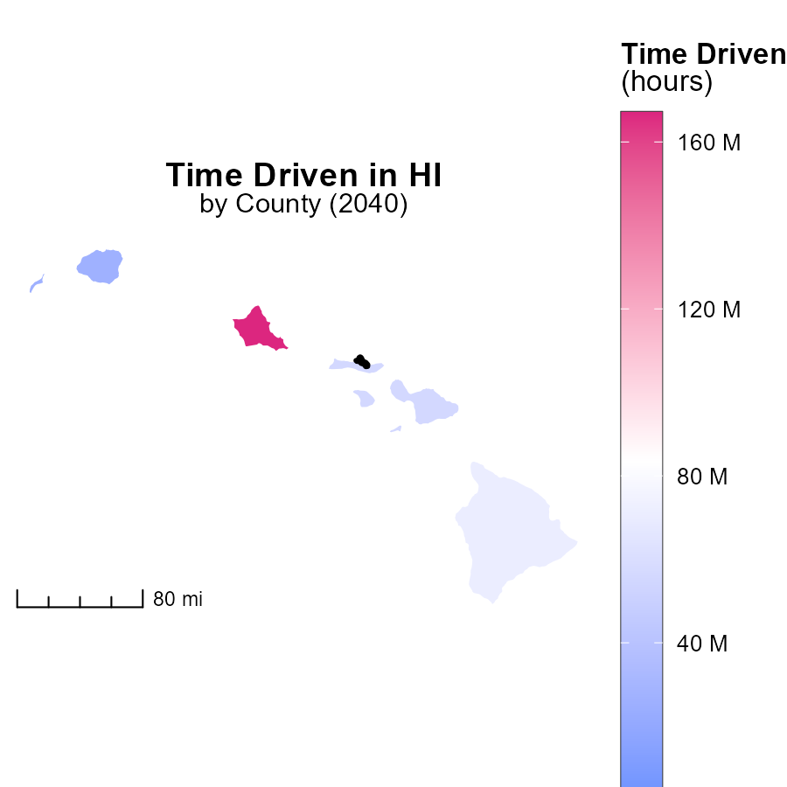

## Findings

* Honolulu County, HI has the highest emissions with 167.1 million hours.
* Maui County, HI has a median emission level of 55.7 million hours.
* Kalawao County, HI has the lowest emissions, recording 0.0 hours.

## Recommendations

To lower emissions, focus on Honolulu County by promoting telecommuting or flexible work hours. Implement public transportation incentives in Maui County. Explore sustainable transportation alternatives in Kalawao County.

# Emissions by Regulatory Class over Time

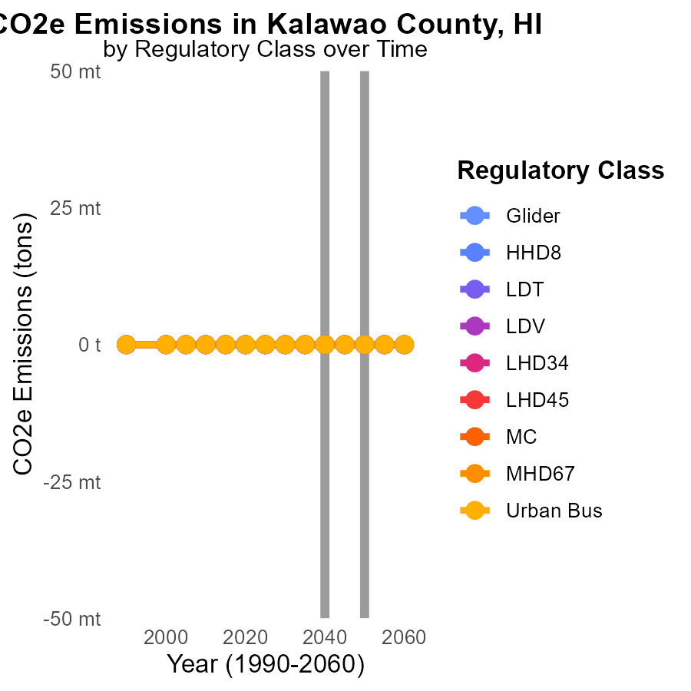

## Findings

* Emissions in Kalawao County, HI across various sectors are projected to remain at 0 tons from 2030 to 2050.
* No significant changes in emissions are forecasted in any sector, including Glider, HHD8, LDT, LDV, LHD34, LHD45, MC, MHD67, and Urban Bus.
* The data suggests there is no expected reduction in carbon emissions over the next two decades in Kalawao County, HI.

## Recommendations

To lower emissions in Kalawao County, HI, incentivize and prioritize the adoption of renewable energy sources across all sectors to reduce dependency on carbon-intensive practices.

# Time Driven by Fuel Type over Time

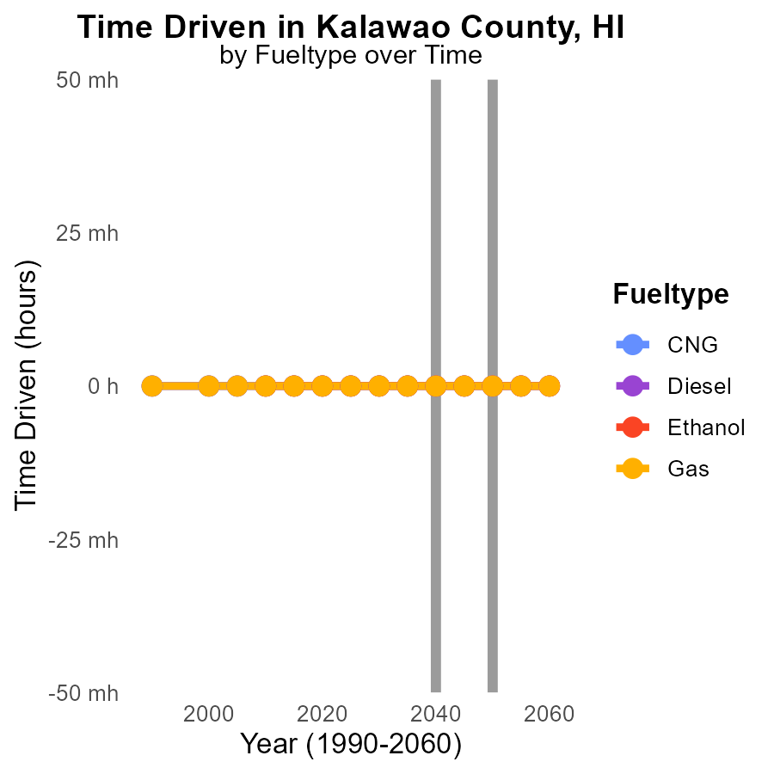

## Findings

* There are no projected CO2e emissions for Kalawao County, HI up to 2050 across different fuel types.
* The emissions for CNG, Diesel, Ethanol, and Gas are all expected to remain at 0.0 for the period 2030-2050.
* There is no change in emissions from 2030 to 2050, indicating a stable emission scenario for Kalawao County.

## Recommendations

Considering the consistent zero emissions projected for all fuel types in Kalawao County until 2050, policymakers should focus on maintaining and enhancing existing alternative fuel infrastructure and promoting sustainable transportation practices to ensure emissions remain at this low level.

# Areas Ranked by Hotelling (Diesel Aux)

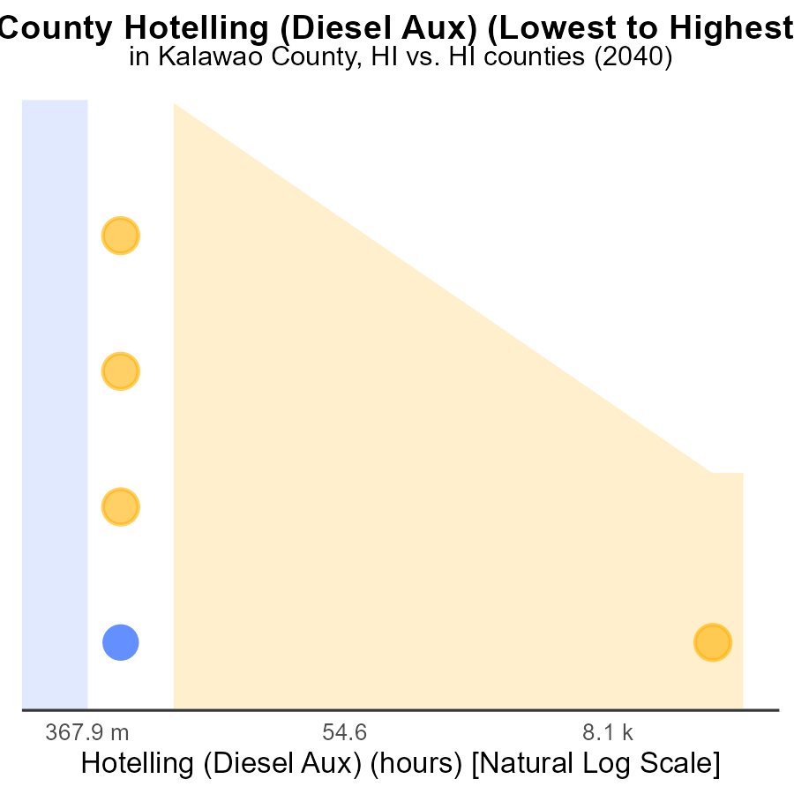

## Findings

* Kalawao has no emissions from Hotelling (Diesel Aux) in 2040.
* Hawaii has the 2nd highest emissions from Hotelling (Diesel Aux), but still very low.
* Honolulu has the highest emissions at 311.3 k CO2e in 2040.

## Recommendations

To decrease emissions, Kalawao can continue its low-emission practices. Hawaii should explore alternative energy sources. Honolulu needs to invest in cleaner technologies for Hotelling (Diesel Aux).

# Areas Ranked by Vehicle Starts

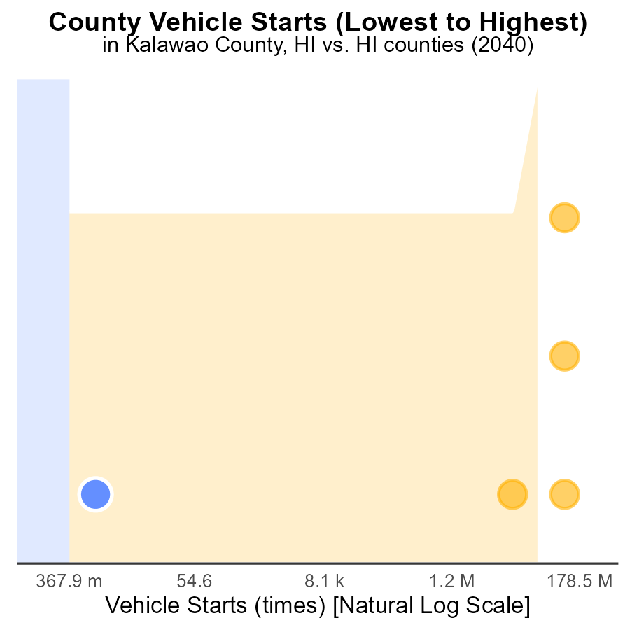

## Findings

* Kalawao has zero vehicle starts in 2040, ranking 1st with 20.0% percentile.
* Kauai had 87.8 million vehicle starts, ranking 2nd with 40.0% percentile.
* Honolulu recorded 753.6 million vehicle starts in 2040, ranking 5th at 100.0% percentile.

## Recommendations

To reduce emissions, focus on promoting public transportation and carpooling in Kalawao to maintain zero starts. Implement vehicle start reduction programs in Kauai to lower emissions. In Honolulu, invest in electric vehicles and improve infrastructure to decrease the emissions from the high number of vehicle starts.

# Conclusion

In conclusion, the data from the report on CO2 Equivalent emissions from on-road transportation in Kalawao County, HI in 2040 paints a positive picture of zero emissions from idling vehicles, per capita emissions, and emissions per mile. It is evident that the county has successfully maintained low emission levels through a combination of promoting clean energy vehicles, strict idling regulations, and sustainable practices.

Given the consistent zero emissions projected for various sectors and fuel types until 2050, policymakers in Kalawao County should focus on sustaining and enhancing the current practices. Efforts should be directed towards investing in renewable energy sources, promoting sustainable transportation alternatives, and continuously raising public awareness to ensure emissions remain minimal in the coming years. By prioritizing these initiatives, Kalawao County can set a benchmark for environmental sustainability and serve as a model for other regions to follow.

# About This Report

Data based on MOVES estimates collected by the Climate Action in Transportation program at Cornell University. Demographic data sourced from the US Census's American Community Survey 5-year estimates. This report was generated with the help of AI.

# References

* U.S. Census Bureau. (2023). American Community Survey 5-year estimates: Detailed tables. Retrieved from https://data.census.gov
* U.S. Environmental Protection Agency. (2024). Motor Vehicle Emission Simulator (MOVES 4.0) [Software]. Retrieved from https://www.epa.gov/moves