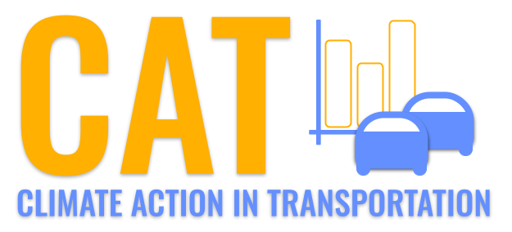 

**NOx Emissions in Hawaii County, 2050**  
Made with CAT VISUALIZER by Gao Labs @ Cornell University.



## Keywords

Oxides of Nitrogen; NOx emissions; on-road transportation; Hawaii County, HI; 2050; environmental impact

## Highlights

* Assessing NOx emissions from on-road transportation in Hawaii County, HI in 2050.
* Analyzing the impact of NOx emissions on air quality and public health.
* Investigating strategies to mitigate NOx emissions and promote sustainability.
* Highlighting the importance of addressing environmental concerns in transportation planning.
* Exploring the future outlook for NOx emissions in Hawaii County.

# Introduction

In this report, we examine the Oxides of Nitrogen (NOx) emissions resulting from on-road transportation in Hawaii County, HI in the year 2050. As the demand for transportation grows, concerns about the environmental impact of these emissions have become more pronounced. NOx emissions are known to contribute to air pollution, affecting air quality and public health.

Our analysis delves into the current state of NOx emissions in Hawaii County, projecting future trends based on anticipated changes in transportation technology and infrastructure. The report also explores potential strategies to mitigate NOx emissions and promote sustainable practices in transportation. By addressing these concerns, Hawaii County can work towards a cleaner, healthier environment for its residents.

# Emissions Rate (per vehicle) by Regulatory Class

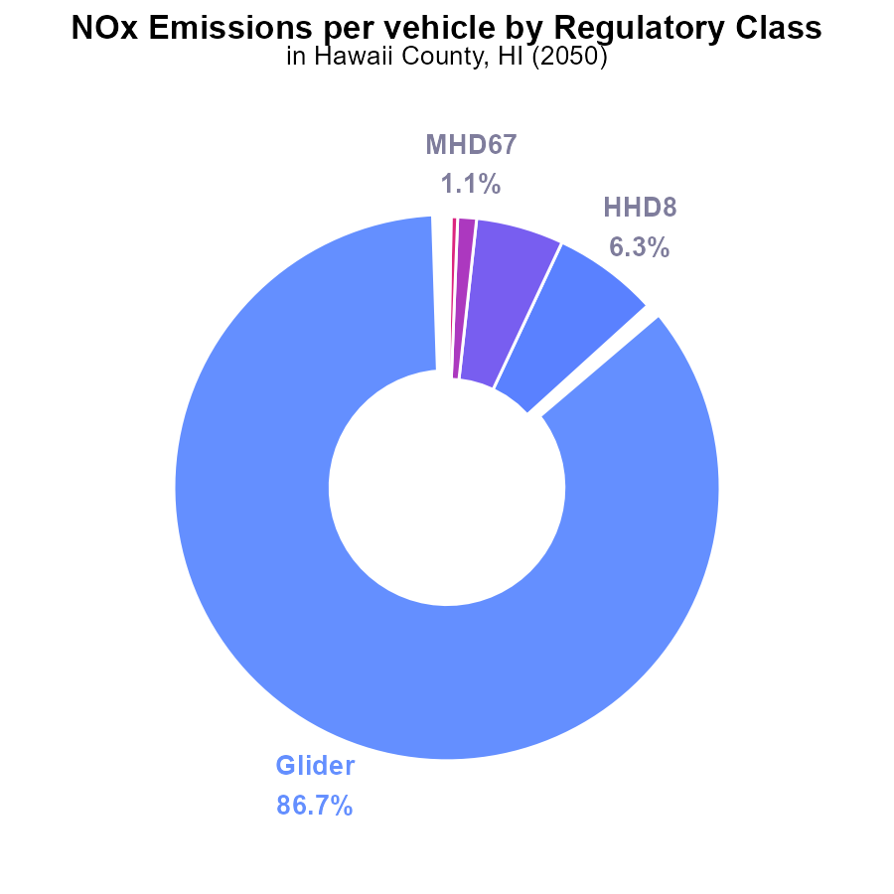

## Findings

* Glider vehicles contribute to 86.7% of NOx emissions per vehicle.
* Heavy-duty diesel vehicles (HHD8) and Urban buses also make significant contributions, 6.3% and 5.2% respectively.
* Light-duty trucks (LDT) and Light-duty vehicles (LDV) have minimal impact, contributing less than 0.1% each.

## Recommendations

To reduce NOx emissions, focus on reducing emissions from glider vehicles, HHD8, and Urban buses. Implement stricter emission standards, promote use of cleaner fuels, and invest in alternative transportation modes.

# Idling by Fuel Type



## Findings

* In 2050, diesel vehicles in Hawaii County emitted 0.0% of NOx from idling.
* No data available for CNG, ethanol, or gas vehicles in terms of NOx emissions from idling in 2050.

## Recommendations

To lower NOx emissions from idling in Hawaii County, focus on diesel vehicles for further reduction measures. Additionally, gather data on CNG, ethanol, and gas vehicles to assess their contribution and implement targeted strategies.

# Emissions Rate (per vehicle) over Time for Buses

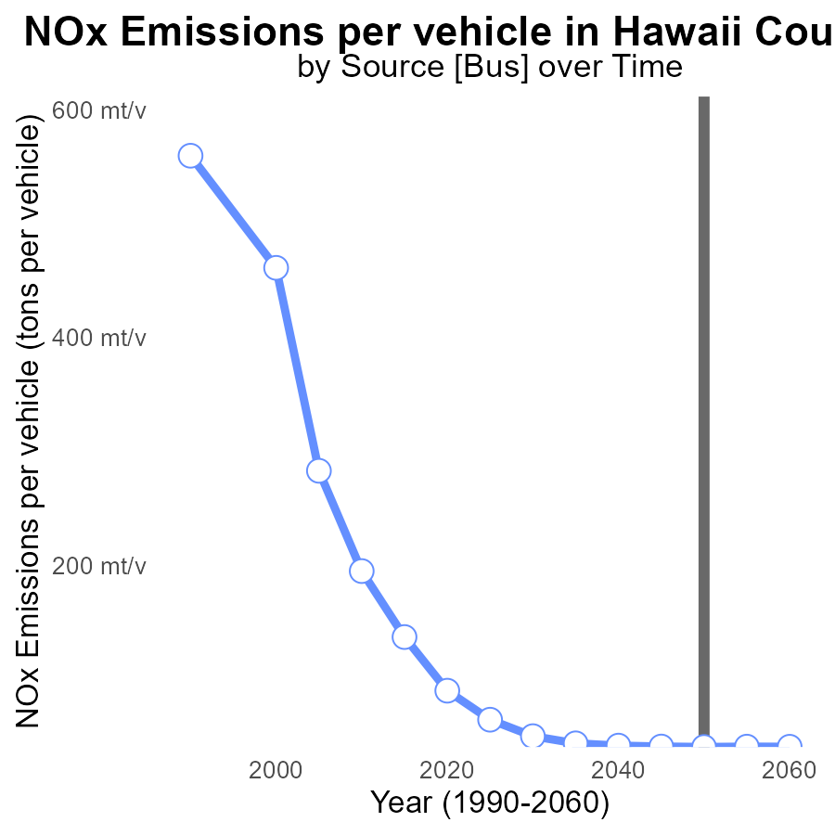

## Findings

* NOx emissions per vehicle in Hawaii County are decreasing steadily over the years.
* The benchmark difference shows a consistent improvement trend until 2050, where it stabilizes.
* From 2030 to 2060, there is an overall reduction in NOx emissions per vehicle by 9.3 tons.

## Recommendations

To further lower NOx emissions, Hawaii County should invest in promoting the use of electric vehicles, enhance public transportation, and enforce stricter emission standards for vehicles.

# Vehicles over Time for Buses

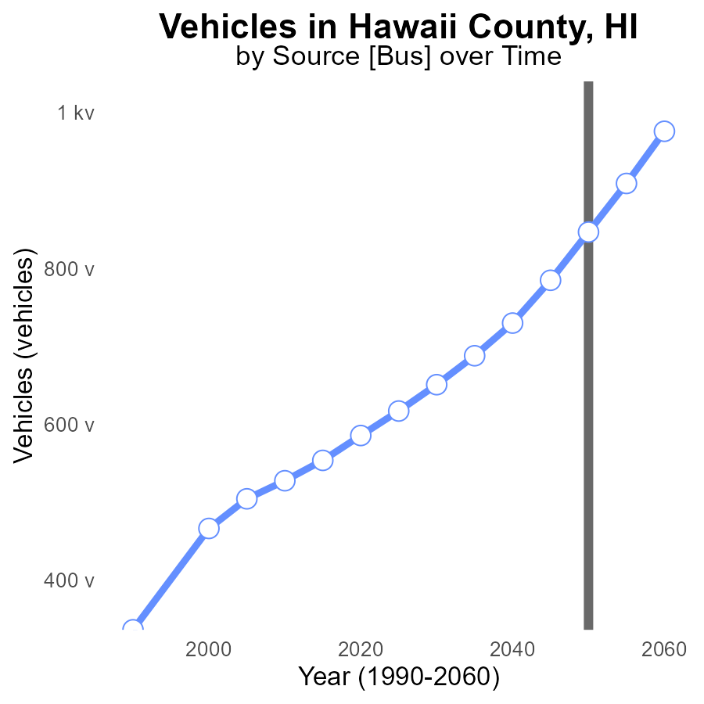

## Findings

* NOx emissions from vehicles in Hawaii County are projected to decrease by 23.1% from 2030 to 2050.
* By 2060, NOx emissions are expected to decrease by 15.1% compared to 2050 levels.
* The trend indicates a continuous reduction in NOx emissions from vehicles in Hawaii County over the next few decades.

## Recommendations

To further reduce NOx emissions, policymakers should consider promoting the adoption of electric vehicles, implementing stricter vehicle emissions standards, and investing in public transportation infrastructure.

# Vehicle Miles Traveled Mapped by Area

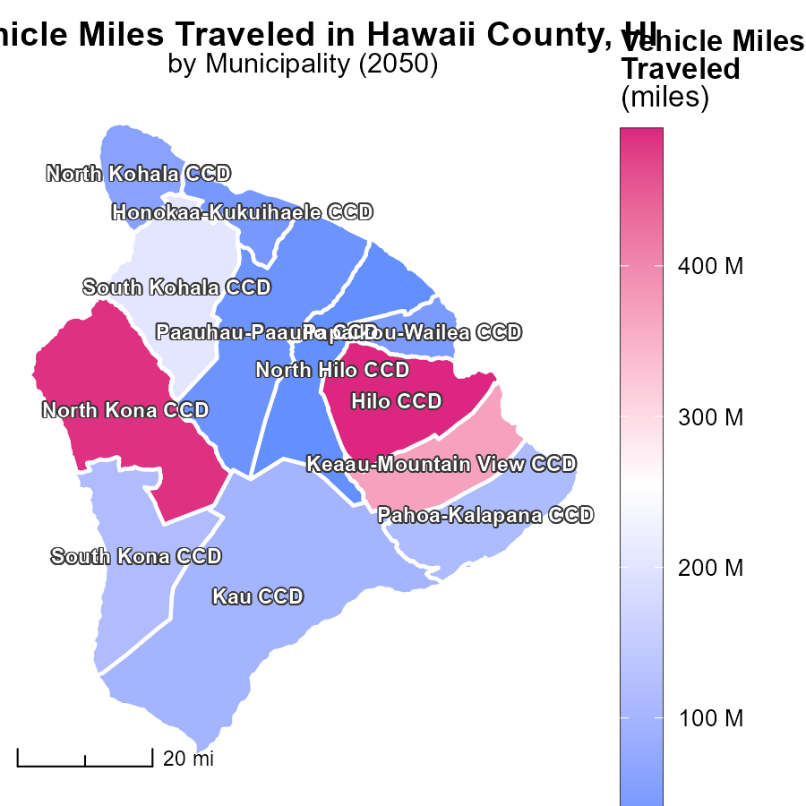

## Findings

* Hilo CCD, HI has the highest vehicle miles traveled at 490.7 million.
* Pahoa-Kalapana CCD, HI has a median vehicle miles traveled of 113.5 million.
* North Hilo CCD, HI has the lowest vehicle miles traveled at 16.9 million.

## Recommendations

To lower emissions, focus on improving public transportation in areas with high vehicle miles traveled, incentivize carpooling, and invest in infrastructure for biking and walking.

# Hotelling (Engines Off) in My Region

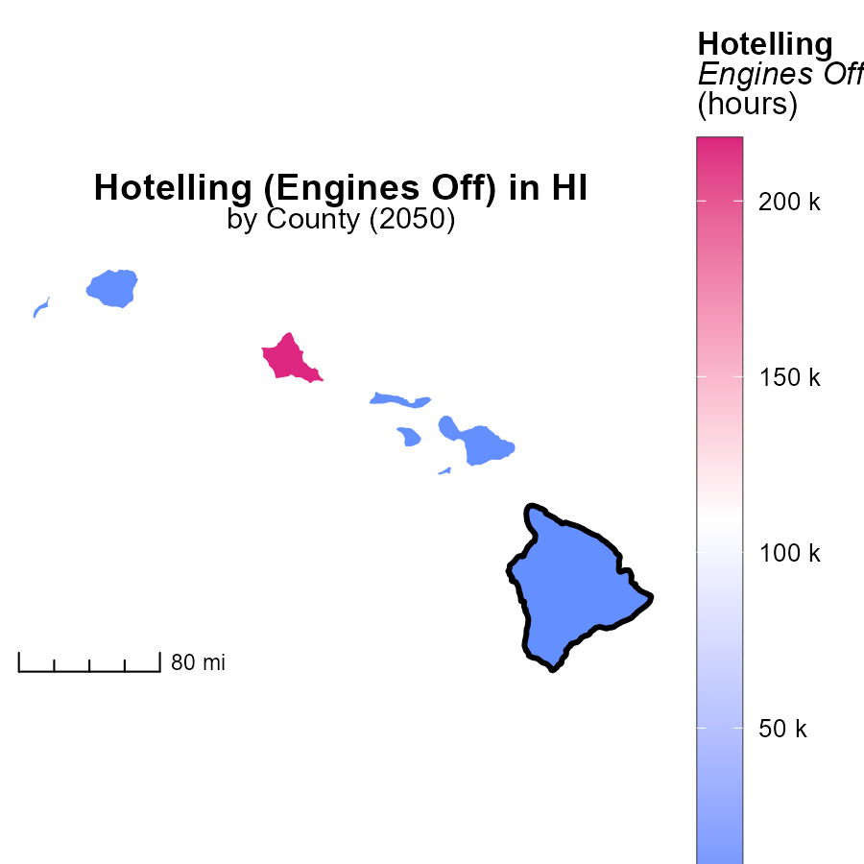

## Findings

* Honolulu County, HI has a maximum of 217.8k hours of emissions from Hotelling (Engines Off).
* Kalawao County, HI has a median value of 0.0 hours of emissions from Hotelling (Engines Off).
* Maui County, HI has a minimum of 0.0 hours of emissions from Hotelling (Engines Off).

## Recommendations

To lower emissions, prioritize transitioning to renewable energy sources in Honolulu County, continue monitoring emissions in Kalawao County to prevent any increase, and in Maui County, implement policies encouraging alternative transportation methods to reduce emissions.

# Hotelling (Engines Off) by Vehicle Type over Time

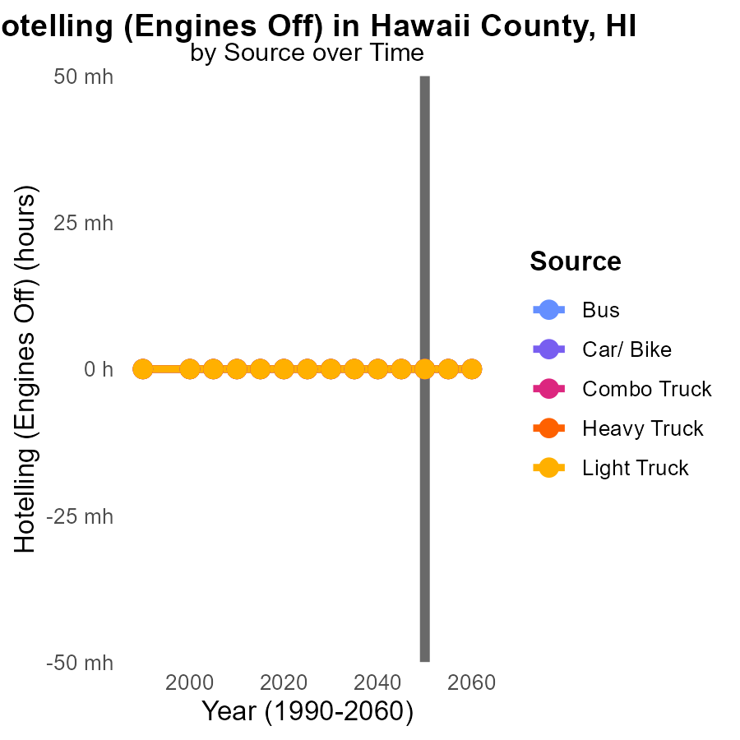

## Findings

* NOx emissions from vehicles in Hawaii County, HI are projected to be consistently 0.0 units from 2040 to 2060.
* This indicates a positive trend in the reduction of NOx emissions over this 20-year period.
* All types of vehicles, including Buses, Cars/Bikes, Combo Trucks, Heavy Trucks, and Light Trucks, are expected to maintain zero emissions.

## Recommendations

To further reduce emissions, policymakers can incentivize the adoption of electric vehicles, invest in public transportation infrastructure, and promote carpooling to maintain and accelerate the current trend of zero NOx emissions.

# Population by Fuel Type over Time

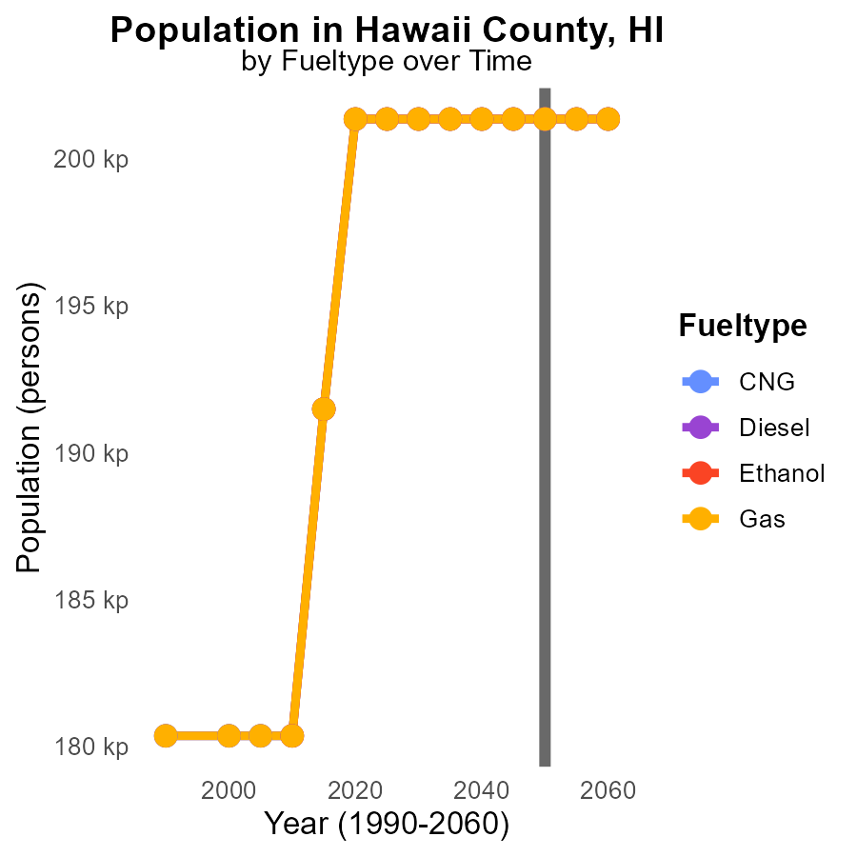

## Findings

* NOx emissions in Hawaii County are consistent across different fuel types from 2040 to 2060.
* The population is projected to remain constant at 201.4k residents from 2040 to 2060.
* There are no significant differences in NOx emissions by fuel type over the 20-year period.

## Recommendations

Given the consistent NOx emissions and population size, policymakers should focus on implementing sustainable transportation initiatives and promoting the use of cleaner fuel technologies to further reduce emissions.

# Areas Ranked by Emissions Rate (per mile)

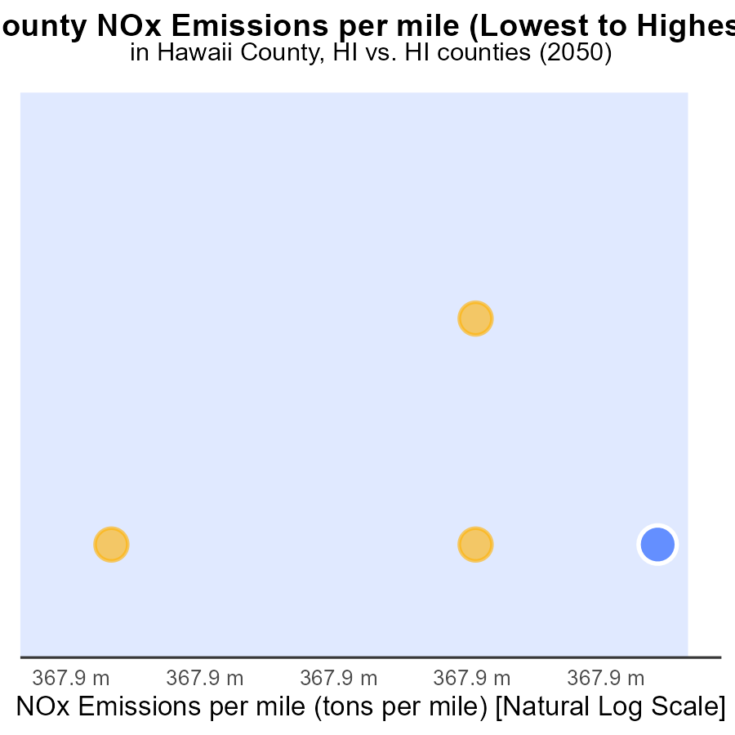

## Findings

* Hawaii emits 188.1 tons of NOx per mile, ranking 4th in emissions
* Kauai emits 180.7 tons of NOx per mile, ranking 3rd in emissions

## Recommendations

To lower NOx emissions, consider promoting alternative transportation methods, improving public transportation systems, implementing stricter vehicle emission standards, and encouraging the use of electric vehicles in Hawaii and Kauai.

# Areas Ranked by Time Driven

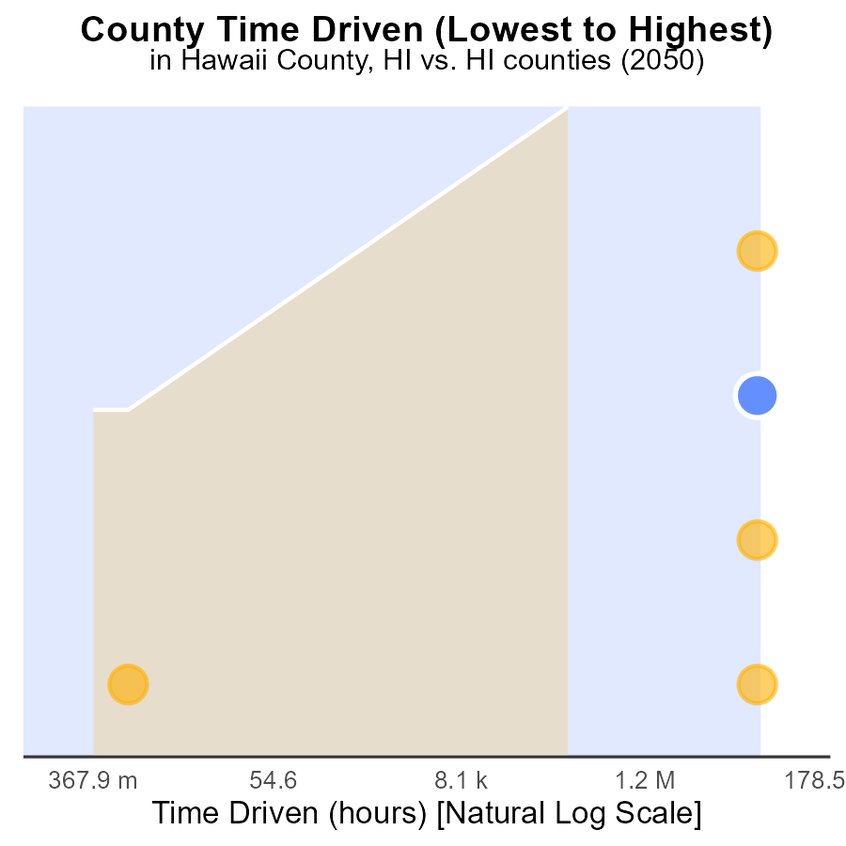

## Findings

* Honolulu has the highest NOx emissions with 180.1 million source hours.
* Hawaii ranks 4th in NOx emissions with 76.3 million source hours.
* Kalawao has the lowest NOx emissions with no recorded source hours.

## Recommendations

To reduce NOx emissions, Honolulu should focus on implementing stricter emissions standards for industries and vehicles. Hawaii should invest in cleaner technology to decrease emissions further, while Kalawao can continue its low-emission practices to maintain its status.

# Conclusion

In conclusion, the data from Hawaii County, HI in 2050 regarding Oxides of Nitrogen (NOx) emissions from on-road transportation paints a clear picture of the major contributors to NOx and the trends in emissions over the years. Glider vehicles were identified as the primary source of NOx emissions, followed by heavy-duty diesel vehicles and urban buses. To address these emissions, implementing stricter emission standards, promoting cleaner fuels, and investing in alternative transportation modes are crucial.

The data also showed a steady decrease in NOx emissions per vehicle over the years, with projections indicating a further reduction by 23.1% from 2030 to 2050. Electric vehicles, public transportation enhancements, and strict emissions regulations were highlighted as effective strategies to continue lowering NOx emissions in the county. The consistent 0.0 units of NOx emissions from vehicles between 2040 and 2060, regardless of fuel type, present an optimistic outlook for sustained emission reduction efforts in Hawaii County. Policymakers are recommended to focus on sustainable transportation initiatives, cleaner fuel technologies, and population-focused emission reduction strategies to maintain the positive trend observed in the data.

# About This Report

Data based on MOVES estimates collected by the Climate Action in Transportation program at Cornell University. Demographic data sourced from the US Census's American Community Survey 5-year estimates. This report was generated with the help of AI.

# References

* U.S. Census Bureau. (2023). American Community Survey 5-year estimates: Detailed tables. Retrieved from https://data.census.gov
* U.S. Environmental Protection Agency. (2024). Motor Vehicle Emission Simulator (MOVES 4.0) [Software]. Retrieved from https://www.epa.gov/moves