 

**SO2 Emissions in York County, 2035**  
Made with CAT VISUALIZER by Gao Labs @ Cornell University.

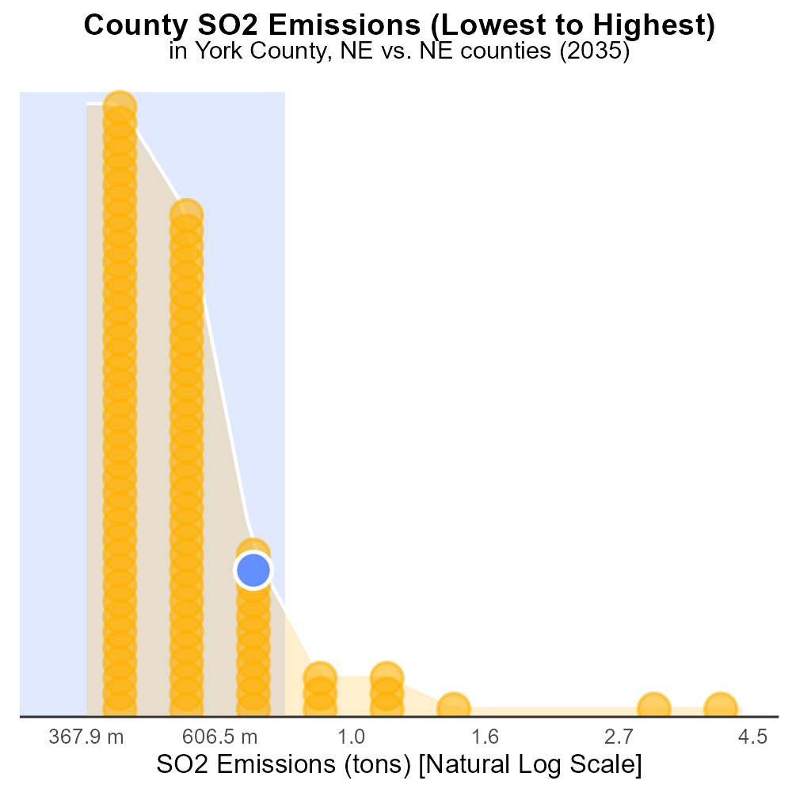

## Keywords

Sulfur Dioxides; SO2 emissions; on-road transportation; York County, NE; 2035

## Highlights

* Evaluating 2035 SO2 emissions from on-road transportation in York County, NE.
* Assessing the environmental impact and health risks of SO2 emissions.
* Projecting future trends and potential measures to reduce SO2 emissions.
* Analyzing the role of on-road transportation in air pollution in York County.
* Addressing the need for policy interventions to mitigate SO2 emissions.

# Introduction

Sulfur Dioxides (SO2) emissions from on-road transportation play a significant role in air quality and public health. This report focuses on examining the projected SO2 emissions in York County, NE in 2035, specifically from vehicles operating on the county's roads. With increasing concerns about air pollution and its detrimental effects, it is crucial to assess the environmental impact and health risks associated with high levels of SO2 emissions.

By analyzing current trends and future projections, this report aims to provide insights into the contribution of on-road transportation to SO2 emissions in York County. Additionally, it will explore potential strategies and interventions that could be implemented to reduce SO2 emissions and improve air quality in the region. Addressing the challenges posed by on-road transportation emissions requires a comprehensive understanding of the sources, trends, and impacts of SO2, paving the way for effective policy measures and sustainable solutions.

# Population by Regulatory Class

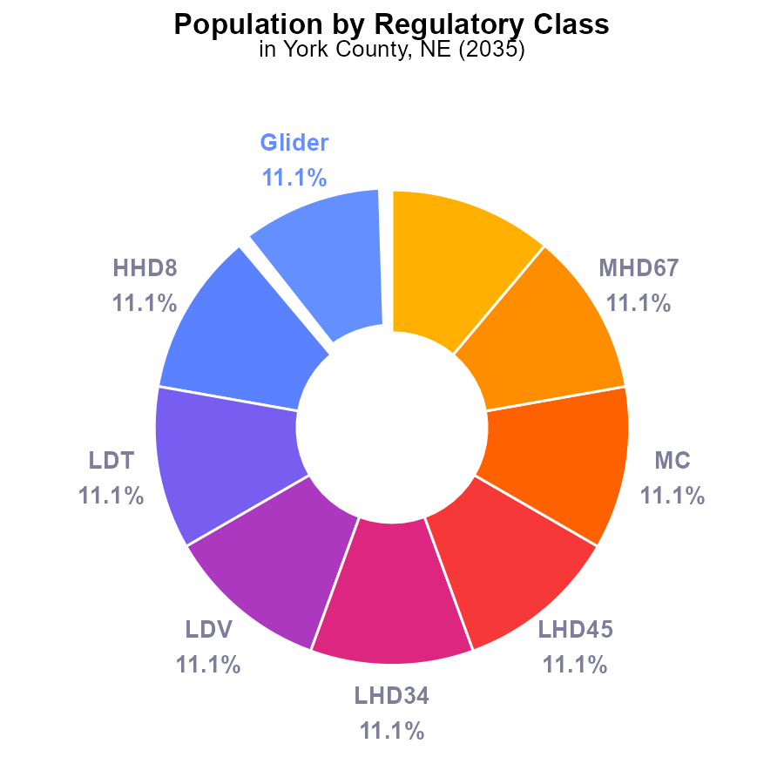

## Findings

* Glider, HHD8, LDT, LDV, LHD34, LHD45, MC, MHD67, and Urban Bus each contribute 11.1% of SO2 emissions.
* In 2035, all vehicle types in York County emit the same amount of SO2, totaling 123.3 k persons.
* SO2 emissions in York County are evenly distributed across different vehicle types and urban buses.

## Recommendations

To lower SO2 emissions in York County, consider implementing stricter emission standards for all vehicle types and urban buses to reduce the overall environmental impact. Encourage the use of cleaner fuels and alternative transportation methods.

# Hotelling (Engines Off) Overall by Area

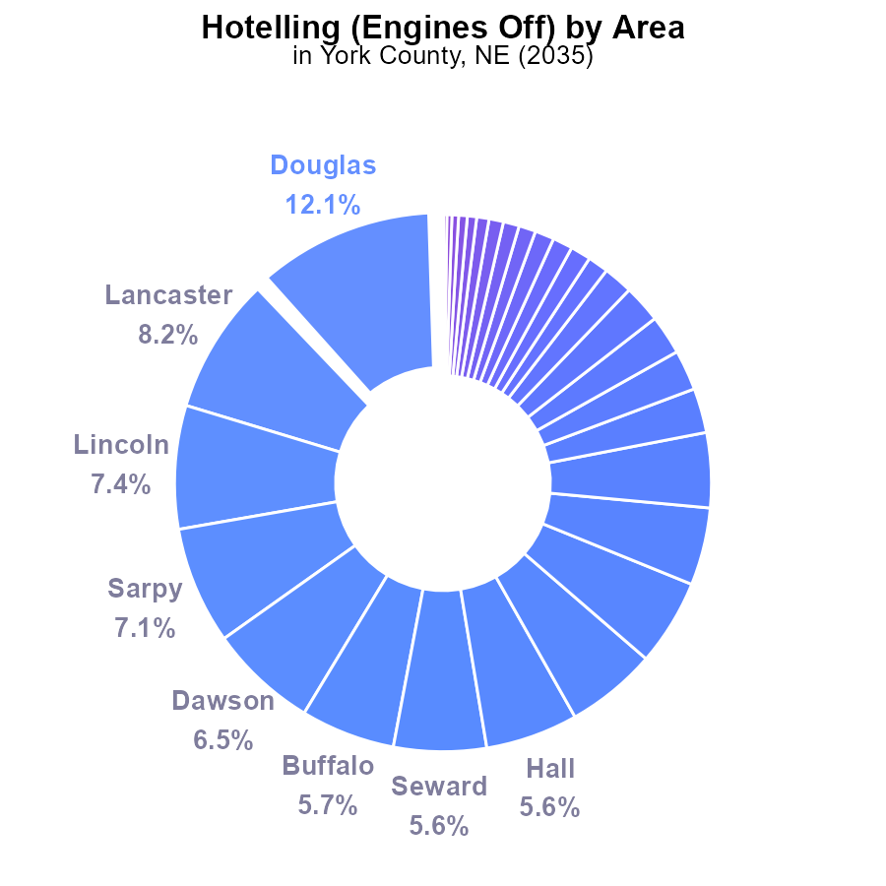

## Findings

* Top 5 counties (Douglas, Lancaster, Lincoln, Sarpy, Dawson) account for 40.2% of SO2 emissions.
* 27 counties have 0.0% SO2 emissions, indicating potential for overall reduction.
* Concentration in a few counties suggests targeted policies can yield substantial emission reductions.

## Recommendations

To lower SO2 emissions, focus efforts on top emitting counties. Implement emissions control measures, promote cleaner technologies, and monitor progress diligently for continual improvement.

# Emissions Rate (per vehicle) over Time for Buses

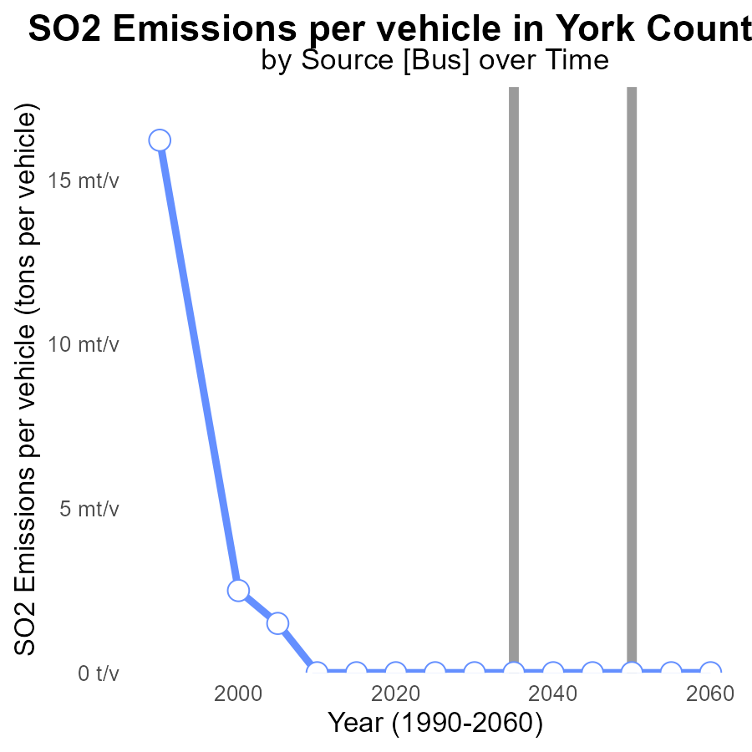

## Findings

* Emissions of SO2 per vehicle in York County, NE have been consistently at 0 tons from 2015 to 2055.
* There has been no change in SO2 emissions per vehicle, indicating a lack of progress in reducing pollution in the area.
* York County, NE has maintained the benchmark with no difference in emissions per vehicle from the set target.

## Recommendations

To lower emission levels, even though they are currently at 0, it is crucial for policymakers to implement sustainable transportation policies, incentivize zero-emission vehicles, and invest in renewable energy sources to prevent any future increase in emissions.

# Population over Time for Passenger Vehicles

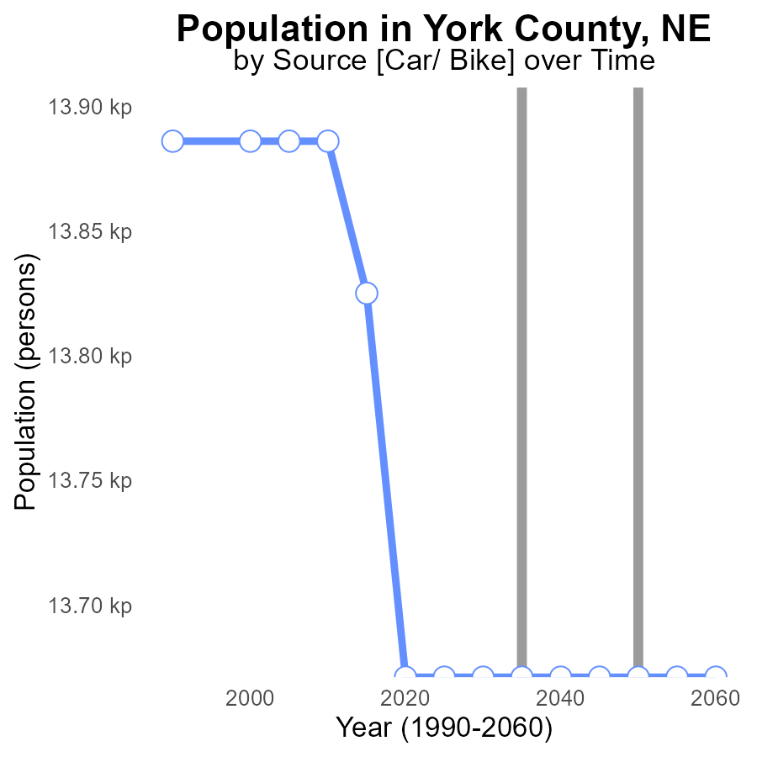

## Findings

* SO2 emissions in York County decreased by 1% from 2015 to 2020.
* SO2 emissions have remained constant at 13.7 kilotons from 2020 to 2055.
* The benchmark difference indicates that emissions have met the target since 2015.

## Recommendations

To maintain the achieved reduction, focus on implementing stricter regulations on industrial emissions. Regular monitoring and enforcement of emission standards are crucial to sustain the current levels.

# Vehicle Miles Traveled Mapped by Area

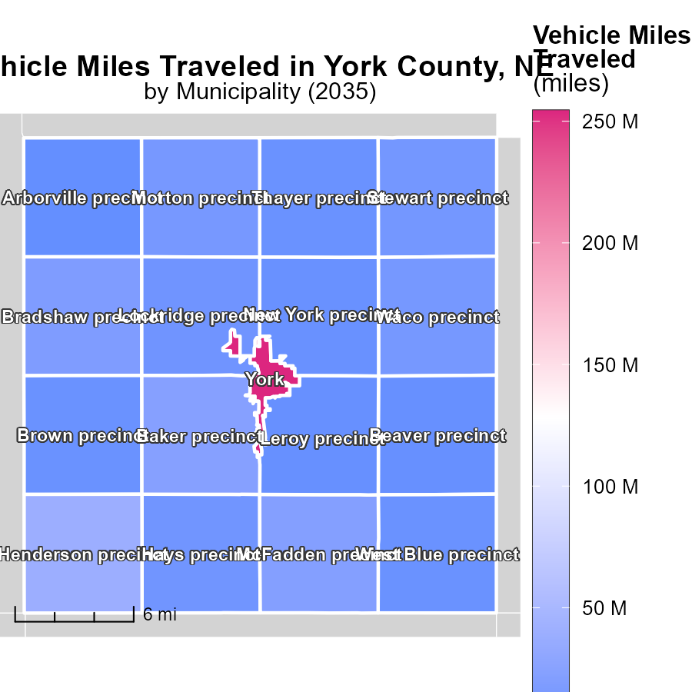

## Findings

* York, NE has the highest vehicle miles traveled with 254.3 million miles.
* Hays precinct, NE has a median of 9.5 million miles traveled by vehicles.
* Arborville precinct, NE has the lowest vehicle miles traveled at 2.2 million miles.

## Recommendations

To lower emissions, focus on reducing vehicle miles traveled in high-traffic areas like York, NE. Encourage carpooling or use of public transportation. For areas with lower mileage like Arborville precinct, promote eco-friendly transportation options to maintain low emissions levels.

# Population Mapped by Area

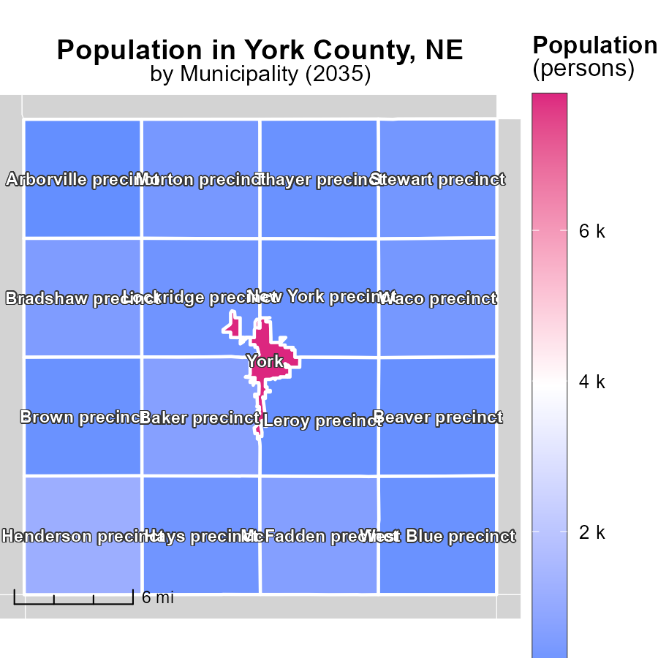

## Findings

* The highest population in York, NE is 7.8k.
* The median population in Hays precinct, NE is 293.
* The lowest population in Arborville precinct, NE is 69.

## Recommendations

To lower emissions, focus on areas with higher population densities like York, NE, implementing efficient public transportation and promoting carpooling. In regions like Arborville precinct, where the population is low, encourage sustainable activities to maintain lower emission levels.

# Vehicle Starts by Vehicle Type over Time

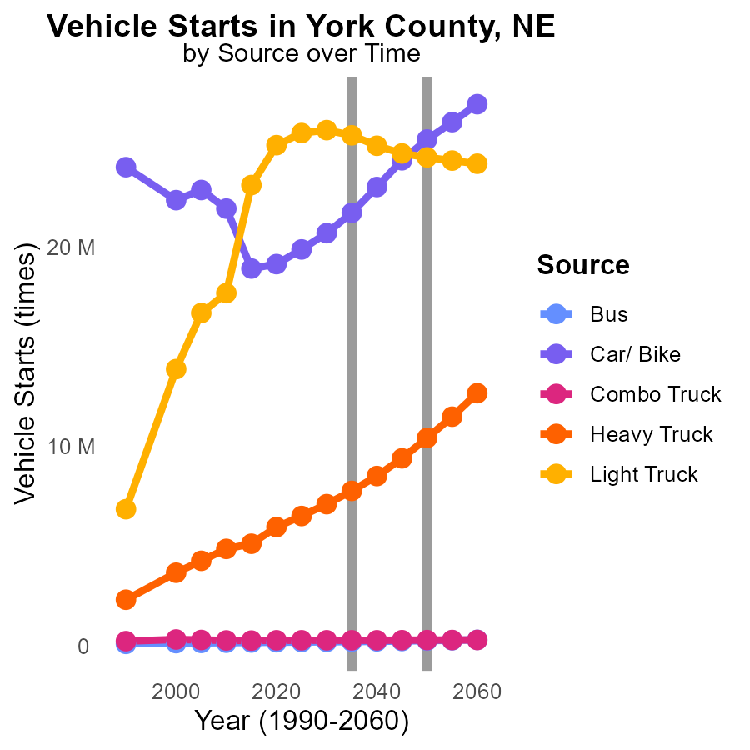

## Findings

* Emissions from Cars/ Bikes are projected to increase from 19.9M in 2025 to 24.3M in 2045, a 22% rise.
* Heavy Trucks emissions show a growth trend, from 6.5M in 2025 to 9.4M in 2045, representing a 45% increase.
* Combo Trucks are stable with a slight increase, from 277.4k in 2025 to 282.4k in 2045, an uptick of 2%.

## Recommendations

To reduce emissions, incentivize the transition to electric vehicles by expanding charging infrastructure. Implement stricter emission standards for heavy-duty trucks, encouraging the adoption of cleaner technologies. Promote public transportation to decrease reliance on individual vehicles.

# Time Driven by Vehicle Type over Time

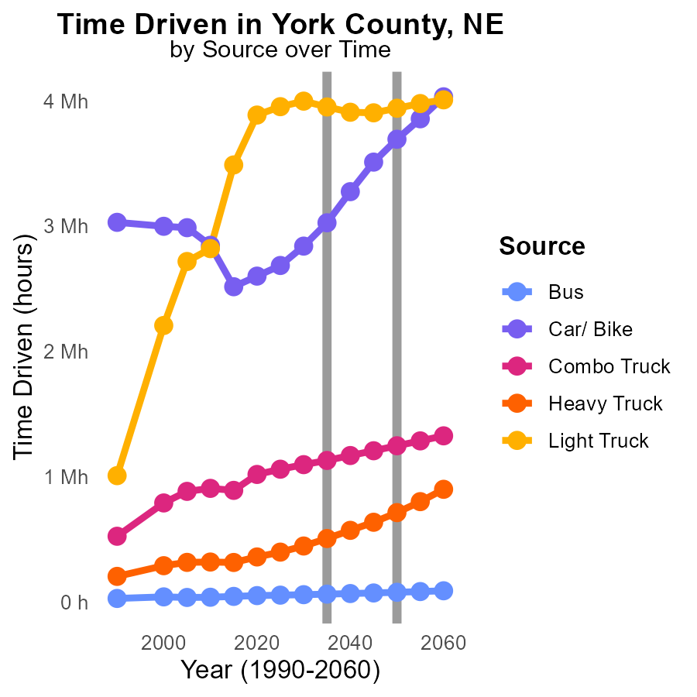

## Findings

* SO2 emissions from all vehicle types are projected to decrease from 2025 to 2045.
* The highest SO2 emissions in 2045 are expected from cars/bikes (3.5M) followed by light trucks (3.9M).
* Bus emissions show the most significant reduction, with a decrease of 55k from 2025 to 2045.

## Recommendations

To decrease SO2 emissions further, focus on promoting the use of buses to reduce emissions drastically. Implement policies to incentivize the use of public transportation and discourage private car use.

# Areas Ranked by Emissions

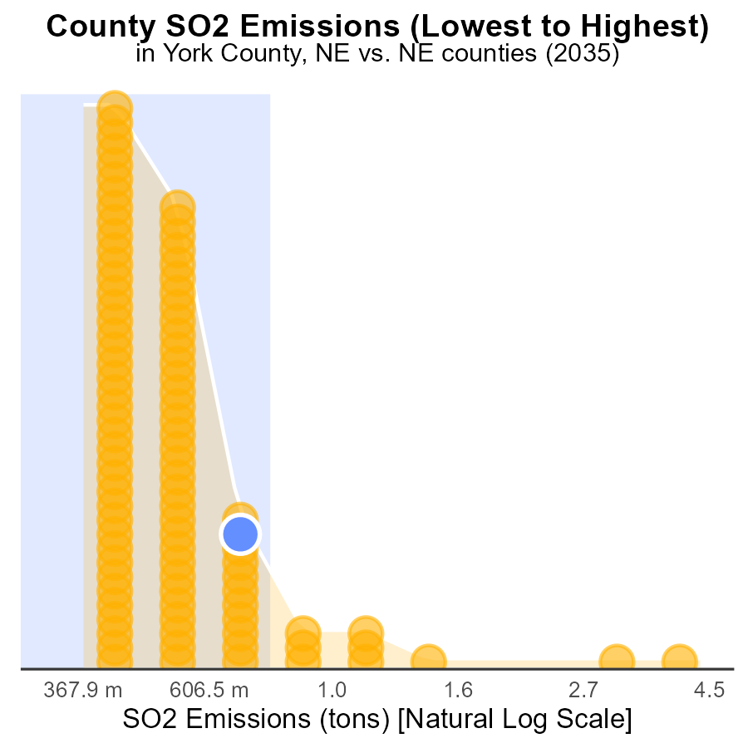

## Findings

* Douglas county has the highest SO2 emissions in tons with 11.1 tons.
* Arthur county has the lowest SO2 emissions with 0.0 tons, ranking 1st.
* York, Platte, and Keith counties have similar SO2 emissions around 1.0 to 1.1 tons, ranking in the 83rd to 84th percentile.

## Recommendations

To reduce overall SO2 emissions, focus on implementing stricter emission control measures in Douglas county, while maintaining efforts in York, Platte, and Keith to prevent an increase in emissions. Consider assisting Arthur county in sustaining its zero-emission status.

# Areas Ranked by Time Driven

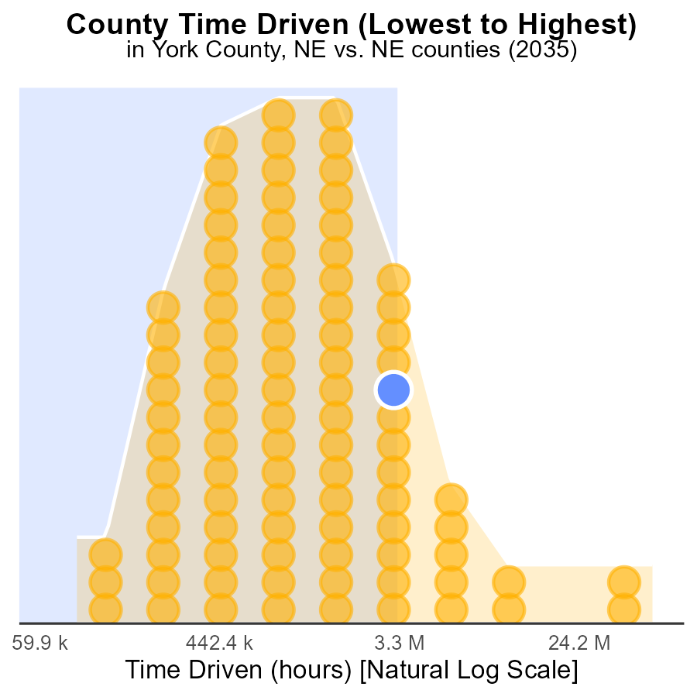

## Findings

* Douglas county has the highest SO2 emissions with 148.6 million source hours.
* Arthur county has the lowest SO2 emissions with 245.6 thousand source hours, ranking 1st.
* Scotts Bluff county ranks 81st in SO2 emissions, with 9.4 million source hours.

## Recommendations

To lower SO2 emissions, focus on decreasing source hours in Douglas county by introducing stricter emission controls. Invest in cleaner technologies in Scotts Bluff county to reduce emissions significantly. Develop sustainable practices in Arthur county to maintain the low emission levels.

# Conclusion

In conclusion, the analysis of Sulfur Dioxide (SO2) emissions from on-road transportation in York County, NE in 2035 reveals a relatively stable scenario with emissions evenly distributed across different vehicle types and urban buses. Despite the lack of improvement in SO2 emissions per vehicle over the years and the consistent total emissions, there is a potential for reduction by implementing stricter emission standards and promoting cleaner fuels and alternative transportation methods. Targeted policies in high-emitting counties and monitoring progress diligently are crucial for achieving substantial emission reductions. To maintain the achieved reductions and prevent future increases in emissions, sustainable transportation policies, incentivization of zero-emission vehicles, and investment in renewable energy sources are essential measures to be taken.

Efforts should focus on reducing vehicle miles traveled in high-traffic areas like York, NE, and promoting eco-friendly transportation options in low-mileage regions. In addition, the transition to electric vehicles, stricter regulations on industrial emissions, and promotion of buses as a mode of transportation can further contribute to lowering SO2 emissions. By combining these strategies with targeted approaches at the county level, it is possible to make significant progress towards reducing SO2 emissions from on-road transportation in York County, NE in 2035.

# About This Report

Data based on MOVES estimates collected by the Climate Action in Transportation program at Cornell University. Demographic data sourced from the US Census's American Community Survey 5-year estimates. This report was generated with the help of AI.

# References

* U.S. Census Bureau. (2023). American Community Survey 5-year estimates: Detailed tables. Retrieved from https://data.census.gov
* U.S. Environmental Protection Agency. (2024). Motor Vehicle Emission Simulator (MOVES 4.0) [Software]. Retrieved from https://www.epa.gov/moves