 

**VOC Emissions in Davis County, 2020**  
Made with CAT VISUALIZER by Gao Labs @ Cornell University.

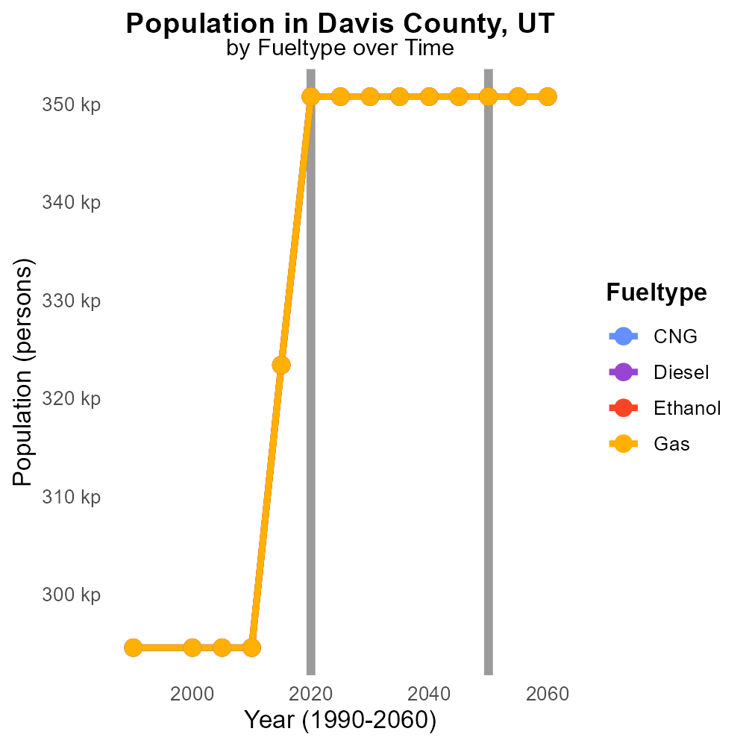

## Keywords

Volatile Organic Compounds; emissions; on-road transportation; Davis County; UT; 2020

## Highlights

* Study on VOC emissions from transportation in 2020 in Davis County, UT.
* Focus on impact on air quality and public health.
* Analysis of sources, trends, and mitigation strategies.
* Significance of reducing VOC emissions for environmental sustainability.
* Implications for policy-making and future research.

# Introduction

In 2020, the emissions of Volatile Organic Compounds (VOCs) from on-road transportation in Davis County, UT, became a focal point of concern due to their significant impact on local air quality and public health. This report aims to thoroughly examine the sources, trends, and effects of VOC emissions within the county, shedding light on the potential risks they pose to the environment and community well-being.

The findings of this study are crucial for understanding the current state of air pollution in Davis County and formulating effective strategies to mitigate VOC emissions. By investigating the levels of VOCs released by on-road transportation, we can assess the urgency of reducing these harmful pollutants for the sake of environmental sustainability and public health. This report also discusses the implications of its results for policy-makers, urging proactive measures to curb VOC emissions and advocating for further research in this field.

# Emissions Rate (per capita) by Regulatory Class

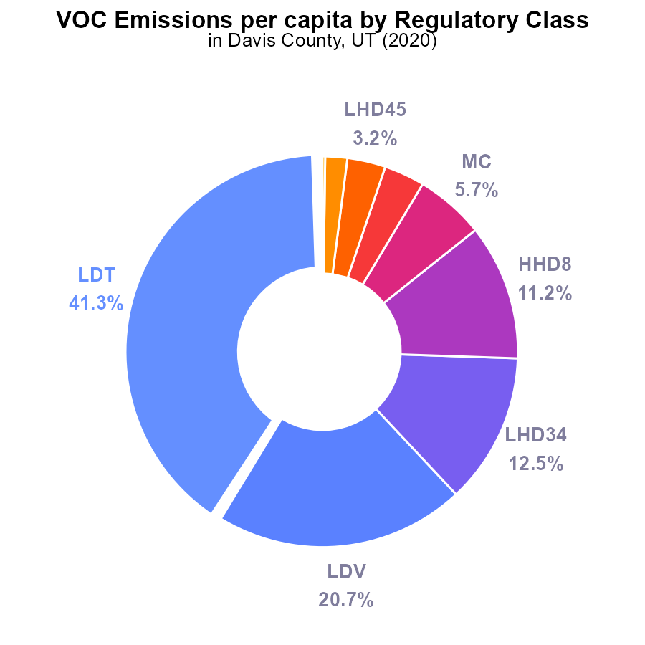

## Findings

* Light-duty trucks (LDT) are the largest contributor to VOC emissions per capita, accounting for 41.3% of total emissions.
* Significant contributors also include light-duty vehicles (LDV) at 20.7% and heavy-duty vehicles with 12.5% of total emissions per capita.
* In contrast, urban buses have the lowest impact, contributing only 0.2% of VOC emissions per capita.

## Recommendations

To reduce VOC emissions in Davis County, it is recommended to focus on mitigating emissions from light-duty trucks, light-duty vehicles, and heavy-duty vehicles. Implementing stricter vehicle emissions standards, encouraging the use of electric or hybrid vehicles, and promoting public transportation can all contribute to lowering emissions levels significantly.

# Idling by Regulatory Class

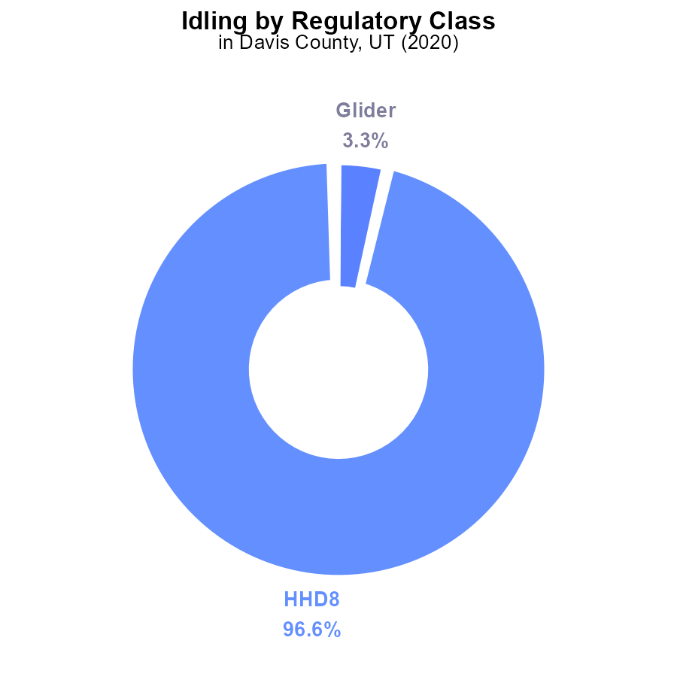

## Findings

* HHD8 vehicles contributed to 96.6% of VOC emissions from idling in Davis County in 2020.
* Glider vehicles accounted for 3.3% of VOC emissions from idling in the same period.
* MHD67 vehicles only contributed 0.1% to VOC emissions from idling.

## Recommendations

To lower VOC emissions from idling in Davis County, focus on reducing idling time of HHD8 vehicles, implementing stricter regulations for glider vehicles, and monitoring MHD67 vehicles closely.

# Idling over Time for Passenger Idling

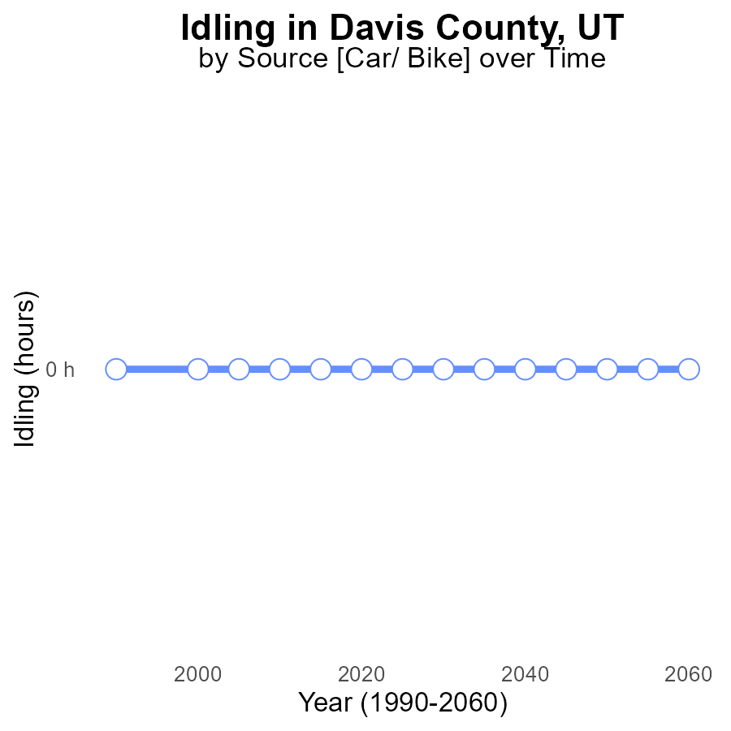

## Findings

* Between 2000-2040, no VOC emissions from idling were reported in Davis County, UT.
* The emissions remained constant at 0.0 hours throughout the entire period.
* The benchmark difference also indicates no change in emissions compared to the benchmark.

## Recommendations

Since VOC emissions from idling have remained consistently at zero in Davis County, UT, it is crucial to continue monitoring and implementing measures to maintain this achievement. Regular checks on vehicles, promoting alternative transportation modes, and educating the public on the importance of reducing idling can further help in keeping emissions at negligible levels.

# Time Driven over Time for Buses

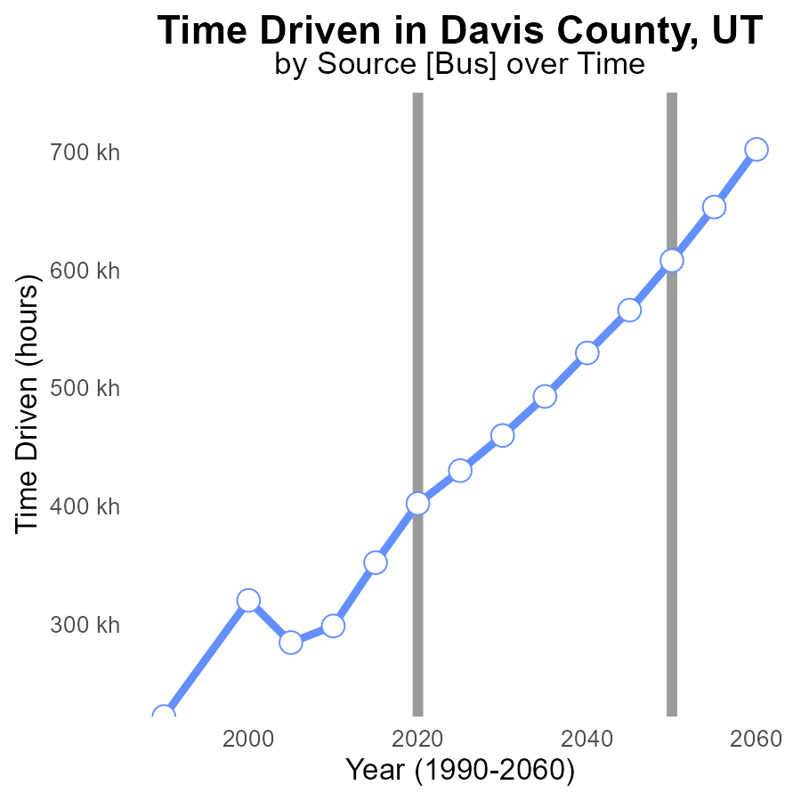

## Findings

* Emissions in Davis County, UT are increasing steadily from 2000 to 2040.
* The benchmark difference shows a consistent reduction over time, indicating improvements.
* By 2040, the emissions are projected to reach 529.7 k, with a benchmark difference of 78178.3.

## Recommendations

To lower emissions, Davis County should focus on implementing stricter regulations on VOC emissions from various sources like industrial activities and transportation. Additionally, promoting the use of electric vehicles and enhancing public transportation can significantly reduce emissions in the area.

# Vehicles Mapped by Area

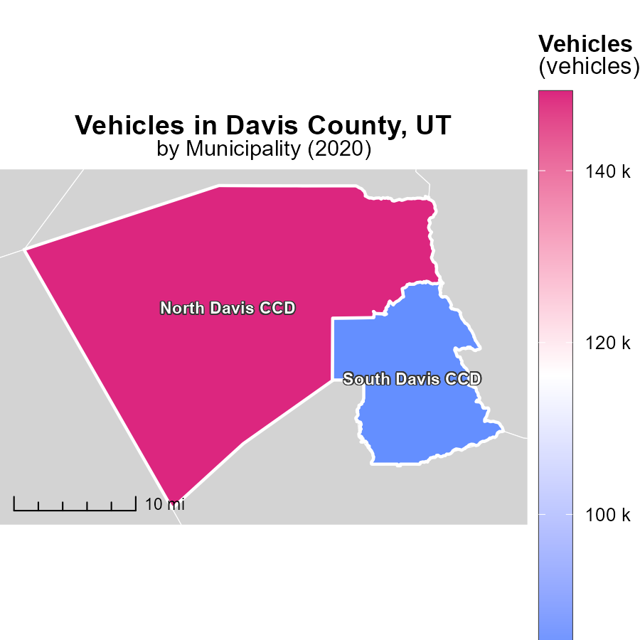

## Findings

* In 2020, North Davis CCD, UT emitted 149.2 kilotons of CO2 from vehicles, exceeding South Davis CCD, UT's 83.2 kilotons.
* North Davis CCD, UT had a higher maximum emission, with a difference of 66 ktons compared to South Davis CCD, UT.
* South Davis CCD, UT had a median emission level of 83.2 kilotons, indicating a balanced distribution in emissions from vehicles.

## Recommendations

To lower emissions, North Davis CCD, UT should focus on reducing high outliers causing the significant difference observed. South Davis CCD, UT can strive for further reductions to bring down the median emission level.

# Emissions Rate (per capita) in My Region

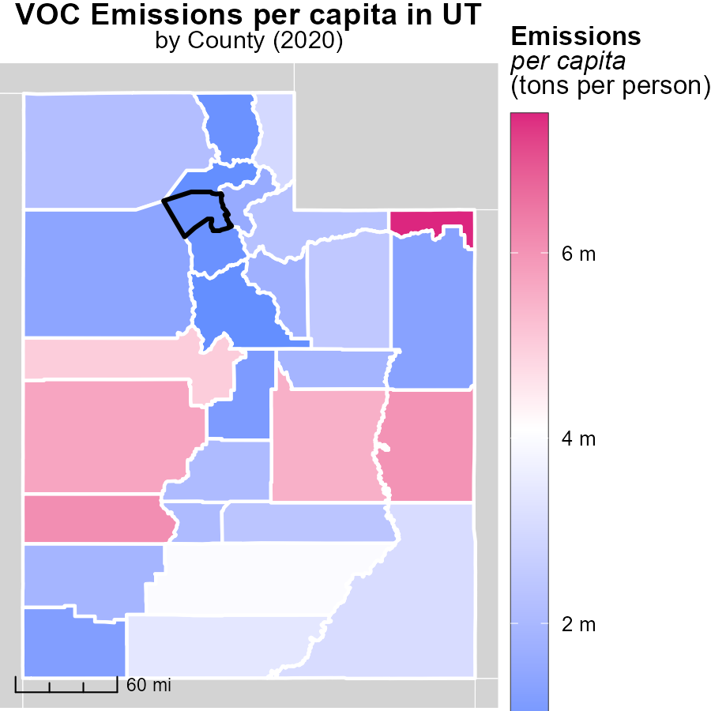

## Findings

* Daggett County, UT had the highest emissions per capita at 7.5 tons per person
* Piute County, UT had a median emissions level of 2.1 tons per person
* Weber County, UT had the lowest emissions per capita at 730.2 kilograms per person

## Recommendations

To lower emissions, Daggett County should focus on reducing its per capita emissions through implementing green initiatives. Piute County can maintain its median level while promoting sustainable practices. Weber County should continue efforts to decrease emissions further to set an example for other counties.

# Time Driven by Vehicle Type over Time

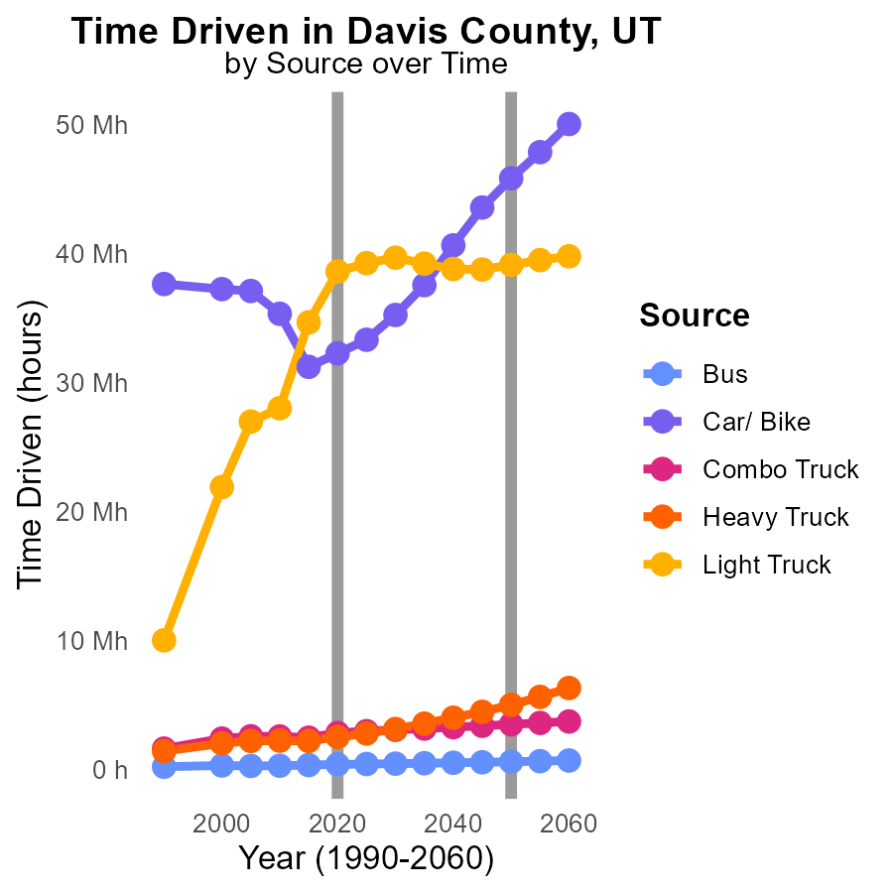

## Findings

* VOC emissions from buses are projected to decrease by 51.4% from 2010 to 2030
* Car and Bike VOC emissions are forecasted to decrease by 67.5% from 2010 to 2030
* VOC emissions from Heavy Trucks are estimated to reduce by 35.1% from 2010 to 2030

## Recommendations

To further lower VOC emissions, focus on promoting the adoption of electric buses to replace traditional buses. Encourage the use of bicycles and promote carpooling to reduce the reliance on personal vehicles. Invest in the upgrade of heavy trucks to more fuel-efficient models.

# Population by Fuel Type over Time

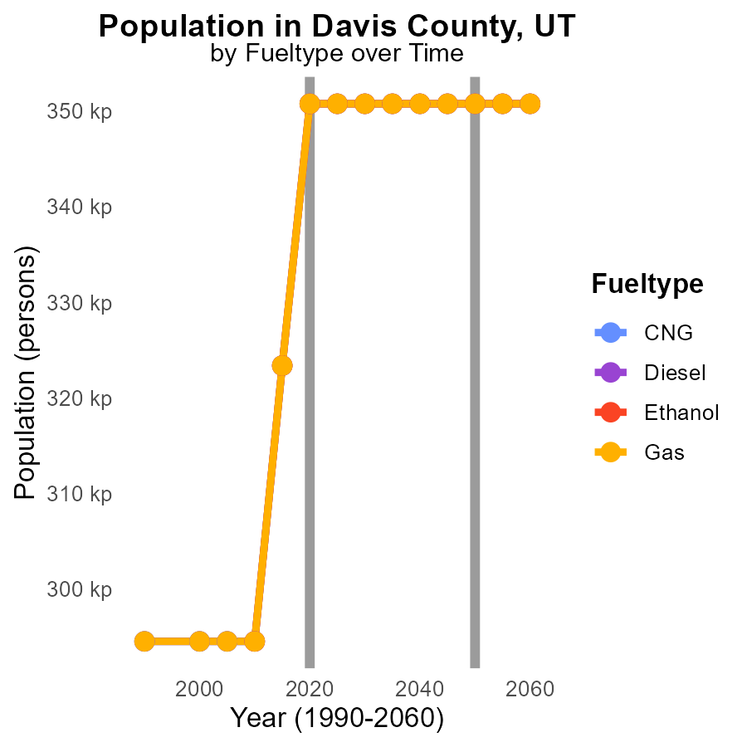

## Findings

* CNG emissions remained constant at 350.8k from 2020 to 2030.
* Diesel, Ethanol, and Gas emissions held steady at 350.8k from 2020 to 2030.
* Overall, there was a significant decrease in emissions from 2010 to 2030 for all fuel types.

## Recommendations

To continue reducing emissions, policy interventions such as promoting electric vehicles and enhancing public transportation should be prioritized for a sustainable future.

# Areas Ranked by Time Driven

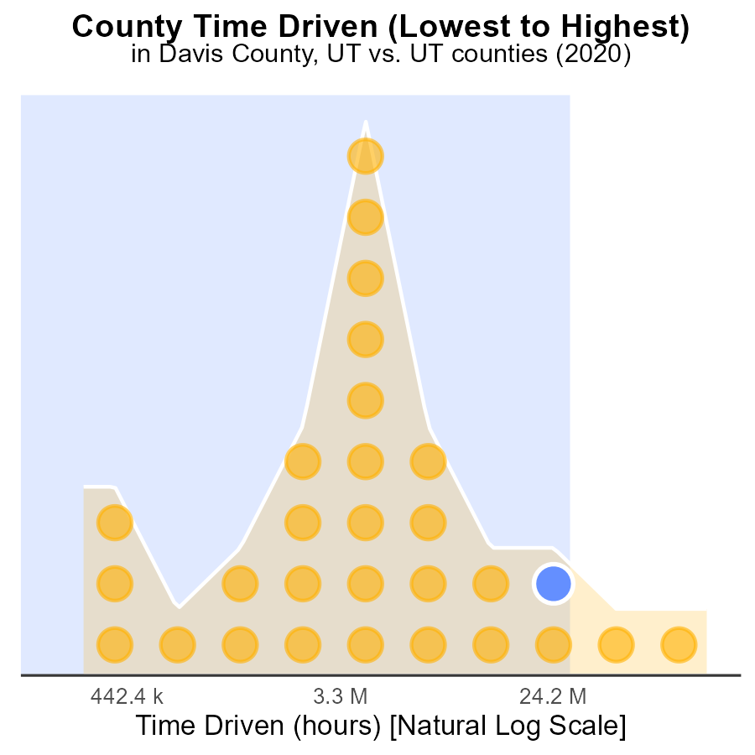

## Findings

* Salt Lake county had the highest VOC emissions in 2020 with 285.7 million hours.
* Davis county ranked 27th with 76.6 million hours and Piute county ranked 1st with 796.3 thousand hours.
* Overall, Salt Lake, Utah, and Weber counties together contributed over 70% of total VOC emissions.

## Recommendations

To reduce VOC emissions, focus on implementing stricter regulations on high-emission sources in Salt Lake, Utah, and Weber counties. Encourage the use of cleaner technologies and practices to reduce air pollution.

# Areas Ranked by Emissions Rate (per vehicle)

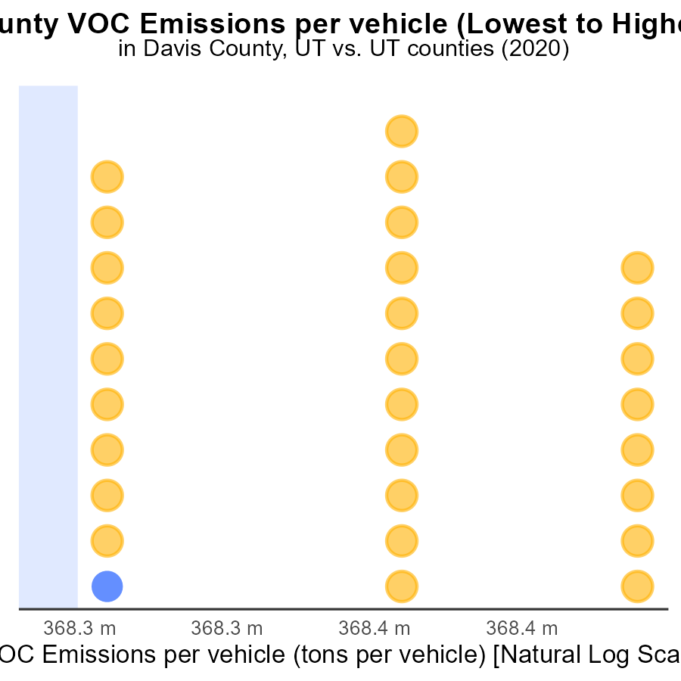

## Findings

* Davis county has the highest emissions per vehicle at 3.4 tons per vehicle
* Salt Lake county ranks 2nd with emissions per vehicle at 6.9%
* Washington county has the lowest emissions per vehicle at 100.0%

## Recommendations

To lower emissions, Davis and Salt Lake counties should focus on implementing stricter vehicle emission standards and promoting the use of public transportation. Washington county should continue its efforts to maintain low emissions levels.

# About This Report

Data based on MOVES estimates collected by the Climate Action in Transportation program at Cornell University. Demographic data sourced from the US Census's American Community Survey 5-year estimates. This report was generated with the help of AI.

# References

* U.S. Census Bureau. (2023). American Community Survey 5-year estimates: Detailed tables. Retrieved from https://data.census.gov
* U.S. Environmental Protection Agency. (2024). Motor Vehicle Emission Simulator (MOVES 4.0) [Software]. Retrieved from https://www.epa.gov/moves