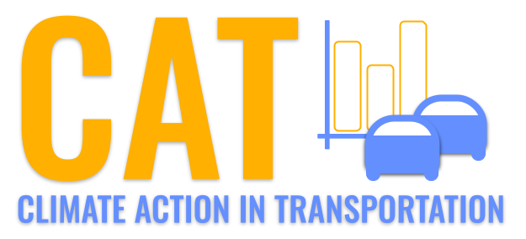 

**PM2.5 Emissions in Meigs County, 2020**  
Made with CAT VISUALIZER by Gao Labs @ Cornell University.

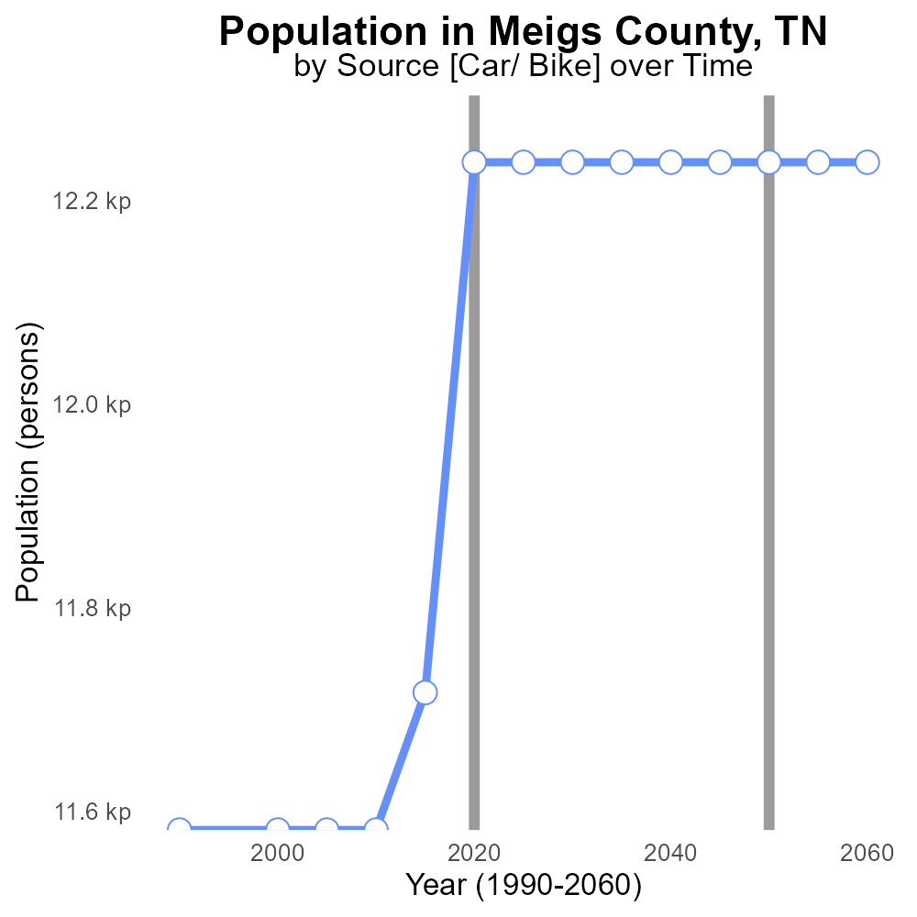

## Keywords

Primary Exhaust PM2.5; Total emissions; on-road transportation; Meigs County; TN; 2020

## Highlights

* Examination of primary exhaust PM2.5 emissions in Meigs County, TN.
* Analysis of total emissions from on-road transportation in 2020.
* Implications of high PM2.5 levels on public health and the environment.
* Identification of key contributors to air pollution in the county.
* Recommendations for reducing PM2.5 emissions for a sustainable future.

# Introduction

The report focuses on assessing the impact of primary exhaust PM2.5 emissions from on-road transportation in Meigs County, Tennessee, during the year 2020. With a growing concern for air quality, it is crucial to understand the sources and extent of PM2.5 pollutants in the region.

By analyzing the total emissions generated by on-road transportation, we aim to gain insights into the level of pollution and its potential consequences on public health and the environment. Through this report, we seek to identify the major contributors to PM2.5 emissions and provide recommendations for mitigating their effects in Meigs County.

# Vehicle Miles Traveled Overall by Area

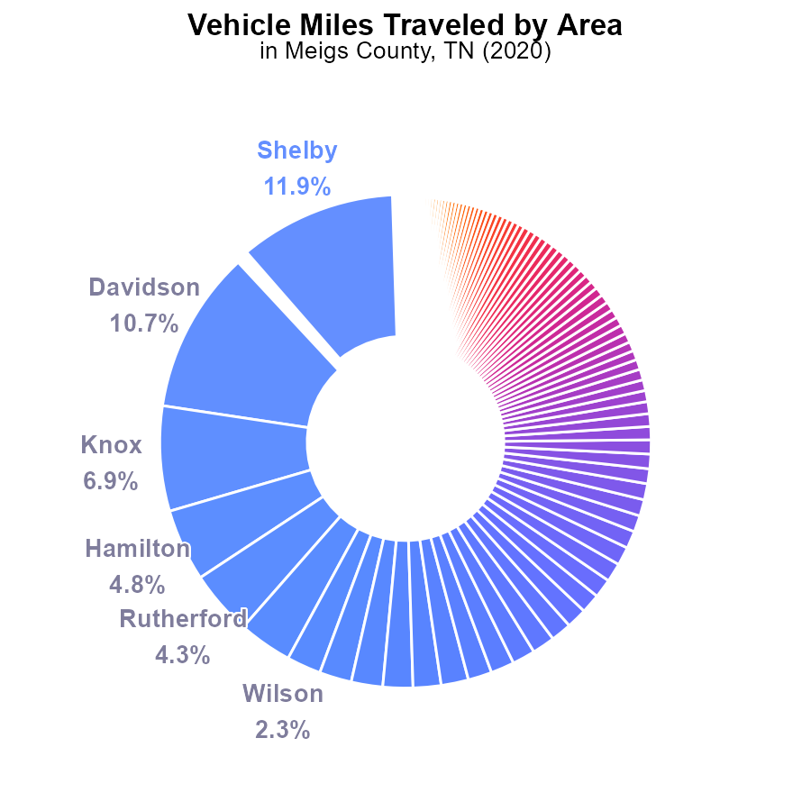

## Findings

* The top five counties with the highest PM2.5 emissions from vehicle miles traveled in 2020 were Shelby (9.7 G), Davidson (8.7 G), Knox (5.6 G), Hamilton (3.9 G), and Rutherford (3.4 G).
* Counties with the lowest PM2.5 emissions from vehicle miles traveled in 2020 were Lake (44.8 M), Hancock (46.9 M), Pickett (54.6 M), Moore (70.7 M), and Houston (70.7 M).
* Overall, vehicle miles traveled contributed to PM2.5 emissions across all counties in Tennessee in 2020, indicating a need for targeted emissions reduction strategies.

## Recommendations

To reduce PM2.5 emissions, policymakers should prioritize strategies like promoting electric vehicles, investing in public transportation, implementing vehicle emission standards, and encouraging carpooling to decrease overall vehicle miles traveled in the state.

# Hotelling (Engines Off) by Road Type

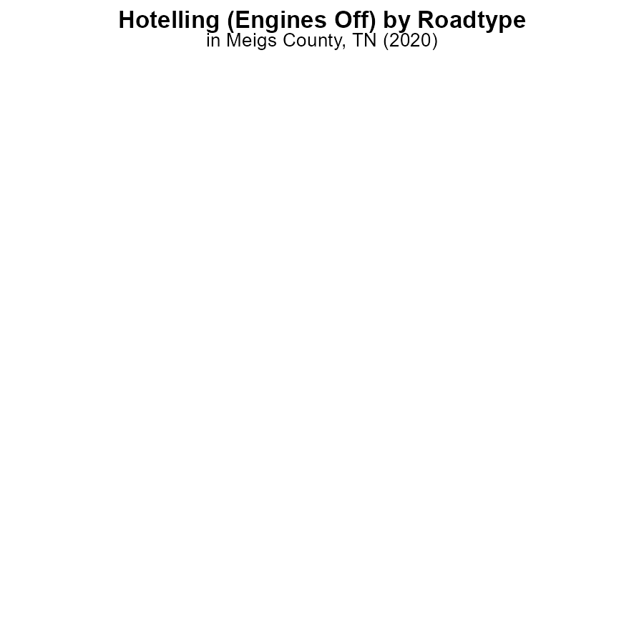

## Findings

* In 2020, no PM2.5 emissions were recorded in Meigs County, TN from Hotelling (Engines Off) activities.
* All types of areas (Rural Restricted, Rural Unrestricted, Urban Restricted, Urban Unrestricted) showed 0.0 hours of PM2.5 emissions.
* No percentage distribution data is available as all emissions were zero.

## Recommendations

To further minimize emissions in Meigs County, TN, it is suggested to monitor and enforce Hotelling activities to ensure compliance with regulations. Additionally, promoting the use of emission-reducing technologies can help maintain the current emission-free status.

# Population over Time for Passenger Vehicles

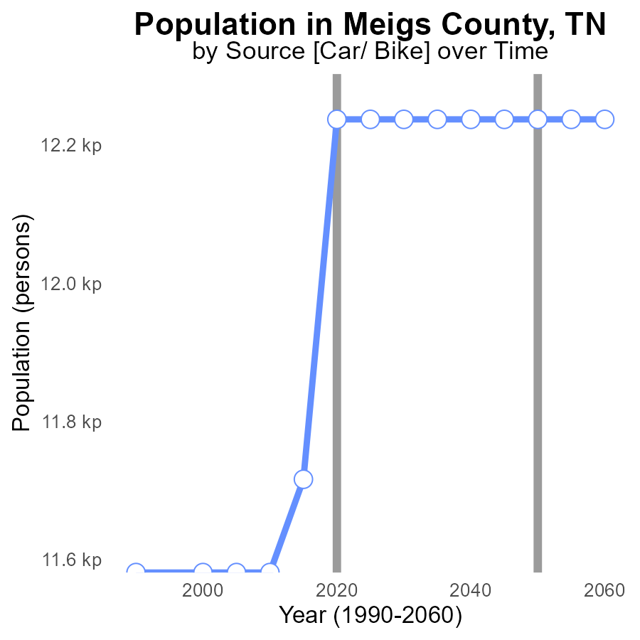

## Findings

* PM2.5 emissions in Meigs County, TN have remained stable from 2000 to 2010 at around 11.6k persons.
* Between 2015 and 2020, there was a slight increase in PM2.5 emissions from 11.7k to 12.2k persons.
* From 2020 to 2040, PM2.5 emissions are projected to stay constant at 12.2k persons.

## Recommendations

To lower PM2.5 emissions in Meigs County, TN, initiatives such as promoting clean energy sources, enhancing public transportation to reduce individual vehicle usage, and enforcing stricter emission regulations on industries should be considered.

# Vehicle Starts over Time for Passenger Vehicle Starts

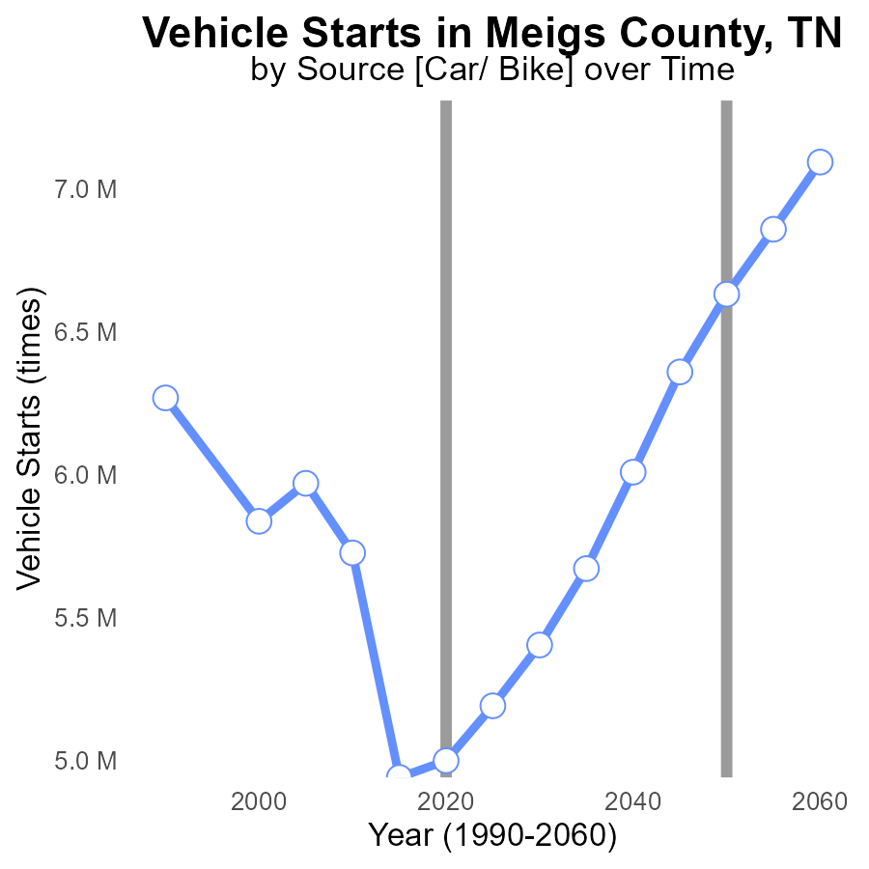

## Findings

* From 2000 to 2020, vehicle starts in Meigs County remained relatively stable, ranging from 5.8 to 5.0 million.
* There was a significant spike in PM2.5 emissions between 2010 and 2015, with levels increasing from 5.7 to 4.9 million times the benchmark.
* Despite minor fluctuations, PM2.5 emissions are projected to decrease gradually from 2025 to 2040, reaching levels slightly above the benchmark in 2040.

## Recommendations

To lower PM2.5 emissions in Meigs County, it is essential to implement stricter vehicle emission standards, promote the use of electric vehicles, and improve public transportation systems. Additionally, investing in infrastructure for biking and walking can help reduce dependency on vehicles.

# Idling Mapped by Area

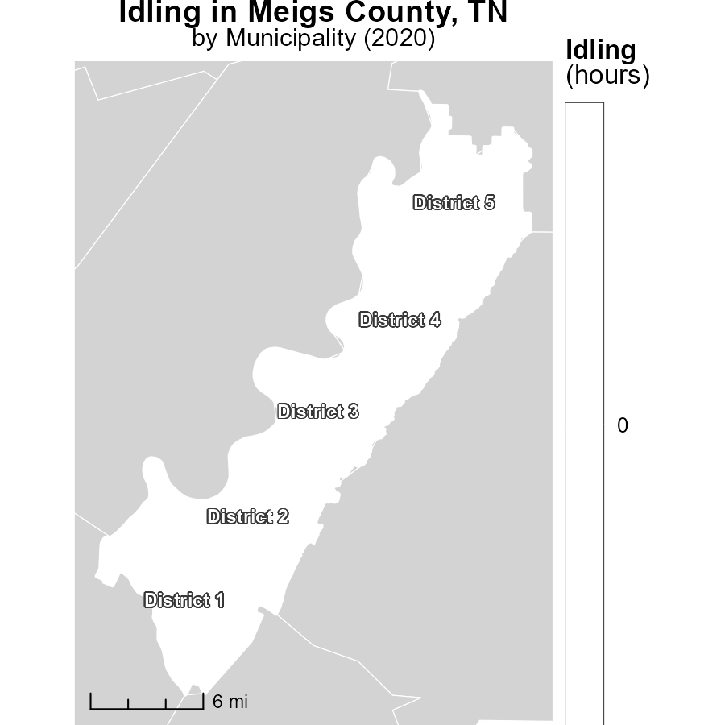

## Findings

* District 1, TN had the highest idling hours in 2020 at 0.0 hours.
* District 3, TN had a median idling time of 0.0 hours.
* District 5, TN had the lowest idling hours in 2020 at 0.0 hours.

## Recommendations

To lower idling emissions, consider implementing idling reduction policies such as promoting anti-idling campaigns, providing incentives for using idle-reduction technologies, and enforcing idling restrictions.

# Time Driven Mapped by Area

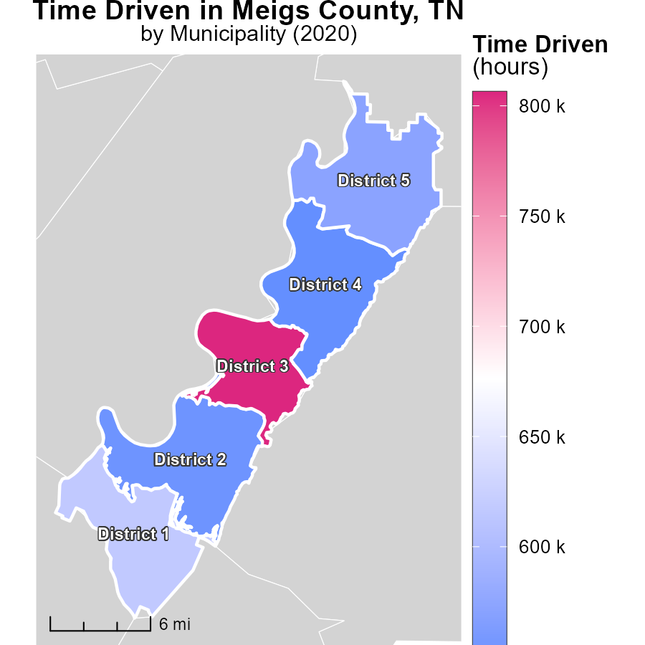

## Findings

* District 3, TN had the highest emissions with 806.2k hours in 2020.
* District 5, TN had median emissions with 572.0k hours in 2020.
* District 4, TN had the lowest emissions with 547.0k hours in 2020.

## Recommendations

To lower emissions, focus on reducing the hours driven in District 3 while maintaining the level in District 5 to decrease the overall emissions. Implement strategies that encourage carpooling or the use of public transportation in high-emission districts.

# Vehicle Miles Traveled by Area over Time

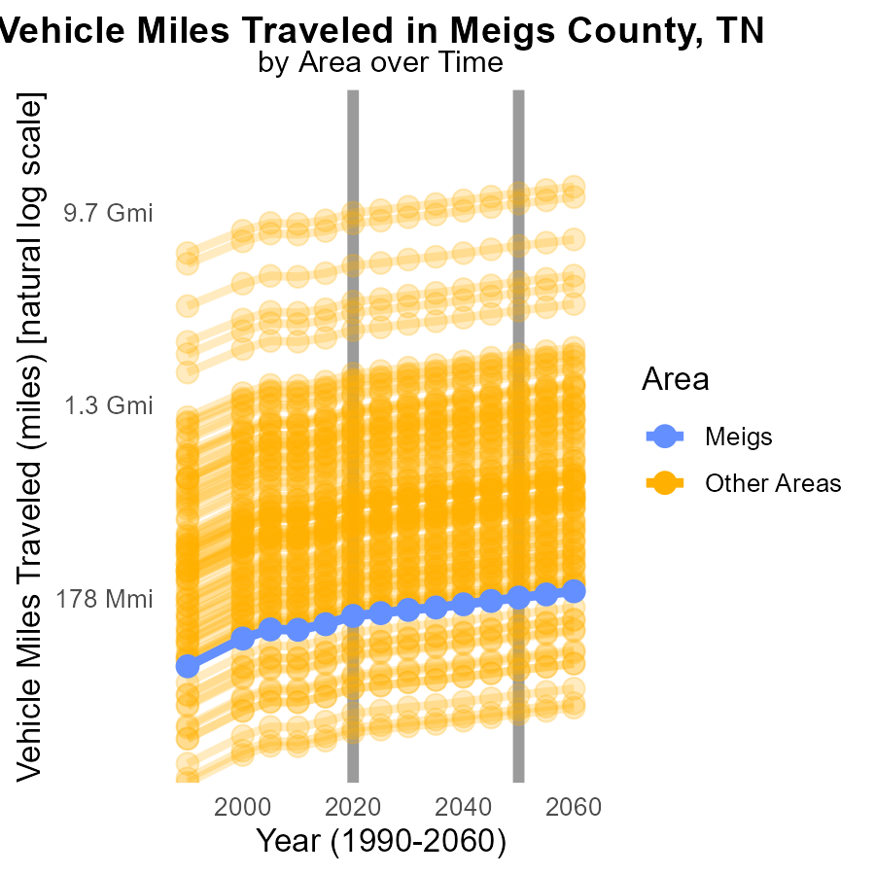

# Vehicle Miles Traveled by Fuel Type over Time

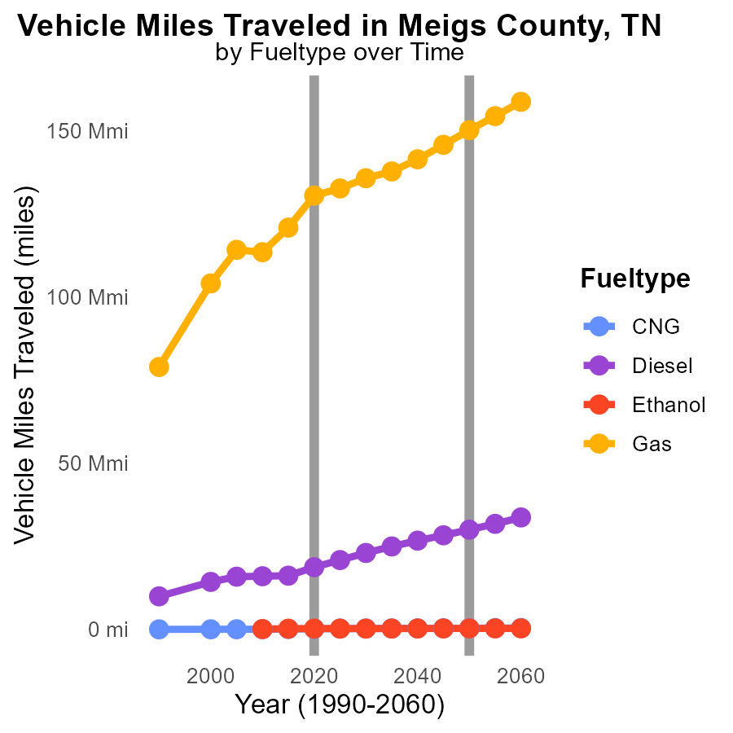

## Findings

* Highest emissions come from Gas vehicles in 2030 with 135.6 million miles traveled.
* On the contrary, CNG vehicles show a decrease in emissions from 37.6 thousand miles in 2010 to 251.2 thousand miles in 2030.
* Diesel vehicle emissions increase significantly from 16.0 million miles in 2010 to 23.0 million miles in 2030.

## Recommendations

To reduce emissions, policymakers should incentivize the transition to CNG vehicles due to their declining trend. Additionally, promoting alternative fuels like ethanol can help in curbing the rising emissions from Diesel vehicles. Encouraging the use of public transportation or carpooling can also reduce the overall vehicle miles traveled.

# Areas Ranked by Emissions

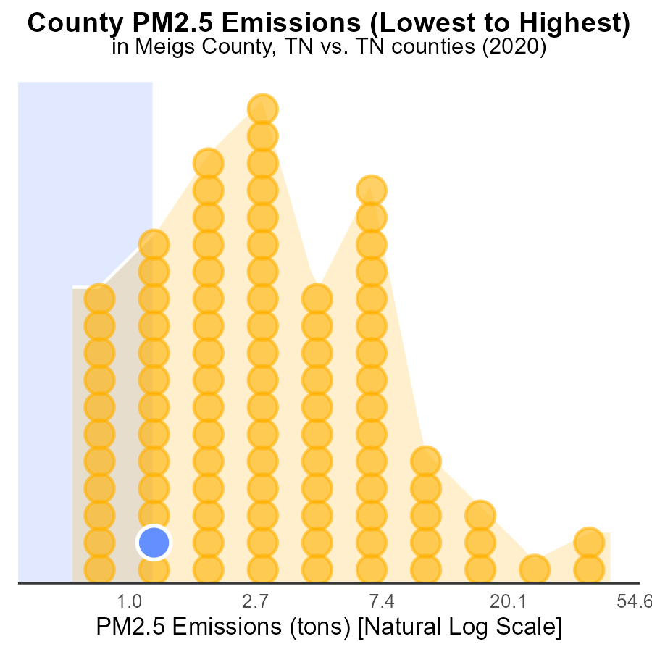

## Findings

* The county with the highest PM2.5 emissions in 2020 was Hancock with 700.0 tons, ranking 1st.
* Shelby county had the highest proportion of emissions, accounting for 100.0% at 124.0 tons.
* Meigs and Wayne counties had similar emissions, with both contributing 2.2 tons and ranking 13rd and 14th, respectively.

## Recommendations

To lower emissions, focus on reducing industrial activities in Hancock county to significantly decrease the highest emission source. Implement stricter regulations to reduce PM2.5 emissions in Shelby county and prioritize air quality improvement measures in Meigs and Wayne counties.

# Areas Ranked by Hotelling (Diesel Aux)

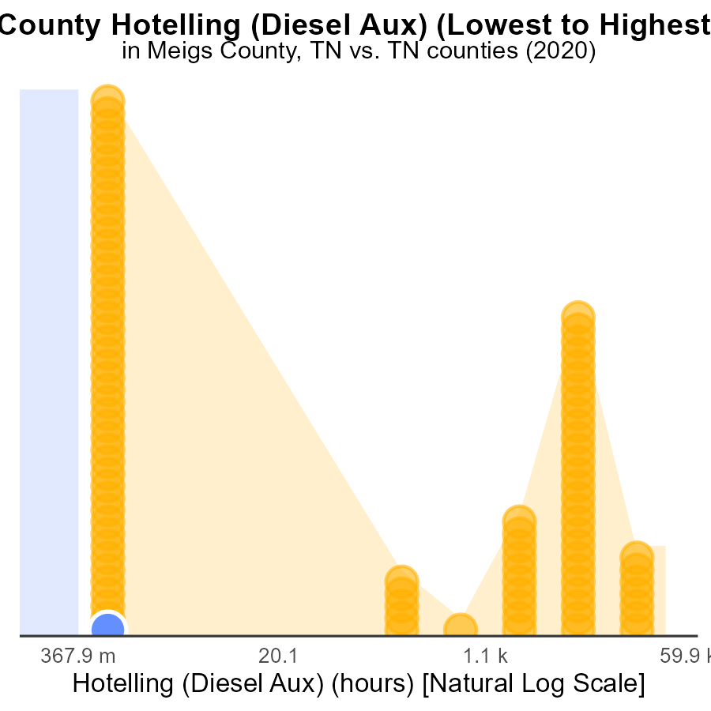

## Findings

* Meigs County had the lowest PM2.5 emissions from Hotelling (Diesel Aux) in 2020.
* Davidson County had the highest PM2.5 emissions from Hotelling (Diesel Aux) in 2020.
* Hotelling (Diesel Aux) in Davidson County accounted for 100% of the total emissions percentile in 2020.

## Recommendations

To decrease PM2.5 emissions, focus on reducing Hotelling (Diesel Aux) activities in Davidson County. Implement stricter emission control measures, promote alternative energy sources, and encourage the use of cleaner technologies.

# Conclusion

In conclusion, the data from the report highlights the significant impact of vehicle miles traveled on PM2.5 emissions in various counties in Tennessee, including Meigs County. Although Meigs County did not record any PM2.5 emissions from Hotelling activities, there is still room for improvement in reducing overall emissions. Strategies such as promoting electric vehicles, investing in public transportation, and enforcing stricter emission regulations can help mitigate PM2.5 emissions and improve air quality in the region.

Additionally, the projected stability of PM2.5 emissions from 2020 to 2040 in Meigs County suggests the importance of implementing long-term sustainable solutions to combat air pollution. By encouraging the use of clean energy sources, enhancing public transportation infrastructure, and enforcing emission standards on industries and vehicles, Meigs County can work towards achieving lower PM2.5 emissions and a healthier environment for its residents.

# About This Report

Data based on MOVES estimates collected by the Climate Action in Transportation program at Cornell University. Demographic data sourced from the US Census's American Community Survey 5-year estimates. This report was generated with the help of AI.

# References

* U.S. Census Bureau. (2023). American Community Survey 5-year estimates: Detailed tables. Retrieved from https://data.census.gov
* U.S. Environmental Protection Agency. (2024). Motor Vehicle Emission Simulator (MOVES 4.0) [Software]. Retrieved from https://www.epa.gov/moves