 

**PM2.5 Emissions in Dawson County, 2055**  
Made with CAT VISUALIZER by Gao Labs @ Cornell University.

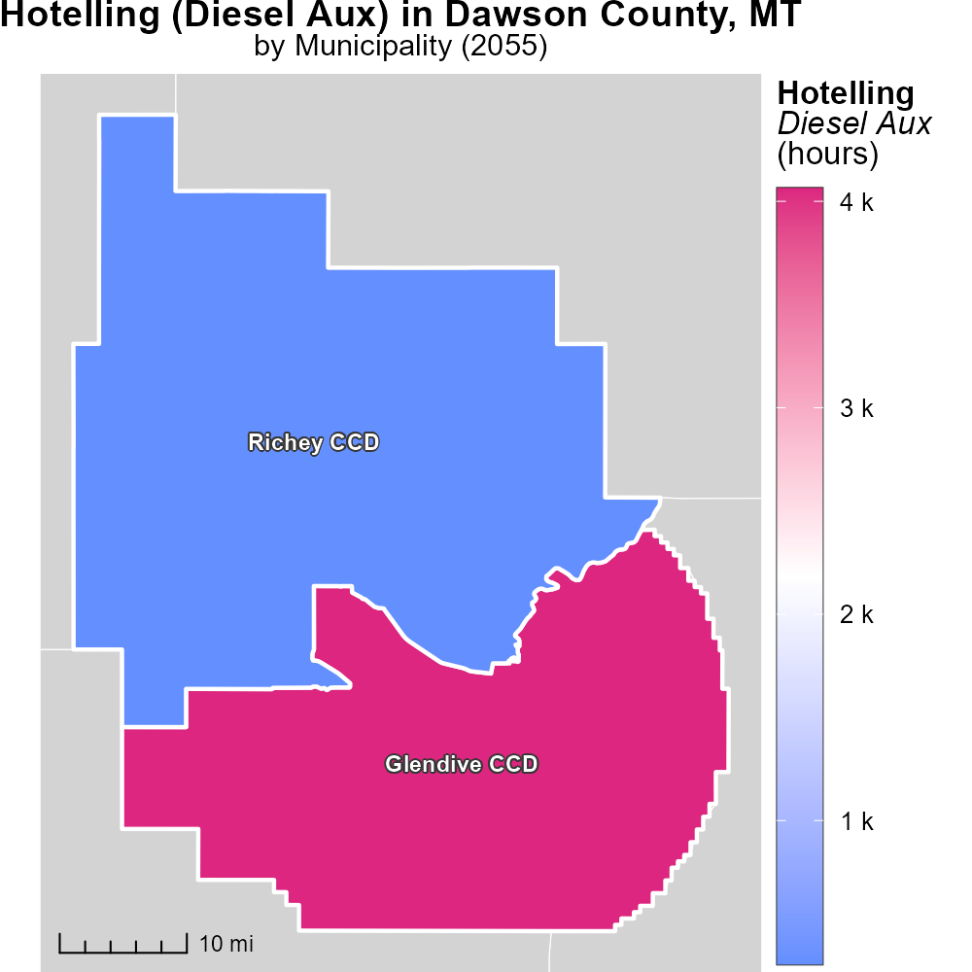

## Keywords

Primary Exhaust PM2.5; Total emissions; on-road transportation; Dawson County; MT; 2055

## Highlights

* Analysis of PM2.5 emissions from on-road transportation in Dawson County, MT.
* Impact of transportation on air quality in 2055.
* Quantification of primary exhaust emissions.
* Insights into environmental challenges and solutions.
* Implications for public health and policy decisions.

# Introduction

The report focuses on the evaluation of Primary Exhaust PM2.5 emissions from on-road transportation in Dawson County, MT in the year 2055. PM2.5, particulate matter with a diameter of less than 2.5 micrometers, is a major air pollutant with significant health implications.

The total emissions from on-road transportation play a crucial role in determining the air quality and overall environmental health of the region. By examining the trends and levels of PM2.5 emissions, this report aims to provide insights into the environmental challenges faced by Dawson County and potential solutions to mitigate the impact of transportation activities on air quality.

# Emissions Rate (per vehicle) Overall by Area

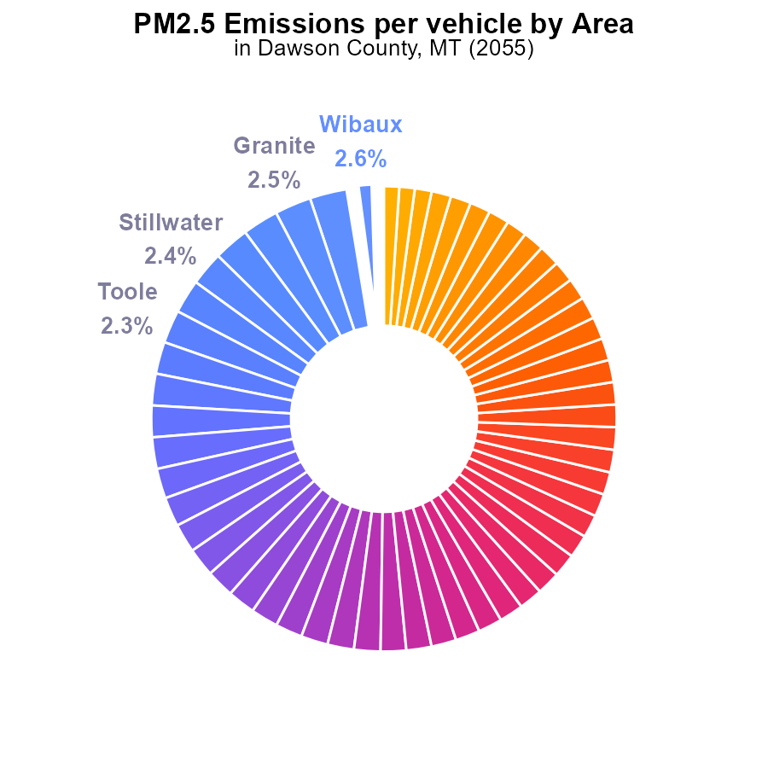

## Findings

* Dawson County has the highest PM2.5 emissions at 42.7 tons per vehicle.
* Top 5 counties contribute 13.2% of the total emissions.
* Several counties have low emissions with Golden Valley and Garfield at 1.1% each.

## Recommendations

To reduce emissions, focus on high-emitting counties like Dawson by promoting cleaner transport methods. Collaborate with top emitters for targeted reduction strategies. Support low-emitting counties by maintaining their efforts.

# Population by Road Type

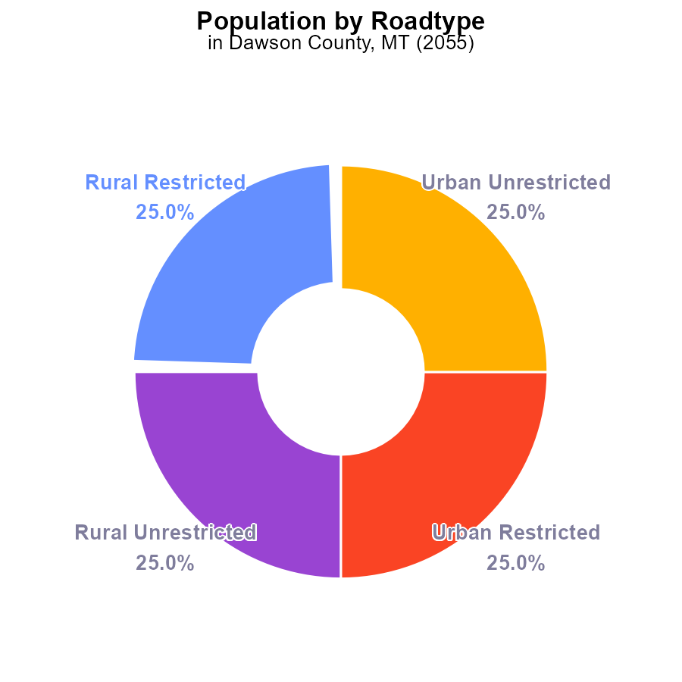

## Findings

* PM2.5 emissions in Dawson County, MT in 2055 are 35.2 k in total.
* Each type (Rural Restricted, Rural Unrestricted, Urban Restricted, Urban Unrestricted) contributes 25% equally to the total emissions.
* The emissions are evenly distributed among different population categories.

## Recommendations

In order to lower PM2.5 emissions, policies need to focus on all population types equally. Implementing stricter emission controls and promoting cleaner technologies across the county can help reduce overall emissions.

# Emissions Rate (per capita) Overall over Time

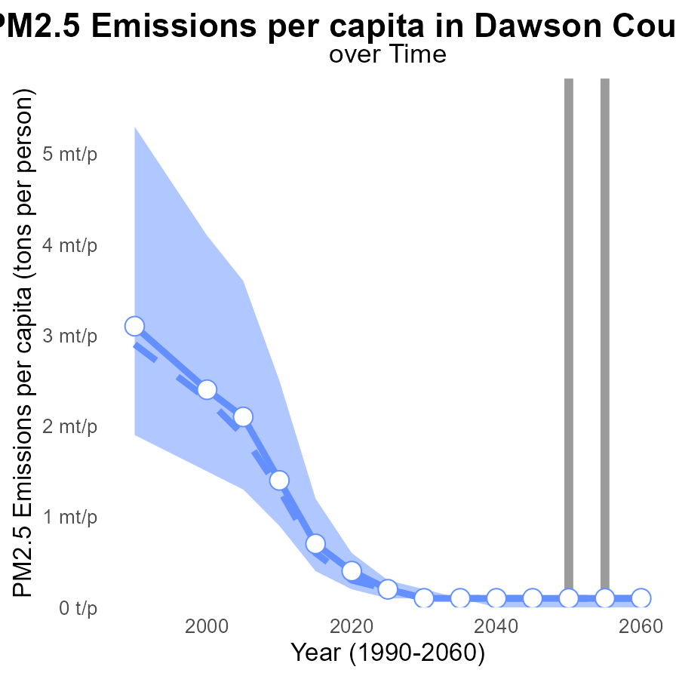

## Findings

* Dawson County's PM2.5 emissions per capita are consistently above the median area level by around 7.5 to 7.8 micrograms per cubic meter.
* In 2035, the emissions are 90.7 µg, in 2040, 79.3 µg, and this trend continues up to 2060.
* There is no improvement in PM2.5 emissions as they stay constant at 1e-04 tons per person for all years.

## Recommendations

To reduce Dawson County's high PM2.5 emissions, focus on implementing stricter emission controls in industries and promoting the use of cleaner energy sources to bring down the emissions per capita levels.

# Hotelling (Diesel Aux) over Time for Passenger Vehicles

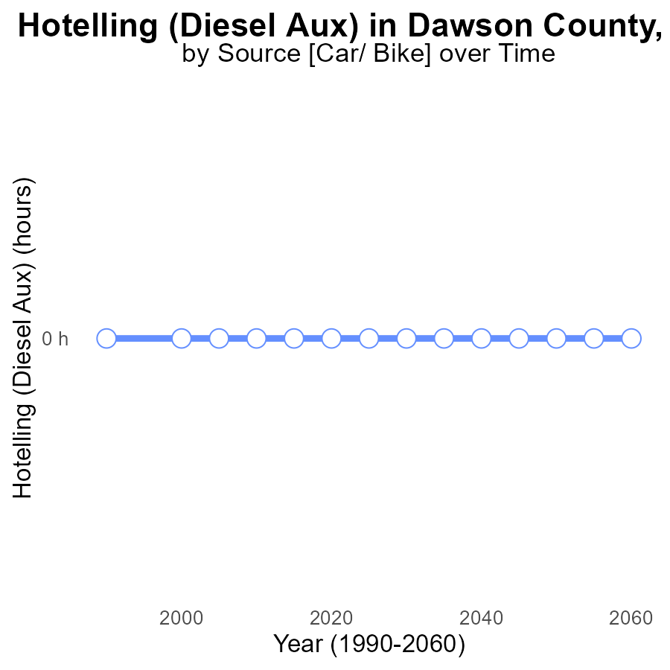

## Findings

* Between 2035-2060, no PM2.5 emissions from Hotelling (Diesel Aux) were reported in Dawson County, MT.
* The benchmark difference remained constant at 0 across all years.
* There is no data to suggest any PM2.5 emissions or changes in emissions from 2035 to 2060.

## Recommendations

Since there are no reported emissions, focus on implementing sustainable practices to maintain this clean air standard. Monitor future emissions for early intervention.

# Hotelling (Diesel Aux) Mapped by Area

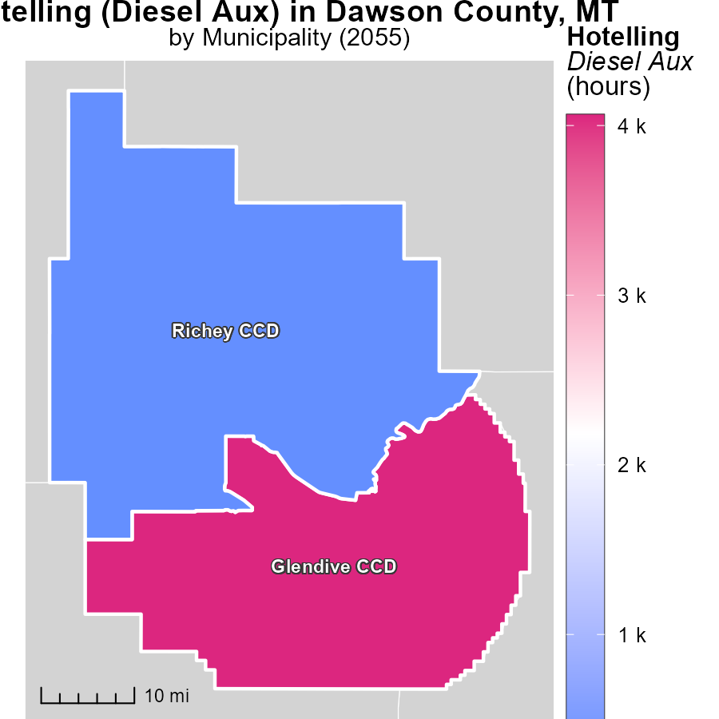

## Findings

* The maximum emissions recorded in Glendive CCD, MT was 4.1 k hours.
* The median emissions recorded in Richey CCD, MT was 306.4 hours.
* Hotelling (Diesel Aux) emissions in Glendive CCD were significantly higher compared to those in Richey CCD.

## Recommendations

To lower emission levels, consider implementing stricter regulations in Glendive CCD to reduce Hotelling (Diesel Aux) operation hours. Additionally, invest in cleaner energy sources to decrease overall emissions in both regions.

# Vehicle Starts Mapped by Area

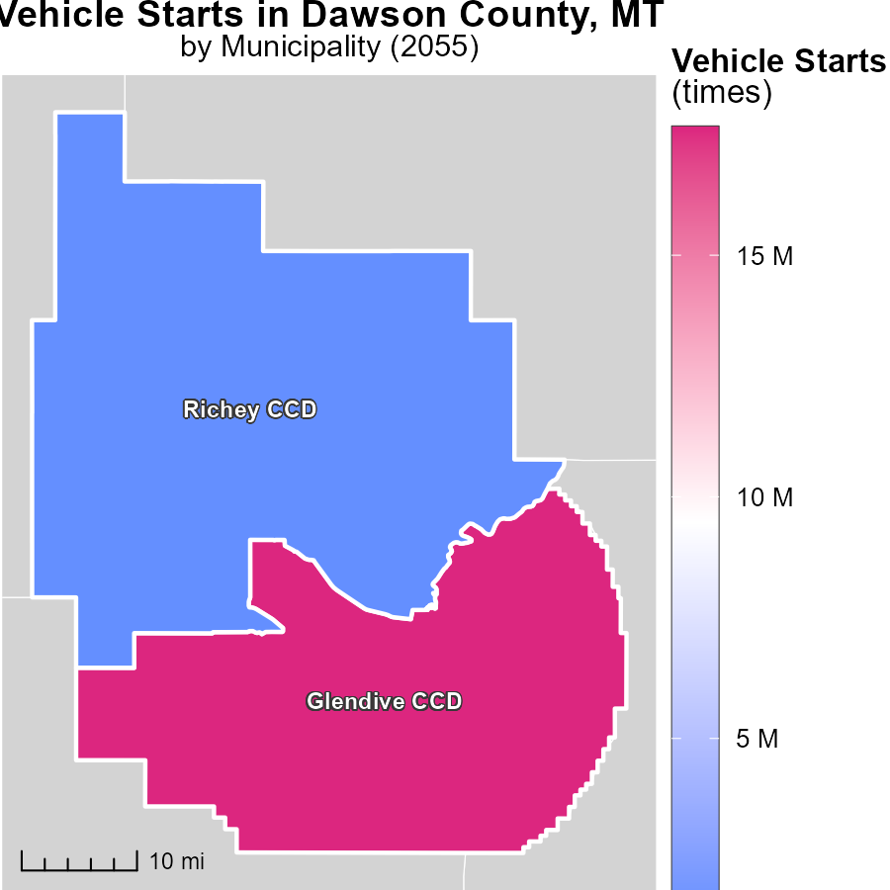

## Findings

* Glendive CCD, MT has a maximum of 17.6 million vehicle starts in 2055.
* Richey CCD, MT has a median of 1.3 million vehicle starts in 2055.

## Recommendations

To lower the emission levels related to vehicle starts, consider implementing stricter vehicle emission standards, promoting public transportation, and incentivizing the use of electric vehicles in these regions.

# Hotelling (Diesel Aux) by Regulatory Class over Time

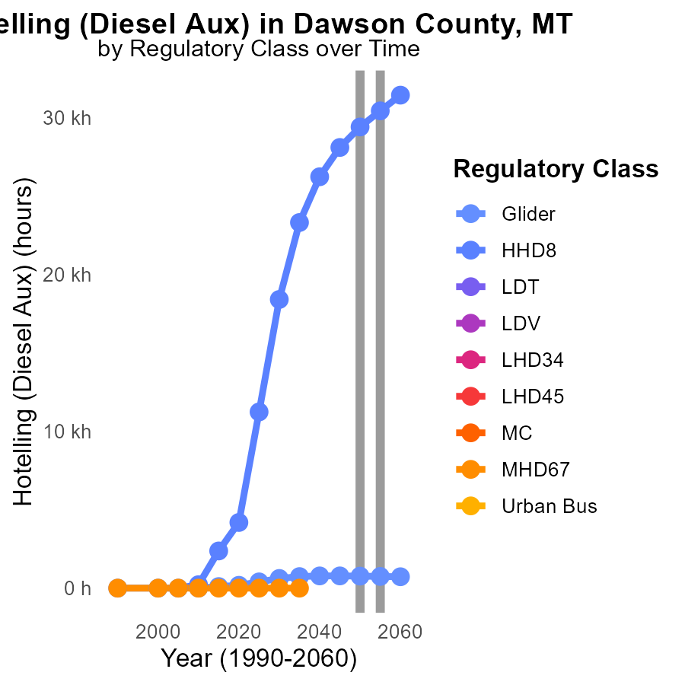

## Findings

* Glider emissions are projected to decrease by 13.7% from 2050 to 2045, then 39.4% by 2060.
* HHD8 emissions will increase significantly by 1306.6% from 2050 to 2045 and then decrease by 2027.9% by 2060.
* Other vehicle types such as LDT, LDV, LHD34, MHD67, and Urban Bus show no data or emissions throughout the years.

## Recommendations

To reduce emissions, focus on regulating and reducing emissions from HHD8 vehicles by implementing stricter emission standards, promoting the use of cleaner fuels, and incentivizing the adoption of cleaner technologies in the transport sector.

# Vehicle Starts by Road Type over Time

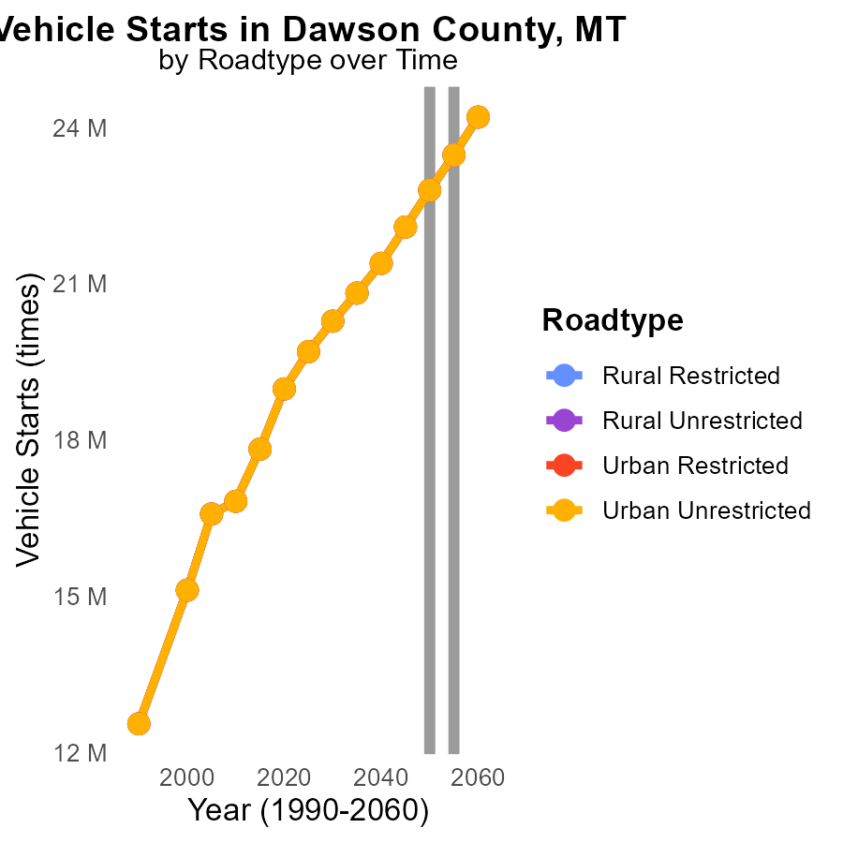

## Findings

* PM2.5 emissions from vehicle starts in Dawson County are projected to increase from 22.8M in 2050 to 24.2M in 2060.
* Emissions from Rural Restricted areas are consistently higher compared to other road types, with a 5.4% increase from 2050 to 2060.
* There is a downward trend in emissions from all urban areas, with Urban Unrestricted areas showing the most significant decrease of 6.2% from 2050 to 2060.

## Recommendations

To lower PM2.5 emissions, policies should focus on reducing vehicle starts in Rural Restricted areas where emissions are highest. Implementing measures to incentivize cleaner transportation modes can aid in curbing emissions. Additionally, investing in infrastructure improvements to promote public transportation and carpooling in Urban areas is crucial for sustaining the observed downward trend in emissions.

# Areas Ranked by Emissions Rate (per capita)

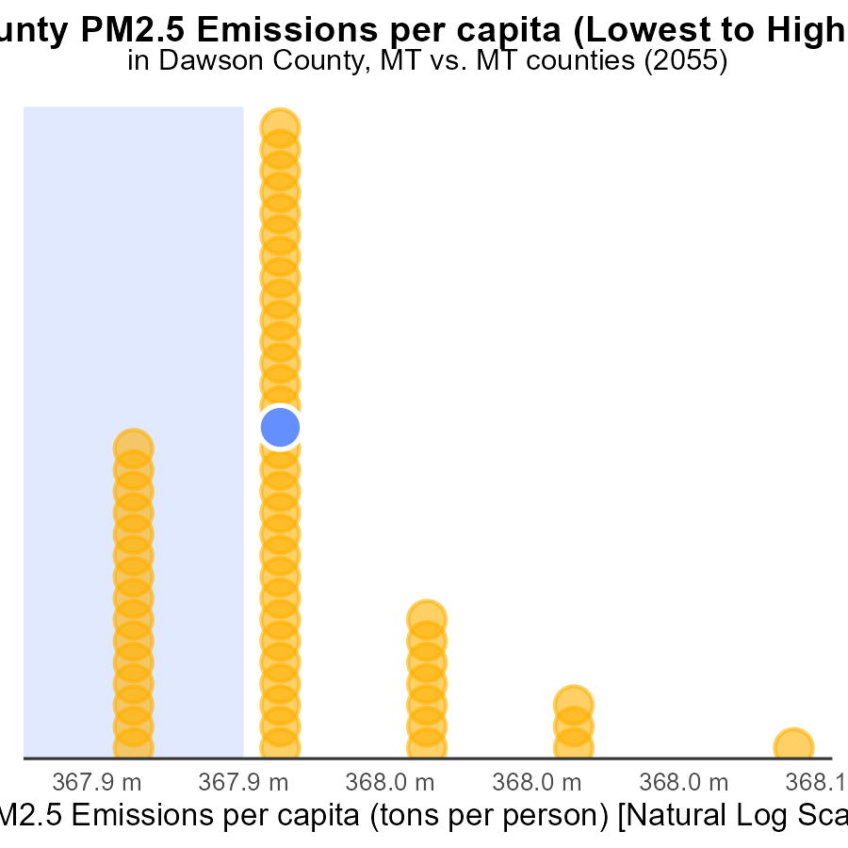

## Findings

* Treasure county has the highest PM2.5 emissions per capita at 488.6 tons per person.
* Ravalli county has the lowest PM2.5 emissions per capita at 27.6 tons per person.
* Madison and Dawson counties have high PM2.5 emissions per capita with 82.1 and 79.3 tons per person respectively.

## Recommendations

To lower the emission levels, Treasure county should focus on reducing PM2.5 emissions through stricter regulations and investment in cleaner technologies. Similarly, Madison and Dawson counties need to implement measures to decrease their high emissions rates. Collaborative efforts between counties could also be beneficial in tackling regional air quality issues.

# Areas Ranked by Population

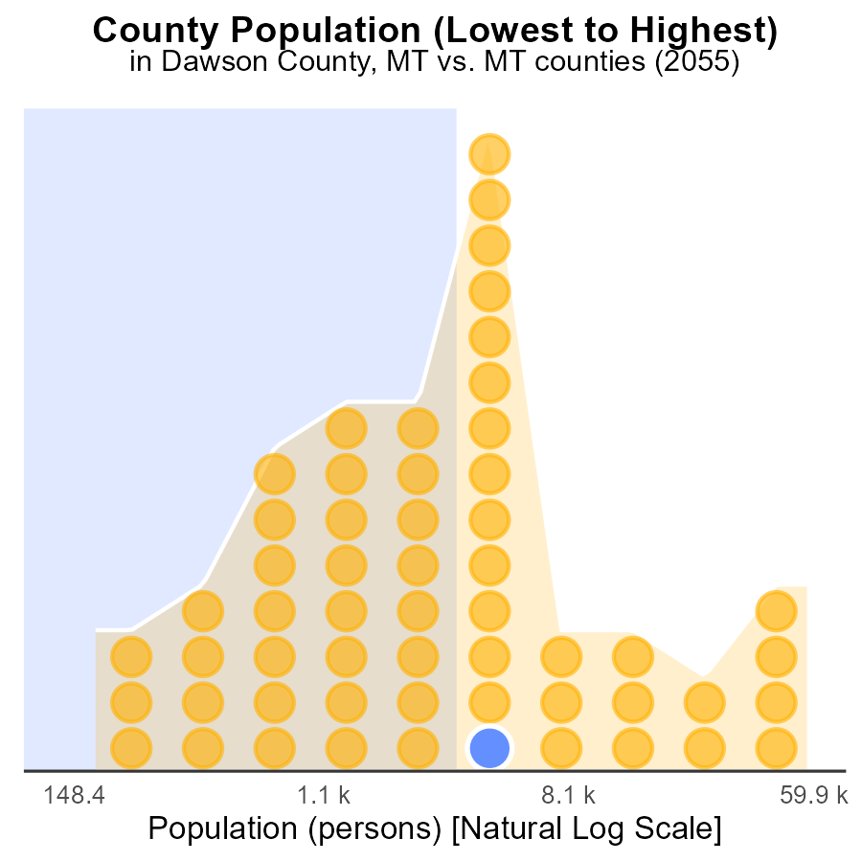

## Findings

* Yellowstone has the highest population with 160.4k persons.
* Dawson follows with 8.8k persons, ranking 62nd in population.
* Petroleum has the lowest population with 464 persons, ranking 2nd in fewest inhabitants.

## Recommendations

To reduce emissions, focus on densely populated areas like Yellowstone with 160.4k persons to have a larger impact on overall emissions. Implement targeted strategies and pollution control measures in areas like Dawson and Petroleum as their smaller populations also contribute to emissions.

# Conclusion

In conclusion, the analysis of PM2.5 emissions from on-road transportation in Dawson County, MT in 2055 reveals concerning trends. With 35.2 k total emissions, the county continues to face challenges in reducing pollution levels, especially with the highest PM2.5 emissions per vehicle at 42.7 tons. The data highlights the need for targeted strategies to address emissions from different road types and vehicle categories.

To effectively lower PM2.5 emissions, it is crucial to implement stricter emission controls, promote cleaner technologies, and incentivize the adoption of sustainable practices across the county. Collaborative efforts between high-emitting counties like Dawson, low-emitting counties, and densely populated areas such as Yellowstone are necessary to achieve a significant reduction in overall emissions. By focusing on cleaner transport methods and investing in infrastructure improvements, Dawson County can work towards a healthier environment for its residents and future generations.

# About This Report

Data based on MOVES estimates collected by the Climate Action in Transportation program at Cornell University. Demographic data sourced from the US Census's American Community Survey 5-year estimates. This report was generated with the help of AI.

# References

* U.S. Census Bureau. (2023). American Community Survey 5-year estimates: Detailed tables. Retrieved from https://data.census.gov
* U.S. Environmental Protection Agency. (2024). Motor Vehicle Emission Simulator (MOVES 4.0) [Software]. Retrieved from https://www.epa.gov/moves