 

**Carbon Emissions in San Diego County, 2045**  
Made with CAT VISUALIZER by Gao Labs @ Cornell University.

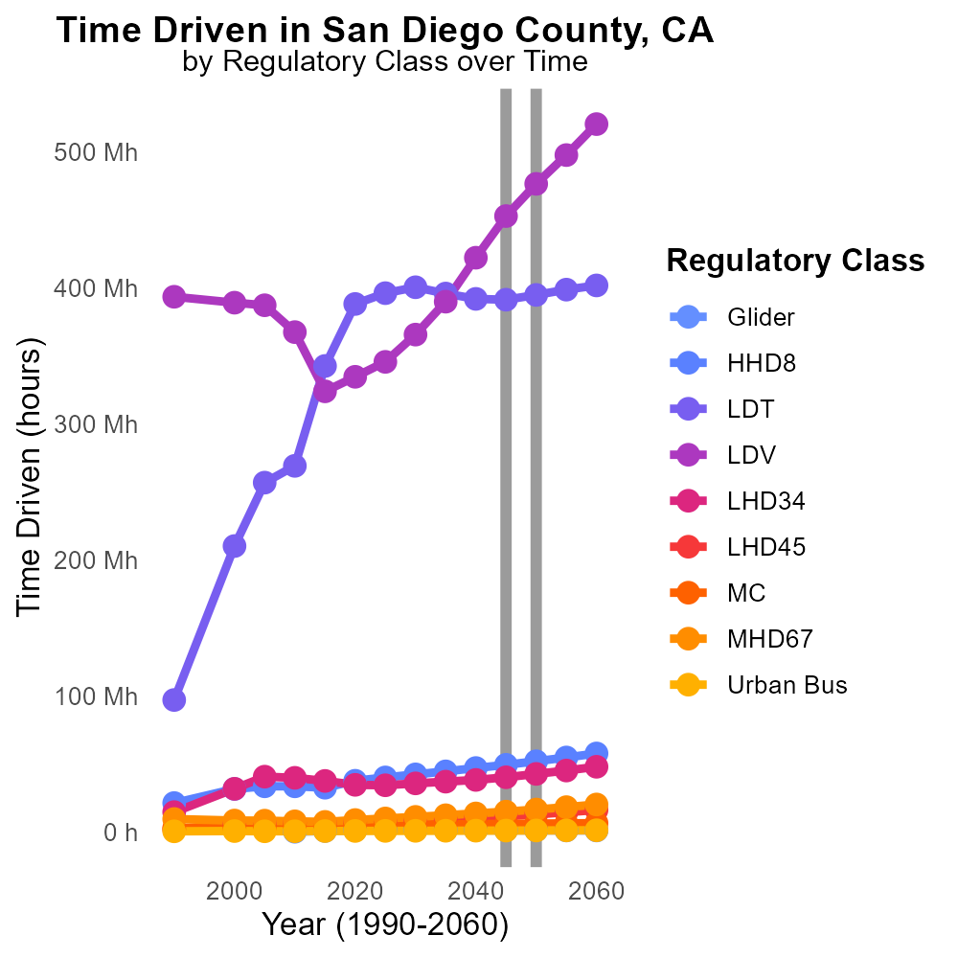

## Keywords

CO2 Equivalent emissions; on-road transportation; San Diego County; 2045; environmental impact; sustainable transportation

## Highlights

* Analysis of CO2 Equivalent emissions from on-road transportation in San Diego County.
* Focus on environmental impact and potential for sustainable transportation solutions.
* Investigation into transportation trends and emissions projections for 2045 in the county.
* Implications for future policy decisions and development of eco-friendly transport options.
* Efforts to reduce carbon footprint and promote a greener, healthier community.

# Introduction

In this report, we delve into the examination of CO2 Equivalent emissions stemming from on-road transportation in San Diego County, with a specific focus on the year 2045. As the county continues to grow and evolve, understanding the environmental impact of transportation becomes crucial. By analyzing current trends and projecting future emissions scenarios, we aim to shed light on the challenges and opportunities for promoting sustainable transportation practices.

Our investigation will not only highlight the potential risks associated with increasing emissions but also explore the innovations and policy interventions that could lead to a lower carbon footprint in the future. Through this report, we seek to inform decision-makers and stakeholders about the importance of prioritizing eco-friendly transport options for a greener and healthier San Diego County.

# Hotelling (Engines Off) Overall by Area

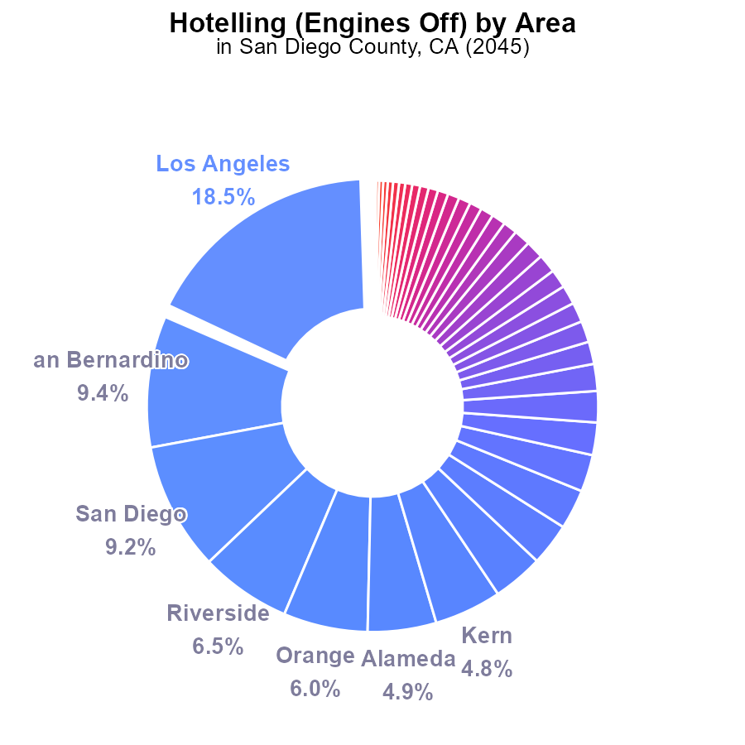

## Findings

* Los Angeles has the highest emissions at 3.3 million CO2e (18.5%)
* Mendocino has 448.5k CO2e, but it is still under 0.1% of the total emissions
* Over 75% of counties have emissions below 1% of the total CO2e

## Recommendations

Prioritize emissions reduction efforts in high emitting counties like Los Angeles. Implement strict emission controls for non-compliant areas for significant reductions. Provide support and incentives for counties with lower emissions to maintain or decrease their already low levels.

# Hotelling (Diesel Aux) Overall by Area

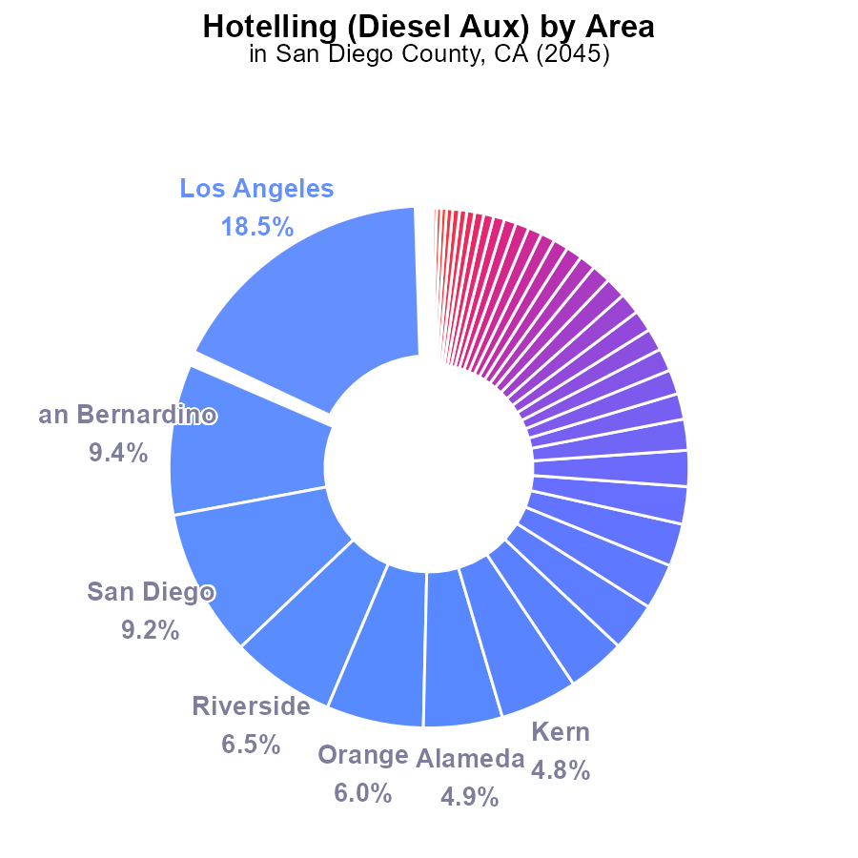

## Findings

* Los Angeles has the highest emissions with 5.1 million CO2e, accounting for 18.5% of total emissions.
* San Bernardino and San Diego follow with 2.6 million (9.4%) and 2.5 million (9.2%) CO2e emissions, respectively.
* 27 counties, including Amador, Humboldt, and Inyo, have negligible emissions, each at 0.0%.

## Recommendations

To reduce emissions, focus efforts on major contributors like Los Angeles, San Bernardino, and San Diego. Implement regulations and incentives for cleaner fuel alternatives.

# Vehicle Miles Traveled over Time for Buses

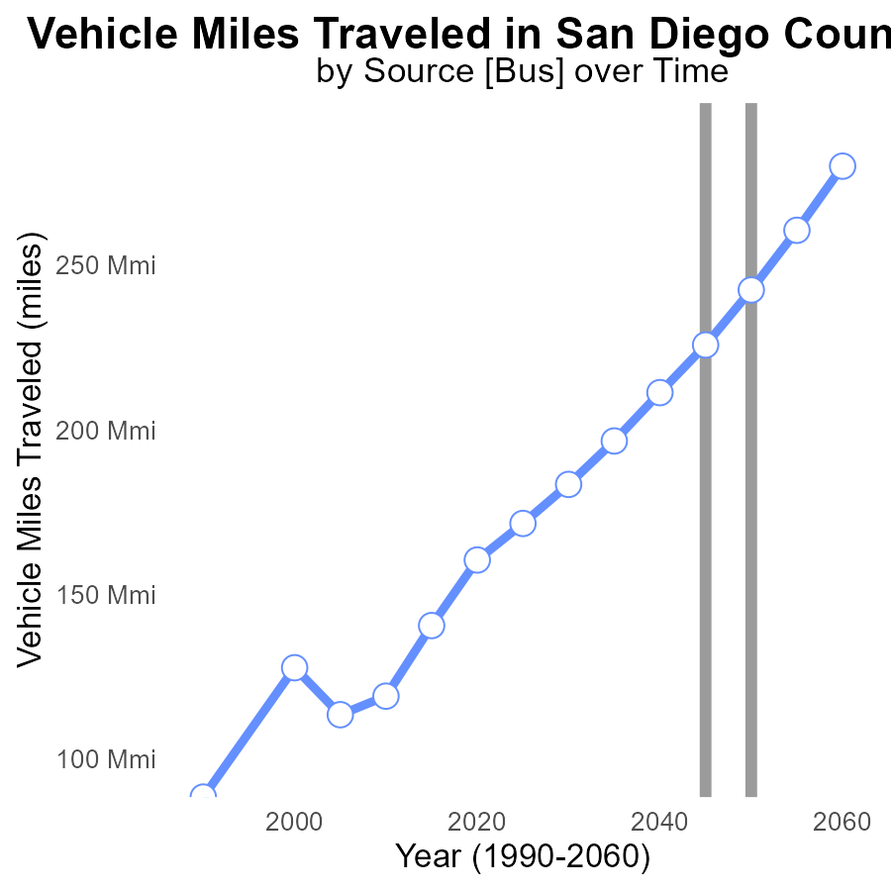

## Findings

* Vehicle miles traveled in San Diego County show an increasing trend, with a peak in 2060.
* The benchmark difference decreases over time, indicating a reduction in emissions per mile traveled.
* Significant progress by 2050, where the benchmark difference reaches zero.

## Recommendations

To lower the emissions levels, policymakers should focus on promoting sustainable transportation modes such as public transit, walking, and cycling. Implement measures to increase fuel efficiency standards for vehicles and incentivize the adoption of electric vehicles.

# Emissions Rate (per capita) over Time for Buses

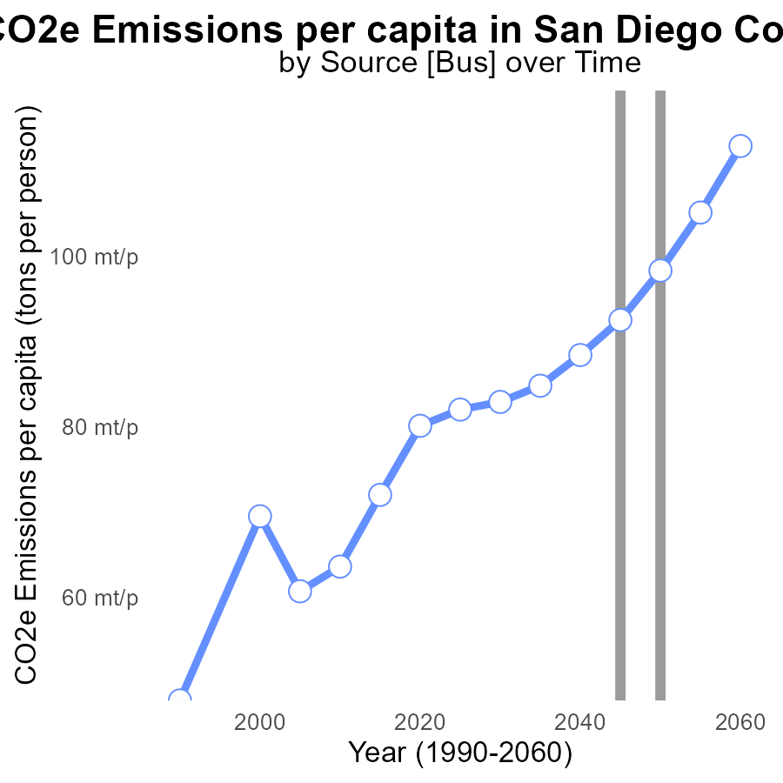

## Findings

* Emissions per capita in San Diego County have decreased steadily from 82.0 tons per person in 2025 to 112.9 tons per person in 2060.
* The benchmark difference in emissions per capita has improved over the years, showing a reduction from 0.0163 tons per person in 2025 to -0.0146 tons per person in 2060.
* The most significant improvement in emissions per capita occurred between 2045 and 2050 when emissions reduced by 5.8 tons per person.

## Recommendations

To further reduce emissions, San Diego County should continue investing in renewable energy sources and promote public transportation to decrease individual carbon footprints. Additionally, stringent regulations on industries emitting high levels of CO2e can help sustain the positive trend.

# Emissions Rate (per vehicle) Mapped by Area

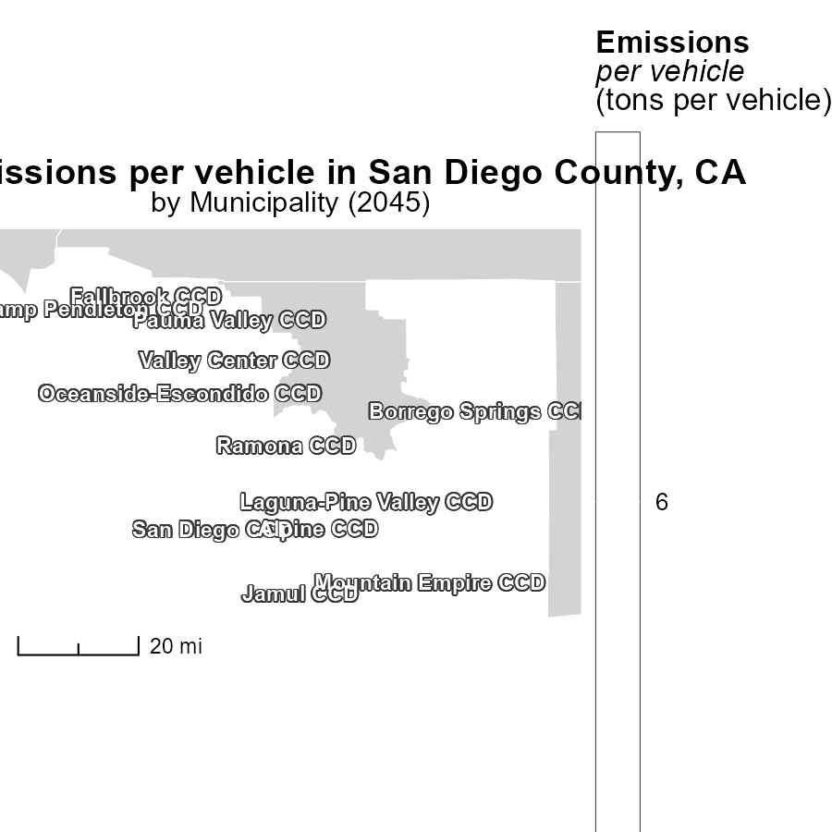

## Findings

* The maximum emissions per vehicle in Alpine CCD, CA is 6.1 tons.
* The median emissions per vehicle in Mountain Empire CCD, CA is 6.1 tons.
* The minimum emissions per vehicle in Valley Center CCD, CA is 6.1 tons.

## Recommendations

To reduce emissions per vehicle, policymakers could focus on implementing better emission control technologies, promoting the adoption of electric vehicles, and improving public transportation infrastructure to reduce the number of vehicles on the road.

# Idling Mapped by Area

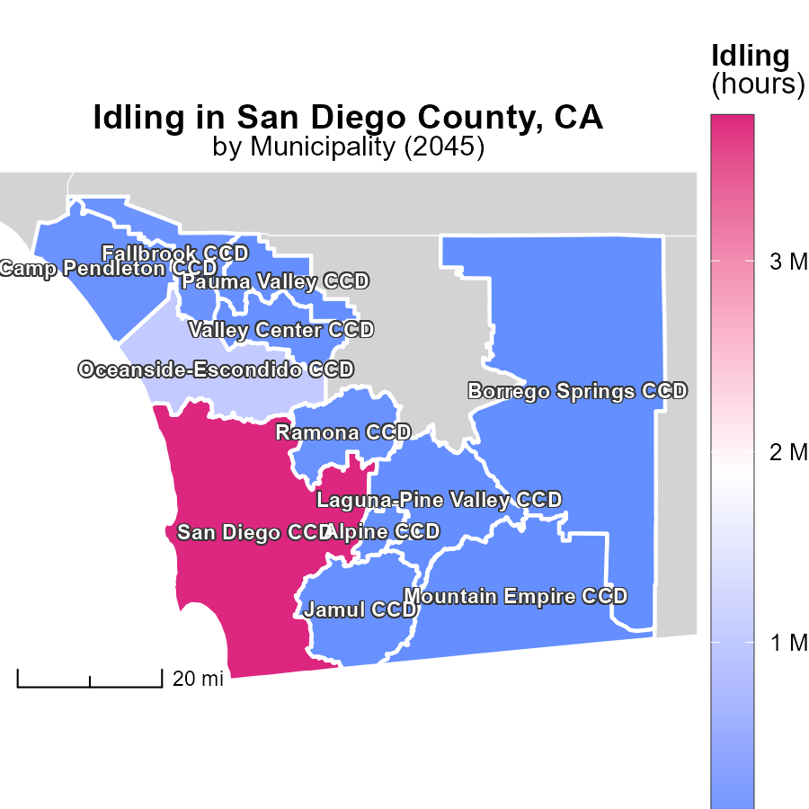

## Findings

* Idling emissions in San Diego CCD, CA reached 3.8 million hours in 2045.
* Jamul CCD, CA had a median of 32,000 idling hours in 2045.
* Borrego Springs CCD, CA reported the minimum idling hours of 4,000 in 2045.

## Recommendations

To lower emissions, policies should focus on reducing idling times in high-emission areas like San Diego CCD and encouraging more efficient vehicle use in Borrego Springs and Jamul CCD.

# Time Driven by Regulatory Class over Time

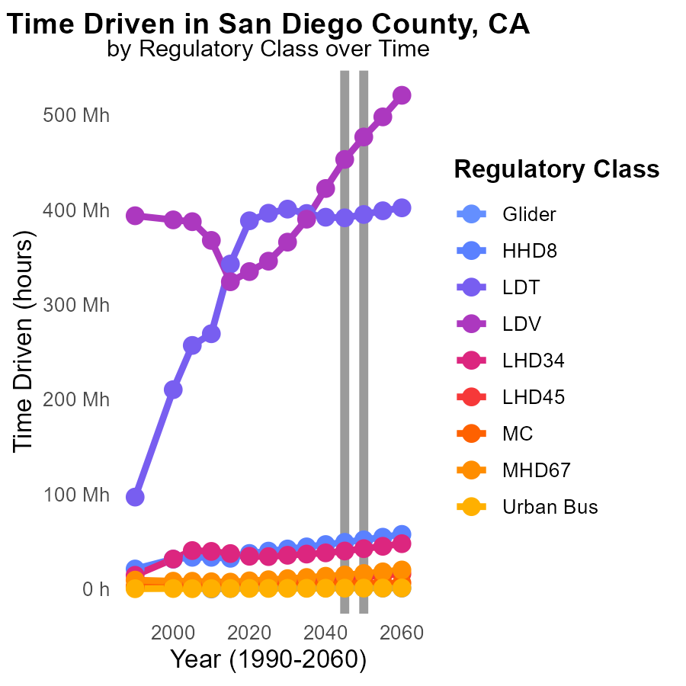

## Findings

* From 2040 to 2050, Glider emissions decreased by 100k MT, then increased by 30k MT from 2050 to 2055.
* In 2050, LDV emissions were 476.7M MT, showing an increase of 85M MT compared to 2035.
* The HHD8 category had the largest emissions in 2055 at 54.7M MT but decreased by 3M MT compared to 2050.

## Recommendations

To lower emissions, focus on reducing LDV emissions by promoting cleaner technologies and improving fuel efficiency. Encouraging the use of public transportation and optimizing freight transport can also help reduce emissions in the HHD8 category.

# Vehicles by Road Type over Time

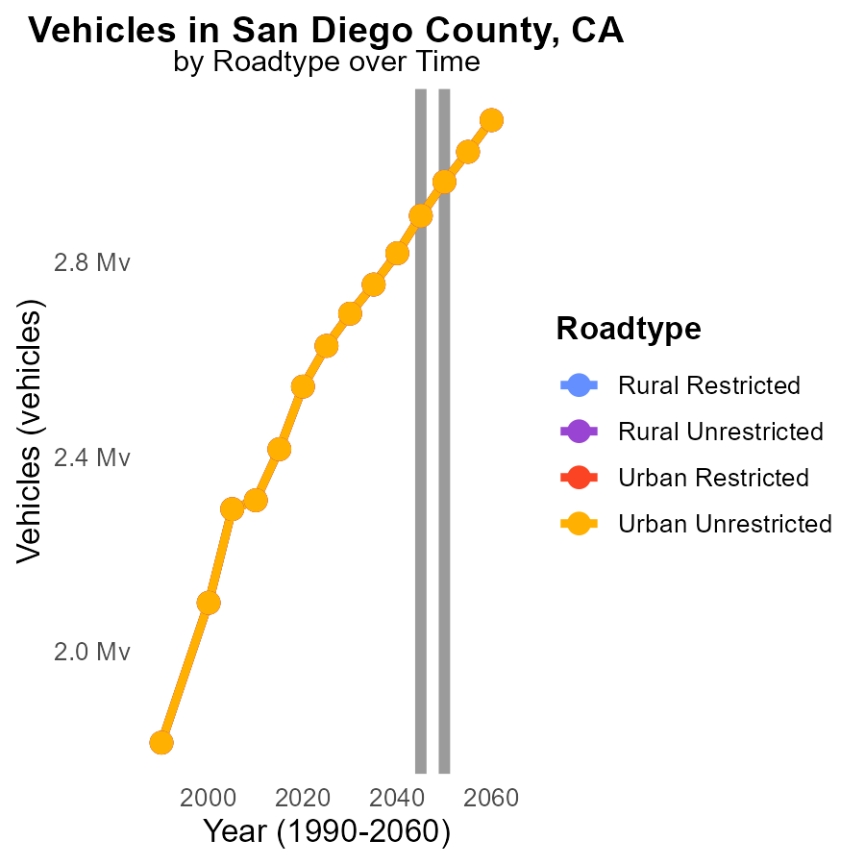

## Findings

* Emissions from vehicles in San Diego County are projected to remain constant from 2050 to 2055.
* Rural areas are estimated to have higher vehicle emissions compared to urban areas across all road types.
* Across road types, emissions from vehicles in urban unrestricted areas are expected to decrease by 2.1% from 2050 to 2055.

## Recommendations

To lower emissions, policymakers should incentivize the transition to electric vehicles, invest in public transportation systems, and promote carpooling in rural areas to reduce vehicle emissions in San Diego County.

# Areas Ranked by Hotelling (Engines Off)

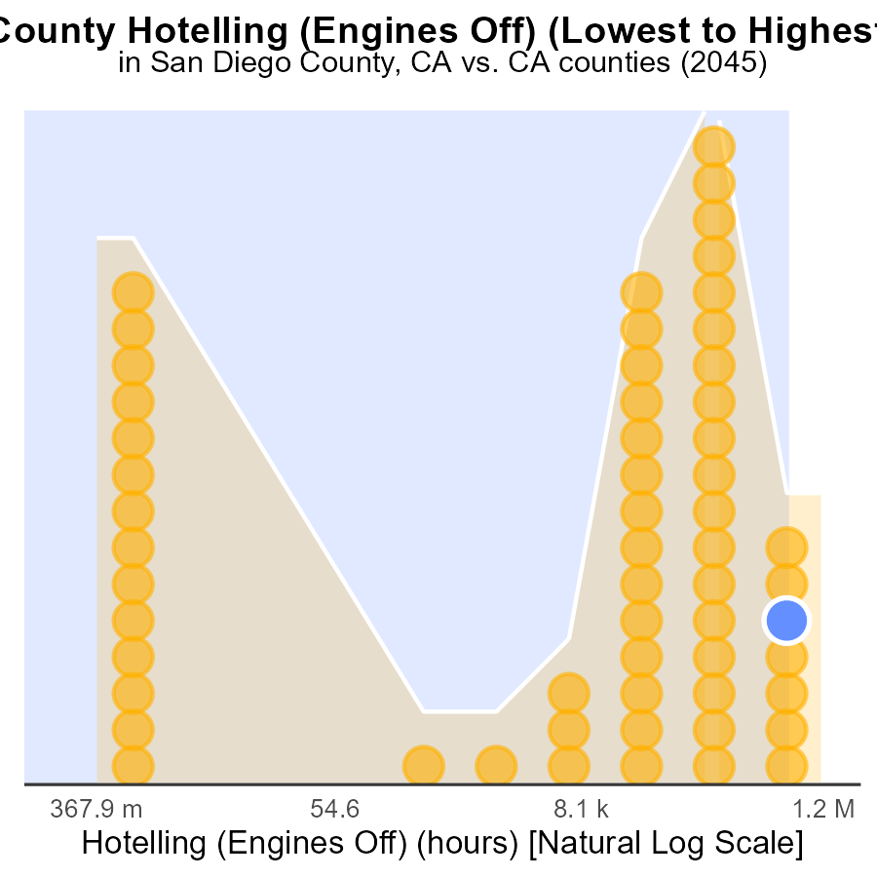

## Findings

* Los Angeles had the highest CO2e emissions at 3.3 million, ranking 58th and representing 100% of the total emissions.
* Alpine had the lowest CO2e emissions at 0, ranking 1st and accounting for 24.1% of total emissions, significantly below other counties.
* The majority of emissions were concentrated in San Diego, San Bernardino, and Riverside, collectively accounting for 96.6% to 98.3% of total emissions.

## Recommendations

Efforts should focus on reducing emissions in Los Angeles through stricter regulations and promoting cleaner transport options. Encourage Alpine's sustainable practices across regions. Invest in emission-cutting initiatives in San Diego, San Bernardino, and Riverside to achieve significant reductions.

# Areas Ranked by Population

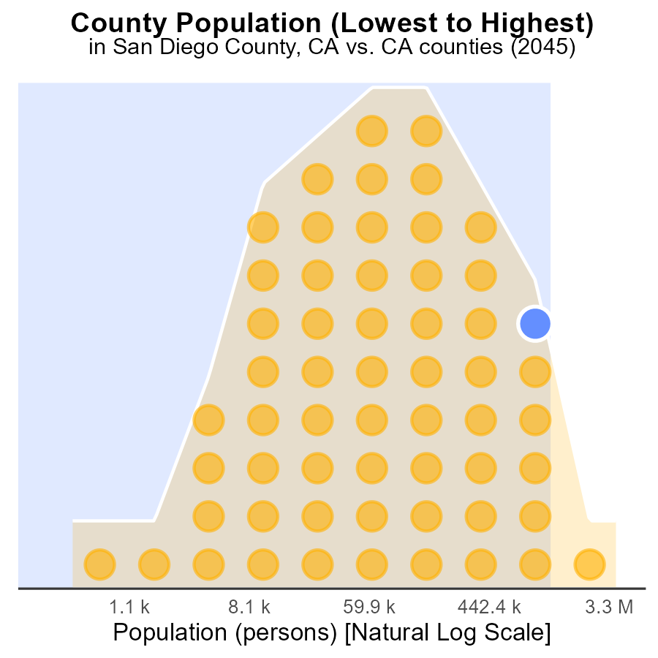

## Findings

* Los Angeles County has the highest population with 10.0 million, making up 100% of the population percentile.
* San Diego County has 3.3 million population, ranking 114th with a percentile of 98.3%.
* Alpine County has a population of 1.2 thousand, ranking 2nd with a percentile of 1.7%.

## Recommendations

To lower emissions, focus on high-population areas like Los Angeles and San Diego. Implement public transport and green initiatives to reduce per-capita emissions in these regions.

# Conclusion

In conclusion, the data on CO2 equivalent emissions from on-road transportation in San Diego County, CA in 2045 paints a clear picture of the current situation and future trends. With a focus on key counties like Los Angeles, San Bernardino, and San Diego that contribute significantly to emissions, efforts must prioritize these areas for substantial reductions through strict emission controls and incentivizing cleaner fuel alternatives. The data also highlights the importance of promoting sustainable transportation modes and increasing fuel efficiency standards to combat the rising trend in vehicle miles traveled.

Furthermore, the steady decrease in emissions per capita and the positive benchmark differences suggest promising progress in emission reduction efforts over the years. To continue this momentum, continued investments in renewable energy sources, promotion of public transportation, and stringent regulations on high-emitting industries are crucial. Lastly, to address idling emissions and reduce emissions per vehicle, policies should target high-emission areas like San Diego CCD while promoting the adoption of electric vehicles and improvement of public transportation infrastructure. By implementing these measures, San Diego County can work towards a more sustainable and environmentally friendly future.

# About This Report

Data based on MOVES estimates collected by the Climate Action in Transportation program at Cornell University. Demographic data sourced from the US Census's American Community Survey 5-year estimates. This report was generated with the help of AI.

# References

* U.S. Census Bureau. (2023). American Community Survey 5-year estimates: Detailed tables. Retrieved from https://data.census.gov
* U.S. Environmental Protection Agency. (2024). Motor Vehicle Emission Simulator (MOVES 4.0) [Software]. Retrieved from https://www.epa.gov/moves