 

**NOx Emissions in McNairy County, 2050**  
Made with CAT VISUALIZER by Gao Labs @ Cornell University.

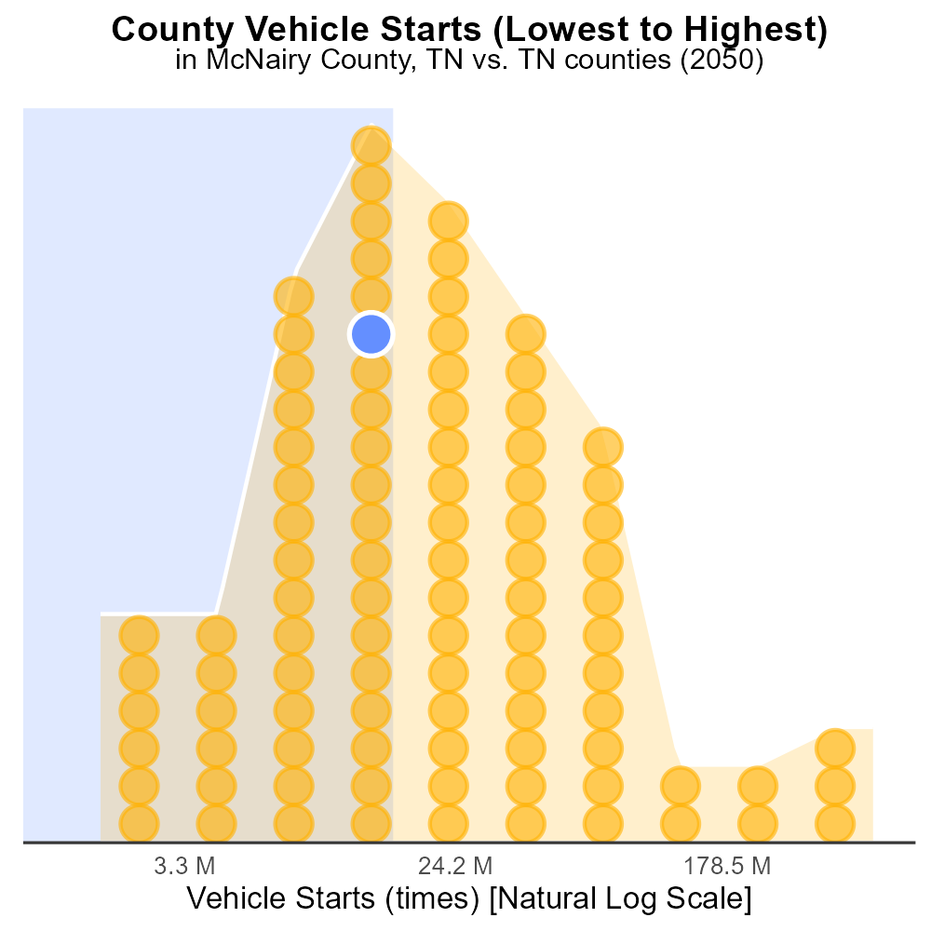

## Keywords

Oxides of Nitrogen; NOx emissions; on-road transportation; McNairy County; TN; 2050

## Highlights

* Study on NOx emissions from 2050 on-road transportation in McNairy County, TN
* Importance of monitoring and reducing NOx emissions for public health
* Analysis of potential sources contributing to NOx emissions

# Introduction

By 2050, the issue of Oxides of Nitrogen (NOx) emissions from on-road transportation in McNairy County, TN is expected to be a pressing concern. This report aims to investigate the extent and impact of NOx emissions in this region as we approach the midpoint of the century.

The focus will be on understanding the sources, trends, and potential mitigation strategies for NOx emissions from vehicles operating within McNairy County. Given the environmental and public health implications associated with NOx, it is crucial to assess the current state and project future scenarios to inform policy decisions and interventions.

# Emissions Rate (per mile) by Fuel Type

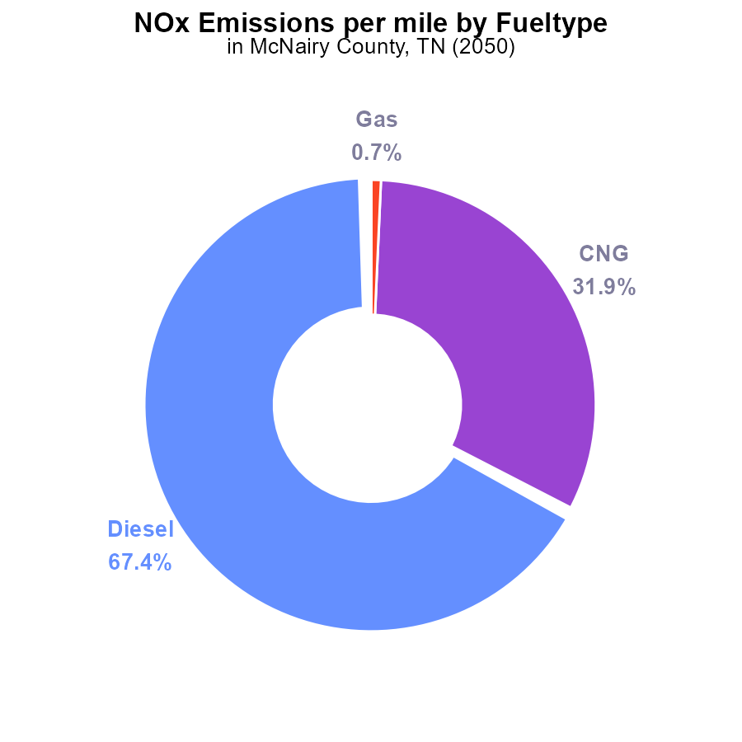

## Findings

* Diesel vehicles emit 1.2 tons of NOx per mile, accounting for 67.4% of total emissions.
* CNG vehicles emit 549.3 pounds of NOx per mile, contributing 31.9% of total emissions.
* Gasoline vehicles emit 12.3 pounds of NOx per mile, making up 0.7% of total emissions.

## Recommendations

To reduce NOx emissions in McNairy County, policymakers should incentivize the transition to cleaner fuel sources such as electric vehicles. Phasing out diesel vehicles and promoting the use of CNG could significantly decrease emissions.

# Emissions Rate (per capita) by Regulatory Class

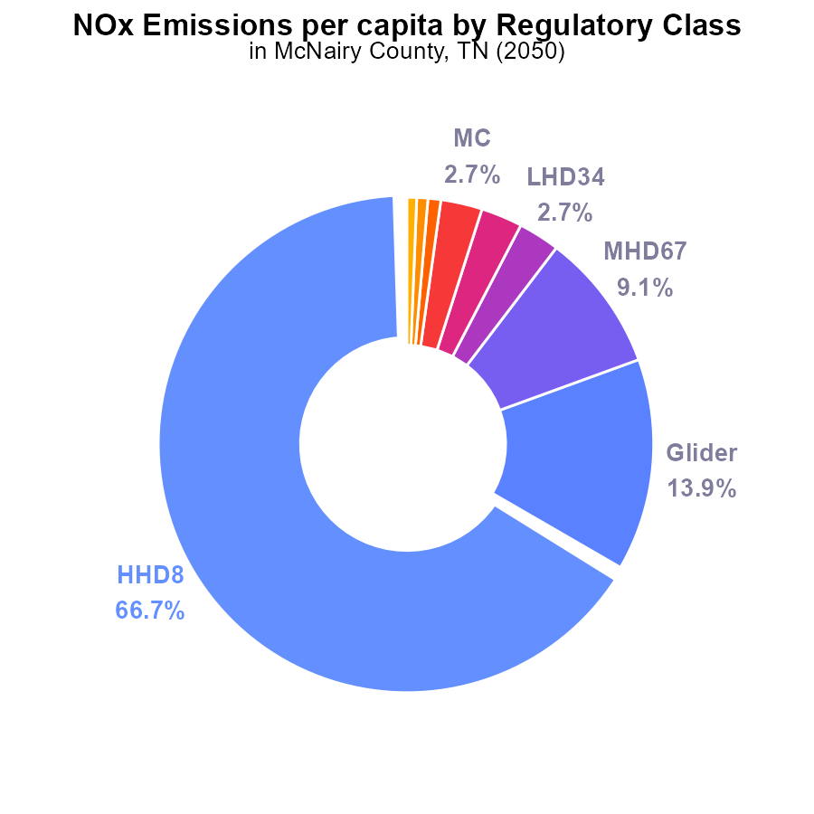

## Findings

* The highest NOx emissions come from HHD8 with 66.7% of the total.
* Glider and MHD67 contribute significantly at 13.9% and 9.1%, respectively.
* Urban Bus, LDV, and LDT have the lowest emissions, each below 1%.

## Recommendations

To lower NOx emissions in McNairy County, focus on reducing emissions from HHD8, Glider, and MHD67, as they are the largest contributors. Consider implementing stricter emissions standards for these sources and promoting the use of cleaner technologies.

# Vehicle Starts Overall over Time

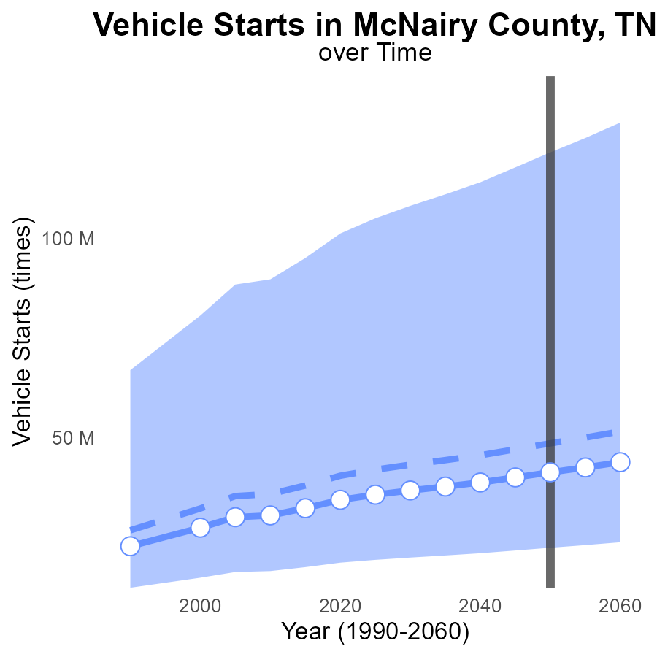

## Findings

* NOx emissions in McNairy County, TN are projected to decrease over the next three decades.
* Vehicle starts are expected to remain fairly constant with a slight decrease over time.
* McNairy County is performing below the upper 75th percentile and above the lower 25th percentile in terms of NOx emissions per vehicle start.

## Recommendations

To further reduce NOx emissions in McNairy County, measures such as promoting the adoption of electric vehicles, improving public transportation infrastructure, and incentivizing carpooling can be considered. Additionally, implementing stricter vehicle emission standards and encouraging the use of eco-friendly transportation modes could help in lowering emissions even more.

# Emissions over Time for Passenger Vehicles

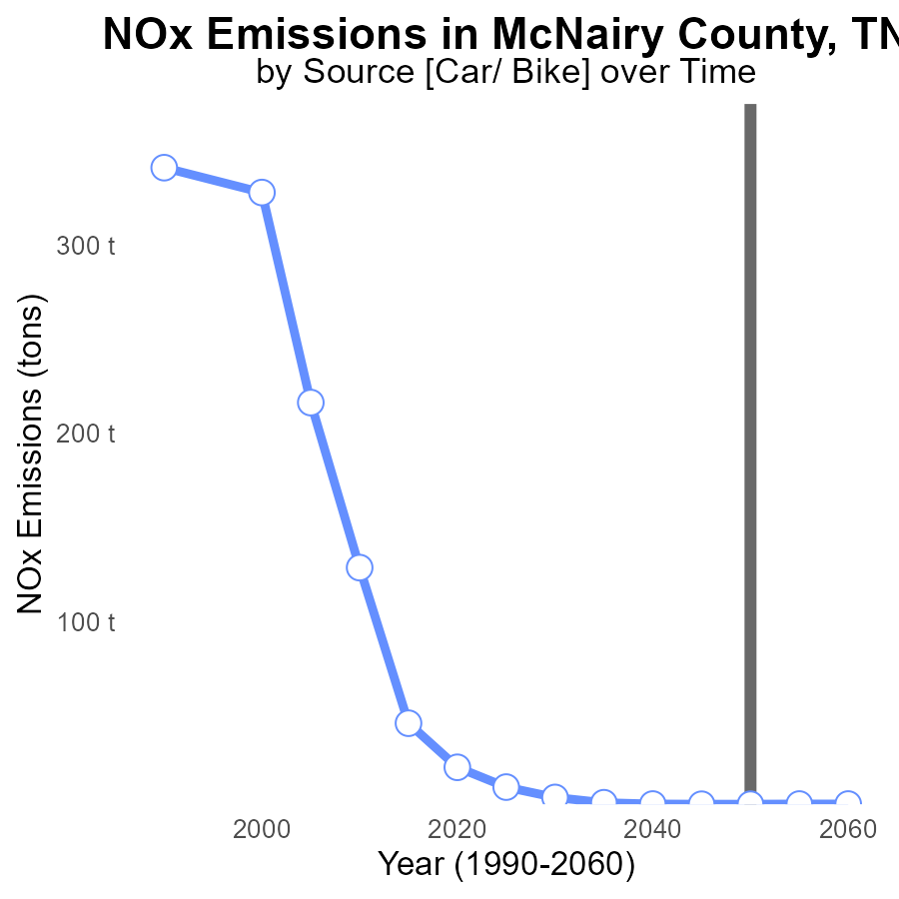

## Findings

* NOx emissions in McNairy County are projected to decrease steadily
* By 2060, NOx emissions are estimated to reach only 3.3 tons, a reduction of 3.6 tons from 2030
* The emissions are on track to meet the benchmark set for 2045, indicating good progress

## Recommendations

To further lower NOx emissions, consider implementing stricter emission control measures, promoting the use of cleaner technologies, and incentivizing the adoption of renewable energy sources.

# Emissions Rate (per mile) Mapped by Area

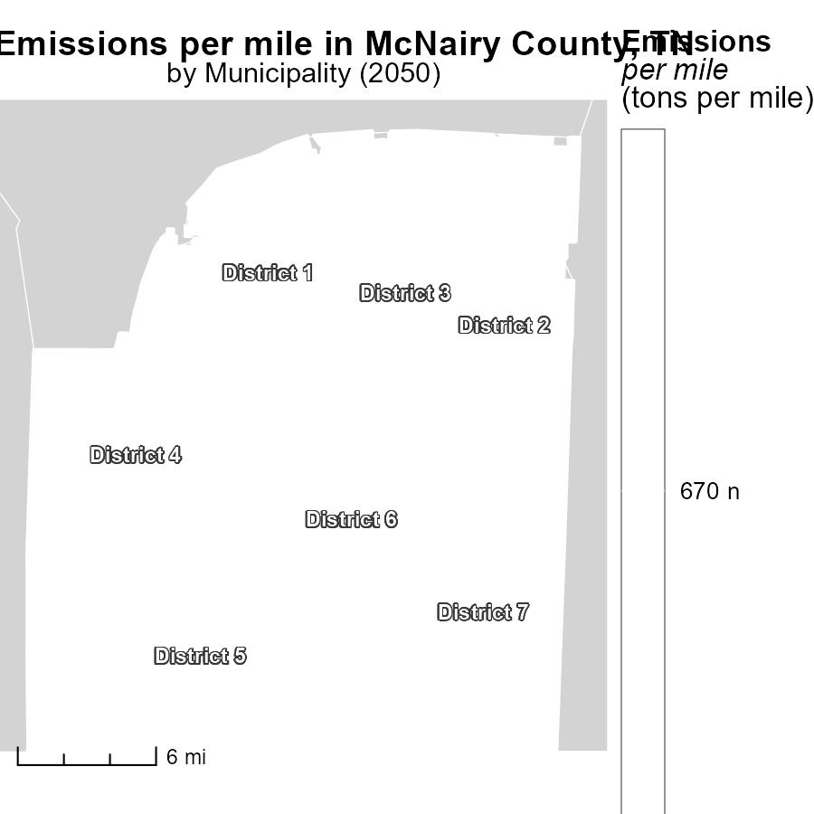

## Findings

* District 1, TN has the highest emissions per mile at 670.5 tons.
* District 4, TN has a median emissions level of 670.5 tons per mile.
* District 7, TN has the lowest emissions per mile at 670.5 tons.

## Recommendations

To lower emissions, focus on implementing cleaner transportation methods in all districts to reduce the 670.5 tons per mile to a more sustainable level.

# Population in My Region

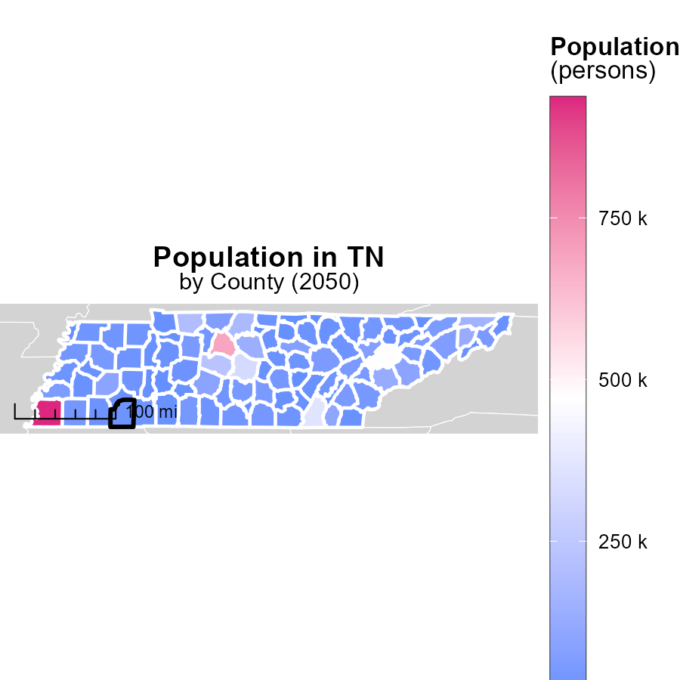

## Findings

* Shelby County, TN has the highest population with 936.6 thousand persons in 2050.
* Claiborne County, TN has a median population with 31.8 thousand persons in 2050.
* Pickett County, TN has the lowest population with 5.1 thousand persons in 2050.

## Recommendations

To lower emissions, focus on densely populated areas like Shelby County by promoting public transport and carpooling. Invest in renewable energy sources in all counties to reduce carbon footprint.

# Vehicle Starts by Road Type over Time

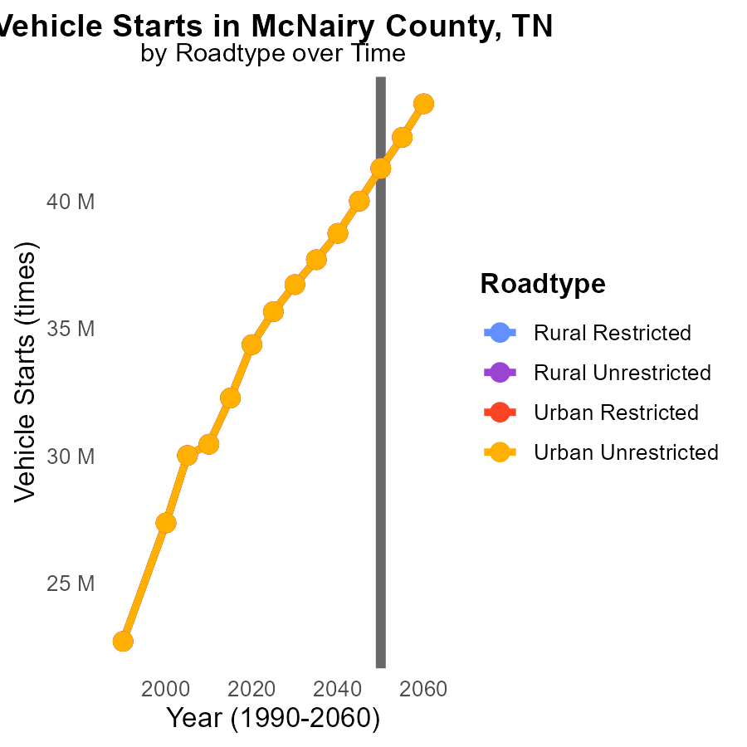

## Findings

* NOx emissions are projected to increase by 5% from 2040 to 2060 in McNairy County, TN.
* Vehicle starts show a consistent growth rate of 2.7% across different road types from 2040 to 2060.
* Significant reductions in NOx emissions varying from 16% to 62% are needed by 2060 to reach 2050 levels.

## Recommendations

To lower emissions, implement stricter vehicle emission standards, promote electric vehicle adoption, and invest in public transportation infrastructure to reduce vehicle starts and NOx emissions by at least 16-62% by 2060.

# Emissions Rate (per vehicle) by Area over Time

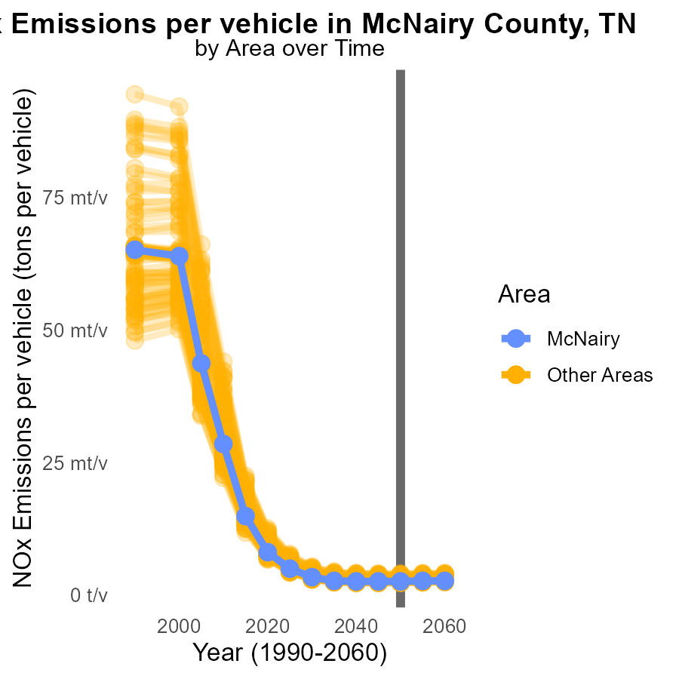

## Findings

* In 2050, the minimum county had 2.3 million tons of NOx emissions per vehicle.
* In 2050, the maximum county had 4.1 million tons of NOx emissions per vehicle.
* By 2060, recommendations to reduce NOx emissions must be implemented to avoid further increases.

## Recommendations

To lower NOx emissions by 2060, policies like stricter vehicle emission standards, promoting electric vehicles, and investing in public transportation are crucial.

# Areas Ranked by Time Driven

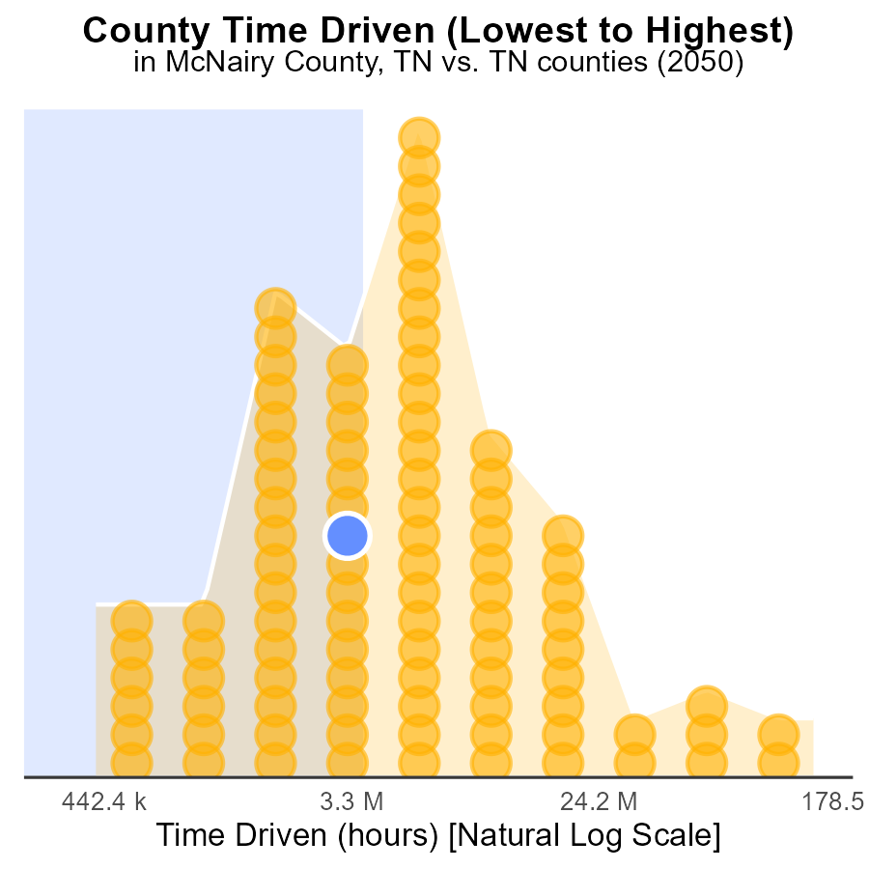

## Findings

* Shelby county has the highest NOx emissions with 374.4 million source hours.
* Lake county has the lowest NOx emissions with 1.1 million source hours, ranking 1st.
* The top 5 counties (Shelby, McNairy, Smith, Carroll, and Lake) contribute to 221.6 million source hours, accounting for 80.1% of the total emissions.

## Recommendations

To reduce NOx emissions, focus on the top emitters like Shelby, McNairy, Smith, Carroll, and Lake counties by implementing stricter emission controls, promoting the use of cleaner technologies, and increasing public transportation options.

# Areas Ranked by Vehicle Starts

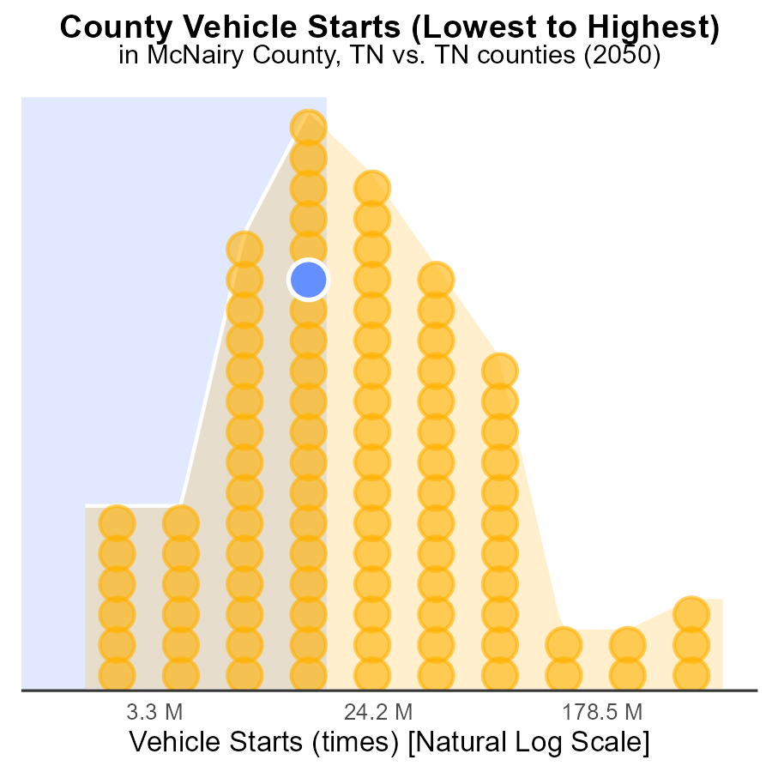

# Conclusion

In conclusion, NOx emissions from on-road transportation in McNairy County, TN in 2050 remain a significant environmental concern. Diesel vehicles are the primary contributors, emitting 1.2 tons of NOx per mile and accounting for two-thirds of total emissions. Transitioning to cleaner fuel sources like electric vehicles and phasing out diesel vehicles could notably reduce NOx emissions. The data shows heavy-duty vehicles like HHD8, Gliders, and MHD67 as the largest contributors to NOx emissions in the county, while urban buses and light-duty vehicles emit the least.

To effectively lower NOx emissions in McNairy County, policies must focus on reducing emissions from high-emitting sources, implementing stricter emission controls, and promoting the adoption of cleaner technologies. While the projections suggest a decrease in NOx emissions by 2060, targeted efforts are necessary to achieve substantial reductions. Collaborative efforts between policymakers, industry stakeholders, and the community are essential in mitigating NOx emissions and improving air quality in the region.

# About This Report

Data based on MOVES estimates collected by the Climate Action in Transportation program at Cornell University. Demographic data sourced from the US Census's American Community Survey 5-year estimates. This report was generated with the help of AI.

# References

* U.S. Census Bureau. (2023). American Community Survey 5-year estimates: Detailed tables. Retrieved from https://data.census.gov
* U.S. Environmental Protection Agency. (2024). Motor Vehicle Emission Simulator (MOVES 4.0) [Software]. Retrieved from https://www.epa.gov/moves