 

**CO Emissions in Brevard County, 2025**  
Made with CAT VISUALIZER by Gao Labs @ Cornell University.

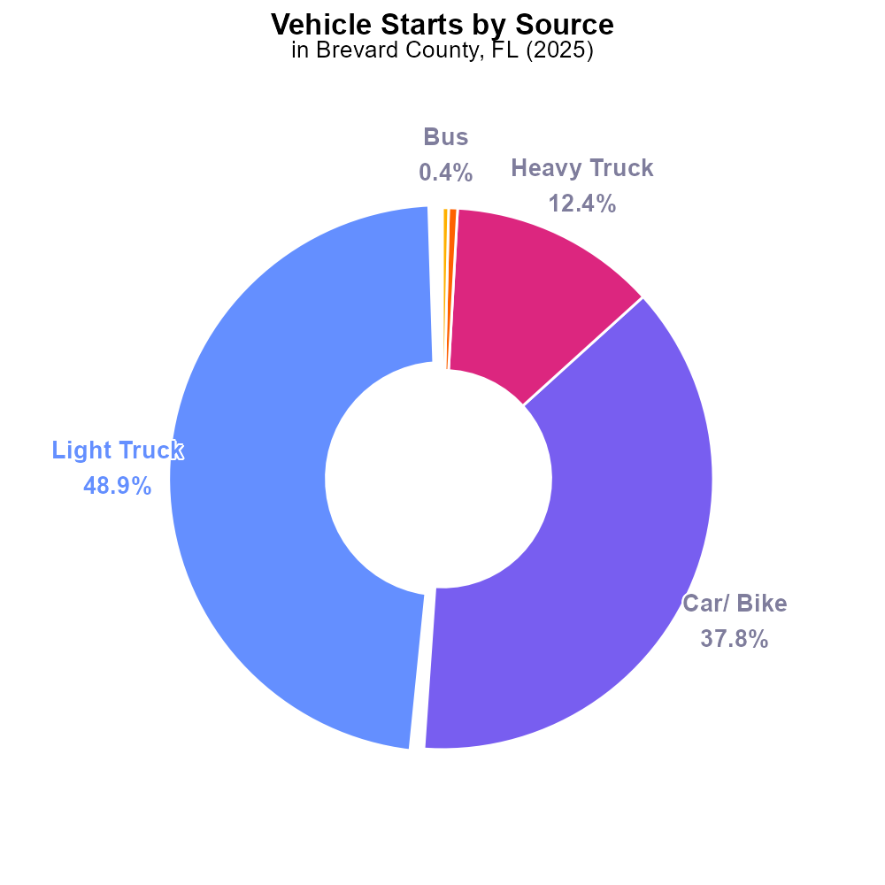

## Keywords

Carbon monoxide emissions; On-road transportation; Brevard County FL; 2025

## Highlights

* Study on CO emissions from on-road transportation in Brevard County, FL in 2025.
* Focus on impact of transportation on air quality and public health.
* Analysis to identify sources and trends of CO emissions in the region.
* Recommendations to mitigate CO emissions and improve air quality.
* Significance of understanding the environmental impact of transportation.

# Introduction

The report aims to investigate carbon monoxide (CO) emissions resulting from on-road transportation in Brevard County, FL, with a specific focus on the year 2025. With the increasing concern over air quality and its impact on public health, understanding the sources and trends of CO emissions is crucial for effective environmental management.

By analyzing the data collected, the report will provide insights into the extent to which transportation activities contribute to CO pollution in the region. Additionally, recommendations will be proposed to mitigate these emissions and improve overall air quality, highlighting the importance of sustainable transportation practices for a healthier environment in Brevard County.

# Vehicle Starts by Vehicle Type

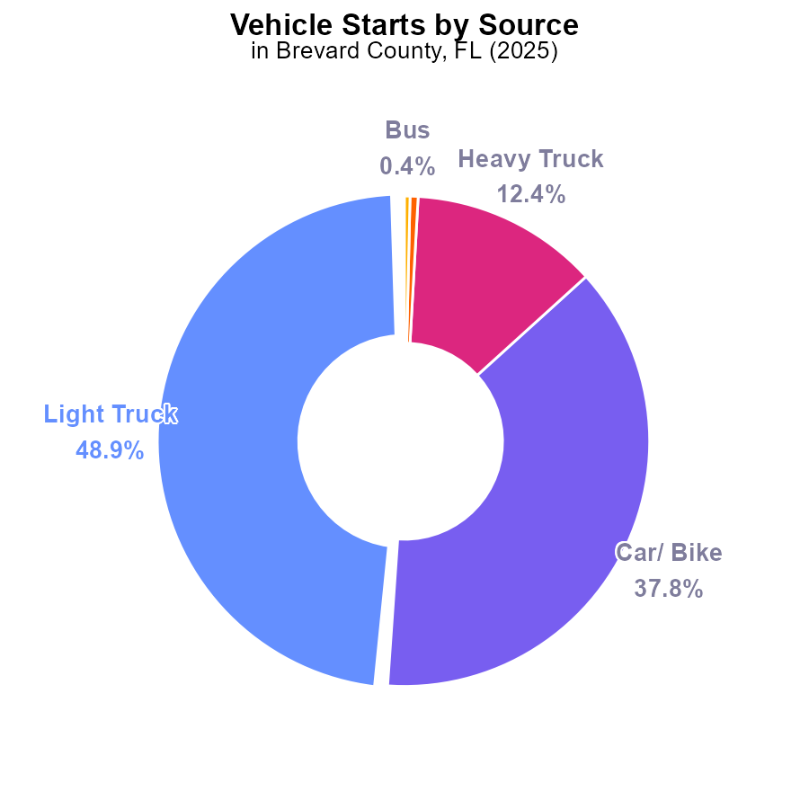

## Findings

* Light trucks account for 48.9% of CO emissions from vehicle starts
* Cars/bikes contribute 37.8% to CO emissions during vehicle starts
* Heavy trucks and combo trucks together emit 12.9% of CO during vehicle starts

## Recommendations

To reduce CO emissions from vehicle starts in Brevard County, FL, focus on improving the efficiency of light trucks and cars/bikes as they are the main contributors. Encouraging the use of electric or hybrid vehicles could significantly decrease emissions from these sources.

# Time Driven Overall by Area

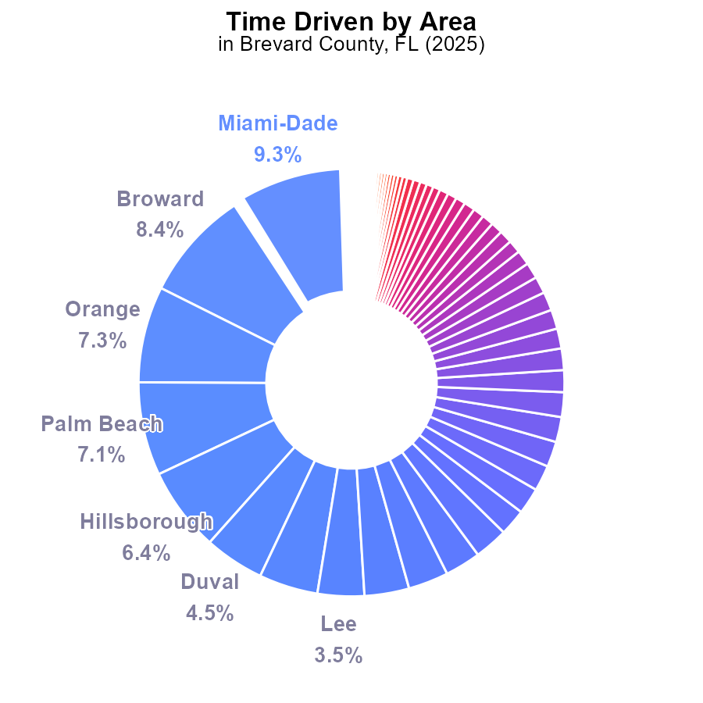

## Findings

* Miami-Dade County had the highest CO emissions in Brevard County in 2025, at 601.5 million label_value, accounting for 9.3% of total emissions.
* Five counties (Miami-Dade, Broward, Orange, Palm Beach, and Hillsborough) collectively contributed over 38% of total CO emissions.
* Twenty-seven counties had CO emissions below 1.5%, with the lowest being Liberty County at 0.0%.

## Recommendations

To lower CO emissions, focus on implementing emission reduction strategies such as promoting public transportation and increasing the use of electric vehicles. Encourage the adoption of renewable energy sources in residential and commercial sectors.

# Emissions over Time for Passenger Vehicles

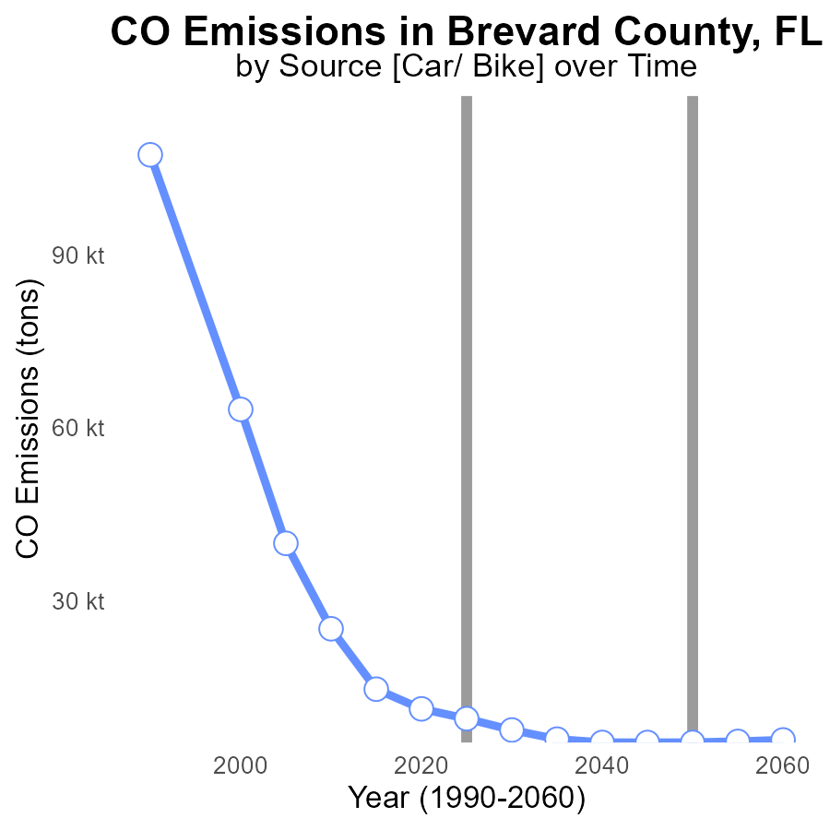

## Findings

* Emissions in Brevard County, FL have shown a decreasing trend from 2005 to 2045.
* The emissions have been consistently decreasing, with the most substantial reduction occurring between 2005 and 2010.
* By the year 2040, Brevard County, FL is expected to reach a point where emissions match the benchmark.

## Recommendations

To continue the positive trend, Brevard County should focus on implementing and enforcing stricter emissions regulations, investing in renewable energy sources, promoting public transportation, and incentivizing green technologies in industries.

# Emissions Overall over Time

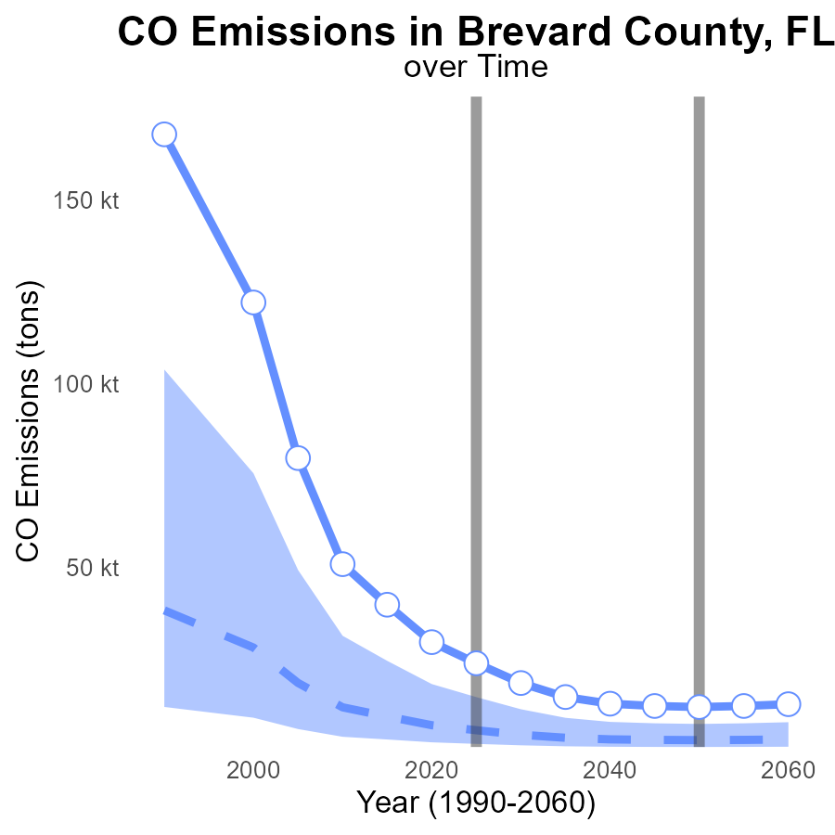

## Findings

* Emissions in Brevard County, FL have been consistently above the median area level since 2005.
* The emissions have decreased over the years, but still remain significantly higher than the median and upper 75th percentile areas.
* By 2045, emissions are projected to decrease but will still be around 12.1 k tons, significantly higher than the median area level.

## Recommendations

To lower emissions, the county should invest in renewable energy sources, promote public transportation, and implement energy-efficient technologies across industries to align with the benchmark and reduce emissions levels.

# Emissions Rate (per mile) in My Region

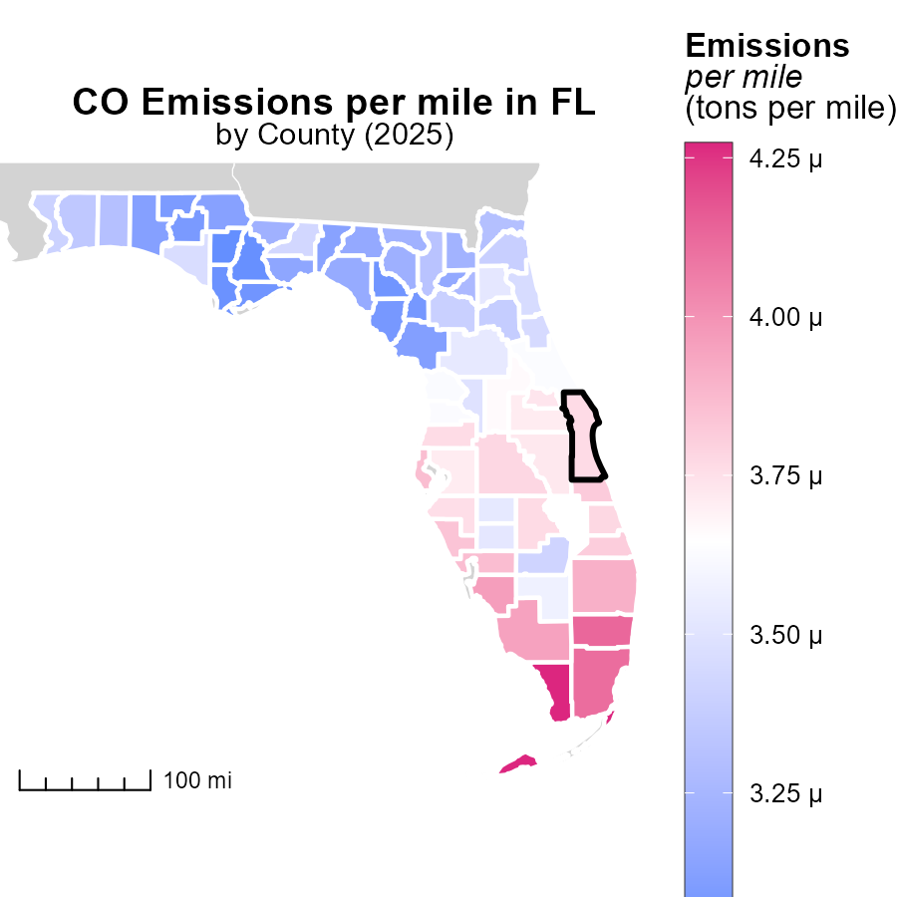

## Findings

* Monroe County, FL has the highest emissions per mile at 4.3 tons
* St. Johns County, FL has median emissions per mile at 3.5 tons
* Calhoun County, FL has the lowest emissions per mile at 3.0 tons

## Recommendations

Policymakers should focus on reducing emissions by promoting electric vehicles, improving public transportation infrastructure, and implementing stricter vehicle emission standards in counties with higher emissions per mile.

# Emissions Rate (per vehicle) in My Region

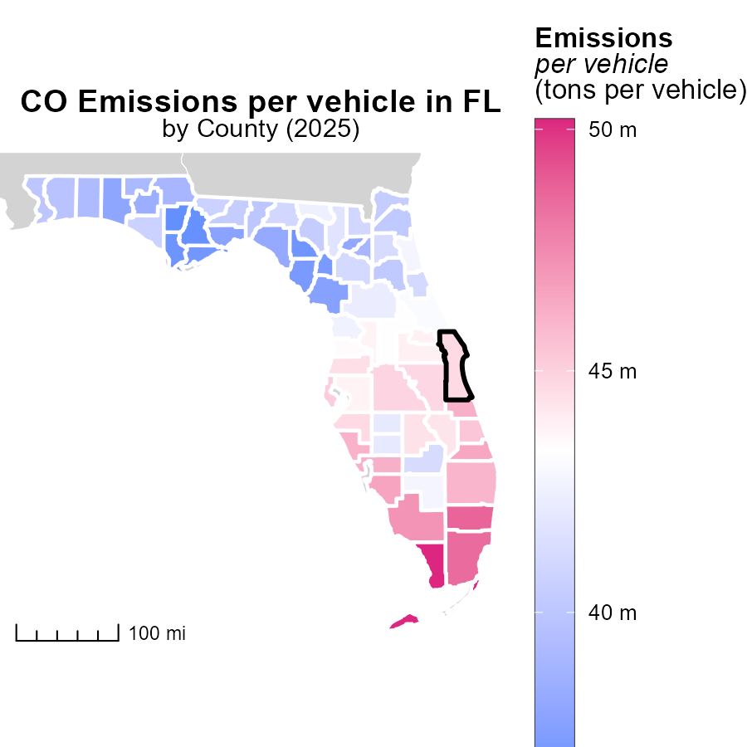

## Findings

* In 2025, Monroe County, FL had the highest emissions per vehicle at 50.2 tons.
* Columbia County, FL had median emissions of 41.8 tons per vehicle.
* Calhoun County, FL had the lowest emissions per vehicle at 36.5 tons.

## Recommendations

Policymakers should focus on implementing stricter emission standards for vehicles in Monroe County. Promote carpooling and the use of public transportation in Columbia County to reduce emissions. Encourage the adoption of electric vehicles in Calhoun County to further decrease emissions.

# Hotelling (Engines Off) by Vehicle Type over Time

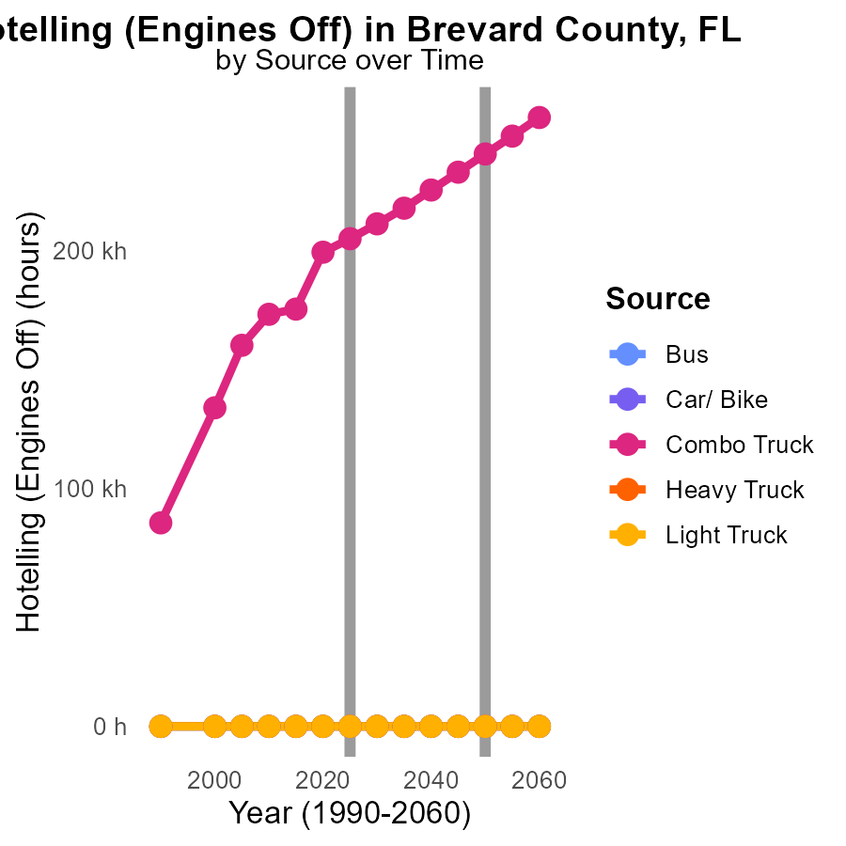

## Findings

* No emissions in Bus and Car/Bike categories from 2015 to 2035.
* Emissions from Combo Trucks decreased by 60% from 175.4k in 2015 to 217.8k in 2035.
* Emissions remained at 0.0 in Heavy Truck and Light Truck categories throughout 2015-2035.

## Recommendations

To further reduce emissions in Combo Trucks, consider incentivizing the adoption of cleaner technologies. Evaluate the feasibility of transitioning Heavy Trucks and Light Trucks to cleaner alternatives.

# Emissions Rate (per mile) by Fuel Type over Time

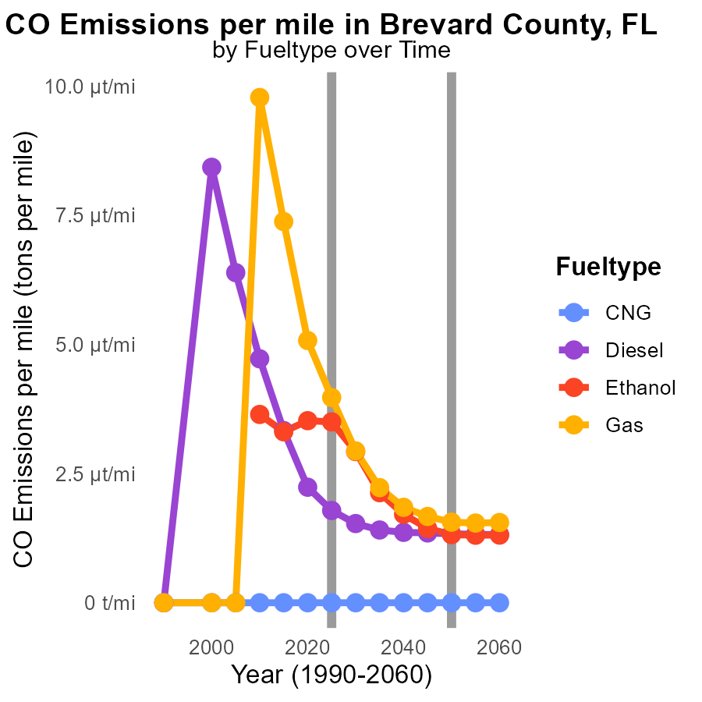

## Findings

* Emissions per mile decreased by 51.4% for Diesel from 2015 to 2035.
* CNG had the highest emissions per mile in all years, with a slight increase by 84.7% from 2015 to 2035.
* Gasoline showed a substantial reduction of 70.3% in emissions per mile from 2015 to 2035.

## Recommendations

To lower emissions levels, focus on transitioning more vehicles to cleaner fuel types like Gasoline and Diesel, while incentivizing the adoption of cleaner technologies for CNG vehicles. Additionally, promoting the use of public transportation and carpooling can also help reduce overall emissions.

# Areas Ranked by Time Driven

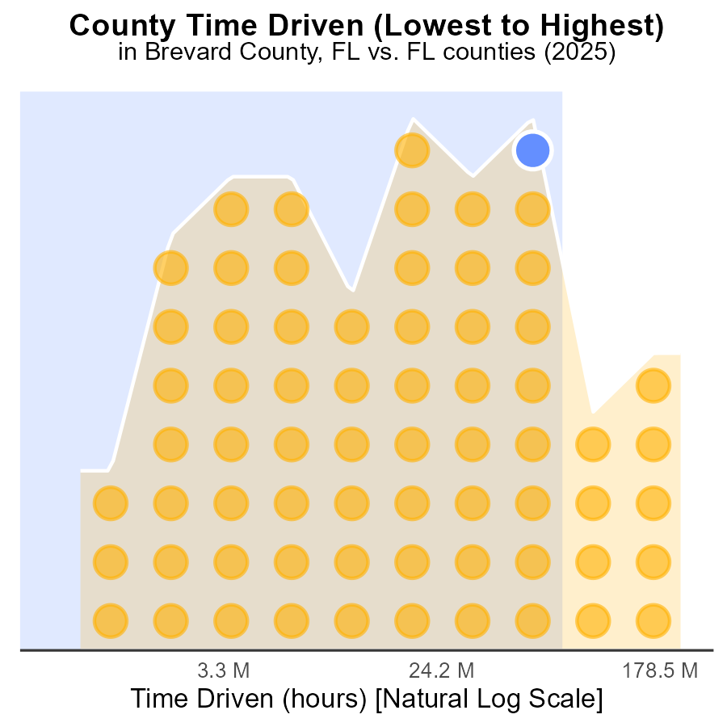

## Findings

* Miami-Dade county has the highest source hours of CO emissions in 2025
* Polk county has the highest percentile of CO emissions rank in 2025
* Liberty county has the lowest percentile of CO emissions rank in 2025

## Recommendations

To lower CO emissions, focus on policies and initiatives in counties with high source hours like Miami-Dade and Polk. Encourage public transportation, carpooling, and cleaner energy sources.

# Areas Ranked by Vehicle Miles Traveled

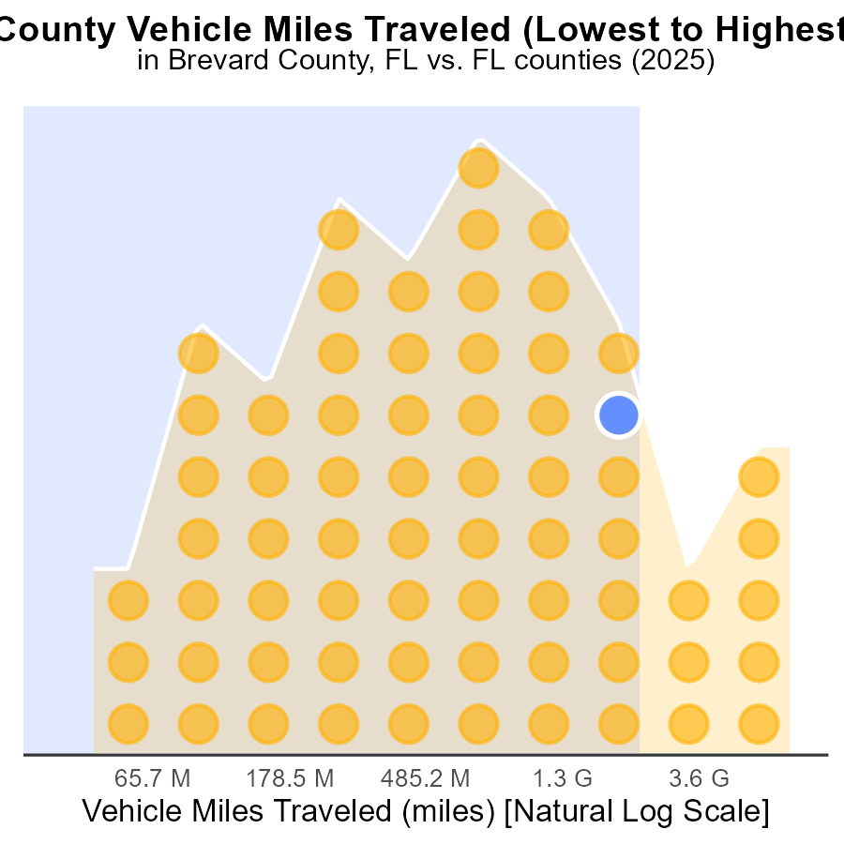

## Findings

* Miami-Dade county has the highest VMT with 19.5 billion miles
* Liberty county has the lowest VMT with 115.5 million miles
* Miami-Dade county represents 100% of the highest VMT percentile

## Recommendations

To lower emissions, reduce vehicle miles traveled: promote public transport, carpooling, and telecommuting. Encourage biking and walking infrastructure. Implement policies to support electric vehicles.

# Conclusion

In conclusion, the data from Brevard County, FL in 2025 highlights the significant impact of on-road transportation on Carbon Monoxide (CO) emissions. With light trucks and cars/bikes contributing to nearly 86.7% of CO emissions during vehicle starts, targeting these vehicle types for improved efficiency and promoting the adoption of electric or hybrid vehicles could greatly reduce emissions in the county.

Moreover, the findings emphasize the importance of regional collaborations to address CO emissions, with five counties contributing over 38% of total emissions. By implementing emission reduction strategies such as promoting public transportation, increasing the use of electric vehicles, and investing in renewable energy sources, Brevard County can continue its positive trend of decreasing emissions. It is essential for policymakers to focus on stricter emissions regulations, incentivizing green technologies, and making investments in renewable energy to align with emission benchmarks and lower CO levels in the coming years.

# About This Report

Data based on MOVES estimates collected by the Climate Action in Transportation program at Cornell University. Demographic data sourced from the US Census's American Community Survey 5-year estimates. This report was generated with the help of AI.

# References

* U.S. Census Bureau. (2023). American Community Survey 5-year estimates: Detailed tables. Retrieved from https://data.census.gov
* U.S. Environmental Protection Agency. (2024). Motor Vehicle Emission Simulator (MOVES 4.0) [Software]. Retrieved from https://www.epa.gov/moves