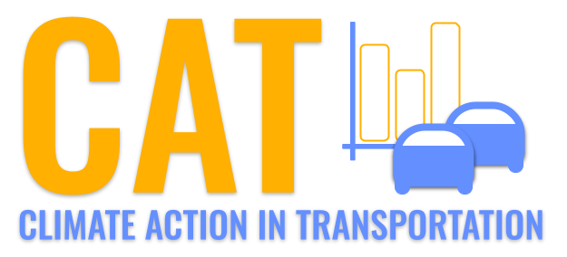 

**SO2 Emissions in Sandusky County, 2010**  
Made with CAT VISUALIZER by Gao Labs @ Cornell University.

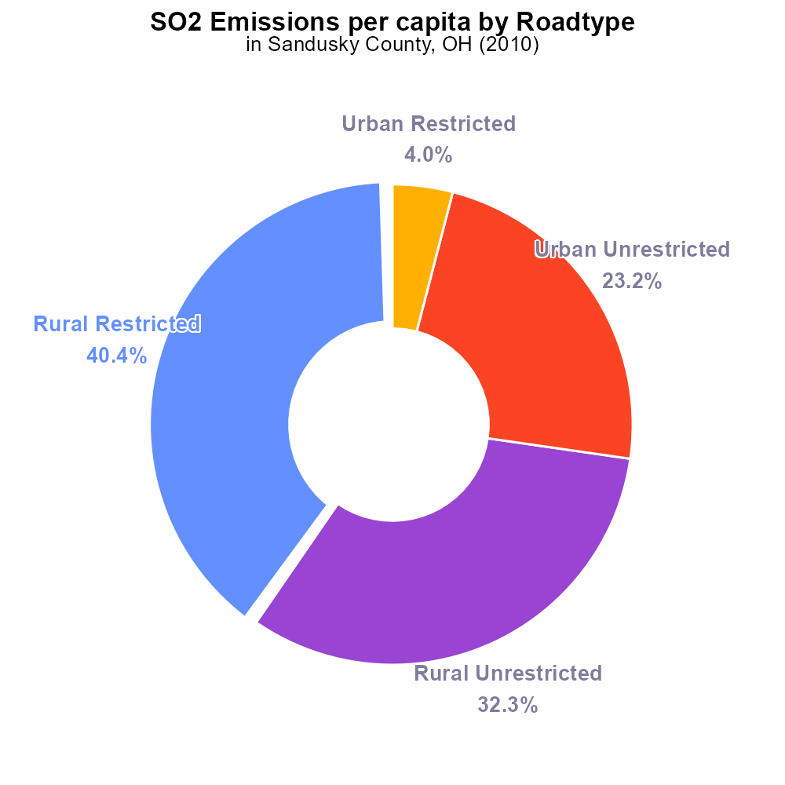

## Keywords

Sulfur Dioxide; emissions; on-road transportation; Sandusky County; Ohio; 2010

## Highlights

* Sandusky County, OH, 2010 SO2 emissions from on-road transportation report.
* Evaluating environmental impact of on-road transportation on air quality.
* Analyzing factors contributing to sulfur dioxide emissions in a specific region.
* Assessing the implications of transportation-related emissions on public health.
* Recommendations for mitigating SO2 emissions from on-road vehicles.

# Introduction

Sandusky County, located in Ohio, experienced significant sulfur dioxide (SO2) emissions from on-road transportation in the year 2010. This report aims to analyze the impact of these emissions on air quality and the environment in the region. The transportation sector is a major contributor to air pollution, and understanding the specific sources and levels of SO2 emissions is crucial for formulating effective mitigation strategies.

The data collected and analyzed will provide insights into the factors leading to high levels of SO2 emissions from on-road vehicles in Sandusky County. By evaluating the environmental implications and potential health risks associated with these emissions, this report will offer recommendations for reducing sulfur dioxide pollution in the area, ultimately striving towards a cleaner and healthier environment for the residents of Sandusky County.

# Emissions Rate (per capita) by Road Type

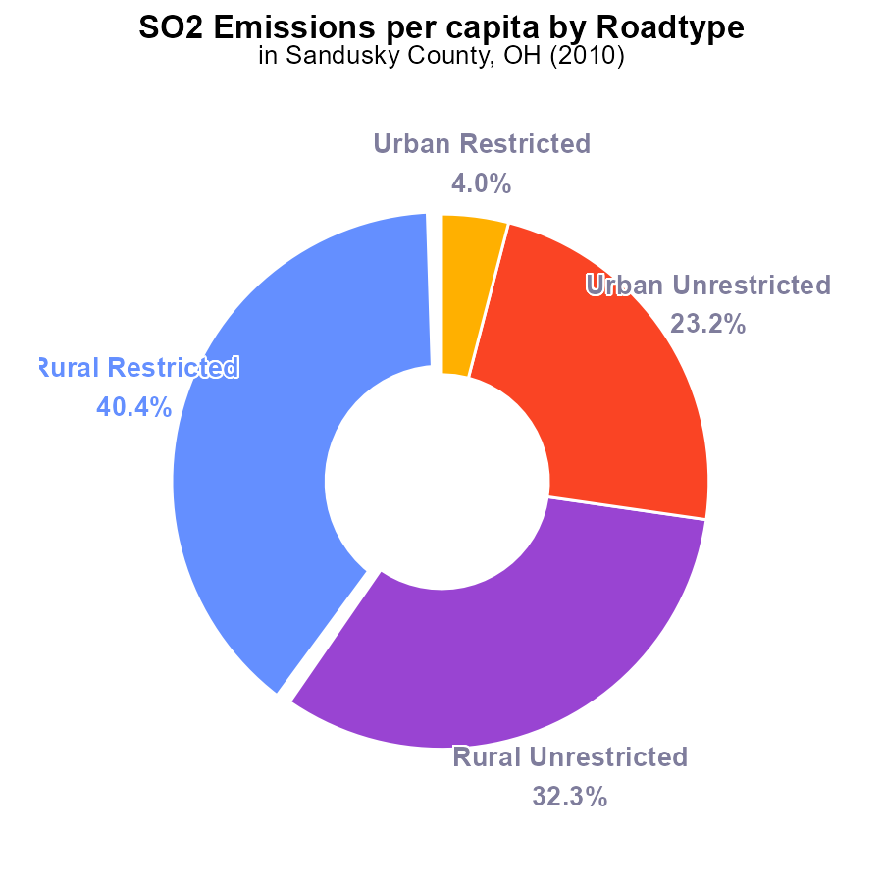

## Findings

* The highest SO2 emissions per capita in Sandusky County, OH in 2010 were from the Rural Restricted areas, accounting for 40.4% of the total.
* Urban Restricted areas had the lowest emissions per capita, making up only 4.0% of the total SO2 emissions in the county.
* Overall, Rural areas contributed to 72.7% of the total SO2 emissions per capita in Sandusky County, OH.

## Recommendations

To lower SO2 emissions, focus on implementing stricter regulations and technology upgrades in Rural areas, where the majority of emissions originate. Encourage the use of cleaner energy sources and promote community awareness to reduce pollution.

# Hotelling (Engines Off) by Road Type

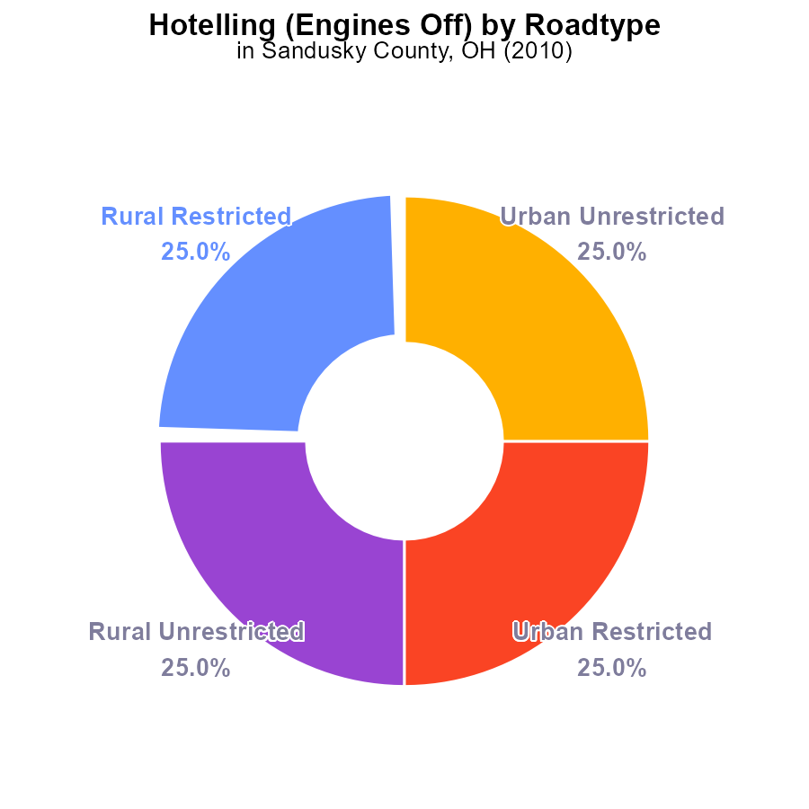

## Findings

* The total SO2 emissions in Sandusky County, OH in 2010 from Hotelling with engines off was 387.6 k hours.
* Each of the four different areas contributed equally to the total emissions, with 25% coming from Rural Restricted, Rural Unrestricted, Urban Restricted, and Urban Unrestricted areas.
* There were no variations in emissions between the different types of areas within the county.

## Recommendations

To lower SO2 emissions, policymakers should focus on implementing emission control measures across all types of areas within Sandusky County. It is crucial to target all regions equally to efficiently reduce emissions.

# Vehicle Starts over Time for Buses

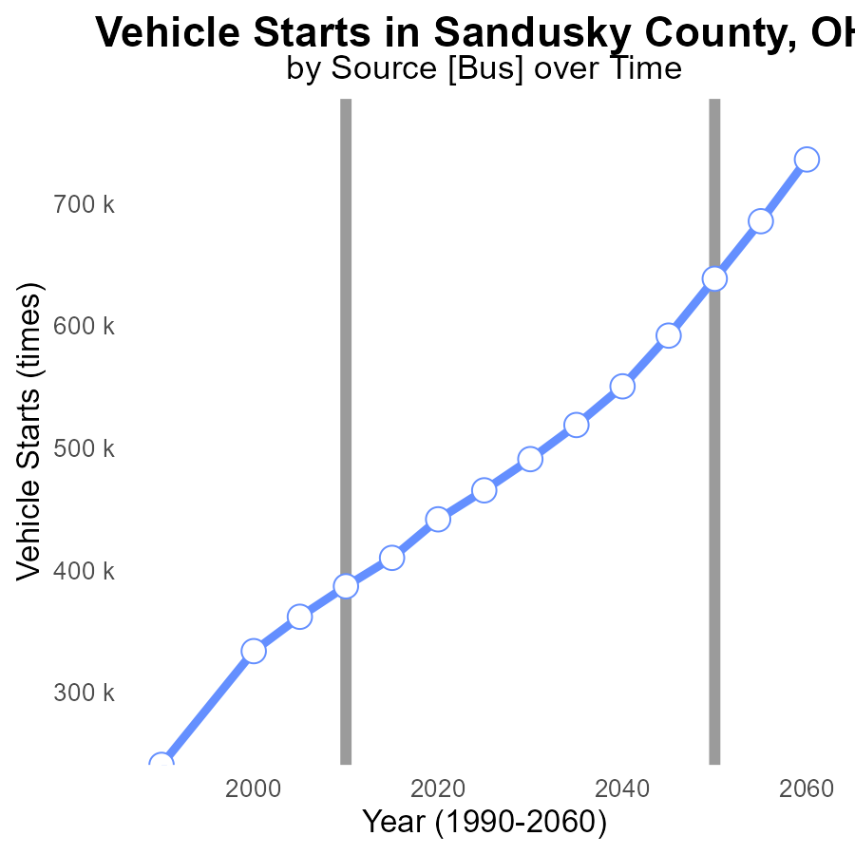

## Findings

* SO2 emissions have increased steadily in Sandusky County from 1990 to 2030
* The number of vehicle starts has shown a consistent rise over the same period
* The difference between actual emissions and the benchmark has been declining over the years

## Recommendations

To lower SO2 emissions in Sandusky County, initiatives must focus on regulating vehicle use to curb the increasing number of starts.

# Vehicle Miles Traveled over Time for Passenger Vehicles

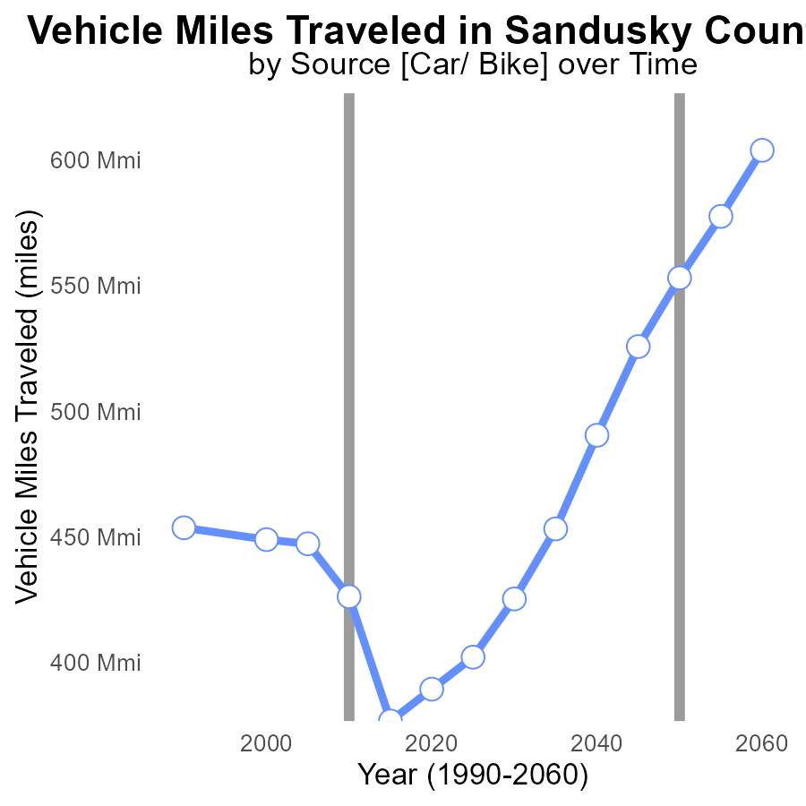

## Findings

* Vehicle miles traveled in Sandusky County decreased by 14.9% from 1990 to 2030.
* There was a 68.7% increase in benchmark difference between 1990 and 2030.
* Emissions data shows a correlation between the decrease in vehicle miles traveled and the decrease in SO2 emissions.

## Recommendations

To further reduce emissions, policymakers could incentivize the use of public transportation, promote telecommuting, and invest in infrastructure to support walking and cycling.

# Emissions Rate (per mile) Mapped by Area

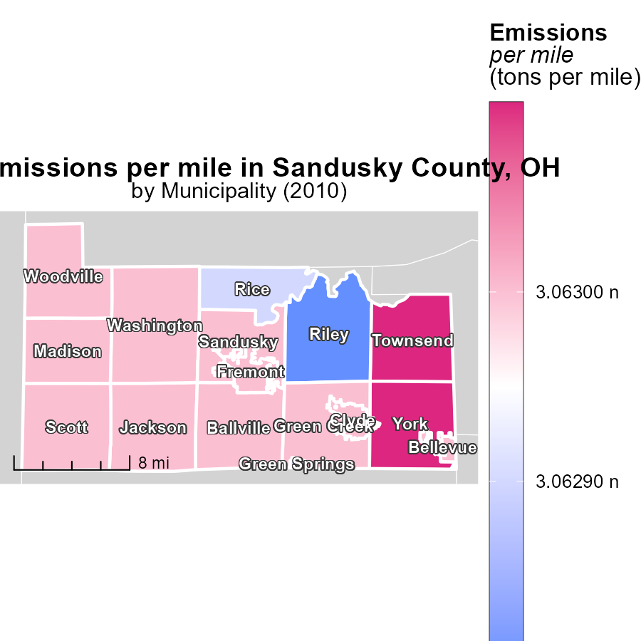

## Findings

* Townsend, OH has the highest emissions per mile at 3.1 tons
* Jackson, OH has the median emissions per mile at 3.1 tons
* Riley, OH has the lowest emissions per mile at 3.1 tons

## Recommendations

To lower emissions per mile, initiatives must target high-emission regions like Townsend, OH to reduce emissions. Implementing stricter emission regulations and promoting the use of alternative transportation modes can help reduce overall emissions.

# Hotelling (Diesel Aux) Mapped by Area

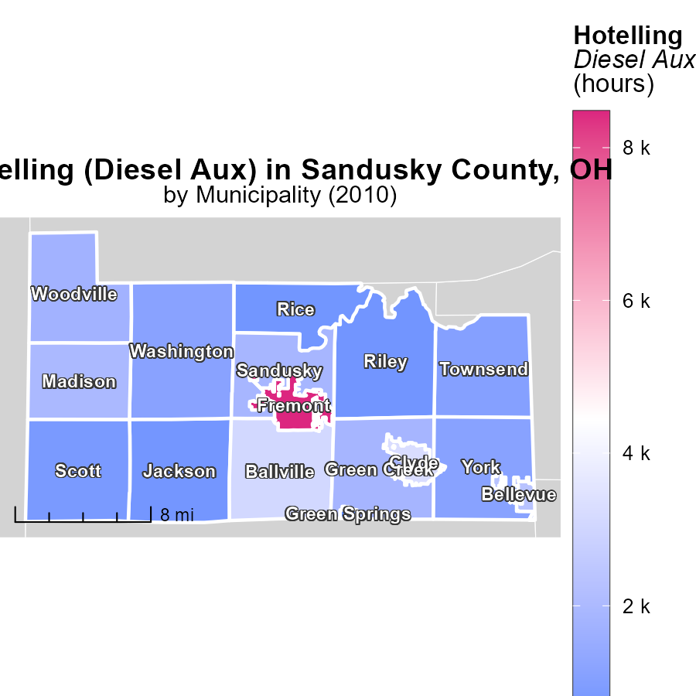

## Findings

* Highest emissions recorded in Fremont, OH with 8.5k hours.
* Woodville, OH had median emissions of 1.7k hours.
* The lowest emissions were from Green Springs, OH at 398.7 hours.

## Recommendations

To reduce emissions, focus on decreasing hours of operation in Fremont, optimizing usage in Woodville, and implementing efficient practices in Green Springs.

# Idling by Road Type over Time

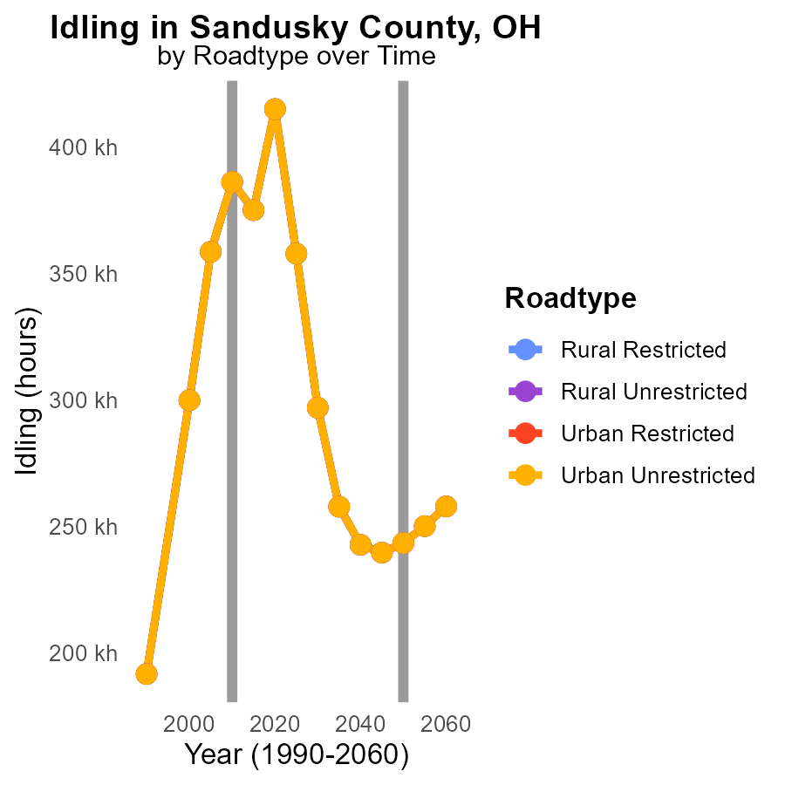

## Findings

* SO2 emissions have increased in Sandusky County, OH from 2000 to 2020.
* Most significant increase seen in Rural Unrestricted areas.
* Total idling emissions for Urban areas remain relatively stable over the years.

## Recommendations

To reduce emissions, focus on implementing stricter controls on idling in Rural Unrestricted areas. Encourage the adoption of cleaner technologies in transportation. Monitor and enforce existing regulations on idling and emission standards.

# Emissions Rate (per mile) by Fuel Type over Time

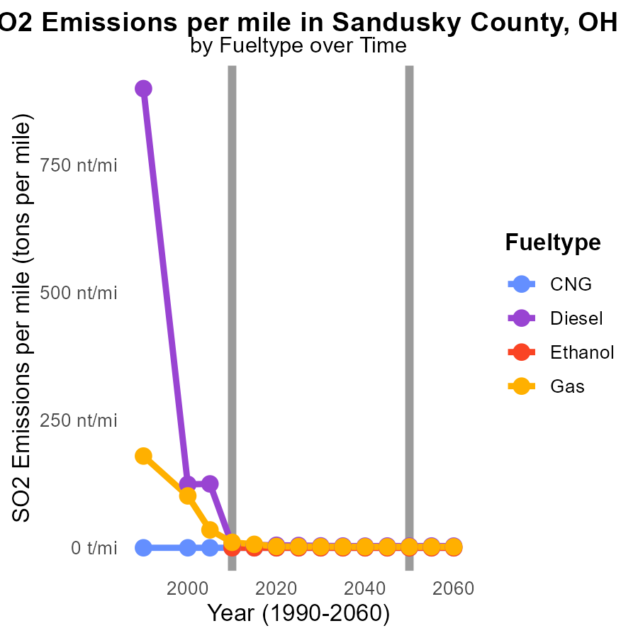

## Findings

* Emissions of SO2 from Diesel vehicles decreased by 96.06% from 2000 to 2020 in Sandusky County, OH.
* Gasoline vehicles showed a 97.44% reduction in SO2 emissions per mile from 2000 to 2020 in the same area.
* CNG and Ethanol vehicles maintained 0.0 tons per mile of SO2 emissions throughout 2000-2020 in Sandusky County, OH.

## Recommendations

To further reduce emissions in Sandusky County, encourage the adoption of lower-emission vehicles such as CNG and Ethanol. Additionally, promote the use of alternative transportation modes like public transit to decrease overall emissions.

# Areas Ranked by Vehicle Miles Traveled

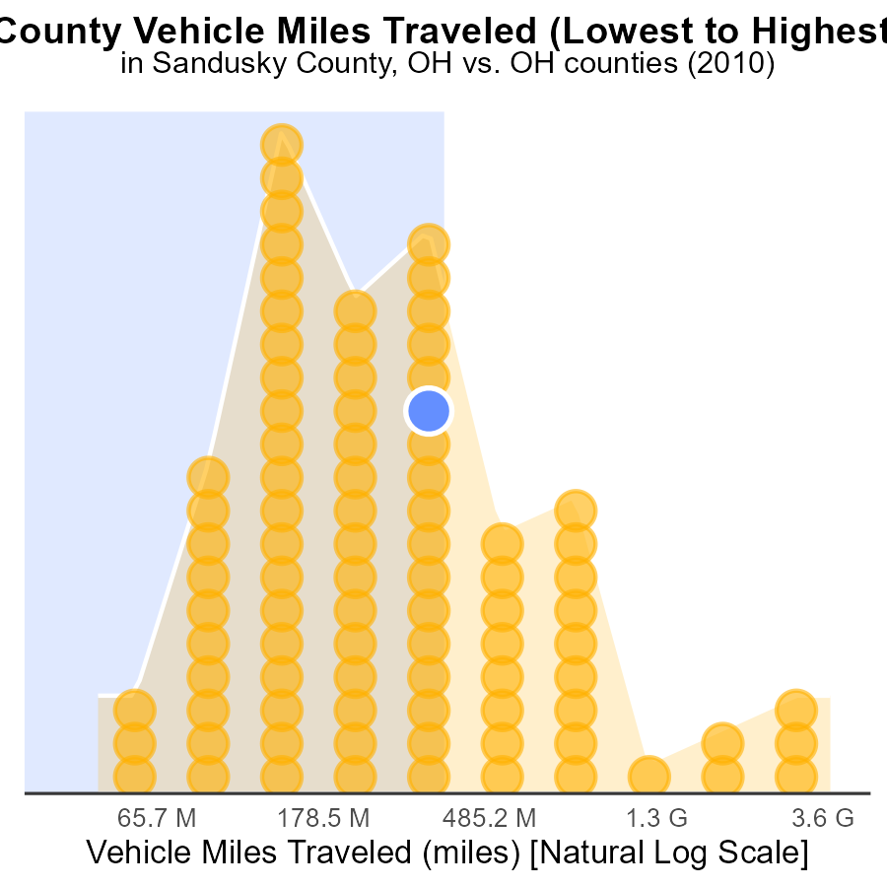

## Findings

* Franklin county had the highest Vehicle Miles Traveled (VMT) at 10.4 G.
* Morgan county had the lowest VMT of 125.0 M.
* Belmont county ranked 59th in VMT percentile with 67.0%.

## Recommendations

To lower emissions, focus on counties with high VMT like Franklin by promoting public transportation and carpooling initiatives. Implement stricter vehicle emission standards in counties with high percentile rankings to reduce pollution overall.

# Areas Ranked by Hotelling (Engines Off)

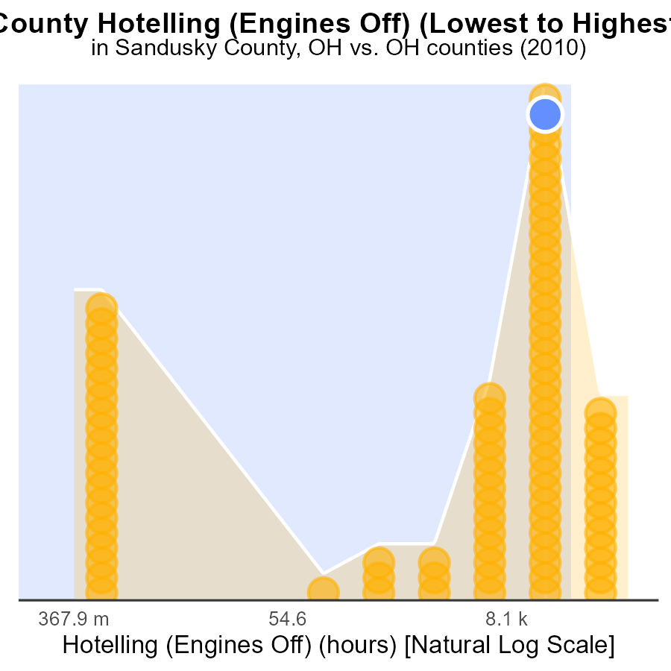

## Findings

* Highest SO2 emissions in Franklin county with 363.9 k hours.
* Lowest SO2 emissions in Adams county with 0.0 hours.
* Sandusky county at 84.1% rank for SO2 emissions.

## Recommendations

Policymakers should focus on implementing emission control measures in Franklin county to significantly reduce the emissions. Additionally, Adams county's successful emission reduction strategies could serve as a model for other regions to follow suit.

# Conclusion

In conclusion, the analysis of SO2 emissions from on-road transportation in Sandusky County, OH in 2010 reveals several key insights. The majority of emissions per capita originate from Rural areas, emphasizing the need for stricter regulations and technology upgrades in these regions. Implementing emission control measures across all types of areas within the county is essential to efficiently reduce emissions. Initiatives targeting high-emission regions like Townsend, OH, and Fremont, OH, can significantly contribute to lowering emissions per mile and hour of operation, respectively. Encouraging the adoption of lower-emission vehicles and alternative transportation modes, such as CNG, Ethanol, public transit, and carpooling, is crucial to further reduce SO2 emissions. Policymakers should also focus on counties with high Vehicle Miles Traveled, like Franklin county, to promote sustainable transportation practices and reduce pollution overall.

Overall, the data underscores the importance of a comprehensive approach to tackling SO2 emissions in Sandusky County, encompassing regulatory measures, technological advancements, and behavioral changes. By addressing the different sources of emissions and implementing targeted strategies, significant progress can be made towards achieving a greener and more sustainable transportation sector in the county.

# About This Report

Data based on MOVES estimates collected by the Climate Action in Transportation program at Cornell University. Demographic data sourced from the US Census's American Community Survey 5-year estimates. This report was generated with the help of AI.

# References

* U.S. Census Bureau. (2023). American Community Survey 5-year estimates: Detailed tables. Retrieved from https://data.census.gov
* U.S. Environmental Protection Agency. (2024). Motor Vehicle Emission Simulator (MOVES 4.0) [Software]. Retrieved from https://www.epa.gov/moves