 

**PM2.5 Emissions in Lowndes County, 2055**  
Made with CAT VISUALIZER by Gao Labs @ Cornell University.

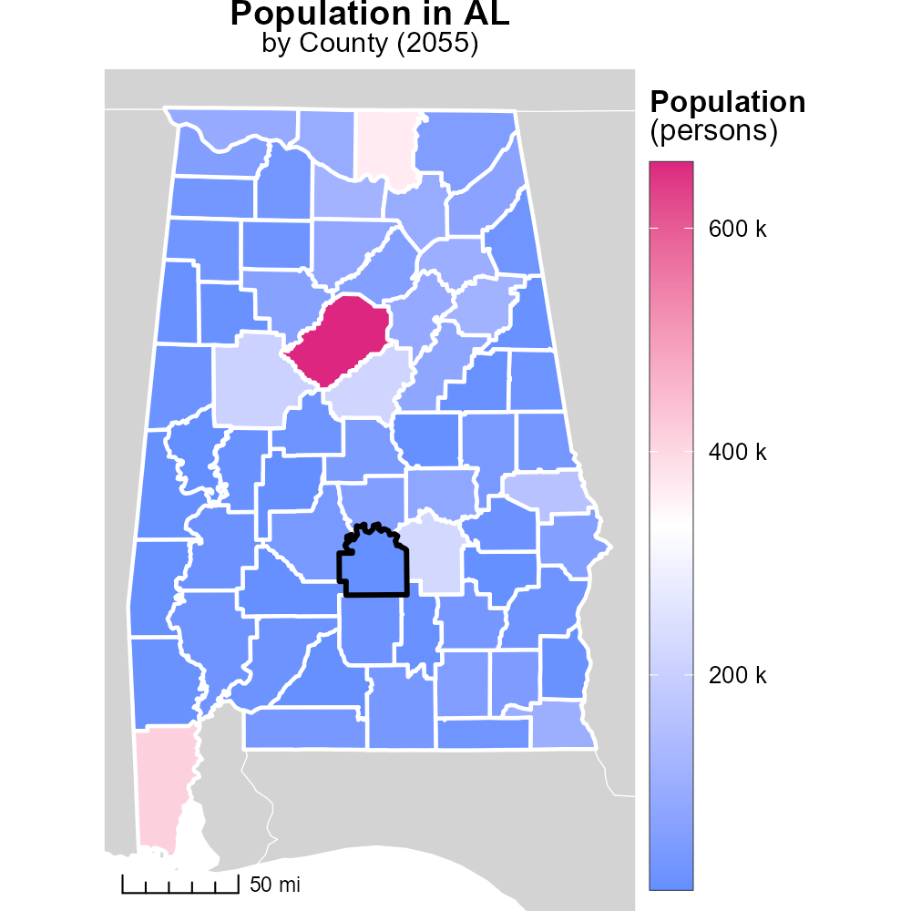

## Keywords

Primary Exhaust PM2.5; Total emissions; On-road transportation; Lowndes County, AL; 2055

## Highlights

* Investigating primary exhaust PM2.5 emissions from on-road transportation in Lowndes County, AL.
* Assessing the total emissions impact on air quality in the region in the year 2055.
* Examining the potential health and environmental implications of increased PM2.5 levels.
* Identifying trends and patterns in transportation-related pollution for targeted intervention strategies.
* Providing recommendations for mitigation measures and policy changes to reduce emissions.

# Introduction

The report focuses on analyzing primary exhaust PM2.5 emissions stemming from on-road transportation activities in Lowndes County, Alabama in the year 2055. By delving into the total emissions generated by vehicles in this region, we aim to gain a comprehensive understanding of the environmental impact on air quality and public health.

Through this investigation, we seek to uncover trends and patterns in PM2.5 emissions related to transportation, offering valuable insights for implementing targeted intervention strategies. By identifying areas of concern and potential sources of pollution, the report ultimately aims to provide recommendations for effective mitigation measures and policy changes to reduce harmful emissions and safeguard the well-being of the community.

# Population by Fuel Type

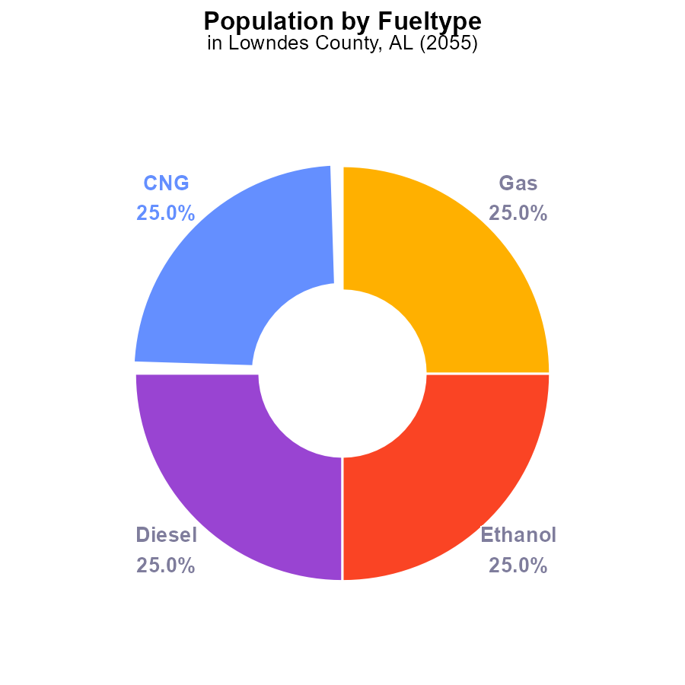

## Findings

* The total PM2.5 emissions in Lowndes County, AL in 2055 is 39.6 k.
* Each fuel type (CNG, Diesel, Ethanol, Gas) contributes 25.0% to the total PM2.5 emissions.
* The population of persons affected by these emissions is not provided in the data.

## Recommendations

To lower the PM2.5 emissions in Lowndes County, AL, a balanced approach targeting all fuel types is necessary. Consider shifting towards cleaner fuels and promoting stricter emission standards for all fuel types.

# Emissions by Regulatory Class

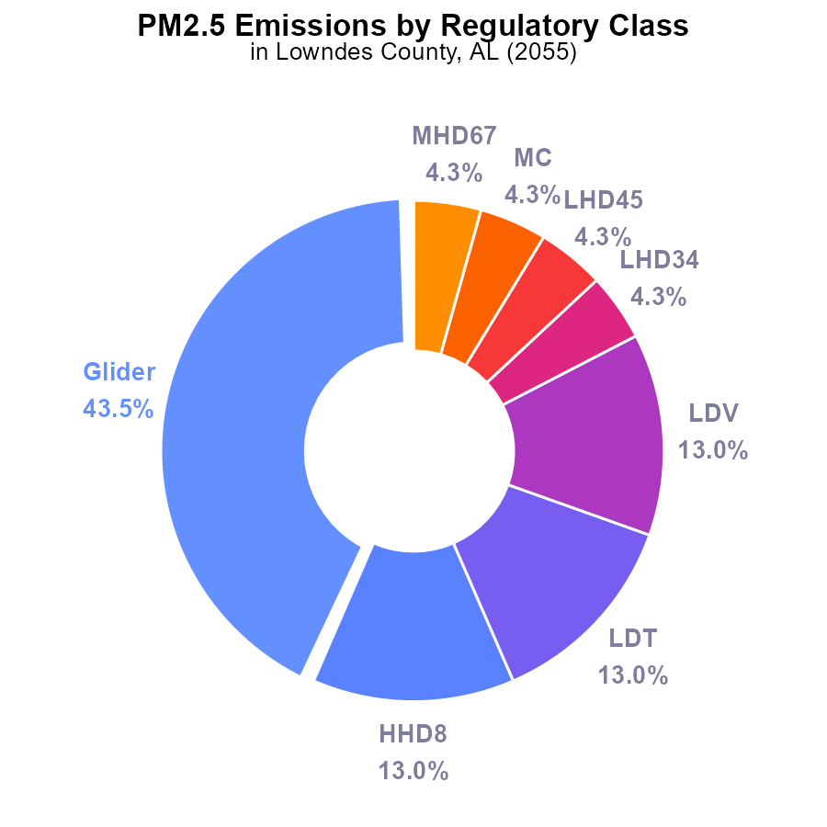

## Findings

* Glider emissions contribute to 43.5% of PM2.5 emissions in Lowndes County, AL in 2055.
* HHD8, LDT, and LDV vehicles collectively contribute 39% of total emissions.
* Urban buses do not emit PM2.5 in Lowndes County, AL in 2055.

## Recommendations

To reduce PM2.5 emissions: prioritize reducing glider emissions due to their significant contribution, promote cleaner technologies for HHD8, LDT, and LDV vehicles, and consider expanding the use of zero-emission urban buses.

# Emissions Rate (per capita) over Time for Passenger Vehicles

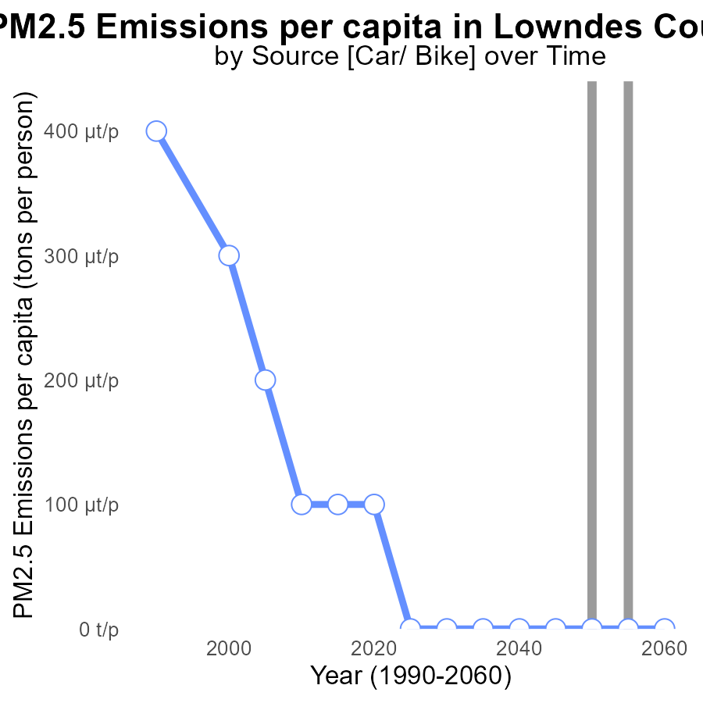

## Findings

* Emissions of PM2.5 in Lowndes County, AL have remained constant at 30.2 tons per person from 2035 to 2045.
* There is a noticeable increase to 40.3 tons per person starting in 2050, which is a 33% rise from the previous level.
* This rise continues until 2060, maintaining the same high level of 40.3 tons per person, signifying a sustained increase in emissions.

## Recommendations

To lower the emission level of PM2.5 in Lowndes County, AL, focus must be given to implementing stricter pollution control measures on industries and promoting the adoption of cleaner technologies. Additionally, investing in renewable energy sources and enhancing public transportation to reduce individual vehicle emissions can significantly contribute to decreasing the overall emissions per capita in the region.

# Vehicle Starts Overall over Time

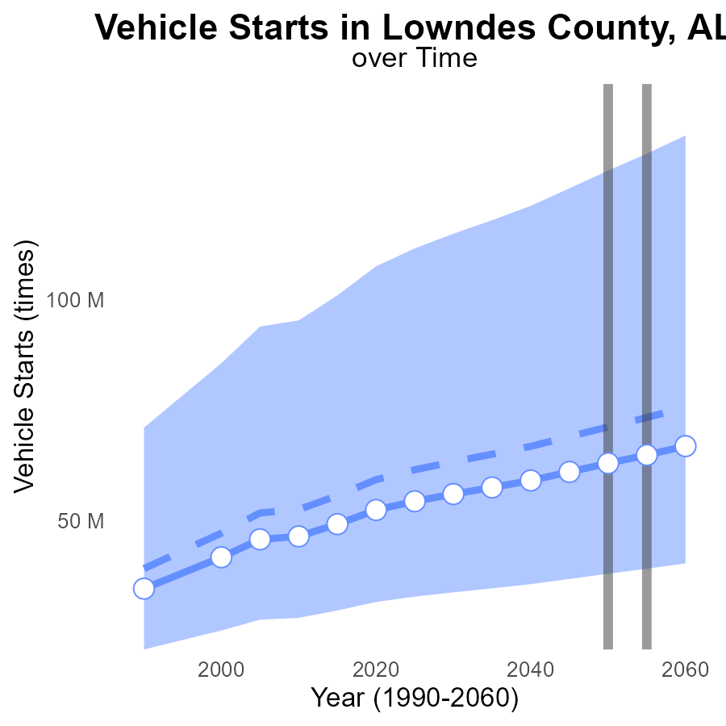

## Findings

* PM2.5 emissions from vehicle starts in Lowndes County are projected to decrease by 8.7 million times by 2060 compared to the median area in 2050.
* In 2050, PM2.5 emissions from vehicle starts in Lowndes County are expected to be 63.1 million times, which is 8.2 million times lower than the median area.
* By 2045, the benchmark difference for PM2.5 emissions from vehicle starts in Lowndes County will be 1,957,148 times compared to the lower 25th percentile of areas.

## Recommendations

To lower PM2.5 emissions from vehicle starts further, the county should invest in promoting electric vehicles, improving public transportation infrastructure, and enforcing stricter vehicle emission standards. Collaborating with industries to adopt cleaner technologies can also help in reducing overall emissions.

# Population in My Region

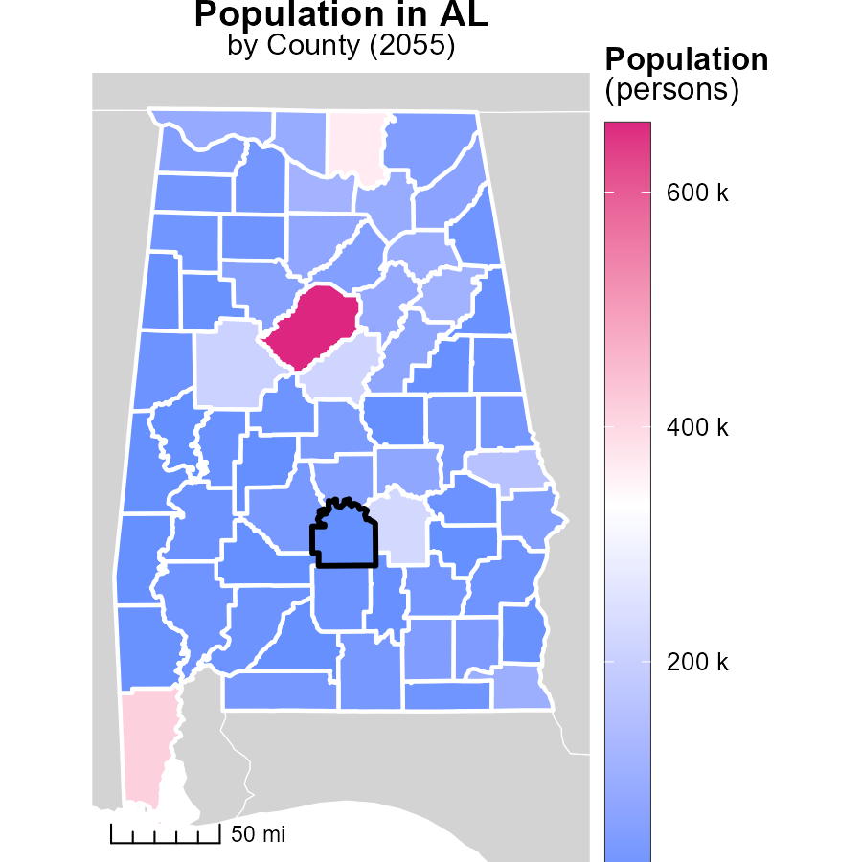

## Findings

* Jefferson County, AL has the highest population with 658.6k persons, Chambers County, AL has a median population with 33.4k persons, and Greene County, AL has the lowest population with 8.2k persons.

## Recommendations

To lower emissions, focus on Jefferson County due to its higher population share. Implement energy-efficient programs tailored to the varying population sizes in Chambers and Greene Counties.

# Emissions Rate (per vehicle) in My Region

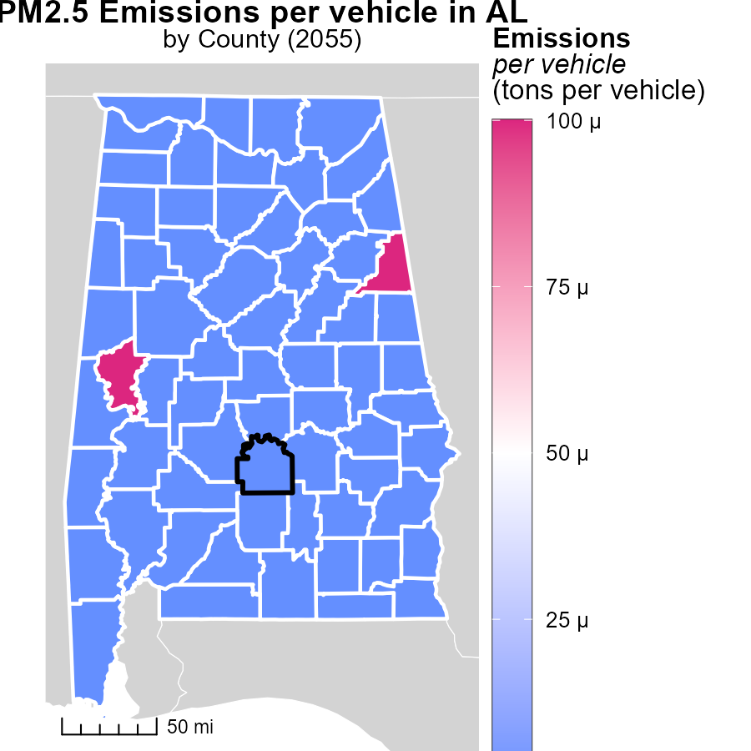

## Findings

* The maximum emissions per vehicle in Cleburne County, AL, are 51.4 tons.
* The median emissions per vehicle in Henry County, AL, are 34.7 tons.
* The minimum emissions per vehicle in Winston County, AL, are 33.9 tons.

## Recommendations

To reduce emissions per vehicle, policymakers could promote the adoption of electric vehicles, improve public transportation infrastructure, and incentivize carpooling and telecommuting.

# Hotelling (Diesel Aux) by Regulatory Class over Time

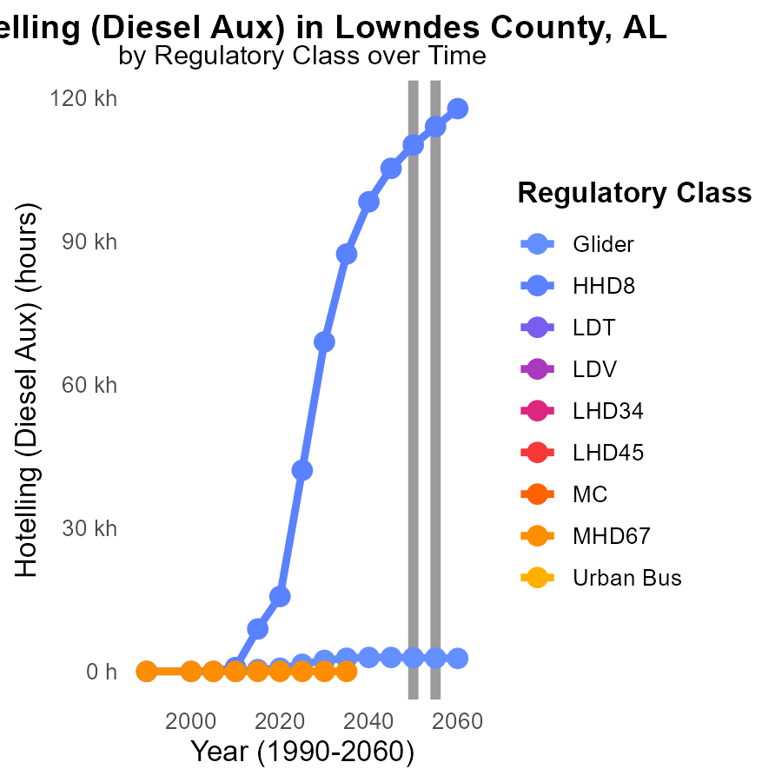

## Findings

* PM2.5 emissions for Glider vehicles decreased by 51.5% from 2050 to 2045.
* PM2.5 emissions for HHD8 vehicles increased by 4899.0% from 2050 to 2045.
* LDT, LDV, LHD34, MHD67, and Urban Bus showed no data available for PM2.5 emissions from 2045 to 2060.

## Recommendations

To reduce PM2.5 emissions, focus on improving Glider vehicles technology to maintain the decreasing trend seen from 2050 to 2045. For the HHD8 vehicles, stricter regulations and technological upgrades are necessary to curb the alarming 4899.0% increase observed from 2050 to 2045. Furthermore, efforts should be made to collect and report PM2.5 emissions data for LDT, LDV, LHD34, MHD67, and Urban Bus to assess and mitigate their environmental impact effectively.

# Emissions by Road Type over Time

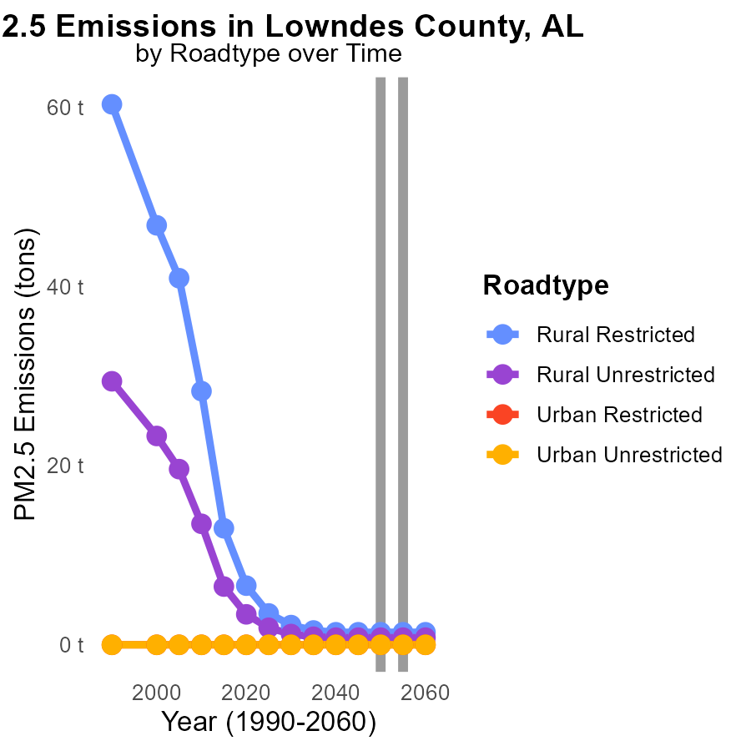

## Findings

* PM2.5 emissions in Lowndes County, AL are consistently low from 2045 to 2060.
* Highest emissions in 2045 come from Rural Unrestricted roads at 800.0 tons.
* Urban areas show no PM2.5 emissions throughout the years under consideration.

## Recommendations

To maintain low PM2.5 emissions in the county, focus on monitoring and enforcing emission standards for vehicles traveling on Rural Unrestricted roads. Implement incentives for cleaner transportation options.

# Areas Ranked by Population

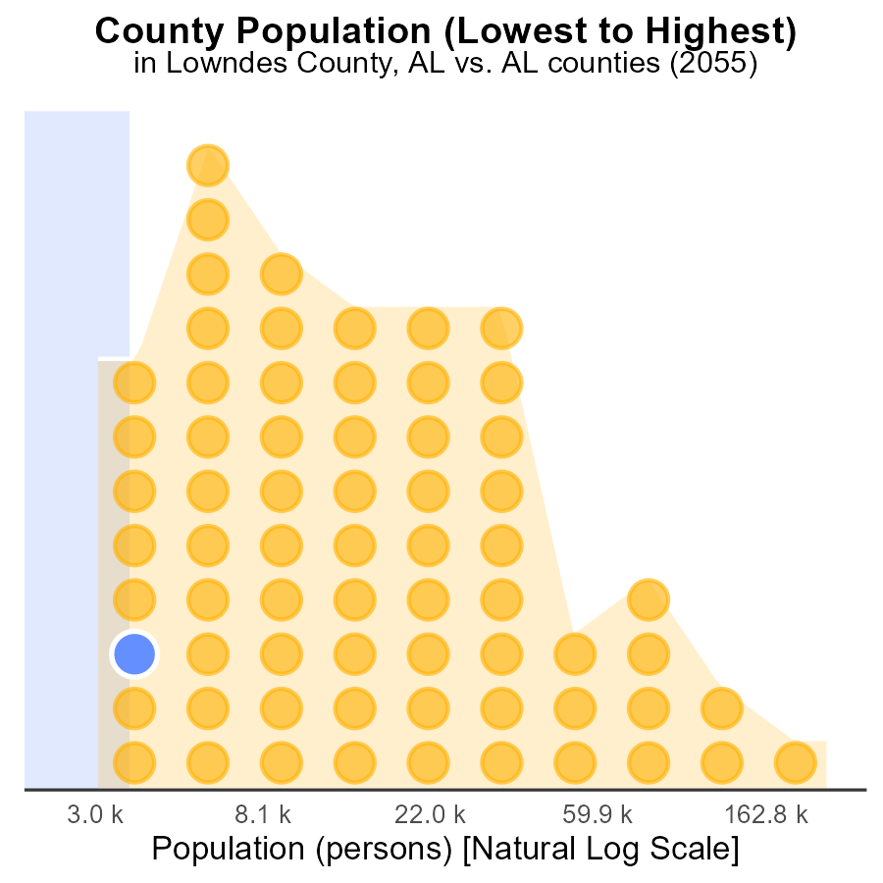

## Findings

* Jefferson county has the highest population with 658.6k people.
* Lowndes county has the lowest population with 9.9k people, ranking 6th.
* Greene county has a population of 8.2k, ranking 2nd in population size.

## Recommendations

To reduce emissions in these counties, targeted strategies focused on high population areas like Jefferson should be implemented. Implementing stricter regulations and promoting cleaner technologies can help decrease emissions in these areas.

# Areas Ranked by Emissions

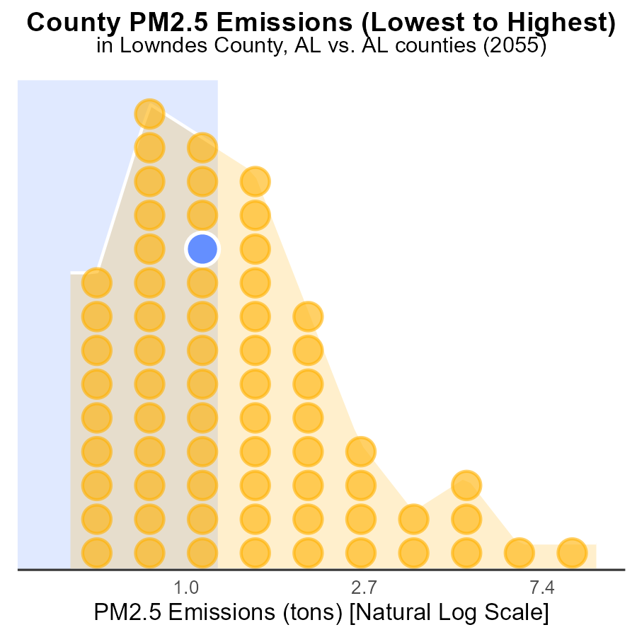

## Findings

* Jefferson County has the highest PM2.5 emissions at 26.1 tons, ranking 67th.
* Perry County ranks 1st for emissions with 400.0 tons, but only contributes 1.5% to total emissions.
* Lowndes County ranks 33rd with 2.2 tons and contributes 49.3% to total emissions.

## Recommendations

To lower PM2.5 emissions, focus on reducing emissions from Jefferson County, despite ranking 67th, as it has the highest emissions. Implement stricter regulations and incentivize cleaner technologies in Perry and Lowndes counties to reduce their high percentile contributions.

# Conclusion

In conclusion, the analysis of PM2.5 emissions in Lowndes County, AL in 2055 reveals a concerning trend of increasing emissions per person, with a notable rise observed from 2050 onwards. The data highlights the significant contributions of different fuel types and vehicle categories to the total emissions, emphasizing the need for a comprehensive approach to lower PM2.5 levels in the county.

To address the escalating emissions, strategies focusing on reducing glider emissions, promoting cleaner technologies for various vehicle categories, and enhancing public transportation, particularly urban buses, are recommended. Additionally, enforcing stricter emission standards for industries and encouraging the adoption of renewable energy sources can play a pivotal role in combatting the rising PM2.5 levels in the region.

# About This Report

Data based on MOVES estimates collected by the Climate Action in Transportation program at Cornell University. Demographic data sourced from the US Census's American Community Survey 5-year estimates. This report was generated with the help of AI.

# References

* U.S. Census Bureau. (2023). American Community Survey 5-year estimates: Detailed tables. Retrieved from https://data.census.gov
* U.S. Environmental Protection Agency. (2024). Motor Vehicle Emission Simulator (MOVES 4.0) [Software]. Retrieved from https://www.epa.gov/moves