 

**NOx Emissions in Pinellas County, 2060**  
Made with CAT VISUALIZER by Gao Labs @ Cornell University.

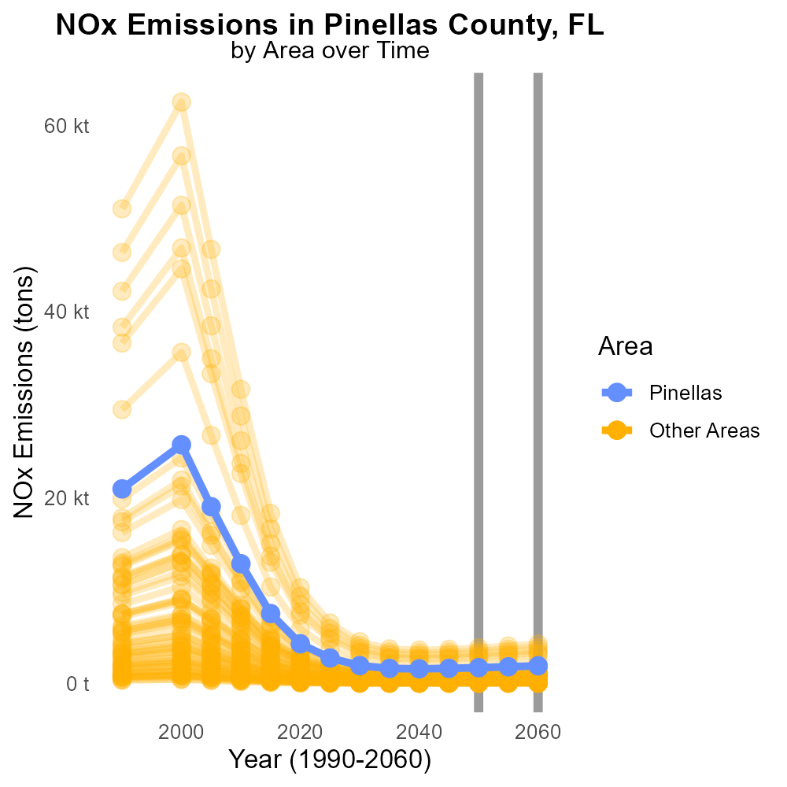

## Keywords

NOx emissions; on-road transportation; Pinellas County; 2060; environmental impact; air pollution

## Highlights

* Investigating NOx emissions from transportation in Pinellas County, FL in 2060.
* Assessment of environmental impact and air pollution due to increased on-road transportation.
* Focus on strategies for reducing NOx emissions to improve local air quality.
* Comparison of current and projected data to quantify the growth of NOx emissions.
* Implications for public health and sustainable urban development in the region.

# Introduction

This report delves into the increasing concern of Oxides of Nitrogen (NOx) emissions from on-road transportation in Pinellas County, FL, projected for the year 2060. With a growing population and expanding urban infrastructure, the levels of NOx emissions are expected to rise significantly, impacting the local environment and air quality.

By analyzing historical data and projecting future trends, this report aims to assess the environmental implications of NOx emissions from transportation. Furthermore, it will evaluate potential strategies and policies to mitigate these emissions and enhance sustainable development in the region.

# Emissions Rate (per mile) by Road Type

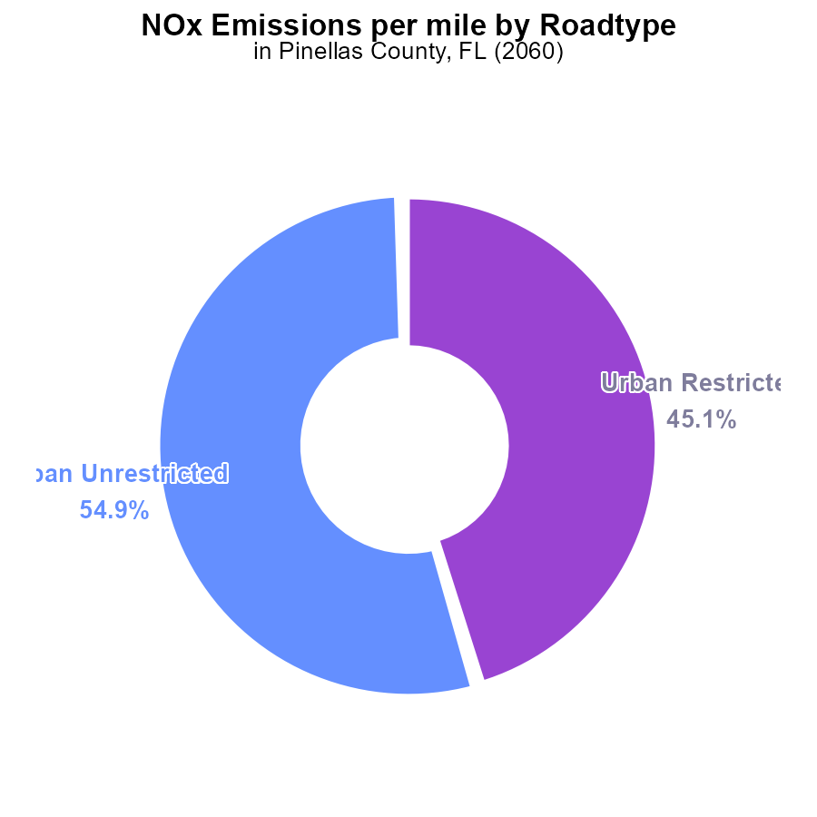

## Findings

* Urban Unrestricted areas emit 187.1 tons of NOx per mile, accounting for 54.9% of total emissions.
* Urban Restricted areas emit 153.7 tons of NOx per mile, making up 45.1% of total NOx emissions.
* Data on Rural Restricted and Unrestricted areas is needed to complete the emissions profile.

## Recommendations

To reduce NOx emissions, focus on improving vehicle technologies in Urban areas to decrease emissions per mile. Encourage the use of electric vehicles and public transportation to lower overall emissions.

# Emissions Rate (per mile) Overall by Area

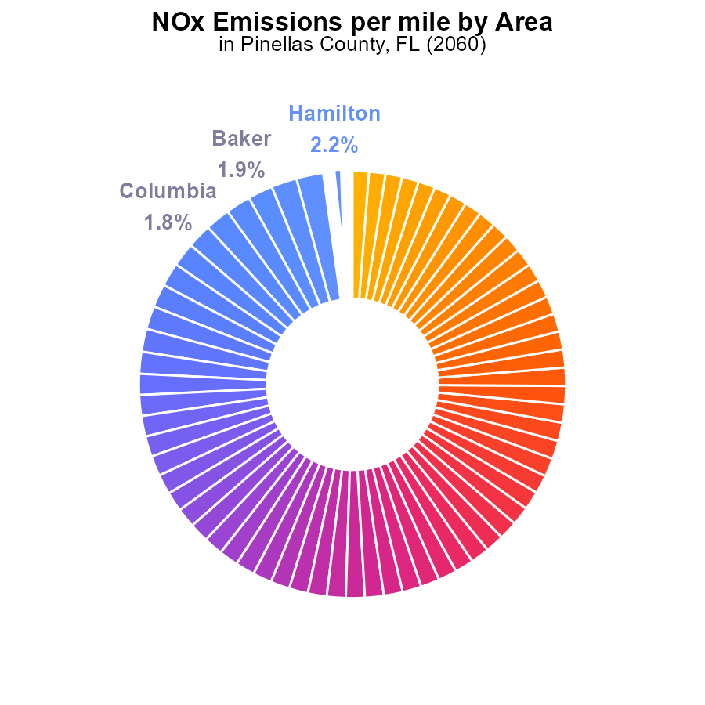

## Findings

* Counties with the highest NOx emissions per mile are Hamilton, Madison, and Jefferson.
* Pinellas County has a NOx emission level of 181.8 tons per mile, ranking among the top 10 highest emitters.
* Miami-Dade County has the lowest NOx emissions per mile at 171.2 tons.

## Recommendations

The data shows a need for targeted NOx reduction strategies in high-emitting counties like Hamilton, Madison, and Jefferson. Implementation of stringent emission controls on vehicles and industrial sources is necessary to lower emissions. Pinellas County should focus on improving transportation infrastructure to reduce per mile NOx emissions. Further studies to identify specific sources of NOx emissions in each county can aid in developing localized reduction measures. Continuous monitoring and strict enforcement of emission standards are essential for sustained reduction in NOx levels.

# Population over Time for Buses

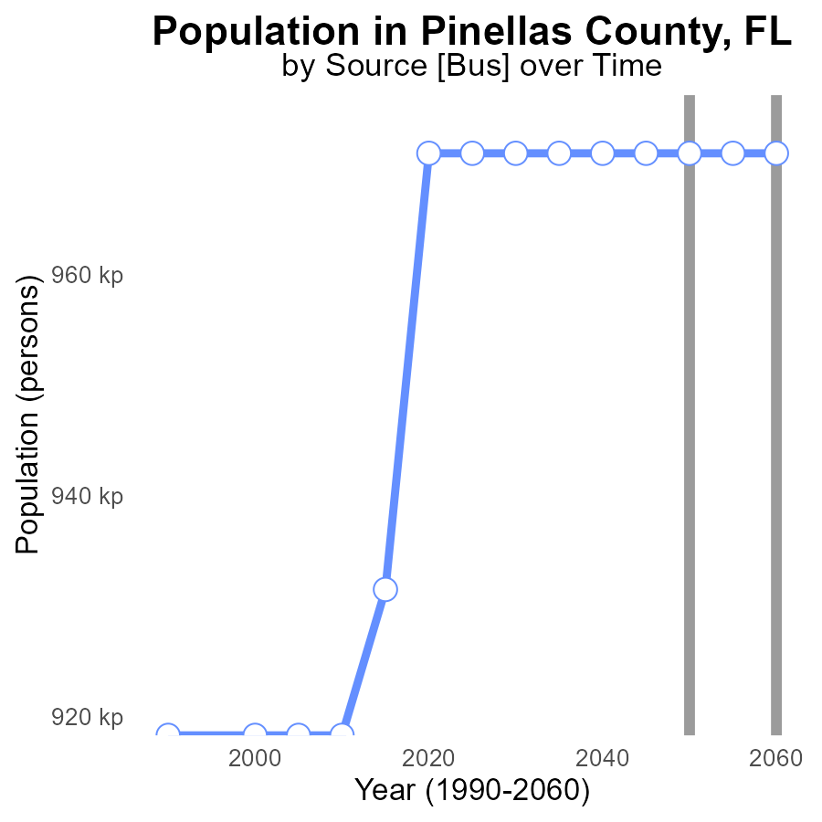

## Findings

* NOx emissions in Pinellas County are projected to remain constant at 971.0 kilotons from 2040 to 2060.
* There is no improvement in NOx emissions over the 20-year period, with no reduction in benchmark difference.
* The county's population remaining stable indicates that emission levels aren't decreasing relative to population growth.

## Recommendations

To reduce NOx emissions in Pinellas County, despite a stable population, implementation of stricter emission controls and promoting electric vehicles could help in achieving a decrease in overall emissions.

# Idling Overall over Time

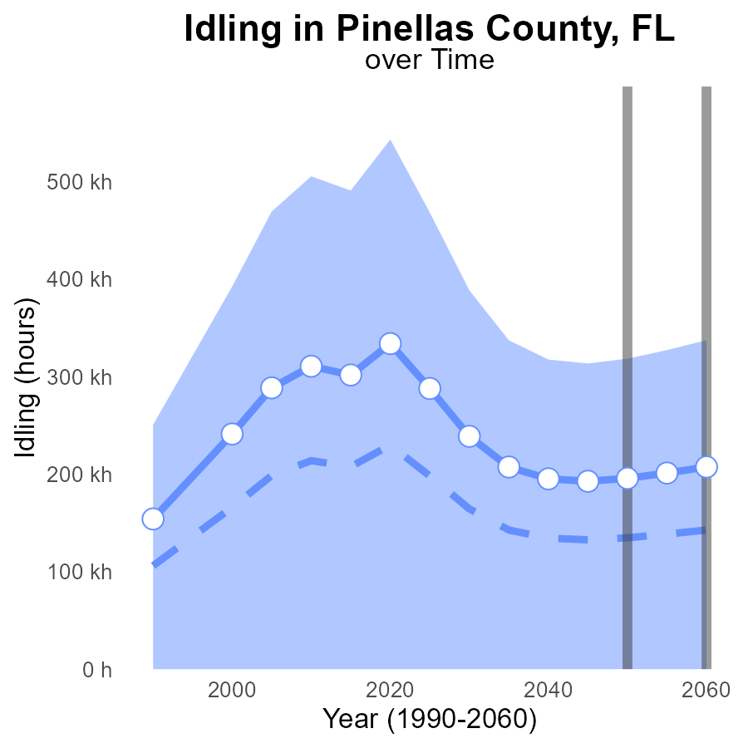

## Findings

* NOx emissions in Pinellas County from idling are projected to increase steadily through 2060.
* The current emissions exceed the upper 75th percentile benchmark for the area.
* By 2060, there is a substantial difference of -11674.9 in NOx emissions compared to the median area.

## Recommendations

To reduce idling-related NOx emissions in Pinellas County, immediate actions are necessary. Implementing idling reduction strategies for vehicles can be effective. Introducing and enforcing idling regulations, promoting public transportation, and investing in electric vehicle infrastructure are vital steps to lower emissions.

# Idling Mapped by Area

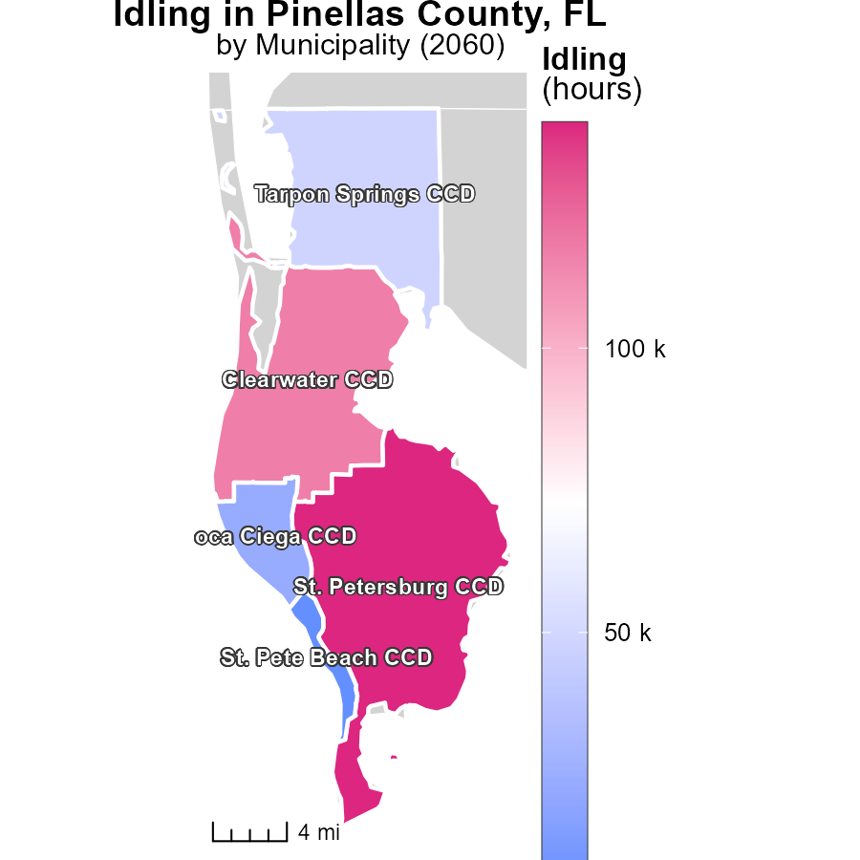

## Findings

* St. Petersburg CCD, FL had the highest idling hours with 139.6k, Tarpon Springs CCD, FL had a median of 48.2k idling hours, while St. Pete Beach CCD, FL had the lowest at 5.6k hours.
* St. Petersburg CCD, FL idling hours were approximately 25 times higher than St. Pete Beach CCD, FL.
* The difference in idling hours between St. Petersburg CCD, FL and Tarpon Springs CCD, FL was about 91.4k hours.

## Recommendations

To lower emissions, initiatives should focus on reducing idling times, especially in areas with significantly high idling hours like St. Petersburg CCD, FL. Implementing idling reduction campaigns and promoting anti-idling policies can help decrease emissions in these areas.

# Vehicle Miles Traveled in My Region

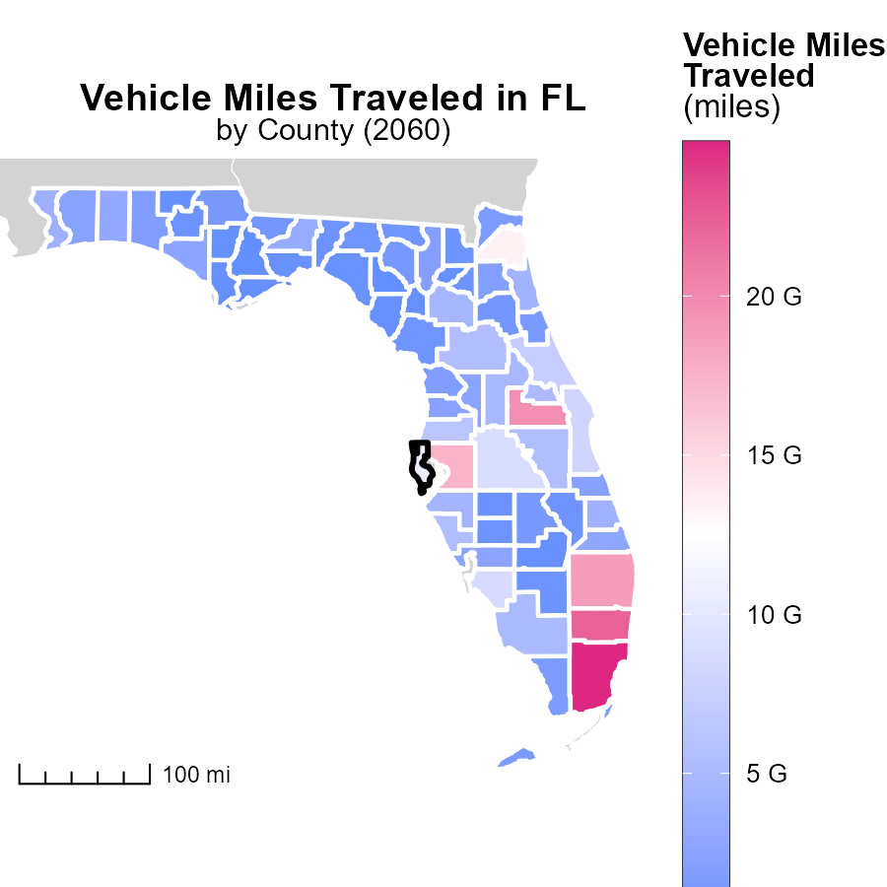

## Findings

* Miami-Dade County, FL has the highest vehicle miles traveled at 24.8 billion miles.
* Clay County, FL has a median vehicle miles traveled of 2.0 billion miles.
* Liberty County, FL has the lowest vehicle miles traveled at 144.8 million miles.

## Recommendations

To lower emissions due to vehicle miles traveled, strategies such as promoting public transportation, carpooling, and implementing bike-friendly initiatives should be considered. Encouraging remote work and adopting electric vehicles can also help in reducing emissions.

# Population by Regulatory Class over Time

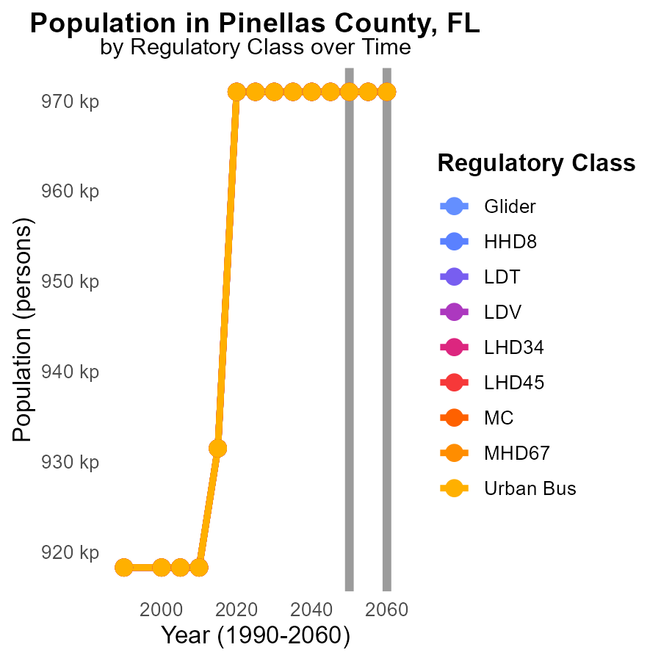

## Findings

* NOx emissions remain constant at 971.0 k for all vehicle types from 2050 to 2060 in Pinellas County, FL.
* There is no significant deviation in NOx emissions across different vehicle classes over the years 2050 to 2060.
* Although population data is not provided, emissions per person can be calculated to assess the environmental impact.

## Recommendations

Given the consistent NOx emissions across vehicle types and years, implementing stricter emission standards and promoting the use of eco-friendly vehicles could help reduce overall NOx emissions. Additionally, investing in public transportation infrastructure and incentivizing green technology adoption among residents can further contribute to lowering emission levels from transportation sources.

# Emissions by Area over Time

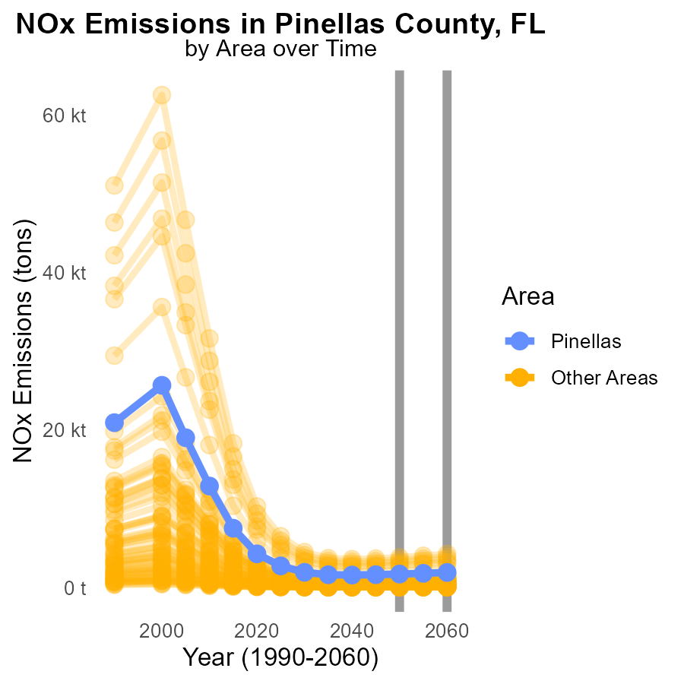

## Findings

* In 2060, the minimum county emitted 28.9 tons of NOx, a decrease of 2.5 tons from 2050.
* In 2060, the maximum county emitted 4.3 thousand tons of NOx, a reduction of 414.7 tons from 2050.
* In 2060, the target county emitted 1.9 thousand tons of NOx, showing a decrease of 200.5 tons compared to 2050.

## Recommendations

To further lower NOx emissions, continue support for emissions reduction programs in counties with the highest levels, implement stricter regulations, and invest in cleaner technologies to achieve long-term decreases.

# Areas Ranked by Emissions Rate (per vehicle)

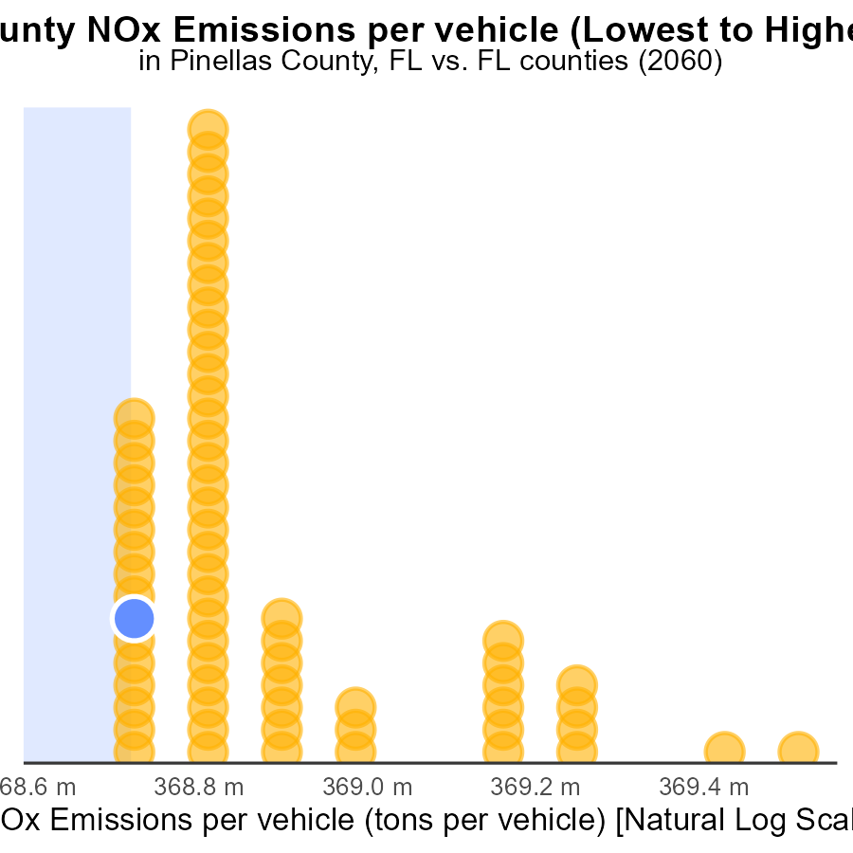

## Findings

* Hamilton county has the highest NOx emissions per vehicle with 4.4 tons.
* Miami-Dade county ranks 1st with the lowest NOx emissions per vehicle at 1.5% percentile.
* Pinellas county ranks 7th with NOx emissions per vehicle at 10.4% percentile.

## Recommendations

To reduce NOx emissions, focus on Hamilton County with the highest emissions per vehicle by implementing stricter vehicle emission standards. Encourage public transportation and promote the use of electric vehicles.

# Areas Ranked by Vehicle Starts

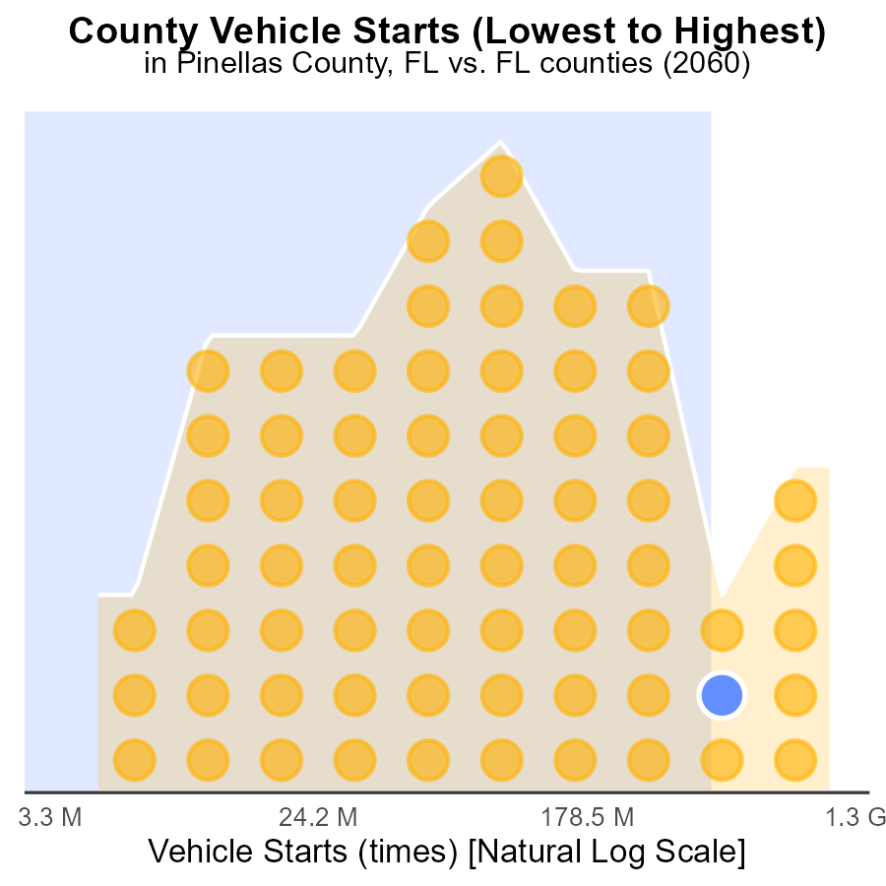

## Findings

* Miami-Dade has the highest NOx emissions from vehicle starts in 2060.
* Liberty has the lowest NOx emissions from vehicle starts in 2060.
* Miami-Dade ranks 67th in NOx emissions percentile, while Liberty ranks 1st.

## Recommendations

To lower NOx emissions from vehicle starts, Miami-Dade should implement stricter vehicle emission standards and promote the use of electric vehicles. Liberty can focus on maintaining and expanding its current sustainable transportation initiatives.

# Conclusion

In conclusion, the data on Oxides of Nitrogen (NOx) emissions from on-road transportation in Pinellas County, FL in 2060 reveals a concerning trend of stagnant NOx levels with no visible improvement over the 20-year period. Despite a stable population, NOx emissions are projected to remain constant at 971.0 kilotons, indicating a lack of progress in emission reduction relative to population growth. Immediate actions are necessary to address this issue, particularly by implementing stricter emission controls and promoting the adoption of electric vehicles to achieve an actual decrease in overall emissions. Pinellas County should focus on enhancing its transportation infrastructure to reduce per mile NOx emissions, thereby contributing to a healthier environment for its residents. Additionally, targeted strategies are essential for high-emitting counties like Hamilton, Madison, and Jefferson, where stringent emission controls on vehicles and industrial sources are imperative for lowering emissions and enhancing air quality.

The findings underscore the importance of continued efforts to curb NOx emissions through the enforcement of emission standards, investment in cleaner technologies, and the promotion of sustainable transportation options such as public transit and electric vehicles. By implementing these measures and addressing specific sources of NOx emissions in each county, significant progress can be made towards reducing overall emissions and improving air quality in Pinellas County and beyond. It is crucial to prioritize idling reduction strategies, especially in areas with high idling hours, and to explore innovative solutions to tackle NOx emissions effectively. Through collaborative action and a commitment to sustainable practices, communities can work towards a cleaner and healthier future for all.

# About This Report

Data based on MOVES estimates collected by the Climate Action in Transportation program at Cornell University. Demographic data sourced from the US Census's American Community Survey 5-year estimates. This report was generated with the help of AI.

# References

* U.S. Census Bureau. (2023). American Community Survey 5-year estimates: Detailed tables. Retrieved from https://data.census.gov
* U.S. Environmental Protection Agency. (2024). Motor Vehicle Emission Simulator (MOVES 4.0) [Software]. Retrieved from https://www.epa.gov/moves