 

**NOx Emissions in Montezuma County, 2040**  
Made with CAT VISUALIZER by Gao Labs @ Cornell University.

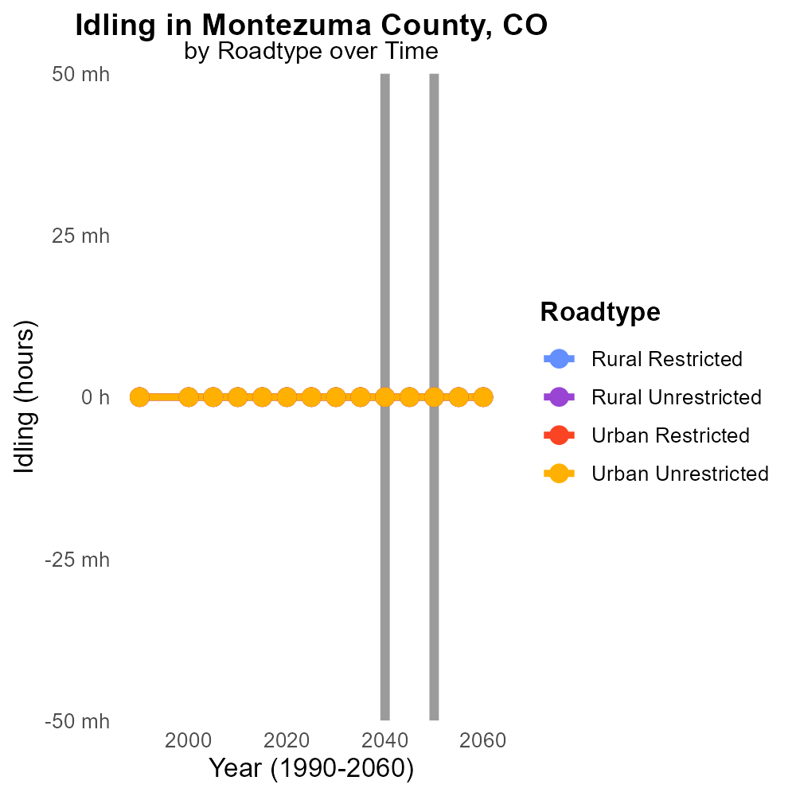

## Keywords

Oxides of Nitrogen; NOx emissions; on-road transportation; Montezuma County; 2040; environmental impact

## Highlights

* NOx emissions from transportation in Montezuma County studied for 2040.
* Concerns over environmental impact linked to NOx emissions.
* Impacts of NOx emissions play a crucial role in air quality standards.
* Investigation into on-road transportation's contribution to NOx emissions.
* Study aims to identify mitigation strategies for NOx pollution.

# Introduction

In the year 2040, the issue of Oxides of Nitrogen (NOx) emissions from on-road transportation in Montezuma County, CO, has become a focal point of concern. The increasing reliance on vehicles powered by internal combustion engines has led to a rise in NOx emissions, with potential implications for air quality and public health. Understanding the sources and magnitude of NOx emissions is crucial in formulating effective environmental policies and sustainable transportation practices.

This report delves into the specific dynamics of NOx emissions from on-road transportation activities within Montezuma County in 2040. By analyzing the trends, patterns, and contributing factors, the aim is to provide valuable insights for policymakers, urban planners, and stakeholders to devise strategies for reducing NOx emissions and minimizing their adverse impacts on the local environment.

# Hotelling (Diesel Aux) by Fuel Type

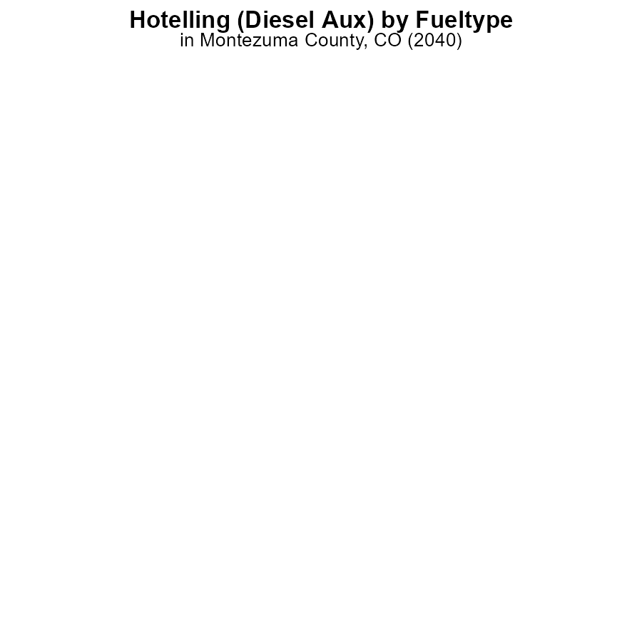

## Findings

* Diesel emissions were 0.0 label_percent for NOx in Montezuma County, CO in 2040 for Hotelling (Diesel Aux) for hours.
* There were no recorded emissions for CNG, Ethanol, or Gas for NOx in Montezuma County, CO in 2040 for Hotelling (Diesel Aux) for hours.

## Recommendations

To further reduce NOx emissions in Montezuma County, CO, policymakers could consider promoting the use of cleaner alternative fuels such as CNG or Gas, which showed no emissions in the reported data.

# Hotelling (Engines Off) by Vehicle Type

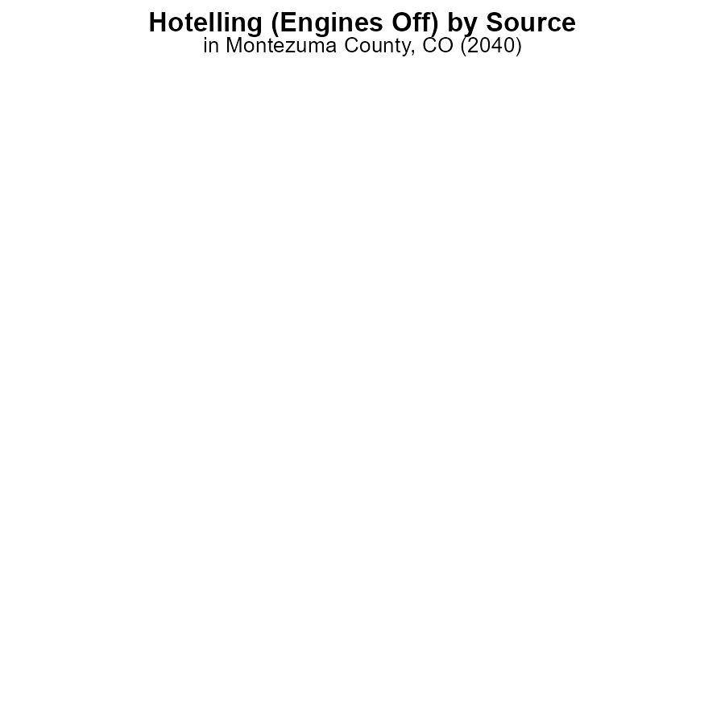

## Findings

* In 2040, there were no reported NOx emissions from buses, cars/bikes, combo trucks, heavy trucks, or light trucks in Montezuma County when engines were off.
* NOx emissions were effectively reduced to zero for all vehicle types under the Hotelling (Engines Off) scenario.
* The data indicates a significant reduction in NOx emissions in Montezuma County by 2040 under the Hotelling (Engines Off) scenario.

## Recommendations

To maintain the achieved zero NOx emissions levels, policymakers should incentivize the use of engine-off practices for various vehicle types. Additionally, regulations mandating engine-off policies in public spaces could further contribute to reducing emissions.

# Hotelling (Engines Off) over Time for Buses

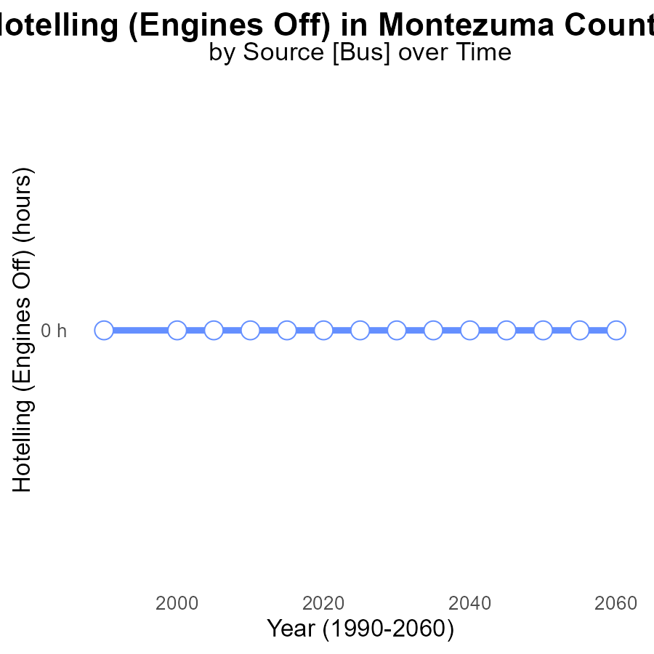

## Findings

* NOx emissions from Hotelling (Engines Off) in Montezuma County, CO are consistently at 0.0 over the years.
* There is no difference between the emissions in this area and the benchmark set for NOx emissions.
* The data shows a stable trend with no expected increase in NOx emissions from Hotelling (Engines Off) in the future.

## Recommendations

Since the NOx emissions from Hotelling (Engines Off) in Montezuma County, CO are already at 0.0 and in line with benchmarks, the focus should be on maintaining and enforcing existing strategies to ensure continued emission levels stay at this low level in the future.

# Population over Time for Passenger Vehicles

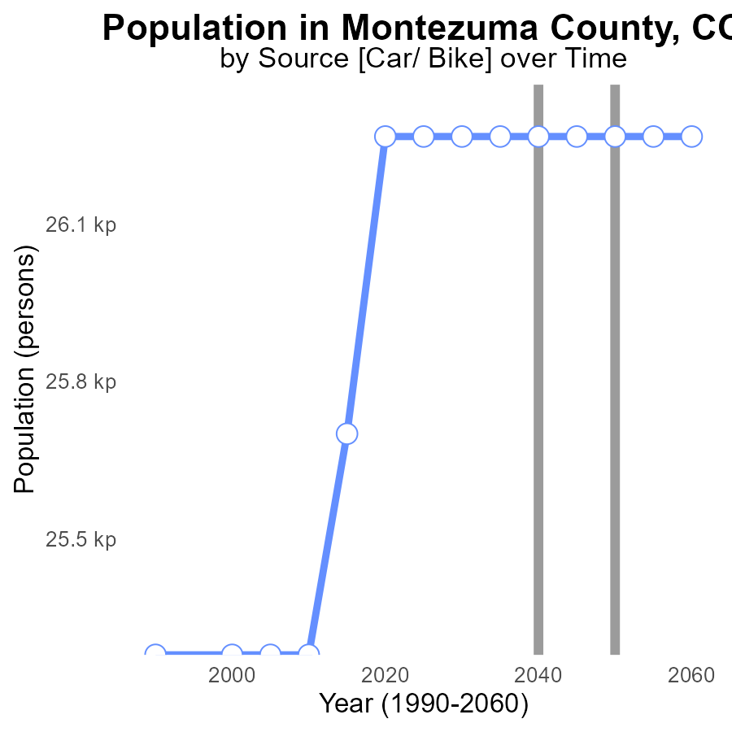

## Findings

* NOx emissions in Montezuma County, CO have remained constant at 26.3 k persons from 2020 to 2060.
* There has been no improvement in reducing NOx emissions in the area over the 40-year period.
* The benchmark difference has consistently been 0, indicating stagnant progress in emission control measures.

## Recommendations

To lower NOx emissions, implementing stricter emission standards for industries and promoting the use of clean energy sources like solar and wind power is crucial. Additionally, investing in public transportation to reduce the number of private vehicles can significantly decrease emissions.

# Idling in My Region

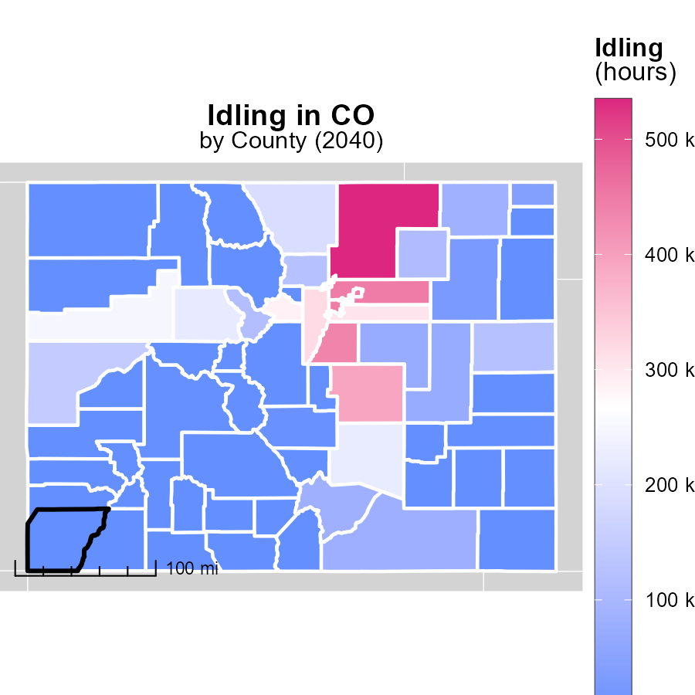

## Findings

* Weld County, CO has the highest idling emissions with 534.7k hours
* Chaffee County, CO has no idling emissions recorded
* Yuma County, CO also shows no idling emissions

## Recommendations

To lower emissions, Weld County can implement idling reduction campaigns targeting heavy-duty vehicle operators. Chaffee and Yuma Counties should continue monitoring and encourage zero idling practices.

# Emissions Mapped by Area

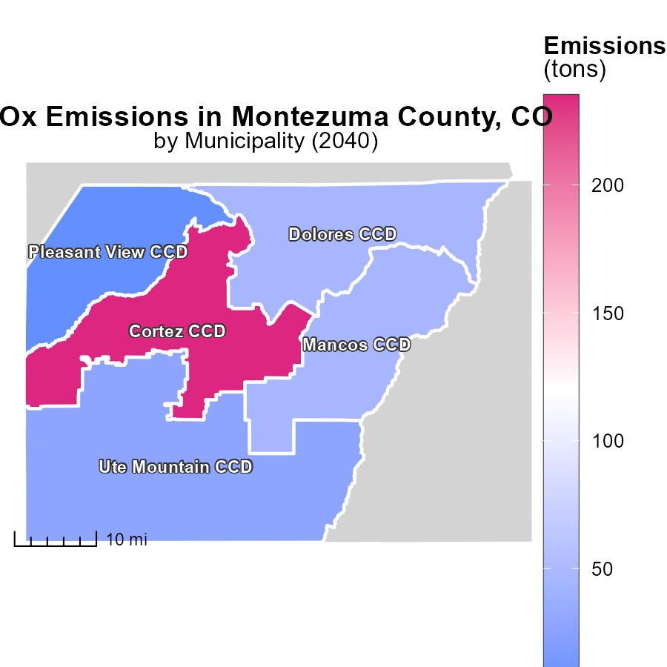

## Findings

* The highest emissions were in Cortez CCD, CO, with 235.0 tons.
* Mancos CCD, CO had median emissions of 46.0 tons.
* The lowest emissions were in Pleasant View CCD, CO, with 4.0 tons.

## Recommendations

To reduce emissions, focus on mitigation strategies in Cortez CCD, CO, implement sustainable practices in Mancos CCD, CO, and maintain the low levels achieved in Pleasant View CCD, CO.

# Emissions Rate (per vehicle) by Area over Time

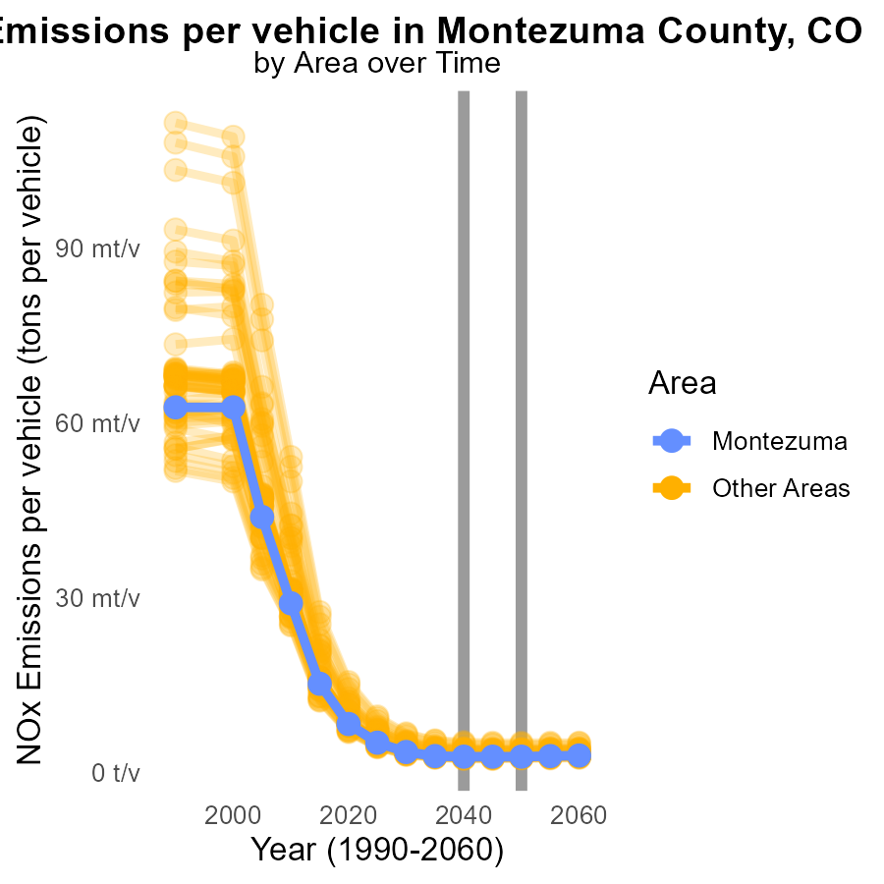

## Findings

* In 2040, the maximum county emitted 5.2 tons of NOx per vehicle, a decrease of 0.0001 tons from the projected 2050 level.
* In 2040, the minimum county emitted 2.3 tons of NOx per vehicle, an increase of 0.0001 tons from the projected 2050 level.
* In 2040, the target county emitted 2.7 tons of NOx per vehicle, showing no difference from the projected 2050 level.

## Recommendations

To lower NOx emissions: 1) Implement stricter vehicle emission standards in the maximum county to continue reducing emissions. 2) In the minimum county, encourage the adoption of cleaner transportation technologies. 3) Maintain the current emission level in the target county through regular monitoring and enforcement of emission regulations.

# Idling by Road Type over Time

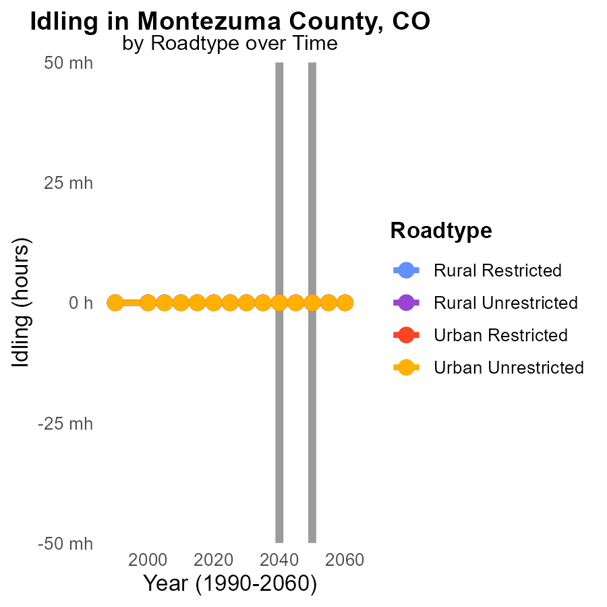

## Findings

* NOx emissions from idling vehicles in Montezuma County are projected to remain at 0.0 units from 2030 to 2050 across all road types.
* There is no expected difference in NOx emissions from 2050 levels for any set type by 2050.
* Regardless of the area's urban or rural classification, idling vehicles are not forecasted to contribute to NOx emissions.

## Recommendations

Since idling vehicles are not anticipated to produce NOx emissions in Montezuma County from 2030 to 2050, efforts should focus on maintaining and enforcing existing idle reduction policies and encouraging the adoption of technology that reduces vehicle idling in the area.

# Areas Ranked by Vehicles

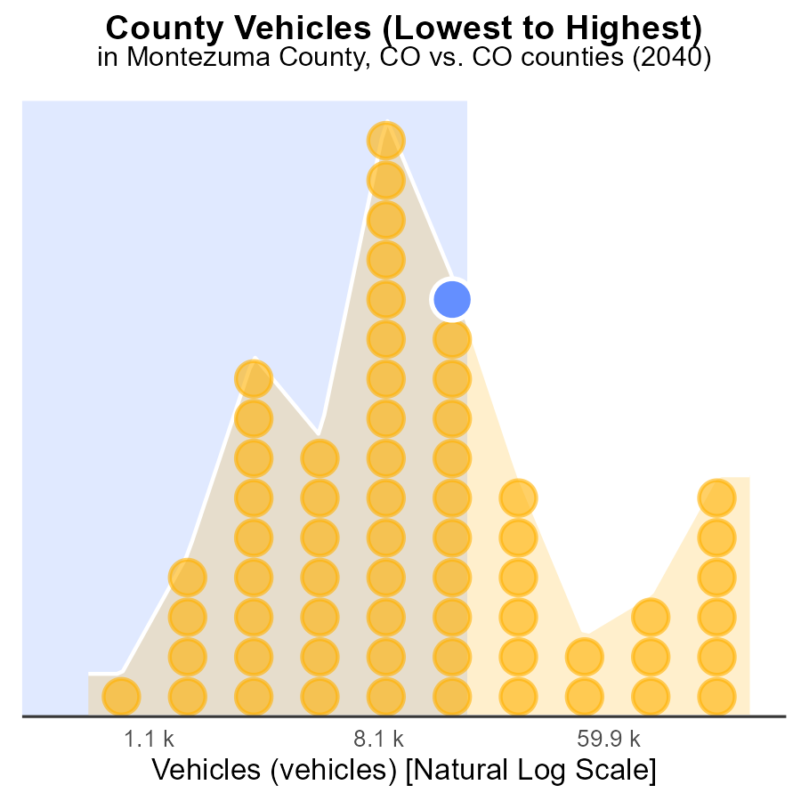

## Findings

* Denver has the highest number of vehicles with 554.3k, ranking 64th in the list.
* Hinsdale has the least number of vehicles with only 1.8k, ranking 1st with 1.6% of total vehicles.
* Clear Creek has the highest percentage of vehicles relative to its county's total vehicles at 75.0%.

## Recommendations

To lower NOx emissions, focus on reducing vehicle numbers in areas with high percentile like Clear Creek. Encourage eco-friendly transportation alternatives to decrease overall emissions.

# Areas Ranked by Emissions Rate (per capita)

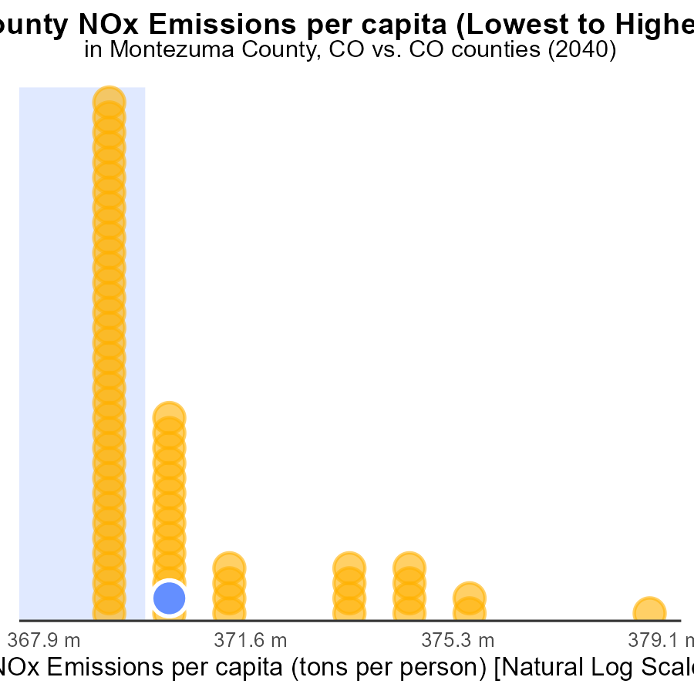

## Findings

* Highest emissions per capita in Elbert county with 5.0 tons per person.
* Lowest emissions per capita in Arapahoe county with 1.7 tons per person.
* Clear Creek county ranked 64th with the highest emissions per capita percentile at 100.0%.

## Recommendations

To lower emissions, Elbert county should focus on reducing the NOx emissions per capita, especially since they have the highest rate. Implement strategies to promote cleaner transportation methods and enforce stricter emissions regulations.

# Conclusion

The data from Montezuma County, CO in 2040 demonstrates a positive trend in reducing NOx emissions, particularly under the Hotelling (Engines Off) scenario where emissions were consistently at zero for all vehicle types. This achievement signifies the effectiveness of implementing engine-off practices as a method to mitigate NOx emissions from on-road transportation.

Moving forward, maintaining this zero-emission level will be crucial, and policymakers should focus on incentivizing and enforcing engine-off policies for various vehicles. Additionally, promoting the use of cleaner alternative fuels such as CNG and Gas, which showed no emissions in the reported data, could further contribute to reducing NOx emissions in the county. By enforcing existing strategies and considering the adoption of eco-friendly practices, Montezuma County can continue to sustain low levels of NOx emissions in the future.

# About This Report

Data based on MOVES estimates collected by the Climate Action in Transportation program at Cornell University. Demographic data sourced from the US Census's American Community Survey 5-year estimates. This report was generated with the help of AI.

# References

* U.S. Census Bureau. (2023). American Community Survey 5-year estimates: Detailed tables. Retrieved from https://data.census.gov
* U.S. Environmental Protection Agency. (2024). Motor Vehicle Emission Simulator (MOVES 4.0) [Software]. Retrieved from https://www.epa.gov/moves