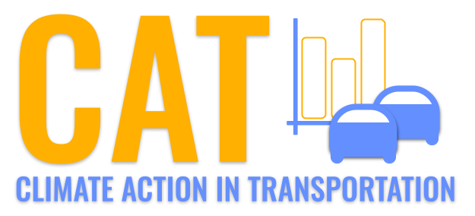 

**VOC Emissions in Dearborn County, 2055**  
Made with CAT VISUALIZER by Gao Labs @ Cornell University.

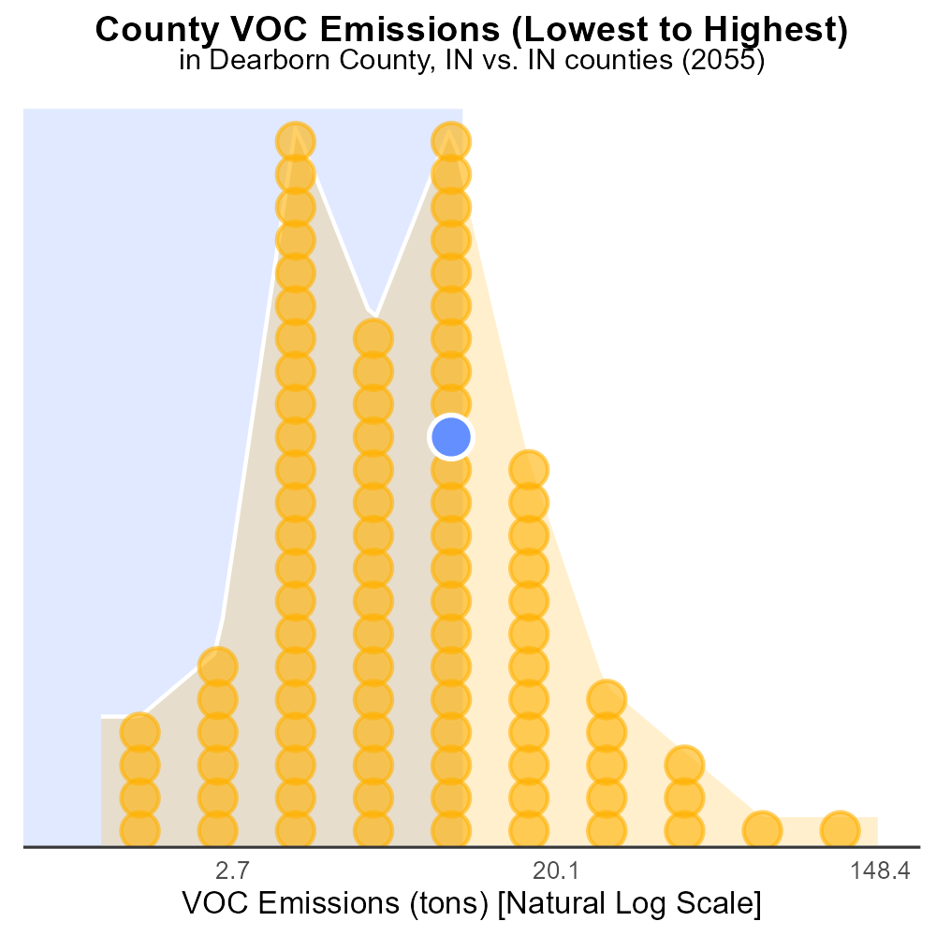

## Keywords

Volatile Organic Compounds; emissions; on-road transportation; Dearborn County; IN; 2055

## Highlights

* Study on VOC emissions from transportation in Dearborn Co., IN in 2055.
* Impact of on-road vehicles on air quality and public health.
* Analyzing trends, sources, and mitigation strategies for VOCs.
* Addressing the urgency of reducing emissions for sustainable future.
* Exploring technological advancements to curb VOCs from transportation.

# Introduction

This report investigates the Volatile Organic Compounds (VOC) emissions from on-road transportation in Dearborn County, Indiana, in the year 2055. With a focus on the environmental impact and public health concerns, the study delves into the increasing challenges posed by transportation-related VOC emissions.

The analysis will explore the sources of VOCs, trends in emissions, and potential mitigation strategies to address this pressing issue. Considering the urgency of reducing emissions for a sustainable future, the report aims to provide valuable insights into the current state of VOC emissions from on-road transportation and evaluate the effectiveness of technological advancements in curbing these harmful pollutants.

# Emissions Rate (per vehicle) by Regulatory Class

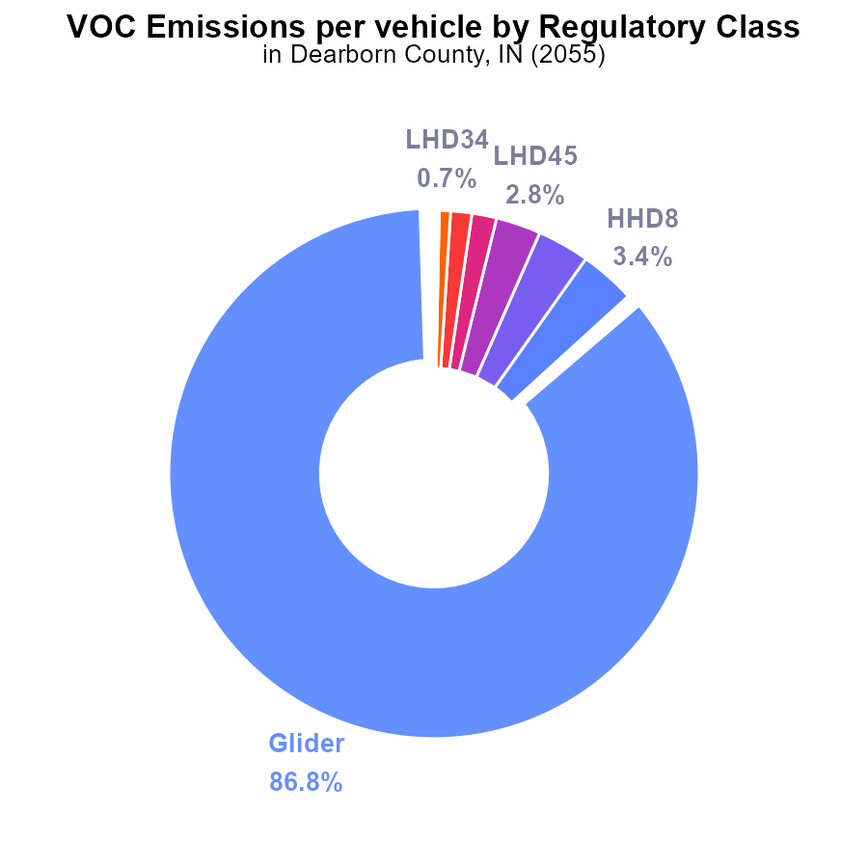

## Findings

* Glider vehicles contribute the most to VOC emissions at 86.8% per vehicle.
* HHD8 and Urban Bus follow with 3.4% and 3.2%, respectively, per vehicle.
* More than 99% of VOC emissions come from Glider, HHD8, and Urban Bus vehicles combined.

## Recommendations

To reduce VOC emissions, focus efforts on Glider, HHD8, and Urban Bus vehicles which account for the vast majority of emissions. Consider implementing stricter emission standards and promoting the use of cleaner alternative fuels.

# Emissions Rate (per mile) by Road Type

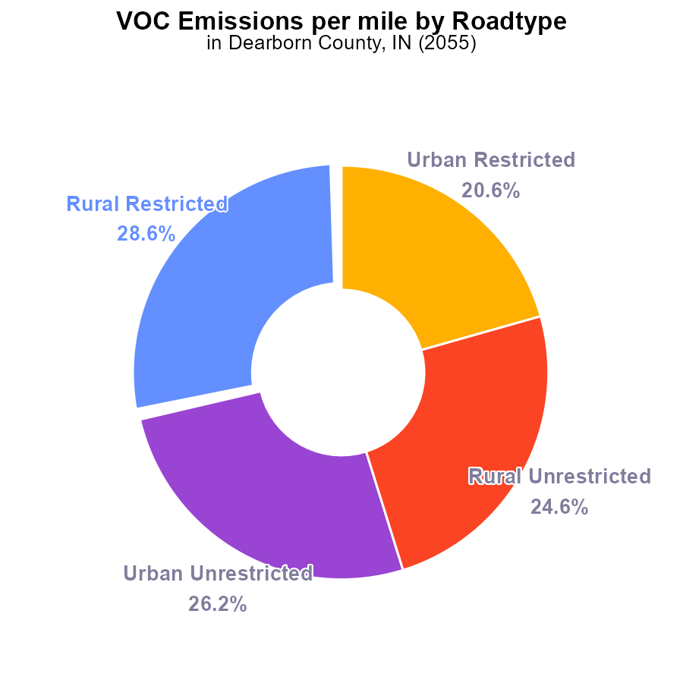

## Findings

* The highest emissions per mile are from Rural Restricted areas with 37.0 tons.
* Urban Unrestricted areas follow closely with 33.8 tons per mile.
* Urban Restricted areas have the lowest emissions per mile at 26.7 tons.

## Recommendations

To decrease emissions, focus resources on Rural Restricted and Urban Unrestricted areas with the highest emissions per mile to achieve a notable reduction in total emissions. Implementing stricter emission controls and promoting public transportation can help in lowering emissions.

# Emissions Rate (per vehicle) Overall over Time

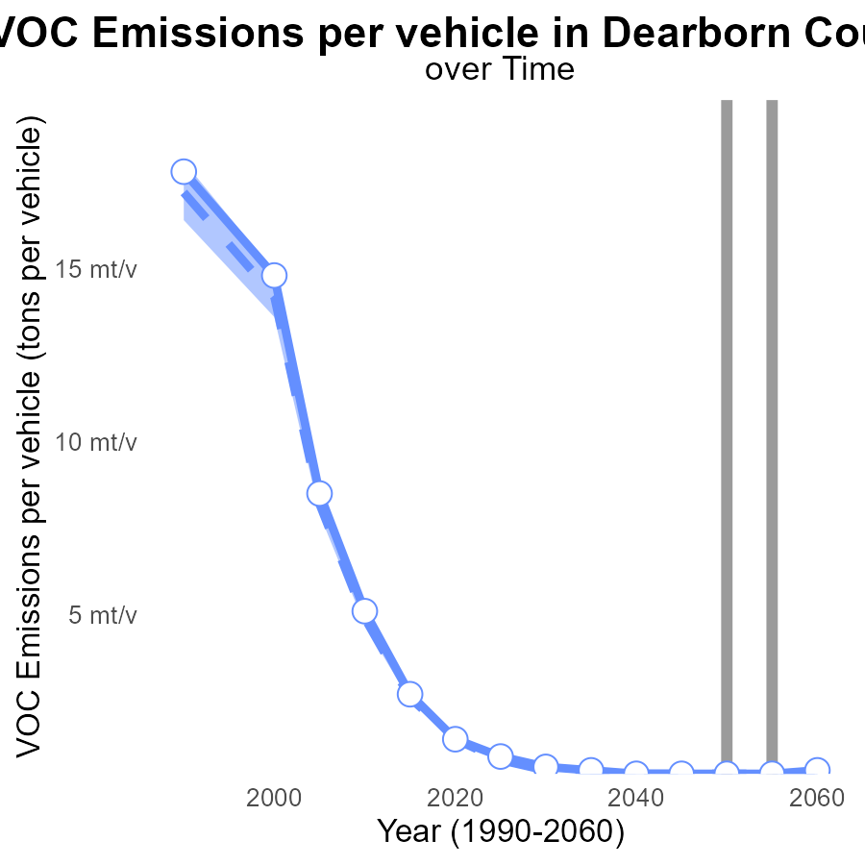

## Findings

* Emissions per vehicle are consistently above the median for Dearborn County.
* The upper 75% of areas have higher VOC emissions per vehicle than Dearborn County.
* By 2060, emissions per vehicle are projected to increase to 455.5 µ tons per vehicle.

## Recommendations

To lower emissions, Dearborn County should focus on implementing stricter vehicle emission standards, promoting the use of electric vehicles, and investing in public transportation to reduce the number of vehicles on the road.

# Emissions over Time for Passenger Vehicles

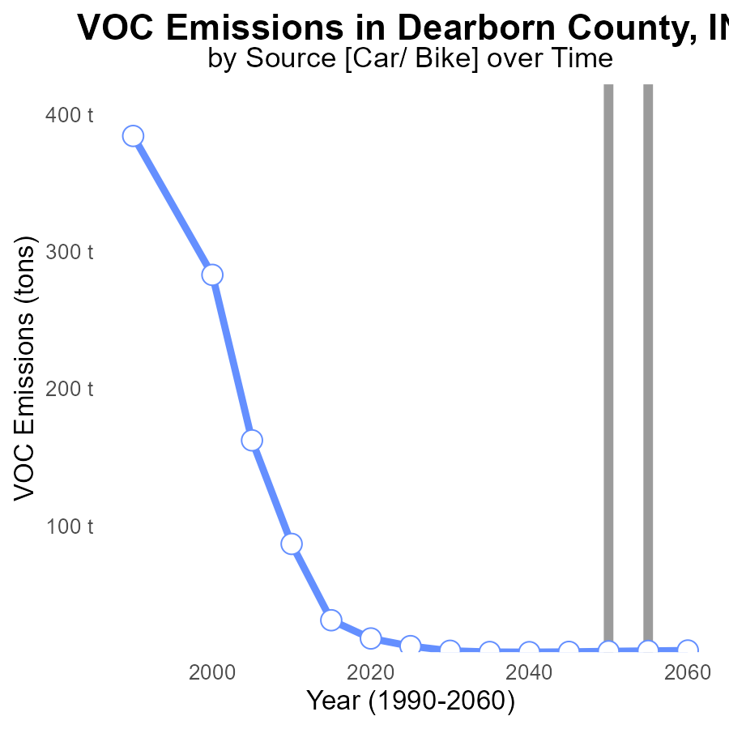

## Findings

* VOC emissions in Dearborn County, IN have generally decreased over the years.
* The emissions were highest in 2060 with 8.9 tons and lowest in 2040 with 7.7 tons.
* The benchmark difference indicates an improvement in emission control measures.

## Recommendations

To further reduce VOC emissions, the county should focus on promoting the use of cleaner energy sources, implementing tighter regulations on industrial emissions, and encouraging public transportation to reduce vehicle emissions.

# Vehicles Mapped by Area

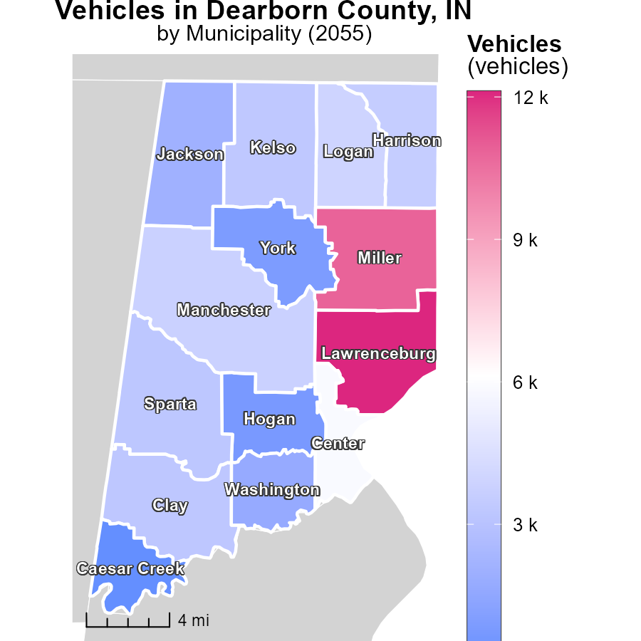

## Findings

* The highest emissions of vehicles were in Lawrenceburg, IN with 12.1k units.
* Clay, IN had a median emission level of 3.3k vehicles.
* Caesar Creek, IN exhibited the lowest emissions with 151.8 vehicles.

## Recommendations

To reduce vehicle emissions, incentivize the use of public transportation, carpooling, and electric vehicles in high-emission areas such as Lawrenceburg, IN. Encourage infrastructure development for alternative transport.

# Emissions Rate (per vehicle) Mapped by Area

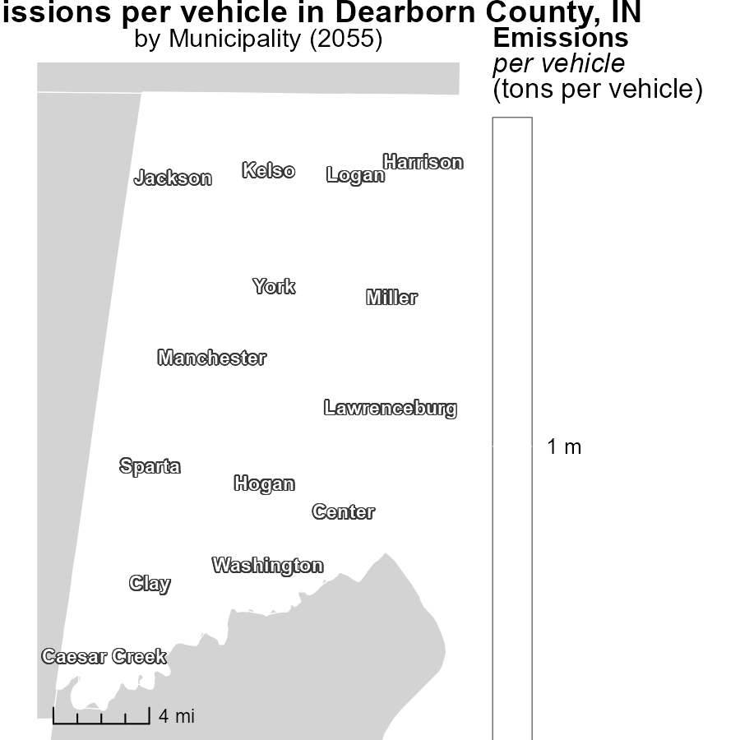

## Findings

* Emissions per vehicle in Caesar Creek, IN are at a maximum of 1.4 tons
* Lawrenceburg, IN has median emissions per vehicle at 1.4 tons
* The minimum emissions per vehicle of 1.4 tons are in York, IN

## Recommendations

To lower emissions, implementing vehicle emission testing in Caesar Creek and Lawrenceburg, and promoting cleaner transportation methods in York is advised.

# Time Driven by Road Type over Time

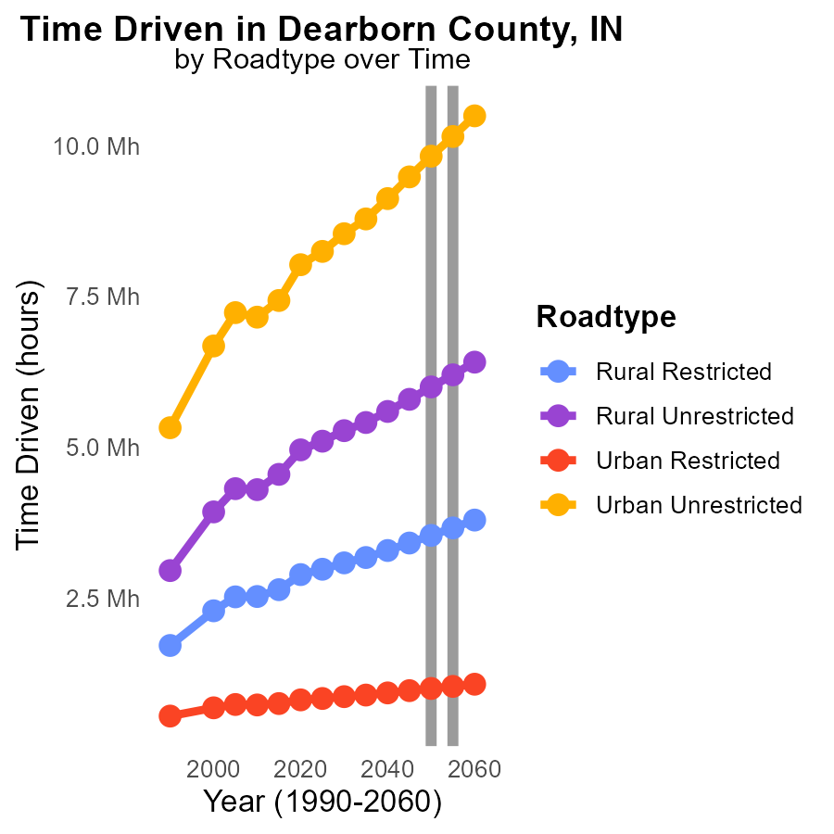

## Findings

* Between 2050 and 2060, VOC emissions are decreasing for all road types in Dearborn County.
* Rural Unrestricted areas have the highest VOC emissions, with a decrease of 6.8% from 2050 to 2060.
* Urban Restricted areas show a consistent increase in VOC emissions over the years, with a 11.1% rise by 2060.

## Recommendations

To lower VOC emissions, focus on implementing stricter regulations in rural unrestricted areas where emissions are highest. Encourage the use of low-emission vehicles. Invest in public transportation to reduce car dependency in urban restricted areas.

# Emissions Rate (per mile) by Regulatory Class over Time

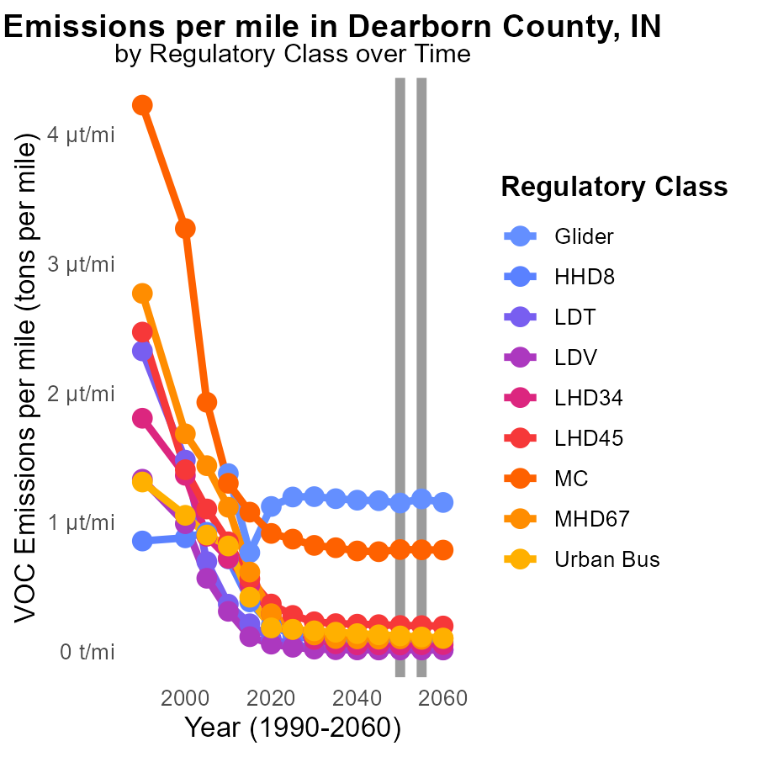

## Findings

* Emissions per mile for different vehicle types vary with LDV being the lowest at 12.6 n and MC being the highest at 789.3 n.
* From 2045 to 2060, Glider emissions per mile remained relatively stable around 1.2 µ.
* Urban Bus emissions per mile showed a decreasing trend from 129.8 n in 2045 to 104.9 n in 2060.

## Recommendations

To reduce emissions, focus efforts on improving the efficiency of vehicles with higher emissions like MC. Implement policies to encourage the adoption of cleaner technology in urban buses to sustain the decreasing trend.

# Areas Ranked by Emissions

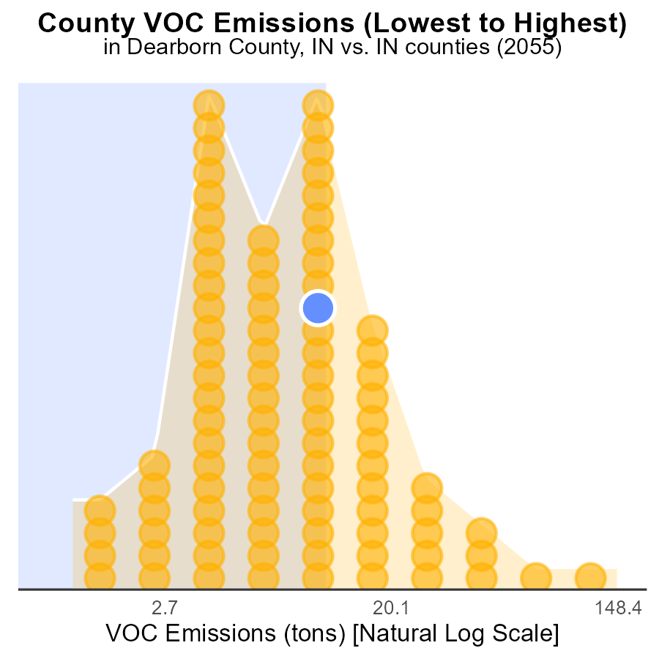

## Findings

* Highest VOC emissions in Marion county at 391.2 tons
* Lowest VOC emissions in Ohio county at 2.2 tons
* Combined VOC emissions of Dearborn, Putnam, and Warrick counties account for over 198 tons

## Recommendations

To lower VOC emissions, focus on implementing stricter regulations and monitoring in Marion county, targeting industries with the highest emissions. Encourage the adoption of cleaner technologies in Dearborn, Putnam, and Warrick to reduce their combined emissions.

# Areas Ranked by Vehicle Starts

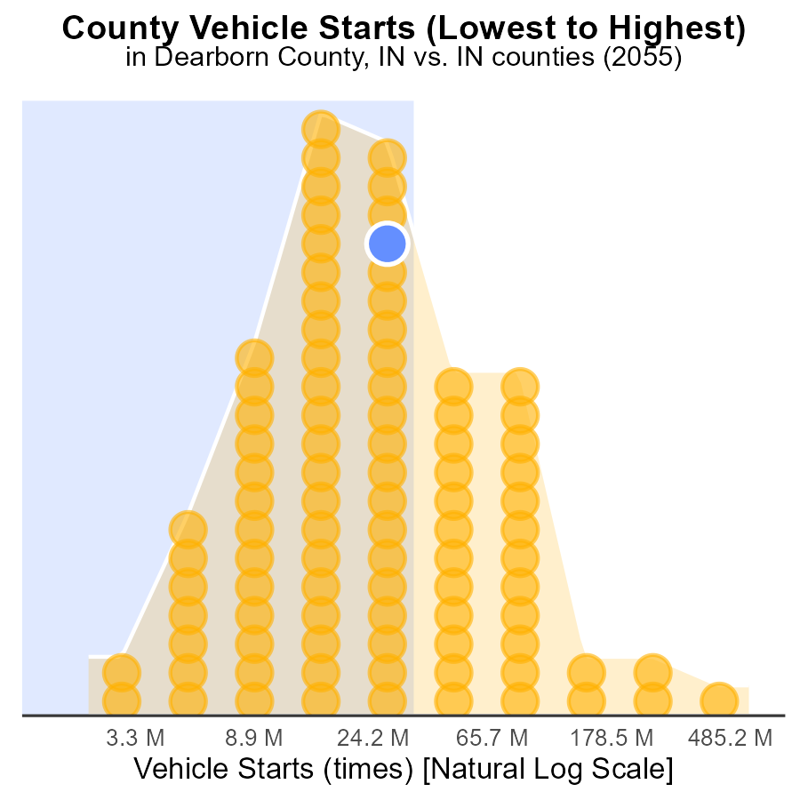

## Findings

* Marion county has the highest vehicle starts with 1.6 billion times.
* Ohio county has the lowest vehicle starts with 6.0 million times, ranking 1st.
* Combined vehicle starts of Dearborn, Huntington, and DeKalb counties account for 195.5 million starts.

## Recommendations

To reduce VOC emissions, focus on implementing vehicle emission testing programs in high-ranking counties like Marion to ensure compliance. Encourage the adoption of electric vehicles in areas with high vehicle starts and promote carpooling to decrease individual vehicle usage.

# Conclusion

In conclusion, the analysis of Volatile Organic Compounds (VOC) emissions from on-road transportation in Dearborn County, IN, in 2055 reveals key areas for targeted intervention to reduce emissions. Glider vehicles emerge as the primary contributors to VOC emissions, with HHD8 and Urban Bus vehicles also playing significant roles. To effectively lower VOC emissions, efforts should prioritize implementing stricter emission standards and promoting cleaner alternative fuels for these high-emission vehicle types.

Moreover, the data highlights the importance of focusing on areas with the highest emissions per mile, such as Rural Restricted and Urban Unrestricted regions. By concentrating resources in these areas and introducing stringent emission controls alongside initiatives to enhance public transportation, substantial reductions in total emissions can be achieved. The projections for 2060 indicate a potential increase in emissions per vehicle, underscoring the urgency for measures like stricter vehicle emission standards, electrification of transport, and increased reliance on public transportation to mitigate this rise. Overall, by embracing these targeted strategies, Dearborn County can further build on its downward trend in VOC emissions and work towards a more sustainable transportation landscape for the future.

# About This Report

Data based on MOVES estimates collected by the Climate Action in Transportation program at Cornell University. Demographic data sourced from the US Census's American Community Survey 5-year estimates. This report was generated with the help of AI.

# References

* U.S. Census Bureau. (2023). American Community Survey 5-year estimates: Detailed tables. Retrieved from https://data.census.gov
* U.S. Environmental Protection Agency. (2024). Motor Vehicle Emission Simulator (MOVES 4.0) [Software]. Retrieved from https://www.epa.gov/moves