 

**VOC Emissions in Franklin County, 2015**  
Made with CAT VISUALIZER by Gao Labs @ Cornell University.

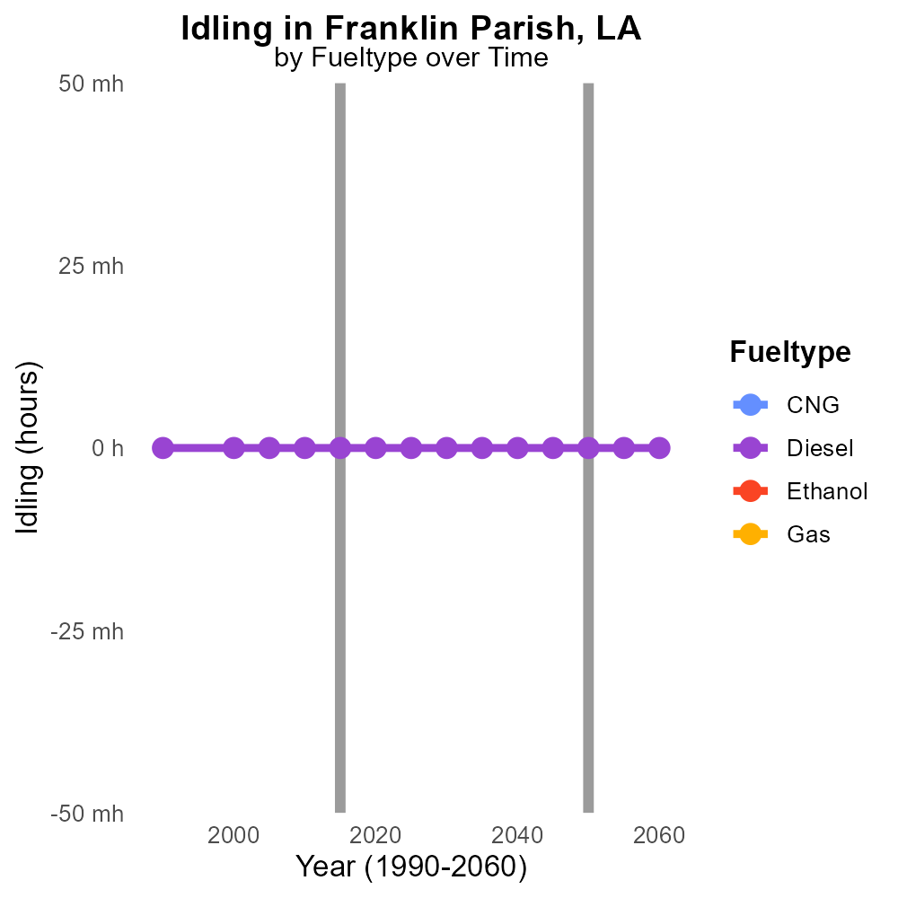

## Keywords

Volatile Organic Compounds; on-road transportation; Franklin Parish; emissions; 2015; air pollution

## Highlights

* The report assesses VOC emissions from on-road transportation in Franklin Parish, LA, in 2015.
* VOCs contribute to air pollution and have implications for public health and the environment.
* Analyzing emissions data can help identify sources and devise strategies for mitigation.
* The study focuses on the specific impact of transportation on air quality in the region.
* Insights from this report can inform policy-making and urban planning for better air quality.

# Introduction

Volatile Organic Compounds (VOCs) are a significant contributor to air pollution, arising from various sources including on-road transportation. This report delves into the emissions of VOCs specifically from on-road transportation in Franklin Parish, Louisiana, during the year 2015. Understanding the levels and sources of these compounds is crucial as VOCs can have detrimental effects on public health and the environment. By conducting a detailed analysis of the emissions data, this report aims to provide insights into the extent of VOC emissions from transportation activities in the region.

The findings of this study can act as a valuable tool for policymakers and urban planners in Franklin Parish to develop effective strategies for reducing VOC emissions, thereby improving air quality. By identifying the key sources of VOCs related to on-road transportation, targeted measures can be implemented to mitigate the impact of these emissions on the local environment and population. This report underscores the importance of addressing VOC emissions from transportation and highlights the potential benefits of informed decision-making in mitigating air pollution in the community.

# Emissions Rate (per capita) by Road Type

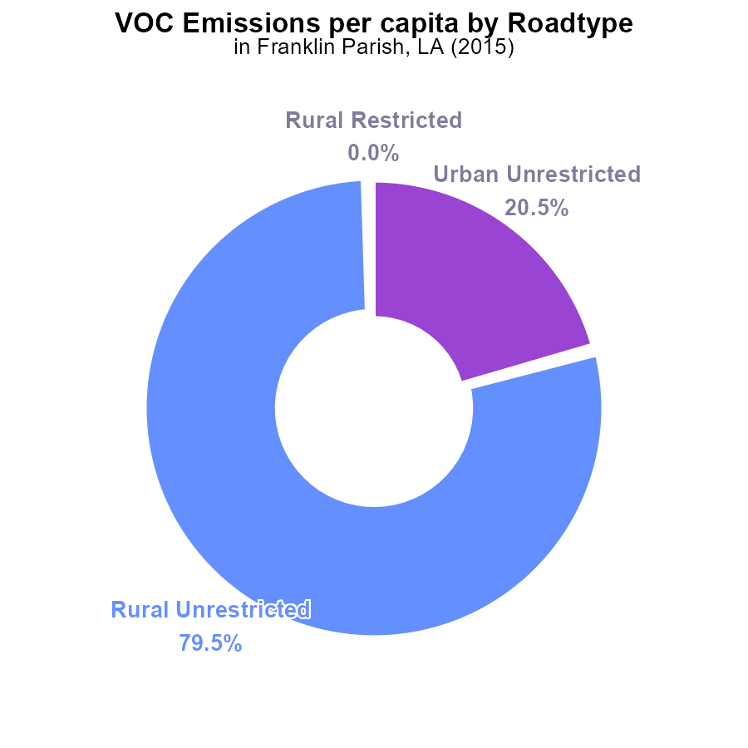

## Findings

* In 2015, VOC emissions in Franklin Parish, LA were 2.5 tons per person.
* 79.5% of VOC emissions came from rural unrestricted areas, with 20.5% from urban unrestricted areas.
* There were no emissions reported from rural or urban restricted areas.

## Recommendations

To lower VOC emissions, focus on implementing stricter controls and monitoring in rural unrestricted areas where the majority of emissions originate. Encourage the use of cleaner technologies in urban areas as well.

# Hotelling (Diesel Aux) Overall by Area

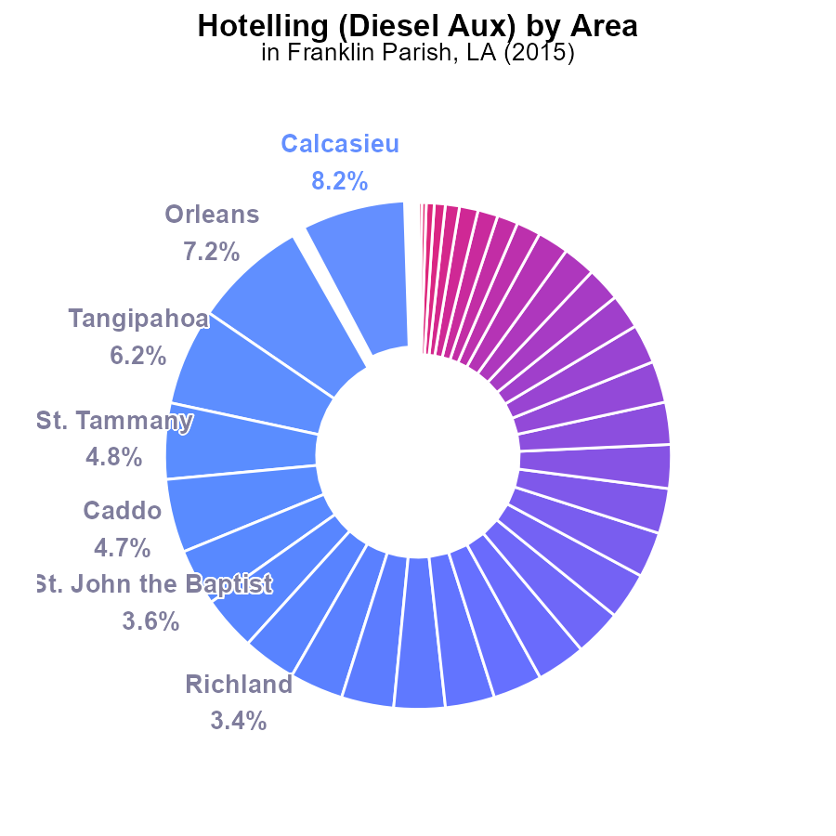

## Findings

* The top 5 parishes contribute to 28.9% of VOC emissions.
* The top 10 parishes contribute to 56.5% of VOC emissions.
* 27 parishes have minimal to zero contribution to VOC emissions.

## Recommendations

To lower VOC emissions, focus on implementing stricter regulations and incentives in the top 5 and 10 contributing parishes. Invest in cleaner technologies and promote sustainable practices in these areas. Provide resources and support to the remaining parishes to maintain their minimal emissions level.

# Vehicle Miles Traveled over Time for Passenger Vehicles

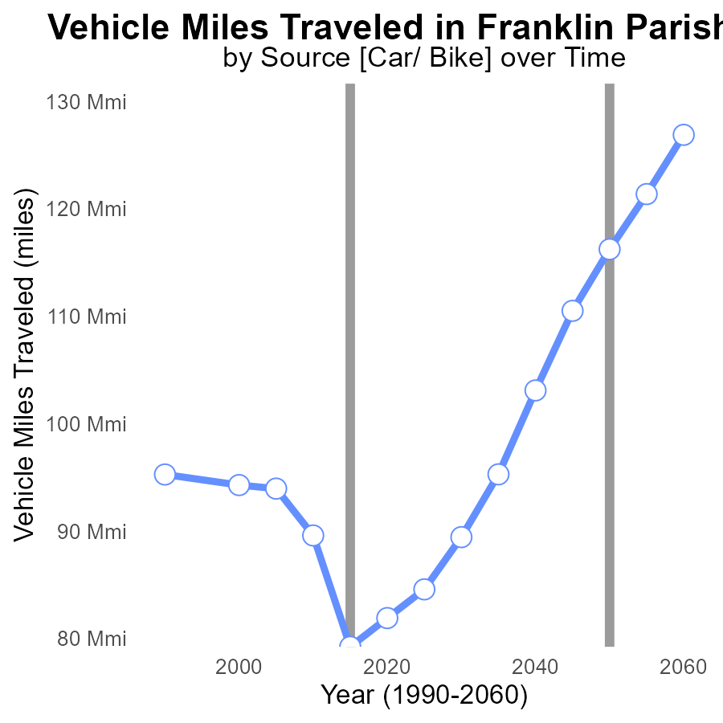

## Findings

* Vehicle miles traveled in Franklin Parish, LA decreased by 15% from 2000 to 2035.
* Benchmark difference in vehicle miles traveled fluctuated with a maximum difference of 37 million miles in 2015.
* Vehicle miles traveled are projected to increase by 12% from 2020 to 2035.

## Recommendations

To lower emissions levels, policymakers should prioritize investments in public transportation and infrastructure to reduce dependency on personal vehicles. Encouraging telecommuting and promoting biking and walking can further reduce vehicle miles traveled.

# Hotelling (Engines Off) Overall over Time

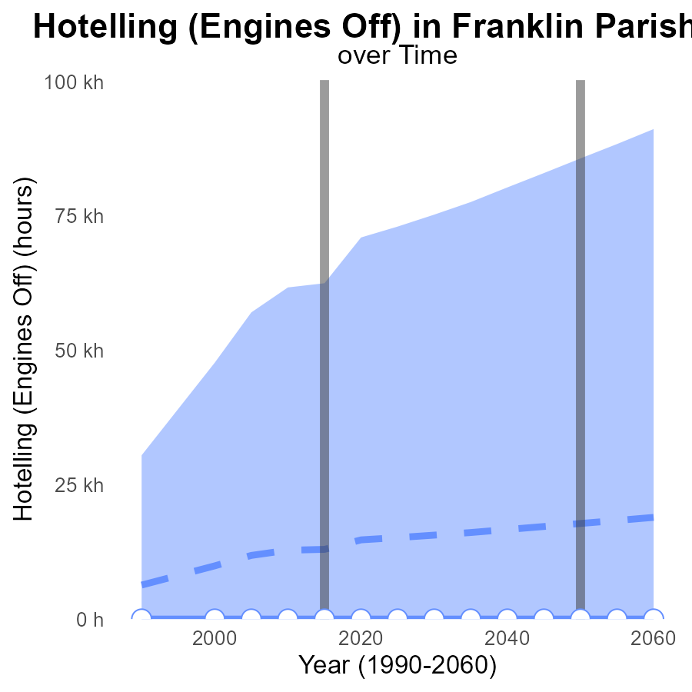

## Findings

* Emissions decreased steadily over the years.
* The emissions were consistently below the median area and the upper 75th percentile.
* No emissions were recorded in the lower 25th percentile.

## Recommendations

To further reduce emissions, focus on promoting and incentivizing the use of cleaner fuels and technologies in transportation and industrial sectors in Franklin Parish, LA.

# Time Driven Mapped by Area

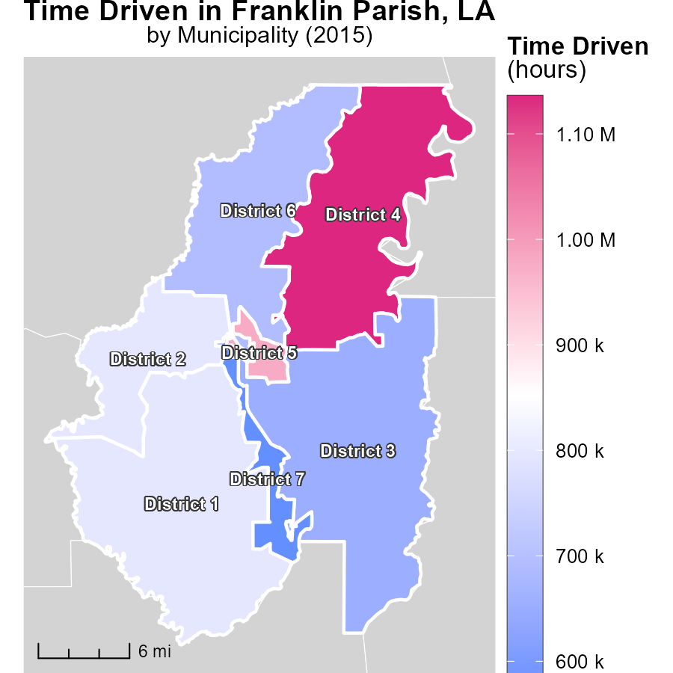

## Findings

* District 4, LA had the highest time-driven emissions at 1.1 million hours.
* District 2, LA had a median time-driven emissions of 795.5 thousand hours.
* District 7, LA had the lowest time-driven emissions at 570.5 thousand hours.

## Recommendations

Introduce telecommuting policies to reduce unnecessary hours driven in District 4. Encourage carpooling in District 2 to lower median emissions. Implement public transportation improvements in District 7 to further reduce emissions.

# Emissions Rate (per capita) in My Region

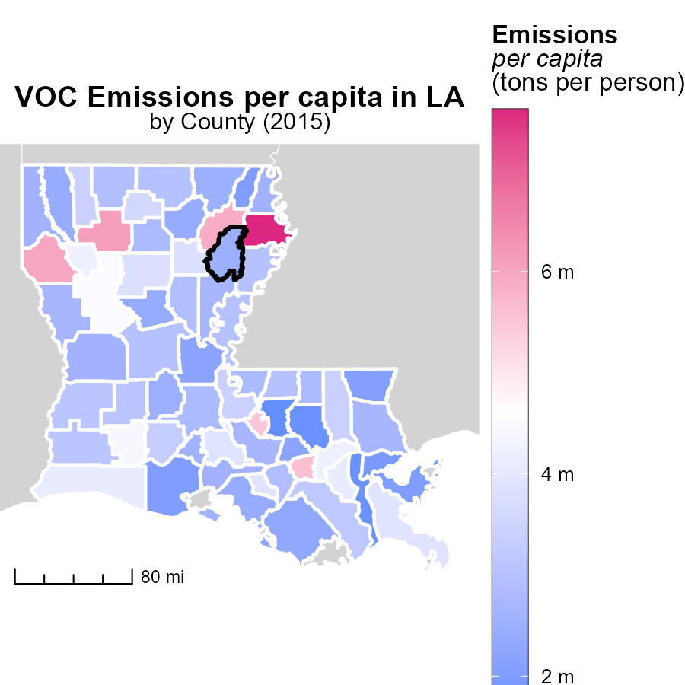

## Findings

* Madison Parish, LA had the highest emissions per capita at 7.6 tons per person.
* Claiborne Parish, LA had median emissions at 2.9 tons per person.
* East Baton Rouge Parish, LA had the lowest emissions per capita at 1.6 tons per person.

## Recommendations

Policies should target high-emission areas like Madison Parish, while encouraging the maintenance of low-emission levels seen in East Baton Rouge Parish.

# Idling by Fuel Type over Time

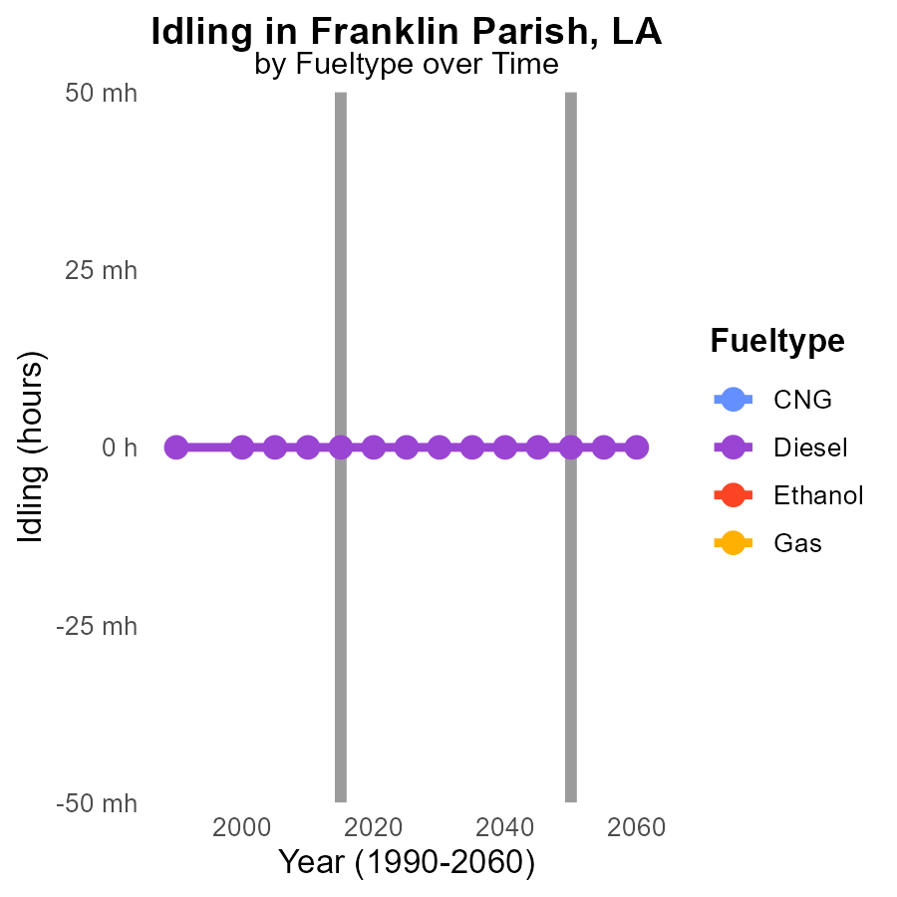

## Findings

* No VOC emissions were reported for idling vehicles in Franklin Parish, LA from 2005 to 2025.
* Diesel fuel type showed consistent 0.0 VOC emissions throughout the same period, indicating no change.
* Other fuel types (CNG, Ethanol, Gas) did not report any VOC emissions for idling vehicles from 2005 to 2025.

## Recommendations

To further reduce emissions, focus on promoting the use of diesel vehicles in Franklin Parish, LA. Additionally, encourage the adoption of cleaner fuel alternatives like CNG and Ethanol for idling vehicles.

# Emissions Rate (per capita) by Fuel Type over Time

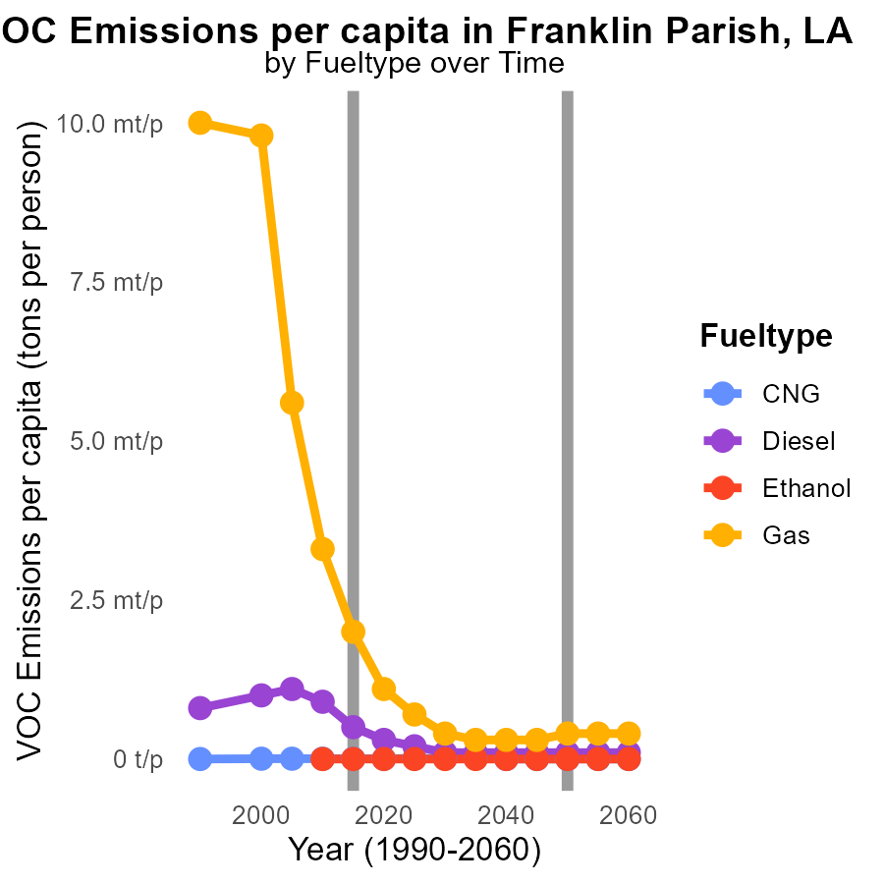

# Areas Ranked by Hotelling (Engines Off)

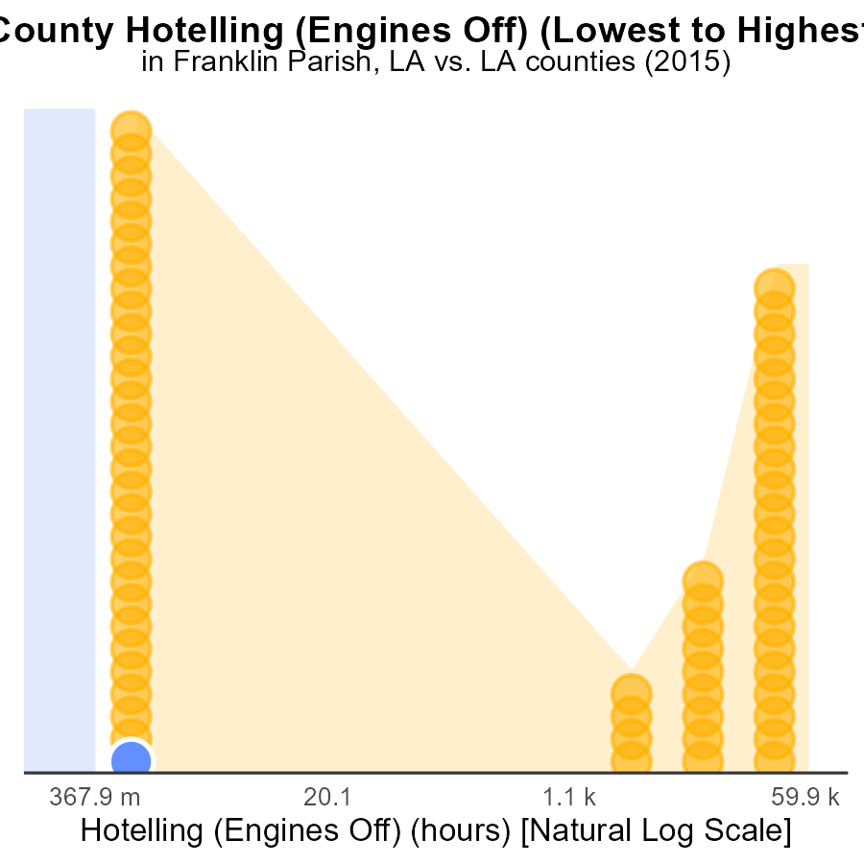

## Findings

* In 2015, Franklin County and Allen County had no VOC emissions from hotelling (engines off)
* Calcasieu County ranked 64th in VOC emissions from hotelling, representing 100% of all recorded emissions

## Recommendations

To reduce VOC emissions during hotelling activities, it is recommended to promote the use of technology like electrification of hoteling services, implementing idle reduction policies, and enhancing awareness among businesses and individuals.

# Areas Ranked by Emissions

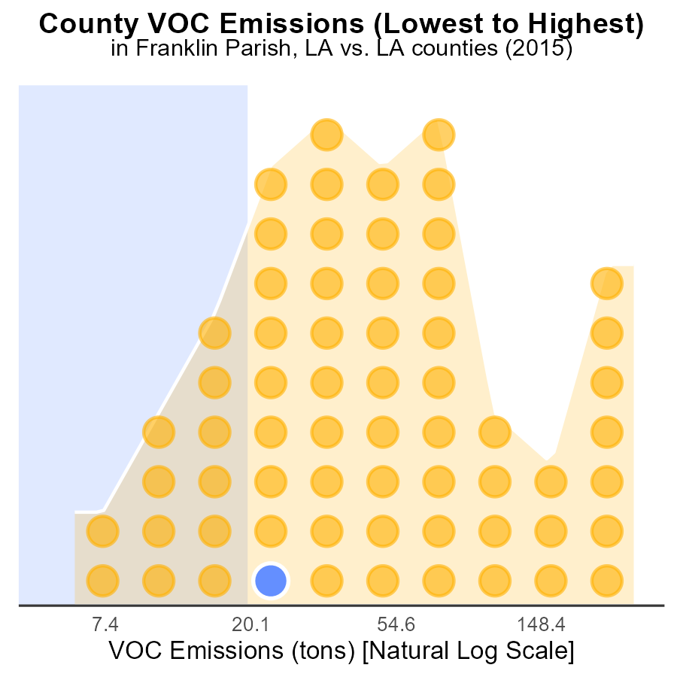

## Findings

* Jefferson County had the highest VOC emissions in 2015 with 752.5 tons, ranking 64th.
* Grant County followed with 54.0 tons, Franklin with 51.3 tons, and Claiborne with 48.5 tons.
* Tensas County had the lowest VOC emissions with 14.9 tons, ranking 1st with only 1.6% of the total emissions.

## Recommendations

To lower VOC emissions, priority should be given to Jefferson and Grant counties by implementing stricter emission control measures on industries and encouraging the use of cleaner technologies.

# Conclusion

In conclusion, the analysis of Volatile Organic Compounds (VOC) emissions from on-road transportation in Franklin Parish, LA in 2015 reveals several key insights. The majority of VOC emissions, 79.5%, emanated from rural unrestricted areas, underscoring the importance of implementing stricter controls and monitoring in these regions. Conversely, urban unrestricted areas contributed 20.5% of the emissions, indicating a need for cleaner technologies usage in urban settings.

Targets for emission reduction efforts should focus on the top 5 and 10 parishes contributing to 28.9% and 56.5% of VOC emissions, respectively. Encouraging sustainable practices and cleaner technologies in these areas is essential. Additionally, investments in public transportation, infrastructure, and promotion of telecommuting can help reduce vehicle miles traveled, thereby lowering emissions levels. Finally, promoting the use of cleaner fuels and technologies in transportation and industrial sectors is crucial for further decreasing VOC emissions in Franklin Parish, LA.

# About This Report

Data based on MOVES estimates collected by the Climate Action in Transportation program at Cornell University. Demographic data sourced from the US Census's American Community Survey 5-year estimates. This report was generated with the help of AI.

# References

* U.S. Census Bureau. (2023). American Community Survey 5-year estimates: Detailed tables. Retrieved from https://data.census.gov
* U.S. Environmental Protection Agency. (2024). Motor Vehicle Emission Simulator (MOVES 4.0) [Software]. Retrieved from https://www.epa.gov/moves