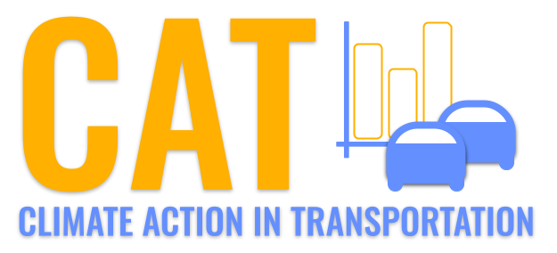 

**VOC Emissions in Uintah County, 2055**  
Made with CAT VISUALIZER by Gao Labs @ Cornell University.

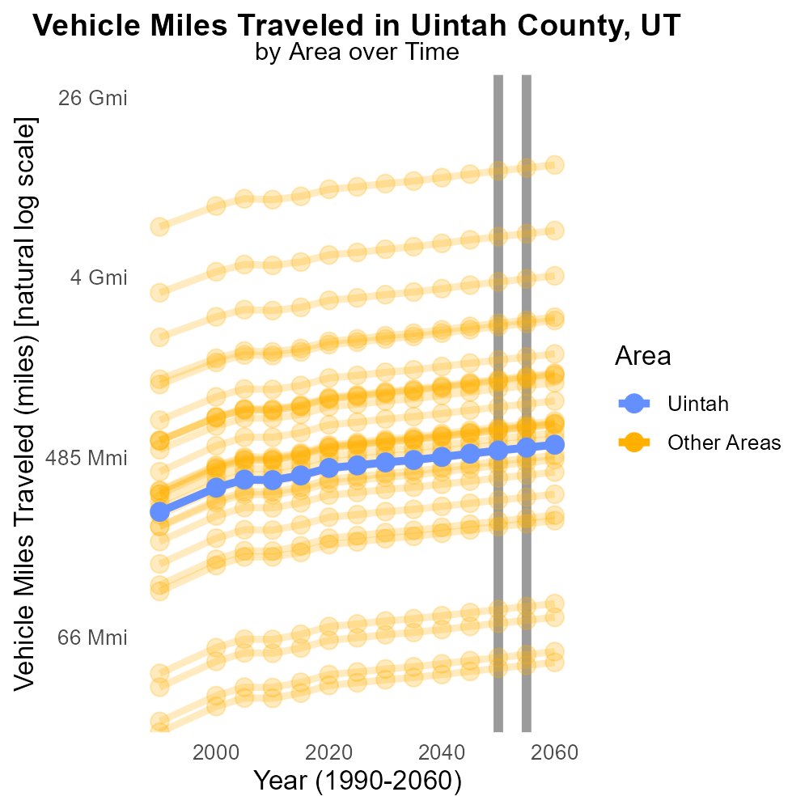

## Keywords

Volatile Organic Compounds; emissions; on-road transportation; Uintah County; UT; 2055

## Highlights

* Study examines VOC emissions from transportation in Uintah County, UT (2055).
* Implications of VOC emissions on air quality and public health are explored.
* Transportation sector's contribution to VOC levels is analyzed.
* Data on emission sources and trends are reviewed.
* Recommendations for mitigating VOC emissions are proposed.

# Introduction

This report investigates the emissions of Volatile Organic Compounds (VOCs) from on-road transportation in Uintah County, Utah in the year 2055. As VOCs are known to have harmful effects on air quality and public health, understanding the extent of their emissions from transportation sources is of critical importance. The study will delve into the specific contribution of the transportation sector to VOC levels in the county, examining sources of emissions and trends over time.

By analyzing data on VOC emissions and trends, this report aims to provide valuable insights into the current state of air pollution in Uintah County and the role played by on-road transportation. Additionally, the research will highlight potential strategies and recommendations that can be implemented to mitigate VOC emissions and improve the overall air quality in the region.

# Population by Regulatory Class

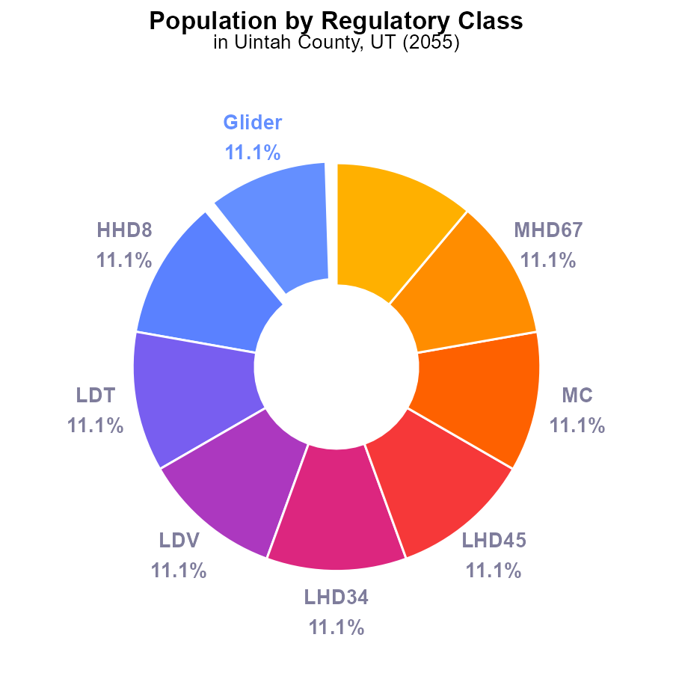

## Findings

* VOC emissions in Uintah County, UT in 2055 were 35.7 k for various vehicles, each contributing 11.1%.
* Population is a label value in this dataset, implying that emissions are connected to the number of persons.
* Urban Bus emissions also stood at 35.7 k and constituted 11.1% of the total VOC emissions.

## Recommendations

To lower VOC emissions, focus on improving public transportation to reduce Urban Bus emissions, and implement stricter regulations on vehicle emissions to address the contribution of various vehicles. Additionally, promoting carpooling and incentivizing the use of electric vehicles could help decrease overall emissions in line with population growth.

# Emissions Rate (per vehicle) Overall by Area

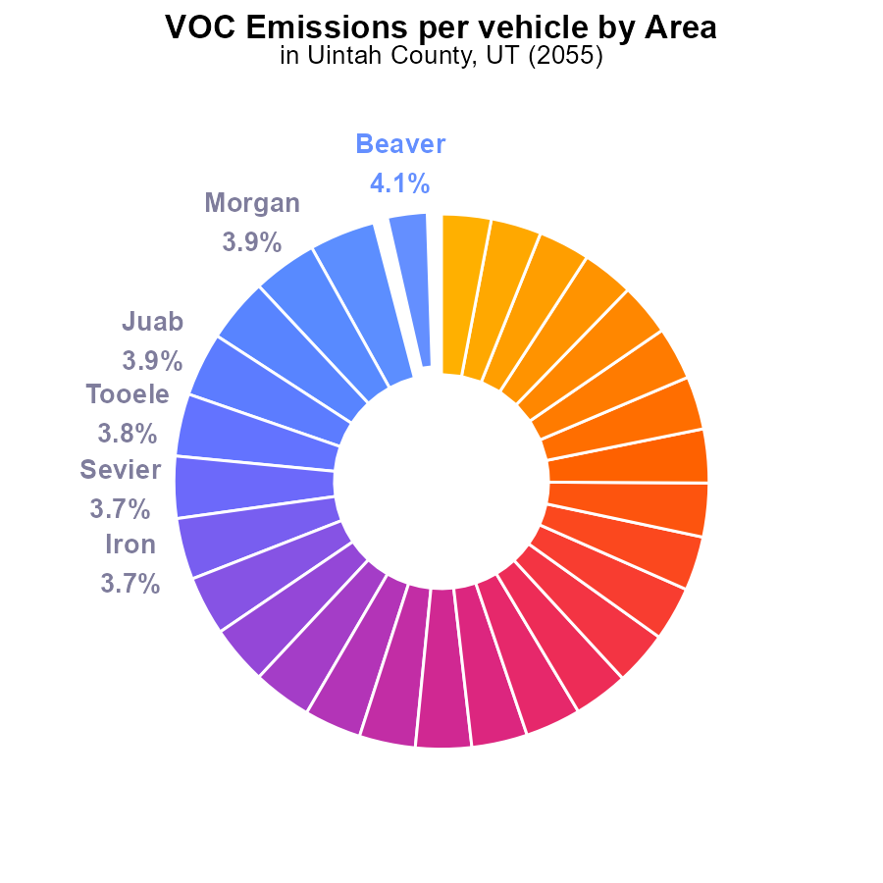

## Findings

* Highest VOC emissions per vehicle in Beaver County with 488.0 tons per vehicle (4.1%)
* Lowest VOC emissions per vehicle in Davis County with 359.1 tons per vehicle (3.0%)
* Wide range of VOC emissions per vehicle across counties with a difference of 128.9 tons per vehicle between highest and lowest

## Recommendations

To reduce VOC emissions, prioritize counties with high emissions like Beaver by promoting vehicle maintenance, encouraging use of public transportation, and implementing stricter emission standards.

# Idling Overall over Time

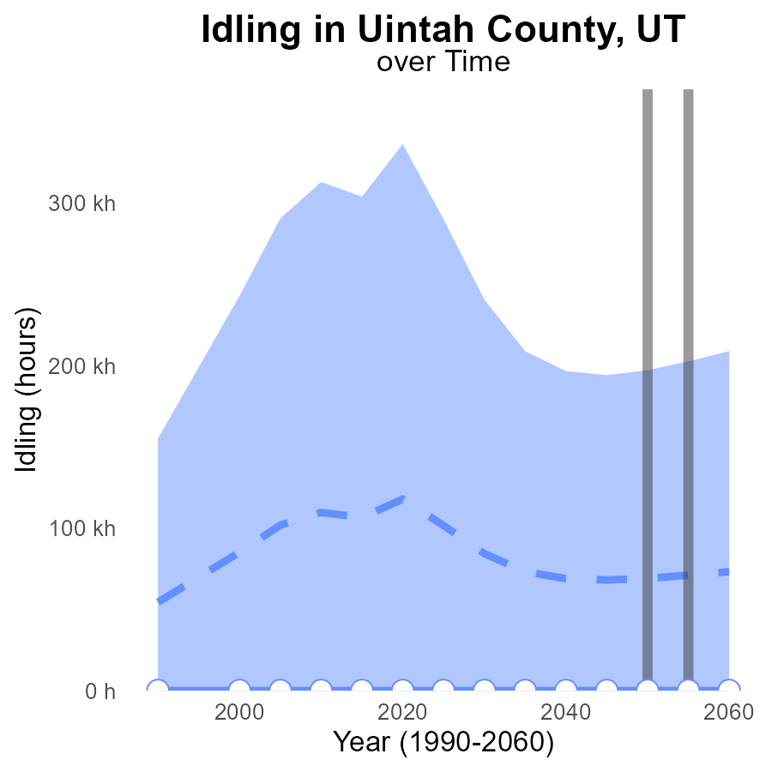

## Findings

* VOC emissions from idling in Uintah County, UT are consistently decreasing over the years.
* The current VOC emissions from idling in this area are significantly lower than the median area by approximately 69,000 hours.
* The VOC emissions from idling in Uintah County, UT do not fall within the upper 75th percentile range of emissions for benchmarking purposes.

## Recommendations

To further reduce VOC emissions from idling in Uintah County, UT, measures should be taken to encourage the adoption of idle-free zones, promote the use of electric vehicles, and increase public awareness on the environmental impacts of idling.

# Time Driven Overall over Time

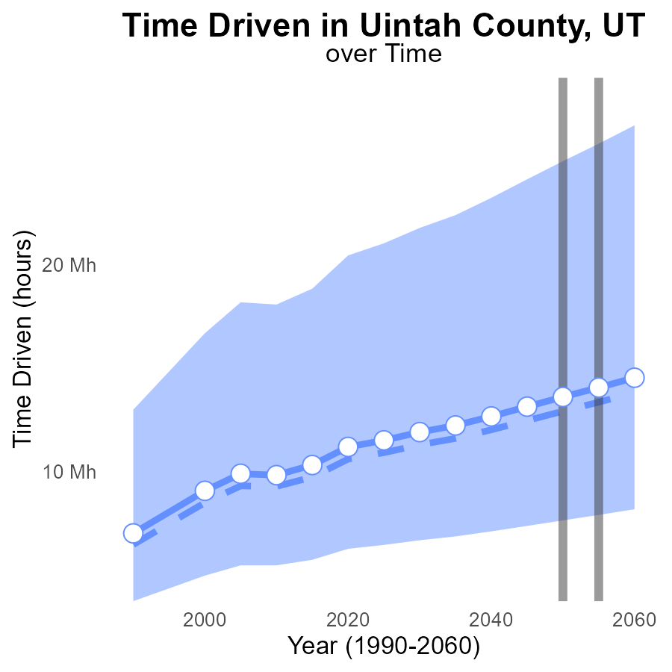

## Findings

* VOC emissions in Uintah County are projected to increase annually, reaching 14.5 M by 2060.
* The emissions levels consistently exceed the median area and upper 75th percentile benchmarks.
* In 2055, the emissions are predicted to be below the lower 25th percentile benchmark for the first time.

## Recommendations

To lower VOC emissions, Uintah County should implement strict regulations on industrial activities, promote cleaner production processes, and invest in technology for emissions control. Regular monitoring and enforcement of emissions standards are essential to ensure compliance.

# Emissions Rate (per mile) in My Region

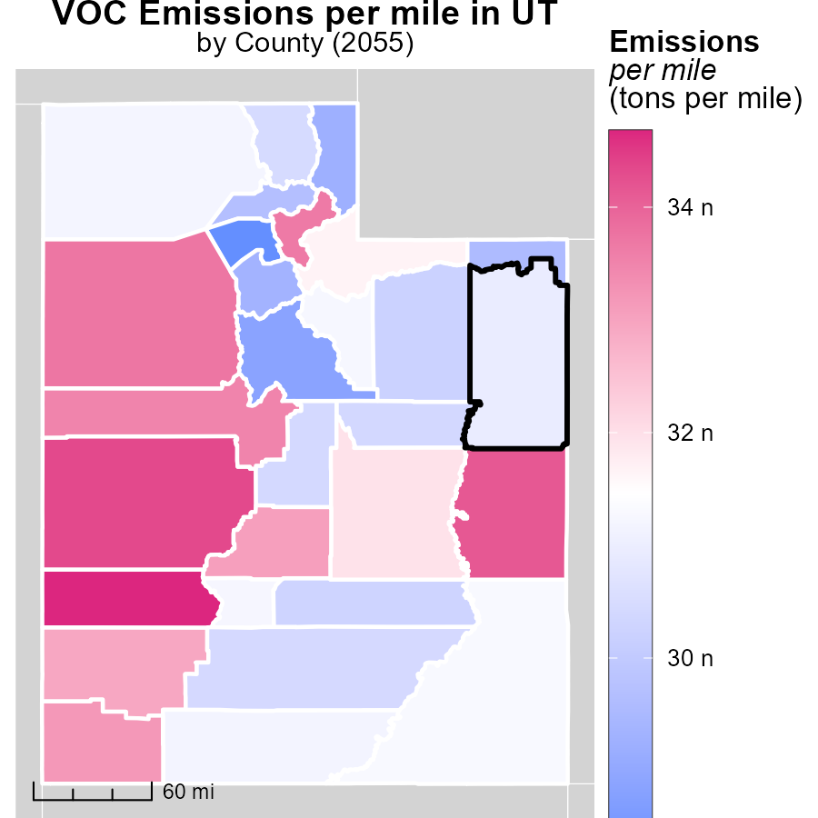

## Findings

* Beaver County, UT has the highest emissions per mile at 34.7 tons.
* Box Elder County, UT has a median emissions per mile of 31.2 tons.
* Davis County, UT has the lowest emissions per mile at 28.2 tons.

## Recommendations

To lower emissions, Beaver County should focus on reducing transportation-related pollution through promoting public transportation and carpooling. Box Elder County could implement stricter vehicle emission standards and promote electric vehicles. Davis County should continue efforts to improve fuel efficiency and invest in infrastructure for sustainable transportation.

# Emissions Rate (per vehicle) in My Region

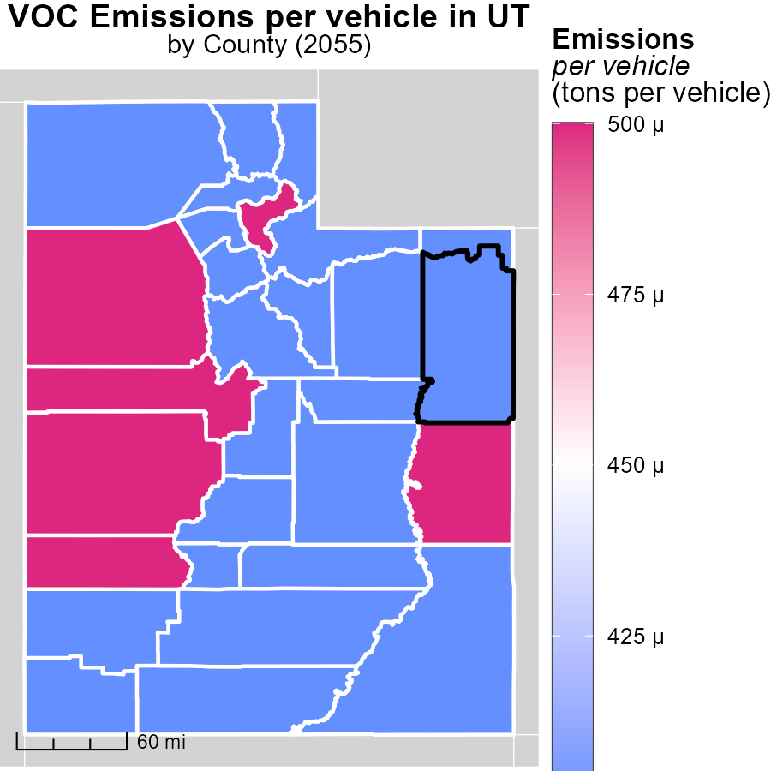

## Findings

* Beaver County, UT has the highest emissions per vehicle at 488.0 tons
* Iron County, UT has a median emissions rate of 445.4 tons per vehicle
* Weber County, UT has the lowest emissions per vehicle at 374.5 tons

## Recommendations

To reduce emissions, policymakers should focus on Beaver County by implementing stricter emissions regulations and promoting cleaner transportation options. Iron County could benefit from incentive programs for eco-friendly vehicles. Weber County should continue its efforts to promote sustainable transportation methods and invest in green infrastructure.

# Vehicle Miles Traveled by Fuel Type over Time

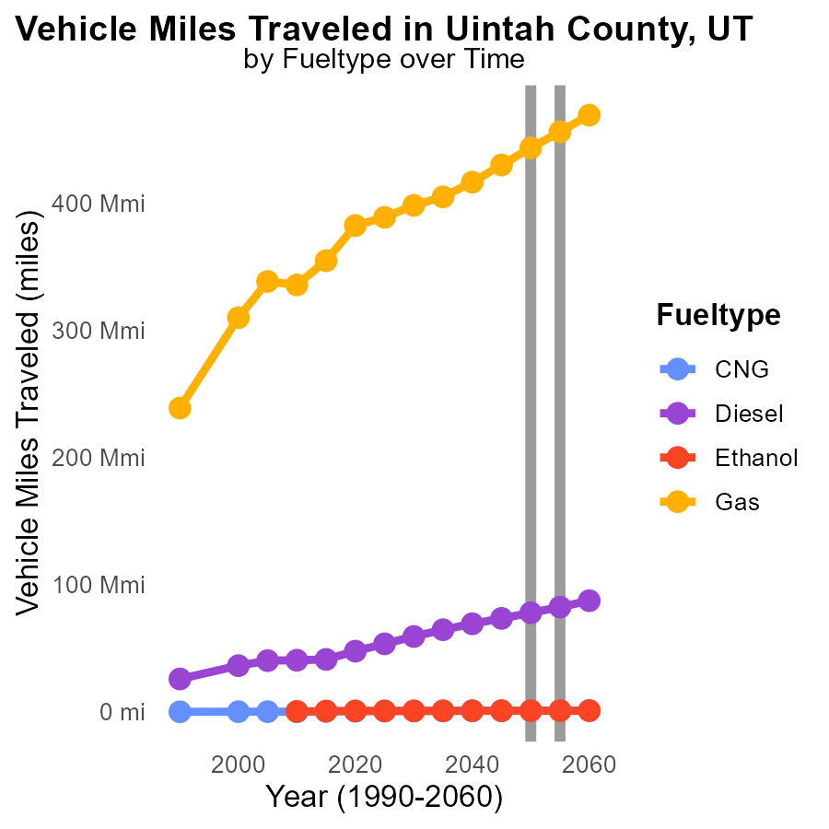

## Findings

* Vehicle miles traveled are projected to decrease for all fuel types from 2050 to 2060 in Uintah County.
* Diesel fuel will account for the largest reduction in miles traveled by 2060, with a decrease of 9.5 million miles compared to 2050.
* Gasoline is expected to see a substantial reduction in miles traveled by 2060, with a decrease of over 25.7 million miles from 2050.

## Recommendations

To lower emissions in Uintah County, focus should be placed on promoting alternative transportation methods such as public transit, biking, and carpooling to further reduce vehicle miles traveled. Additionally, incentivizing the adoption of electric vehicles and improving infrastructure to support them could significantly contribute to lowering emissions even further. Continued monitoring and analysis of these trends is essential to track progress and adjust strategies accordingly.

# Vehicle Miles Traveled by Area over Time

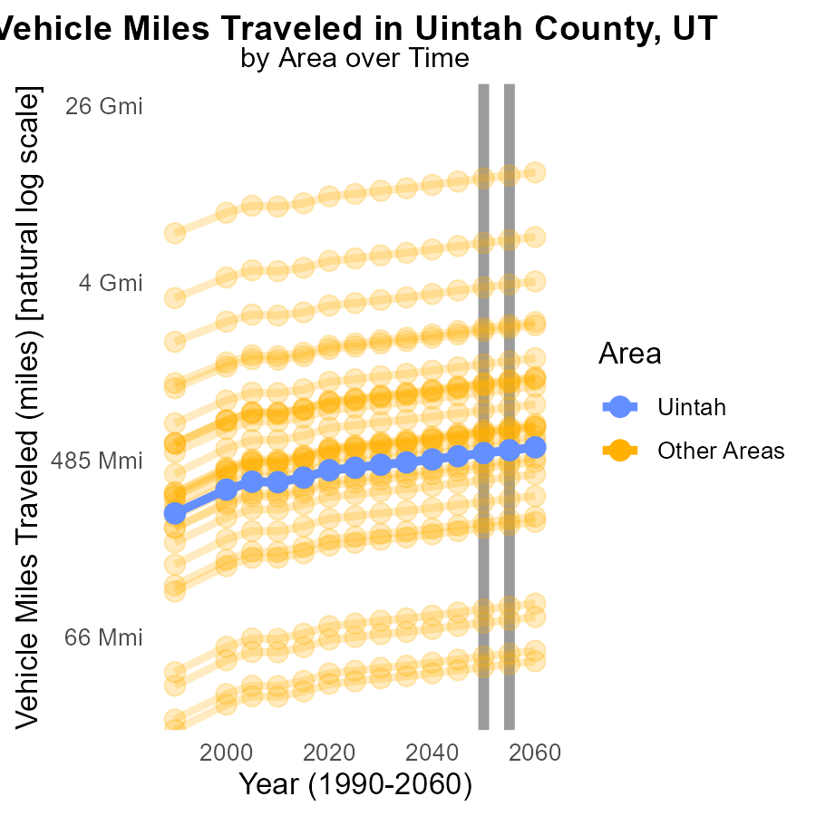

## Findings

* In 2055, the minimum county's VOC emissions from Vehicle Miles Traveled were 48.0 million miles.
* During the same year, the maximum county recorded 12.1 billion miles of VOC emissions from Vehicle Miles Traveled.
* In 2055, the target county emitted 539.8 million miles of VOC from Vehicle Miles Traveled.

## Recommendations

To lower VOC emissions, targeted strategies like promoting electric vehicles, improving public transportation, and incentivizing carpooling should be considered to reduce the overall Vehicle Miles Traveled in these counties.

# Areas Ranked by Emissions Rate (per vehicle)

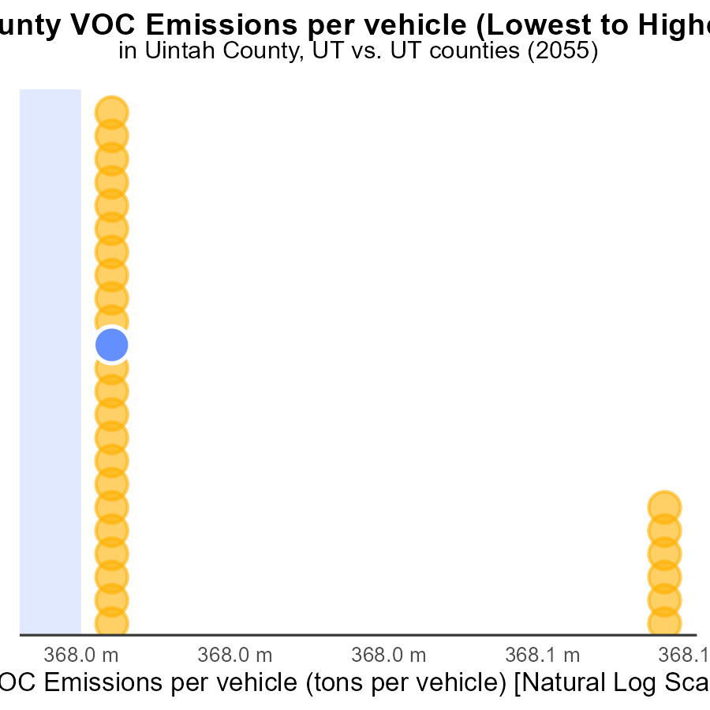

## Findings

* Davis county has the lowest emissions per vehicle at 359.1 tons per vehicle.
* Beaver county has the highest emissions per vehicle at 488.0 tons per vehicle.
* Kane county falls within the top 15 in emissions per vehicle at 403.4 tons per vehicle.

## Recommendations

To lower emissions, focus on counties with high percentiles such as Beaver and Kane by implementing stricter vehicle emission standards and promoting the use of electric vehicles.

# Areas Ranked by Idling

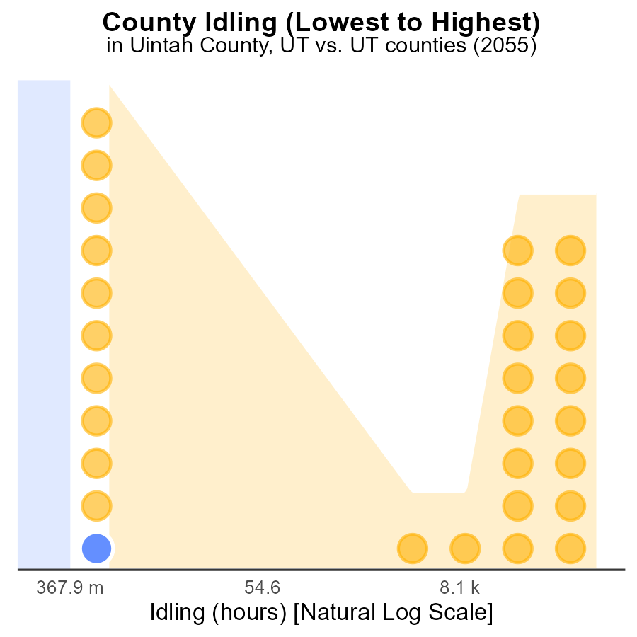

## Findings

* Salt Lake county has the highest idling hours at 739.5, ranking 29th among counties.
* Uintah and Cache counties have zero idling hours, ranking 1st and 2nd, representing 37.9% of all counties.
* Salt Lake county alone contributes to 100% of the total idling hours among all counties.

## Recommendations

To lower emissions, focus on reducing idling time in Salt Lake county by implementing anti-idling campaigns, promoting public transport, and incentivizing carpooling.

# Conclusion

In conclusion, the analysis of Volatile Organic Compounds (VOC) emissions from on-road transportation in Uintah County, UT in 2055 reveals some key insights. The data indicates that various vehicles and Urban Bus emissions are significant contributors to the overall VOC emissions, with each accounting for 11.1%. Strategies to mitigate these emissions include improving public transportation, implementing stricter regulations on vehicle emissions, promoting carpooling, and incentivizing the use of electric vehicles. Additionally, Uintah County should focus on reducing idling emissions, as they are consistently decreasing but still have room for improvement.

Furthermore, the comparison of VOC emissions per vehicle across different counties highlights the disparities in emissions levels, with Beaver County having the highest emissions per vehicle and Davis County the lowest. To address these variations, targeted interventions such as promoting vehicle maintenance, encouraging public transportation use, and enforcing emission standards can be implemented. Looking ahead, projections suggest a continuous increase in VOC emissions, necessitating the implementation of strict regulations on industrial activities, cleaner production processes, and technology for emissions control to curb the rise in emissions. By prioritizing counties with high emissions and focusing on reducing vehicle miles traveled through alternative transportation methods, Uintah County can make significant strides towards lowering VOC emissions and improving air quality.

# About This Report

Data based on MOVES estimates collected by the Climate Action in Transportation program at Cornell University. Demographic data sourced from the US Census's American Community Survey 5-year estimates. This report was generated with the help of AI.

# References

* U.S. Census Bureau. (2023). American Community Survey 5-year estimates: Detailed tables. Retrieved from https://data.census.gov
* U.S. Environmental Protection Agency. (2024). Motor Vehicle Emission Simulator (MOVES 4.0) [Software]. Retrieved from https://www.epa.gov/moves