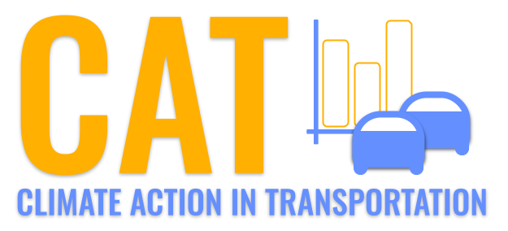 

**VOC Emissions in Grant County, 2045**  
Made with CAT VISUALIZER by Gao Labs @ Cornell University.

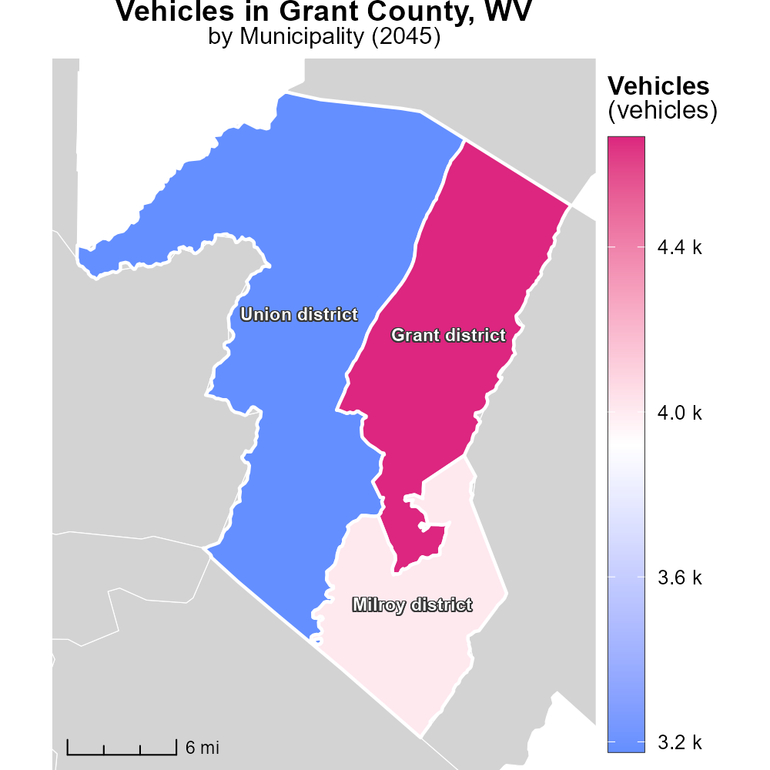

## Keywords

Volatile Organic Compounds; emissions; on-road transportation; Grant County; WV; 2045

## Highlights

* Study on VOC emissions from on-road transport in Grant County, WV.
* Analysis of trends and impacts on air quality in the region.
* Assessment of regulatory measures and mitigation strategies.
* Implications for public health and environmental sustainability.
* Recommendations for future actions to reduce VOC emissions.

# Introduction

In 2045, Grant County, WV, faces a significant challenge in addressing the emissions of Volatile Organic Compounds (VOCs) from on-road transportation. This report presents a comprehensive study on the sources, trends, and impacts of VOC emissions in the region. By analyzing data and projections, we aim to provide insights into the current state of air quality in Grant County and the potential risks associated with elevated VOC levels.

Our assessment includes an examination of existing regulatory measures, as well as the effectiveness of mitigation strategies employed to reduce VOC emissions. Furthermore, we explore the implications of high VOC levels on public health and environmental sustainability, with a focus on identifying opportunities for improvement. The findings of this report will inform recommendations for future actions to curtail VOC emissions and promote a cleaner, healthier environment for the residents of Grant County.

# Vehicle Starts by Road Type

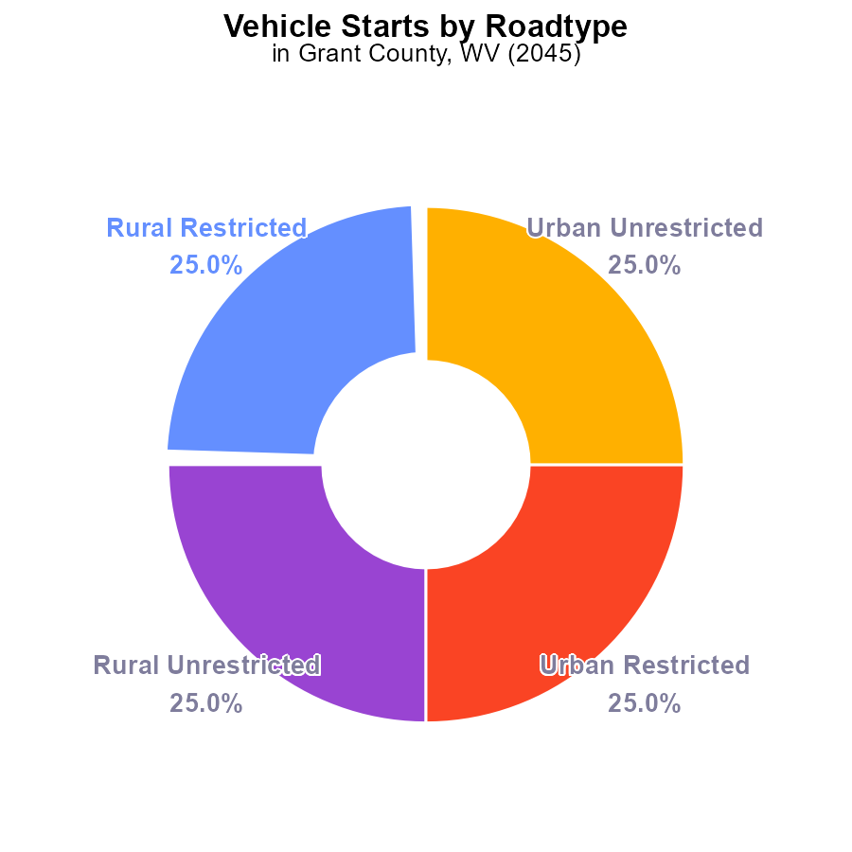

## Findings

* Vehicle starts in Grant County, WV in 2045 result in 59.2 million units of volatile organic compounds (VOC) emissions.
* Rural and urban areas contribute equally to the total VOC emissions, each accounting for 50%.
* A policy focus on reducing VOC emissions during vehicle starts in all areas of Grant County, WV is needed.

## Recommendations

To lower VOC emissions, Grant County should implement vehicle emission testing programs, incentivize the use of electric vehicles, and invest in public transportation infrastructure.

# Emissions Rate (per capita) by Fuel Type

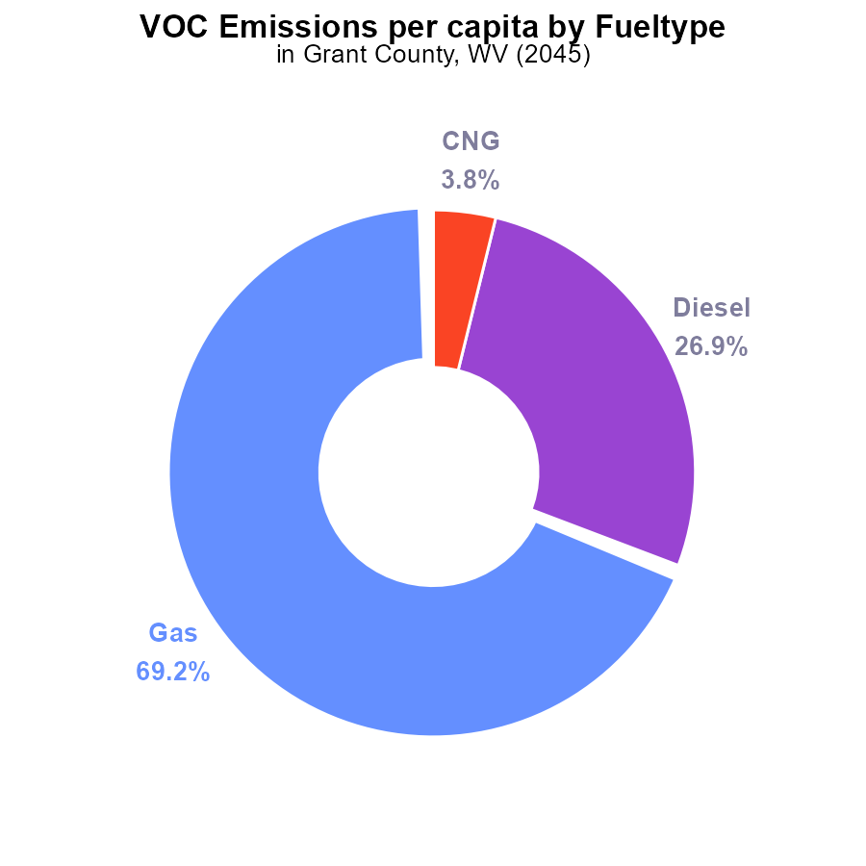

## Findings

* Gasoline emissions are the largest contributor with 69.2% of total VOC emissions.
* Diesel emissions account for 26.9% of total VOC emissions per capita.
* CNG and Ethanol emissions are minimal, with CNG contributing 3.8% and Ethanol contributing 0.0%.

## Recommendations

To reduce VOC emissions, focus on reducing gasoline and diesel usage through promoting public transportation, carpooling, and transitioning to electric vehicles. Encouraging the use of alternative fuels like CNG and Ethanol could also help decrease emissions further.

# Hotelling (Diesel Aux) over Time for Buses

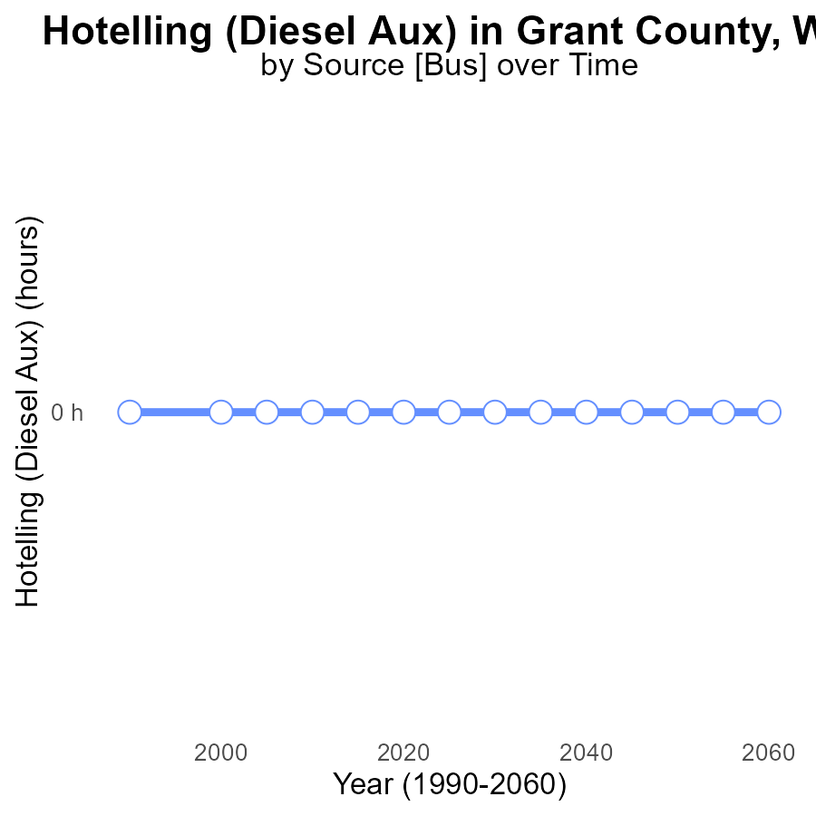

## Findings

* There have been zero VOC emissions from Hotelling (Diesel Aux) in Grant County, WV since 2025 up to 2060.

## Recommendations

To maintain this zero emissions trend, continue monitoring and enforcing strict regulations on Hotelling operations to ensure compliance with environmental standards.

# Emissions over Time for Buses

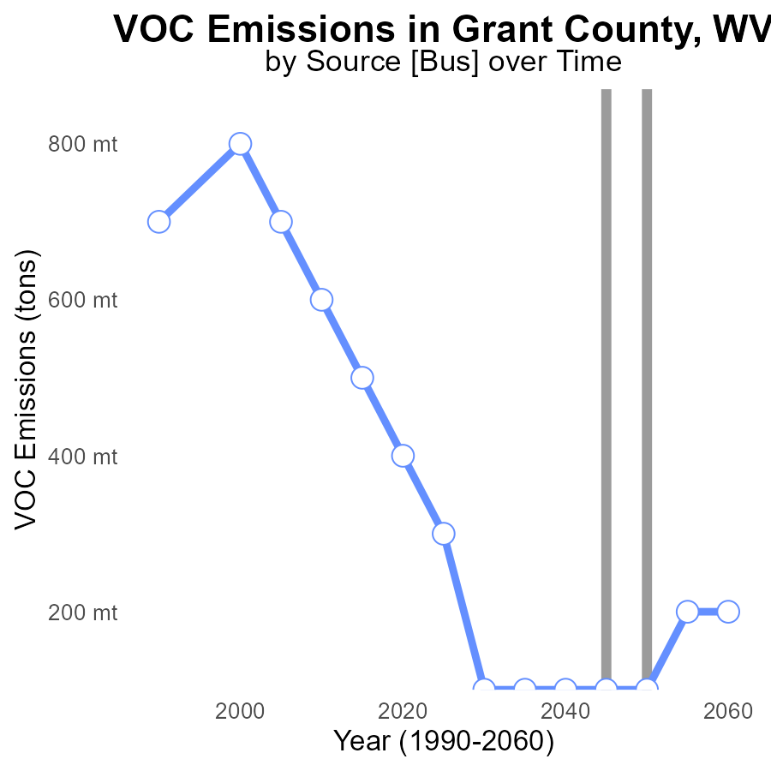

## Findings

* VOC emissions in Grant County, WV have decreased by 0.2 tons from 2025 to 2060.
* There was no change in VOC emissions from 2030 to 2060, remaining at 100.0 tons.
* A slight decrease in VOC emissions of 0.1 tons occurred from 2055 to 2060.

## Recommendations

To continue the positive trend of reducing VOC emissions, enforce stricter regulations on industries, incentivize the use of cleaner technologies, and promote public transportation and carpooling to lower overall emissions further.

# Emissions Rate (per capita) in My Region

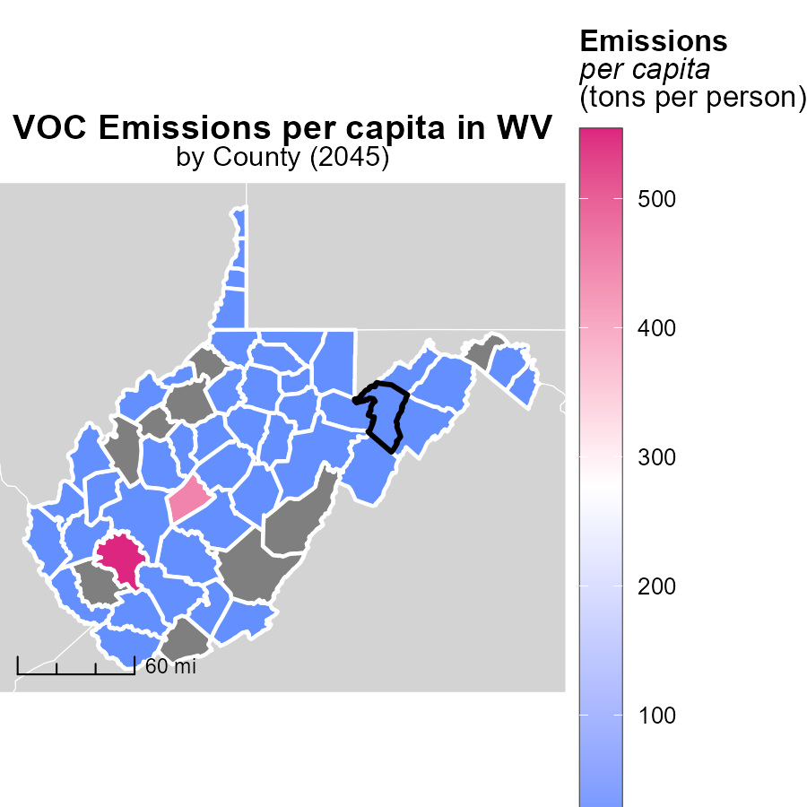

## Findings

* Boone County, WV has the highest emissions per capita at 553.7 tons per person.
* McDowell County, WV has a median emissions level of 436.9 tons per person.
* Hancock County, WV has the lowest emissions per capita at 219.8 tons per person.

## Recommendations

To reduce emissions, focus on Boone and McDowell Counties by implementing renewable energy projects and promoting energy efficiency in industries and households.

# Vehicles Mapped by Area

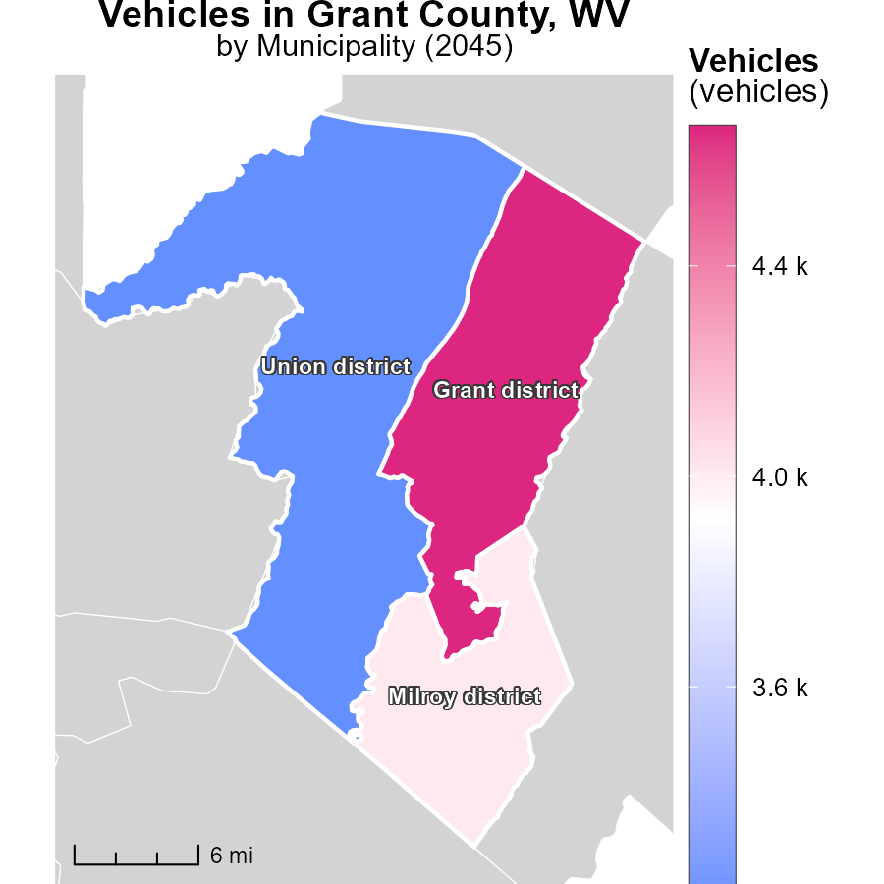

## Findings

* Grant district, WV has the highest vehicle emissions at 4.7k.
* Milroy district, WV has a median emission level of 4.0k from vehicles.
* Union district, WV has the lowest vehicle emissions at 3.2k.

## Recommendations

To lower vehicle emissions, focus on implementing eco-friendly transportation alternatives, improving public transportation systems, and encouraging the adoption of electric vehicles in regions with higher emission levels like Grant district, WV.

# Emissions by Road Type over Time

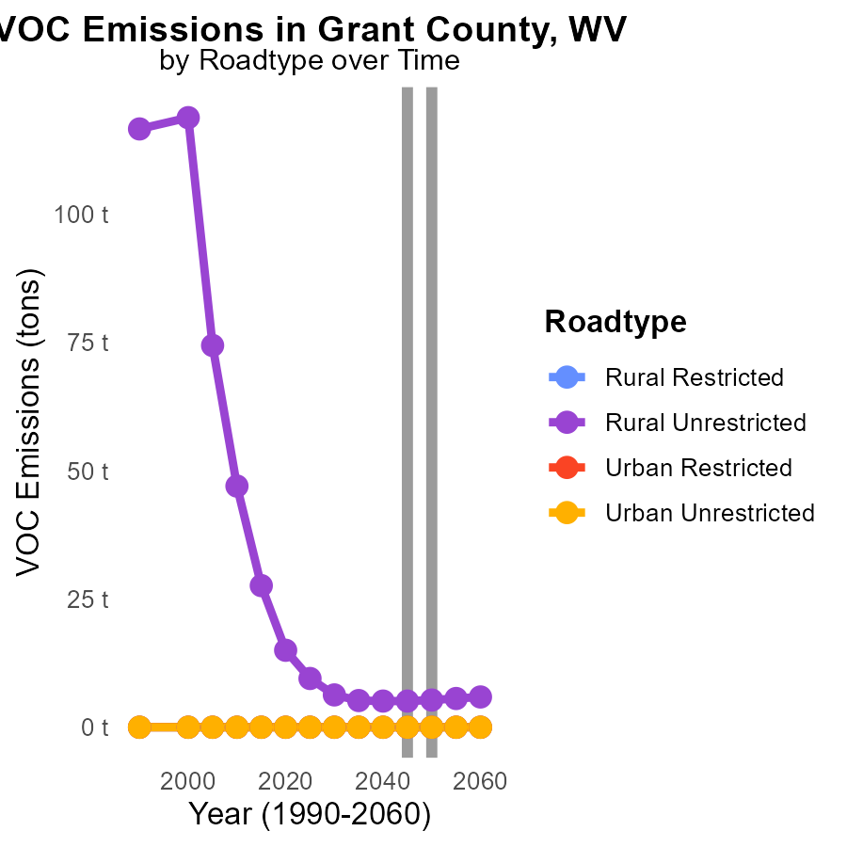

## Findings

* Rural Unrestricted areas had the highest VOC emissions in 2055, at 5.6 tons.
* The difference in VOC emissions between 2040 and 2050 in Rural Unrestricted areas increased by 0.5 tons.
* Urban areas consistently showed no VOC emissions throughout the years.

## Recommendations

To lower VOC emissions, focus on implementing stricter regulations in Rural Unrestricted areas, which are the main contributors. Encourage the adoption of cleaner technologies in transportation.

# Idling by Vehicle Type over Time

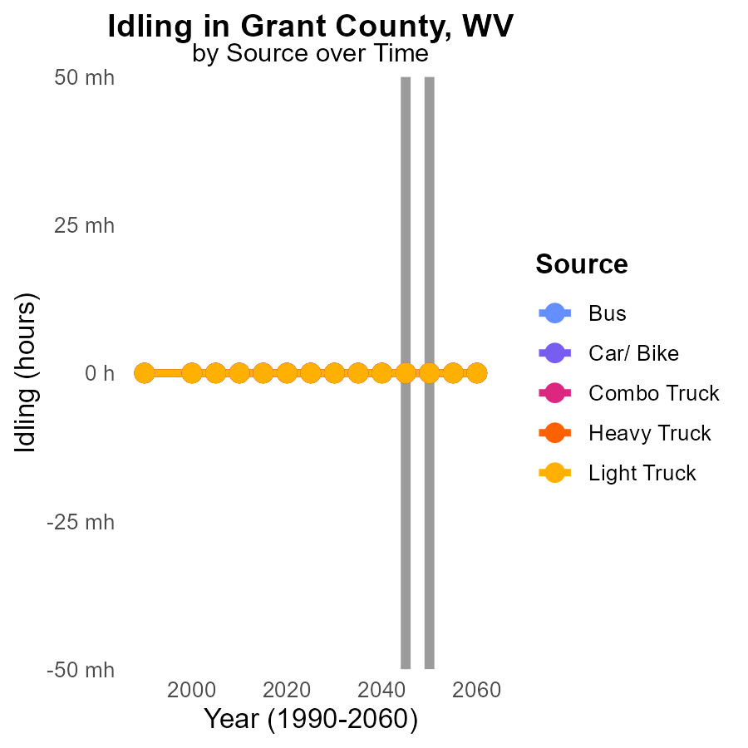

## Findings

* No VOC emissions from idling for various vehicle types in Grant County, WV from 2035 to 2055.

## Recommendations

Given the absence of VOC emissions from idling in Grant County, WV, policymakers should focus on maintaining this status quo through continued monitoring and enforcement of anti-idling regulations.

# Areas Ranked by Idling

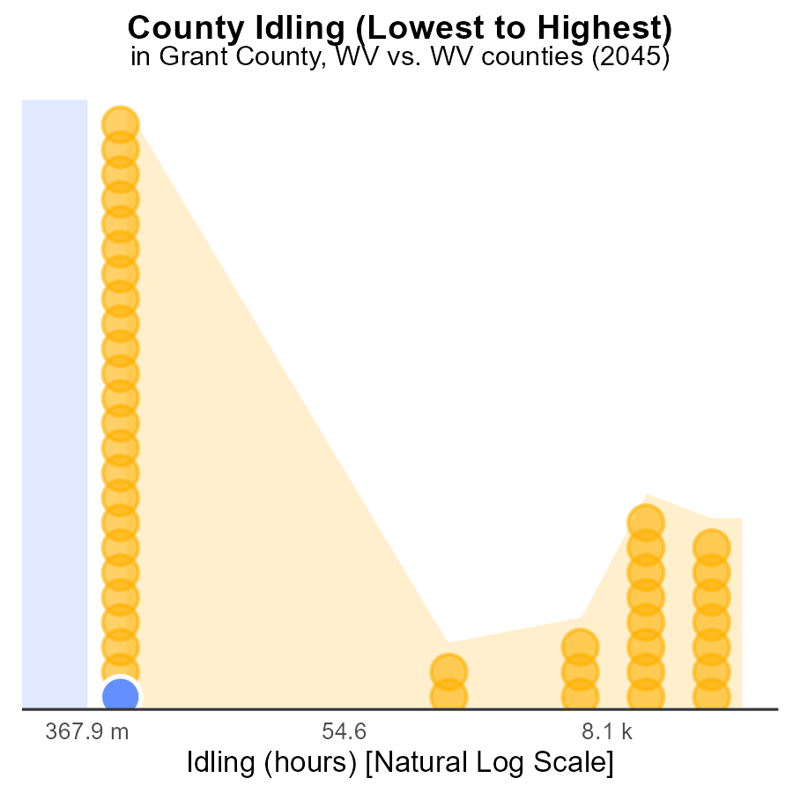

## Findings

* Grant County has the lowest VOC emissions from idling at 0.0 hours
* Barbour County also reports 0.0 hours of VOC emissions from idling
* Both counties rank 1st and 2nd, contributing to 54.5% of the total emissions

## Recommendations

Grant and Barbour counties should focus on implementing anti-idling policies to further reduce VOC emissions. By promoting idling reduction programs and educating the community, these counties can maintain their low emission levels.

# Areas Ranked by Time Driven

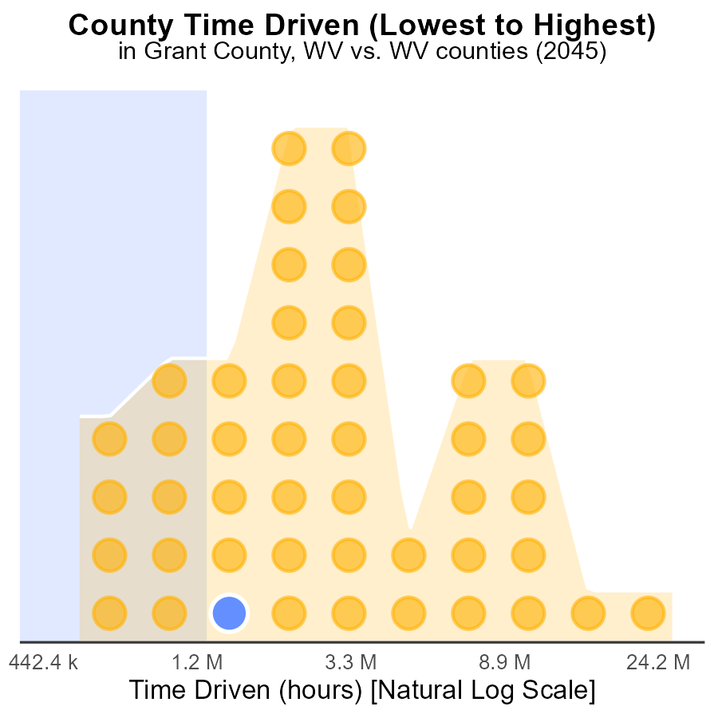

## Findings

* Kanawha county has the highest VOC emissions with 74.4 million source hours.
* Calhoun county has the lowest VOC emissions with 1.5 million source hours, ranking 1st with only 2.2% of the total emissions.
* Roane county has the highest percentage of VOC emissions, contributing 23.9% to the total emissions.

## Recommendations

To lower VOC emissions, focus on reducing sources of pollution in counties with high emissions like Kanawha and Roane. Implement stricter regulations and promote cleaner technologies.

# Conclusion

In conclusion, the data from Grant County, WV in 2045 shows that on-road transportation is a significant contributor to volatile organic compounds (VOC) emissions in the region. With a total of 59.2 million units of VOC emissions, gasoline emissions emerge as the largest contributor at 69.2%, followed by diesel emissions at 26.9%. To address this issue, a policy focus on reducing VOC emissions during vehicle starts is crucial. Strategies such as vehicle emission testing programs, incentivizing electric vehicle use, and investing in public transportation infrastructure are essential to lower VOC emissions.

Moreover, Grant County should continue efforts to decrease VOC emissions further by promoting alternative fuels like CNG and Ethanol, and implementing measures to reduce gasoline and diesel usage. Strict regulations, along with the promotion of cleaner technologies and transportation methods, can play a key role in sustaining the reduction of VOC emissions over time. Additionally, focusing on counties and districts with higher emission levels, such as Boone and McDowell counties, and the Grant district, can help in implementing targeted solutions to address specific sources of pollution and promote a cleaner environment.

# About This Report

Data based on MOVES estimates collected by the Climate Action in Transportation program at Cornell University. Demographic data sourced from the US Census's American Community Survey 5-year estimates. This report was generated with the help of AI.

# References

* U.S. Census Bureau. (2023). American Community Survey 5-year estimates: Detailed tables. Retrieved from https://data.census.gov
* U.S. Environmental Protection Agency. (2024). Motor Vehicle Emission Simulator (MOVES 4.0) [Software]. Retrieved from https://www.epa.gov/moves