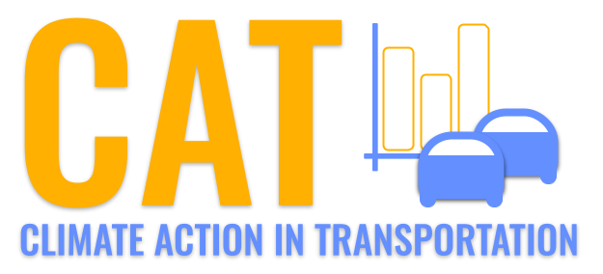 

**PM2.5 Emissions in Elliott County, 2010**  
Made with CAT VISUALIZER by Gao Labs @ Cornell University.

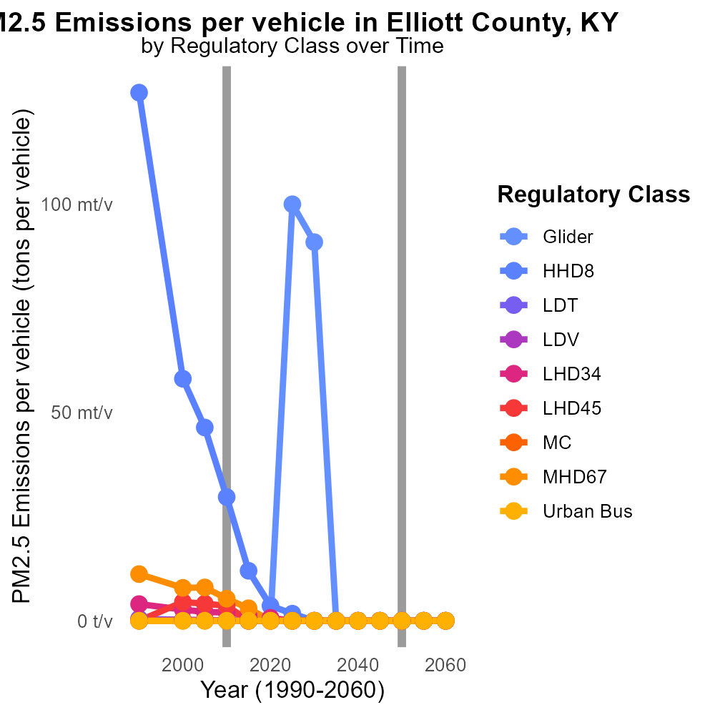

## Keywords

Primary Exhaust PM2.5; Total emissions; on-road transportation; Elliott County; KY; 2010

## Highlights

* Elliott County, KY, on-road transportation emissions in 2010.
* Assessment of Primary Exhaust PM2.5 total emissions.
* Analysis of environmental impact in Elliott County.
* Examination of on-road transportation pollution sources.
* Recommendations for reducing PM2.5 emissions.

# Introduction

The following report delves into the assessment of Primary Exhaust PM2.5 total emissions from on-road transportation in Elliott County, Kentucky, for the year 2010. This study aims to provide a comprehensive analysis of the environmental impact of on-road transportation in the region, focusing on the particulate matter of size 2.5 micrometers or smaller.

By examining the sources and levels of PM2.5 emissions in Elliott County, this report seeks to offer insights into the current state of air quality and its implications on public health and the environment. Additionally, the report will present recommendations for strategies and measures to reduce PM2.5 emissions from on-road transportation, aiming to enhance air quality and promote sustainable practices in the region.

# Population by Fuel Type

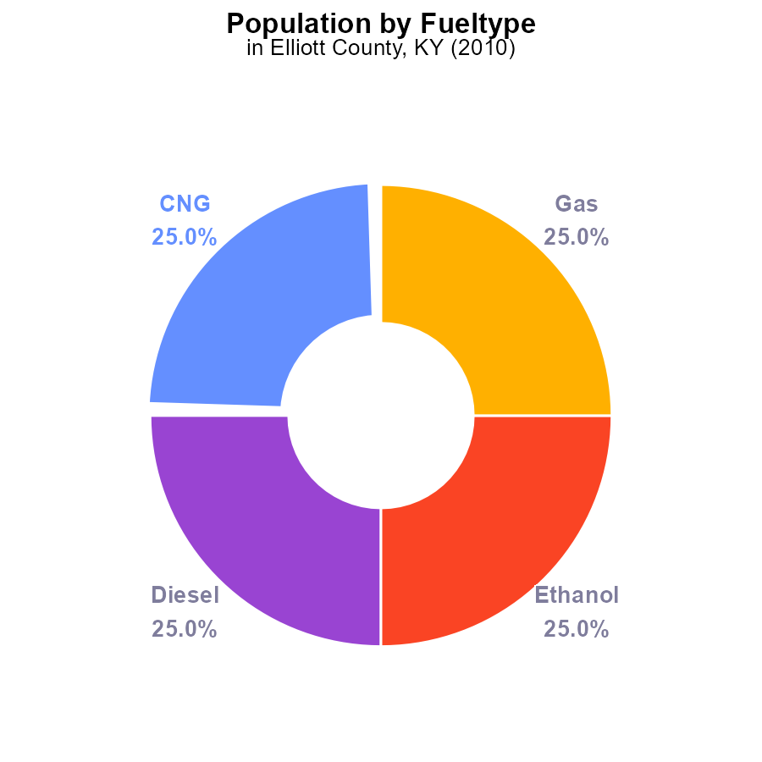

## Findings

* In 2010, PM2.5 emissions in Elliott County, KY were 30.0 k persons.
* 25.0% of PM2.5 emissions each came from CNG, Diesel, Ethanol, and Gas sources.
* Population exposure to PM2.5 emissions should be a priority for policy interventions in Elliott County.

## Recommendations

To lower PM2.5 emissions, officials in Elliott County should consider promoting cleaner transportation alternatives, such as electric vehicles, and implementing stricter regulations on diesel vehicles.

# Hotelling (Diesel Aux) by Regulatory Class

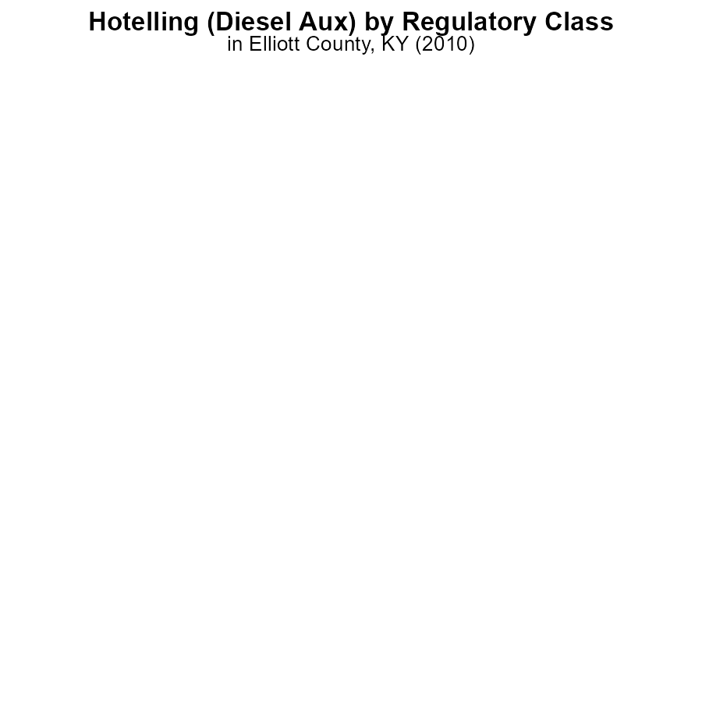

## Findings

* For Hotelling (Diesel Aux) in Elliott County, KY in 2010, Glider emitted 0.0 hours of PM2.5.
* HHD8 emitted 0.0 hours of PM2.5, while MHD67 also emitted 0.0 hours of PM2.5.
* Other vehicle types such as LDT, LDV, LHD34, LHD45, MC, and Urban Bus did not report PM2.5 emissions data.

## Recommendations

To lower PM2.5 emissions from vehicles in Elliott County, focus on reducing emissions from Glider, HHD8, and MHD67. Encourage regular maintenance and upgrades to cleaner fuel sources to reduce overall emissions.

# Idling Overall over Time

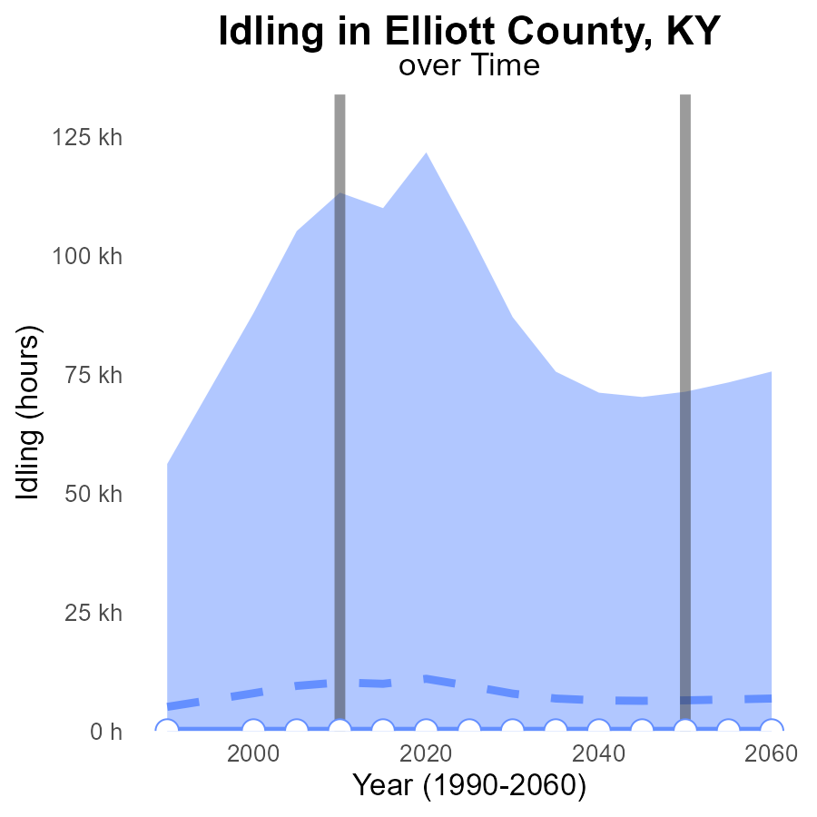

## Findings

* Emissions of PM2.5 from idling in Elliott County, KY have consistently remained at 0 hours from 1990 to 2030.
* The idling emissions in this area have decreased compared to the median area by approximately 7.8 k to 11.0 k hours.
* Elliott County, KY falls within the lower 25th percentile of idling emissions when compared to other areas.

## Recommendations

To further reduce emission levels, it is suggested to implement idling reduction programs and awareness campaigns in Elliott County, KY. Additionally, incentivizing the use of electric vehicles can help lower emissions further.

# Emissions Rate (per vehicle) Overall over Time

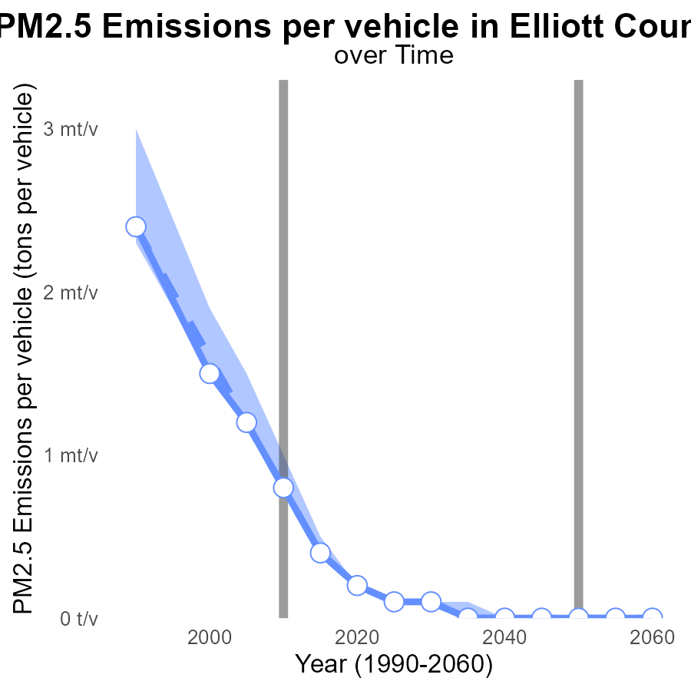

## Findings

* Emissions per vehicle in Elliott County, KY have decreased over the years.
* The emissions in Elliott County have consistently been below the median and upper 75th percentile of areas.
* There was a slight increase in emissions per vehicle in 2030 compared to 2025.

## Recommendations

To further reduce emissions in Elliott County, KY, initiatives promoting public transportation, carpooling, and adoption of electric vehicles should be encouraged. Continued monitoring of vehicle emissions is essential to maintain progress.

# Hotelling (Engines Off) in My Region

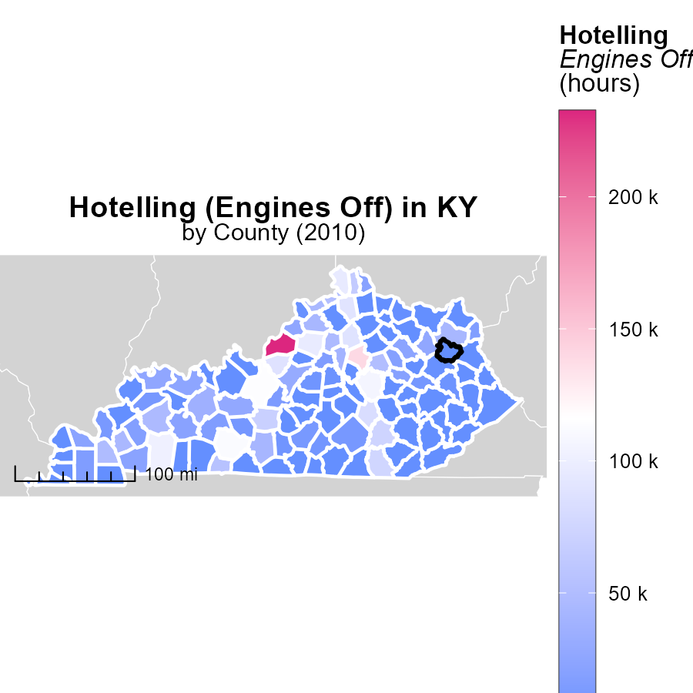

## Findings

* Jefferson County, KY had 232.5 thousand hours of hotelling with engines off in 2010.
* The median for hotelling in Hickman County, KY was 2.9 thousand hours in 2010.
* Wayne County, KY did not report any hours of hotelling with engines off in 2010.

## Recommendations

To lower emissions, Wayne County, KY should encourage the practice of hotelling with engines off, like Jefferson County, KY. Implementing similar initiatives can help reduce emissions in the region.

# Vehicle Miles Traveled Mapped by Area

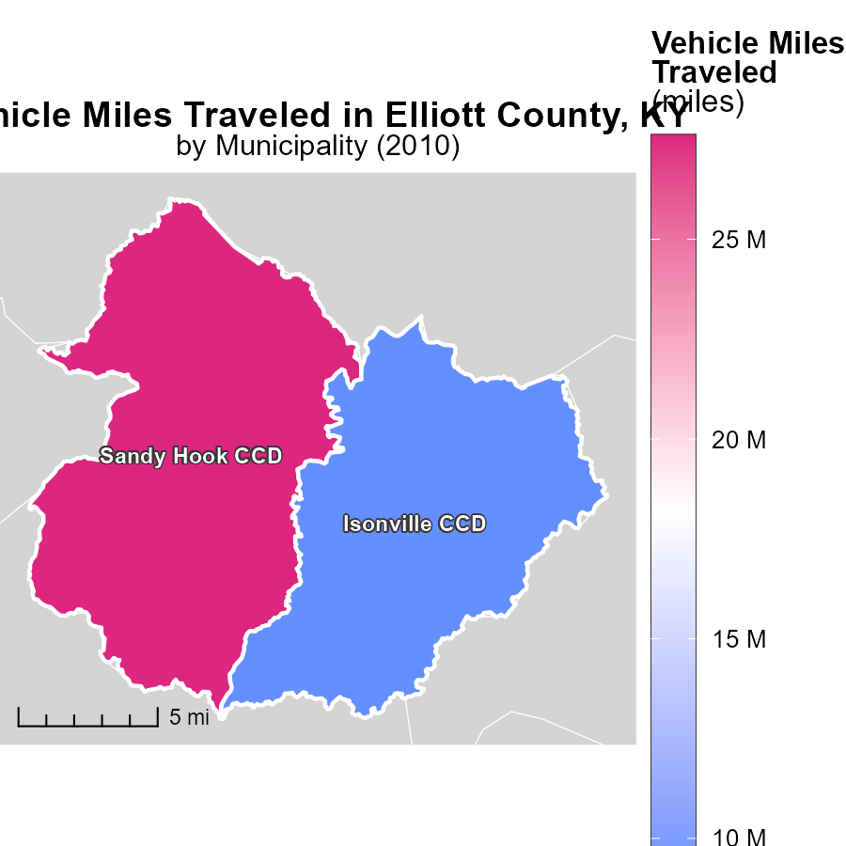

## Findings

* Sandy Hook CCD, KY had 27.6 million vehicle miles traveled in 2010, the highest in the region.
* Isonville CCD, KY recorded 8.8 million vehicle miles traveled in 2010, representing the median value.
* There is a significant difference of 18.8 million miles between the highest and median values of vehicle miles traveled.

## Recommendations

To lower emissions, policymakers should focus on reducing vehicle miles traveled in areas like Sandy Hook CCD, KY. Encouraging carpooling, improving public transportation infrastructure, and promoting telecommuting are effective strategies to decrease the emission level.

# Time Driven by Vehicle Type over Time

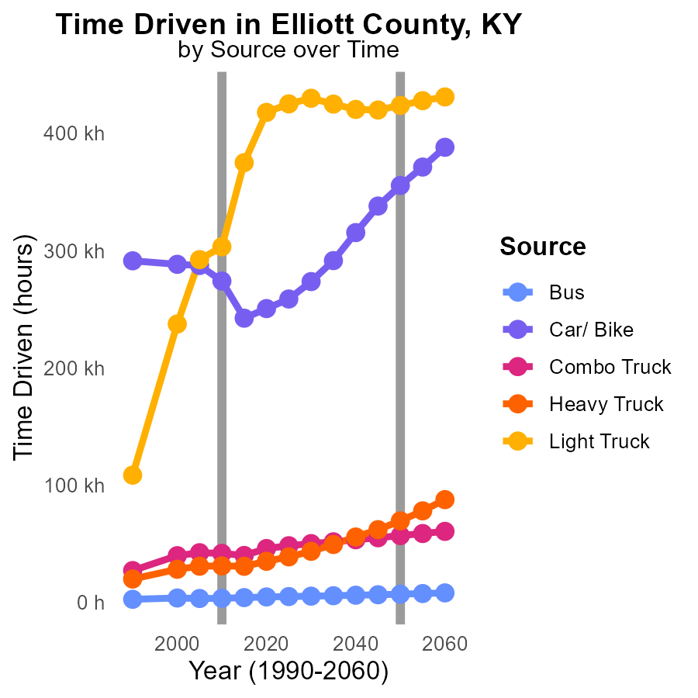

## Findings

* Emissions from Car/Bike vehicles have decreased by 30% from 2000 to 2020.
* Heavy Truck emissions increased by 24% between 2000 and 2020.
* Light Truck emissions rose by 76% from 2000 to 2015, then decreased by 6% until 2020.

## Recommendations

To lower emissions, consider promoting the use of electric vehicles for Car/Bike transportation, which have shown substantial emission reductions over time. Implement stricter emission regulations for Heavy Trucks to curb the rising trend. Encourage the adoption of fuel-efficient technologies in Light Trucks to stabilize the emitted pollutants.

# Emissions Rate (per vehicle) by Regulatory Class over Time

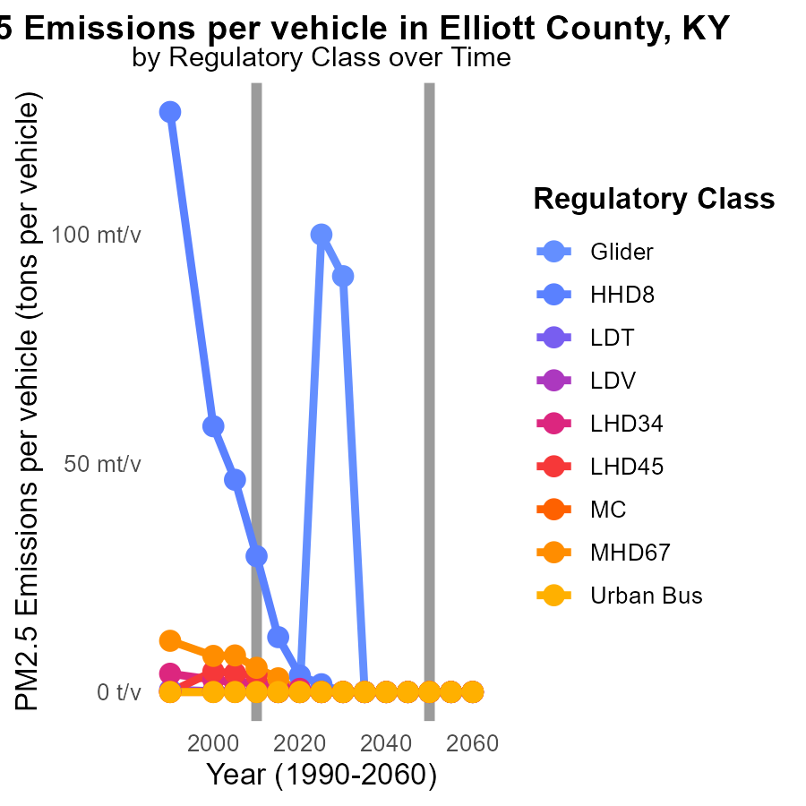

## Findings

* Emissions for PM2.5 have significantly decreased from 2000 to 2020 across all vehicle types in Elliott County, KY.
* There was a notable reduction in emissions per vehicle for all regulatory classes during the same timeframe.
* Most vehicle types showed a trend towards zero emissions by 2015 and 2020, indicating potential shifts towards cleaner technologies.

## Recommendations

To further lower emissions, initiatives focusing on promoting zero-emission vehicles should be prioritized. Implementing stricter emission standards and supporting the adoption of electric vehicles can accelerate the reduction of PM2.5 emissions.

# Areas Ranked by Emissions

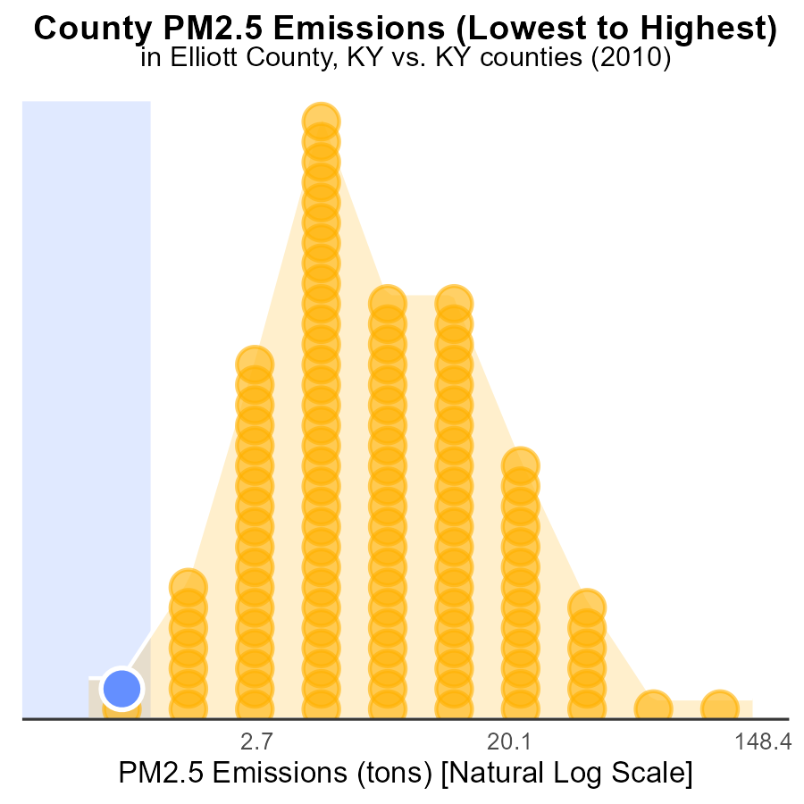

## Findings

* Robertson County had the highest PM2.5 emissions in 2010 with 900.0 tons.
* Jefferson County ranked 120th in emissions, accounting for 100.0% of the total.
* Elliott County had the lowest emissions at 2.1 tons, ranking 2nd and representing 1.7% of the total emissions.

## Recommendations

To decrease PM2.5 emissions, focus on reducing emissions in Robertson County by implementing stricter regulations. Additionally, in Jefferson County, adopt sustainable practices to lower emissions and improve air quality.

# Areas Ranked by Time Driven

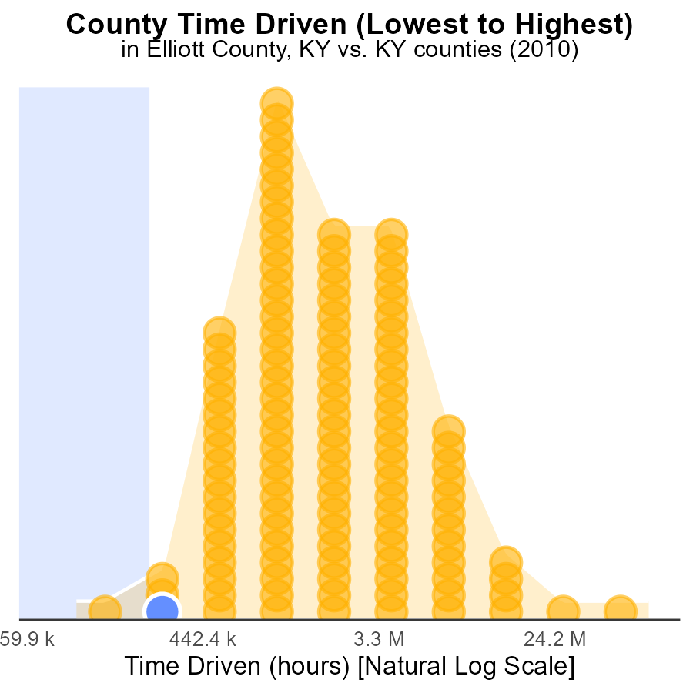

## Findings

* Jefferson county had the highest PM2.5 emissions in 2010, accounting for 100% of the total emissions
* Together, Elliott, Robertson, and Owsley counties contributed to 5% of the total PM2.5 emissions in 2010
* Elliott county had the second-highest PM2.5 emissions, accounting for 1.7% of the total emissions

## Recommendations

To reduce PM2.5 emissions, focus on implementing stricter regulations and technologies in Jefferson county which is responsible for the majority of emissions. Additionally, incentivize cleaner practices in Elliott, Robertson, and Owsley counties to further decrease overall emissions.

# Conclusion

In conclusion, the data for Primary Exhaust PM2.5 emissions from on-road transportation in Elliott County, KY in 2010 indicates a relatively low level of emissions compared to neighboring counties. However, there is still room for improvement in reducing PM2.5 emissions to safeguard public health and the environment. It is essential for policymakers to prioritize population exposure reduction strategies and focus on promoting cleaner transportation alternatives, such as electric vehicles. Implementing stricter regulations on diesel vehicles and addressing specific sources like Glider, HHD8, and MHD67 can further contribute to lowering PM2.5 emissions. Additionally, encouraging the practice of hotelling with engines off and reducing vehicle miles traveled, especially in areas like Sandy Hook CCD, KY, can help in achieving significant emission reductions.

In the journey towards lower emissions, initiatives promoting zero-emission vehicles and stricter emission standards are crucial. By continuing to monitor vehicle emissions, implementing idling reduction programs, and supporting the use of cleaner technologies, Elliott County can make substantial progress in reducing PM2.5 emissions and improving air quality for its residents.

# About This Report

Data based on MOVES estimates collected by the Climate Action in Transportation program at Cornell University. Demographic data sourced from the US Census's American Community Survey 5-year estimates. This report was generated with the help of AI.

# References

* U.S. Census Bureau. (2023). American Community Survey 5-year estimates: Detailed tables. Retrieved from https://data.census.gov
* U.S. Environmental Protection Agency. (2024). Motor Vehicle Emission Simulator (MOVES 4.0) [Software]. Retrieved from https://www.epa.gov/moves