 

**NOx Emissions in Harrison County, 2015**  
Made with CAT VISUALIZER by Gao Labs @ Cornell University.

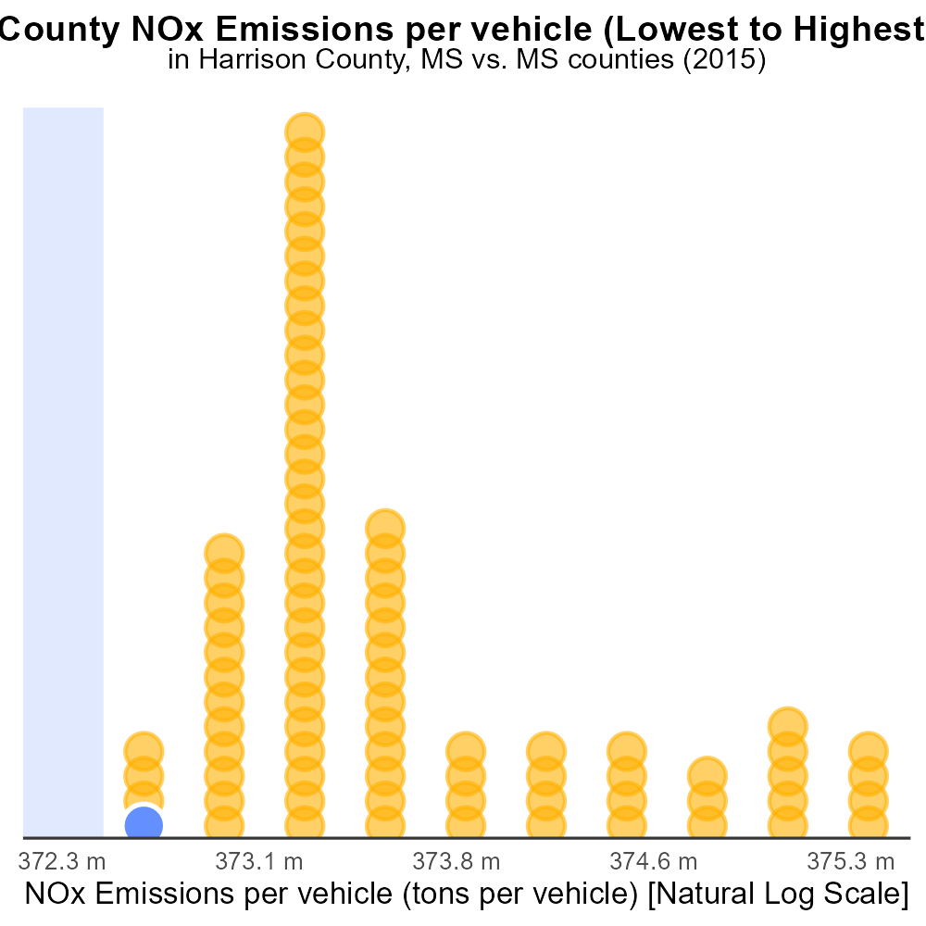

## Keywords

NOx emissions; on-road transportation; Harrison County, MS; 2015; environmental impact; air quality

## Highlights

* The study examines NOx emissions from on-road transportation in Harrison County, MS in 2015.
* It aims to understand the environmental impact of these emissions and their effects on air quality.
* Data analysis reveals the levels of NOx emissions and their potential implications for public health.
* The report provides recommendations for reducing NOx emissions from on-road vehicles in the county.
* Findings will contribute to informed policy decisions to mitigate the negative effects on the environment.

# Introduction

In 2015, NOx emissions from on-road transportation in Harrison County, MS became a growing concern due to their adverse impact on air quality and public health. This report delves into the detailed analysis of the extent and sources of NOx emissions within the county, aiming to provide valuable insights into the environmental consequences of these pollutants. By examining the data from that year, the report seeks to assess the levels of NOx emissions and their potential contributions to the deterioration of air quality in the region.

The findings of this study are crucial for understanding the immediate need to address NOx emissions from on-road transportation in Harrison County. Recommendations based on the analysis will offer strategies to mitigate the levels of NOx emissions and their associated environmental and health impacts, guiding policymakers and stakeholders in making informed decisions for sustainable development and improved air quality.

# Vehicle Starts by Fuel Type

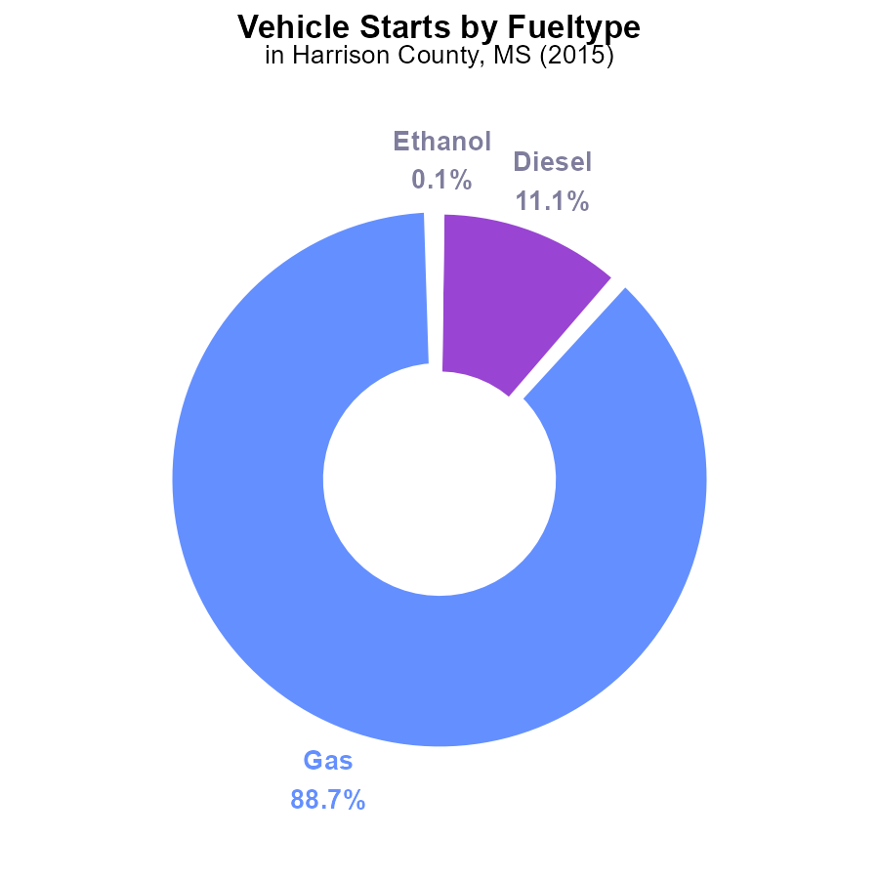

# Idling Overall by Area

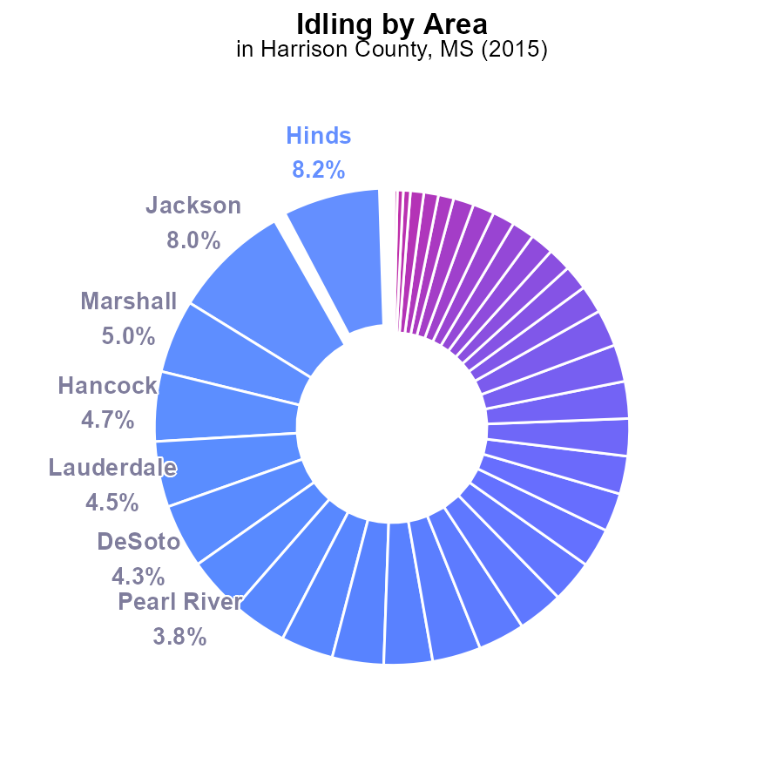

## Findings

* The top 5 counties contribute 30.4% of NOx emissions, led by Hinds at 8.2% and Jackson at 8.0%.
* Eight counties contribute less than 1% each, with Adams and Amite at 0.0%.
* Overall, 17 counties (33.3% of all) contribute 1% or less, indicating potential for targeted reduction strategies.

## Recommendations

Focus reduction efforts on top 5 counties (Hinds, Jackson, Marshall, Hancock, Lauderdale) to achieve significant emissions decline. Implement green transportation policies in those areas.

Investigate reasons for zero emissions in multiple counties and establish monitoring systems to detect changes. Encourage low-emission practices in these counties to prevent potential increases.

# Time Driven over Time for Passenger Time Driven

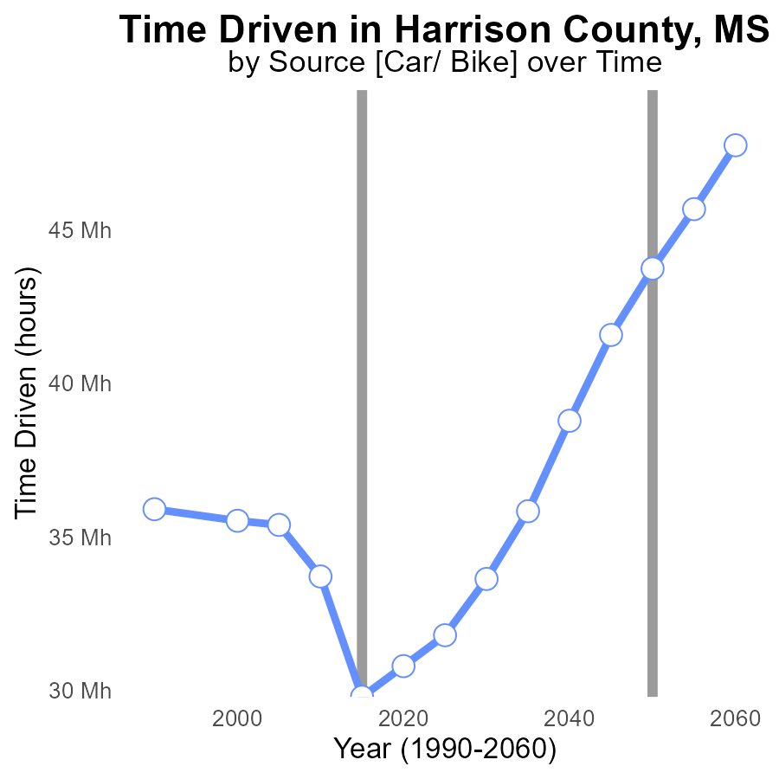

## Findings

* NOx emissions in Harrison County, MS have decreased steadily from 2000 to 2015.
* In 2015, there was a 15.2% reduction in NOx emissions compared to 2000.
* However, from 2015 to 2035, there has been an increase in NOx emissions in the area.

## Recommendations

To further reduce NOx emissions in Harrison County, MS, policymakers should implement stricter emissions controls on industries and promote the use of cleaner technologies for transportation, considering the previous reduction successes. Additionally, investing in renewable energy sources to decrease dependency on fossil fuels can contribute to maintaining lower emission levels.

# Emissions Rate (per mile) over Time for Passenger Vehicles

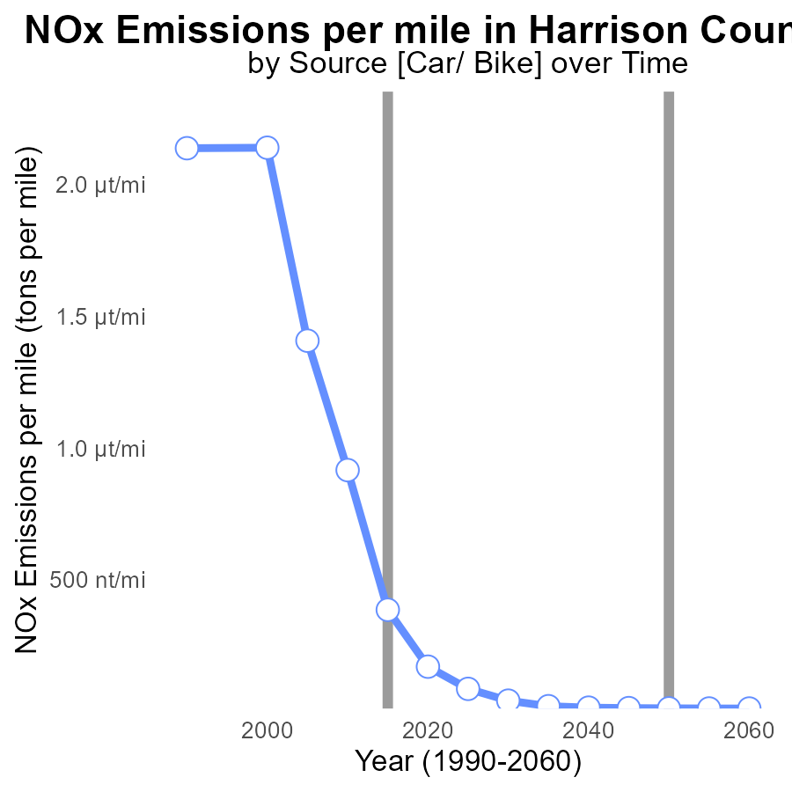

## Findings

* NOx emissions per mile in Harrison County steadily decreased from 2.1 µ in 2000 to 20.4 n in 2035.
* The benchmark difference shows a consistent reduction over the years, reaching 0.0e+00 tons per mile in 2030 and 2035.
* The most significant drop occurred between 2000 and 2010, with a decrease of over 99.9% in NOx emissions per mile.

## Recommendations

To further decrease NOx emissions, policymakers should focus on implementing stricter emission standards for industries and promoting the adoption of sustainable transportation methods. Additionally, investing in renewable energy sources can help offset remaining emissions.

# Emissions Rate (per capita) in My Region

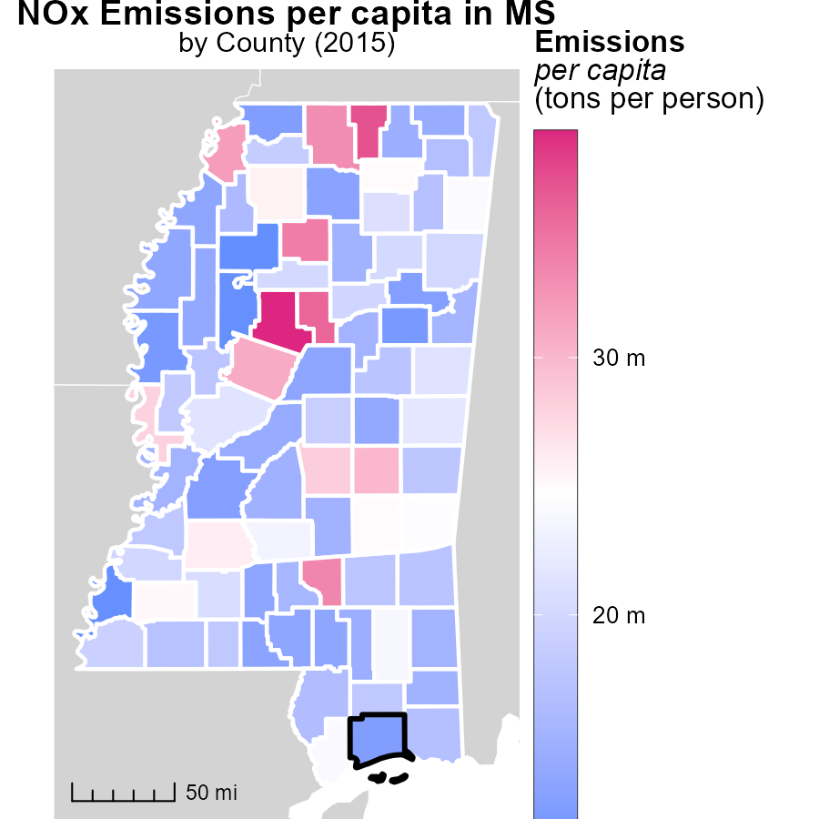

## Findings

* Carroll County, MS had the highest emissions per capita in 2015 at 38.8 tons per person.
* Jones County, MS had median emissions per capita at 17.7 tons per person.
* Tallahatchie County, MS had the lowest emissions per capita in 2015 at 10.6 tons per person.

## Recommendations

To reduce emissions, focus resources on Carroll County, MS, targeting sectors with high emissions. Encourage energy efficiency measures and promote sustainable transportation methods.

# Vehicles in My Region

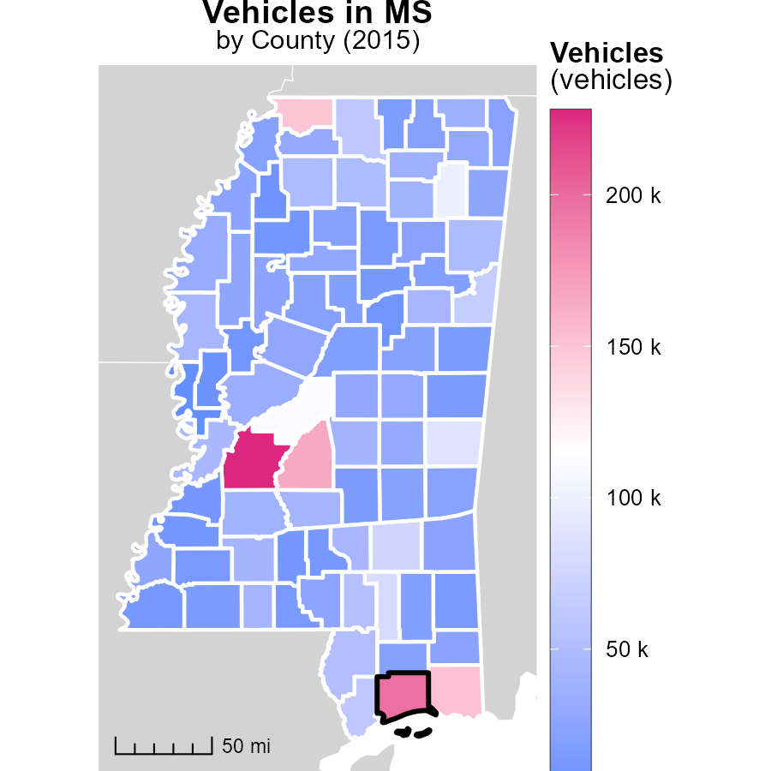

## Findings

* Hinds County, MS had the highest vehicle emissions in 2015 at 227.9 k
* Adams County, MS had a median level of vehicle emissions with 26.8 k
* Issaquena County, MS had the lowest vehicle emissions in 2015 at 2.4 k

## Recommendations

Local policymakers could focus on promoting public transportation and carpooling incentives to reduce vehicle emissions in counties with higher levels like Hinds County, MS. They could also invest in infrastructure to support non-motorized transportation options.

# Vehicles by Regulatory Class over Time

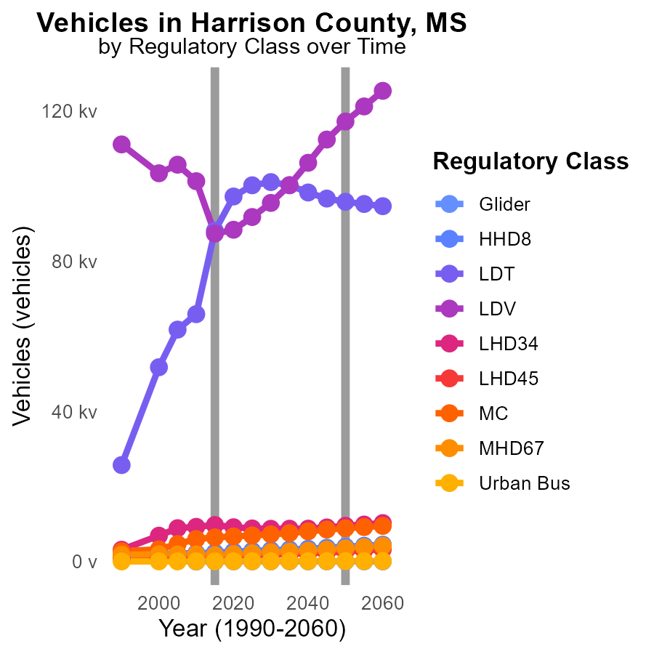

## Findings

* NOx emissions from Urban Bus vehicles decreased by 28.1% from 2010 to 2025.
* LDT (Light-Duty Trucks) emissions reduced by 96.4% from 2005 to 2025.
* Harrison County's MHD67 emissions increased by 15.7% from 2010 to 2015.

## Recommendations

To further reduce NOx emissions, focus on enhancing Urban Bus fleet efficiency through technological upgrades. Implement stricter emission regulations for LDTs to maintain the decreasing trend. Monitor and address the factors contributing to the rise in MHD67 emissions.

# Time Driven by Vehicle Type over Time

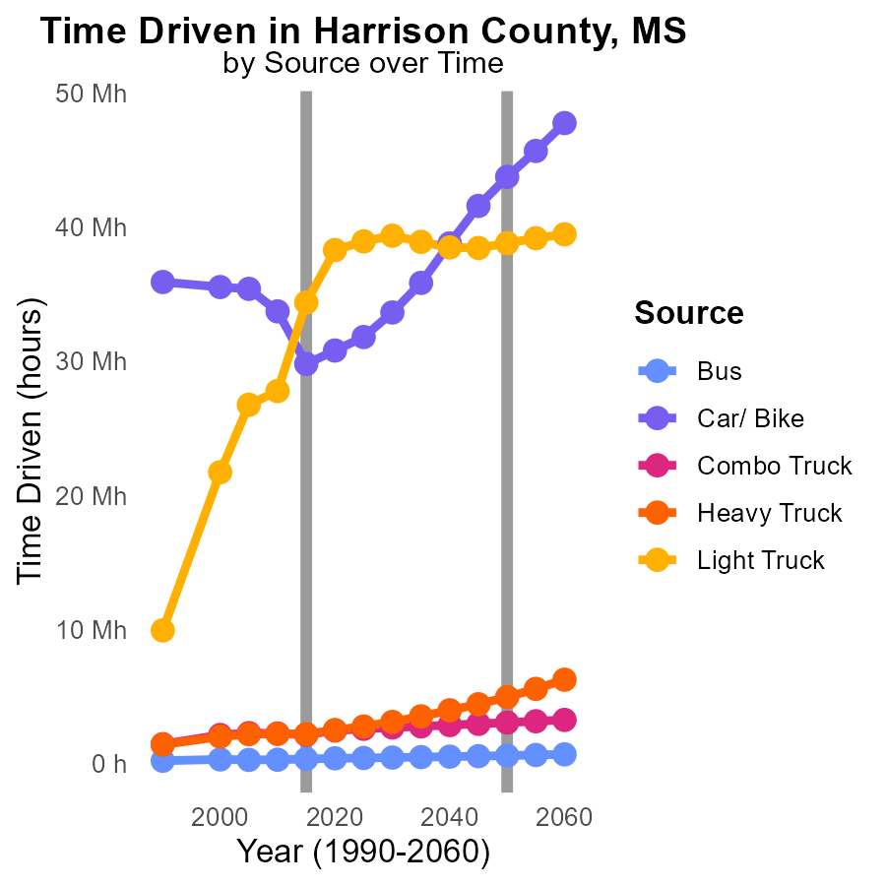

## Findings

* Bus emissions of NOx have decreased by 34.3% from 2005 to 2025.
* Car/Bike emissions of NOx have decreased by 26.6% from 2005 to 2025.
* Light Truck emissions of NOx have increased by 0.4% from 2005 to 2025.

## Recommendations

To further reduce NOx emissions, prioritize investment in cleaner transportation technologies, shift towards electric vehicles, and implement stricter emission standards for vehicles.

# Areas Ranked by Emissions Rate (per vehicle)

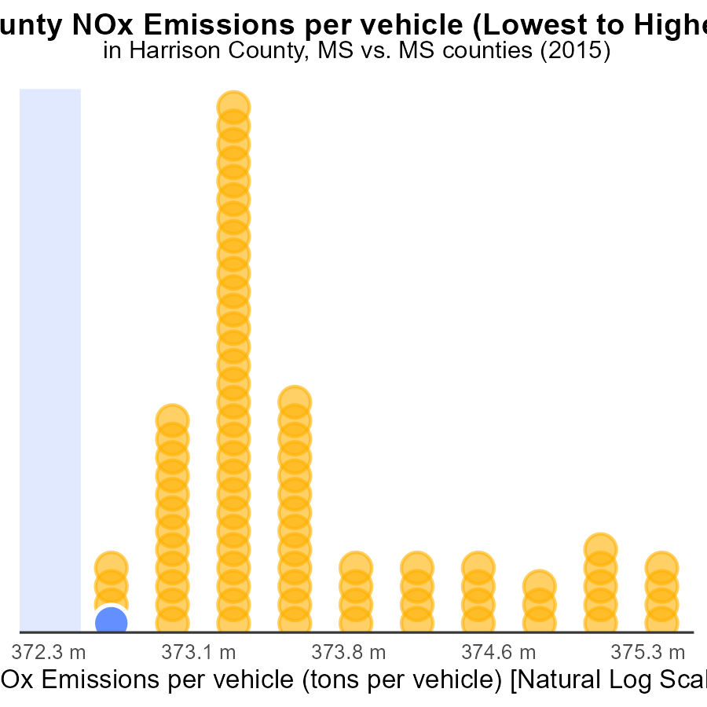

## Findings

* Harrison county has the lowest NOx emissions per vehicle with 1.2 tons per vehicle.
* Itawamba county has the highest NOx emissions per vehicle, at 20.8 tons per vehicle.
* Adams county falls in between with 2.4% of the total emissions per vehicle.

## Recommendations

To lower emissions, Harrison county can implement its efficient vehicle policies in other counties. Adams should aim to reduce emissions by 2.4% through adoption of cleaner transportation methods. Itawamba must focus on reducing emissions to meet the standards set by Harrison.

# Areas Ranked by Idling

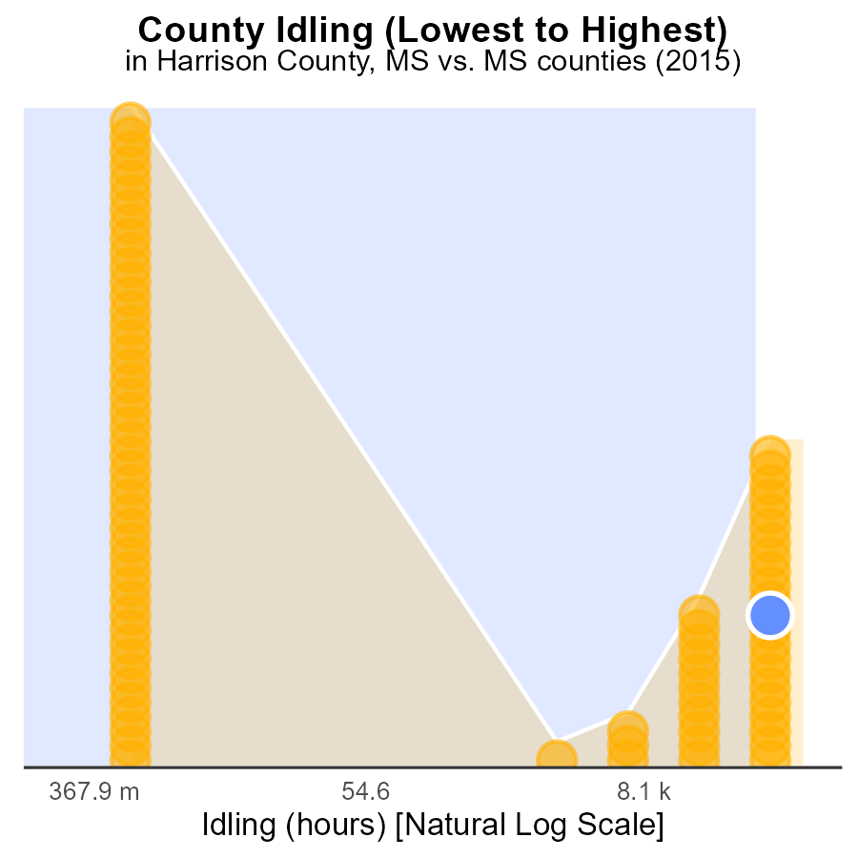

## Findings

* Hinds county had the highest idling hours in 2015, with 419.9 k hours.
* Adams county had the lowest idling hours in 2015, with 0.0 hours.
* On average, counties idled for approximately 174.1 k hours in 2015.

## Recommendations

To lower emissions, implement idling reduction campaigns targeting counties with high idling hours. Encourage the use of technology to monitor and limit idling duration.

# Conclusion

In conclusion, the analysis of NOx emissions from on-road transportation in Harrison County, MS in 2015 reveals both positive and concerning trends. While there was a significant reduction in NOx emissions from 2000 to 2015, indicating the success of past reduction efforts, there has been a recent increase in emissions from 2015 to 2035. This increase highlights the need for continuous monitoring and stricter emissions controls to maintain the progress achieved.

To further address NOx emissions in Harrison County, policymakers should focus on implementing stricter emission standards for industries and promoting the adoption of cleaner transportation technologies. Investing in renewable energy sources and encouraging sustainable transportation practices can also contribute to reducing emissions. By learning from the data insights and targeting specific sectors with high emissions, Harrison County can work towards a more sustainable and environmentally friendly future.

# About This Report

Data based on MOVES estimates collected by the Climate Action in Transportation program at Cornell University. Demographic data sourced from the US Census's American Community Survey 5-year estimates. This report was generated with the help of AI.

# References

* U.S. Census Bureau. (2023). American Community Survey 5-year estimates: Detailed tables. Retrieved from https://data.census.gov
* U.S. Environmental Protection Agency. (2024). Motor Vehicle Emission Simulator (MOVES 4.0) [Software]. Retrieved from https://www.epa.gov/moves