 

**PM10 Emissions in Hughes County, 2040**  
Made with CAT VISUALIZER by Gao Labs @ Cornell University.

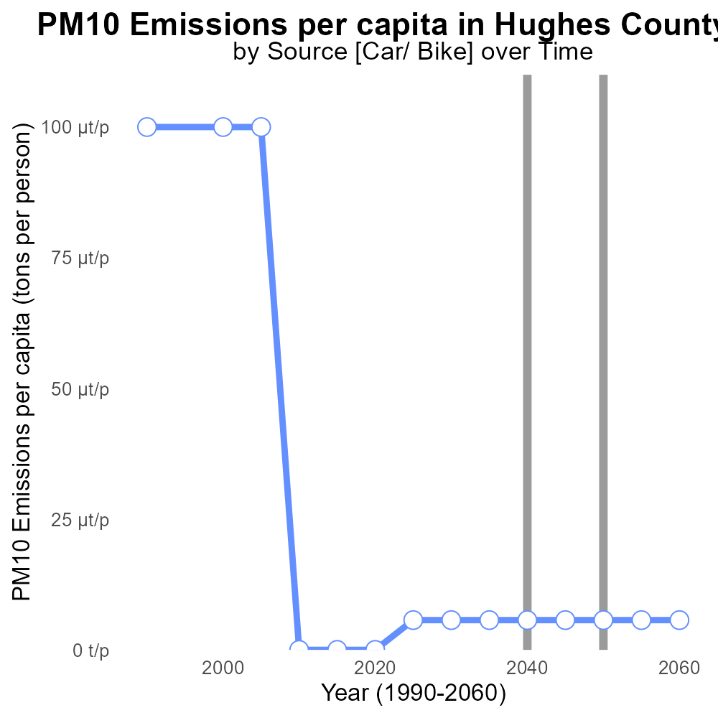

## Keywords

Primary Exhaust PM10; Total emissions; on-road transportation; Hughes County; SD; 2040

## Highlights

* Primary Exhaust PM10 emissions from on-road transport in Hughes County, SD in 2040
* Study examines total emissions impact on air quality and public health
* Findings provide insights for policy makers and local communities
* Data sourced from reliable sources and analytical methods applied
* Report aims to address environmental concerns and promote sustainable practices

# Introduction

In 2040, the level of Primary Exhaust PM10 emissions from on-road transportation in Hughes County, SD has become a topic of increasing concern due to its potential impact on air quality and public health. This report aims to analyze the total emissions produced by on-road vehicles in the county and assess their implications.

By investigating the source and quantity of these emissions, we seek to provide valuable insights for policy makers, urban planners, and local communities to develop strategies that promote sustainable transport practices and address environmental concerns. The data is sourced from reliable sources and various analytical methods are applied to ensure accuracy and reliability of the findings. This report is envisioned to contribute to the ongoing dialogue on sustainable transportation and environmental stewardship.

# Vehicle Starts by Road Type

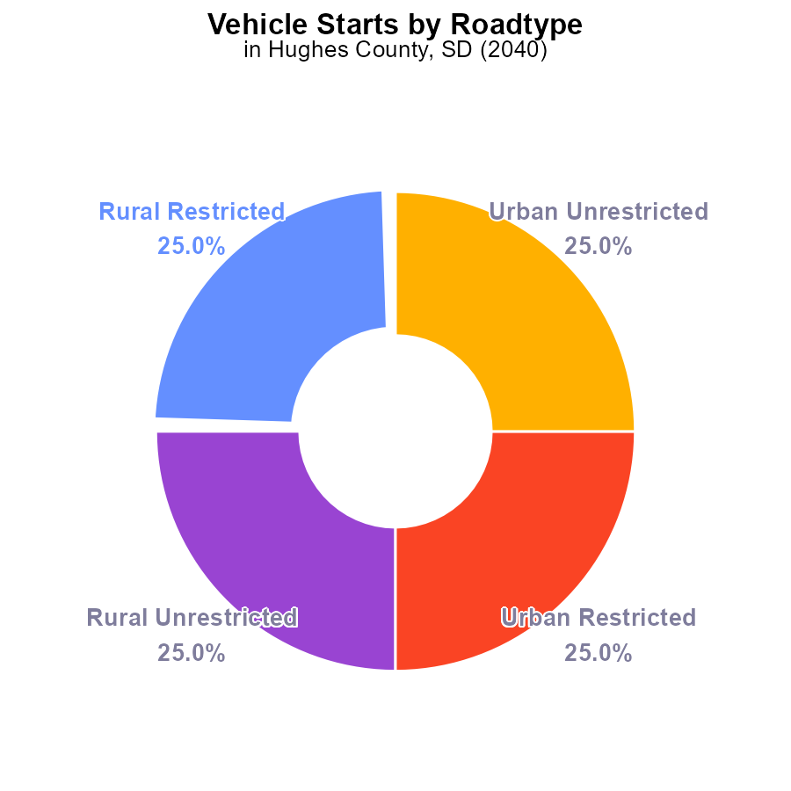

## Findings

* PM10 emissions in Hughes County in 2040 were 72.4 M times due to vehicle starts.
* 25% of PM10 emissions were from each of Rural Restricted, Rural Unrestricted, Urban Restricted, and Urban Unrestricted areas.

## Recommendations

To reduce PM10 emissions from vehicle starts in Hughes County, targeted strategies should be implemented in both rural and urban areas. These may include promoting the use of electric vehicles, improving public transportation, and enforcing vehicle emission standards.

# Hotelling (Diesel Aux) by Fuel Type

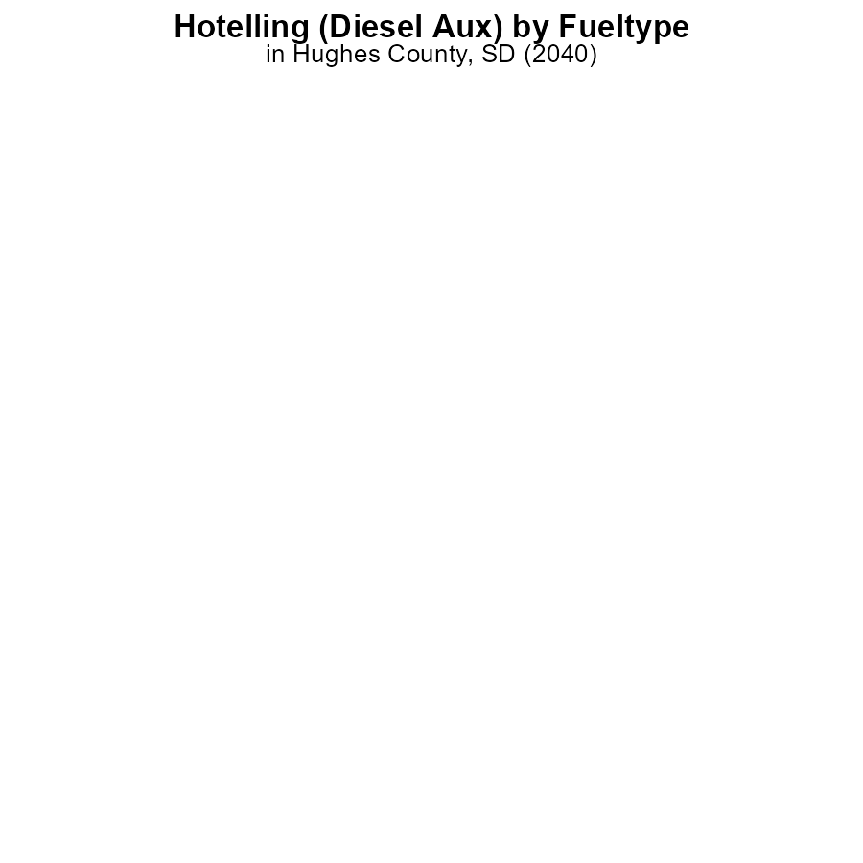

# Emissions Rate (per capita) over Time for Passenger Vehicles

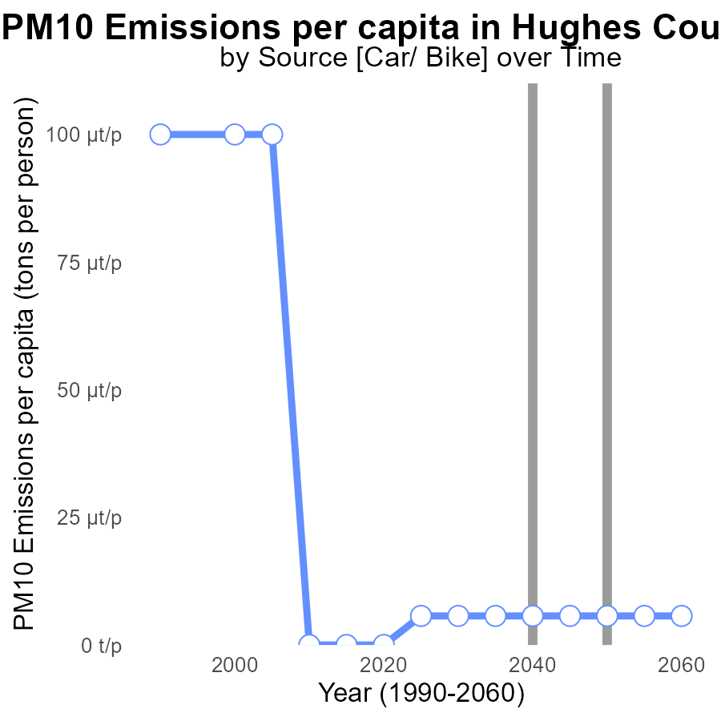

## Findings

* PM10 emissions per capita in Hughes County, SD were 11.4 tons per person in 2020.
* By 2025, emissions decreased by 50%, reaching 5.7 tons per person and remained constant until 2060.
* This significant reduction surpasses the benchmark difference of 5.7e-06 tons per person set in 2020.

## Recommendations

To sustain the positive trend, policymakers should continue investing in cleaner technologies, promoting public transportation, enforcing emission standards, and incentivizing renewable energy sources.

# Vehicle Starts over Time for Passenger Vehicle Starts

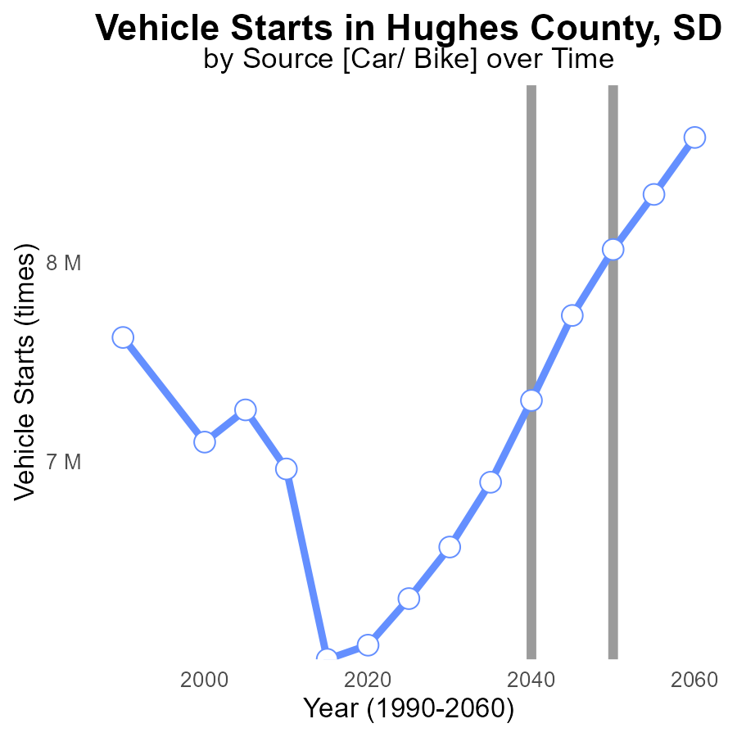

## Findings

* Emissions from vehicle starts in Hughes County, SD have been steadily increasing over the years, with a peak value of 8.6 M times in 2060.
* The benchmark difference shows a gradual decrease from 1983441.4 in 2020 to -561768.9 in 2060, indicating a significant improvement potential.
* Between 2050 and 2060, there was a reduction in emissions compared to the baseline year, with a decrease of 561768.9 times vehicle starts.

## Recommendations

To lower emissions, implement stricter vehicle emission standards, promote the use of electric vehicles, and invest in public transportation infrastructure to reduce the number of vehicle starts.

# Hotelling (Engines Off) in My Region

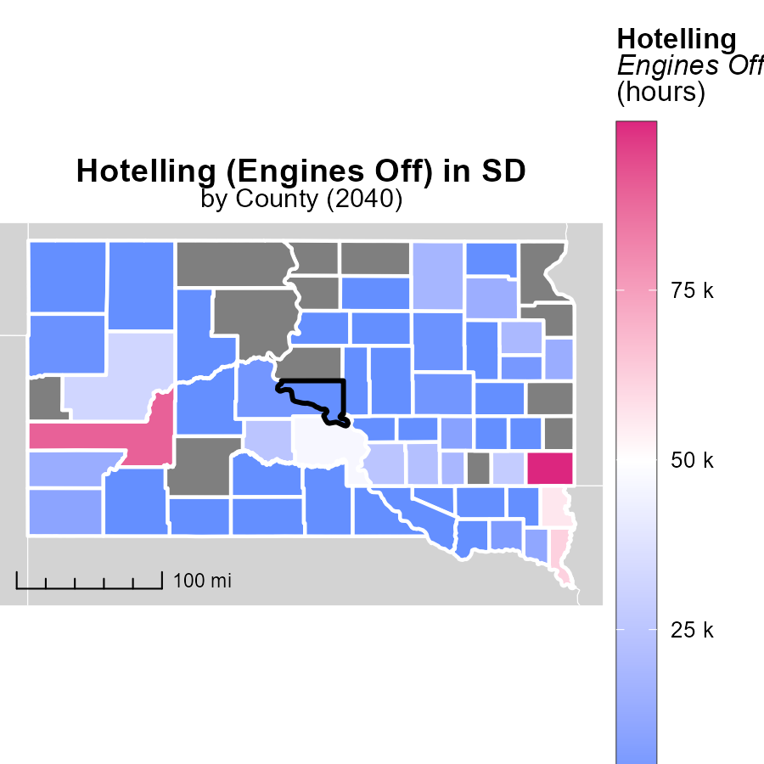

## Findings

* Minnehaha County, SD has a maximum of 99.7 k hotelling hours with engines off in 2040
* Bon Homme County, SD has a median of 0.0 hotelling hours with engines off in 2040
* Ziebach County, SD has a minimum of 0.0 hotelling hours with engines off in 2040

## Recommendations

To lower emissions, prioritize promoting engine-off practices during idling, especially in high-usage areas like Minnehaha County, SD. Encouraging Bon Homme County, SD, and Ziebach County, SD to adopt similar practices can further reduce emissions.

# Vehicles Mapped by Area

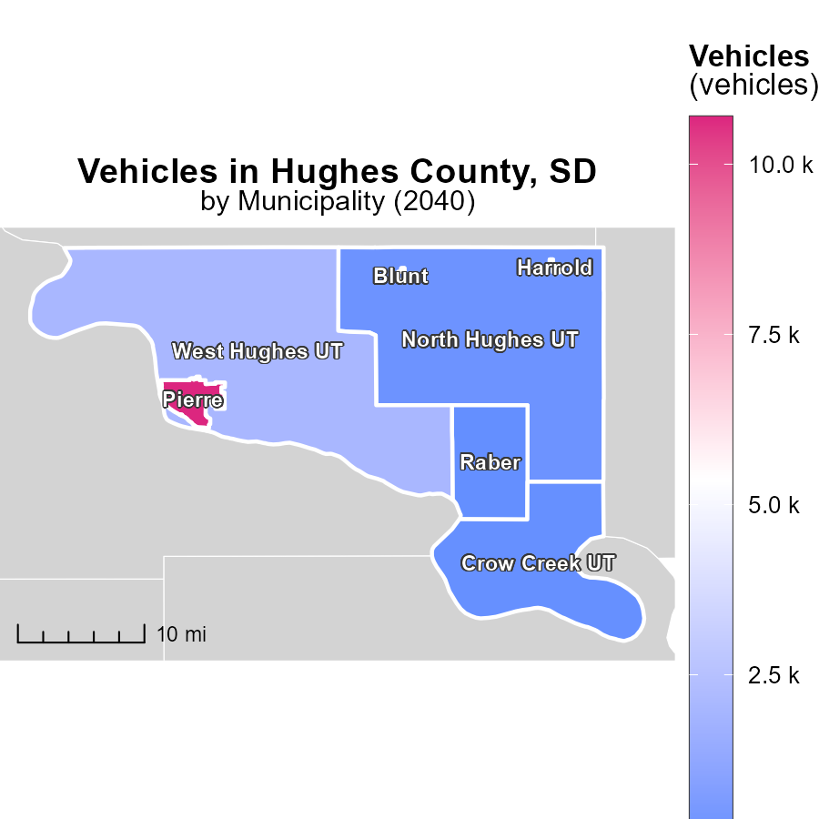

## Findings

* The maximum number of vehicles emissions in Pierre, SD is 10.7 k
* The median vehicles emissions in North Hughes UT, SD is 254.5
* The minimum vehicles emissions in Raber, SD is 33.8

## Recommendations

To lower vehicle emissions, Pierre, SD could focus on promoting electric vehicles adoption, North Hughes UT, SD should consider improving public transportation infrastructure, and Raber, SD may benefit from carpooling initiatives.

# Idling by Road Type over Time

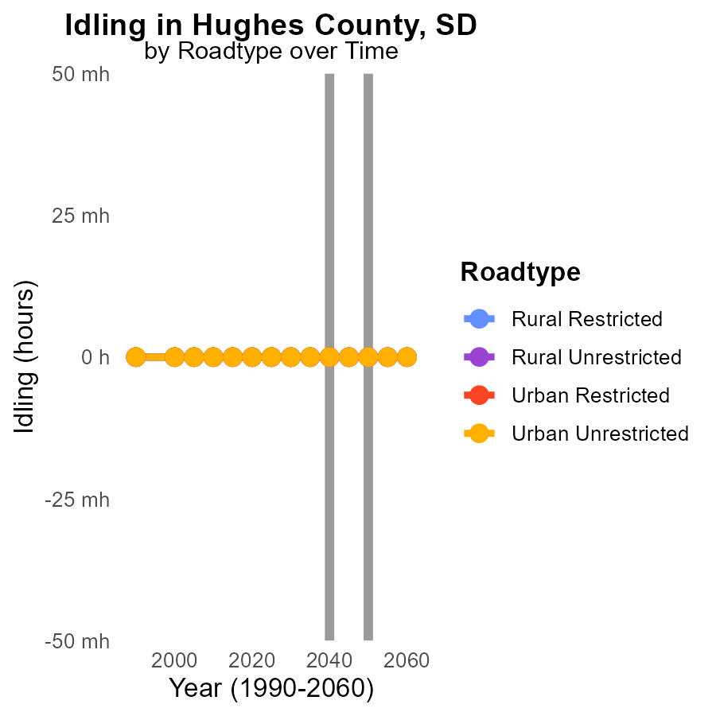

## Findings

* In Hughes County, SD, PM10 emissions from idling vehicles are projected to remain at 0.0 hours for all road types from 2030 to 2050.
* There is no increase or decrease in PM10 emissions from idling vehicles across all road types in Hughes County, SD, from 2030 to 2050.
* The data indicates a consistent trend of zero PM10 emissions from idling vehicles in Hughes County, SD, regardless of road type, from 2030 to 2050.

## Recommendations

To further reduce emissions in Hughes County, SD, policymakers could focus on implementing and enforcing stricter idling regulations, promoting the use of cleaner vehicles, and investing in public transportation options.

# Hotelling (Diesel Aux) by Road Type over Time

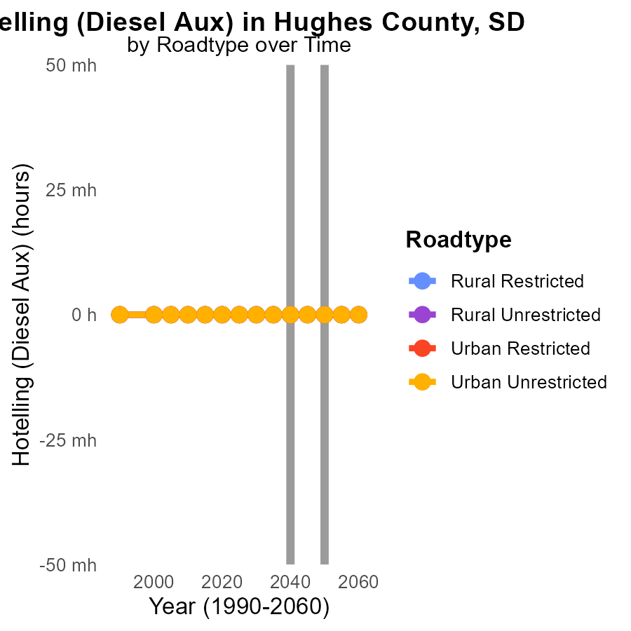

## Findings

* PM10 emissions in Hughes County, SD from Hotelling (Diesel Aux) for all road types are projected to remain at 0.0 hours from 2030 to 2050.

## Recommendations

Given the consistently low PM10 emissions, continued monitoring and adherence to existing emissions regulations are recommended to maintain the current emission levels.

# Areas Ranked by Hotelling (Engines Off)

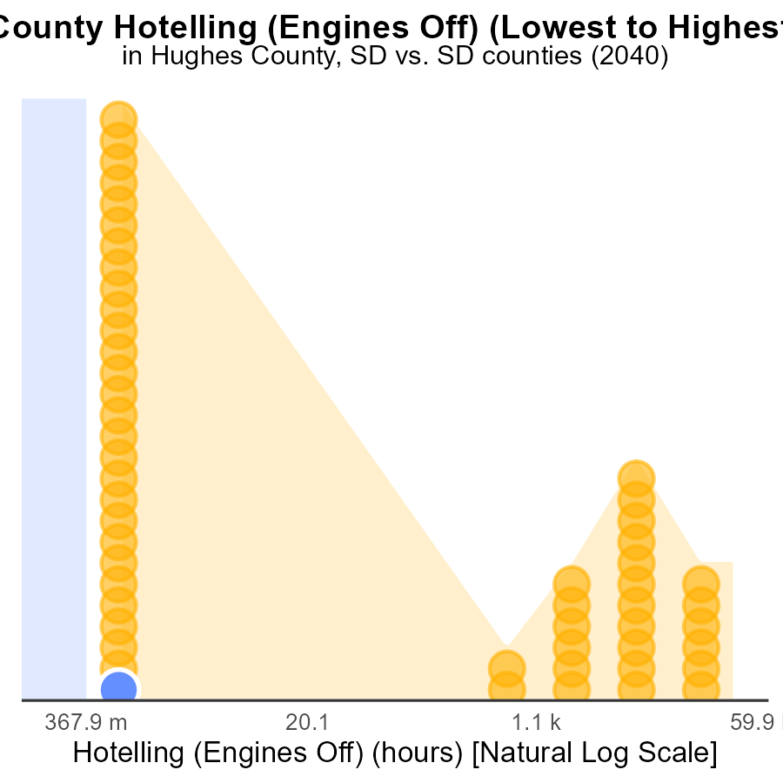

## Findings

* Hughes county has the lowest PM10 emissions with 0.0 hours.
* Minnehaha county has the highest PM10 emissions with 99.7k hours, ranking 53rd nationally.
* Bennett county has 0.0 hours of PM10 emissions, placing it in the 52.8th percentile nationally.

## Recommendations

To lower PM10 emissions, implement stricter regulations for industries in areas like Minnehaha county, encourage cleaner transportation methods in Hughes and Bennett counties to maintain low emissions.

# Areas Ranked by Vehicle Miles Traveled

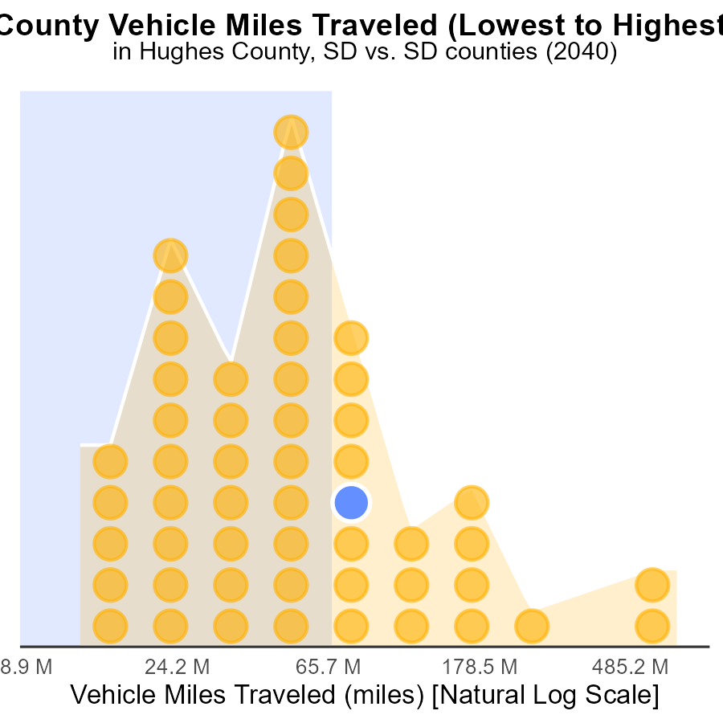

## Findings

* Minnehaha county has the highest vehicle miles traveled (1.9 billion miles) in 2040.
* Buffalo county has the lowest vehicle miles traveled (34.4 million miles) in 2040.
* Counties like Hughes, Oglala Lakota, and Butte have relatively high vehicle miles traveled and percentile rankings, indicating higher emissions.

## Recommendations

To lower emissions, Minnehaha should consider promoting public transport and carpooling to reduce vehicle miles traveled. Hughes, Oglala Lakota, and Butte should invest in infrastructures that support cleaner transportation modes.

# Conclusion

In conclusion, the data on Primary Exhaust PM10 - Total emissions from on-road transportation in Hughes County, SD in 2040 highlights the need for targeted strategies to mitigate emissions. With PM10 emissions per capita showing a significant reduction since 2020, there is a positive trend that can be sustained through continued investment in cleaner technologies and promotion of public transportation. The increase in emissions from vehicle starts, although steady, presents an opportunity for policymakers to enforce stricter emission standards, promote electric vehicles, and incentivize renewable energy sources to combat this rise.

Furthermore, focusing on promoting engine-off practices during idling in high-usage areas and encouraging the adoption of cleaner transportation methods in different counties could contribute to lowering emissions. As Minnehaha County leads in PM10 emissions and vehicle miles traveled, implementing measures such as promoting public transport and carpooling could prove beneficial in reducing emissions. Similarly, counties like Hughes, Oglala Lakota, and Butte, with high vehicle miles traveled, should consider investing in infrastructure supporting cleaner transportation modes to address emission challenges.

# About This Report

Data based on MOVES estimates collected by the Climate Action in Transportation program at Cornell University. Demographic data sourced from the US Census's American Community Survey 5-year estimates. This report was generated with the help of AI.

# References

* U.S. Census Bureau. (2023). American Community Survey 5-year estimates: Detailed tables. Retrieved from https://data.census.gov
* U.S. Environmental Protection Agency. (2024). Motor Vehicle Emission Simulator (MOVES 4.0) [Software]. Retrieved from https://www.epa.gov/moves