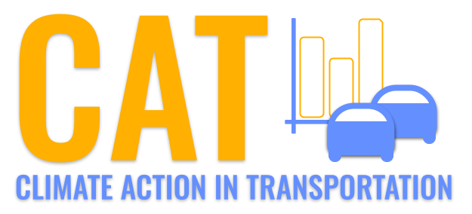 

**PM2.5 Emissions in Maui County, 2005**  
Made with CAT VISUALIZER by Gao Labs @ Cornell University.

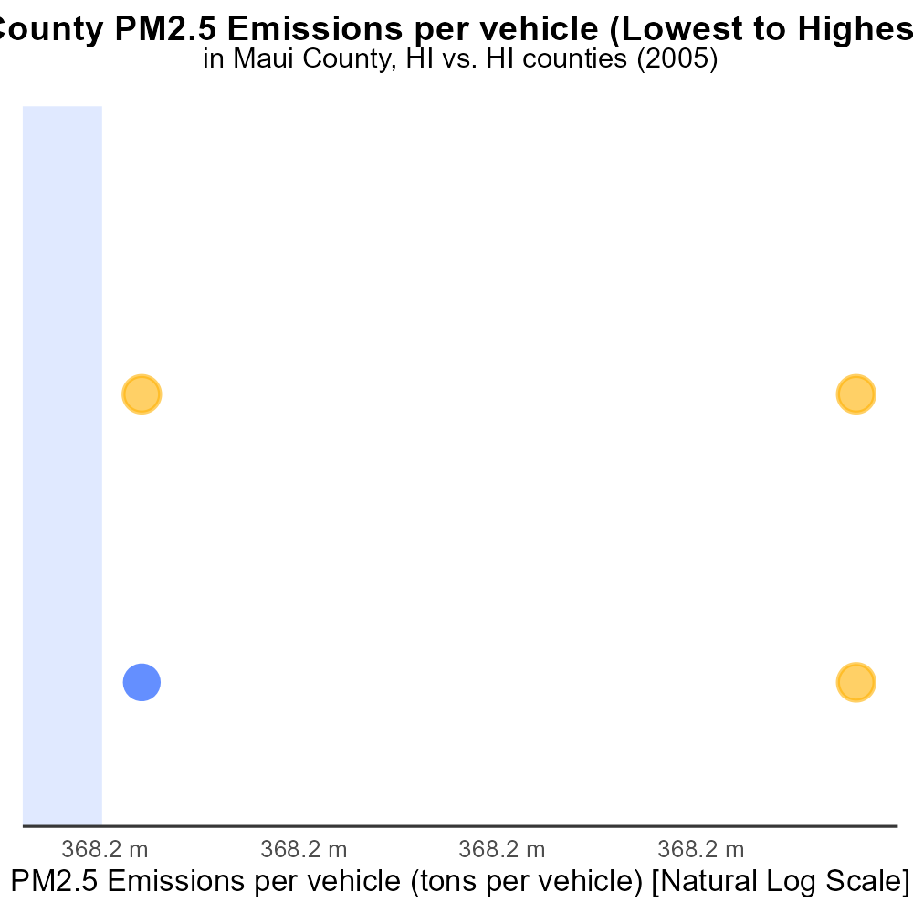

## Keywords

Primary Exhaust PM2.5; Total emissions; On-road transportation; Maui County; HI; 2005

## Highlights

* Examination of primary exhaust PM2.5 emissions in Maui County, HI in 2005.
* Focus on total emissions from on-road transportation for a comprehensive analysis.
* Insights into the impact of on-road vehicles on air quality in Maui County.
* Significance of studying primary exhaust PM2.5 for environmental and health assessment.
* Results may inform policies to reduce emissions and improve air quality in the region.

# Introduction

The report delves into the primary exhaust PM2.5 emissions originating from on-road transportation in Maui County, Hawaii in the year 2005. With a specific focus on total emissions, the analysis aims to provide a comprehensive understanding of the impact of vehicular activities on air quality in the region. This investigation is crucial in assessing the environmental and health implications associated with PM2.5 emissions, particularly from on-road vehicles.

By examining the data from 2005, the report seeks to shed light on the trends, sources, and levels of primary exhaust PM2.5 in Maui County. This information can be instrumental in guiding policymakers and stakeholders to develop strategies aimed at reducing emissions and enhancing the overall air quality standards in the area.

# Hotelling (Diesel Aux) by Road Type

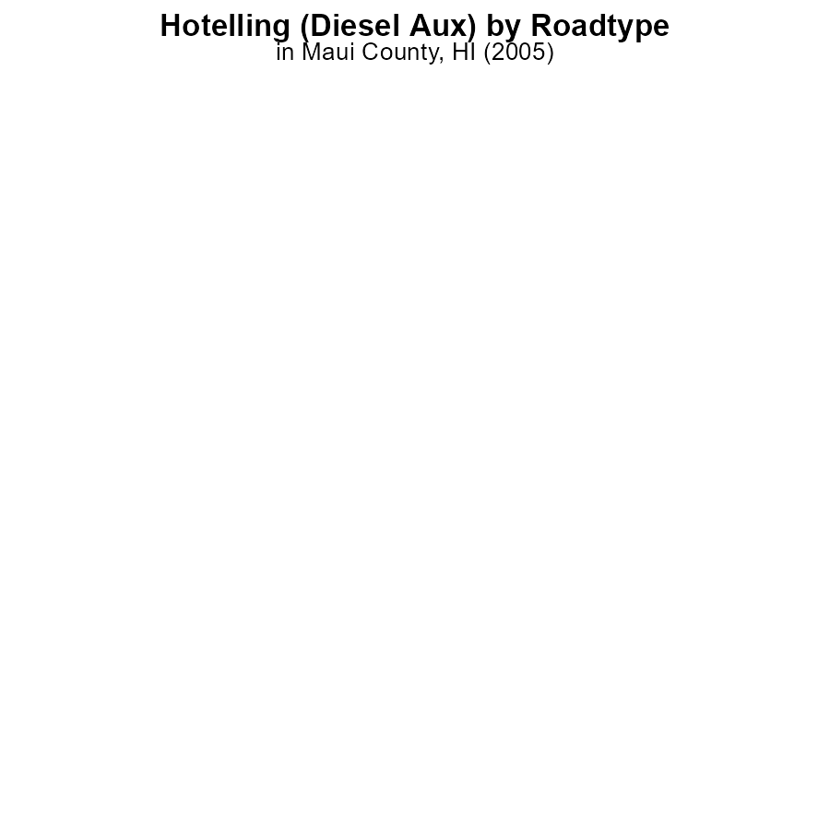

## Findings

* In 2005, PM2.5 emissions from Hotelling (Diesel Aux) in Maui County, HI were 0.0 hours across all urban and rural areas.
* There were no emissions recorded in any specific category - Rural Restricted, Rural Unrestricted, Urban Restricted, Urban Unrestricted.
* This data indicates a notable absence of PM2.5 emissions from this specific source in the specified year and location.

## Recommendations

To maintain the low levels of PM2.5 emissions, it is recommended to continue monitoring and enforcing regulations on diesel auxiliary sources. Additionally, exploring alternative energy sources could further reduce emissions.

# Vehicles Overall by Area

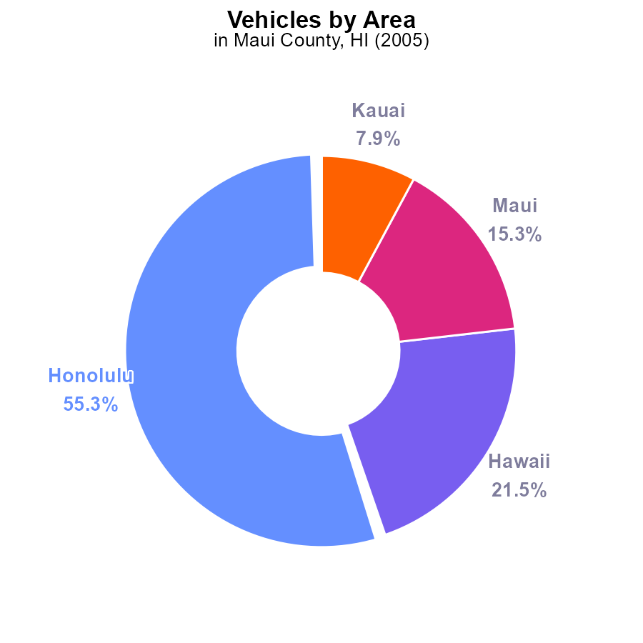

## Findings

* Honolulu emitted the highest PM2.5 from vehicles in Maui County in 2005, at 55.3%.
* Hawaii emitted 21.5% of PM2.5 from vehicles in Maui County in 2005.
* Maui emitted 15.3% and Kauai emitted 7.9% of PM2.5 from vehicles in Maui County in 2005.

## Recommendations

To lower PM2.5 emissions in Maui County, targeting vehicle emissions is crucial. Implementing stricter vehicle emission standards and promoting the use of electric vehicles can significantly reduce pollution levels from transportation sources.

# Idling Overall over Time

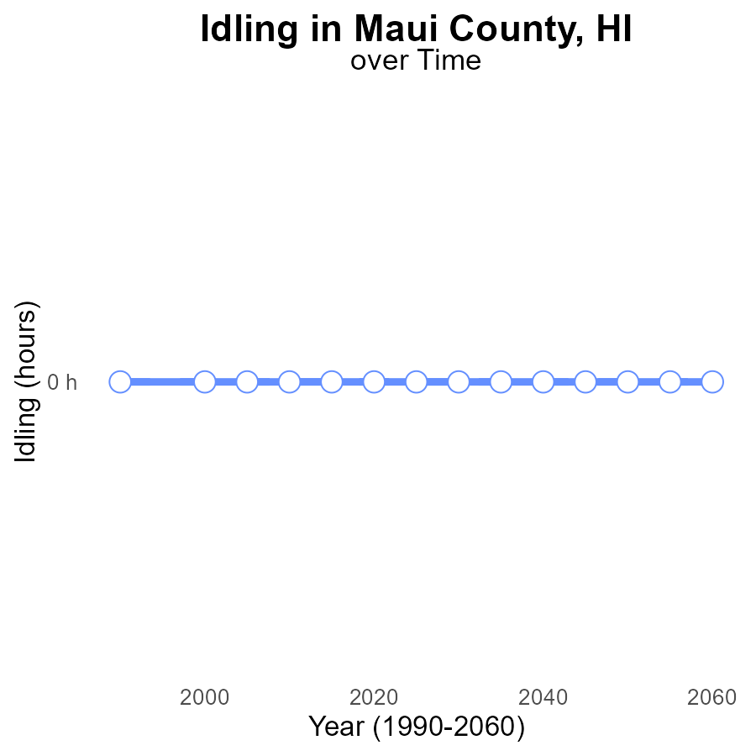

## Findings

* PM2.5 emissions in Maui County, HI from idling have remained at zero since 1990.
* The emissions are consistently lower than the median, upper 75th percentile, and lower 25th percentile of other areas.
* There is no difference in emissions from idling compared to the benchmark.

## Recommendations

Given the consistently low emissions from idling activities in Maui County, policymakers could further incentivize the use of electric vehicles or promote carpooling to maintain these low levels and potentially reduce emissions even further.

# Hotelling (Diesel Aux) Overall over Time

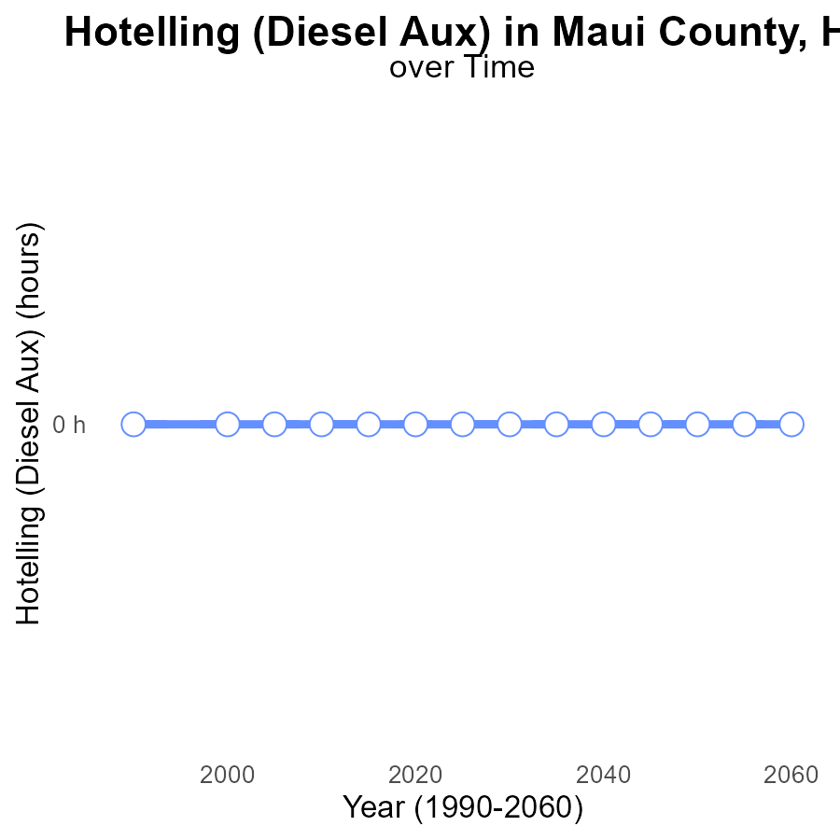

## Findings

* PM2.5 emissions in Maui County have consistently been at 0.0 hours from 1990 to 2025.
* There is no difference from the median area, which has also been 0 hours.
* The emissions benchmark difference is 0 hours, indicating no deviation from the benchmark.

## Recommendations

Given the consistent 0.0 hours of PM2.5 emissions in Maui County, focus should be on maintaining existing clean air initiatives. Regular monitoring and enforcement are critical to sustain the current low emission levels.

# Vehicles Mapped by Area

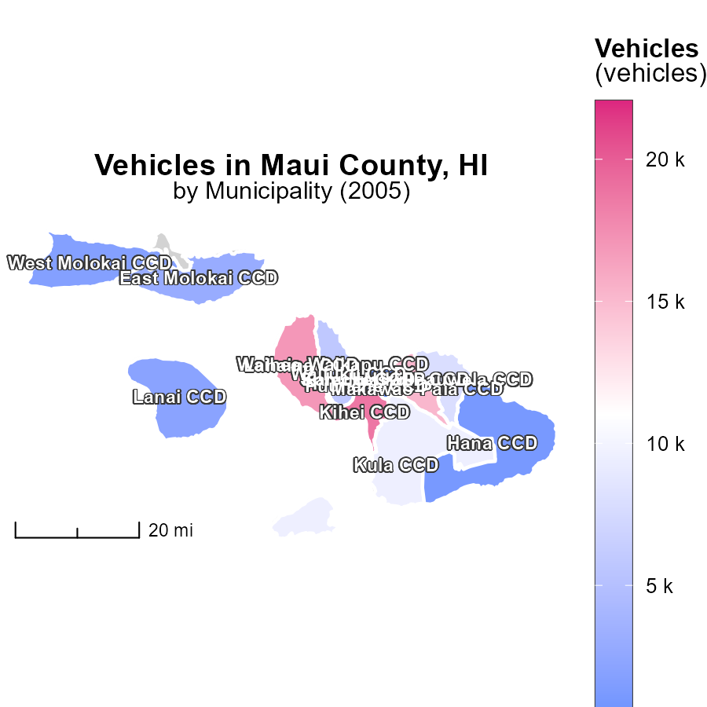

## Findings

* In 2005, Kahului CCD, HI had the highest vehicle emissions at 22.0 k
* Waihee-Waikapu CCD, HI had a median vehicle emission of 5.8 k in 2005
* Puunene CCD, HI had the lowest vehicle emissions at 0.0 in 2005

## Recommendations

To reduce emissions, consider promoting public transportation, investing in electric vehicles, and implementing carpooling initiatives in areas with higher emissions, such as Kahului CCD, HI.

# Emissions Rate (per capita) Mapped by Area

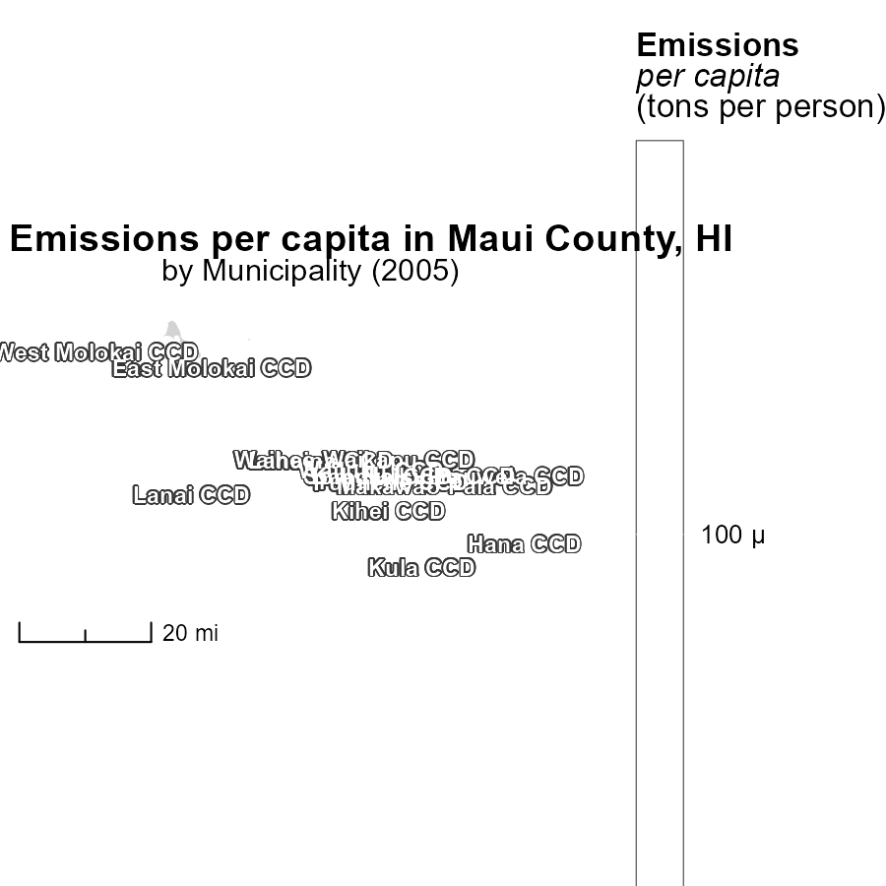

## Findings

* In 2005, East Molokai CCD, HI had the highest emissions per capita at 114.0 tons per person.
* Lanai CCD, HI had an emissions per capita of 114.0 tons per person, standing out as the median.
* Puunene CCD, HI had the lowest emissions per capita in 2005, with the exact value not provided.

## Recommendations

To lower emissions per capita, targeted measures should be implemented in areas with high levels like East Molokai CCD, HI. Encouraging sustainable practices and investing in renewable energy sources can help reduce emissions significantly.

# Vehicles by Area over Time

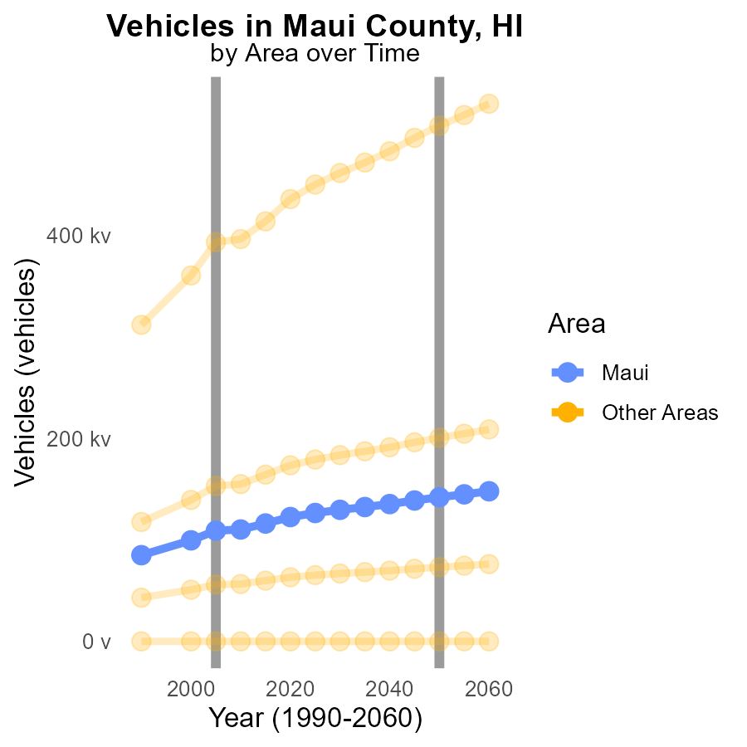

## Findings

* In 2005, the maximum county had 393.5 k units of PM2.5 emissions from vehicles, a difference of 114,648.1 from the target set for 2050.
* In the same year, the minimum county had 0.0 units of PM2.5 emissions, meeting the 2050 target.
* Target county in 2005 had 109.1 k units of PM2.5 emissions from vehicles, 32,932.0 more than the 2050 target.

## Recommendations

To lower PM2.5 emissions, focus on reducing vehicle emissions in counties exceeding 2050 targets while maintaining the standards in counties meeting them.

# Idling by Road Type over Time

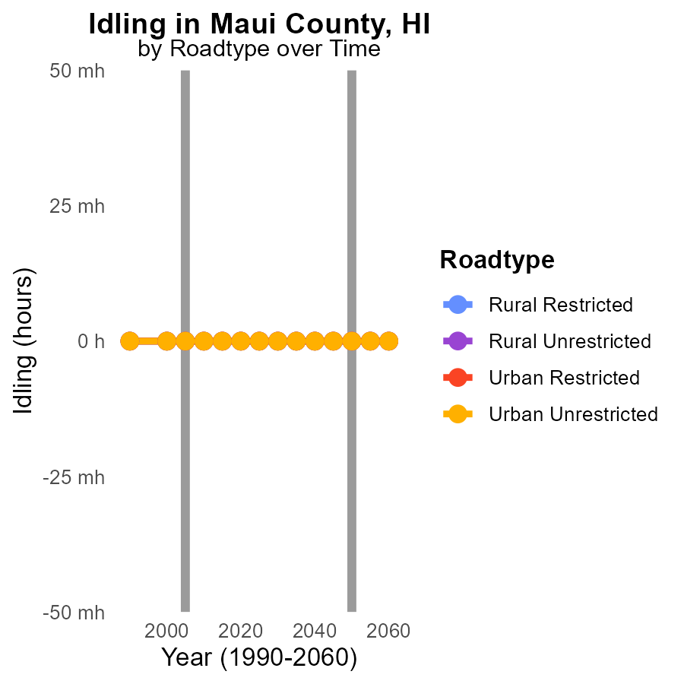

## Findings

* PM2.5 emissions from idling vehicles in Maui County, HI were consistently 0.0 during 2000-2015 across different road types.
* There was no change in PM2.5 emissions from idling vehicles in Maui County, HI over the 15-year period analyzed.
* Emissions from idling vehicles on both rural and urban road types remained at 0.0 from 2000 to 2015.

## Recommendations

To lower PM2.5 emissions from idling vehicles, focus on implementing stricter idling regulations, promoting the use of electric vehicles, and investing in public transportation to reduce the overall number of vehicles on the road.

# Areas Ranked by Emissions Rate (per vehicle)

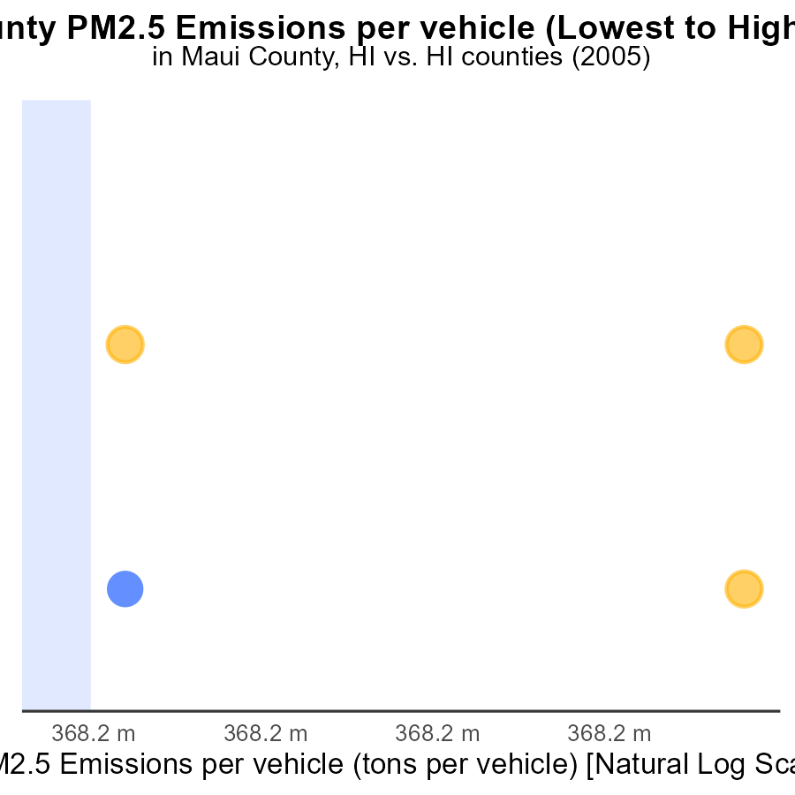

## Findings

* In 2005, Maui had an emissions rate of 914.6 µ tons per vehicle, ranking 1st.
* Honolulu in 2005 had an emissions rate of 917.2 µ tons per vehicle, ranking 2nd.
* Compared to other counties, Honolulu's emissions per vehicle percentile was at 50.0%.

## Recommendations

To reduce emissions, focus on vehicle maintenance programs, promoting public transport, and encouraging carpooling in high-emission counties like Honolulu.

# Areas Ranked by Emissions

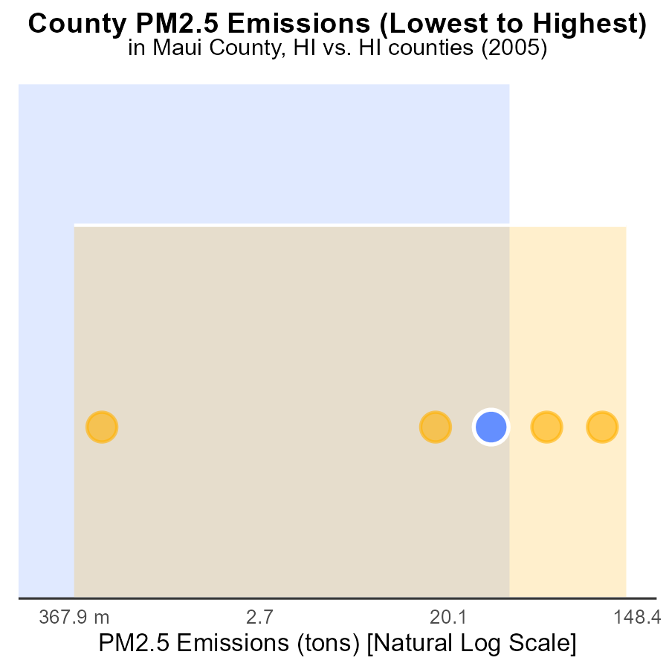

## Findings

* Honolulu had the highest PM2.5 emissions in 2005 at 360.9 tons.
* Kalawao had the lowest PM2.5 emissions in 2005 with 0.0 tons.
* The top five counties accounted for 665.8 tons, with Honolulu contributing 54.2% of the total emissions.

## Recommendations

To reduce emissions, Honolulu should focus on implementing stricter regulations on industries to lower PM2.5 emissions. Other counties should work on adopting cleaner energy sources to decrease their contribution to overall emissions.

# About This Report

Data based on MOVES estimates collected by the Climate Action in Transportation program at Cornell University. Demographic data sourced from the US Census's American Community Survey 5-year estimates. This report was generated with the help of AI.

# References

* U.S. Census Bureau. (2023). American Community Survey 5-year estimates: Detailed tables. Retrieved from https://data.census.gov
* U.S. Environmental Protection Agency. (2024). Motor Vehicle Emission Simulator (MOVES 4.0) [Software]. Retrieved from https://www.epa.gov/moves