 

**Carbon Emissions in Merrimack County, 2005**  
Made with CAT VISUALIZER by Gao Labs @ Cornell University.

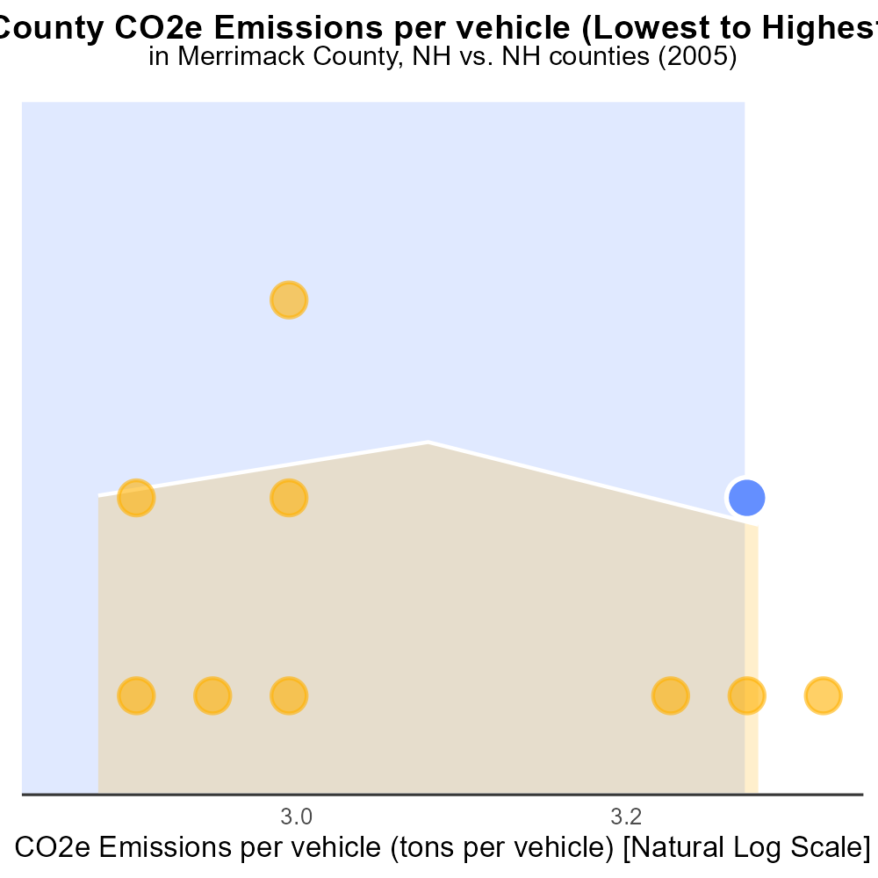

## Keywords

CO2 Equivalent emissions; on-road transportation; Merrimack County; NH; 2005

## Highlights

* Analysis of CO2 emissions from on-road transportation in Merrimack County, NH.
* Exploring the environmental impact of transportation in a specific region.
* Focus on CO2 equivalent emissions in 2005 for a comprehensive understanding.
* Insights into the challenges and opportunities for reducing emissions in the county.
* Informing potential strategies for sustainable transportation practices.

# Introduction

The following report details an analysis of CO2 Equivalent emissions from on-road transportation in Merrimack County, NH, specifically focusing on the year 2005. This study aims to provide insights into the environmental impact of transportation within the county, emphasizing the importance of understanding and addressing carbon emissions from on-road vehicles.

By examining the data from 2005, we can gain a comprehensive overview of the challenges posed by transportation-related emissions in Merrimack County. This report will explore the implications of these emissions, highlight the areas that require attention for emission reduction, and offer recommendations for implementing sustainable practices to mitigate the impact of on-road transportation on the environment.

# Hotelling (Engines Off) by Fuel Type

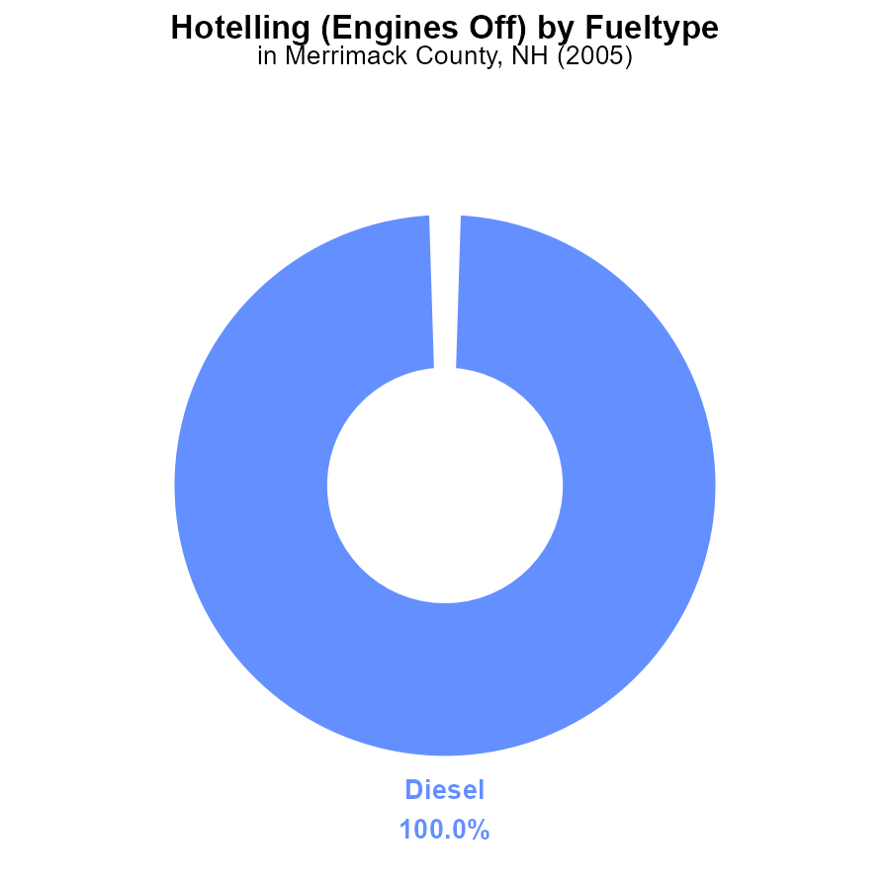

## Findings

* In 2005, Merrimack County, NH emitted 144.6 kCO2e from diesel vehicles with engines off for hours.
* There were no emissions reported from CNG or gas vehicles in Merrimack County, NH in 2005.

## Recommendations

To lower emissions, consider promoting the use of alternative fuel vehicles like CNG or gas in Merrimack County. Additionally, implementing stricter regulations on diesel vehicles could help reduce emissions further.

# Emissions by Regulatory Class

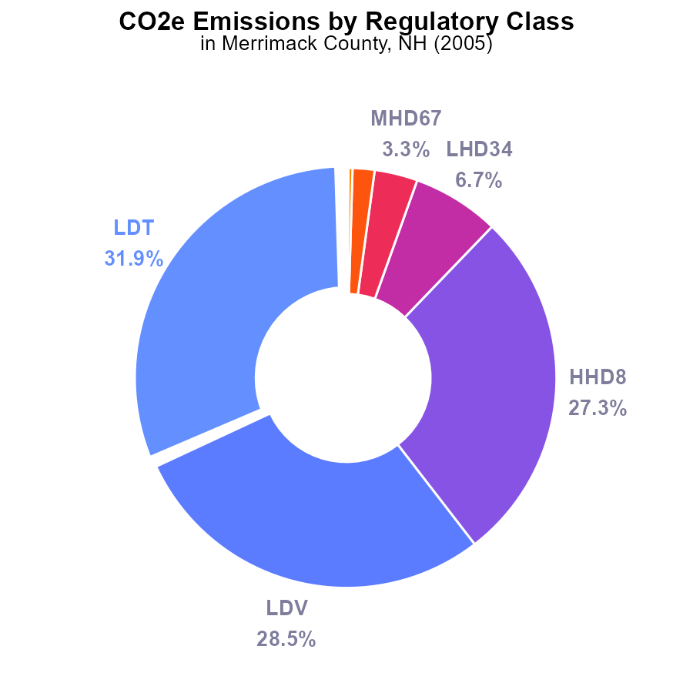

## Findings

* The top 3 emission sources in Merrimack County, NH in 2005 for CO2e were LDT with 31.9%, LDV with 28.5%, and HHD8 with 27.3%.
* Emission contributions from LHD34, MHD67, and LHD45 were relatively lower, accounting for 6.7%, 3.3%, and 1.7% respectively.
* MC and Urban Bus had minimal contributions to the total emissions, at 0.3% and 0.2%, respectively.

## Recommendations

To reduce emissions in Merrimack County, NH, focus on reducing emissions from the top contributors like LDT, LDV, and HHD8 through incentivizing cleaner transportation methods and promoting energy-efficient practices in households and businesses. Implementing stricter emission standards for vehicles in these categories can also have a significant impact on lowering overall emissions levels.

# Vehicles Overall over Time

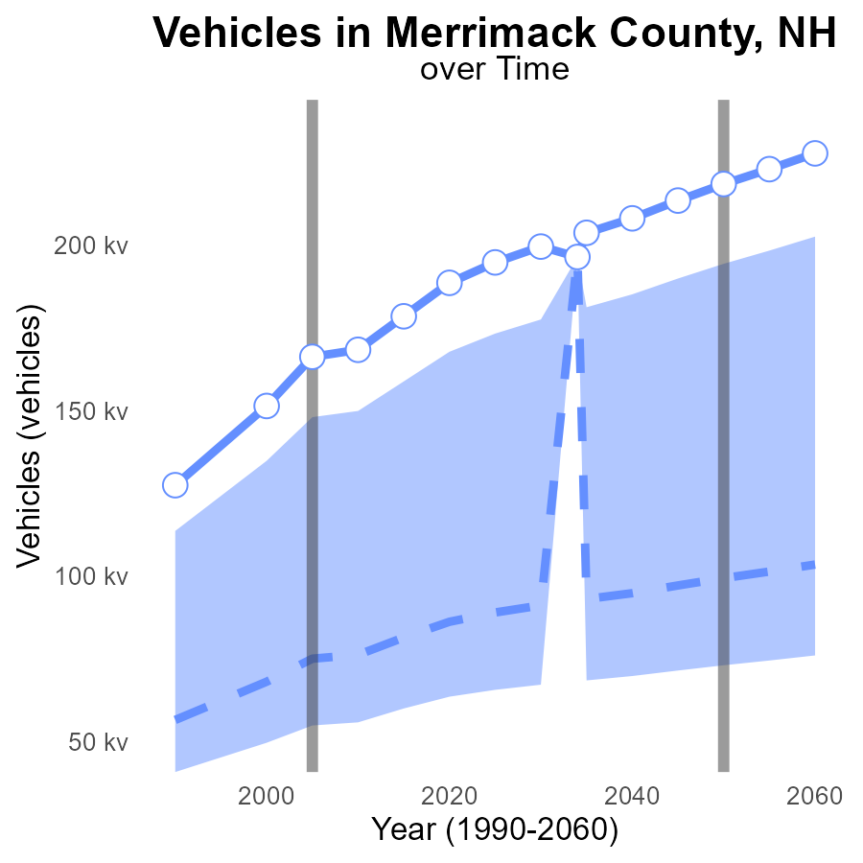

## Findings

* CO2e emissions from vehicles in Merrimack County have consistently increased since 1990.
* The emissions surpassed the upper 75th percentile of all areas in 2000 and continue to rise.
* By 2025, Merrimack County is projected to have a CO2e emission from vehicles of 194.8 kilotons, a 105.7 kiloton increase from the median area.

## Recommendations

To lower emissions, policymakers should prioritize investments in public transportation, promote the use of electric vehicles through incentives, and enhance infrastructure to support walking and cycling.

# Time Driven over Time for Buses

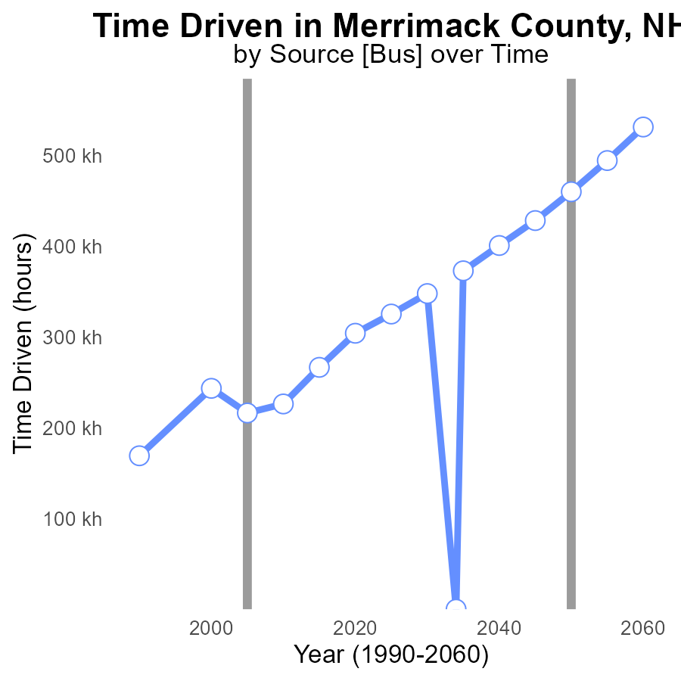

# Hotelling (Engines Off) Mapped by Area

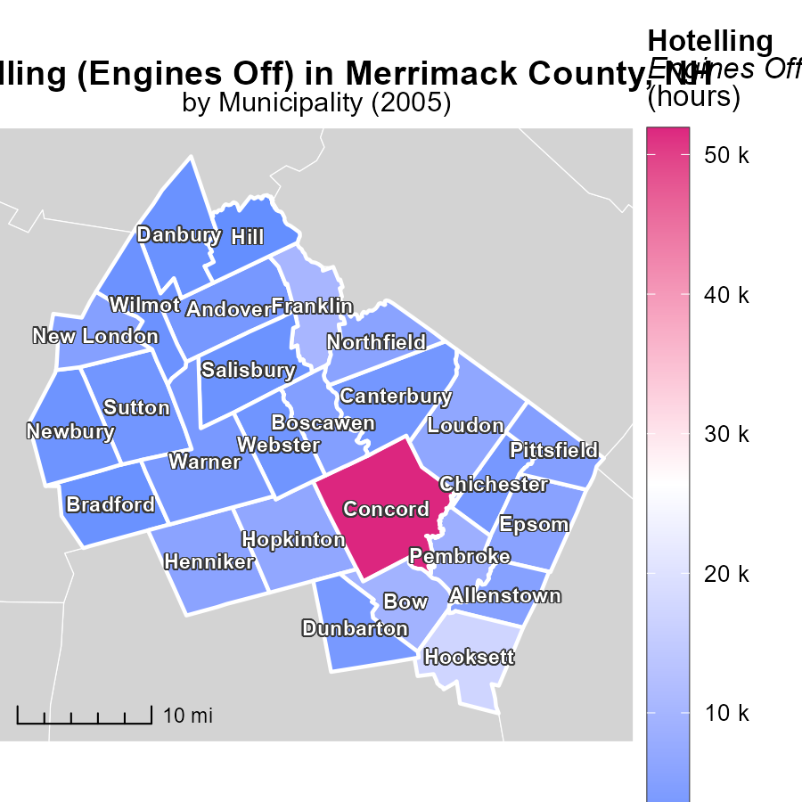

## Findings

* Concord, NH had the highest emissions with 51.9 k hours.
* Boscawen, NH emitted a median of 4.8 k hours.
* Hill, NH had the lowest emissions at 964.6 hours.

## Recommendations

To lower emissions, focus on reducing idling time for vehicles in Concord, NH, encourage the use of more fuel-efficient vehicles in Boscawen, NH, and promote carpooling or the use of public transportation in Hill, NH.

# Emissions Rate (per capita) Mapped by Area

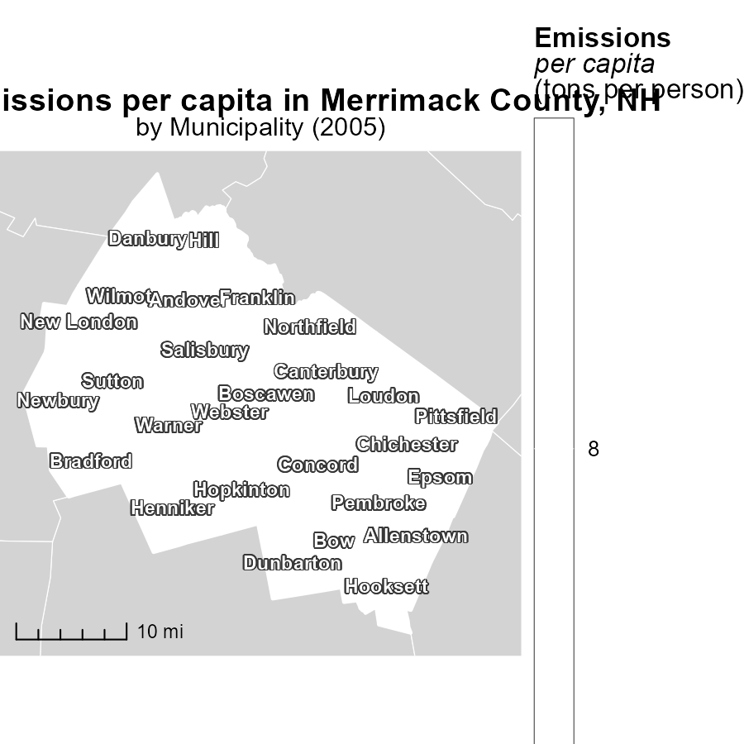

## Findings

* The maximum emissions per capita in Allenstown, NH, in 2005 was 8.5 tons per person.
* The median emissions per capita in Hill, NH, in 2005 was 8.5 tons per person.
* The minimum emissions per capita in Wilmot, NH, in 2005 was 8.5 tons per person.

## Recommendations

To lower emissions per capita, policies focusing on reducing individual carbon footprints are needed across Allenstown, Hill, and Wilmot, NH. Implementing initiatives like promoting public transportation, incentivizing energy-efficient practices, and adopting renewable energy sources can help decrease the emission levels observed in 2005.

# Hotelling (Engines Off) by Area over Time

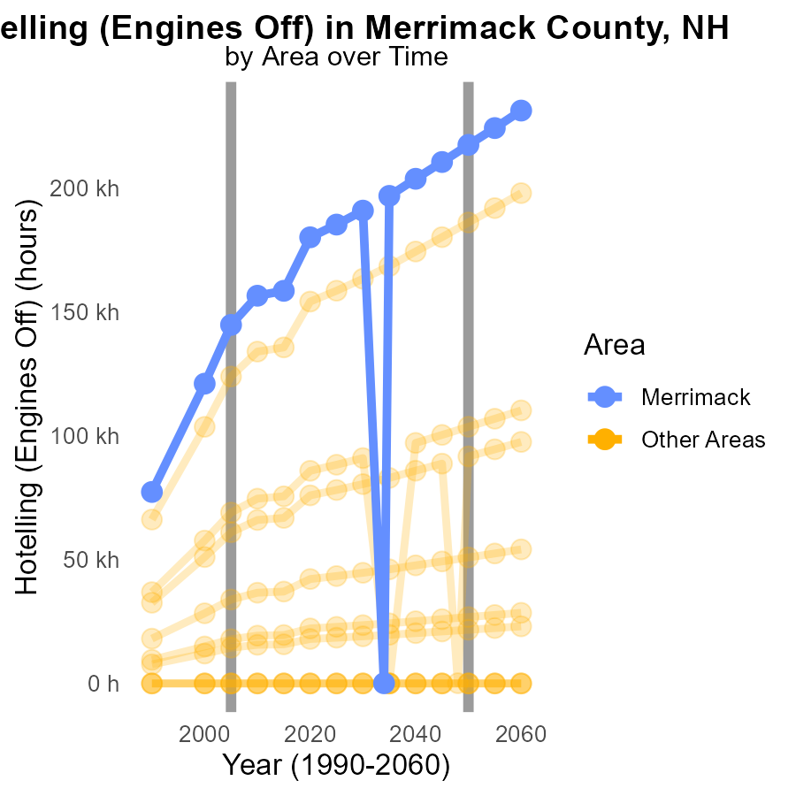

## Findings

* Between 1995-2015, there were no CO2e emissions from Hotelling (Engines Off) in min_county in 2005.
* In 2005, max_county emitted 144.6 k CO2e from Hotelling (Engines Off), a 72,590.8 difference from the 2050 target.
* This data highlights the need for significant reductions in CO2e emissions from Hotelling (Engines Off) to meet future targets.

## Recommendations

To lower emissions, policies should focus on promoting alternative transportation methods or investing in cleaner automotive technologies to reduce CO2e output from Hotelling (Engines Off). Implementing strict regulations on idling vehicles can also help achieve emission reduction goals.

# Vehicle Miles Traveled by Vehicle Type over Time

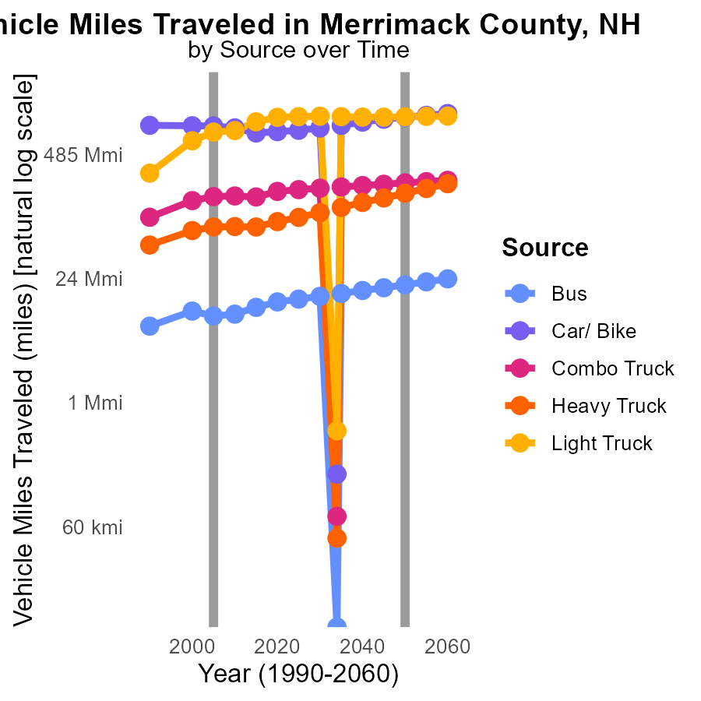

## Findings

* In Merrimack County, NH, vehicle emissions decreased significantly from 2000 to 2015 across all vehicle types.
* Car/Bike emissions showed the most substantial reduction, declining by 15.9% from 2000 to 2015.
* Light trucks displayed the highest emission levels in the county, with emissions increasing by 63.4% from 2000 to 2015.

## Recommendations

To lower emission levels, it is essential to promote alternative transportation options like public transit and biking. Implementing stricter vehicle emission standards and incentivizing the use of electric vehicles can also contribute to reducing emissions.

# Areas Ranked by Idling

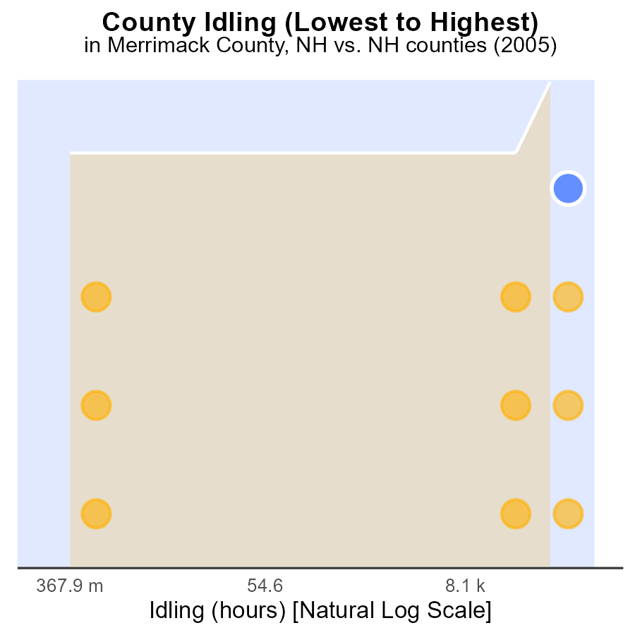

## Findings

* In 2005, Merrimack county had the highest idling hours at 578.4k, ranking 10th nationwide.
* Carroll county had the lowest idling hours at 0.0, placing it 1st in the ranking with only 30.0% of the national average.
* Rockingham county had 495.0k idling hours, ranking 9th with 90.0% of the national average.

## Recommendations

To decrease emissions, focus on Merrimack and Rockingham counties by promoting carpooling, implementing anti-idling policies, and improving public transportation.

# Areas Ranked by Emissions Rate (per vehicle)

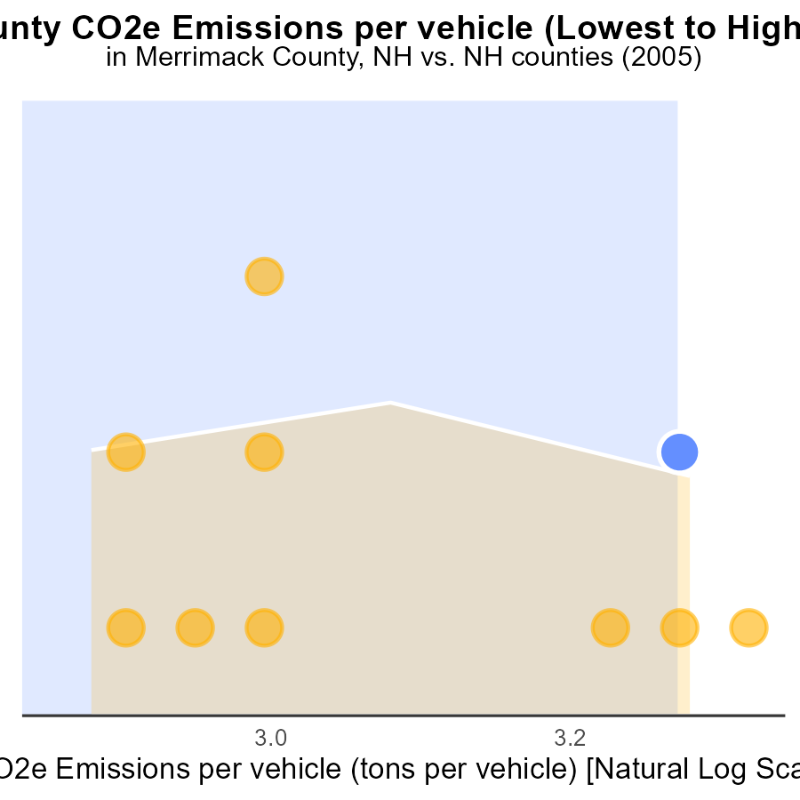

## Findings

* Hillsborough county had the lowest CO2e emissions per vehicle in 2005.
* Grafton county ranked highest in emissions per vehicle at 7.9 tons.
* Merrimack and Sullivan counties had similar emissions per vehicle, both at 7.7 tons.

## Recommendations

To reduce emissions, focus on counties with higher emission rates, like Grafton. Implement vehicle emissions testing and promote vehicle maintenance to enhance fuel efficiency.

# Conclusion

The data on CO2 Equivalent emissions from on-road transportation in Merrimack County, NH in 2005 paints a concerning picture of the environmental impact of vehicles in the region. With emissions steadily increasing since 1990 and projected to rise even further by 2025, urgent action is needed to mitigate these escalating levels.

To address the high emissions in Merrimack County, strategies such as promoting alternative fuel vehicles, implementing stricter regulations on diesel vehicles, and incentivizing cleaner transportation methods are crucial. Focusing on reducing emissions from top contributors like LDT, LDV, and HHD8, as well as investing in public transportation and supporting the adoption of electric vehicles, can significantly contribute to lowering overall emissions and improving air quality in the county. Efforts to reduce idling time, encourage fuel-efficient vehicles, and promote carpooling can also play a key role in lowering emissions in specific towns within the county.

For a sustainable future, it is imperative for policymakers to prioritize emission reduction measures, enhance infrastructure to support eco-friendly transportation options, and engage communities in transitioning towards greener practices. By taking proactive steps now, Merrimack County can work towards a cleaner and healthier environment for current and future generations.

# About This Report

Data based on MOVES estimates collected by the Climate Action in Transportation program at Cornell University. Demographic data sourced from the US Census's American Community Survey 5-year estimates. This report was generated with the help of AI.

# References

* U.S. Census Bureau. (2023). American Community Survey 5-year estimates: Detailed tables. Retrieved from https://data.census.gov
* U.S. Environmental Protection Agency. (2024). Motor Vehicle Emission Simulator (MOVES 4.0) [Software]. Retrieved from https://www.epa.gov/moves