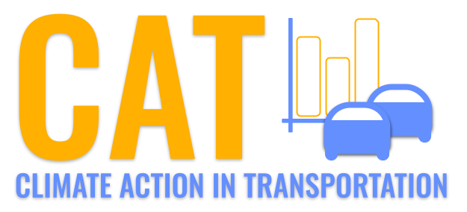 

**CO Emissions in Clark County, 2035**  
Made with CAT VISUALIZER by Gao Labs @ Cornell University.

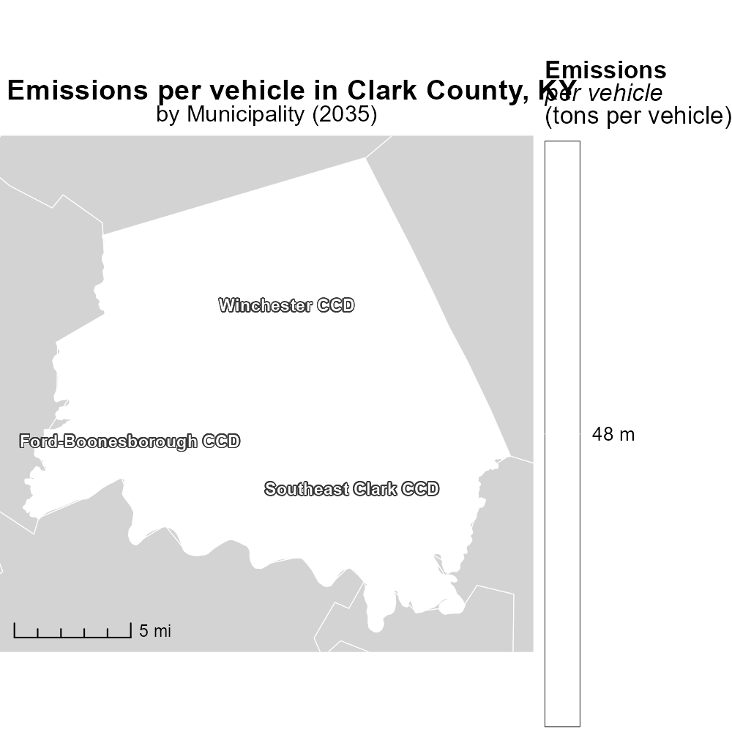

## Keywords

Carbon Monoxide; emissions; on-road transportation; Clark County, KY; 2035

## Highlights

* Report on CO emissions from transportation in Clark County, KY in 2035.
* Focus on impact of on-road transportation on air quality.
* Analysis of trends, future projections, and potential mitigation strategies.
* Importance of monitoring and reducing CO emissions for public health.
* Insights into policy implications for sustainable transportation planning.

# Introduction

This report aims to investigate the carbon monoxide (CO) emissions resulting from on-road transportation in Clark County, KY, projected for the year 2035. With a specific focus on the impact of vehicular emissions on air quality, the study will analyze existing trends, forecast future scenarios, and explore potential mitigation strategies.

Understanding the levels of CO emissions from on-road transportation is crucial for assessing the environmental and public health implications in the region. By examining current data and projecting future emissions, this report will provide valuable insights into the necessity of monitoring and reducing CO levels to safeguard public health and the environment. Additionally, the findings will offer important considerations for policymakers in shaping sustainable transportation planning strategies for the future.

# Population by Fuel Type

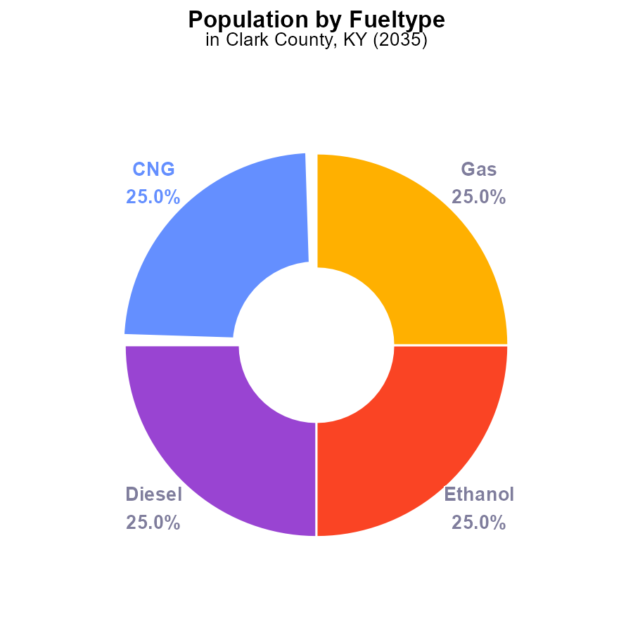

## Findings

* Emissions in Clark County, KY in 2035 are evenly distributed among CNG, Diesel, Ethanol, and Gas, each contributing 25.0%.
* The total carbon monoxide emissions in 2035 are 144.8 k persons.
* The population in Clark County, KY in 2035 generates 36.2 k persons of CO emissions per type.

## Recommendations

To lower emissions, promote the adoption of alternative fuels like electric vehicles. Incentivize public transportation use to reduce individual reliance on personal vehicles fueled by CNG, Diesel, Ethanol, and Gas.

# Time Driven by Fuel Type

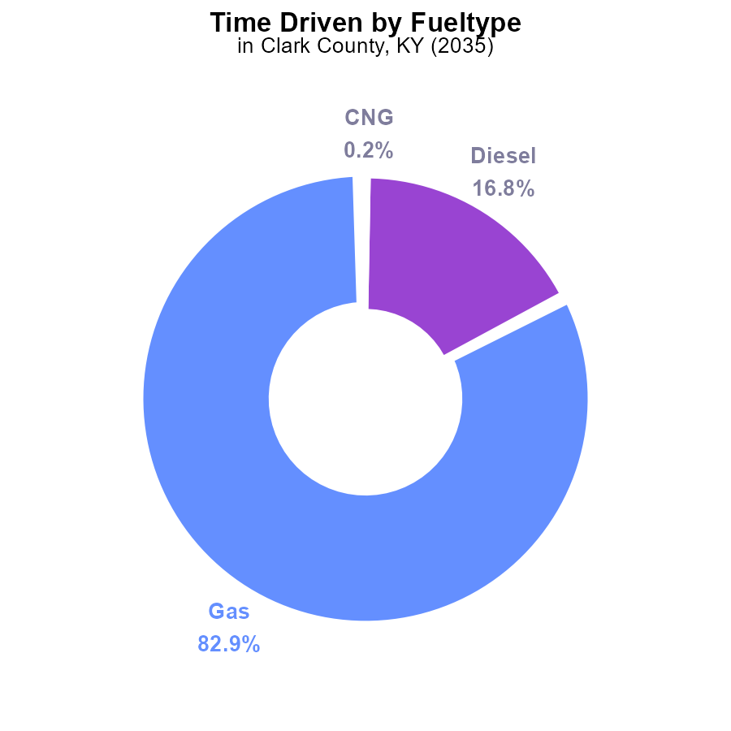

## Findings

* Gasoline emissions in Clark County, KY in 2035 totaled 10.2 million units, contributing to 82.9% of total emissions.
* Diesel emissions amounted to 2.1 million units, accounting for 16.8% of the total emissions in the county.
* CNG and Ethanol emissions were relatively low, with CNG contributing 0.2% (18.7 thousand units) and Ethanol 0.1% (17.0 thousand units) to the total emissions.

## Recommendations

To lower emissions, focus on reducing gasoline and diesel usage through incentivizing electric vehicle adoption, promoting public transport, and investing in renewable energy sources. Encourage the transition to cleaner fuel alternatives to reduce overall emissions.

# Time Driven over Time for Buses

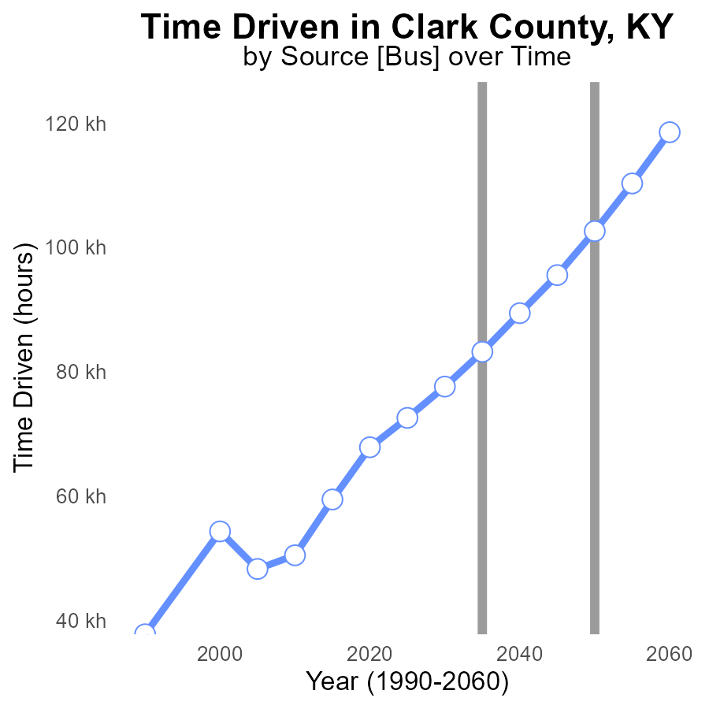

## Findings

* Emissions in Clark County, KY, have consistently increased from 2015 to 2055.
* The benchmark difference decreased over time, showing improvements in emissions efficiency.
* The most significant reduction in benchmark difference occurred between 2035 and 2045.

## Recommendations

To lower emissions, Clark County should focus on further improving emissions efficiency, as seen in the decreasing benchmark difference. This can be achieved by investing in cleaner technologies, promoting energy conservation practices, and implementing stricter emission regulations.

# Hotelling (Engines Off) over Time for Passenger Vehicles

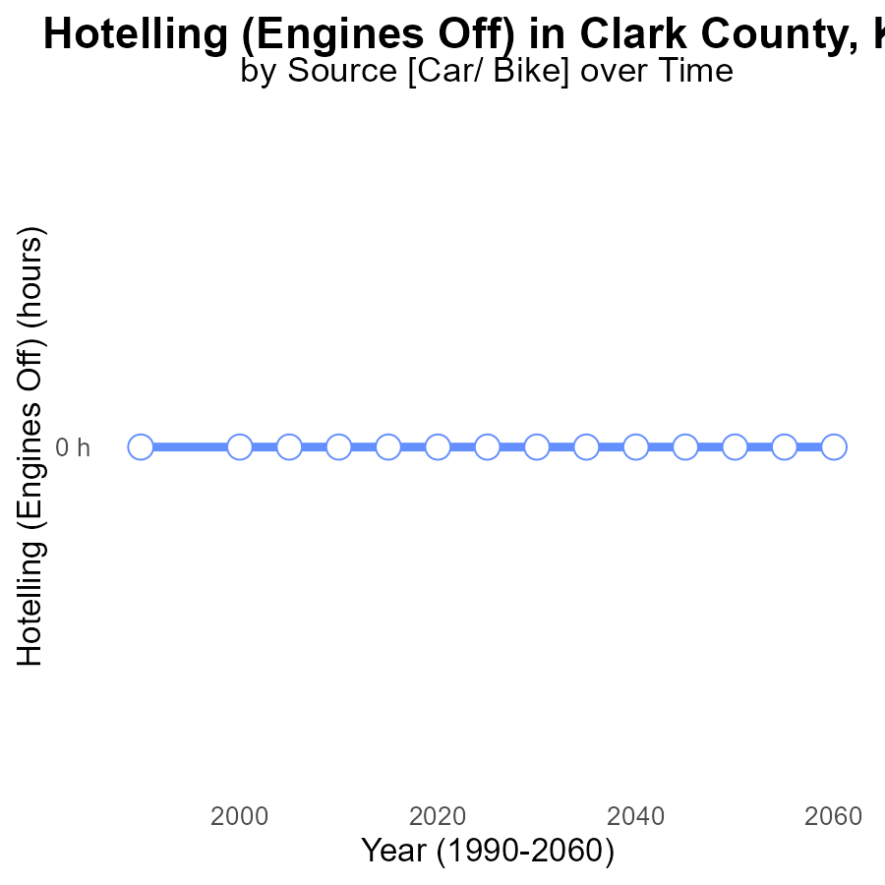

## Findings

* From 2015 to 2055, there have been zero CO emissions in Clark County, KY from engines left running with hotelling.
* The emissions benchmark difference has consistently been zero over the years, indicating no deviation from expectations.
* There is no measurable impact on CO emissions from engines left running with hotelling up to 2055.

## Recommendations

Given the consistently zero emissions from hotelling engines, no specific recommendations are needed to lower CO emissions in this context. Continued monitoring is advised to ensure emissions remain at negligible levels.

# Vehicle Starts in My Region

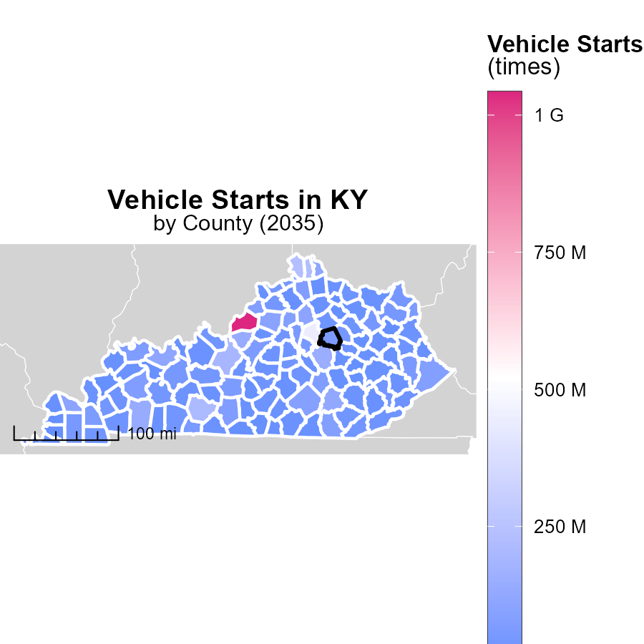

## Findings

* Jefferson County, KY had the highest vehicle starts at 1.0 billion times.
* Mason County, KY had a median of 25.3 million vehicle starts.
* Robertson County, KY had the lowest vehicle starts at 1.5 million times.

## Recommendations

To lower emissions from vehicle starts, promote carpooling or use of public transportation in Jefferson County. Implement stricter emission standards in Mason County. Encourage the use of electric vehicles in Robertson County.

# Emissions Rate (per vehicle) Mapped by Area

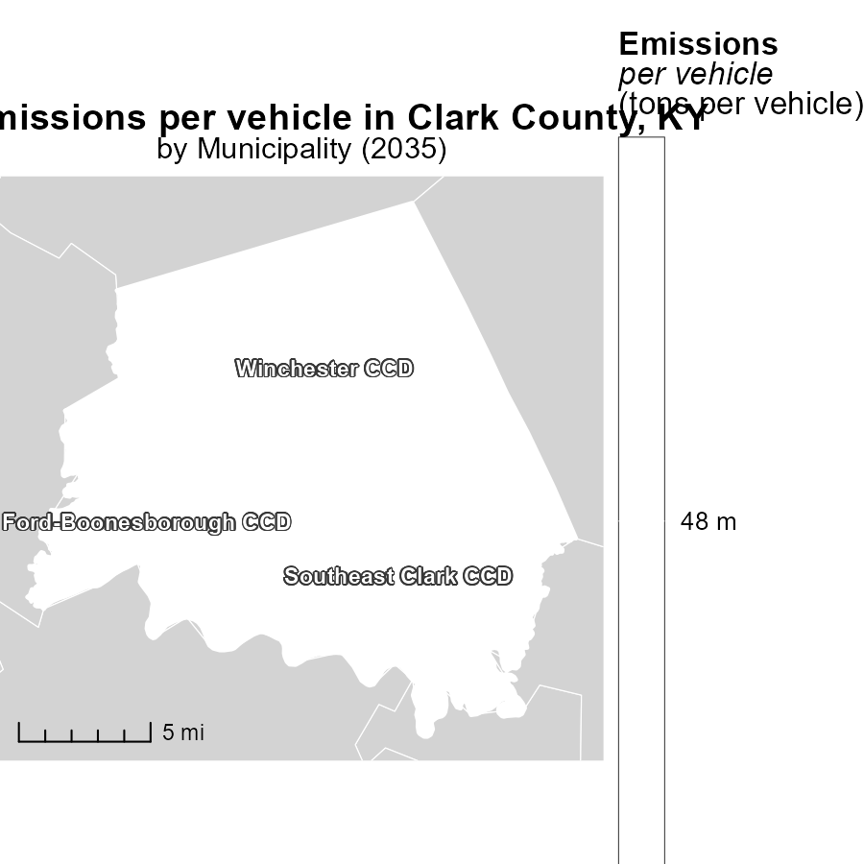

## Findings

* Emissions per vehicle in Ford-Boonesborough CCD, KY is 47.7 tons, the maximum recorded.
* Southeast Clark CCD, KY also has emissions of 47.7 tons per vehicle, the median value.
* Winchester CCD, KY shows emissions of 47.7 tons per vehicle, the minimum reported in the dataset.

## Recommendations

To lower emissions, focus on Ford-Boonesborough CCD, KY by implementing stricter vehicle emission standards. Reduce emissions through incentives for cleaner vehicles in Southeast Clark and Winchester CCDs.

# Emissions by Fuel Type over Time

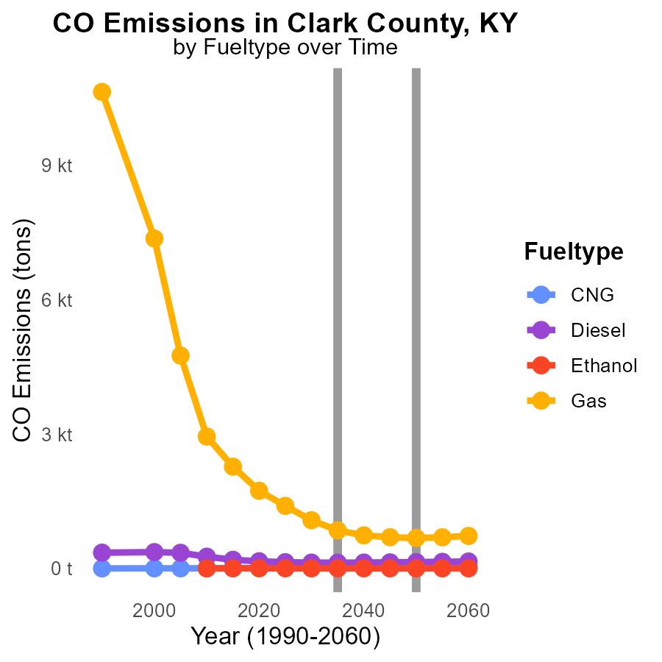

# Idling by Vehicle Type over Time

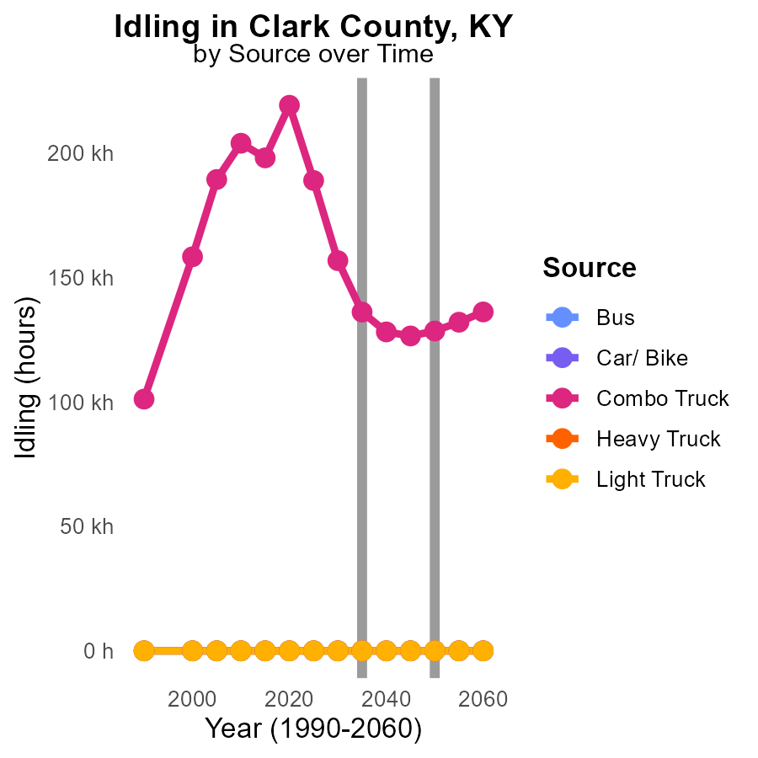

## Findings

* Bus emissions will remain at 0.0 throughout 2025-2045.
* Car/Bike emissions will also stay at 0.0 during the same period.
* Combo Truck emissions will decrease from 189.0 k in 2025 to 126.5 k in 2045.

## Recommendations

To further reduce emissions, focus on transitioning more vehicles to cleaner energy sources and implementing regulations to limit idling time for trucks.

# Areas Ranked by Emissions

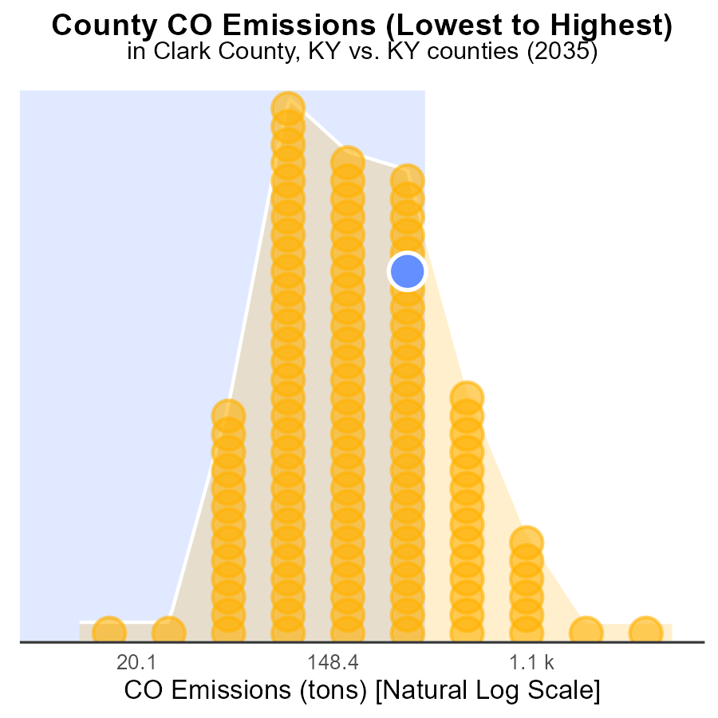

## Findings

* Jefferson County has the highest CO emissions at 13.0k tons, ranking 120th nationally.
* Robertson County has the lowest CO emissions at 28.5 tons, ranking 1st nationally.
* Clark and Hart Counties both emitted 1.0k tons of CO, ranking 93rd and 94th nationally, respectively.

## Recommendations

To lower emissions, Jefferson County should focus on reducing CO output from major sources. Implementing stricter emission controls and investing in clean energy initiatives can help decrease the county's CO emissions significantly.

# Areas Ranked by Population

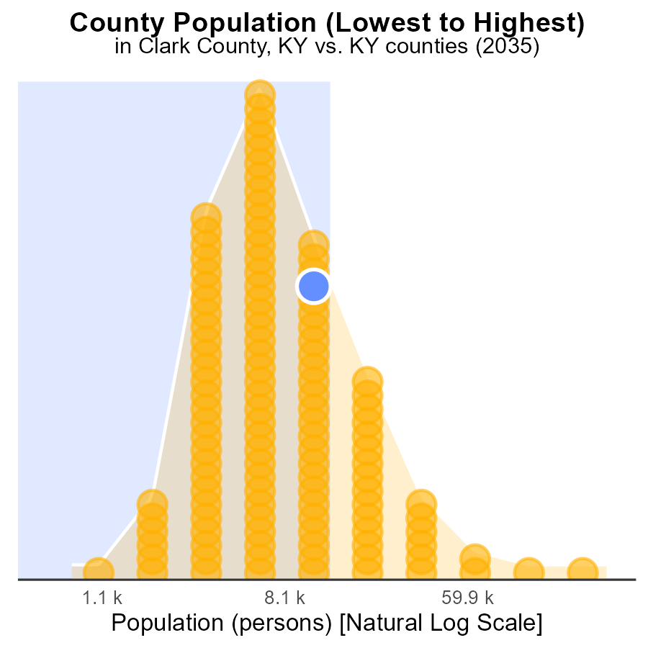

## Findings

* Clark county emitted 36.2 k tons of CO, ranking 184th in population size with 76.7% percentile.
* Robertson emitted 2.1 k tons of CO, ranking 2nd in population size with 0.8% percentile.
* Jefferson emitted 768.4 k tons of CO, ranking 240th in population size with 100.0% percentile.

## Recommendations

To lower emissions, focus on Clark county (36.2 k tons CO) by promoting sustainable transportation and energy-efficient practices. Engage Robertson (2.1 k tons CO) in community-driven carbon reduction initiatives. Develop targeted strategies for Jefferson county (768.4 k tons CO) to transition to renewable energy sources.

# Conclusion

In conclusion, the data on Carbon Monoxide (CO) emissions from on-road transportation in Clark County, KY in 2035 reveals an even distribution of emissions among various fuel types. Gasoline and Diesel remain the primary contributors to CO emissions, with significant room for improvement in transitioning to cleaner fuel alternatives. The consistent increase in emissions from 2015 to 2055 underscores the urgent need for sustainable transportation practices and stricter emission regulations.

Efforts to promote electric vehicle adoption, incentivize public transportation, and invest in renewable energy sources are crucial in reducing overall emissions. The data also highlights the importance of focusing on emissions efficiency, as evidenced by the decreasing benchmark difference over time. While no measurable impact was observed from engines left running with hotelling, areas with high vehicle starts and emissions per vehicle present opportunities for targeted interventions to further decrease CO emissions. By implementing tailored strategies for each county based on their emission levels, Clark County can work towards a greener and more sustainable future.

# About This Report

Data based on MOVES estimates collected by the Climate Action in Transportation program at Cornell University. Demographic data sourced from the US Census's American Community Survey 5-year estimates. This report was generated with the help of AI.

# References

* U.S. Census Bureau. (2023). American Community Survey 5-year estimates: Detailed tables. Retrieved from https://data.census.gov
* U.S. Environmental Protection Agency. (2024). Motor Vehicle Emission Simulator (MOVES 4.0) [Software]. Retrieved from https://www.epa.gov/moves