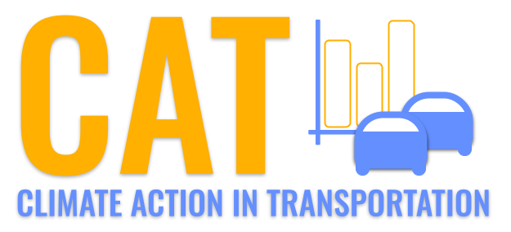 

**Carbon Emissions in Broward County, 2030**  
Made with CAT VISUALIZER by Gao Labs @ Cornell University.

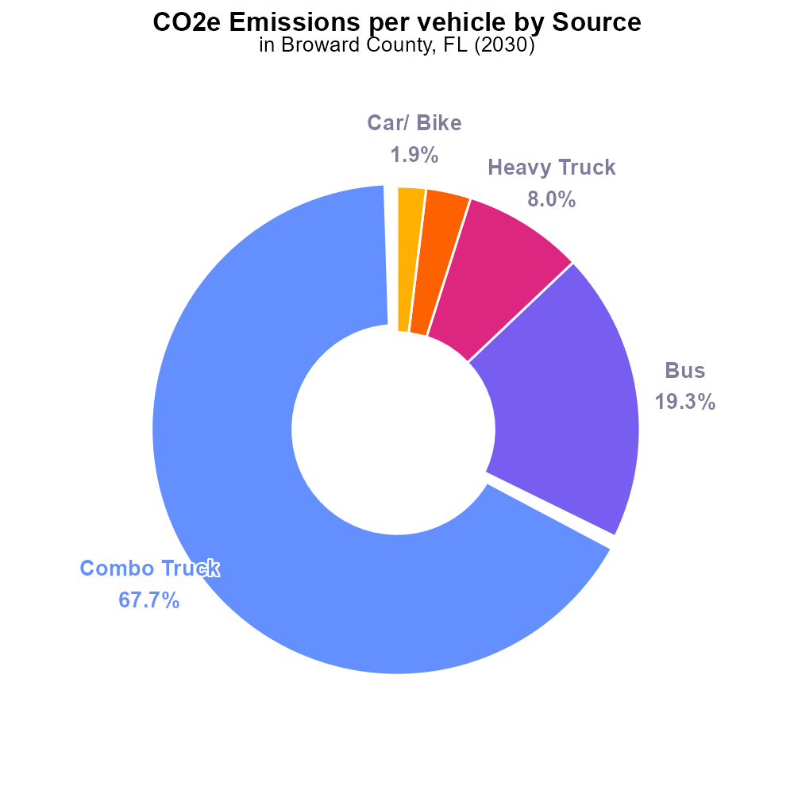

## Keywords

CO2 equivalent emissions; on-road transportation; Broward County; FL; 2030; report

## Highlights

* Analyzing CO2 emissions from Broward County's road transportation in 2030.
* Focus on environmental impact and mitigation strategies.
* Data-driven approach to understanding emissions trends.
* Insights for policymakers and stakeholders in Broward County.
* Addressing the challenges of sustainable transportation.

# Introduction

In 2030, the CO2 equivalent emissions from on-road transportation in Broward County, FL, have become a crucial focal point for sustainable development and environmental stewardship. This report aims to delve into the intricate web of factors contributing to the carbon footprint of the county's transportation sector.

By analyzing historical data, current trends, and predictive models, this report provides a comprehensive overview of the environmental impact of on-road transportation in Broward County. Additionally, it outlines potential mitigation strategies that can be implemented to reduce CO2 emissions and promote sustainable practices in the region. With a data-driven approach, this report offers valuable insights for policymakers, urban planners, and other stakeholders involved in shaping the future of transportation in Broward County.

# Vehicle Miles Traveled by Regulatory Class

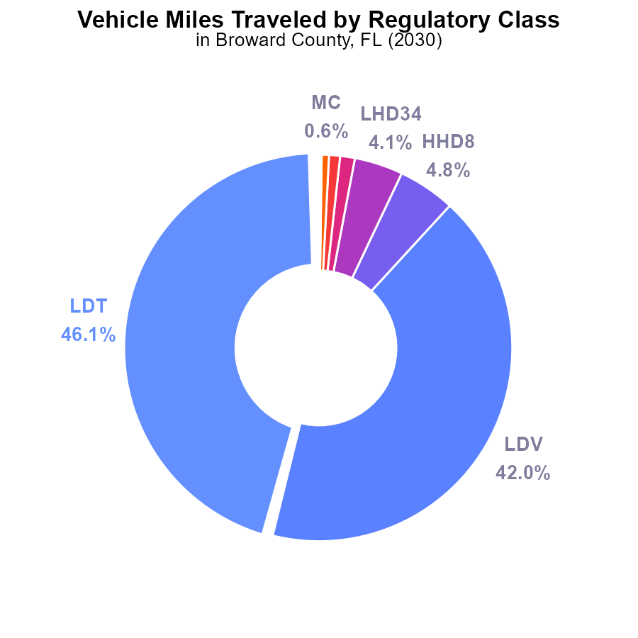

## Findings

* The majority of emissions come from LDT and LDV, accounting for 88.1% of the total CO2e.
* HHD8 and LHD34 contribute to 8.9% of the emissions due to a high volume of miles traveled.
* Other vehicle types such as Glider and Urban Bus have minimal emission contributions of less than 0.1% each.

## Recommendations

To reduce emissions, prioritize initiatives targeting LDT and LDV with 46.1% and 42.0% contribution to CO2e. Implement measures to reduce vehicle miles traveled for HHD8 and LHD34 by promoting public transportation and carpooling.

# Emissions Rate (per vehicle) by Vehicle Type

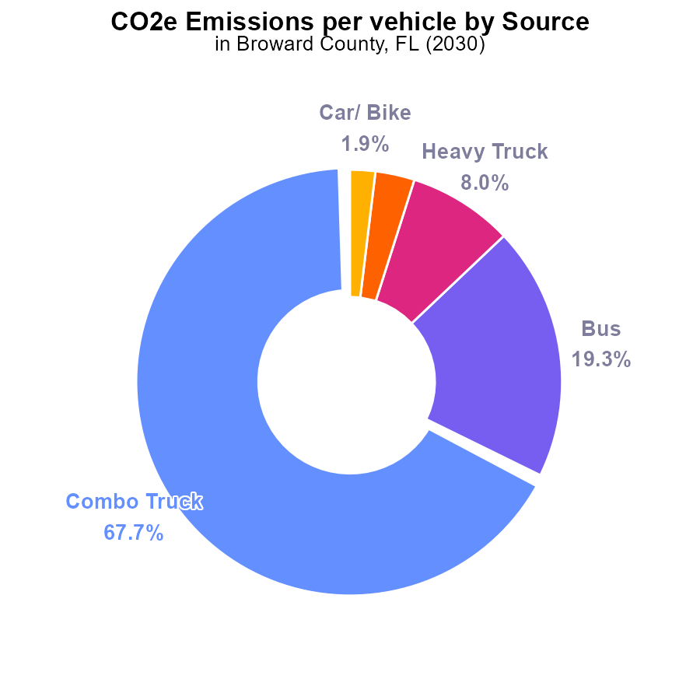

## Findings

* In 2030, Combo Trucks in Broward County emitted the most CO2e per vehicle at 112.2 tons.
* Buses were the second-highest emitters per vehicle, contributing 32.1 tons of CO2e, making up 19.3% of the total emissions.
* Heavy Trucks, Light Trucks, and Cars/Bikes had lower emissions per vehicle, with Heavy Trucks emitting 13.3 tons, Light Trucks emitting 5.0 tons, and Cars/Bikes emitting 3.2 tons of CO2e per vehicle.

## Recommendations

To lower emissions, Broward County should focus on implementing stricter regulations on Combo Trucks and Buses, as they contribute significantly to the total emissions. Encouraging the use of cleaner fuels and promoting public transportation can help reduce the CO2e emissions per vehicle.

# Emissions Rate (per vehicle) over Time for Buses

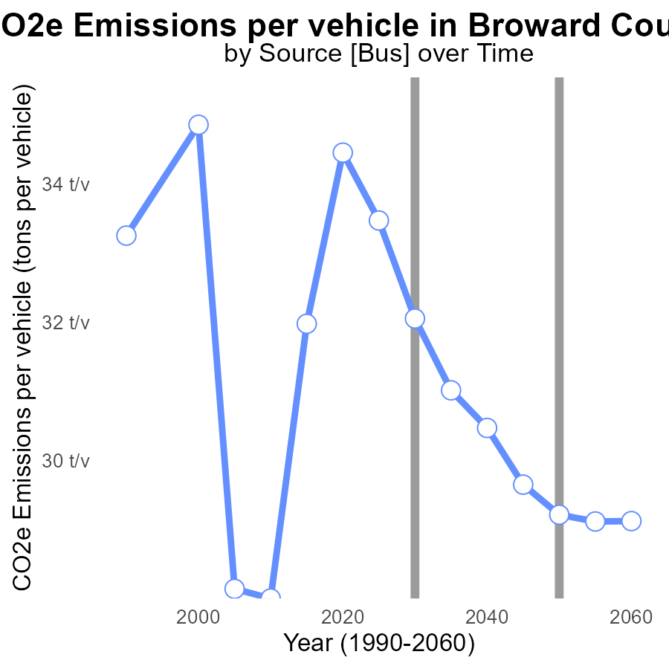

## Findings

* Emissions per vehicle decreased by 4.3% from 2010 to 2050.
* There was a consistent decrease in emissions per vehicle after 2010.
* By 2050, emissions per vehicle are expected to be 4.3% lower than in 2010.

## Recommendations

To further reduce emissions, policymakers should focus on implementing stricter vehicle emission standards, promoting the adoption of electric vehicles, and investing in public transportation infrastructure. Additionally, encouraging carpooling and telecommuting can help reduce the number of vehicles on the road, ultimately lowering emissions.

# Idling over Time for Buses

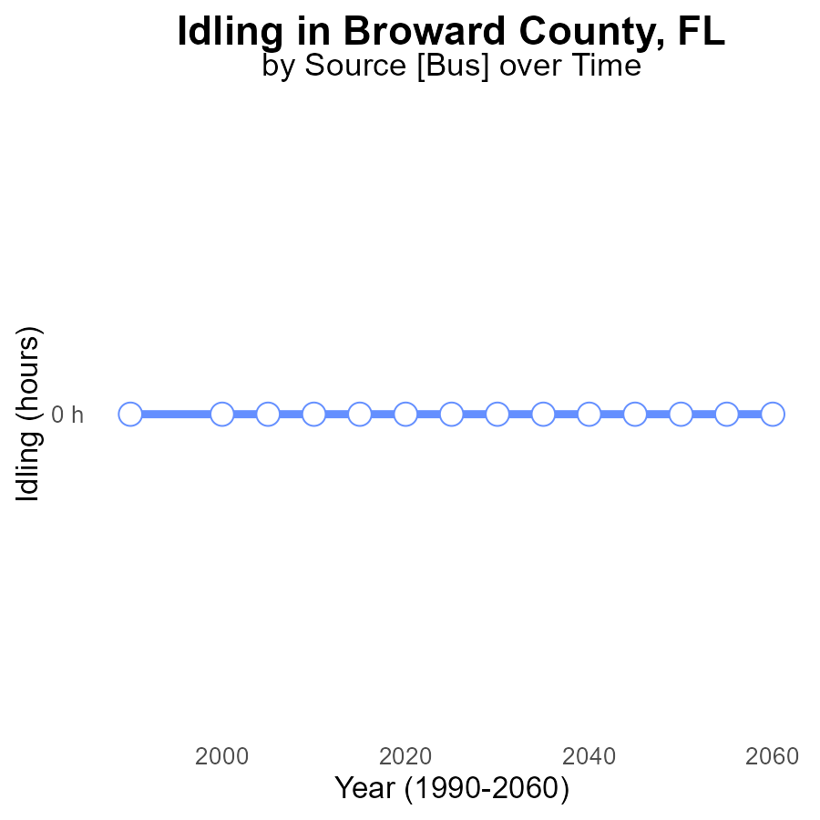

## Findings

* Idling emissions in Broward County, FL have remained at 0.0 CO2e since 2010.
* There has been no change in idling emissions compared to the benchmark over the years.
* There is no projected increase in idling emissions until 2050.

## Recommendations

Given the consistent idling emissions in Broward County, FL, policymakers should focus on implementing awareness campaigns and enforcement of anti-idling regulations to maintain the current low levels of emissions.

# Hotelling (Diesel Aux) Mapped by Area

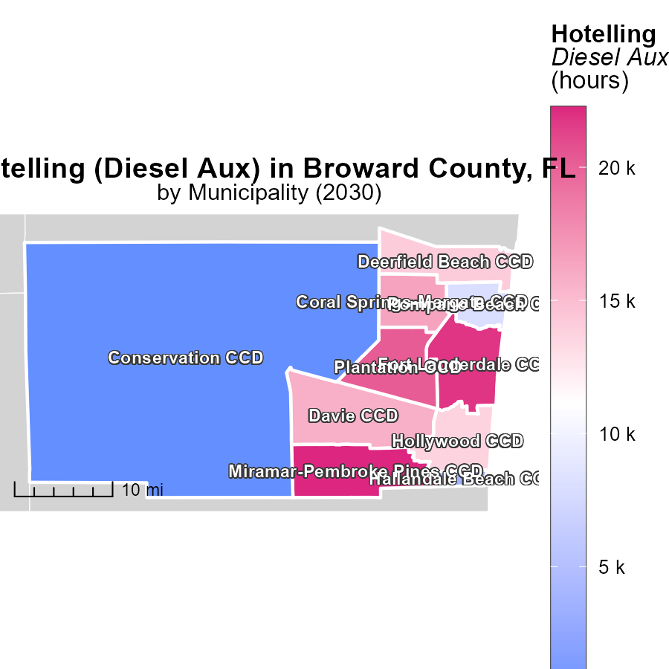

## Findings

* The highest raw emissions level in 2030 for Hotelling (Diesel Aux) was 22.3 k hours in Miramar-Pembroke Pines CCD, FL.
* The median raw emissions level in 2030 for Hotelling (Diesel Aux) was 14.1 k hours in Deerfield Beach CCD, FL.
* There were zero emissions recorded in 2030 for Hotelling (Diesel Aux) in the Conservation CCD, FL.

## Recommendations

To lower emissions, consider introducing stricter regulations for diesel auxiliary systems. Encourage the use of cleaner alternative fuels or technologies to reduce emissions significantly.

# Vehicle Miles Traveled Mapped by Area

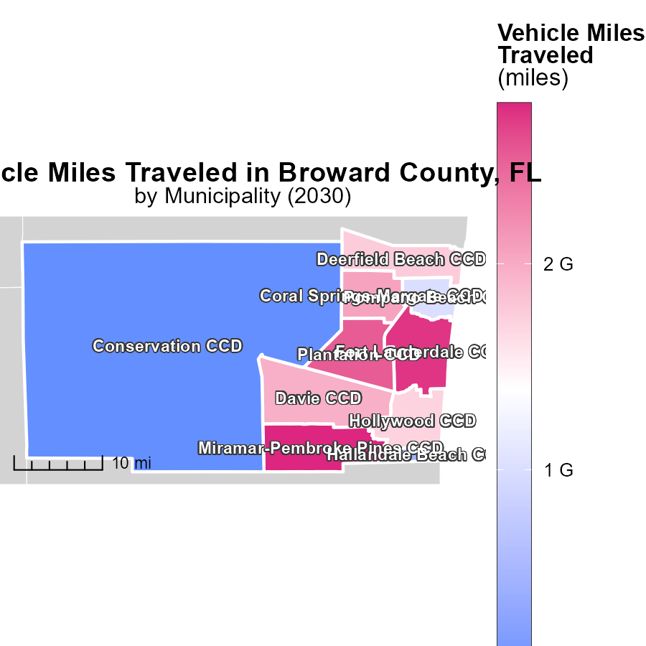

## Findings

* The Miramar-Pembroke Pines CCD in FL has the highest vehicle miles traveled at 2.8 billion miles.
* The Deerfield Beach CCD in FL has a median of 1.8 billion miles traveled by vehicles.
* The Conservation CCD in FL has the lowest vehicle miles traveled, with no recorded emissions.

## Recommendations

To lower emission levels, policymakers could consider promoting public transportation initiatives in the Miramar-Pembroke Pines CCD, implementing carpooling incentives in the Deerfield Beach CCD, and encouraging the use of electric vehicles in the Conservation CCD.

# Vehicles by Regulatory Class over Time

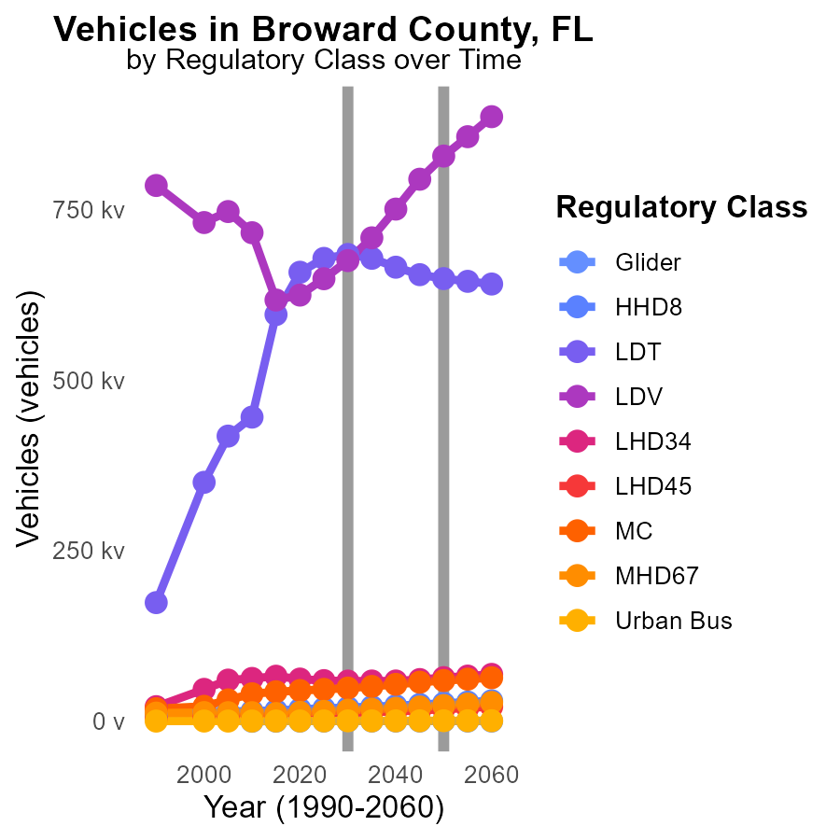

## Findings

* By 2040, CO2e emissions from LDT vehicles will decrease by 16.7%, but LDV emissions will increase by 77,707.3 tons.
* From 2020 to 2040, MC emissions will rise by 20,159.8 tons, a 44.9% increase.
* Urban Bus emissions will grow by 134.6 tons by 2040, a 32.5% increase compared to 2020.

## Recommendations

To reduce LDV emissions, focus on transitioning to electric vehicles and improving public transport systems. Enhance infrastructure to support alternative fuel sources for MC. Implement stricter emission standards for Urban Buses.

# Emissions Rate (per mile) by Road Type over Time

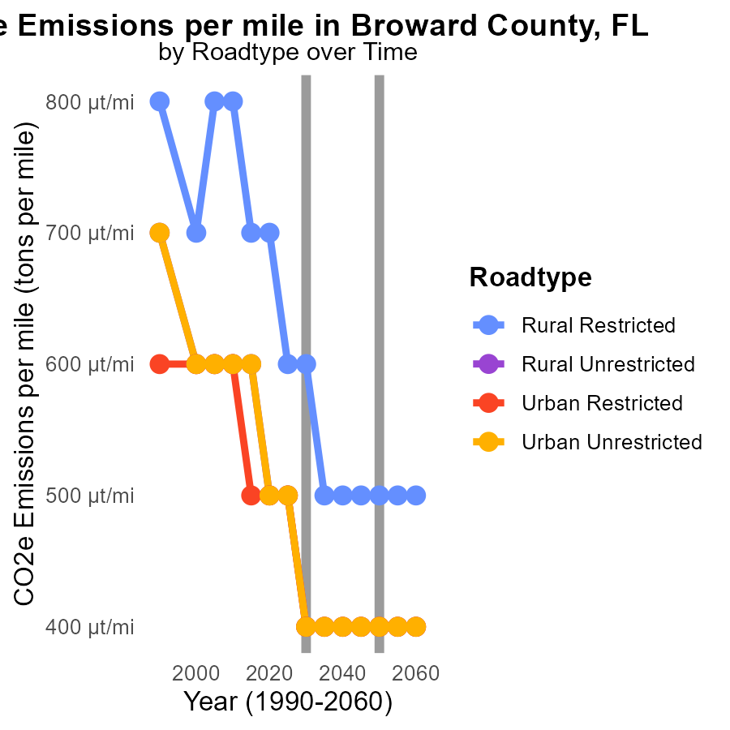

# Areas Ranked by Emissions

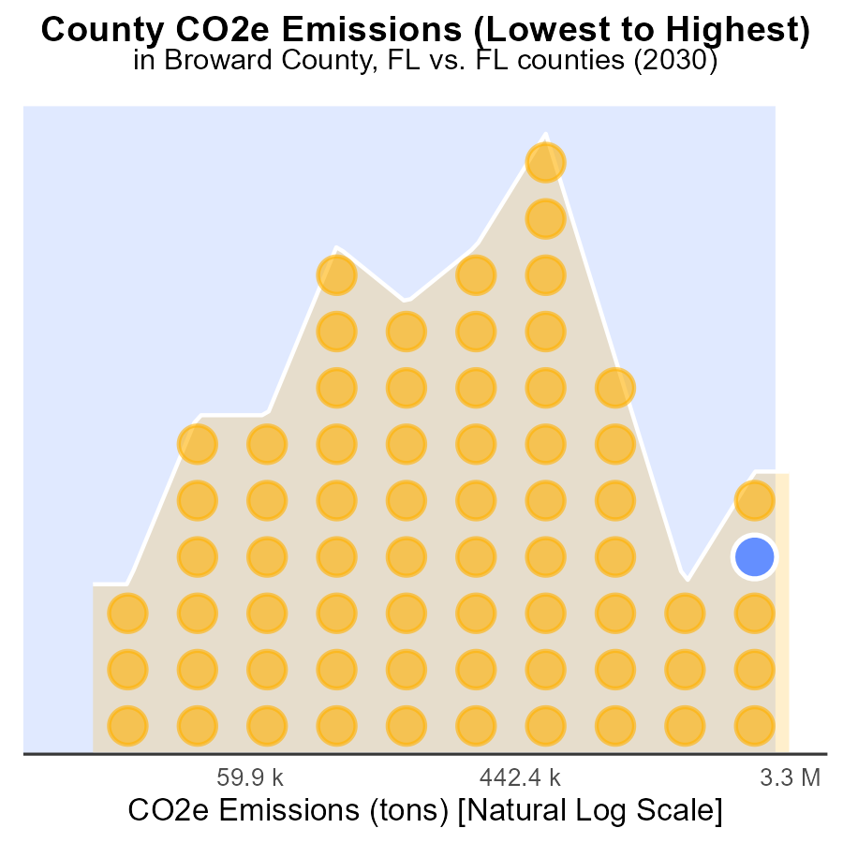

## Findings

* Miami-Dade has the highest emissions at 8.8 million tons in 2030.
* Liberty County has the lowest emissions at 50.9 thousand tons in 2030.
* Miami-Dade is in the 100th percentile for emissions, whereas Liberty County is in the 1.5th percentile.

## Recommendations

To lower emissions, policymakers should prioritize Miami-Dade County due to its high emissions level. Implementing stricter emission regulations for industries and promoting public transportation can help reduce the CO2e emissions significantly. In Liberty County, although emissions are low, encouraging sustainable practices like renewable energy adoption can further decrease emissions and maintain the positive trend observed.

# Areas Ranked by Emissions Rate (per capita)

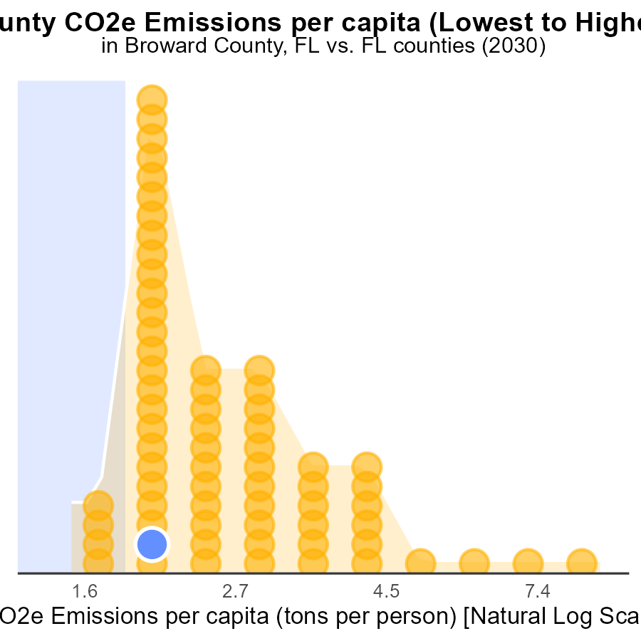

## Findings

* Hamilton county has the highest emissions per capita at 24.2 tons per person.
* Miami-Dade county has the lowest emissions per capita at 3.3 tons per person.
* Hamilton county ranks in the 100th percentile for emissions per capita.

## Recommendations

To lower emissions, Hamilton county should focus on implementing energy-efficient practices and transitioning to renewable energy sources. Encouraging public transportation and promoting carpooling can also help reduce emissions further.

# Conclusion

In conclusion, the data analysis of CO2 equivalent emissions from on-road transportation in Broward County, FL in 2030 reveals key insights that can guide policymakers in devising effective strategies to reduce emissions. The study indicates that Light Duty Trucks (LDT) and Light Duty Vehicles (LDV) are the primary contributors to CO2e, collectively accounting for 88.1% of the total emissions. In contrast, vehicle types like Gliders and Urban Buses have minimal emission impacts.

To address the high emissions from LDT and LDV, prioritizing initiatives that promote public transportation, carpooling, and electric vehicle adoption can be crucial. Additionally, measures to reduce vehicle miles traveled for Heavy Heavy Trucks and Light Heavy Duty Trucks are essential to curbing emissions. The report also highlights the need for stricter regulations on Combo Trucks and Buses, given their significant contribution to total emissions per vehicle.

Furthermore, the consistent decrease in emissions per vehicle since 2010 suggests that ongoing efforts to reduce emissions have been effective. However, to achieve further reductions, policymakers should focus on stricter emission standards, promoting the adoption of cleaner fuels and technologies, and investing in sustainable transportation infrastructure. By addressing these priorities, Broward County can make significant strides in lowering CO2e emissions from on-road transportation by 2030.

# About This Report

Data based on MOVES estimates collected by the Climate Action in Transportation program at Cornell University. Demographic data sourced from the US Census's American Community Survey 5-year estimates. This report was generated with the help of AI.

# References

* U.S. Census Bureau. (2023). American Community Survey 5-year estimates: Detailed tables. Retrieved from https://data.census.gov
* U.S. Environmental Protection Agency. (2024). Motor Vehicle Emission Simulator (MOVES 4.0) [Software]. Retrieved from https://www.epa.gov/moves