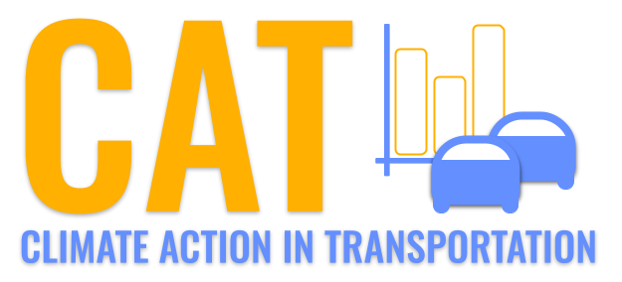 

**VOC Emissions in Montgomery County, 2035**  
Made with CAT VISUALIZER by Gao Labs @ Cornell University.

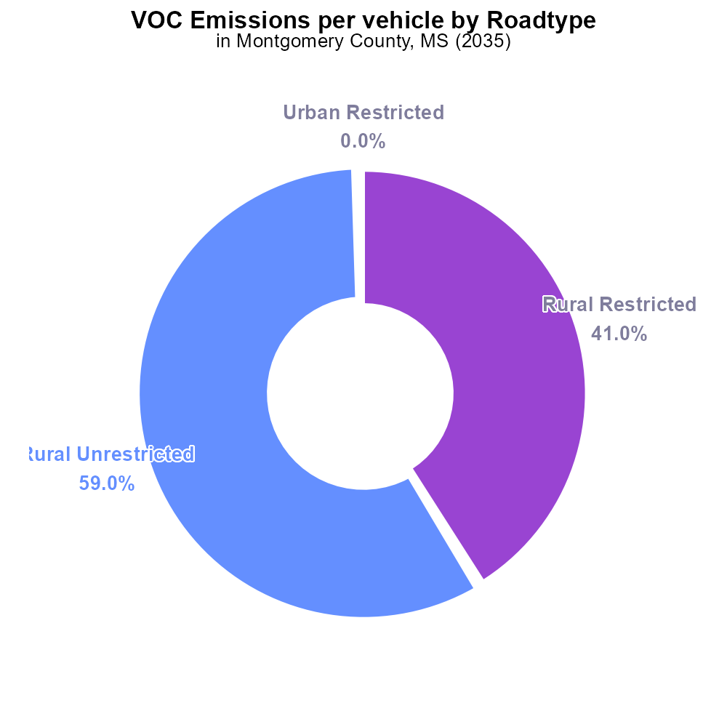

## Keywords

Volatile Organic Compounds; emissions; on-road transportation; Montgomery County; MS; 2035

## Highlights

* Investigation of VOC emissions from on-road transportation in Montgomery County, MS.
* Analysis of the impact of transportation on air quality in the county.
* Assessment of trends in VOC emissions over time in the region.
* Identification of potential strategies to reduce VOC emissions from transportation.
* Insights into the environmental challenges posed by on-road transportation in 2035.

# Introduction

In 2035, Montgomery County, MS faces growing concerns over the emissions of Volatile Organic Compounds (VOCs) from on-road transportation. This report delves into the intricate relationship between transportation activities and air quality within the county.

By examining the trends of VOC emissions from on-road transportation in Montgomery County, this study aims to provide valuable insights for policymakers and environmentalists. Additionally, the report will explore potential strategies and mitigation measures that can be implemented to curb the impact of VOC emissions on the environment by the year 2035.

# Emissions Rate (per vehicle) by Road Type

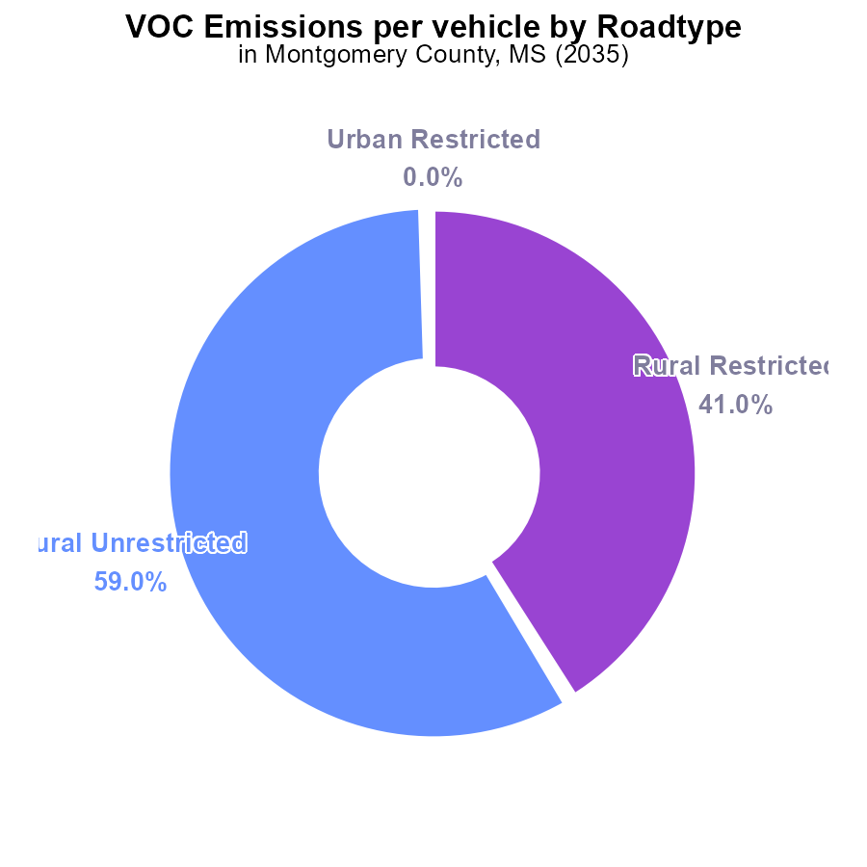

## Findings

* Rural Unrestricted vehicles emit 281.8 tons of VOC per vehicle, accounting for 59.0% of total emissions
* Rural Restricted vehicles emit 195.5 tons of VOC per vehicle, representing 41.0% of total emissions
* Urban areas show no VOC emissions from vehicles in the data

## Recommendations

To reduce VOC emissions, focus on implementing stricter regulations for Rural Unrestricted vehicles, potentially through emissions testing or vehicle restrictions. Invest in cleaner technologies and encourage public transportation in urban areas to maintain zero emissions.

# Time Driven Overall by Area

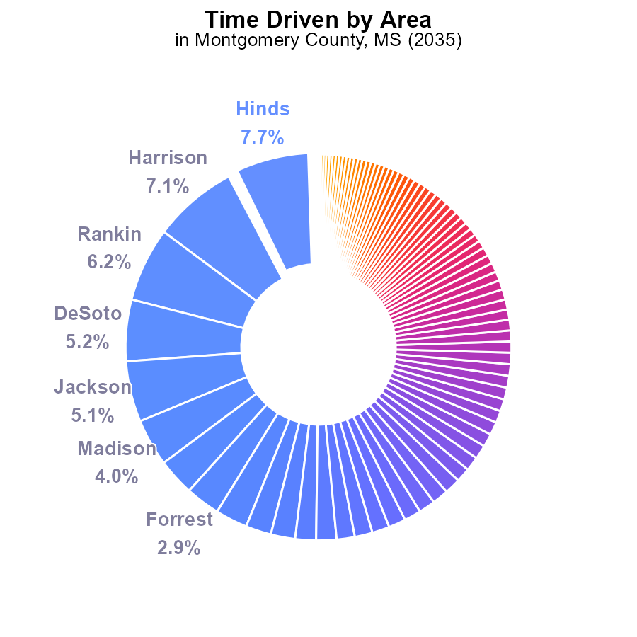

## Findings

* The top 5 counties (Hinds, Harrison, Rankin, DeSoto, Jackson) contribute to 31.3% of VOC emissions.
* The top 20 counties collectively produce 56.3% of VOC emissions.
* Over 50 counties individually account for less than 1% of VOC emissions each.

## Recommendations

To lower VOC emissions, prioritize reduction efforts towards the top 5 emitting counties. Implement stricter regulations and incentives for emissions control technologies. Encourage public transportation and carpooling to reduce vehicle emissions across all counties.

# Emissions Rate (per mile) over Time for Buses

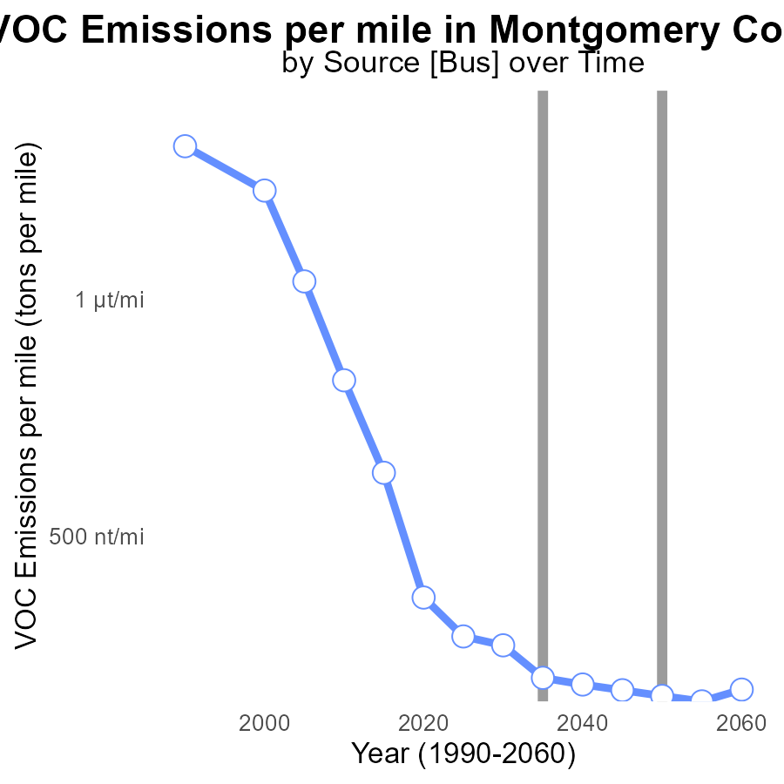

## Findings

* VOC emissions per mile have decreased steadily from 634.6 tons in 2015 to 152.2 tons in 2055.
* The benchmark difference shows a consistent improvement, with levels approaching zero by 2035 and remaining stable thereafter.
* Significant progress has been made in reducing emissions, indicating successful implementation of emission reduction strategies.

## Recommendations

To continue reducing VOC emissions, policymakers should focus on promoting the adoption of electric vehicles, enhancing public transportation infrastructure, and incentivizing carpooling and telecommuting to further decrease emissions per mile.

# Time Driven Overall over Time

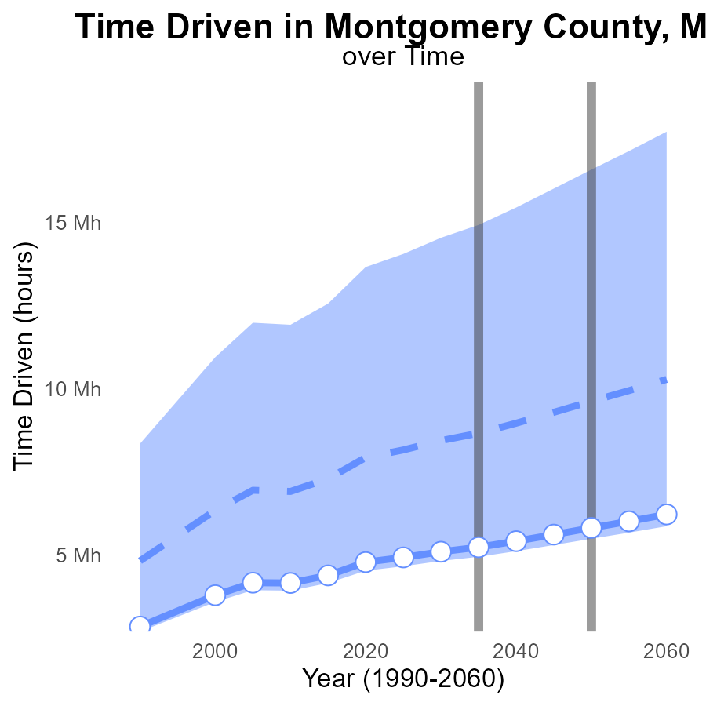

## Findings

* VOC emissions in Montgomery County have been consistently decreasing from 2015 to 2055, with a reduction of up to 3.9 million hours driven below the median area.
* The benchmark difference varies over time, with a peak of 1,428,380.7 hours in 2015 but decreasing to -197,550.5 hours by 2055.
* The upper 75th percentile of areas consistently have higher VOC emissions compared to Montgomery County throughout the years analyzed.

## Recommendations

To further lower VOC emissions, Montgomery County should invest in public transport infrastructure to reduce vehicle usage, promote telecommuting policies for businesses to reduce commuting hours, and incentivize the adoption of electric vehicles to transition towards cleaner modes of transportation.

# Time Driven Mapped by Area

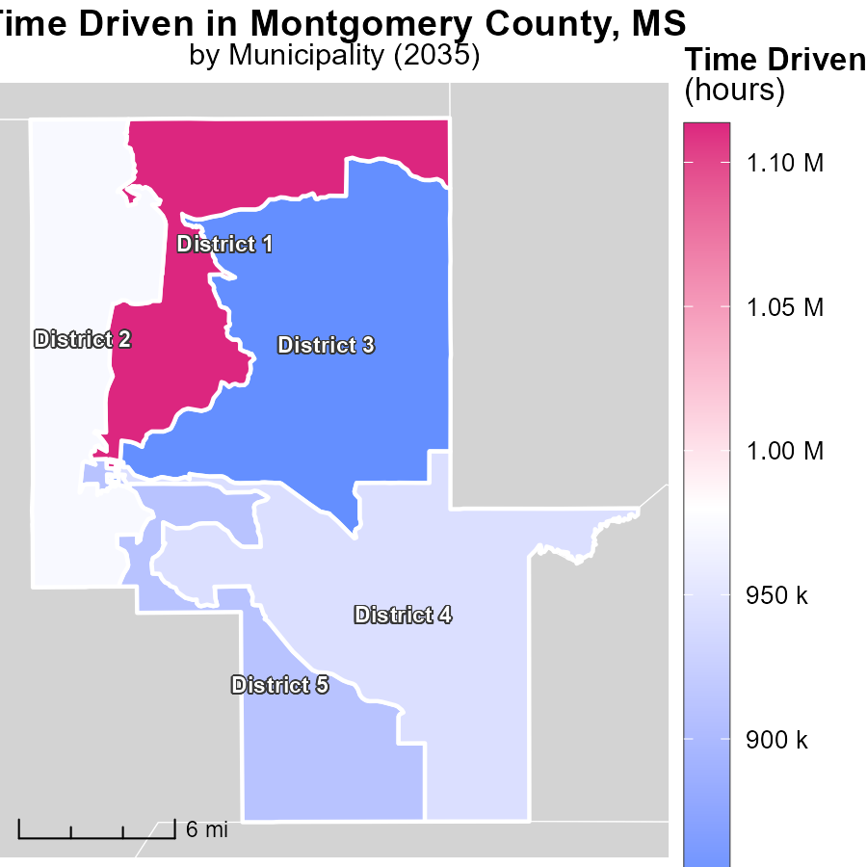

## Findings

* District 1, MS has the highest time-driven emissions at 1.1 million hours.
* District 4, MS has median emissions with 943.5 thousand hours.
* District 3, MS has the lowest time-driven emissions at 846.9 thousand hours.

## Recommendations

To lower emissions, consider optimizing transportation routes and promoting telecommuting to reduce time-driven activities in high-emission districts.

# Emissions Rate (per capita) in My Region

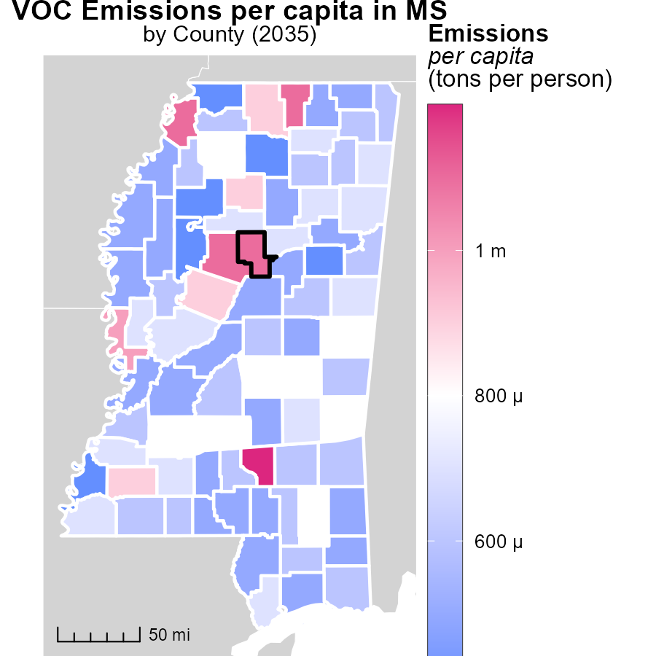

## Findings

* The maximum emissions per capita in Covington County, MS, are 1.2 tons per person.
* The median emissions per capita in Lee County, MS, are 582.6 kilograms per person.
* The minimum emissions per capita in Tallahatchie County, MS, are 370.3 kilograms per person.

## Recommendations

To reduce emissions, focus on Covington County by implementing sustainable practices and technology to lower emissions per person, potentially aiming to bring the levels closer to those of Lee and Tallahatchie counties.

# Vehicle Starts by Regulatory Class over Time

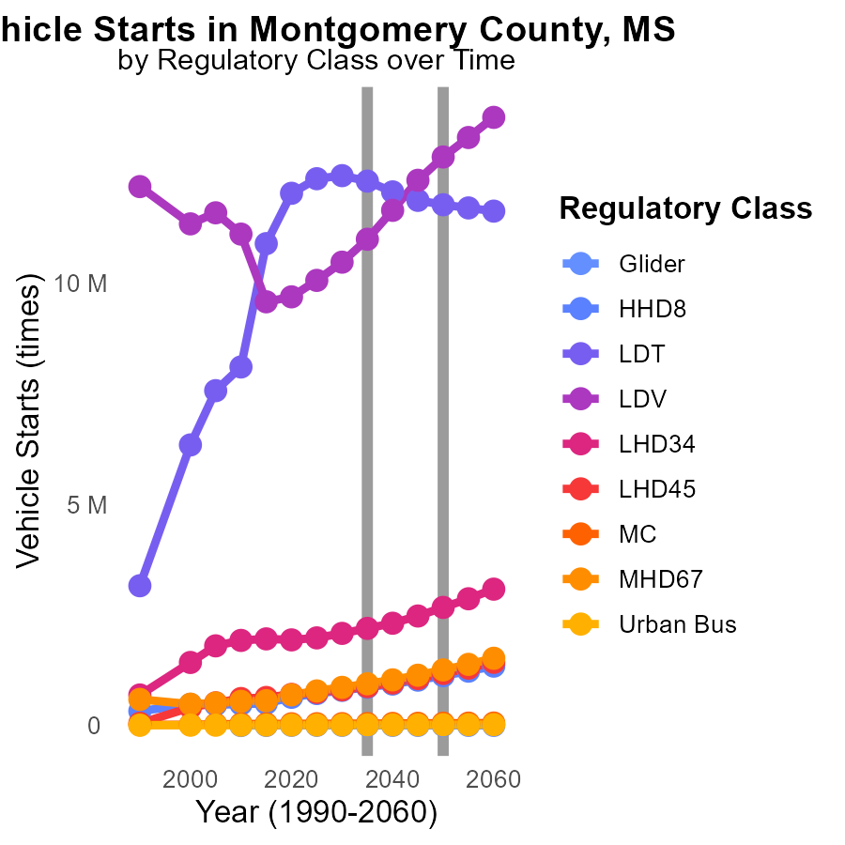

## Findings

* From 2025 to 2045, VOC emissions from Glider vehicles are decreasing by 1178.9 times.
* LDV emissions are increasing steadily from 2025 to 2045, reaching a peak of 12.3 million vehicles in 2045.
* HHD8 vehicles show a significant increase in emissions, with 99588 more vehicles estimated in 2045 compared to 2025.

## Recommendations

To lower emissions, focus on regulating Glider vehicles to sustain the decreasing trend observed. Implement stricter regulations for LDV to curb the steady increase. Invest in alternative fuel technologies for HHD8 vehicles to mitigate the rising emissions.

# Hotelling (Engines Off) by Fuel Type over Time

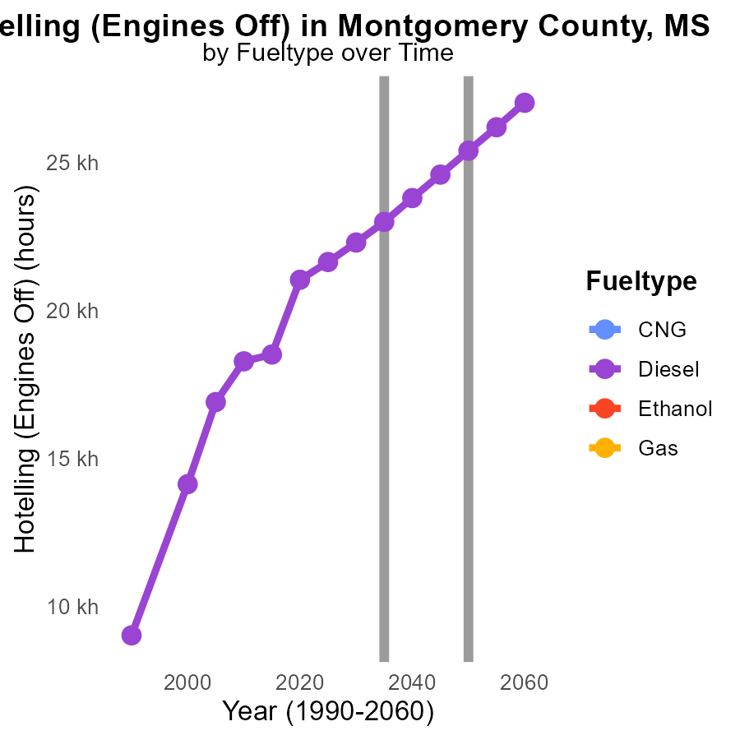

## Findings

* Diesel emissions show a consistent decrease over the years from 21.6 k to 24.6 k, with a difference of 3759.5 in 2025 dropping to 807.7 in 2045.
* CNG, Ethanol, and Gas emissions data are not provided for all years (2025-2045). No conclusion can be drawn.
* There is a need for more detailed and complete emissions data for CNG, Ethanol, and Gas to have a comprehensive overview and comparisons.

## Recommendations

To reduce emissions, prioritize cleaner fuel types like CNG, Ethanol, and Gas by investing in infrastructure and incentivizing their use. Enhance data collection for accurate emission monitoring.

# Areas Ranked by Emissions Rate (per mile)

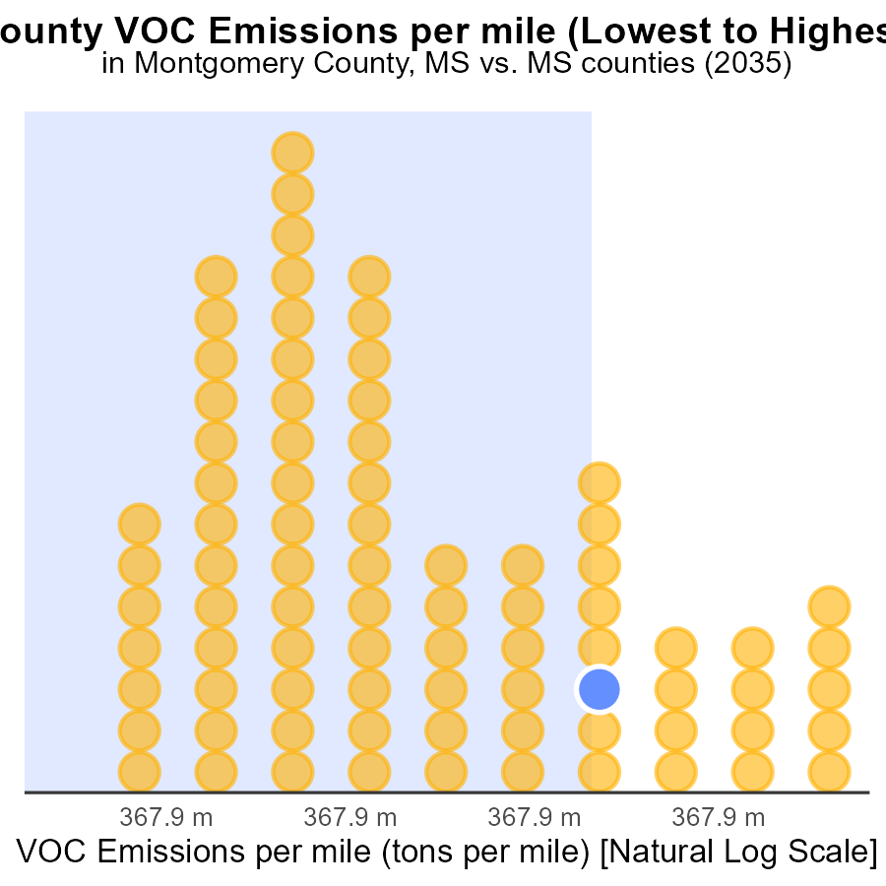

## Findings

* Tippah County has the lowest emissions per mile at 34.6 tons.
* Hancock County has the highest emissions per mile at 38.8 tons.
* Montgomery, Panola, and Lamar counties have similar emissions per mile around 37.3 tons.

## Recommendations

To reduce emissions, consider promoting public transportation in high-emission counties like Hancock. Implementing stricter vehicle emission standards can also help lower VOC emissions in Montgomery, Panola, and Lamar counties.

# Areas Ranked by Time Driven

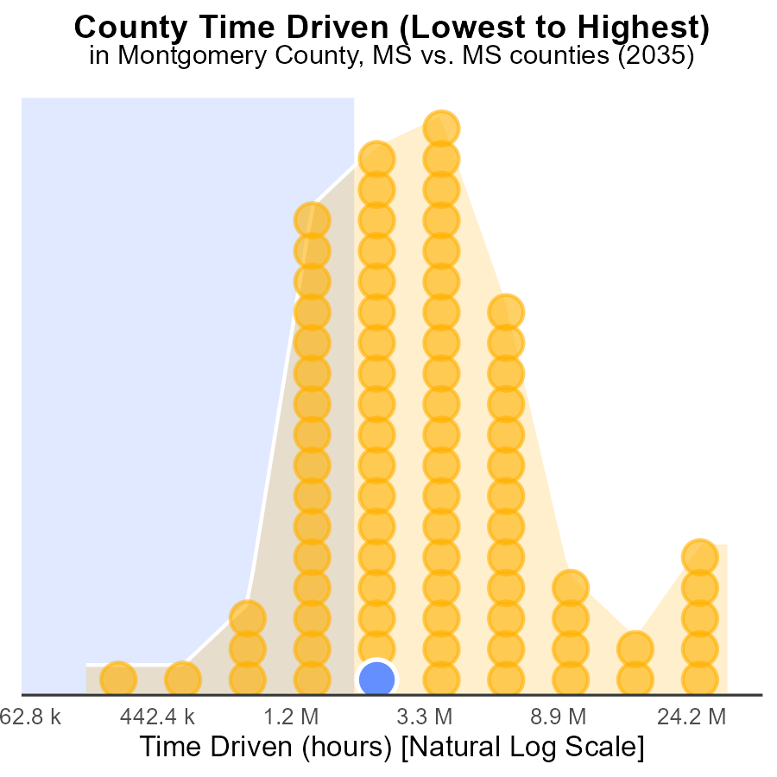

## Findings

* Hinds county has the highest VOC emissions with 88.8 million source hours, ranking 82nd.
* Issaquena county has the lowest VOC emissions with 704,000 source hours, ranking 1st, but only accounts for 1.2% of the total emissions.
* Yalobusha county has VOC emissions of 5.5 million source hours, ranking 23rd, contributing 28.0% of the total emissions.

## Recommendations

To lower VOC emissions, focus on reducing sources in counties with high emissions like Hinds and Yalobusha by implementing stricter emission control measures and promoting cleaner technologies.

# Conclusion

In conclusion, the data from Montgomery County, MS, in 2035 shows a positive trend in decreasing Volatile Organic Compounds (VOC) emissions. With a concerted effort, various strategies have been effective in reducing emissions from on-road transportation. Specifically, focusing on stricter regulations for Rural Unrestricted vehicles and promoting cleaner technologies has yielded significant progress.

To further lower VOC emissions, policymakers should continue to prioritize reduction efforts in the top emitting counties, invest in public transportation infrastructure, and incentivize the adoption of electric vehicles. By enhancing data collection for accurate monitoring and promoting sustainable practices in high emission districts, Montgomery County can continue on the path of reducing VOC emissions and promoting a cleaner environment for the future.

# About This Report

Data based on MOVES estimates collected by the Climate Action in Transportation program at Cornell University. Demographic data sourced from the US Census's American Community Survey 5-year estimates. This report was generated with the help of AI.

# References

* U.S. Census Bureau. (2023). American Community Survey 5-year estimates: Detailed tables. Retrieved from https://data.census.gov
* U.S. Environmental Protection Agency. (2024). Motor Vehicle Emission Simulator (MOVES 4.0) [Software]. Retrieved from https://www.epa.gov/moves