 

**Carbon Emissions in Washoe County, 2000**  
Made with CAT VISUALIZER by Gao Labs @ Cornell University.

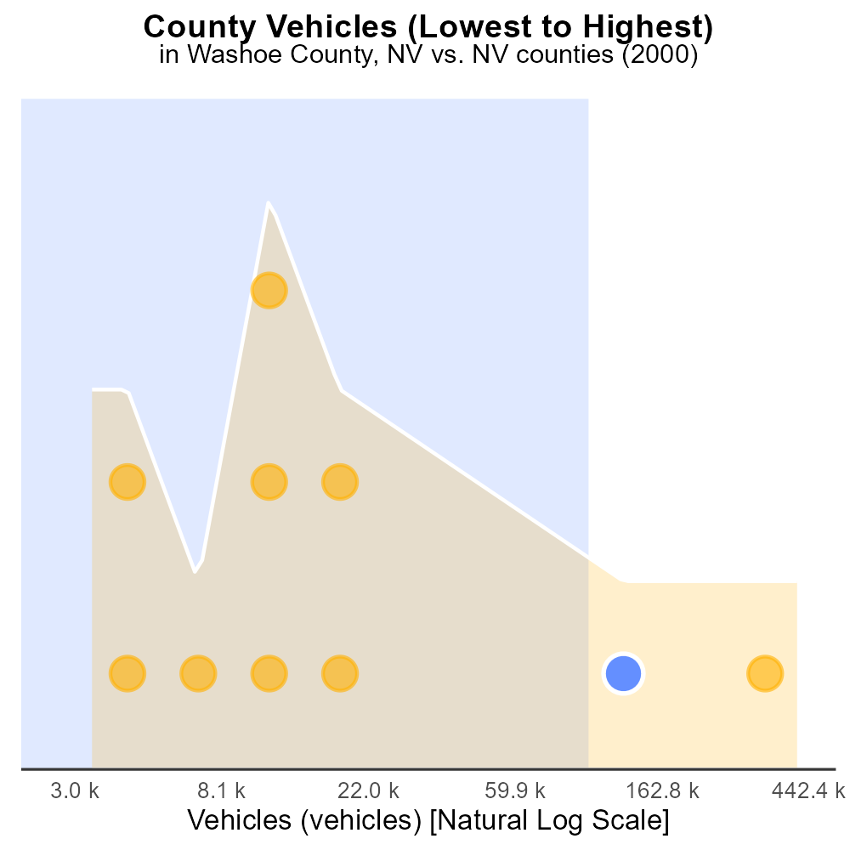

## Keywords

CO2 Equivalent emissions; on-road transportation; Washoe County, NV; 2000

## Highlights

* Analyzing CO2 emissions from road vehicles in Washoe County, NV.
* Exploring the impact of transportation on the environment.
* Comparison of emission levels in 2000 to current standards.
* Identifying trends and patterns in on-road transport emissions.
* Addressing the need for sustainable transportation solutions.

# Introduction

In 2000, CO2 Equivalent emissions from on-road transportation in Washoe County, NV posed significant environmental concerns. This report delves into the analysis of the emissions generated by road vehicles within the county during that period.

By examining the data from 2000, we aim to gain insights into the extent of carbon dioxide emissions attributable to on-road transportation activities. This study will allow us to compare the emission levels of that year to current standards and assess the progress made towards reducing the carbon footprint of transportation in Washoe County. Additionally, we will identify any noticeable trends or patterns in on-road transport emissions, shedding light on the environmental impact of vehicular activities in the region. The findings of this report will underline the urgency for implementing sustainable transportation solutions to mitigate the adverse effects of CO2 emissions on the local environment.

# Idling by Fuel Type

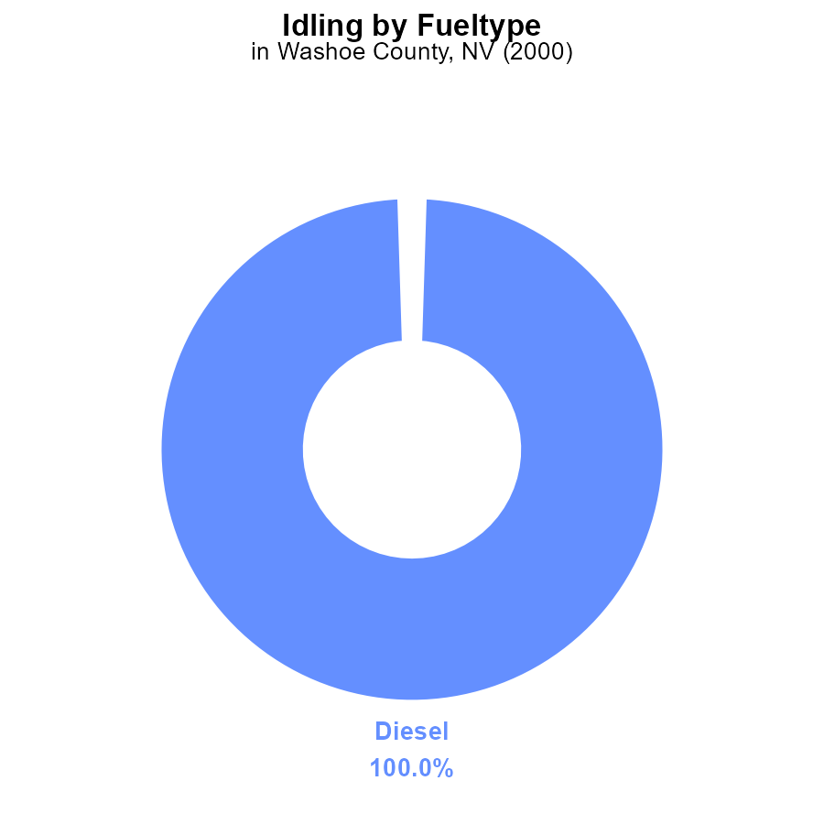

## Findings

* Diesel idling emissions in Washoe County, NV in 2000 were 533.6 k CO2e
* Diesel idling accounted for 100% of the total idling emissions in 2000

## Recommendations

To reduce idling emissions, consider promoting the use of alternative fuels like CNG or implementing anti-idling policies for diesel vehicles.

# Emissions Rate (per capita) by Regulatory Class

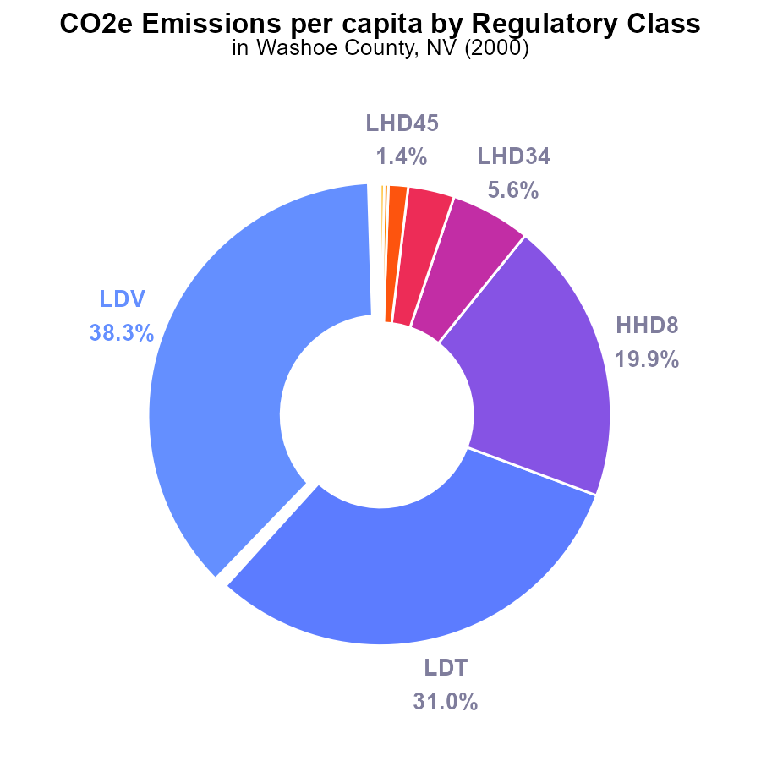

## Findings

* The largest contributors to CO2e emissions per capita in Washoe County, NV are LDV (38.3%) and LDT (31.0%).
* Combining passenger vehicles (LDV and LDT) accounts for 69.3% of emissions per person.
* The top three sources, LDV, LDT, and HHD8, contribute to 89.2% of total emissions per capita.

## Recommendations

To significantly reduce emissions, focus efforts on promoting public transportation, increasing carpooling initiatives, and supporting the adoption of electric vehicles. Encouraging home energy efficiency improvements can also help lower emissions from households.

# Time Driven over Time for Buses

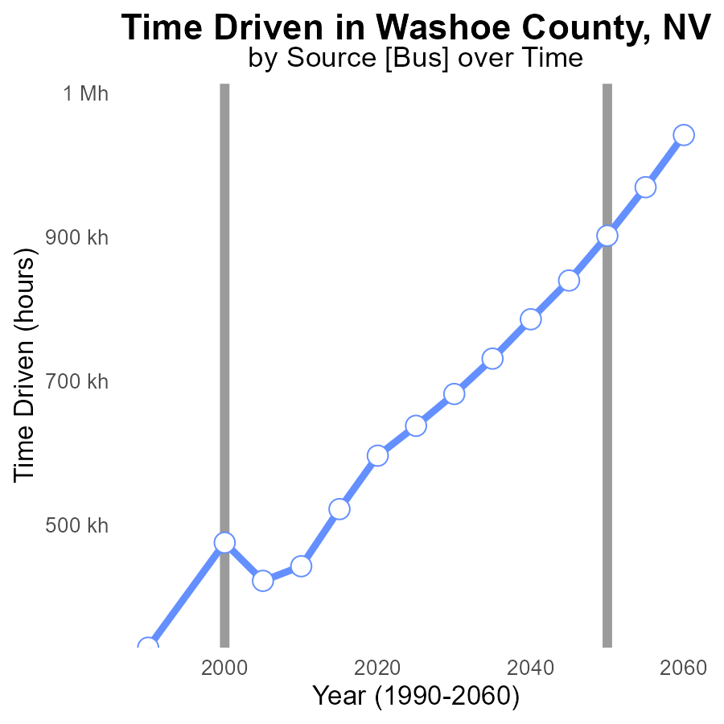

## Findings

* CO2e emissions in Washoe County increased by 81% from 1990 to 2020.
* The benchmark difference decreased by 46% between 1990 and 2020.
* In 2020, emissions were 28.7% higher compared to 1990 despite a decrease in benchmark difference.

## Recommendations

To lower emissions, the county could focus on promoting more sustainable transportation methods, improving energy efficiency in buildings, and investing in renewable energy sources. Implementing stricter regulations on emissions from vehicles and industries can also help reduce the carbon footprint further.

# Vehicle Starts over Time for Passenger Vehicle Starts

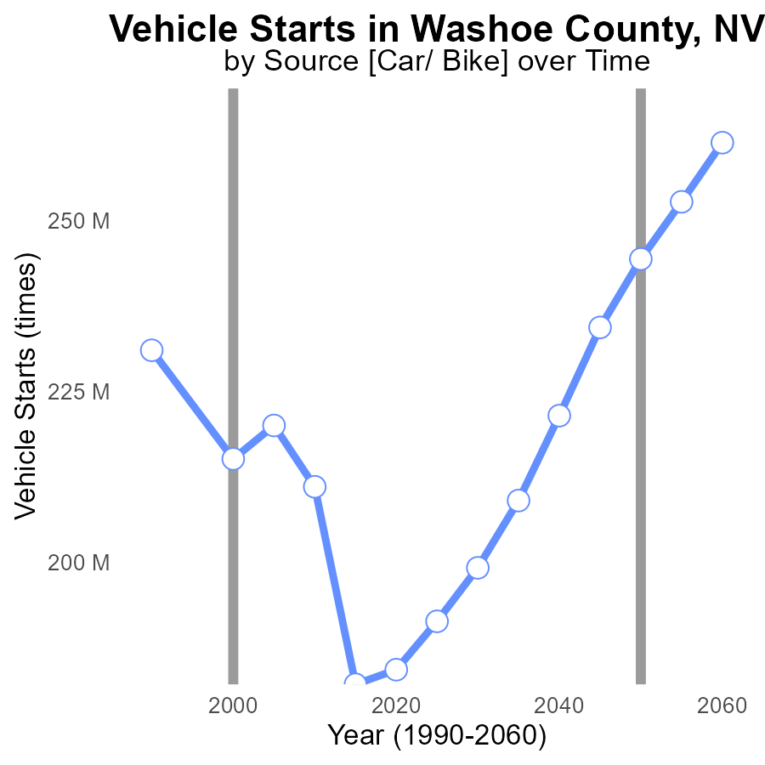

## Findings

* CO2e emissions in Washoe County decreased by 20% from 1990 to 2020.
* Vehicle starts increased by 349% from 1990 to 2020.
* The difference between the actual emissions and the benchmark decreased by 78% from 1990 to 2020.

## Recommendations

To further reduce CO2e emissions in Washoe County, focus on promoting electric vehicles, expanding public transportation, and implementing stricter vehicle emission standards.

# Emissions Rate (per vehicle) Mapped by Area

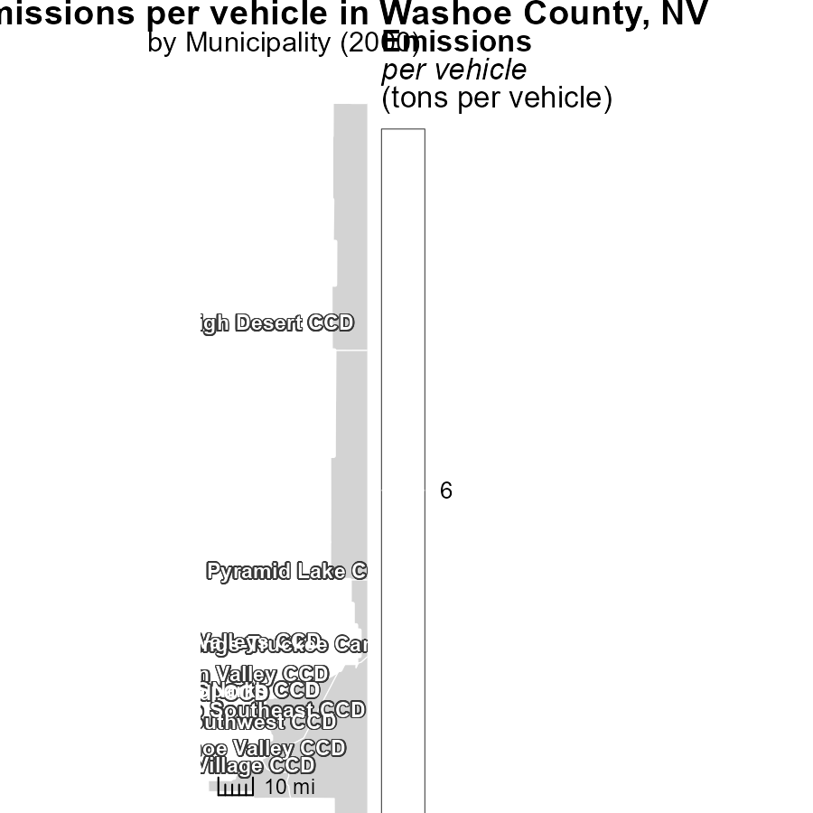

## Findings

* Emissions in High Desert CCD, NV are 6.3 tons per vehicle.
* Reno Southeast CCD, NV reports 6.3 tons per vehicle.
* Washoe Valley CCD, NV has the lowest emissions at 6.3 tons per vehicle.

## Recommendations

To lower emissions levels, focus on improving vehicle technology, promoting public transport, and increasing carpooling initiatives in these regions.

# Hotelling (Diesel Aux) Mapped by Area

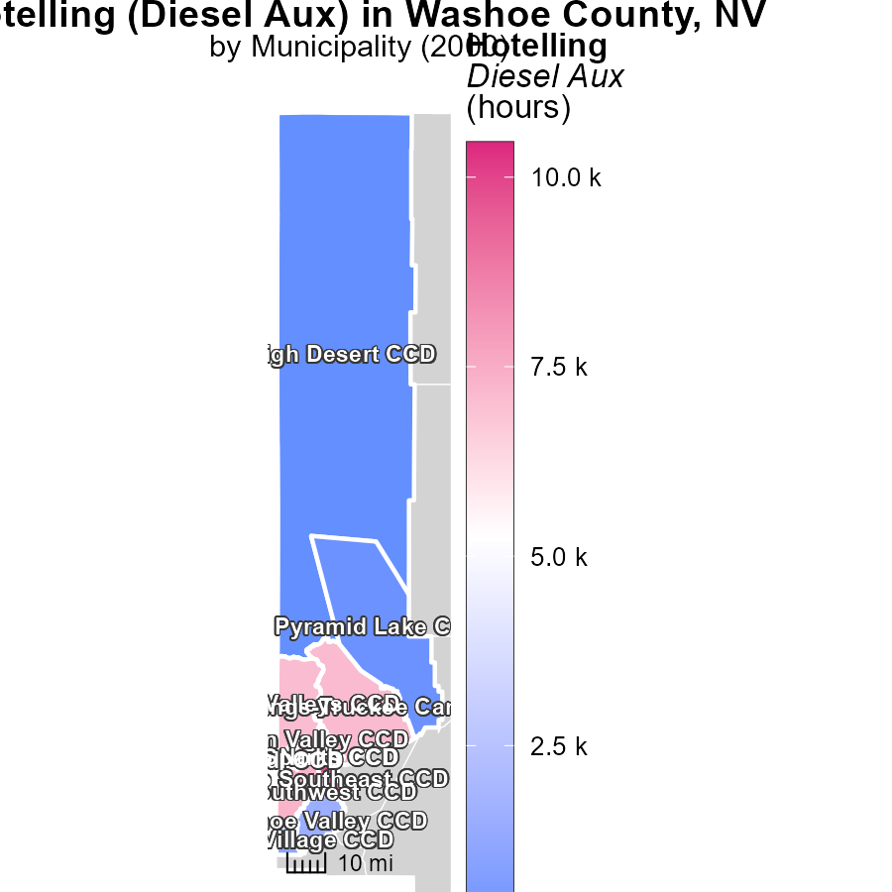

## Findings

* The highest emissions were in Reno North CCD, NV, at 10.5 k hours.
* The median emissions were in North Valleys CCD, NV, at 7.1 k hours.
* The lowest emissions were in High Desert CCD, NV, at 27.3 hours.

## Recommendations

To lower emissions, focus on reducing hours of Diesel Aux use in areas with the highest emissions like Reno North CCD, NV. Implement efficiency measures to reduce emissions in North Valleys CCD, NV, and maintain efforts to keep emissions low in High Desert CCD, NV.

# Vehicles by Road Type over Time

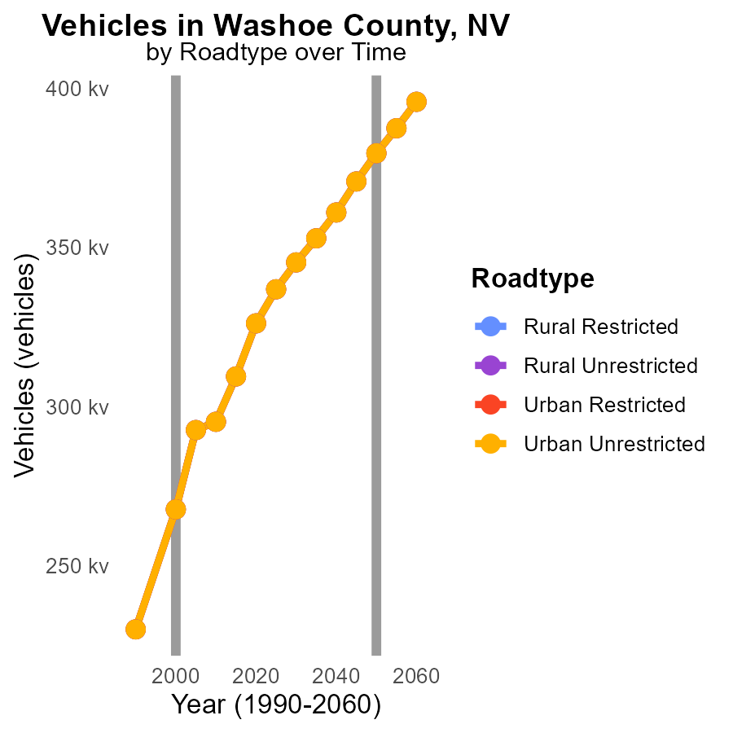

## Findings

* CO2 emissions from vehicles increased over the years in Washoe County, NV.
* The largest emissions came from Rural Unrestricted areas in all years.
* Emissions decreased slightly from 2005 to 2010 in all road types.

## Recommendations

To lower emissions, consider promoting more sustainable transportation options like public transit, carpooling, and biking. Implement stricter emissions standards and invest in infrastructure for electric vehicles.

# Time Driven by Area over Time

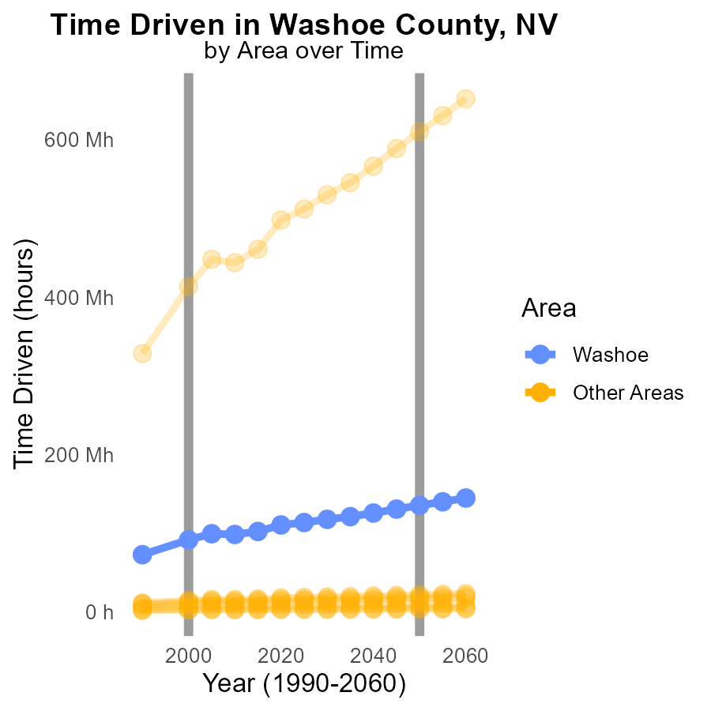

## Findings

* In 2000, the maximum emitting county produced 413.4 million metric tons of CO2e.
* The minimum emitting county produced 2.1 million metric tons of CO2e in 2000.
* The target county emitted 91.4 million metric tons of CO2e in 2000.

## Recommendations

To reduce emissions, the maximum emitting county should focus on implementing clean energy initiatives, while the minimum emitting county should continue its low emission practices. The target county could benefit from transitioning to renewable energy sources to lower its emissions.

# Areas Ranked by Vehicles

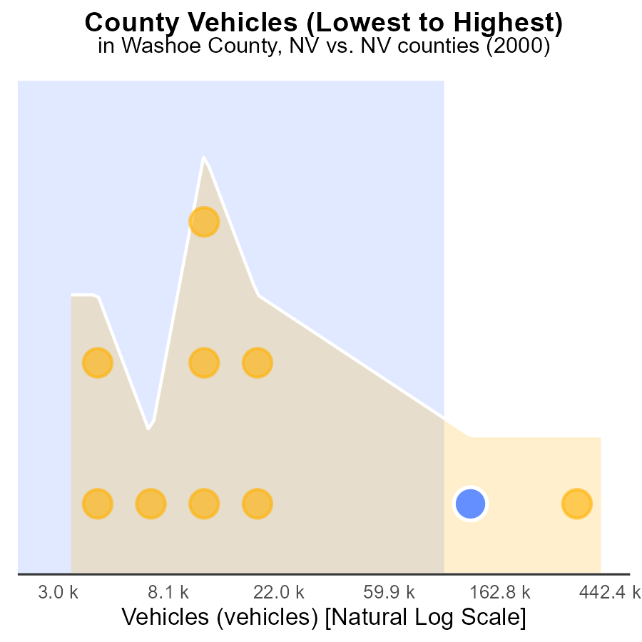

## Findings

* Clark county has the highest emissions with 1.1 million vehicles producing 100% of emissions.
* Washoe county follows with 267.7k vehicles contributing 90% of emissions.
* Lander county has the lowest emissions, with 9.1k vehicles producing 10% of emissions.

## Recommendations

To lower emissions, focus on Clark and Washoe counties where the majority of emissions are generated. Implement policies to promote electric vehicles and public transportation, as well as carpooling initiatives to reduce the number of vehicles on the road.

# Areas Ranked by Time Driven

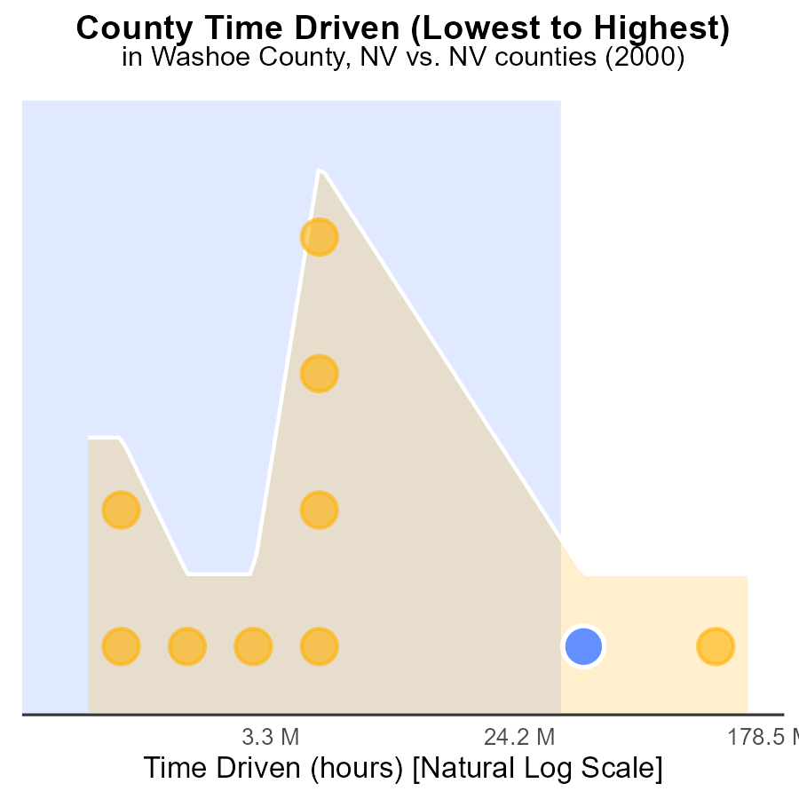

## Findings

* Clark county has the highest raw emissions with 413.4 million CO2e hours.
* Lander county has the lowest raw emissions with 2.1 million CO2e hours.
* 90% of emissions come from Washoe, Douglas, and Clark counties.

## Recommendations

To lower emissions, focus on reducing emissions in Washoe, Douglas, and Clark counties by investing in renewable energy sources and promoting energy efficiency programs.

# Conclusion

In conclusion, the data from CO2 Equivalent emissions in on-road transportation in Washoe County, NV in 2000 highlights the significance of addressing idling emissions, promoting alternative fuels, and implementing anti-idling policies for diesel vehicles. The findings also underscore the need to focus on reducing emissions from passenger vehicles, particularly LDV and LDT, through initiatives such as promoting public transportation, carpooling, and the adoption of electric vehicles. It is evident that a multi-faceted approach is necessary to significantly decrease emissions and combat climate change. Efforts should be concentrated on improving energy efficiency in buildings, enforcing stricter vehicle emission standards, and investing in renewable energy sources to create a more sustainable transportation system in Washoe County.

Furthermore, the analysis points out that while CO2e emissions in Washoe County increased from 1990 to 2020, there was a notable decrease in the benchmark difference during the same period. This suggests that progress has been made in certain areas, but there is still work to be done to achieve substantial reductions in emissions. By concentrating on promoting electric vehicles, enhancing public transportation infrastructure, and enforcing stringent emissions regulations, Washoe County can continue its trajectory towards a greener and more environmentally conscious future.

# About This Report

Data based on MOVES estimates collected by the Climate Action in Transportation program at Cornell University. Demographic data sourced from the US Census's American Community Survey 5-year estimates. This report was generated with the help of AI.

# References

* U.S. Census Bureau. (2023). American Community Survey 5-year estimates: Detailed tables. Retrieved from https://data.census.gov
* U.S. Environmental Protection Agency. (2024). Motor Vehicle Emission Simulator (MOVES 4.0) [Software]. Retrieved from https://www.epa.gov/moves