 

**Carbon Emissions in Lawrence County, 2055**  
Made with CAT VISUALIZER by Gao Labs @ Cornell University.

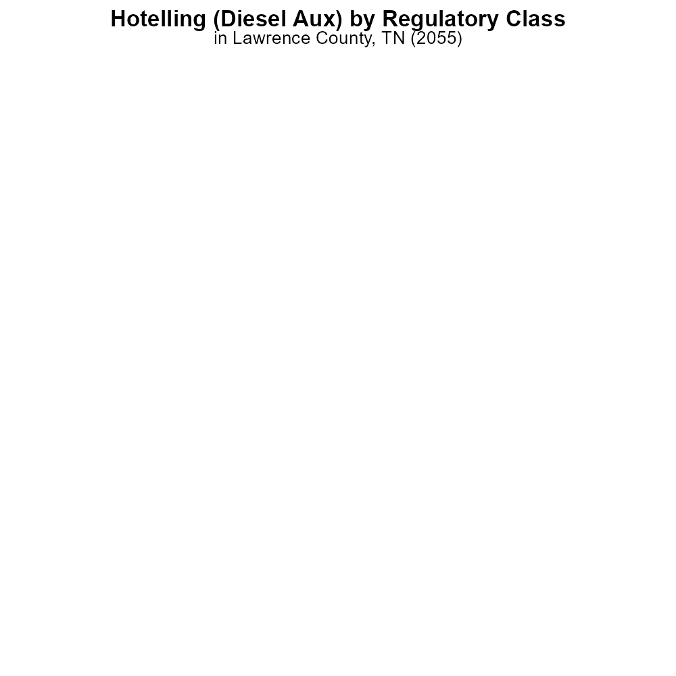

## Keywords

CO2 Equivalent emissions; on-road transportation; Lawrence County, TN; 2055

## Highlights

* Impact of on-road transportation on CO2 emissions in Lawrence County, TN in 2055.
* Analysis of trends and projections for CO2 Equivalent emissions from transportation.
* Comparison of current emissions levels to future estimates in the county.
* Identification of factors influencing the rise or fall of emissions in the region.
* Recommendations for sustainable practices to reduce on-road transportation emissions.

# Introduction

Investigating the CO2 Equivalent emissions from on-road transportation in Lawrence County, TN in 2055 is crucial for understanding the environmental impact of the region's mobility sector. This report aims to analyze the current trends, projections, and factors affecting these emissions, providing insights into the future trajectory of environmental sustainability in the county. By delving into the data concerning CO2 Equivalent emissions, this report will shed light on how on-road transportation contributes to the overall carbon footprint of Lawrence County.

Furthermore, the report will offer recommendations on adopting sustainable practices to mitigate the growing emissions from transportation, paving the way for a greener and more eco-friendly future for the region. By examining the intersection of transportation and environmental impact, this report will provide valuable insights for policymakers, stakeholders, and the community at large.

# Hotelling (Diesel Aux) by Regulatory Class

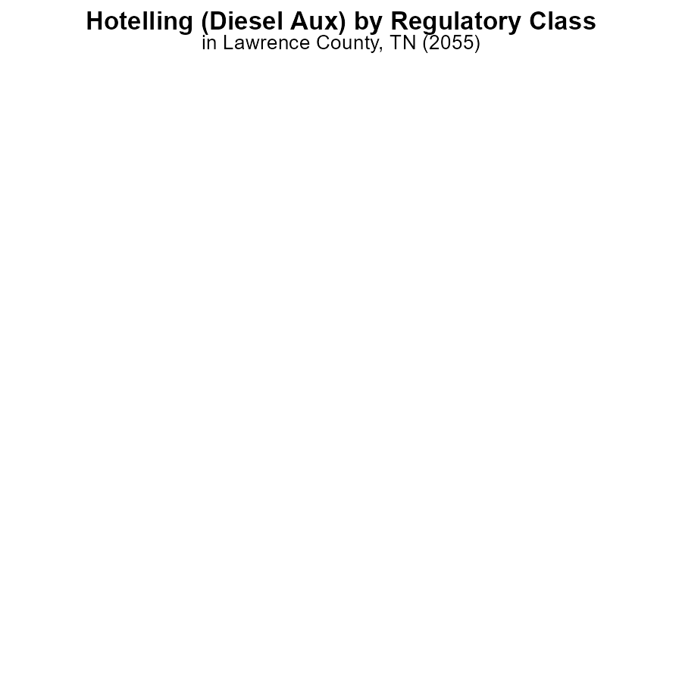

## Findings

* Glider emissions: 0.0 CO2e
* HHD8 emissions: 0.0 CO2e
* No data available for LDT, LDV, LHD34, MHD67, or Urban Bus

## Recommendations

To lower emissions, focus on monitoring and reducing emissions from Glider and HHD8 vehicles. Gather data for missing vehicle types to assess their impact accurately.

# Emissions Rate (per mile) by Fuel Type

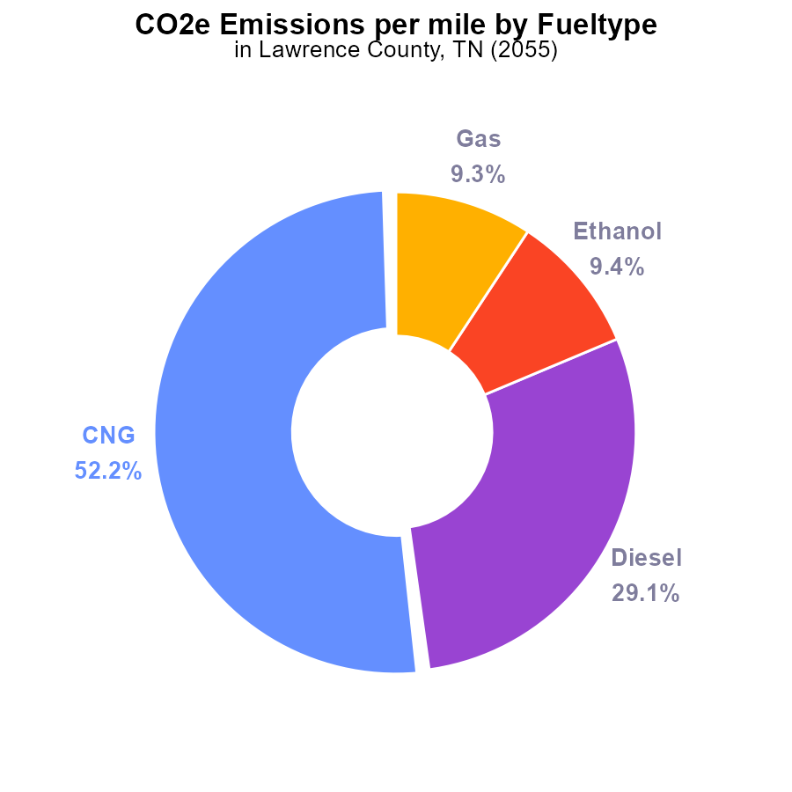

## Findings

* The majority of emissions in Lawrence County, TN in 2055 are from CNG vehicles at 52.2%.
* Diesel vehicles contribute significantly to emissions, accounting for 29.1% of the total.
* Ethanol and Gas vehicles are responsible for 9.4% and 9.3% of emissions, respectively.

## Recommendations

To lower emissions, policymakers should focus on transitioning to cleaner fuel sources for vehicles, especially targeting CNG and Diesel vehicles, which contribute the most to the emissions in Lawrence County, TN.

# Time Driven over Time for Passenger Time Driven

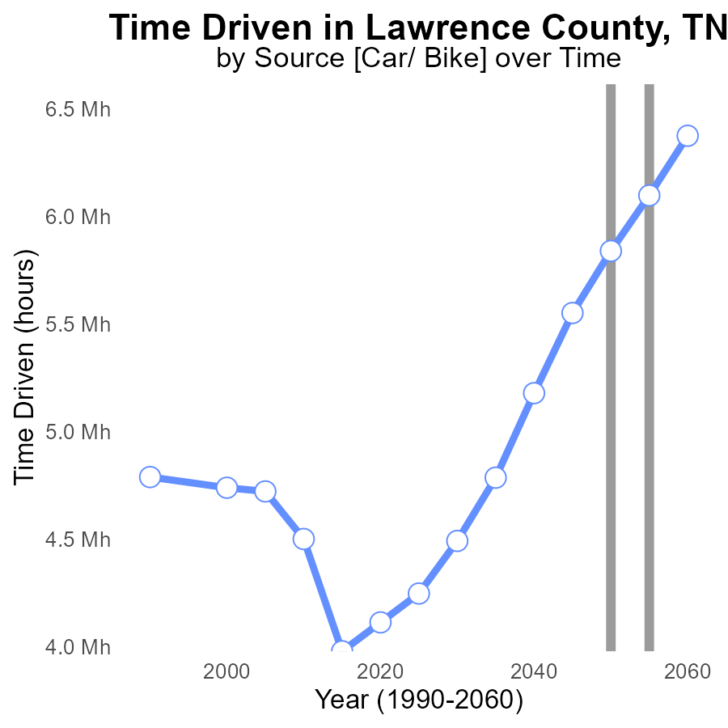

## Findings

* Emissions in Lawrence County, TN have been gradually increasing over the years.
* The largest decrease in emissions, around 8.9%, is seen between 2050 and 2055.
* By 2060, emissions are projected to be reduced by approximately 13.9% compared to 2050 levels.

## Recommendations

To lower emissions in Lawrence County, TN, it is recommended to continue investing in sustainable transportation methods and increasing energy efficiency in buildings. Additionally, promoting renewable energy sources can aid in further reducing emissions.

# Hotelling (Engines Off) Overall over Time

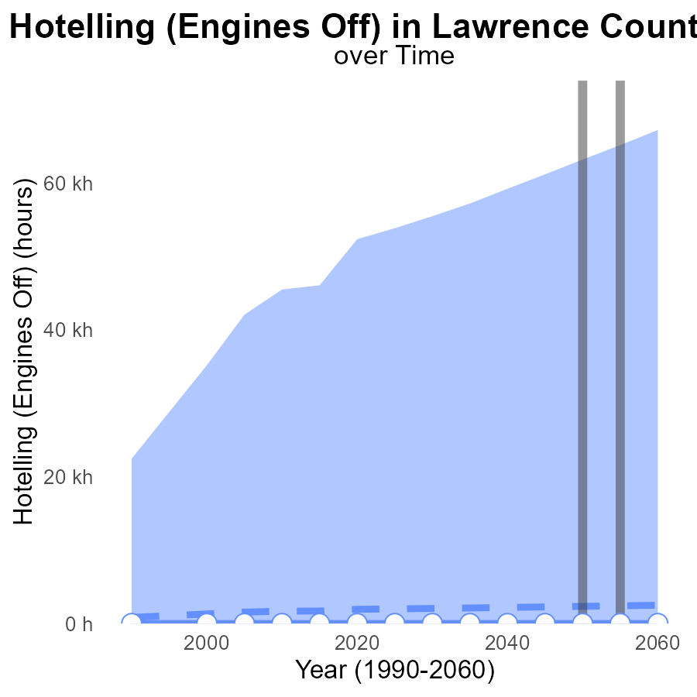

## Findings

* Emissions in Lawrence County, TN are consistently 2.1-2.5 k lower than the median area emissions, showing a positive environmental impact.
* The upper 75th percentile of areas emit significantly higher emissions, with values ranging from 57,181.65 to 67,189.00 CO2e.
* Despite the lower emissions, there seems to be stagnant progress over the years, with no change in benchmark differences recorded.

## Recommendations

To further lower emissions in Lawrence County, TN, initiatives focusing on maintaining or surpassing the current emission levels should be considered. Exploring renewable energy sources and enforcing stricter emission standards can aid in sustaining the positive impact on the environment.

# Emissions Rate (per mile) in My Region

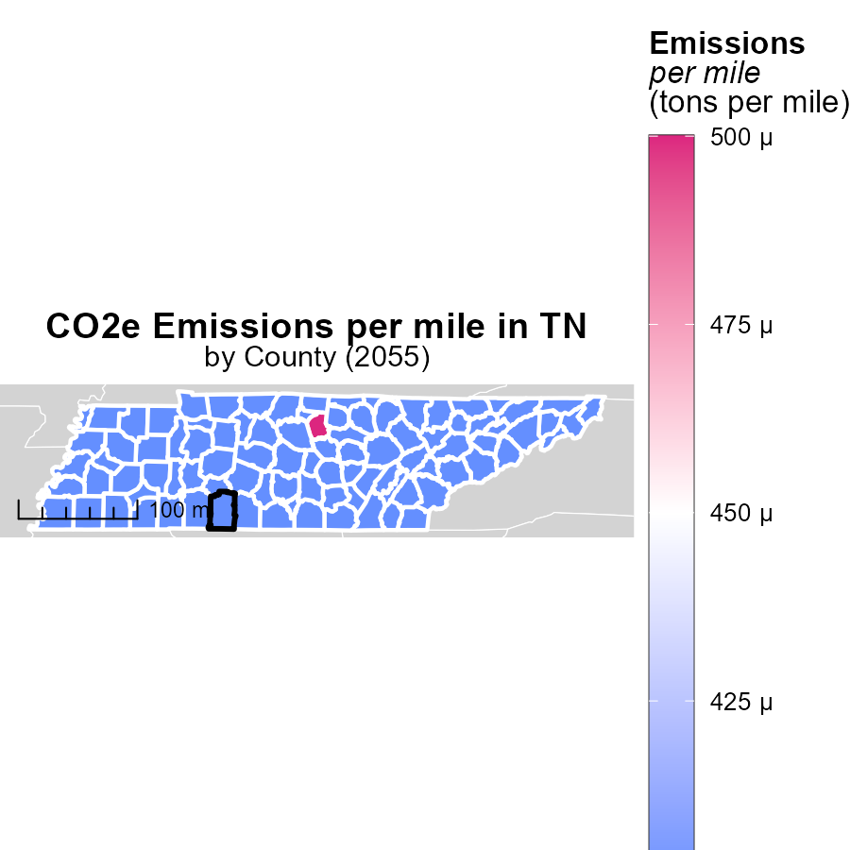

## Findings

* Smith County, TN has the highest emissions per mile at 450.1 tons.
* Knox County, TN has a median emissions rate of 377.7 tons per mile.
* Wilson County, TN has the lowest emissions per mile at 391.4 tons.

## Recommendations

To lower emissions, implement county-specific vehicle emission standards, incentivize electric vehicle usage, and promote public transportation options.

# Vehicle Miles Traveled Mapped by Area

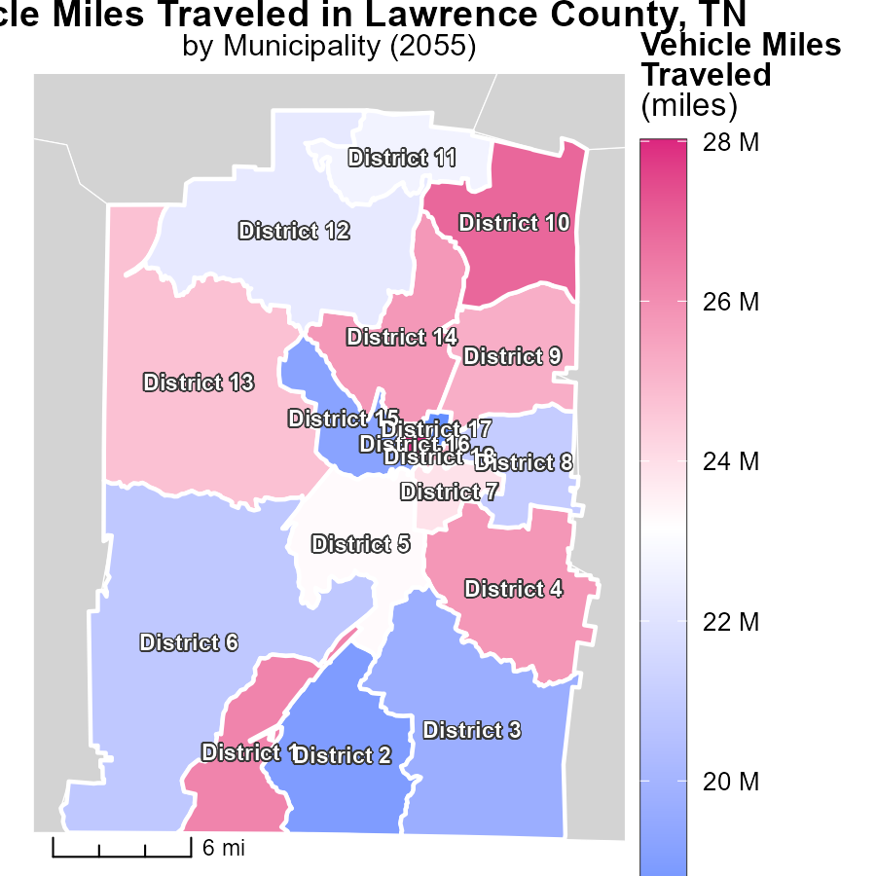

## Findings

* District 16, TN has the highest vehicle miles traveled at 28.0 million miles.
* District 5, TN has a median level of 23.3 million miles traveled.
* District 17, TN has the lowest vehicle miles traveled at 18.3 million miles.

## Recommendations

To lower emissions, District 16 should promote carpooling or public transportation. District 5 could incentivize the use of electric vehicles. District 17 may benefit from encouraging biking or walking for shorter trips. Implementing these measures can help decrease overall emissions from vehicle travel.

# Vehicle Starts by Fuel Type over Time

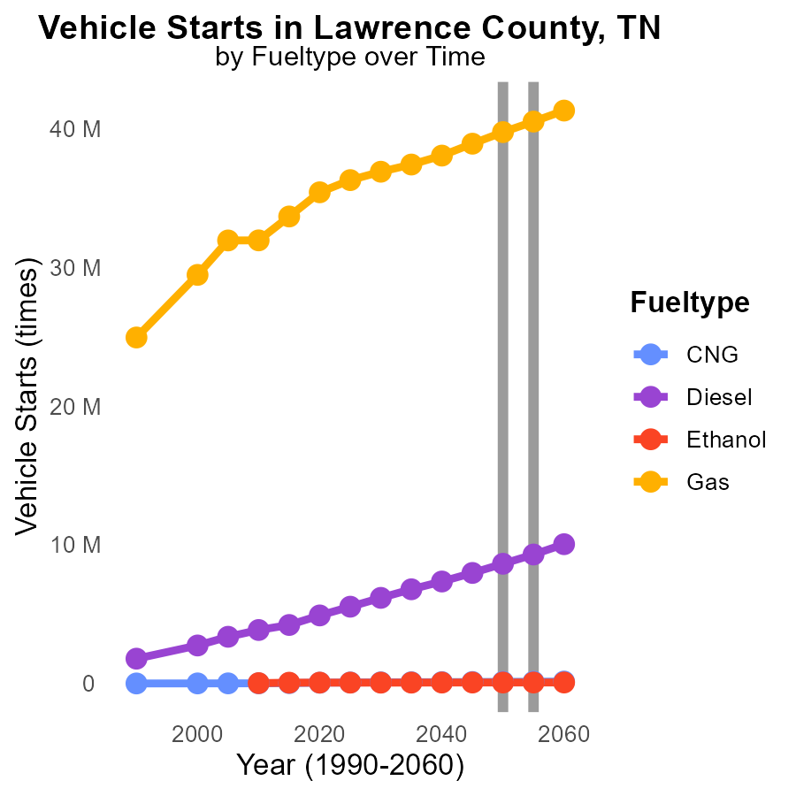

## Findings

* Vehicle starts with CNG fuel type are projected to increase by 32.1% from 2045 to 2060.
* Diesel fuel type shows a decrease in vehicle starts by 16.4% from 2050 to 2060.
* Gas fuel type displays a consistent rise in vehicle starts over the years with an overall increase of 4.4% from 2045 to 2060.

## Recommendations

To decrease CO2 emissions, encourage a gradual shift from diesel to CNG vehicles by providing incentives for CNG vehicle adoption. Invest in infrastructure supporting gas fuel to maintain its upward trajectory, potentially by introducing cleaner gas options. Implement strict regulations to limit diesel vehicle usage to combat the decreasing trend observed in diesel vehicle starts.

# Hotelling (Engines Off) by Fuel Type over Time

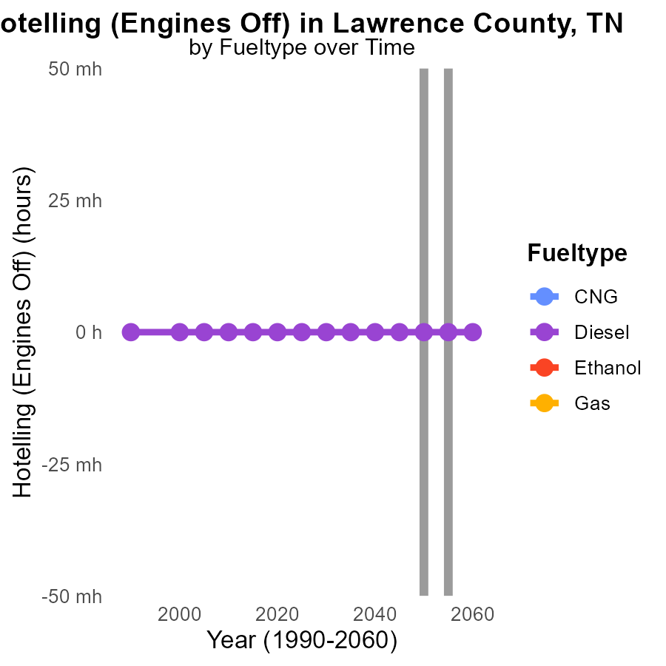

## Findings

* No data is available for CO2e emissions for the years 2045-2060 for all fuel types.
* Emissions for Diesel fuel in Lawrence County, TN are consistently 0.0 CO2e from 2045 to 2060.
* There is a lack of data for CNG, Ethanol, and Gas emissions in Lawrence County, TN from 2045 to 2060.

## Recommendations

To effectively address emissions, it is crucial to gather detailed data on CNG, Ethanol, and Gas emissions in Lawrence County, TN for better policy-making. Implement monitoring systems to track emissions accurately.

# Areas Ranked by Emissions

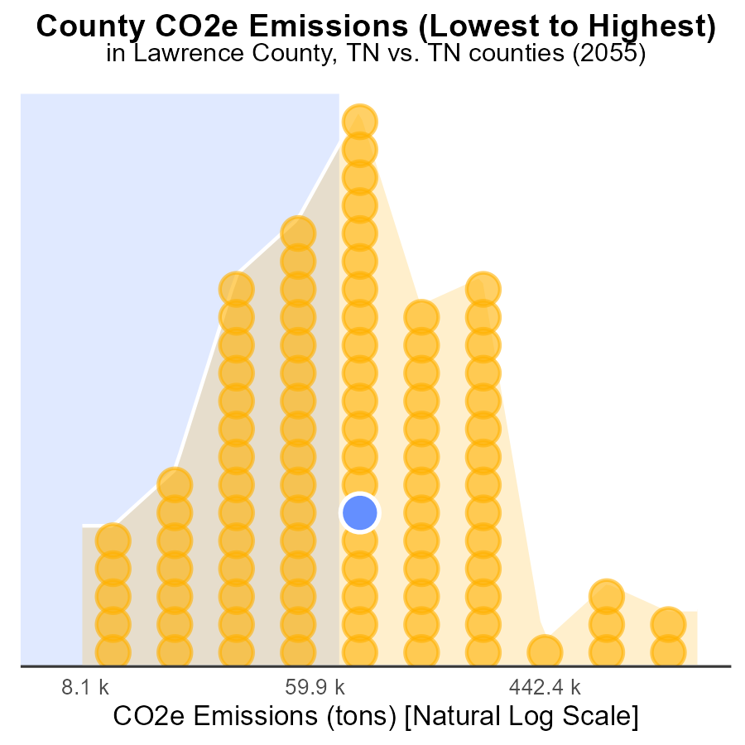

## Findings

* Shelby county has the highest emissions at 4.6 million tons, ranking 95th.
* Lake county has the lowest emissions at 21.5 thousand tons, ranking 1st.
* The top 5 counties contribute to 16.2% of total emissions.

## Recommendations

To lower emissions, focus on high-emitting counties like Shelby by implementing stricter regulations and promoting sustainable practices. Provide incentives for counties with lower emissions, like Lake, to maintain their environmental efforts.

# Areas Ranked by Population

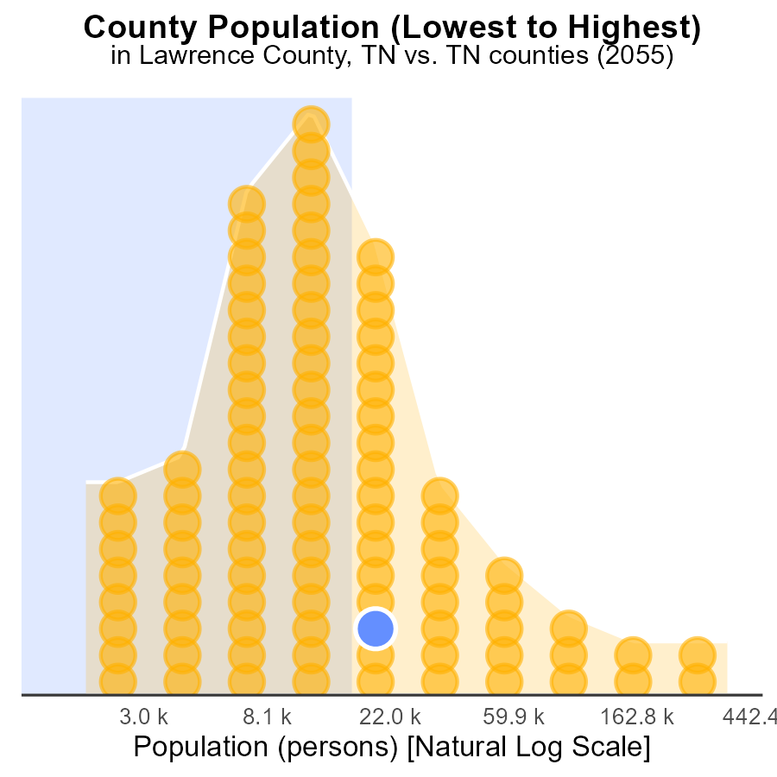

## Findings

* Shelby county has the highest population with 936.6k persons.
* Lawrence county emits CO2e equivalent to 64.2% of Shelby's emission.
* Pickett county has the second-lowest population at 5.1k persons.

## Recommendations

To lower emissions, focus efforts on high-population areas for significant impact. Implement green initiatives in Shelby county; consider carbon offset programs in Lawrence county; promote sustainable practices in Pickett county.

# Conclusion

In conclusion, the data on CO2 equivalent emissions from on-road transportation in Lawrence County, TN in 2055 paints a concerning picture of the current situation. While some progress has been made in reducing emissions, particularly with a noticeable decrease of 8.9% between 2050 and 2055, there is a pressing need for more comprehensive strategies to combat the escalating emissions.

The majority of emissions stem from CNG vehicles, accounting for 52.2% of the total, closely followed by Diesel vehicles at 29.1%. To address this, policymakers should prioritize transitioning to cleaner fuel sources, especially for these high-emitting vehicle types. In addition, the lack of data for certain fuel types indicates a crucial necessity for more comprehensive data collection and monitoring systems to accurately assess the impact of different vehicles on emissions.

Furthermore, while Lawrence County's emissions are lower compared to other areas, stagnation in progress suggests the need for more proactive measures. Implementing sustainable transportation methods, increasing energy efficiency, and promoting renewable energy sources are key steps that can be taken to further reduce emissions. By focusing on these strategies and continuing to invest in environmentally friendly practices, Lawrence County can pave the way towards a greener and more sustainable future.

# About This Report

Data based on MOVES estimates collected by the Climate Action in Transportation program at Cornell University. Demographic data sourced from the US Census's American Community Survey 5-year estimates. This report was generated with the help of AI.

# References

* U.S. Census Bureau. (2023). American Community Survey 5-year estimates: Detailed tables. Retrieved from https://data.census.gov
* U.S. Environmental Protection Agency. (2024). Motor Vehicle Emission Simulator (MOVES 4.0) [Software]. Retrieved from https://www.epa.gov/moves