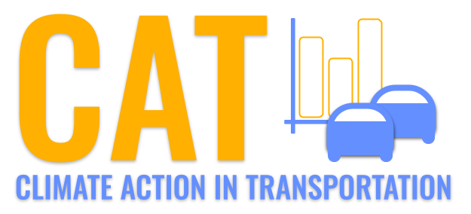 

**Carbon Emissions in Calvert County, 2035**  
Made with CAT VISUALIZER by Gao Labs @ Cornell University.

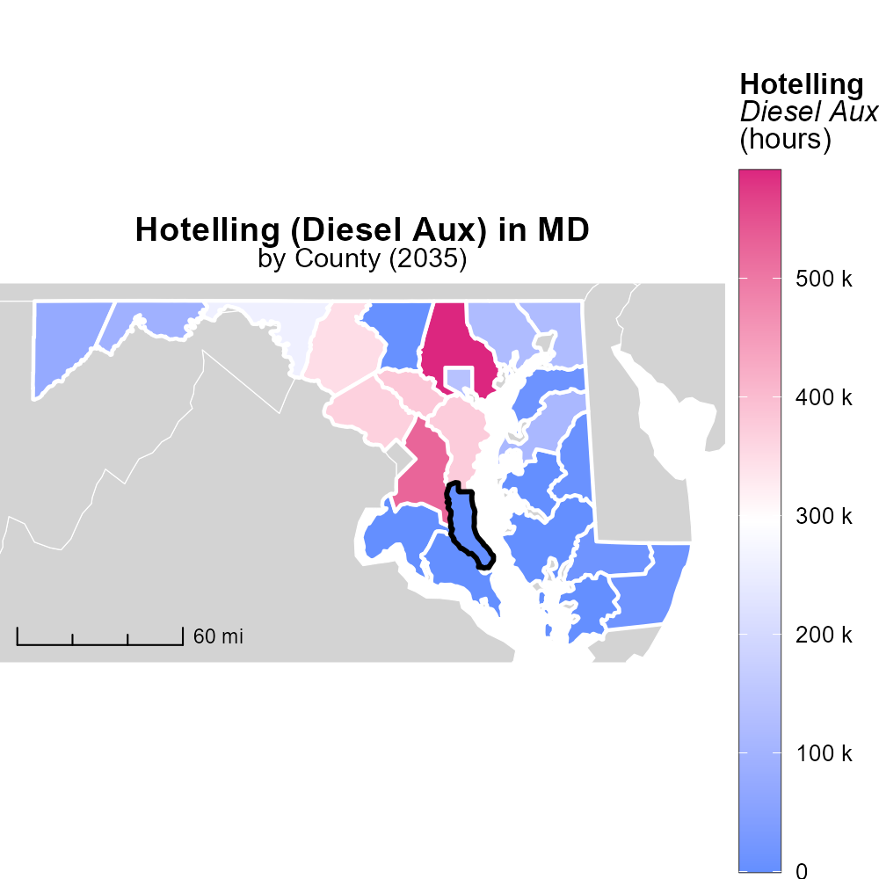

## Keywords

CO2 equivalent emissions; on-road transportation; Calvert County; MD; 2035; report

## Highlights

* Study on CO2 emissions from transportation in Calvert County.
* Analysis of on-road transportation's impact on environment.
* Predictions of future CO2 equivalent emissions in 2035.
* Recommendations for reducing emissions from transportation.
* Importance of addressing emissions for a sustainable future.

# Introduction

In 2035, Calvert County, MD faces a critical juncture in its efforts to address CO2 equivalent emissions from on-road transportation. This report delves into the current scenario, analyzing the impact of vehicular activities on the environment and projecting future emission levels based on existing trends and development plans.

With a focus on sustainable practices, the study aims to provide valuable insights and data-driven recommendations to policymakers, urban planners, and residents. The findings of this report not only shed light on the environmental challenges posed by on-road transportation but also highlight the urgent need for collaborative efforts to mitigate these emissions for a greener and healthier future.

# Time Driven by Vehicle Type

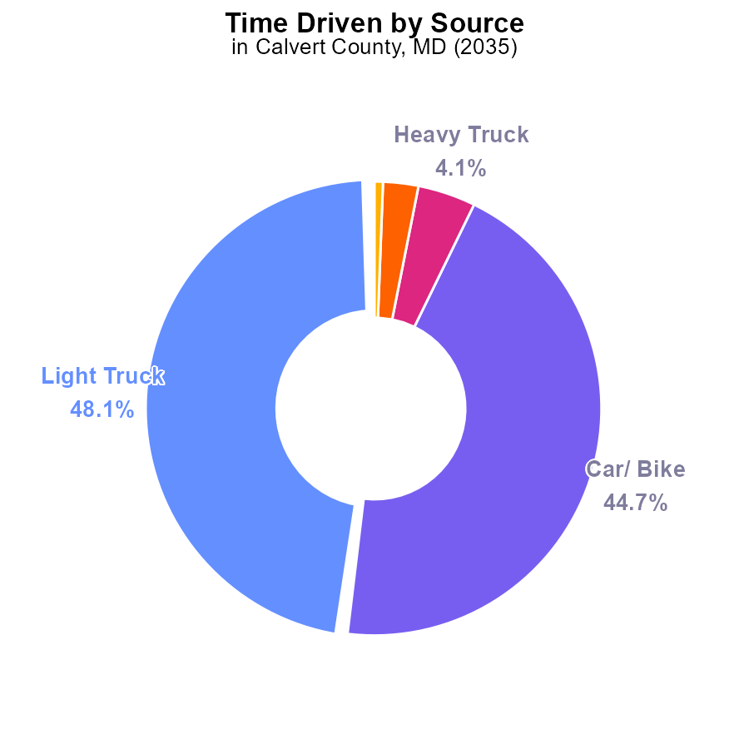

## Findings

* Light trucks emit 48.1% of the total CO2e from transportation in 2035.
* Cars/bikes emit 44.7% of the total CO2e from transportation in 2035.
* Heavy trucks, combo trucks, and buses together emit less than 8% of the total CO2e from transportation in 2035.

## Recommendations

To lower emissions, focus on reducing CO2e from light trucks and cars/bikes, as they contribute to over 92% of total emissions. Implement measures such as promoting public transport, carpooling, and transitioning to electric vehicles to mitigate the impact.

# Vehicle Starts by Fuel Type

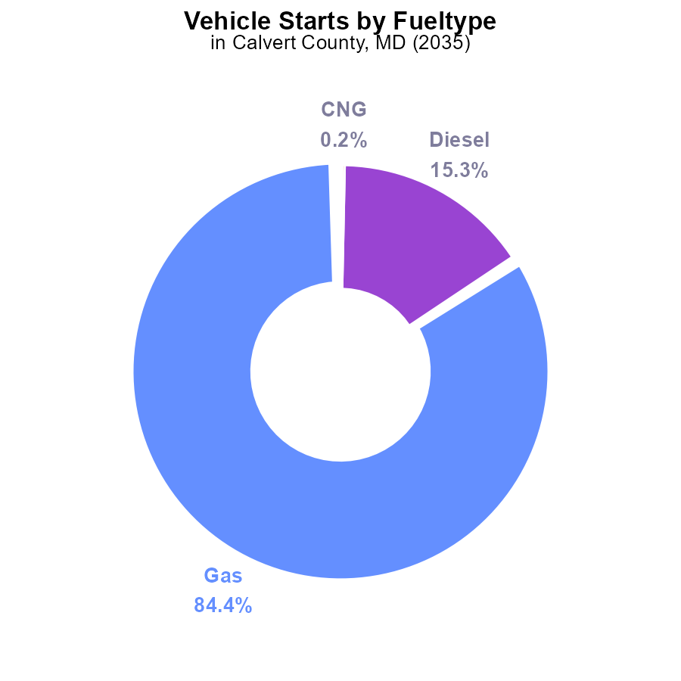

## Findings

* Gasoline vehicles account for 84.4% of total CO2e emissions from vehicle starts in Calvert County.
* Diesel vehicles contribute to 15.3% of the total CO2e emissions from vehicle starts in the county.
* Alternative fuel types like CNG and Ethanol each have a minimal impact, each contributing less than 0.2%.

## Recommendations

To lower emissions, policymakers should focus on strategies to transition from gasoline and diesel vehicles to cleaner alternatives like electric vehicles. Implementing incentives and infrastructure for electric vehicles can significantly reduce CO2e emissions.

# Vehicle Miles Traveled over Time for Passenger Vehicles

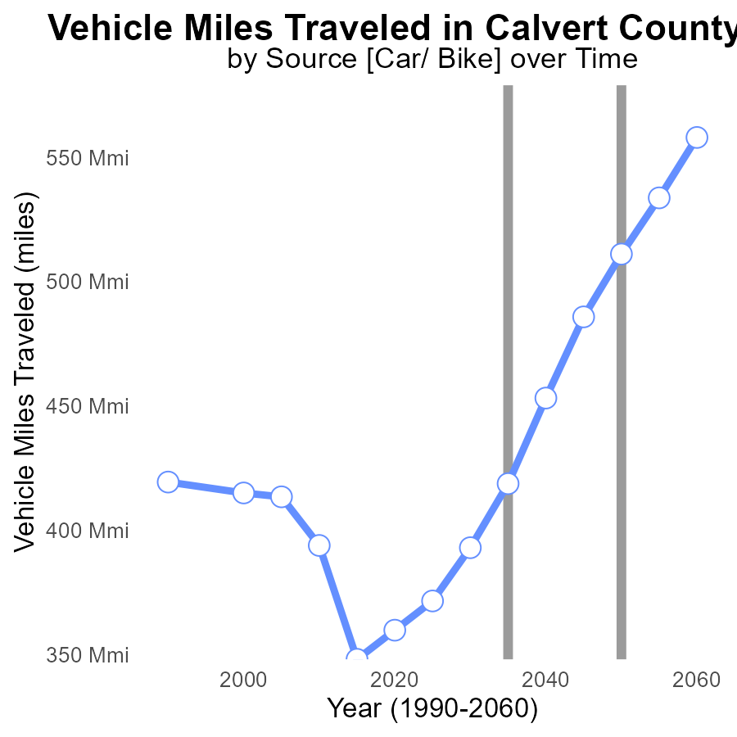

## Findings

* Vehicle miles traveled in Calvert County have increased steadily from 348.2 million miles in 2015 to 533.7 million miles in 2055.
* The benchmark difference has fluctuated, reaching its lowest point in 2050 with zero difference and hitting a peak in 2015 with over 162 million excess miles.
* Emissions could be reduced by promoting telecommuting, public transport, and carpooling to offset the steady increase in vehicle miles traveled observed over the years.

## Recommendations

To lower emissions linked to the rising vehicle miles traveled trend in Calvert County, policymakers should prioritize investments in public transportation infrastructure and promote telecommuting options. Encouraging carpooling and implementing flexible work arrangements can also help reduce the reliance on personal vehicles and subsequently decrease emissions levels over time.

# Vehicles Overall over Time

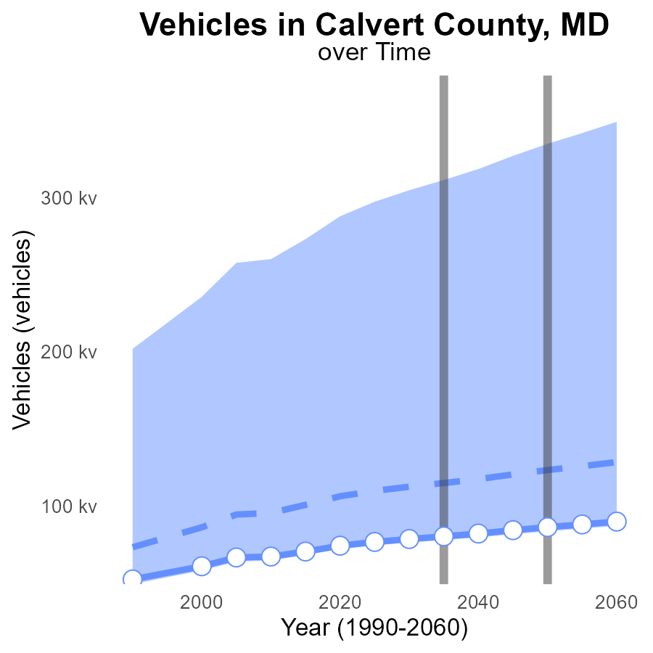

## Findings

* By 2055, CO2e emissions from vehicles are projected to increase to 88.1k, a decrease of 37.8k from the median.
* Throughout the period, the emissions are consistently below the upper 75th percentile of areas for benchmarking.
* There is a downward trend in emissions difference from the benchmark, improving steadily over time.

## Recommendations

To decrease CO2e emissions further, policies promoting electric vehicles and public transport should be implemented. Incentives for carpooling and telecommuting can also reduce emissions.

# Hotelling (Diesel Aux) in My Region

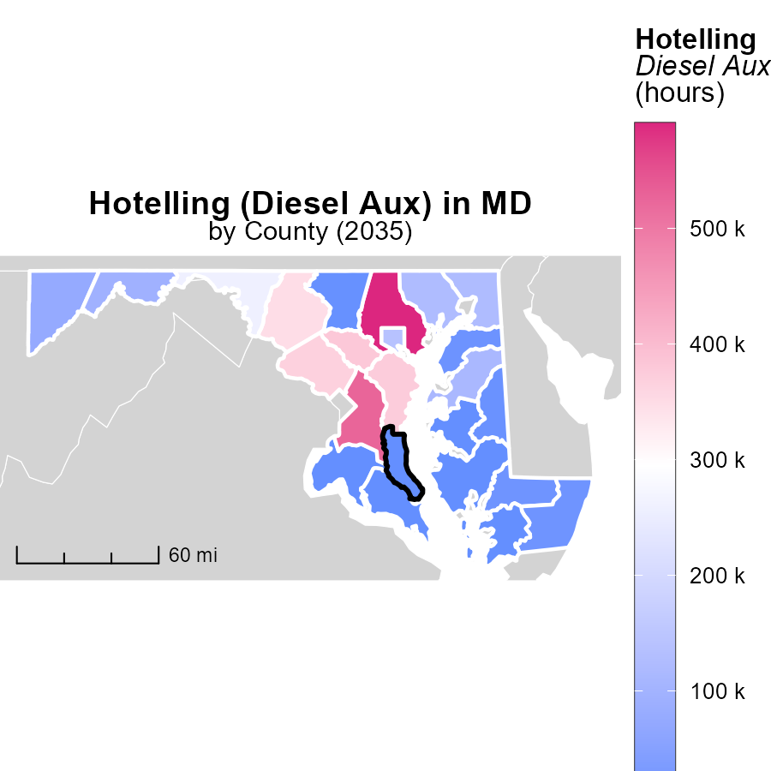

## Findings

* Baltimore County, MD emitted the highest raw emissions with 590.7 k tons.
* Allegany County, MD had a median raw emission of 94.9 k tons.
* Talbot County, MD had the lowest raw emissions at 0.0 tons.

## Recommendations

To lower emissions, Baltimore County should invest in cleaner energy sources for Hotelling (Diesel Aux) to reduce the high emission level. Allegany County could implement emission control measures to decrease its median emissions. Talbot County should continue maintaining its emission-free status and focus on sustainable practices to uphold its low emissions.

# Emissions Rate (per mile) in My Region

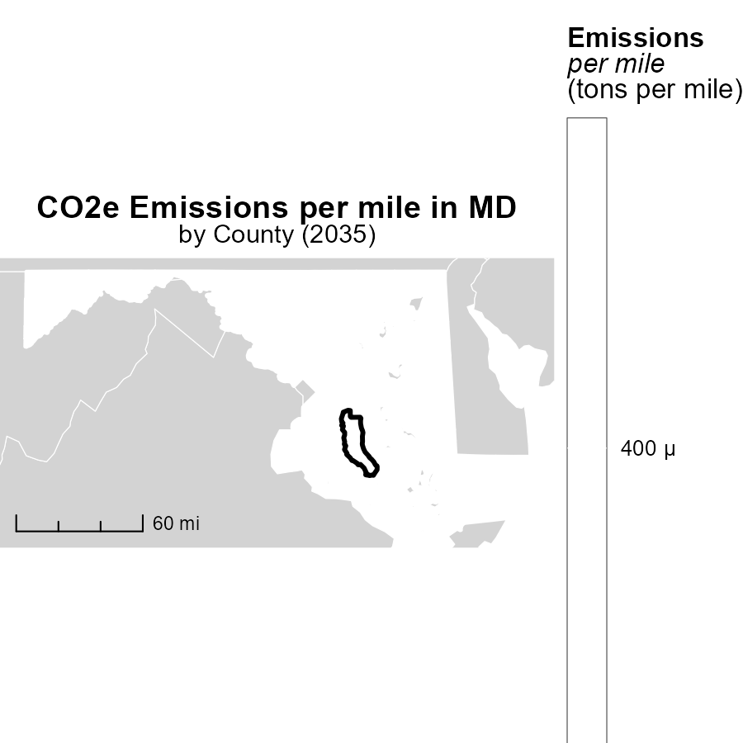

## Findings

* Allegany County, MD has the highest emissions per mile at 422.5 tons.
* Harford County, MD has a median emissions level of 394.8 tons per mile.
* Baltimore city, Maryland County, MD has the lowest emissions per mile at 391.0 tons.

## Recommendations

To lower emissions per mile, Allegany County, MD should invest in cleaner transportation methods. Harford County, MD could promote carpooling initiatives. Baltimore city, Maryland County, MD should focus on improving public transportation systems.

# Vehicle Starts by Regulatory Class over Time

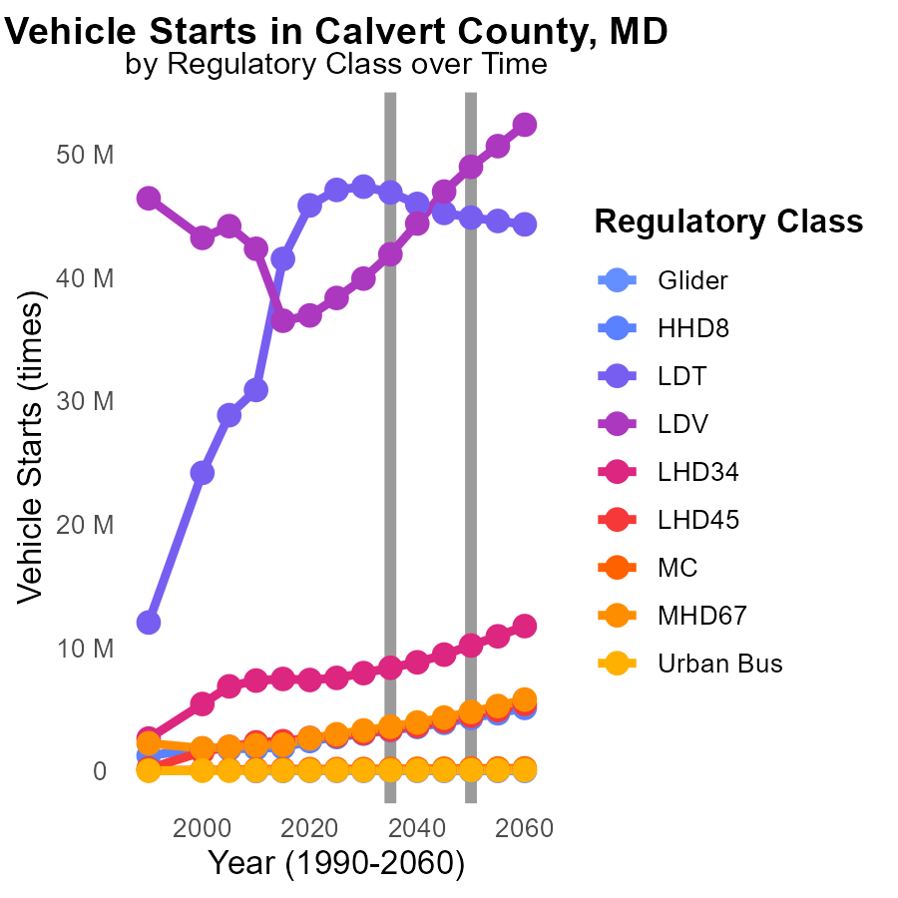

## Findings

* From 2025 to 2045, CO2e emissions from LDV are projected to increase by approximately 10626936.1 tonnes.
* CO2e emissions from LDT vehicles are projected to decrease by around 377878.2 tonnes between 2025 and 2045.
* MC emissions are predicted to rise, with an increase of 8198.0 tonnes by 2045 compared to 2050 levels.

## Recommendations

To lower emissions, policymakers could focus on promoting the adoption of electric vehicles in the LDV category to offset the projected increase. Implementing stricter regulations on MC emissions can help reduce the predicted rise in this sector.

# Emissions Rate (per vehicle) by Area over Time

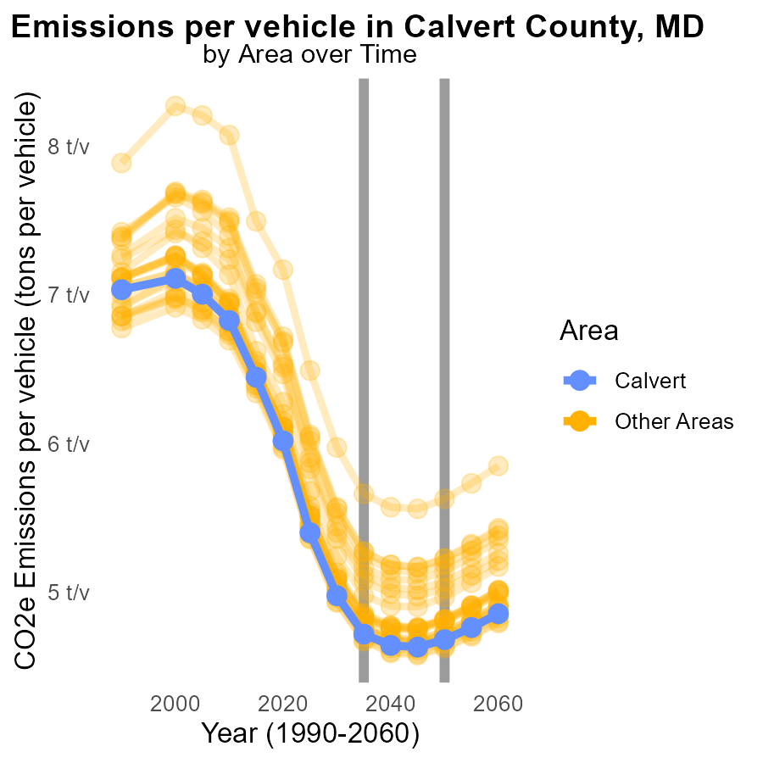

## Findings

* In 2035, the average CO2e emissions per vehicle in target_county were 4.7 tons, which is 0.0371 tons lower than in 2050.
* In the same year, max_county recorded 5.7 tons per vehicle, 0.0342 tons less than in 2050.
* Meanwhile, min_county had the lowest emissions of 4.7 tons per vehicle in 2035, showing a decrease of 0.0461 tons compared to 2050.

## Recommendations

To reduce emissions, encourage the adoption of electric vehicles, enhance public transportation, and incentivize carpooling in all counties.

# Areas Ranked by Vehicles

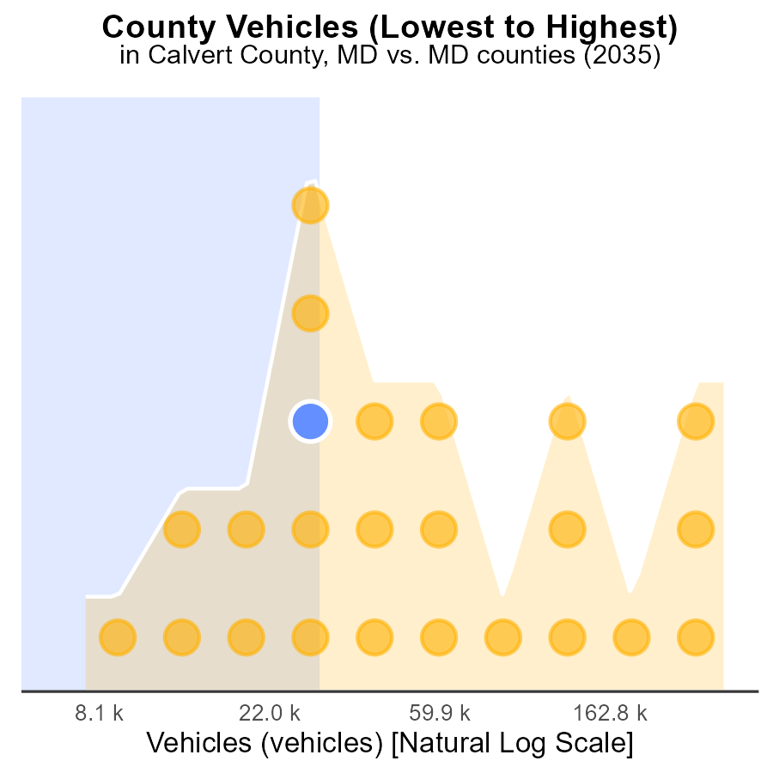

## Findings

* Prince George's County has the highest number of vehicles emissions at 885.4k CO2e.
* Kent County has the lowest vehicle emissions at 20.3k CO2e, ranking 1st with 4.2% percentile.
* Overall, 29.2% to 100.0% of emissions are contributed by vehicles across the counties.

## Recommendations

To lower emissions, policymakers should focus on implementing stricter vehicle emissions standards, promoting electric vehicles, and investing in public transportation infrastructure.

# Areas Ranked by Emissions

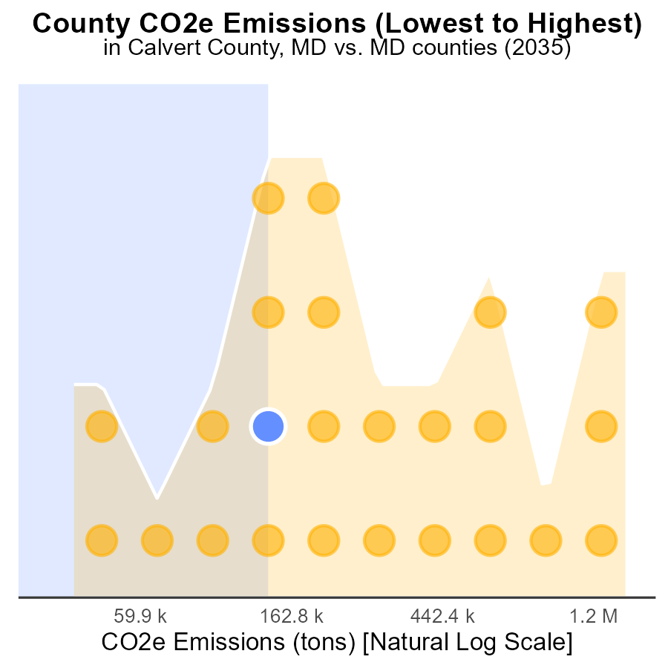

## Findings

* Prince George's county has the highest emissions at 4.1 million tons.
* Allegany county ranks 8th with 415.8 thousand tons, contributing 33.3% of total emissions.
* Kent county ranks lowest in emissions at 104.8 thousand tons, making up 4.2% of the total emissions.

## Recommendations

To lower emissions, focus on strategies in Prince George's and Allegany to target high-emitting sectors. Implement renewable energy projects in these areas. In Kent, enhance existing sustainability efforts to further reduce emissions.

# About This Report

Data based on MOVES estimates collected by the Climate Action in Transportation program at Cornell University. Demographic data sourced from the US Census's American Community Survey 5-year estimates. This report was generated with the help of AI.

# References

* U.S. Census Bureau. (2023). American Community Survey 5-year estimates: Detailed tables. Retrieved from https://data.census.gov
* U.S. Environmental Protection Agency. (2024). Motor Vehicle Emission Simulator (MOVES 4.0) [Software]. Retrieved from https://www.epa.gov/moves