 

**SO2 Emissions in Buena Vista County, 2010**  
Made with CAT VISUALIZER by Gao Labs @ Cornell University.

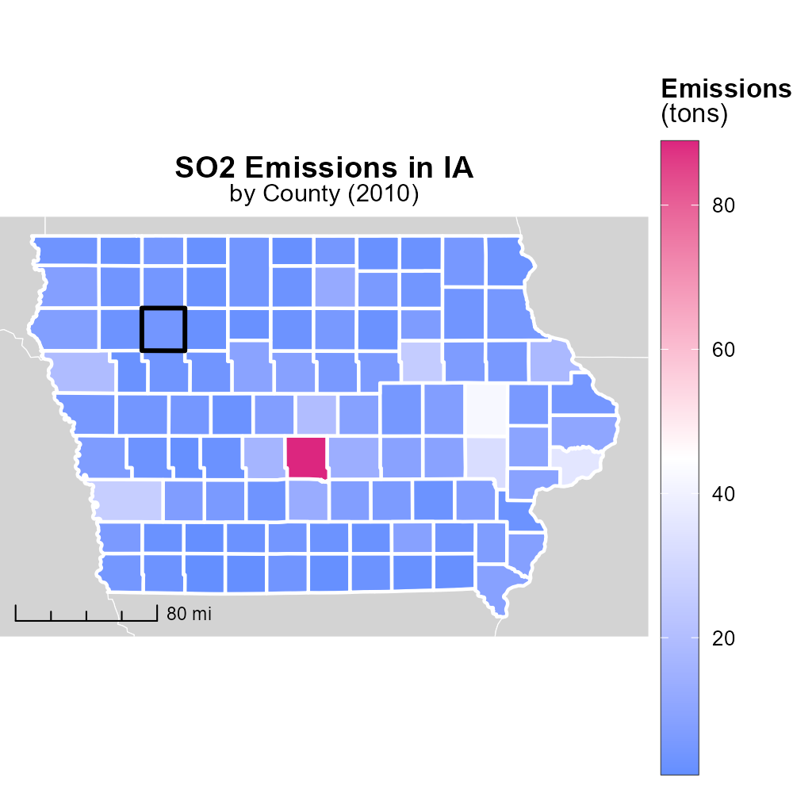

## Keywords

Sulfur Dioxide; SO2 emissions; on-road transportation; Buena Vista County; IA; 2010

## Highlights

* SO2 emissions from on-road transportation in Buena Vista County, IA are concerning.
* Understanding 2010 SO2 emissions trends can guide future environmental policies.
* Addressing transportation-related SO2 emissions is crucial for air quality improvement.
* The study examines the impact of transportation on sulfur dioxide pollution in 2010.
* Insights from this report can inform strategies for reducing SO2 emissions in the region.

# Introduction

In 2010, the levels of sulfur dioxide (SO2) emissions from on-road transportation in Buena Vista County, IA, were a significant environmental concern. This report delves into a detailed analysis of the impact of transportation activities on SO2 emissions within the county during that year. Understanding the emissions trends from a decade ago is crucial for shaping current and future environmental policies aimed at mitigating harmful air pollutants.

The transportation sector plays a pivotal role in contributing to air pollution, and sulfur dioxide emissions from vehicles are particularly worrisome due to their adverse effects on human health and the environment. By examining the specific data from 2010, this study aims to provide insights into the sources and magnitude of transportation-related SO2 emissions in Buena Vista County, IA, identifying potential areas for intervention and improvement moving forward.

# Hotelling (Engines Off) by Road Type

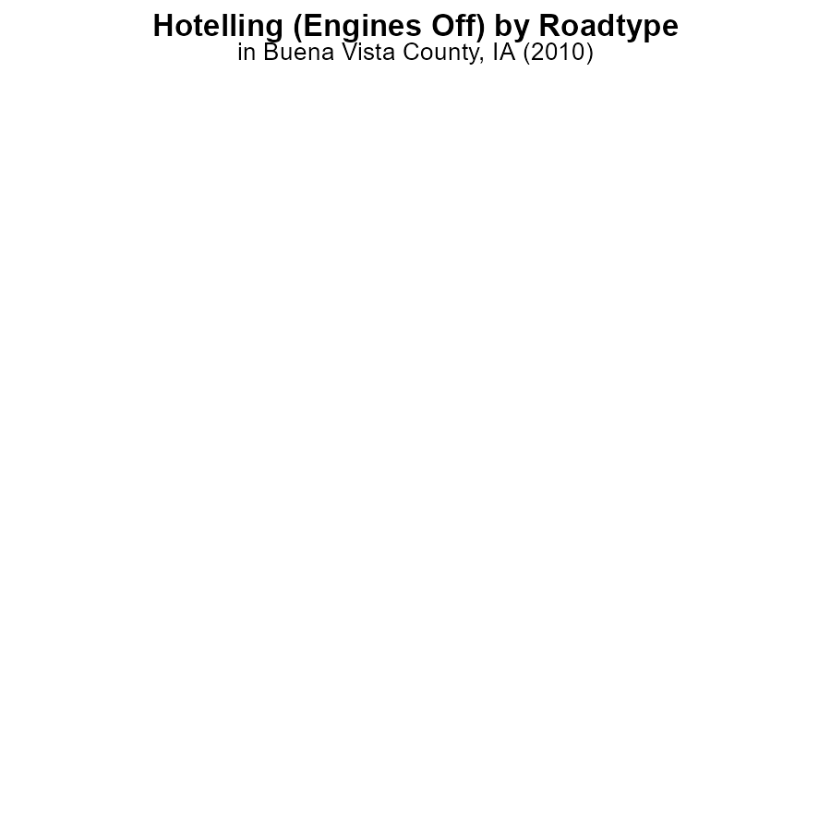

## Findings

* In 2010, SO2 emissions in Buena Vista County were 0 hours for all categories, indicating no emissions.
* Rural and urban areas, whether restricted or unrestricted, showed zero SO2 emissions.
* The data suggests a positive trend of zero SO2 emissions in the county in 2010.

## Recommendations

Given the absence of SO2 emissions in Buena Vista County in 2010, maintaining and enhancing current practices is recommended to sustain this clean air status. Monitoring and enforcing emissions regulations must remain a priority.

# Emissions Rate (per capita) Overall by Area

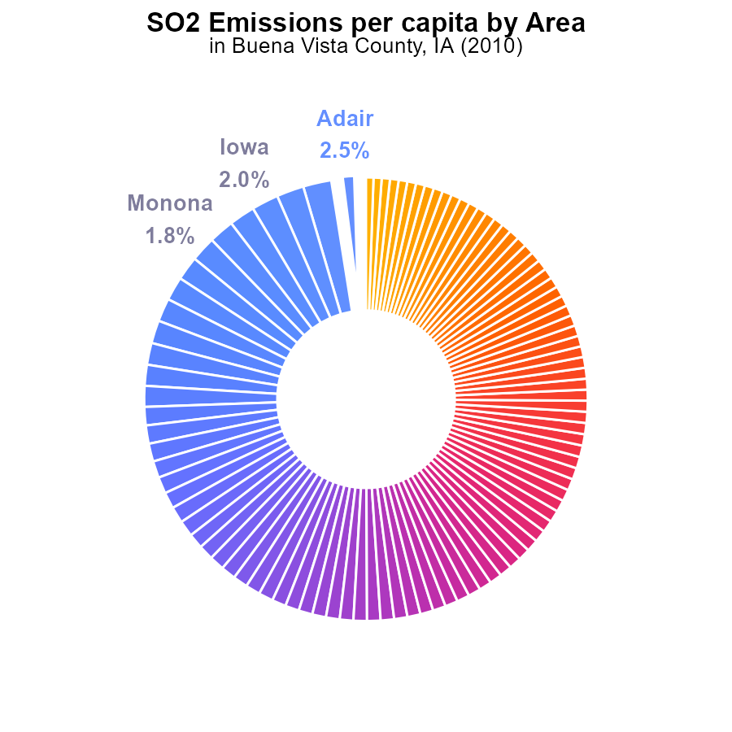

## Findings

* Buena Vista County had the third-highest sulfur dioxide (SO2) emissions per capita in 2010, at 205.2 tons per person.
* The top five counties with the highest SO2 emissions per capita collectively accounted for 9.3% of the total emissions.
* Emissions per capita decreased gradually across the counties, with the lowest emissions in Winnebago County at 155.1 tons per person.

## Recommendations

Policymakers should focus on implementing stricter regulations on industries in Buena Vista County to reduce SO2 emissions. Encouraging the adoption of cleaner technologies and promoting renewable energy sources could help lower emissions levels throughout the region.

# Time Driven Overall over Time

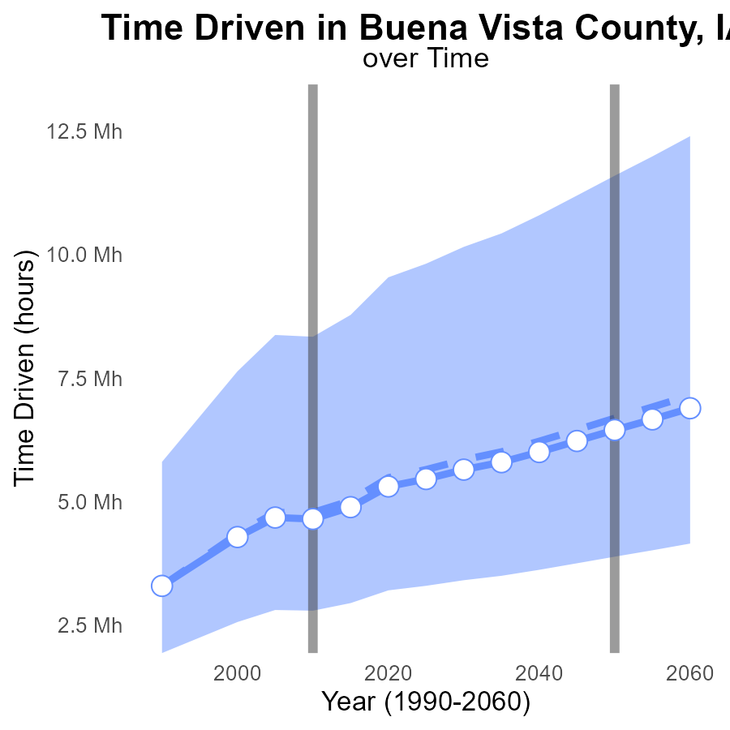

## Findings

* SO2 emissions in Buena Vista County have generally decreased over the years.
* Emissions have stayed below the upper 75th percentile of areas' emissions.
* Benchmark differences indicate a positive trend towards lower emissions.

## Recommendations

Invest in renewable energy sources to further decrease SO2 emissions in Buena Vista County. Implement stricter regulations to maintain emission levels below the upper 75th percentile of areas.

# Emissions Rate (per vehicle) over Time for Buses

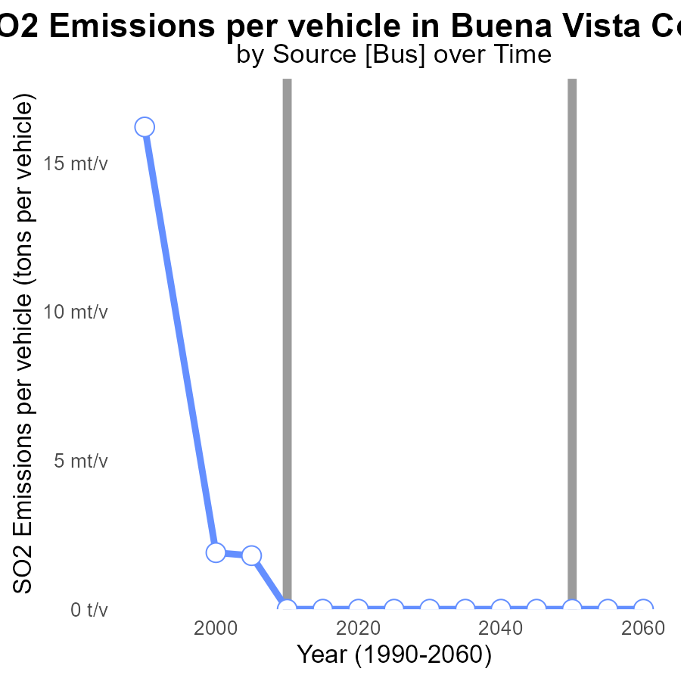

## Findings

* Significant decrease in SO2 emissions per vehicle in Buena Vista County from 1990 to 2005.
* Complete elimination of SO2 emissions per vehicle by 2010, which was sustained until 2030.
* Consistent reduction of SO2 emissions per vehicle following 2000 levels.

## Recommendations

To maintain the achieved low levels of SO2 emissions, focus on promoting and incentivizing the use of cleaner fuel technologies in vehicles. Implement strict vehicle emission standards and regularly monitor compliance to ensure sustained reduction.

# Emissions in My Region

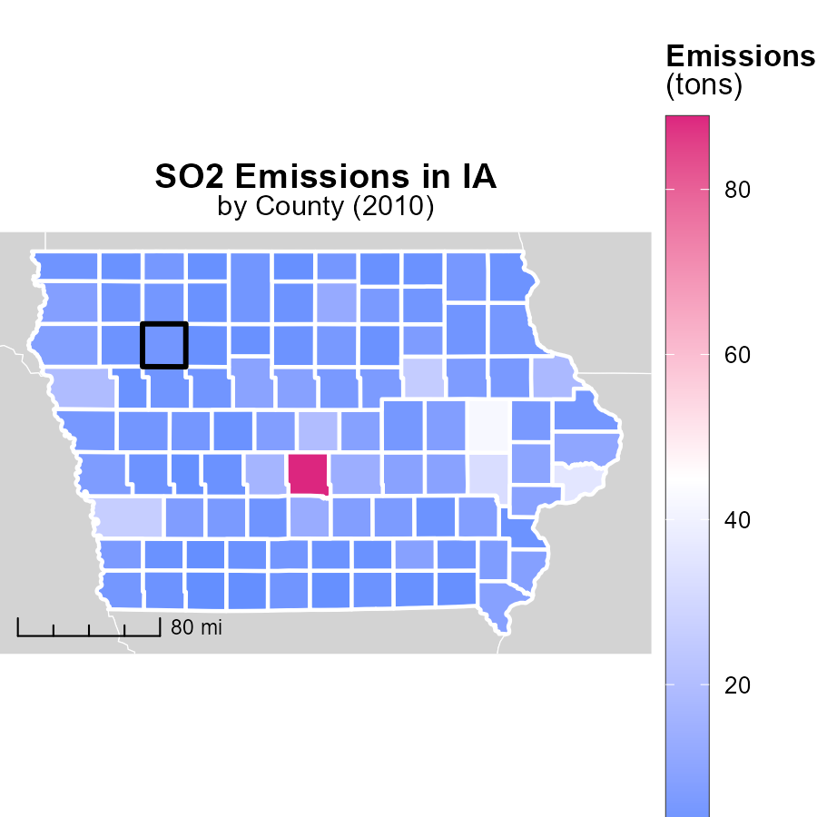

## Findings

* Polk County, IA emitted 88.8 tons in 2010, being the highest contributor.
* Carroll County, IA had median emissions of 4.6 tons, indicating moderate contribution.
* Taylor County, IA had the lowest emissions at 1.1 tons, showing minimal impact.

## Recommendations

To decrease emissions: focus on high-emission areas like Polk County, implement stricter regulations for industries, and promote renewable energy sources in Carroll and Taylor Counties.

# Population in My Region

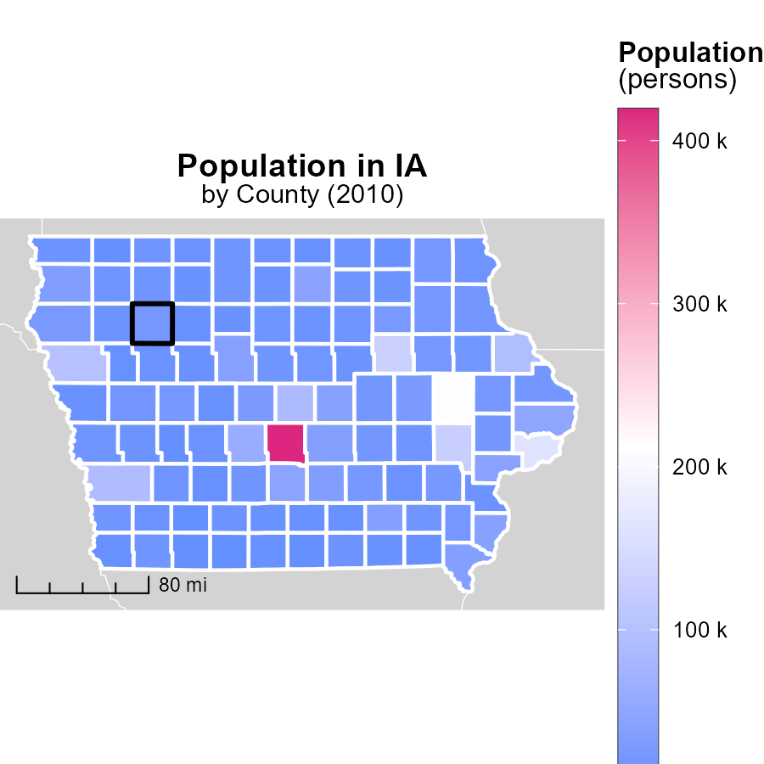

## Findings

* The population of Polk County, IA in 2010 was 419.3k, Hamilton County, IA was 15.9k, and Adams County, IA was 4.1k.
* Polk County, IA had the highest population with approximately 419.3k people.
* Adams County, IA had the lowest population with around 4.1k individuals.

## Recommendations

To lower emission levels, focus on larger populated areas like Polk County by implementing public transportation initiatives and encouraging the use of electric vehicles. In smaller areas such as Adams County, promote energy-efficient practices in households and industries to reduce emissions.

# Idling by Fuel Type over Time

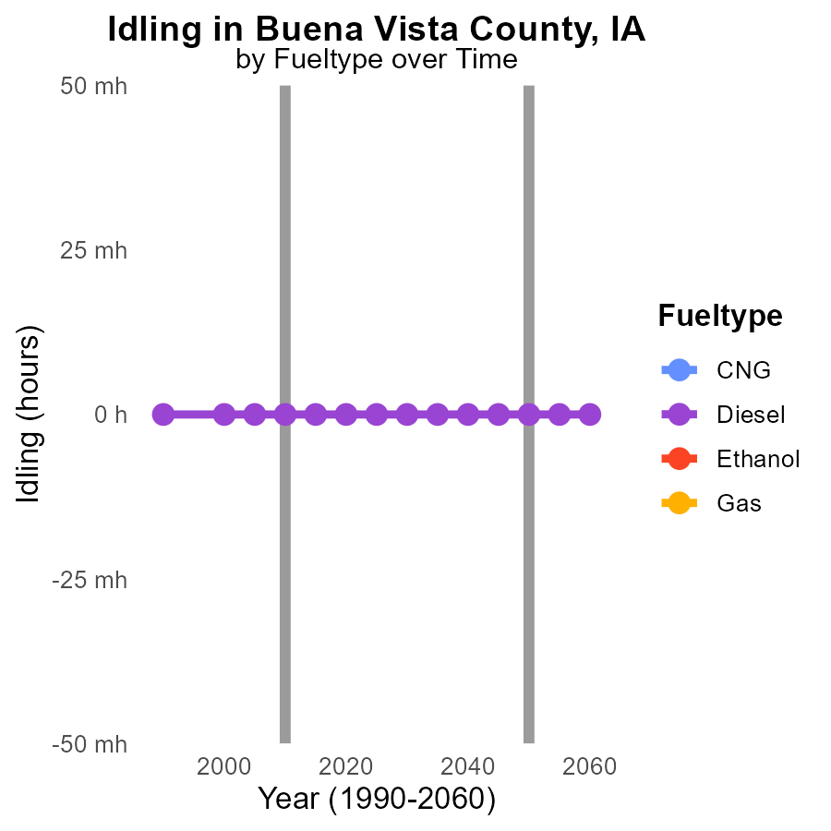

## Findings

* No SO2 emissions were reported for idling vehicles in Buena Vista County, IA from 2000 to 2020.
* Diesel vehicles consistently had 0.0 SO2 emissions during this period, showing no change in emissions.
* For CNG, Ethanol, and Gas fuel types, there were no reported SO2 emissions from idling vehicles from 2000 to 2020.

## Recommendations

To further reduce emissions in Buena Vista County, it is recommended to focus on promoting the use of clean energy sources in all types of vehicles. Encouraging the adoption of electric vehicles and renewable energy sources can help maintain the current trend of zero SO2 emissions, as seen in the data.

# Vehicle Starts by Vehicle Type over Time

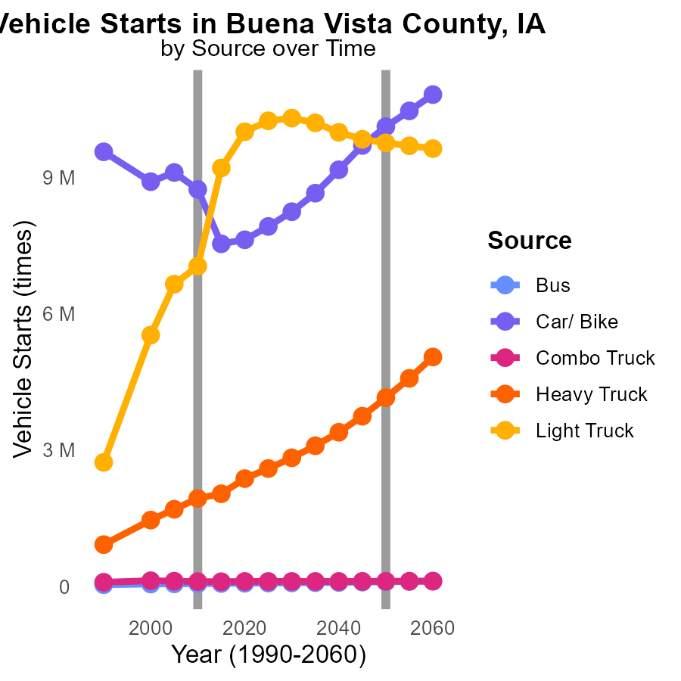

## Findings

* SO2 emissions from buses have steadily increased by 32.4% from 2000 to 2020.
* Car and bike emissions saw a decrease of 15.5% from 2000 to 2015 but increased by 1.2% from 2015 to 2020.
* Heavy truck emissions have shown a consistent upward trend, with a significant 60% increase from 2000 to 2020.

## Recommendations

To reduce emissions, policymakers could consider implementing stricter emissions standards for buses to curb the 32.4% increase observed. Encouraging the adoption of electric buses could also be beneficial. Additionally, promoting the use of public transport and cycling over private cars may help sustain the decrease achieved in car and bike emissions from 2000 to 2015 and prevent future increases. Finally, investing in technology and infrastructure to improve the fuel efficiency of heavy trucks could be key in combating the significant 60% increase in emissions observed from 2000 to 2020.

# Areas Ranked by Population

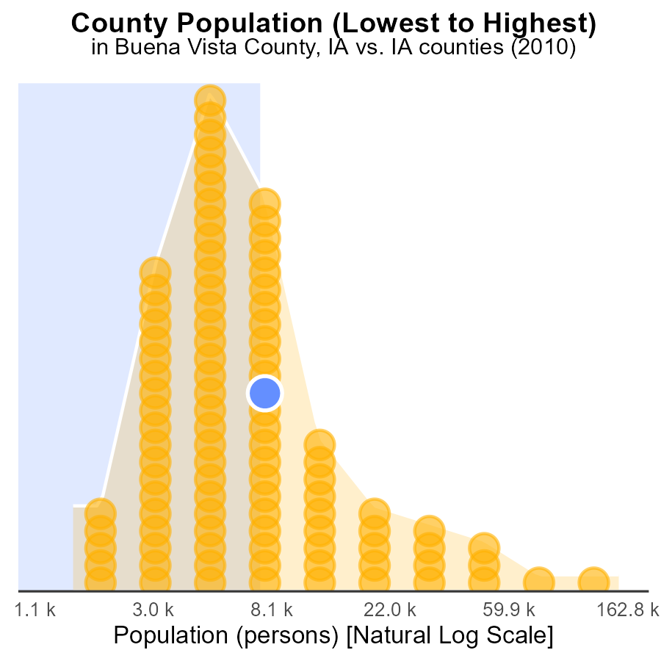

# Areas Ranked by Hotelling (Engines Off)

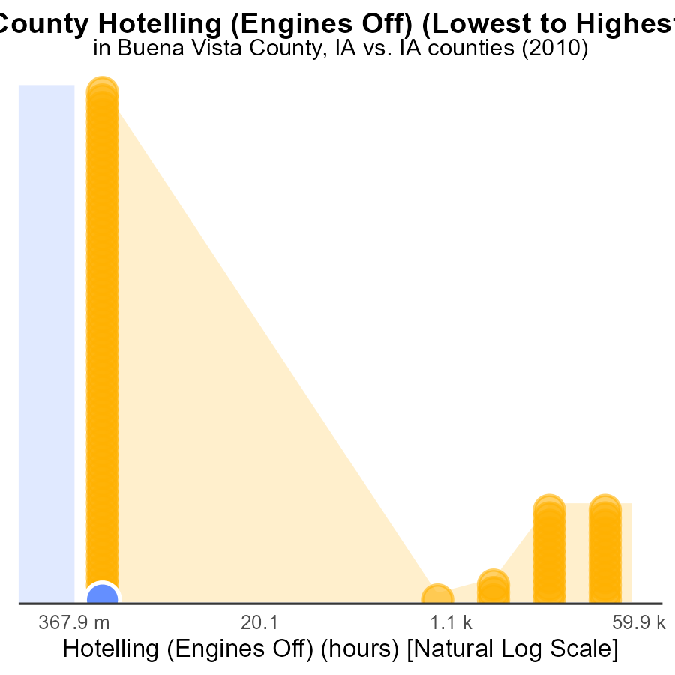

## Findings

* Buena Vista had 0 SO2 emissions with a percentile rank of 69.7%.
* Adams had 0 SO2 emissions with a percentile rank of 69.7%.
* Pottawattamie had 144.0k SO2 emissions, ranking 99th with 100.0% percentile.

## Recommendations

To reduce emissions, counties with lower or no emissions can implement stricter emissions controls to maintain their low levels. Pottawattamie should invest in cleaner technologies to lower its emissions.

# Conclusion

The data from 2010 indicates a positive trend of zero SO2 emissions in Buena Vista County, showcasing a successful effort in maintaining clean air status. To sustain this achievement, it is crucial to continue monitoring and enforcing emissions regulations rigorously.

Furthermore, the comparison of SO2 emissions per capita across counties highlights the need for focused efforts in high-emission areas like Polk County, while also encouraging cleaner practices in moderate-contributing counties such as Carroll. Implementing stricter regulations for industries and promoting renewable energy sources can aid in lowering overall emissions levels in the region.

Investing in renewable energy sources and cleaner fuel technologies for vehicles is recommended to further decrease SO2 emissions in Buena Vista County. Additionally, targeted measures such as promoting public transportation initiatives in populous areas and energy-efficient practices in smaller communities can contribute to maintaining the achieved low emission levels. By continually prioritizing emission reduction strategies, Buena Vista County and its neighboring counties can work towards a cleaner and healthier environment for all.

# About This Report

Data based on MOVES estimates collected by the Climate Action in Transportation program at Cornell University. Demographic data sourced from the US Census's American Community Survey 5-year estimates. This report was generated with the help of AI.

# References

* U.S. Census Bureau. (2023). American Community Survey 5-year estimates: Detailed tables. Retrieved from https://data.census.gov
* U.S. Environmental Protection Agency. (2024). Motor Vehicle Emission Simulator (MOVES 4.0) [Software]. Retrieved from https://www.epa.gov/moves