 

**SO2 Emissions in Aitkin County, 2000**  
Made with CAT VISUALIZER by Gao Labs @ Cornell University.

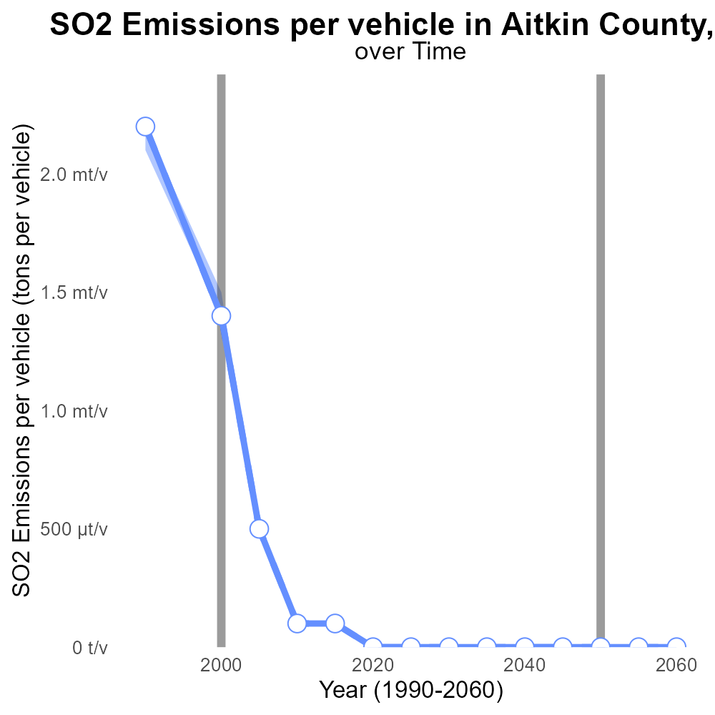

## Keywords

Sulfur Dioxide emissions; on-road transportation; Aitkin County; Minnesota; 2000; air pollution

## Highlights

* Sulfur Dioxide emissions from on-road vehicles in Aitkin County in 2000 are concerning.
* Understanding the impact of transportation on air quality is crucial for environmental protection.
* Rigorous data analysis is necessary to assess the extent of sulfur dioxide emissions.
* Aitkin County's sulfur dioxide levels may have implications for public health and the environment.
* The findings from this report can inform future policies and mitigation strategies.

# Introduction

Sulfur Dioxide (SO2) emissions from on-road transportation have become a critical concern in Aitkin County, Minnesota, especially in the year 2000. As on-road vehicles are a major source of air pollution, it is imperative to analyze their impact on local air quality. This report aims to investigate the extent of SO2 emissions from on-road transportation and its implications for public health and the environment in Aitkin County.

By examining the data from 2000, this report seeks to provide a comprehensive overview of the sulfur dioxide levels in Aitkin County, shedding light on the potential risks associated with transportation-related emissions. The findings of this study will not only contribute to the understanding of air pollution dynamics in the county but also offer valuable insights for policymakers and stakeholders to develop effective mitigation strategies.

# Population by Road Type

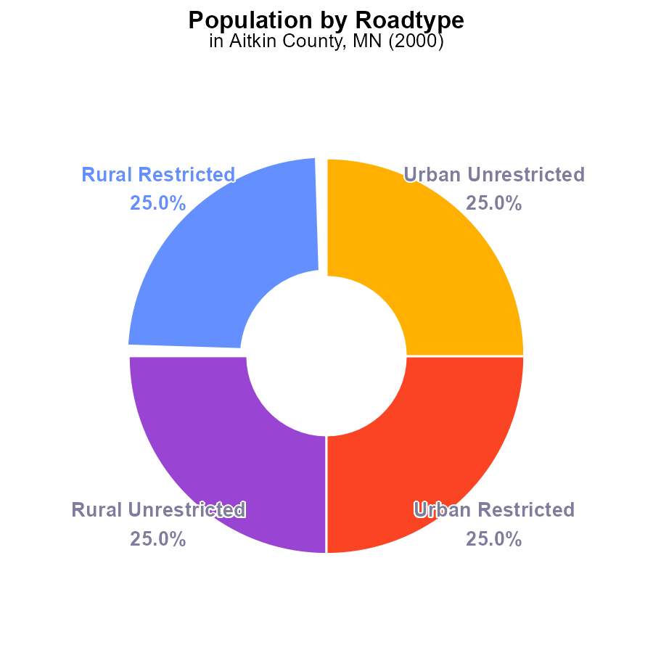

## Findings

* SO2 emissions in Aitkin County in 2000 were 65.2 k
* Each type (Rural Restricted, Rural Unrestricted, Urban Restricted, Urban Unrestricted) contributed equally to the total emissions with 25.0% each
* The population of Aitkin County in 2000 was 65.2 k persons

## Recommendations

To lower SO2 emissions in Aitkin County, a comprehensive emission reduction plan should be developed targeting all types of areas equally to achieve a balanced reduction in emissions.

# Emissions Rate (per mile) by Regulatory Class

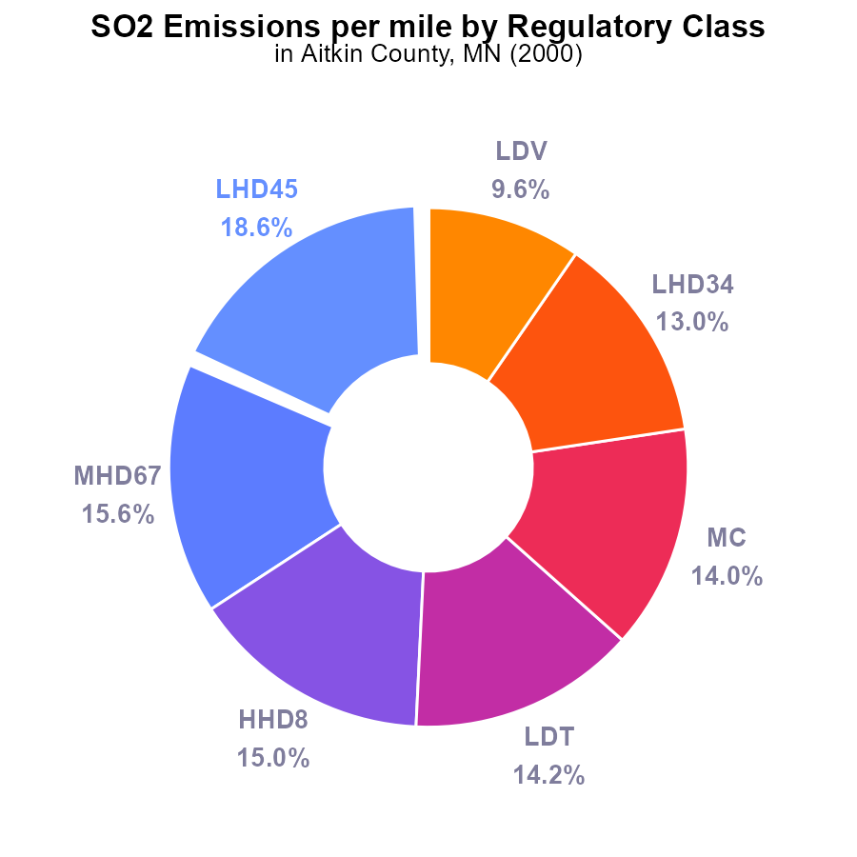

## Findings

* Low Heavy Duty vehicles (LHD45, MHD67, HHD8) contribute to 49.2% of SO2 emissions per mile.
* Medium/Heavy Duty trucks (MHD67, LDT) account for 29.8% of emissions.
* Urban buses have the least contribution to SO2 emissions in Aitkin County, MN.

## Recommendations

To lower SO2 emissions, focus on reducing emissions from Low Heavy Duty vehicles and Medium/Heavy Duty trucks through stricter emission standards and incentivizing cleaner technologies.

# Emissions Rate (per vehicle) Overall over Time

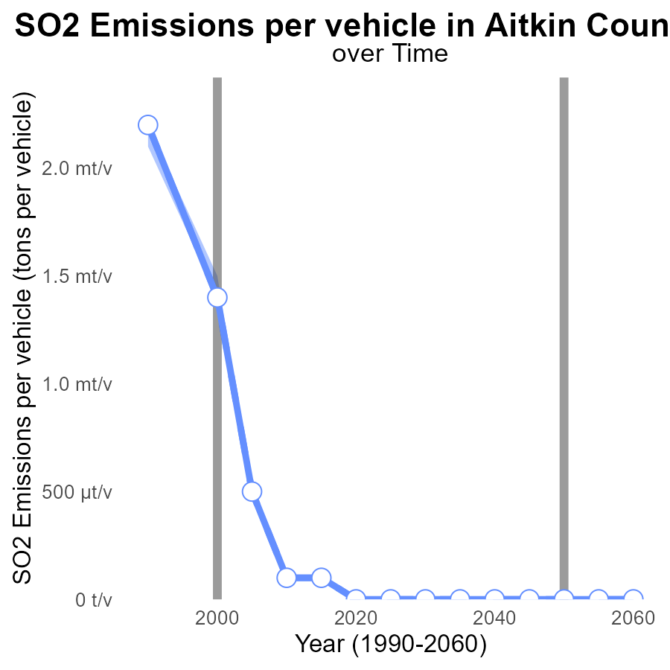

## Findings

* Emissions of SO2 per vehicle in Aitkin County decreased significantly from 1990 to 2020.
* The emissions were above the upper 75th percentile in 1990 but dropped below the median from 2005 onwards.
* There was a substantial decrease in emissions from 2000 to 2010, where it reached the benchmark difference of -0.0001 tons per vehicle.

## Recommendations

To further lower emissions, consider implementing stricter vehicle emissions standards, promoting electric vehicles, and investing in public transportation infrastructure to reduce individual vehicle usage.

# Hotelling (Engines Off) Overall over Time

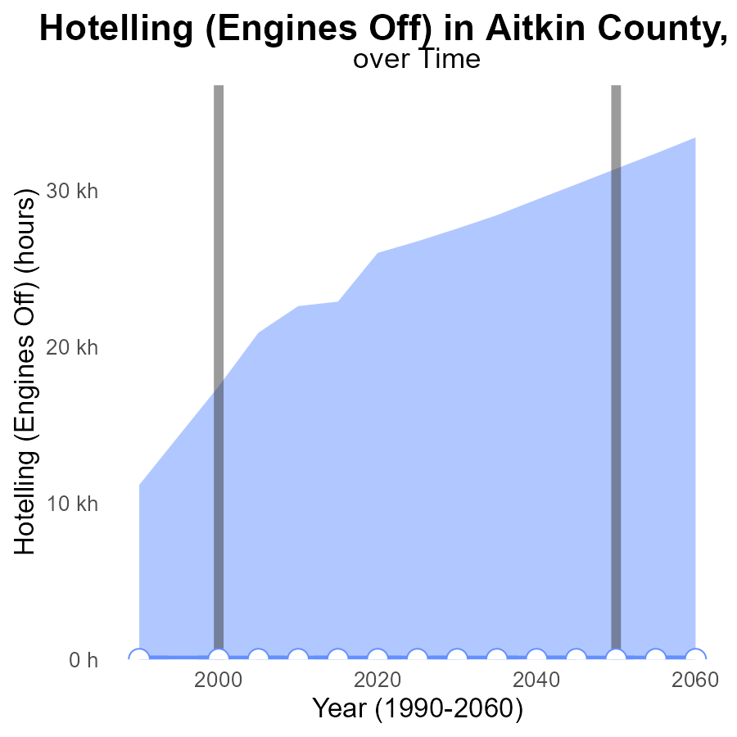

## Findings

* Aitkin County, MN has maintained zero SO2 emissions from hotelling (engines off) activities since 1990.
* The emissions data show no deviation from the median or benchmark set for the area.
* Emission levels have stayed consistently at zero, indicating no negative impact on air quality in the region.

## Recommendations

Given the consistent zero emissions in Aitkin County, MN, policymakers could focus on implementing similar environmentally friendly practices in other sectors to maintain low emission levels.

# Vehicles Mapped by Area

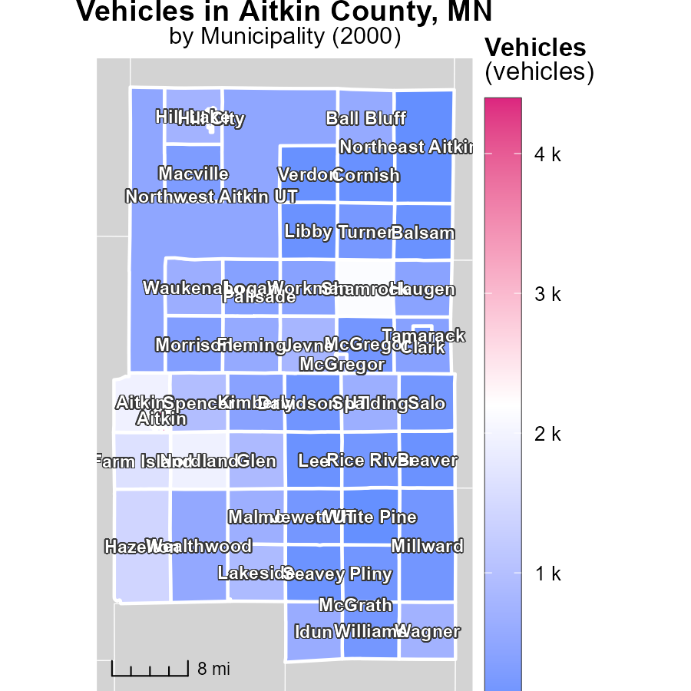

## Findings

* Aitkin, MN emits the highest amount of vehicle emissions at 4.4 k
* Workman, MN emits a median amount of 409.4 vehicle emissions
* Northeast Aitkin UT, MN emits the lowest amount of vehicle emissions at 11.7

## Recommendations

To lower vehicle emissions, focus on reducing the high emissions from Aitkin, MN by promoting electric vehicles and implementing stricter vehicle emission standards. Encourage sustainable transportation methods in Workman, MN. Maintain the low emissions in Northeast Aitkin UT, MN through eco-friendly transportation initiatives.

# Emissions Rate (per vehicle) in My Region

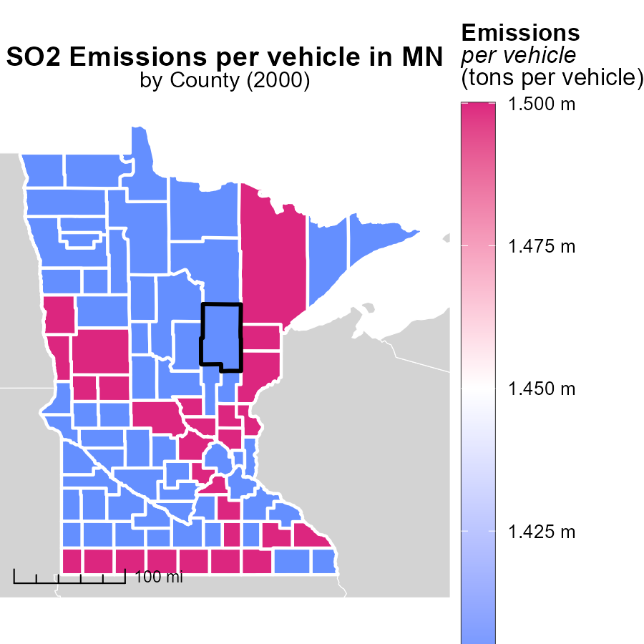

## Findings

* Anoka County, MN has the highest emissions per vehicle at 1.5 tons.
* Goodhue County, MN has a median emissions level of 1.4 tons per vehicle.
* Yellow Medicine County, MN has the lowest emissions per vehicle at 1.4 tons.

## Recommendations

To lower emissions, focus on Anoka County by implementing vehicle emission testing programs. Encourage the adoption of electric vehicles in Goodhue County. Maintain and promote eco-friendly transport options in Yellow Medicine County.

# Emissions Rate (per capita) by Regulatory Class over Time

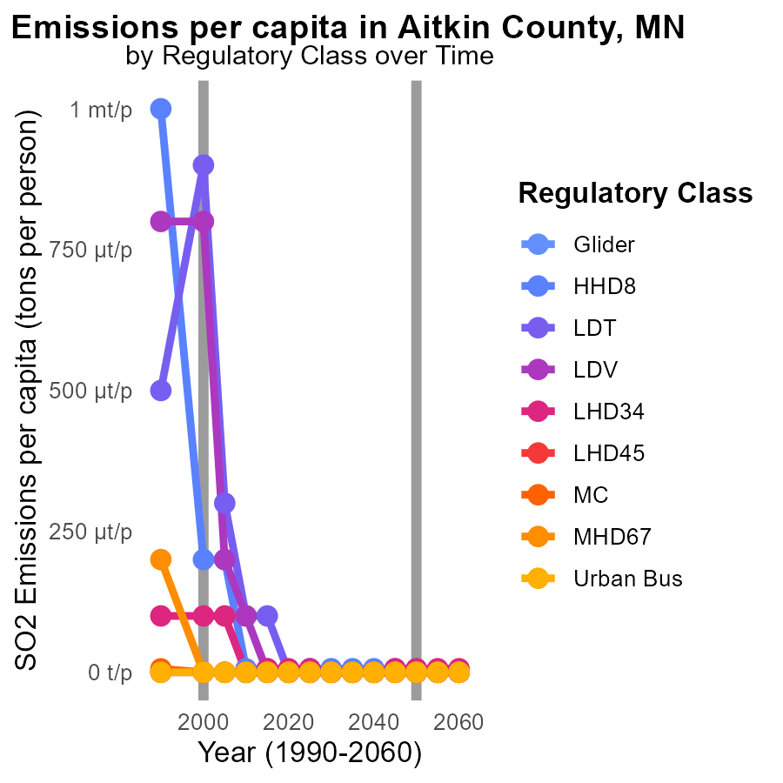

## Findings

* Emissions of SO2 in Aitkin County, MN have decreased significantly per capita from 1990 to 2010 across all sectors.
* The largest reduction in emissions was seen in the HHD8 sector, with a decrease of 986.2 µtons per person in 1990 to 6.1 µtons per person in 2010.
* While most sectors showed a decrease in SO2 emissions, there was minimal to no change in emissions from the Urban Bus sector from 1990 to 2010.

## Recommendations

To further reduce emissions in Aitkin County, targeted efforts should be made to continue the reduction trend seen in sectors like HHD8. Implementing stricter regulations and incentivizing cleaner technologies in other sectors, particularly Urban Bus, is crucial to achieve a significant overall reduction in emissions.

# Emissions Rate (per vehicle) by Fuel Type over Time

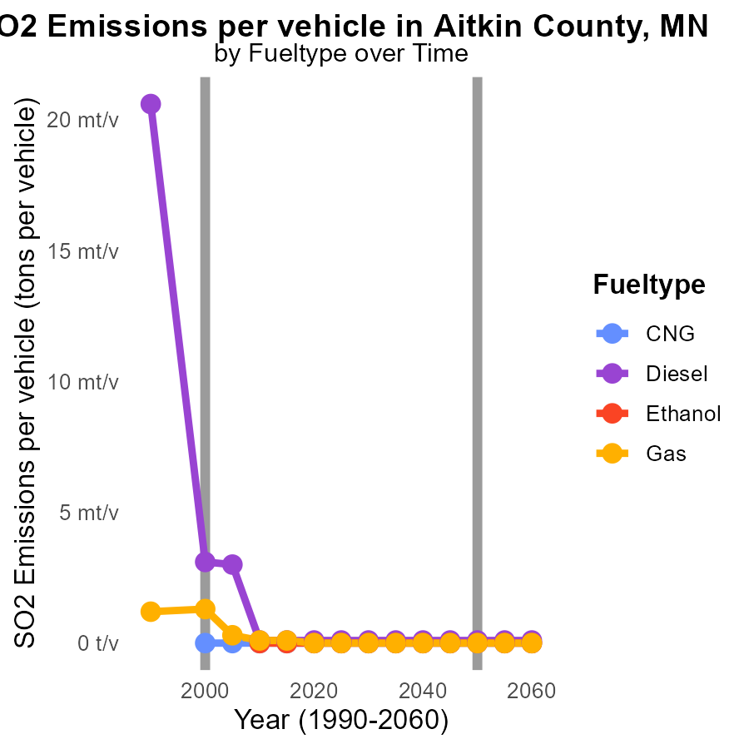

## Findings

* Diesel emissions per vehicle significantly decreased from 20.6 tons in 1990 to 3.1 tons in 2000.
* Gas emissions per vehicle decreased from 1.2 tons in 1990 to 106.6 kg in 2010.
* CNG and ethanol showed no emissions per vehicle by 2010.

## Recommendations

To further reduce emissions, promote the adoption of cleaner fuel types like CNG and ethanol, and incentivize the use of lower-emission vehicles such as electric or hybrid cars.

# Areas Ranked by Population

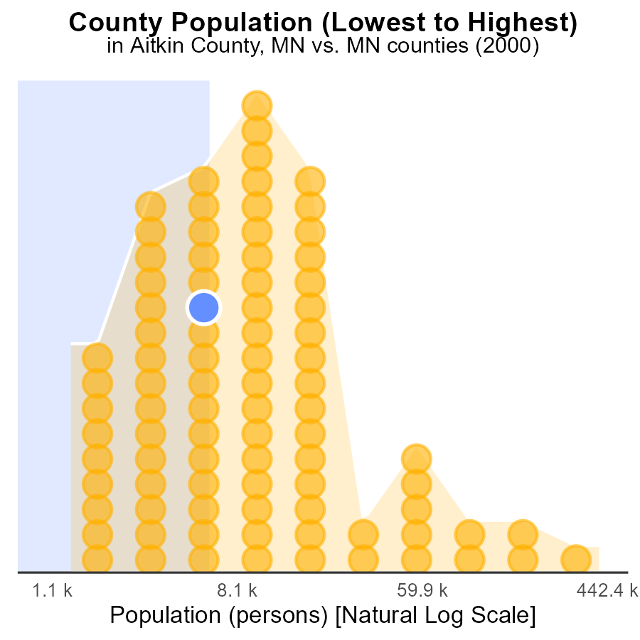

## Findings

* Hennepin county has the highest population and emits the most SO2.
* Aitkin county, with a much smaller population, is the second-highest emitter on a per capita basis.
* Traverse county has the lowest population but emits a significant amount of SO2 relative to its size.

## Recommendations

To reduce emissions, focus on implementing stricter regulations on industries in Hennepin County. Provide support for cleaner technologies to reduce per capita emissions in Aitkin County. Explore the source of emissions in Traverse County to address the disproportionate impact despite its small population.

# Areas Ranked by Emissions

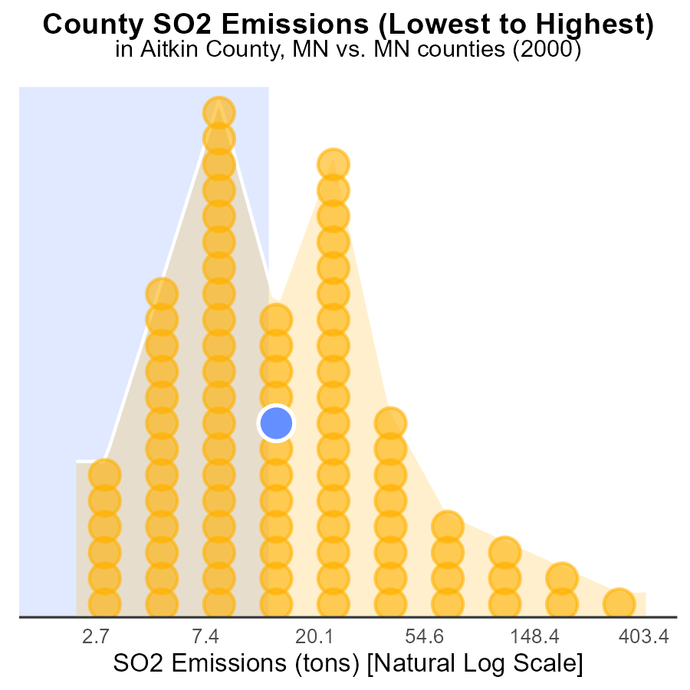

## Findings

* Hennepin county has the highest SO2 emissions at 1.1 k tons.
* Traverse county has the lowest SO2 emissions at 5.0 tons.
* The top 5 counties account for 264.1 tons of SO2 emissions, approximately 13.2% of the total emissions.

## Recommendations

To lower SO2 emissions, targeted reduction plans should focus on counties with high percentiles like Aitkin, Martin, and Nobles. Implement stricter emissions regulations and promote cleaner energy sources.

# Conclusion

In conclusion, the analysis of SO2 emissions from on-road transportation in Aitkin County, MN in 2000 reveals important insights for emission reduction strategies. The data shows that emissions were relatively evenly distributed across different area types, indicating the need for a comprehensive approach to achieve balanced reductions. Low Heavy Duty vehicles and Medium/Heavy Duty trucks were identified as the primary contributors to emissions per mile, suggesting that targeting these vehicles with stricter standards and cleaner technologies could lead to significant improvements. Additionally, the significant decrease in emissions per vehicle from 1990 to 2000 highlights the effectiveness of past efforts but also underscores the importance of continuing to implement stricter regulations and promote cleaner fuel types to further reduce emissions.

Moving forward, policymakers should focus on maintaining the consistently low emissions observed in Aitkin County, MN and consider implementing similar environmentally friendly practices in other sectors to sustain low emission levels. Targeted efforts should be made to continue reducing emissions in sectors like HHD8, while also addressing areas with high emissions such as Aitkin, MN. By adopting stricter emissions regulations, promoting cleaner technologies, and incentivizing the use of electric and hybrid vehicles, significant progress can be made towards achieving a cleaner and more sustainable transportation system in Aitkin County and beyond.

# About This Report

Data based on MOVES estimates collected by the Climate Action in Transportation program at Cornell University. Demographic data sourced from the US Census's American Community Survey 5-year estimates. This report was generated with the help of AI.

# References

* U.S. Census Bureau. (2023). American Community Survey 5-year estimates: Detailed tables. Retrieved from https://data.census.gov
* U.S. Environmental Protection Agency. (2024). Motor Vehicle Emission Simulator (MOVES 4.0) [Software]. Retrieved from https://www.epa.gov/moves