 

**NOx Emissions in Ashland County, 2055**  
Made with CAT VISUALIZER by Gao Labs @ Cornell University.

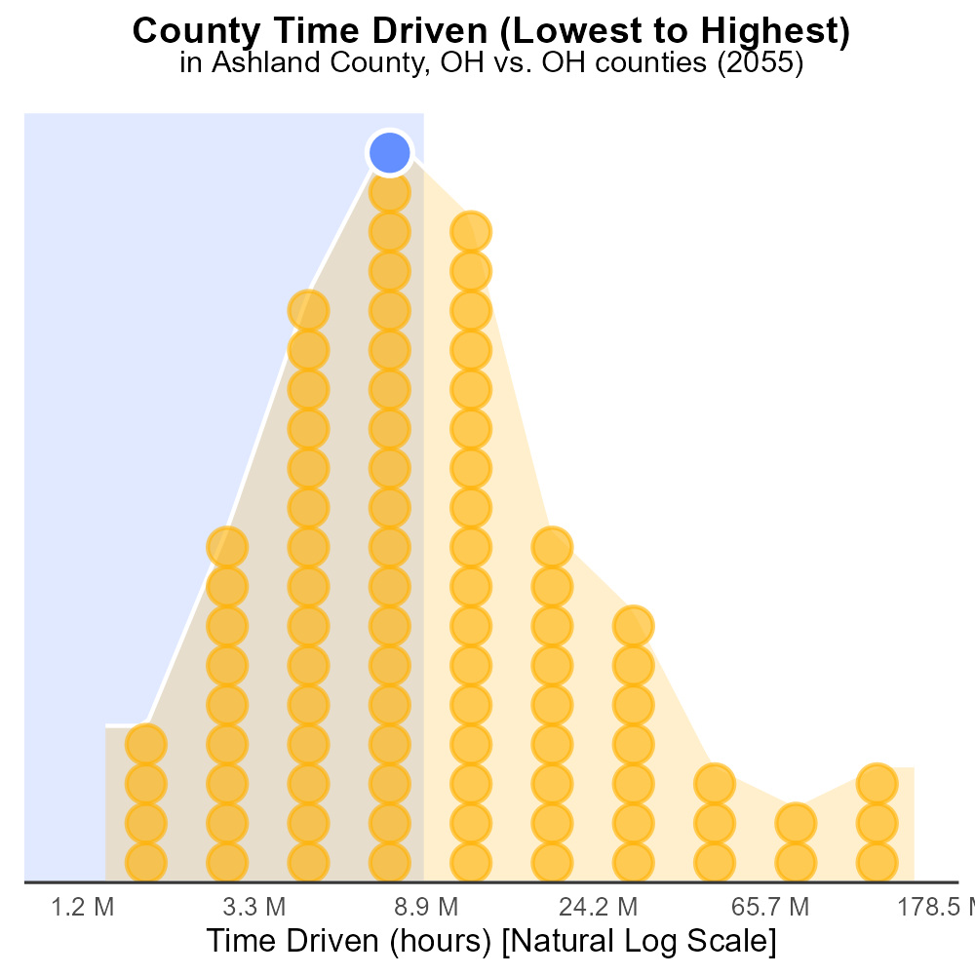

## Keywords

Oxides of Nitrogen; NOx emissions; on-road transportation; Ashland County; 2055; environmental impact

## Highlights

* Examining NOx emissions in Ashland County, OH from on-road transportation.
* Assessing environmental consequences of NOx emissions in 2055.
* Impact of transportation on air quality and health in the county.
* Potential measures to mitigate NOx emissions in the future.
* Forecasting trends and implications for the environment in Ashland County.

# Introduction

In the year 2055, the issue of Oxides of Nitrogen (NOx) emissions from on-road transportation in Ashland County, OH is of utmost concern due to its environmental repercussions. This report aims to provide a comprehensive analysis of the current NOx emissions landscape in the county and forecast the potential impact on the environment in the coming years.

With a focus on the transportation sector, this report will delve into the sources of NOx emissions, their contribution to air pollution, and the associated health risks for the residents of Ashland County. Furthermore, it will explore possible strategies and technologies that could be implemented to reduce NOx emissions and improve air quality in the region, presenting a roadmap for sustainable transportation in the future.

# Emissions by Fuel Type

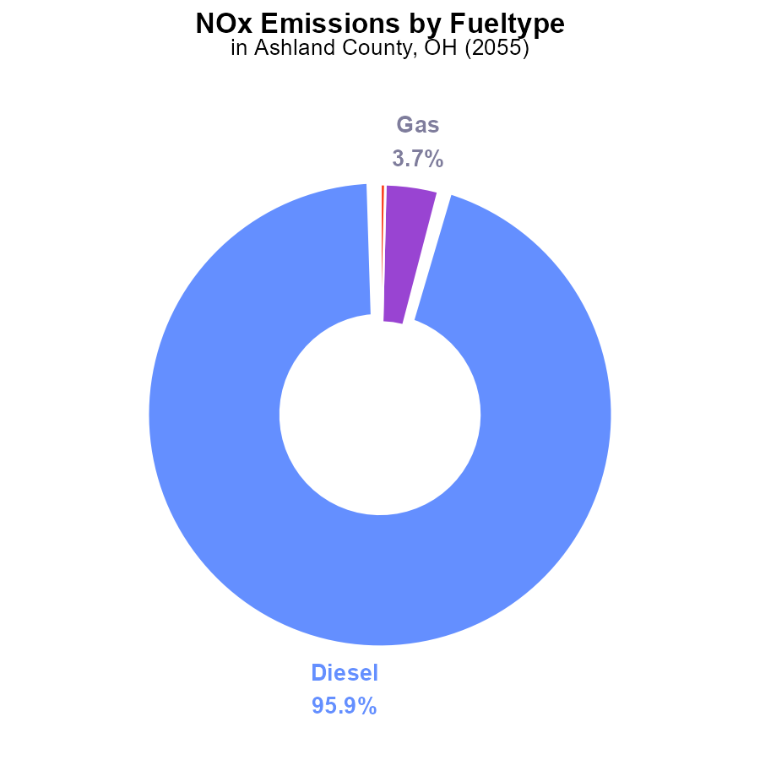

# Time Driven by Regulatory Class

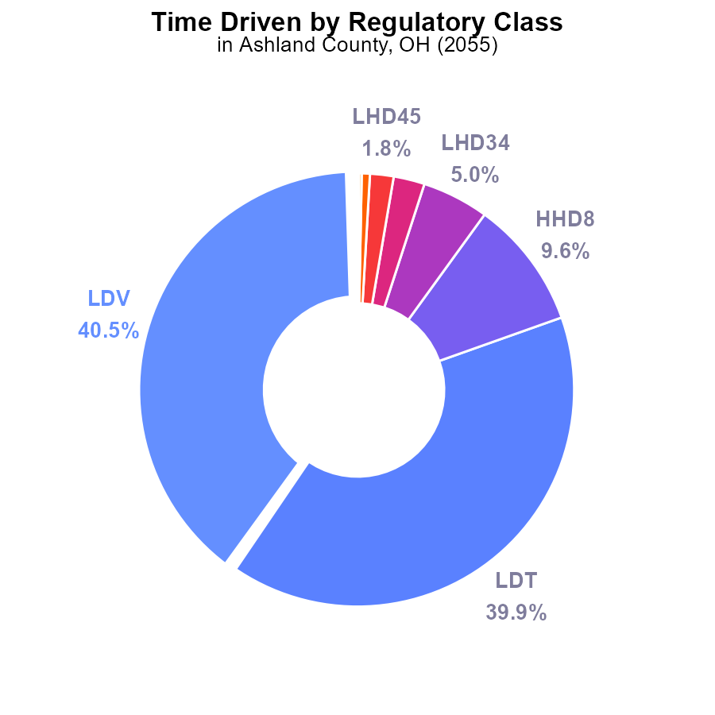

## Findings

* The top two contributors to NOx emissions in Ashland County, OH are LDV and LDT, accounting for 80.4% of total emissions.
* HHD8 and LHD34 vehicle types also contribute significantly, comprising 14.6% of the emissions collectively.
* Lower-emitting vehicle types such as MHD67, LHD45, MC, Glider, and Urban Bus make up only 4.8% of the total emissions.

## Recommendations

To lower NOx emissions, prioritize reducing emissions from LDV and LDT, such as by incentivizing the adoption of cleaner technologies. Additionally, promote the use of lower-emitting vehicle types like MHD67, LHD45, MC, Glider, and Urban Bus to further decrease the overall emissions levels.

# Idling over Time for Buses

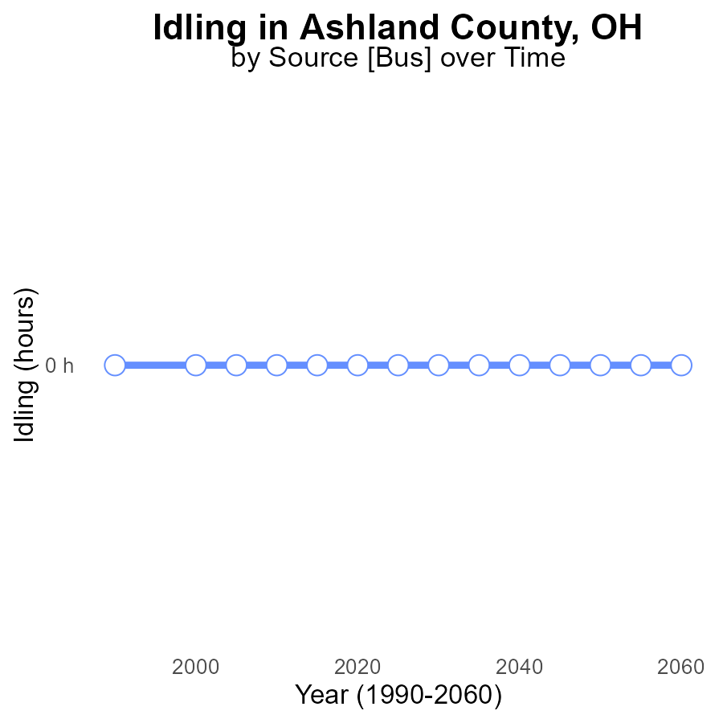

## Findings

* NOx emissions from idling in Ashland County, OH are at 0.0 hours for 2035-2060.
* There has been no significant change in NOx emissions over the years in this area.
* This data suggests that idling activities have not contributed to NOx emissions in Ashland County.

## Recommendations

Given the consistently low NOx emissions from idling, policymakers should focus on other sources of emissions like transportation and industrial activities to further decrease overall emissions in Ashland County.

# Emissions Rate (per capita) over Time for Buses

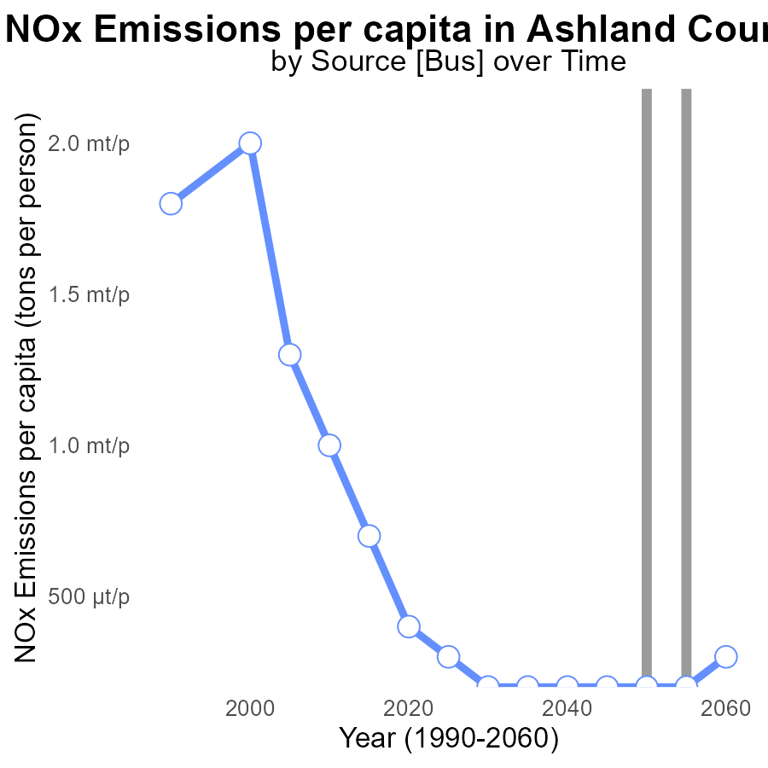

## Findings

* NOx emissions per capita have been increasing steadily from 2035 to 2060 in Ashland County.
* In 2060, there was a slight decrease in NOx emissions compared to the benchmark.
* Emissions were consistently higher than the benchmark throughout the study period.

## Recommendations

To decrease NOx emissions in Ashland County, implement stricter emission standards for industries and vehicles, promote public transportation, and invest in renewable energy sources.

# Vehicle Miles Traveled Mapped by Area

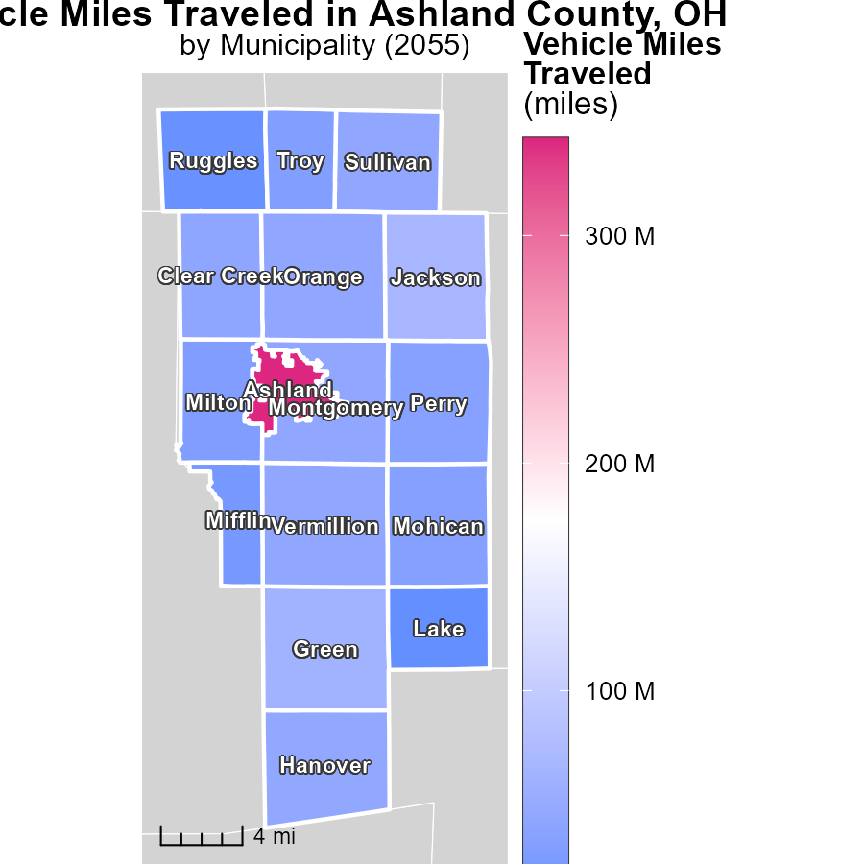

## Findings

* The maximum vehicle miles traveled in Ashland, OH was 342.7 million miles.
* The median miles traveled in Orange, OH was 43.6 million miles.
* The minimum miles traveled in Lake, OH was 6.3 million miles.

## Recommendations

To lower emissions, encourage and invest in public transportation and carpooling in Ashland, prioritize infrastructure improvements in Orange, and promote alternative modes of transportation in Lake.

# Vehicles Mapped by Area

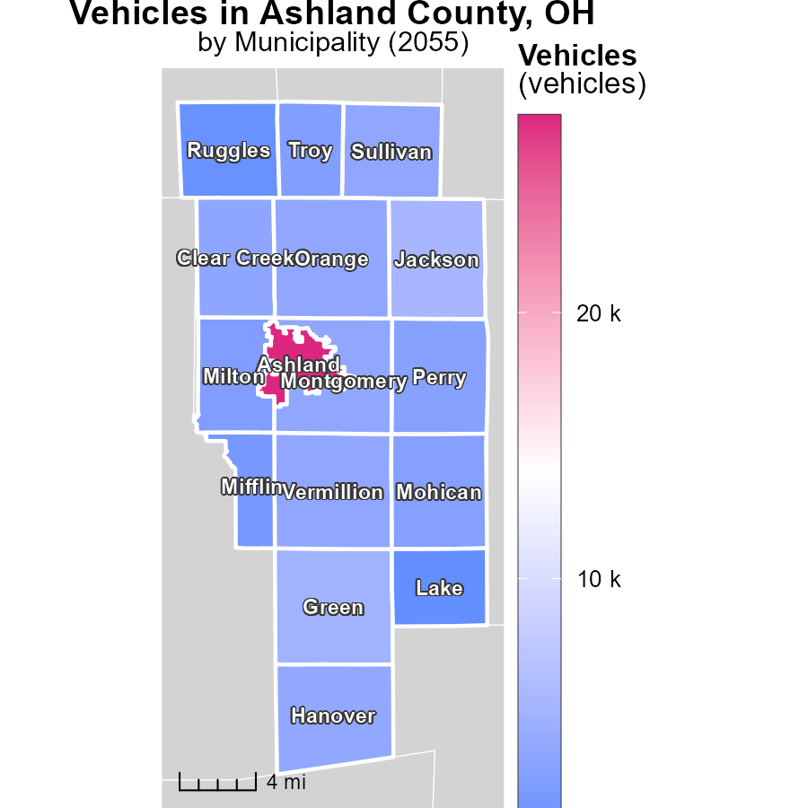

## Findings

* Ashland, OH has the highest vehicle emissions at 27.4k
* Orange, OH has a moderate level of vehicle emissions at 3.5k
* Lake, OH has the lowest vehicle emissions at 506.1

## Recommendations

To lower vehicle emissions, focus on strategies like promoting public transportation, incentivizing electric/hybrid vehicles, and implementing stricter emission standards for automobiles.

# Emissions Rate (per mile) by Area over Time

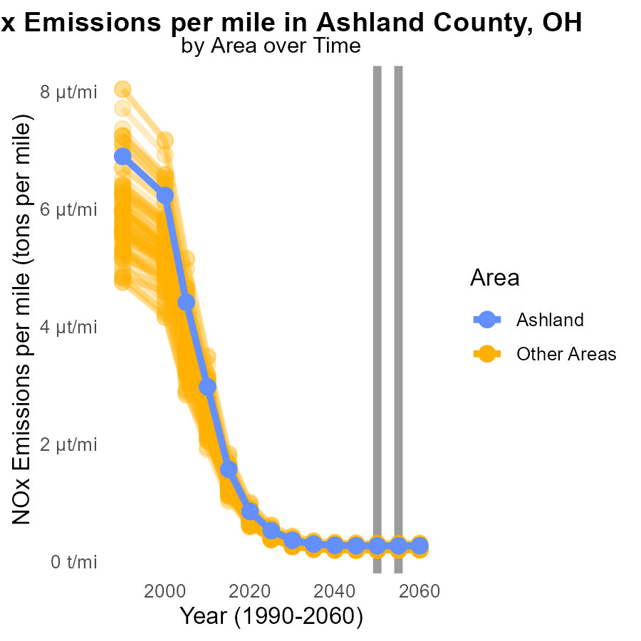

## Findings

* In 2055, the target county emitted 261.8 tons of NOx per mile
* The minimum county emitted 188.9 tons of NOx per mile in 2055
* The maximum county emitted 308.0 tons of NOx per mile in 2055

## Recommendations

To lower NOx emissions, consider targeted policies to reduce emissions from high-emitting counties. Implement industry-specific regulations and promote cleaner technologies to decrease overall NOx emissions. Strengthen monitoring and enforcement mechanisms to ensure compliance with emission standards.

# Emissions Rate (per mile) by Regulatory Class over Time

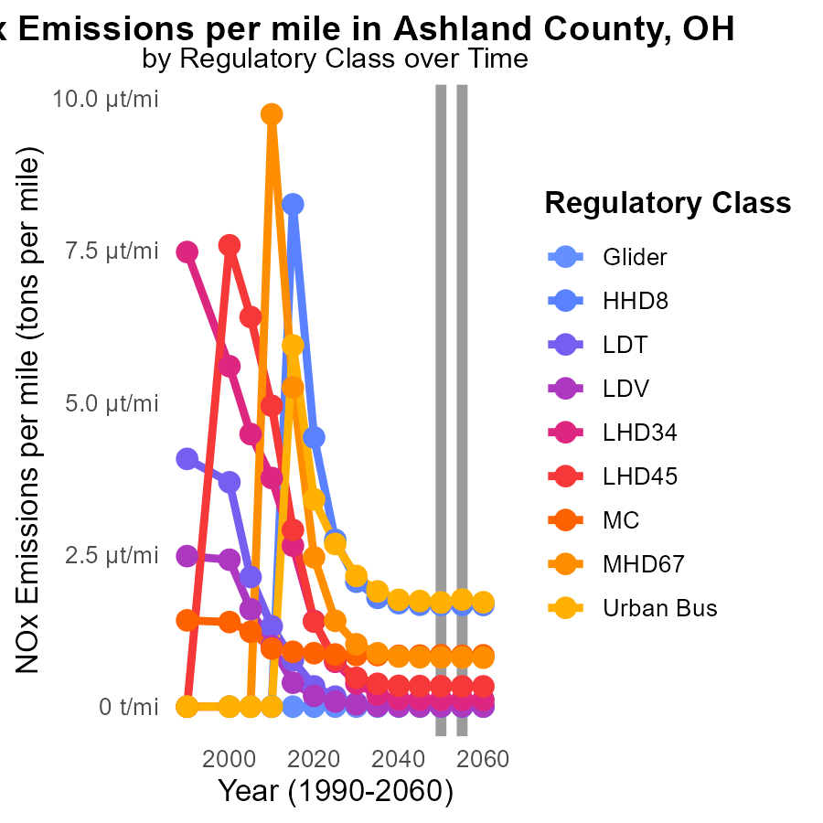

## Findings

* There is a general decline in NOx emissions per mile for most vehicle types from 2045 to 2060.
* Significant reductions in NOx emissions per mile are observed for Heavy Heavy-Duty Diesel vehicles (HHD8) from 2045 to 2060.
* Urban buses show consistent NOx emissions per mile around 1.7-1.8 µ with minimal variation across the years.

## Recommendations

To further lower NOx emissions, focus on upgrading heavy-duty diesel vehicles as they show the most significant improvements. Implement stricter emission standards for all vehicle types to maintain the decreasing trend seen in NOx emissions.

# Areas Ranked by Emissions

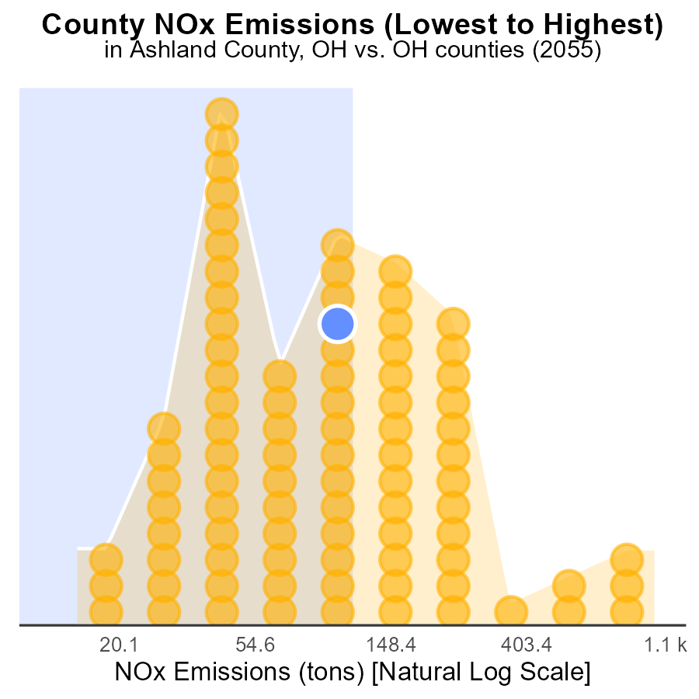

## Findings

* Franklin county has the highest NOx emissions with 2.8k tons.
* Morgan county has the lowest NOx emissions with 38.2 tons.
* Guernsey county has the highest percentile of NOx emissions at 61.4%.

## Recommendations

Efforts should focus on Franklin county to reduce its high emissions. Implementation of stricter regulations and incentives for cleaner technologies may help lower emissions. Collaborative initiatives between industries and authorities are vital to mitigate NOx levels.

# Areas Ranked by Time Driven

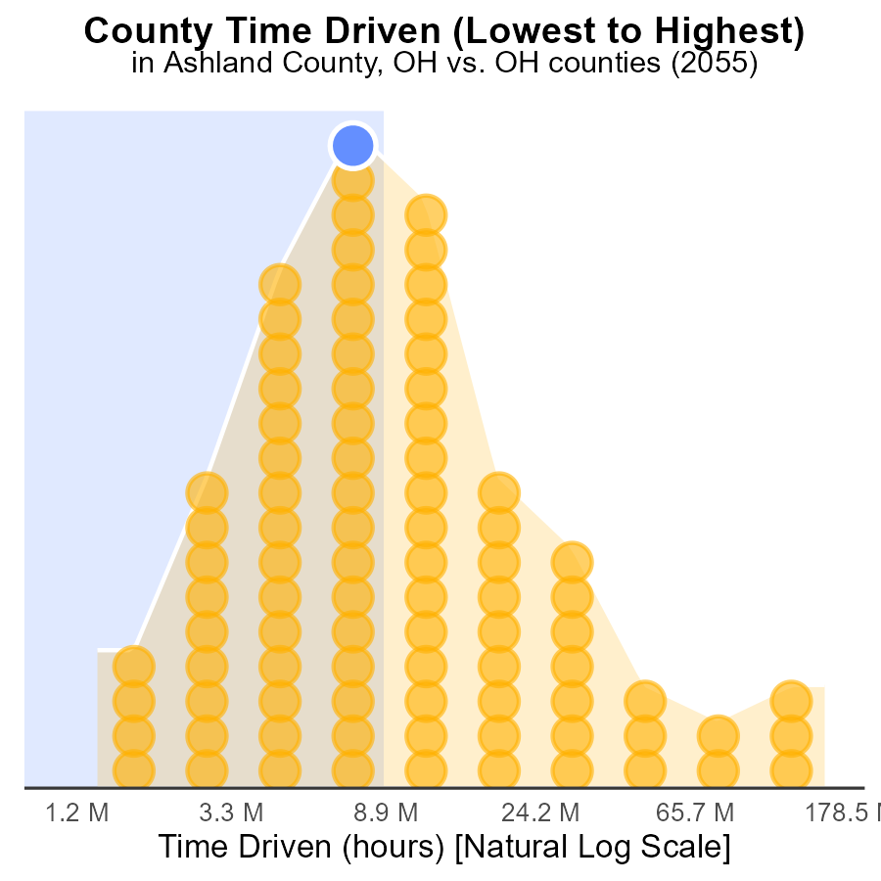

## Findings

* Morgan county has the lowest NOx emissions at 3.7 million hours, ranking 1st.
* Franklin county has the highest NOx emissions at 419.4 million hours, representing 100%.
* In total, the top 5 counties contribute to 211.1 million hours, accounting for 59.3% of total NOx emissions.

## Recommendations

To reduce NOx emissions, focus on Franklin county, which contributes significantly (100%) to the total. Implement stringent emission controls and shift to cleaner energy sources.

# Conclusion

In conclusion, the analysis of NOx emissions from on-road transportation in Ashland County, OH in 2055 reveals several key insights. LDV and LDT are the primary contributors to NOx emissions, comprising 80.4% of the total emissions. Lower-emitting vehicle types make up only a small fraction of the emissions, suggesting a need to prioritize the reduction of emissions from LDV and LDT. While idling activities have not significantly contributed to NOx emissions, the focus should shift towards addressing emissions from transportation and industrial activities.

The data also indicates a concerning increase in NOx emissions per capita over the study period. To combat this trend, it is crucial to implement stricter emission standards for industries and vehicles, promote public transportation, and invest in renewable energy sources. Targeted policies should be developed to reduce emissions from high-emitting counties like Franklin, while encouraging the adoption of cleaner technologies across all vehicle types. By adopting these strategies, Ashland County can work towards achieving lower overall NOx emissions and creating a more sustainable environment for its residents.

# About This Report

Data based on MOVES estimates collected by the Climate Action in Transportation program at Cornell University. Demographic data sourced from the US Census's American Community Survey 5-year estimates. This report was generated with the help of AI.

# References

* U.S. Census Bureau. (2023). American Community Survey 5-year estimates: Detailed tables. Retrieved from https://data.census.gov
* U.S. Environmental Protection Agency. (2024). Motor Vehicle Emission Simulator (MOVES 4.0) [Software]. Retrieved from https://www.epa.gov/moves