 

**PM2.5 Emissions in Apache County, 2000**  
Made with CAT VISUALIZER by Gao Labs @ Cornell University.

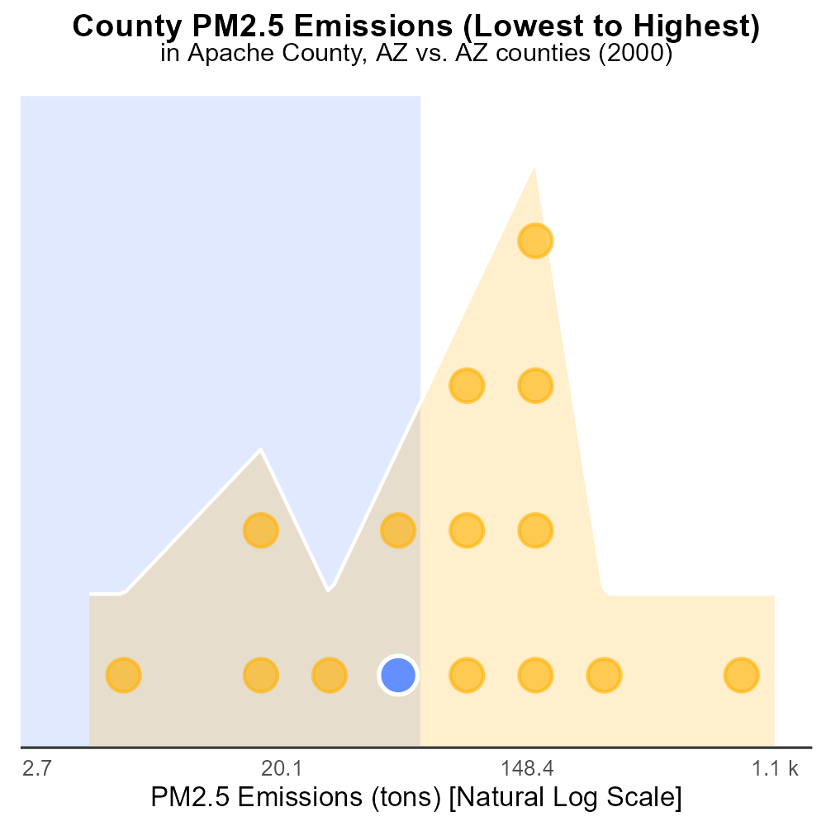

## Keywords

Primary Exhaust PM2.5; On-road transportation; Apache County; Emissions; 2000; Air quality

## Highlights

* Primary exhaust PM2.5 emissions from on-road transportation in Apache County, AZ were analyzed for 2000.
* The report provides a comprehensive overview of the total emissions and their impact on air quality.
* Data on primary exhaust PM2.5 can inform policy decisions and strategies for reducing emissions.
* Understanding the sources and levels of PM2.5 is crucial for protecting public health in Apache County.
* The findings will serve as a valuable resource for stakeholders working towards improving air quality.

# Introduction

The report examines the total emissions of Primary Exhaust PM2.5 from on-road transportation in Apache County, Arizona, specifically focusing on the year 2000. PM2.5 refers to particulate matter with a diameter of 2.5 micrometers or less, which can have significant health impacts due to its ability to penetrate deep into the respiratory system. This study aims to provide a detailed analysis of the sources and levels of PM2.5 emissions in the county, shedding light on the potential environmental and public health consequences.

By quantifying the primary exhaust PM2.5 emissions from on-road transportation, this report seeks to enhance our understanding of air quality challenges in Apache County. The data presented will be instrumental in guiding policies and initiatives aimed at reducing emissions and improving overall air quality for the residents of the county.

# Vehicle Miles Traveled by Regulatory Class

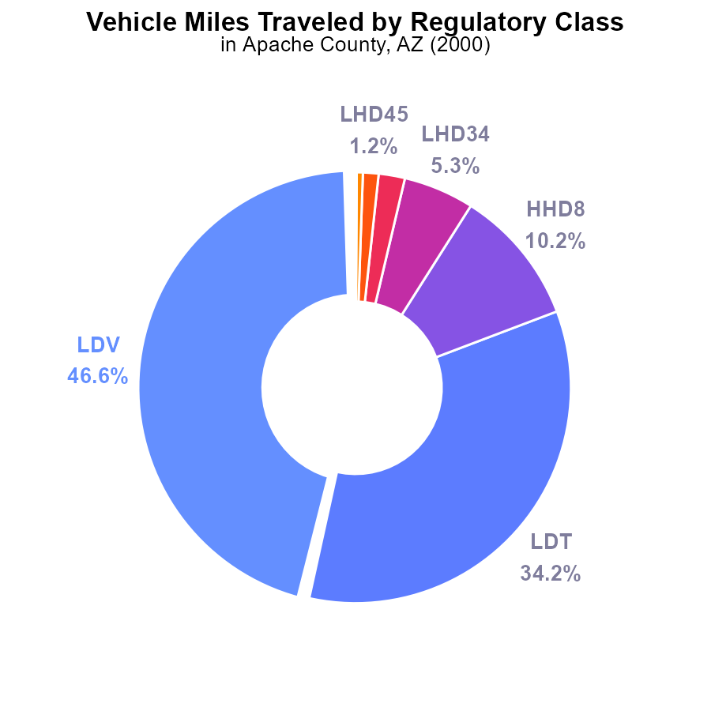

## Findings

* The highest contributor to PM2.5 emissions in Apache County, AZ in 2000 was LDV with 46.6%.
* LDV and LDT together accounted for 80.8% of the emissions from vehicle miles traveled.
* The remaining types of vehicles contributed to less than 13% of the emissions from vehicle miles traveled.

## Recommendations

To lower PM2.5 emissions, focus on reducing emissions from LDV and LDT as they are the primary contributors. Implement measures like promoting public transportation, carpooling, and incentivizing cleaner vehicle technologies to reduce overall emissions from vehicle miles traveled.

# Hotelling (Diesel Aux) by Road Type

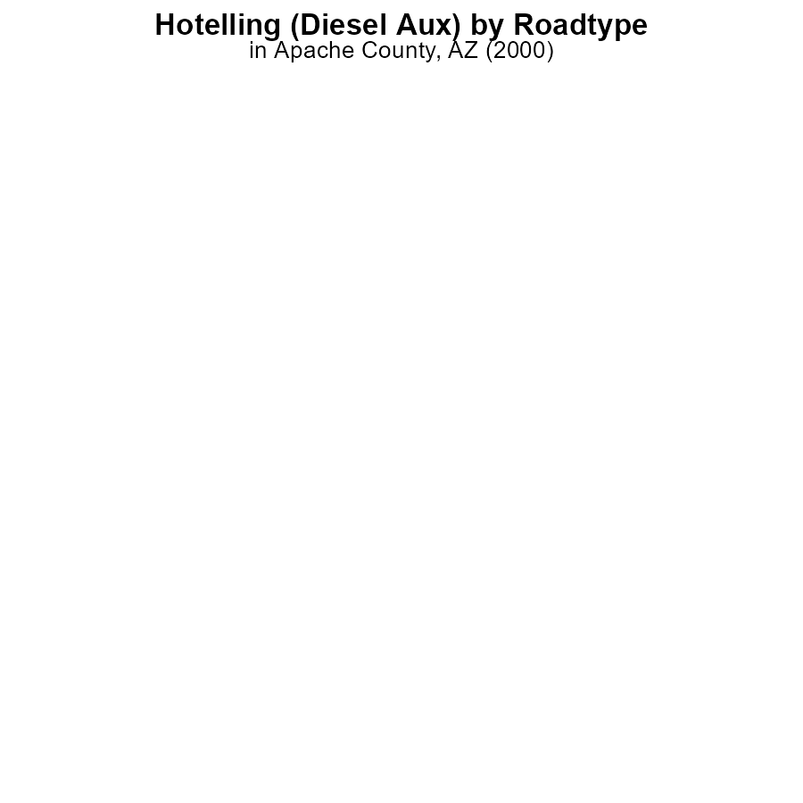

## Findings

* PM2.5 emissions in Apache County, AZ in 2000 from Hotelling (Diesel Aux) were 0.0 hours.
* There were no emissions of PM2.5 in any categories: Rural Restricted, Rural Unrestricted, Urban Restricted, Urban Unrestricted.
* The percentage of PM2.5 emissions for each category is not provided in the data.

## Recommendations

Given the absence of PM2.5 emissions in 2000 in Apache County, AZ, it is recommended to continue monitoring air quality and enforcing regulations to maintain zero emissions levels. Consider promoting cleaner technologies and alternative energy sources for future development.

# Hotelling (Diesel Aux) Overall over Time

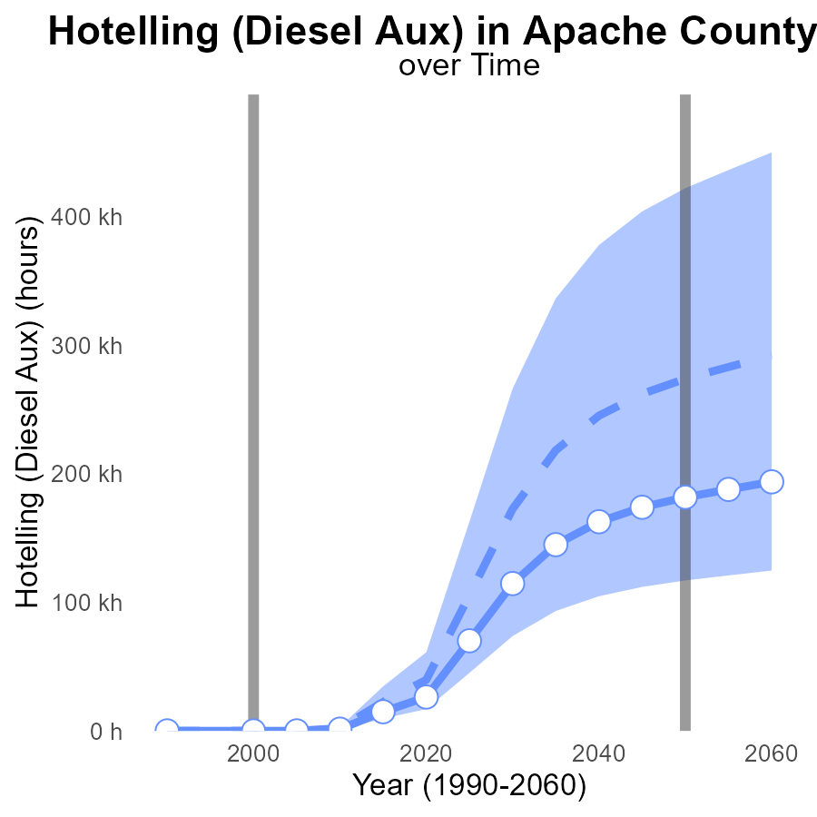

## Findings

* From 2010 to 2020, PM2.5 emissions in Apache County increased by 25 k hours.
* In 2020, emissions were 13.3 k hours below the upper 75th percentile of areas.
* The benchmark difference decreased by 26,312.0 between 1990 and 2020.

## Recommendations

To reduce PM2.5 emissions in Apache County, a focus is needed on monitoring and regulating Hotelling (Diesel Aux) hours. Implement strict emission controls and incentivize clean energy sources in industrial processes.

# Vehicle Starts over Time for Buses

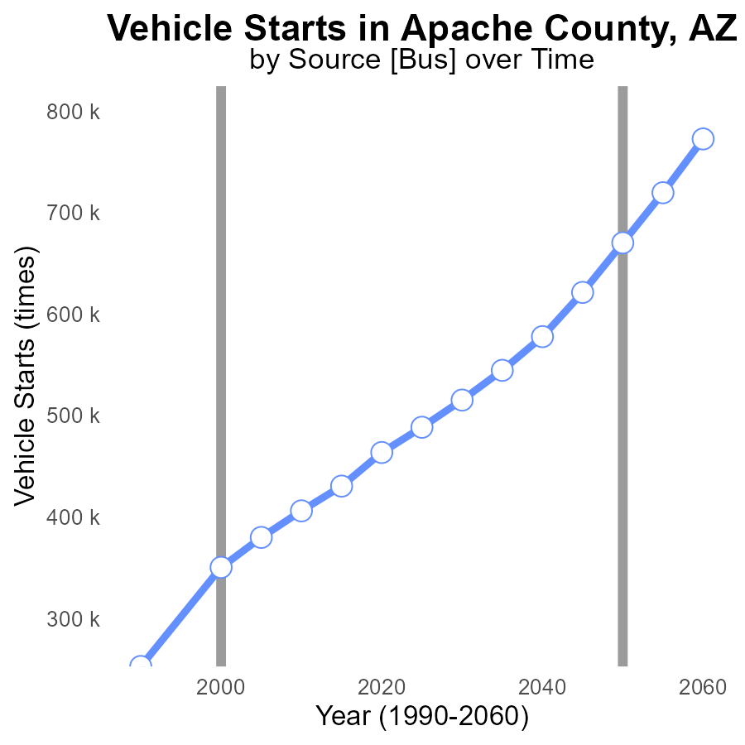

## Findings

* From 1990 to 2020, vehicle PM2.5 emissions in Apache County, AZ increased by 83.07%.
* The benchmark difference decreased by 50.41% from 1990 to 2020.
* Emissions steadily increased over the years, with a notable rise observed after 2005.

## Recommendations

To lower vehicle PM2.5 emissions, policymakers should consider implementing stricter vehicle emission standards, promoting the use of electric vehicles, expanding public transportation options, and investing in infrastructure to support alternative transportation methods. Additionally, campaigns encouraging carpooling and remote work can help reduce the number of vehicle starts in the area.

# Emissions Rate (per vehicle) in My Region

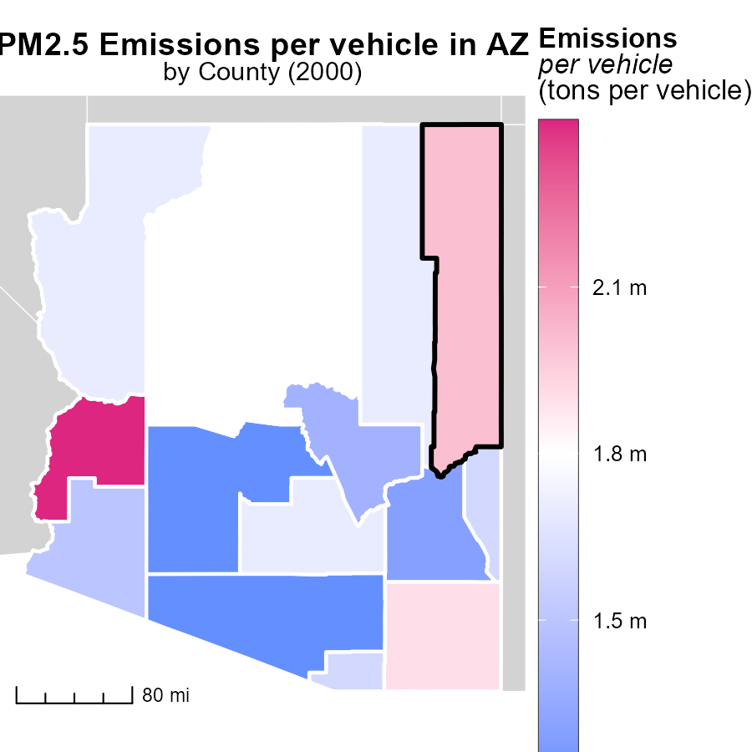

## Findings

* La Paz County, AZ has the highest emissions per vehicle at 2.4 tons.
* Pinal County, AZ has a median emissions level of 1.7 tons per vehicle.
* Pima County, AZ has the lowest emissions per vehicle at 1.2 tons.

## Recommendations

To decrease emissions, policymakers should focus on promoting vehicle electrification in La Paz County. In Pinal County, incentivize carpooling and public transportation. Encourage the use of eco-friendly vehicles in Pima County to further reduce emissions.

# Emissions Rate (per capita) Mapped by Area

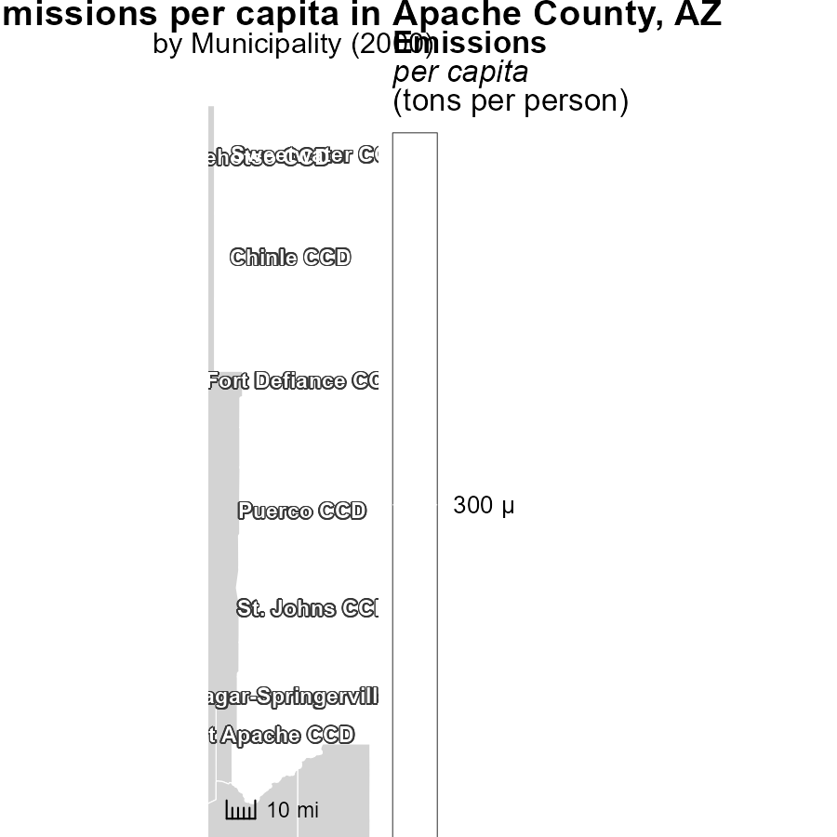

## Findings

* Chinle CCD, AZ has the highest emissions per capita at 331.9 tons per person.
* Fort Apache CCD, AZ has a median emissions per capita of 331.9 tons per person.
* Sweetwater CCD, AZ has the lowest emissions per capita at 331.9 tons per person.

## Recommendations

To lower emissions per capita, targeted policies are needed in high-emitting regions like Chinle CCD, AZ, focusing on sustainable development and renewable energy sources. Additionally, Fort Apache CCD, AZ can benefit from emission reduction initiatives, while efforts should be made to maintain the low emission levels in Sweetwater CCD, AZ.

# Emissions by Road Type over Time

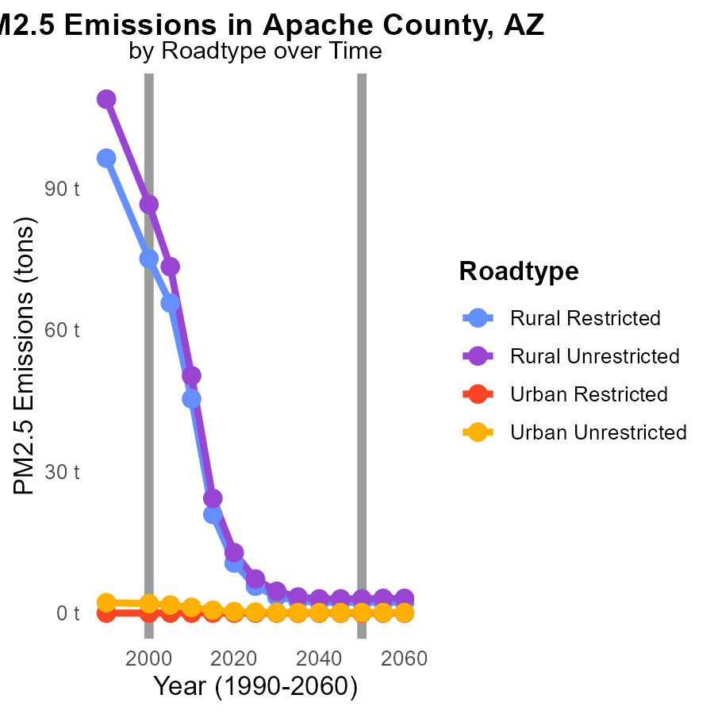

# Vehicle Starts by Vehicle Type over Time

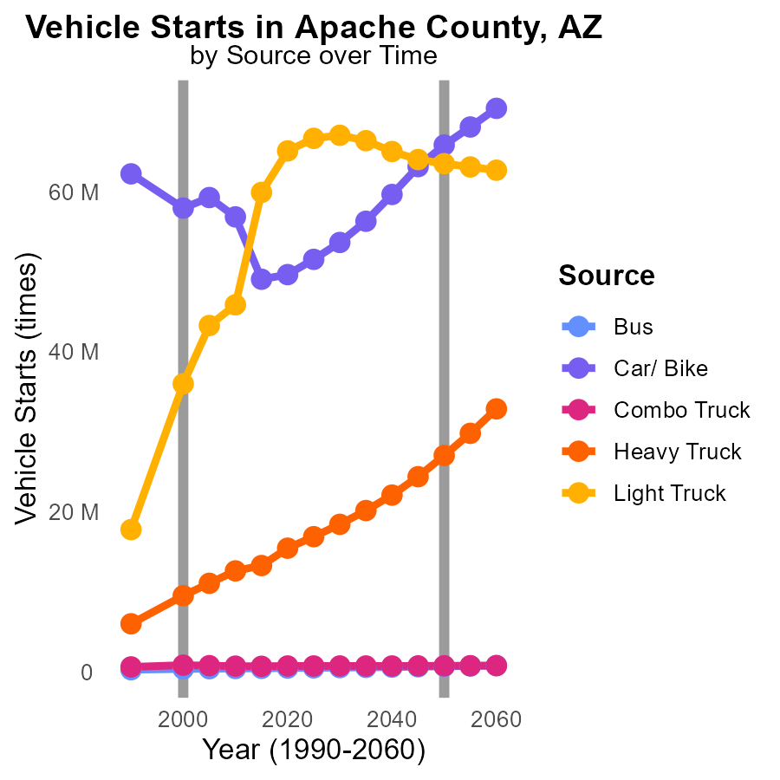

## Findings

* Between 1990 and 2010, Bus emissions decreased by an average of 37.9%.
* Car/ Bike emissions reduced by 27.5% from 1990 to 2010.
* However, Heavy Truck emissions increased by 112.4% over the same period.

## Recommendations

To decrease emissions, focus on improving public transportation infrastructure to further reduce Bus emissions. Encourage the use of electric vehicles for Cars/ Bikes to continue the decreasing trend. Implement stricter regulations for Heavy Trucks to control and decrease their emissions.

# Areas Ranked by Population

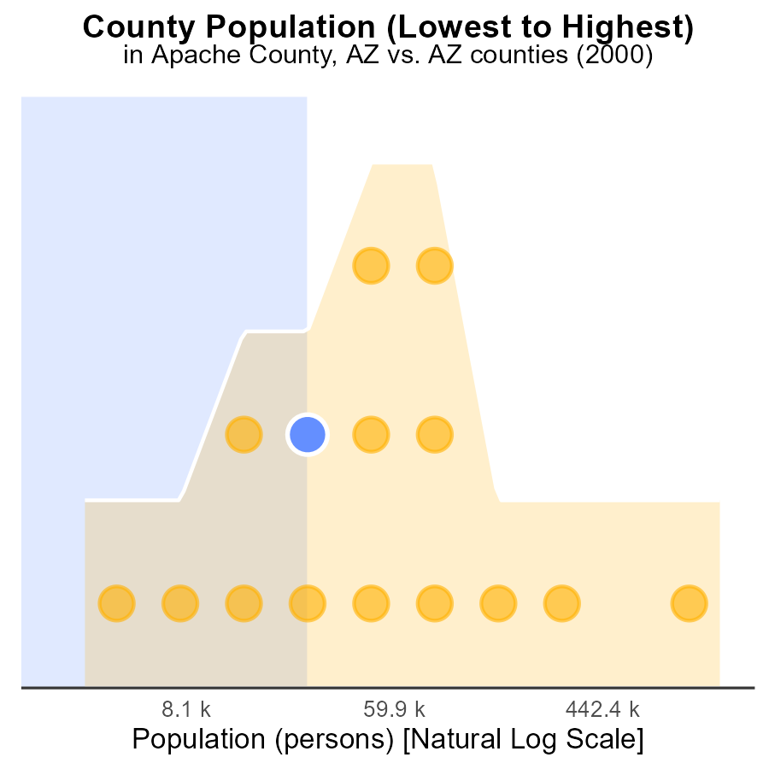

## Findings

* Maricopa county has the highest population with 3.8 million people.
* Apache county ranks 12th with a population of 70.3 thousand people, constituting 40.0% of Maricopa's population.
* Greenlee county ranks 2nd with 8.3 thousand people, forming only 6.7% of Maricopa's population.

## Recommendations

To lower emissions, prioritize reducing PM2.5 sources in Apache county to benefit Maricopa's air quality. Implement strict emission controls in Greenlee to minimize its impact on the overall emission levels.

# Areas Ranked by Emissions

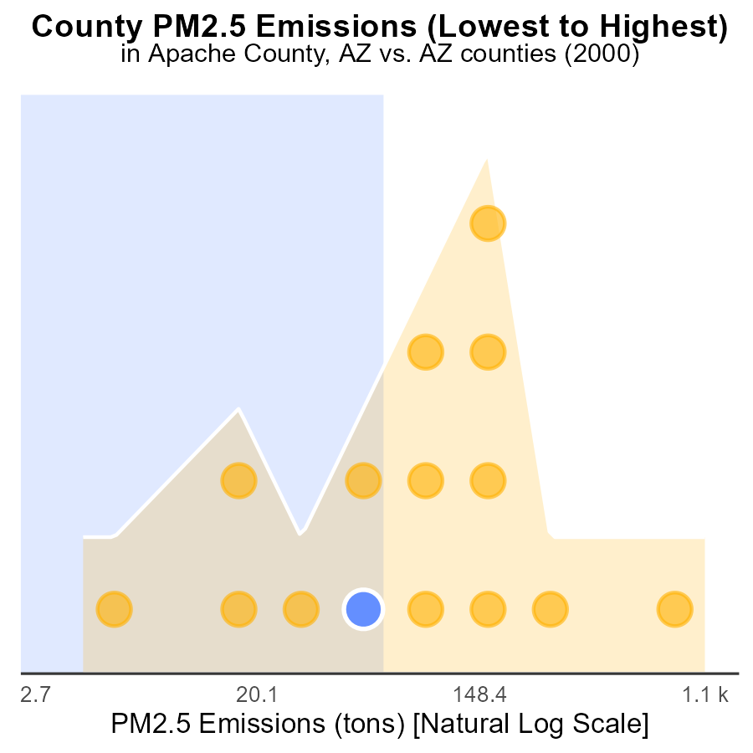

## Findings

* Maricopa has the highest PM2.5 emissions at 3,000 tons.
* La Paz ranks 6th with 173.3 tons, falling in the 40th percentile.
* Greenlee has the lowest emissions at 10.0 tons, ranking 1st in the 6.7th percentile.

## Recommendations

To lower emissions, focus initiatives on Maricopa and La Paz counties, addressing sources and implementing stricter regulations to reduce PM2.5 levels.

# Conclusion

In conclusion, the analysis of PM2.5 emissions in Apache County, AZ in 2000 reveals that LDV and LDT are the primary contributors, accounting for a significant portion of vehicle miles traveled emissions. To effectively reduce PM2.5 emissions, it is crucial to focus on implementing measures that target LDV and LDT emissions, such as promoting public transportation, carpooling, and cleaner vehicle technologies. Additionally, monitoring and regulating Hotelling (Diesel Aux) hours can further contribute to lowering emissions levels.

It is essential to maintain zero-emission levels by enforcing regulations and promoting cleaner technologies and alternative energy sources. Looking ahead, policymakers should consider stricter vehicle emission standards, electric vehicle promotion, and infrastructure investments to support sustainable transportation methods. By addressing the specific emission sources and implementing targeted policies, Apache County can work towards reducing PM2.5 emissions and improving air quality for its residents and neighboring counties like Maricopa and Greenlee.

# About This Report

Data based on MOVES estimates collected by the Climate Action in Transportation program at Cornell University. Demographic data sourced from the US Census's American Community Survey 5-year estimates. This report was generated with the help of AI.

# References

* U.S. Census Bureau. (2023). American Community Survey 5-year estimates: Detailed tables. Retrieved from https://data.census.gov
* U.S. Environmental Protection Agency. (2024). Motor Vehicle Emission Simulator (MOVES 4.0) [Software]. Retrieved from https://www.epa.gov/moves