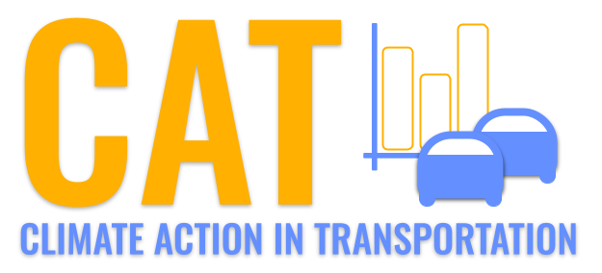 

**CO Emissions in Yates County, 2060**  
Made with CAT VISUALIZER by Gao Labs @ Cornell University.

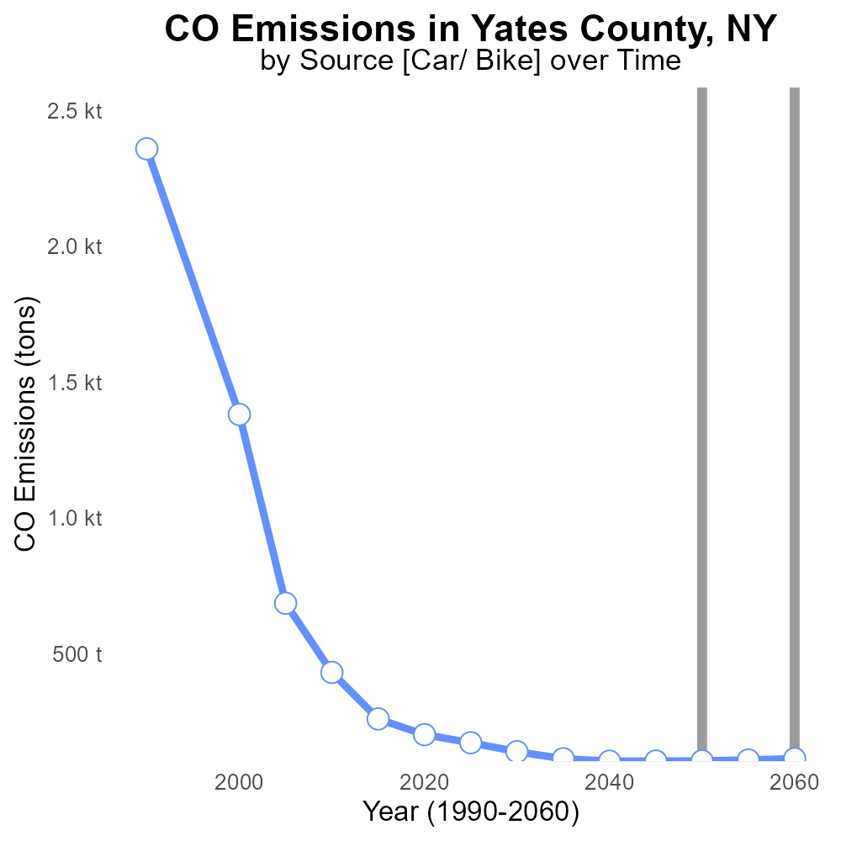

## Keywords

Carbon Monoxide emissions; on-road transportation; Yates County, NY; 2060; environmental impact

## Highlights

* Analyzing CO emissions from on-road transport in Yates County, NY (2060).
* Implications for air quality and human health in the region.
* Measuring the impact of transportation on CO levels by 2060.
* Exploring strategies to reduce CO emissions in the county.
* Understanding the evolving environmental challenges of on-road transportation.

# Introduction

This report delves into the Carbon Monoxide (CO) emissions from on-road transportation in Yates County, New York, projected for the year 2060. As the county continues to grow and develop, the impact of transportation on air quality and human health is a growing concern.

By analyzing the trends and potential scenarios, this report aims to shed light on the future CO emission levels in Yates County and identify strategies to mitigate these emissions. With a focus on environmental sustainability and public health, understanding the evolving landscape of on-road transportation emissions becomes crucial for informed decision-making.

# Emissions Rate (per capita) by Fuel Type

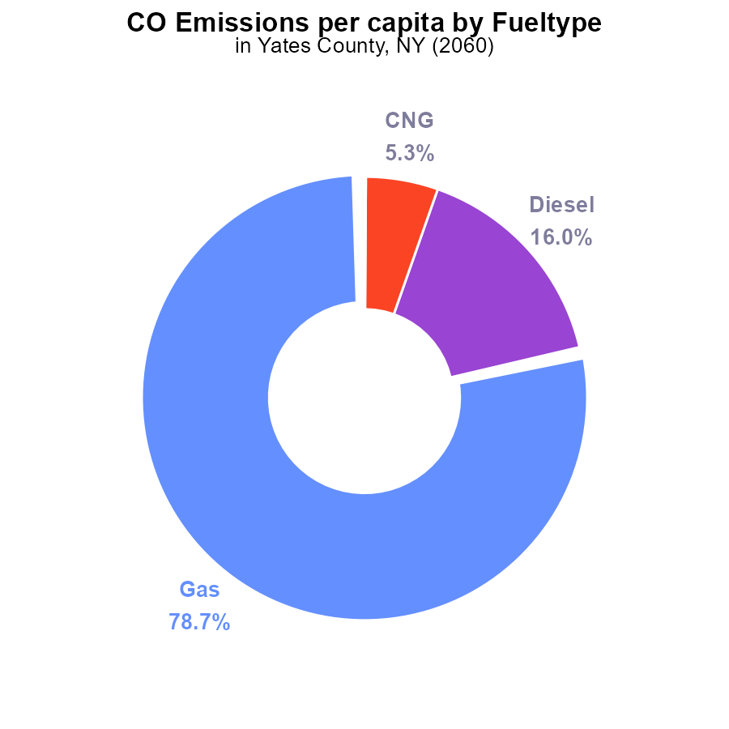

## Findings

* Gasoline emissions are the highest at 78.7% per capita.
* Diesel emissions make up 16.0% per capita.
* CNG and ethanol emissions are lower at 5.3% and 0.1% per capita respectively.

## Recommendations

To lower emissions, focus should be on reducing gasoline and diesel consumption. Encouraging the adoption of cleaner fuel alternatives such as CNG and ethanol could help decrease emissions significantly.

# Emissions Rate (per capita) by Vehicle Type

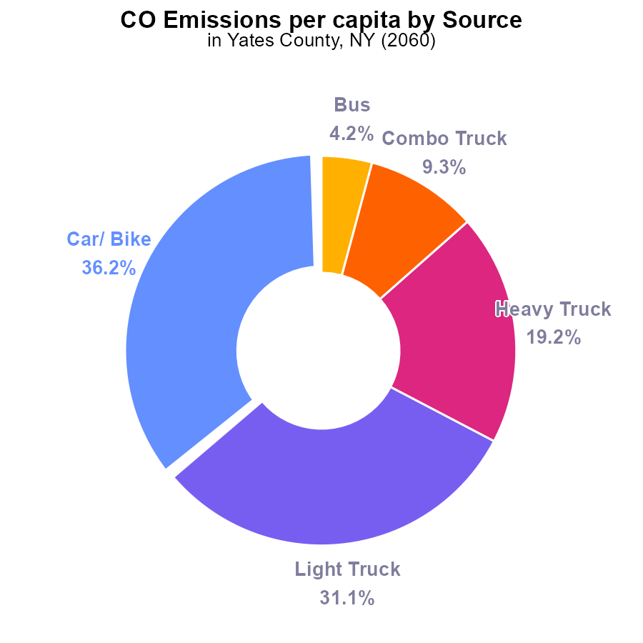

## Findings

* The highest CO emissions per capita in Yates County, NY, in 2060 come from Car/Bike usage at 36.2%.
* Light Trucks follow closely behind at 31.1% of total emissions per person.
* The lowest contribution to CO emissions per capita comes from buses at 4.2%.

## Recommendations

To reduce CO emissions in Yates County, NY, it is recommended to focus on promoting alternative transportation methods like biking, public transportation, and carpooling to decrease emissions from cars and light trucks. Additionally, implementing stricter emissions standards for trucks, especially heavy and combo trucks, can significantly lower the overall CO emissions per capita.

# Emissions over Time for Passenger Vehicles

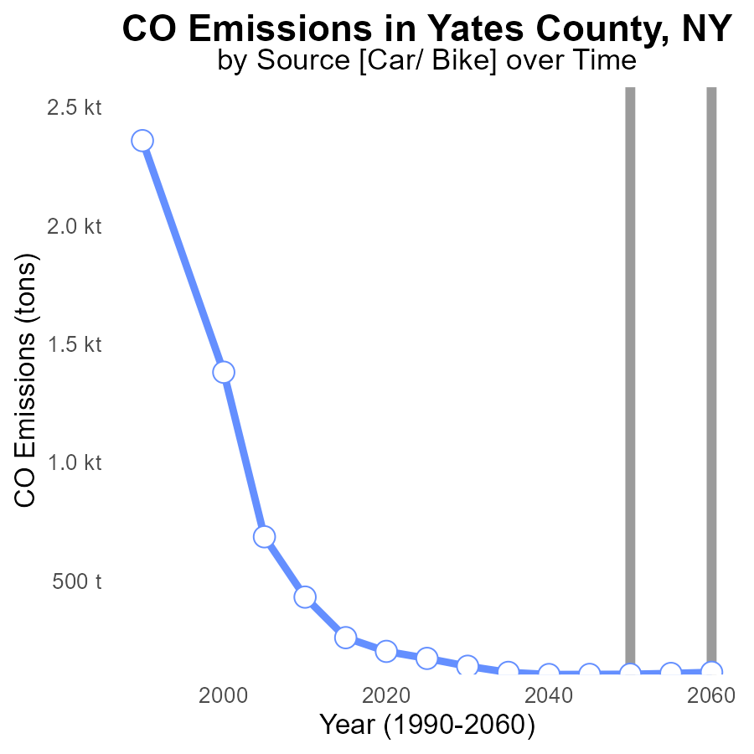

## Findings

* Emissions in Yates County, NY, are projected to increase from 103.5 tons in 2040 to 112.7 tons in 2060.
* However, there has been a benchmark difference, with emissions decreasing by 8.1 tons from 2040 to 2060.
* Overall, there's a positive trend showing a reduction in emissions over the years despite fluctuations.

## Recommendations

To further reduce emissions in Yates County, NY, efforts should focus on adopting cleaner energy sources, improving energy efficiency in buildings, promoting public transportation, and implementing stricter emission regulations for industries within the region.

# Emissions over Time for Buses

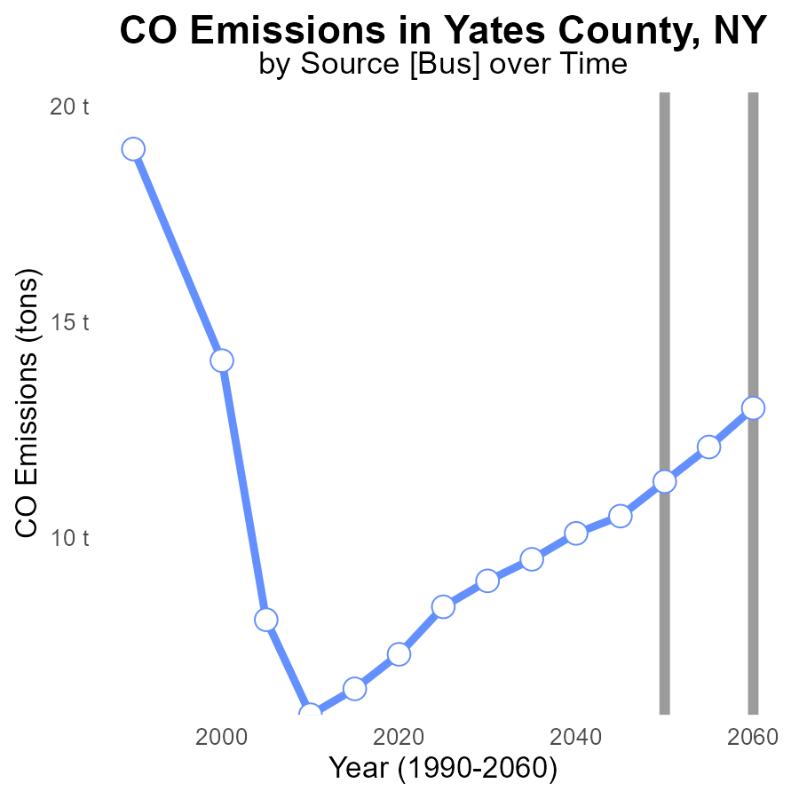

## Findings

* CO emissions in Yates County are increasing over time.
* By 2060, CO emissions are projected to reach 13.0 tons.
* There has been a steady decrease in the CO emissions benchmark difference from 2040 to 2060.

## Recommendations

To lower CO emissions in Yates County, implement stricter emission standards for industries and promote the use of electric vehicles to reduce air pollution levels. Encourage the adoption of renewable energy sources to decrease dependency on fossil fuels.

# Time Driven in My Region

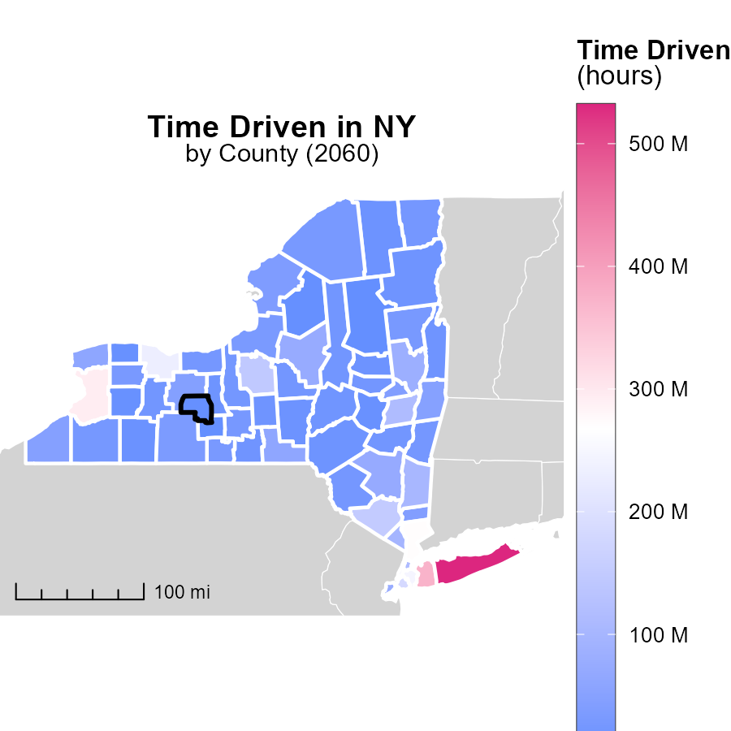

## Findings

* Suffolk County, NY has the highest emissions with 531.9 million units.
* St. Lawrence County, NY has a median emission level of 28.3 million units.
* Hamilton County, NY has the lowest emissions, at 4.0 million units.

## Recommendations

To lower emissions, focus on reducing the hours driven in high-emission areas like Suffolk County. Implement carpooling, public transportation, and telecommuting incentives to decrease overall emissions.

# Vehicle Starts in My Region

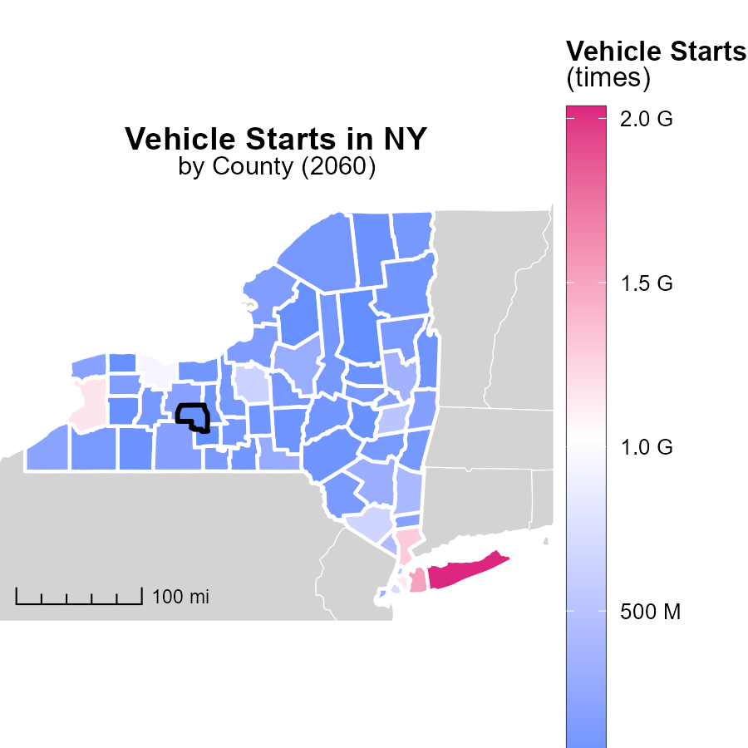

## Findings

* Suffolk County, NY had the highest vehicle starts with 2.0 billion times.
* Sullivan County, NY recorded a median of 122.0 million vehicle starts.
* Hamilton County, NY had the lowest vehicle starts with 16.9 million times.

## Recommendations

To reduce emissions linked to vehicle starts, encourage the use of public transportation, promote carpooling initiatives, and invest in infrastructure that supports biking and walking.

# Vehicle Starts by Area over Time

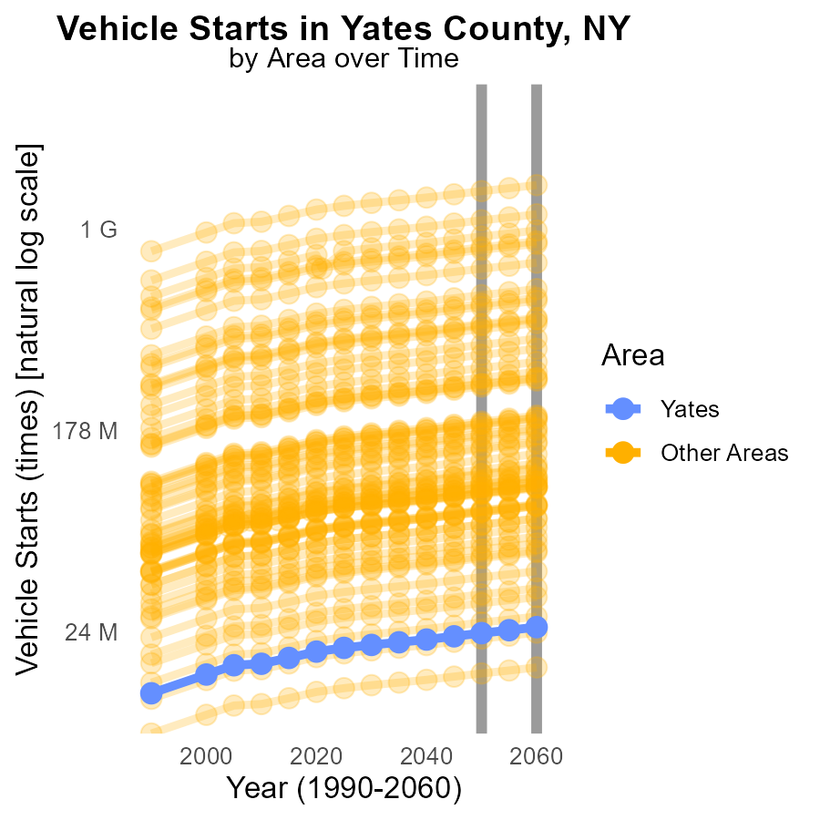

## Findings

* In 2060, minimum county had 16.9 million vehicle starts.
* In 2060, maximum county had 2.0 billion vehicle starts.
* In 2060, target county had 25.3 million vehicle starts.

## Recommendations

To lower emissions, incentivize public transportation, carpooling, and electric vehicle adoption in counties with high vehicle starts. Implement stricter emissions standards for vehicles to reduce overall emissions.

# Emissions Rate (per vehicle) by Area over Time

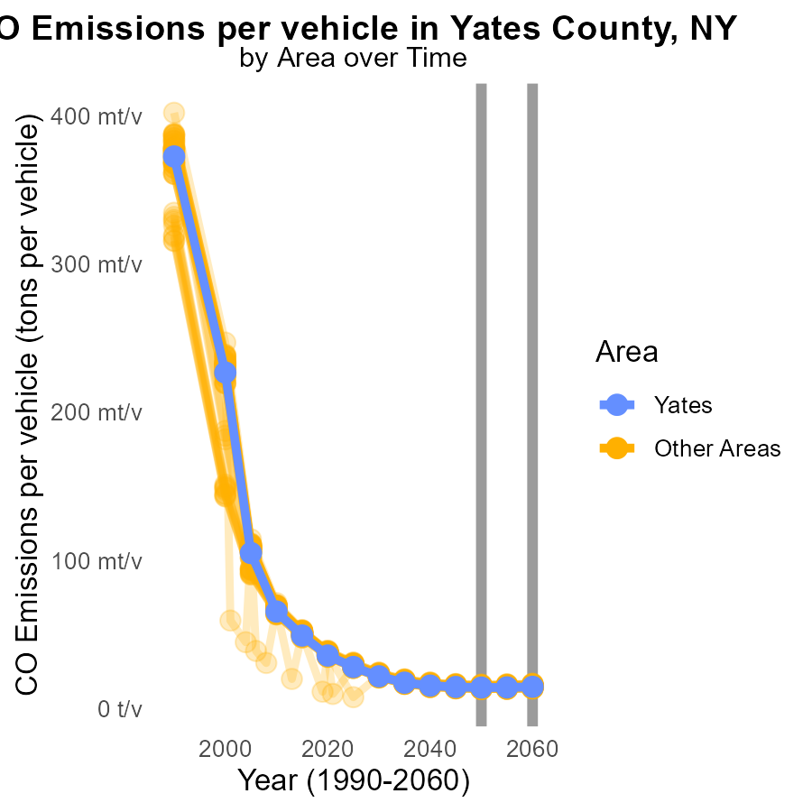

## Findings

* Emissions per vehicle ranged from 13.7 to 16.8 tons in 2060.
* There was a decrease of 0.4 to 0.6 tons per vehicle compared to 2050 levels.
* The target county had emissions of 14.7 tons per vehicle in 2060.

## Recommendations

To lower emissions levels, focus on implementing stricter vehicle emission standards, promoting the use of electric vehicles, and investing in public transportation infrastructure to reduce individual vehicle usage.

# Areas Ranked by Hotelling (Engines Off)

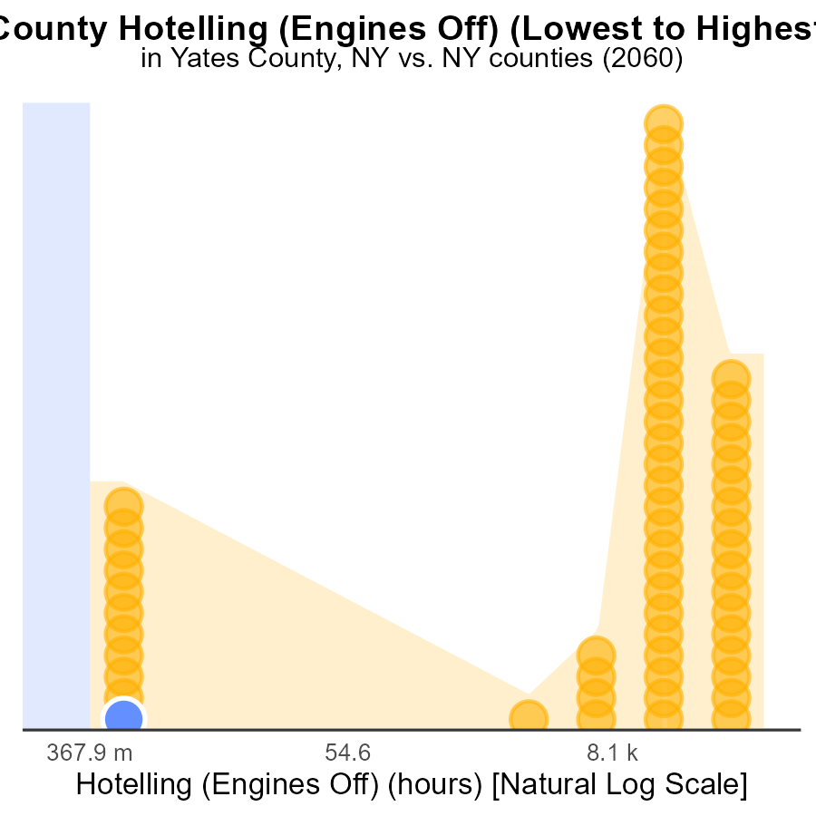

## Findings

* Yates County has the lowest emissions with 0.0 CO in engines off mode.
* Westchester County ranks 62nd out of all with 409.0 k CO emissions in engines off mode, representing 100.0% of the total.
* In general, there is a high level of CO emissions, with 17.7% being the highest percentile observed.

## Recommendations

To lower emissions, focus on counties like Westchester by promoting engine efficiency and usage reduction. Invest in cleaner transportation options to reduce overall CO emissions.

# Areas Ranked by Population

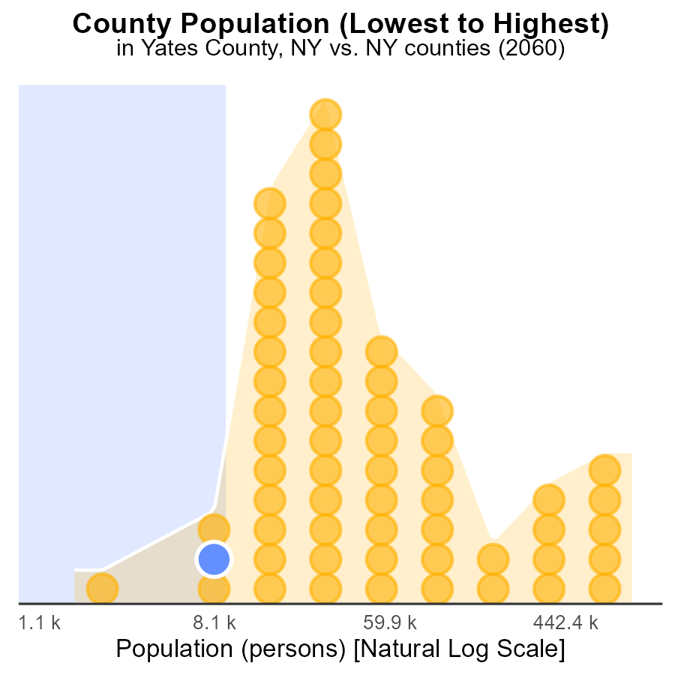

## Findings

* Kings county has the highest population with 2.6 million people, constituting 100% of the total population.
* Yates county is the 6th largest with 25,000 people, accounting for 4.8% of the population.
* Hamilton county ranks 2nd with 4,500 people, representing 1.6% of the total population.

## Recommendations

To reduce emissions, focus on mitigation efforts in Kings county due to its high population impact. Implement eco-friendly initiatives based on emission sources in Yates and Hamilton counties to lower overall emissions.

# Conclusion

In conclusion, the data from the report indicates that while CO emissions in Yates County, NY, have been on the rise, there is a positive trend showing a reduction in emissions over the years despite fluctuations. The key contributors to CO emissions are car and bike usage, as well as light trucks. To effectively lower emissions, the focus should be on promoting alternative transportation methods such as biking, public transportation, and carpooling, while also encouraging the adoption of cleaner fuel alternatives like CNG and ethanol. Implementing stricter emissions standards for vehicles, particularly trucks, and industries can also significantly contribute to decreasing CO emissions in the region.

Efforts should continue to center around adopting cleaner energy sources, enhancing energy efficiency in buildings, and enforcing stringent emission regulations. By incentivizing public transportation, carpooling, and the use of electric vehicles, Yates County can work towards achieving a significant reduction in CO emissions, ensuring a healthier environment for its residents.

# About This Report

Data based on MOVES estimates collected by the Climate Action in Transportation program at Cornell University. Demographic data sourced from the US Census's American Community Survey 5-year estimates. This report was generated with the help of AI.

# References

* U.S. Census Bureau. (2023). American Community Survey 5-year estimates: Detailed tables. Retrieved from https://data.census.gov
* U.S. Environmental Protection Agency. (2024). Motor Vehicle Emission Simulator (MOVES 4.0) [Software]. Retrieved from https://www.epa.gov/moves