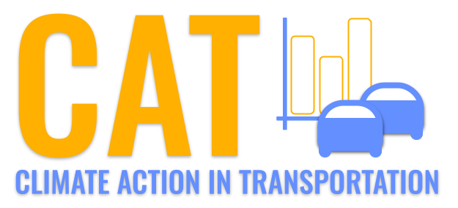 

**CO Emissions in Van Buren County, 2045**  
Made with CAT VISUALIZER by Gao Labs @ Cornell University.

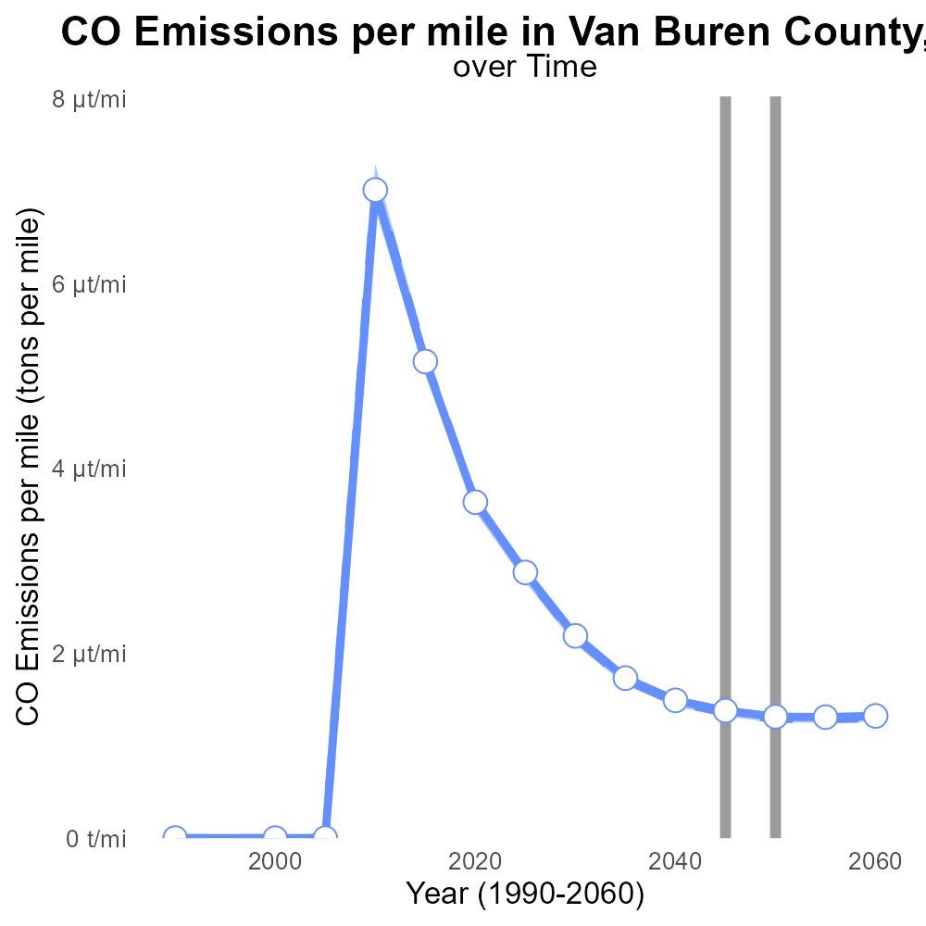

## Keywords

Carbon monoxide emissions; On-road transportation; Van Buren County; MI; 2045

## Highlights

* CO emissions from on-road transport in Van Buren County, MI in 2045.
* Study aims to analyze trends, impacts, and mitigation strategies.
* Understanding CO emissions crucial for sustainable development.
* Results will inform policymakers for effective intervention.
* Transport sector plays a significant role in CO emissions.

# Introduction

Carbon monoxide (CO) emissions from on-road transportation have become a growing concern in Van Buren County, MI, especially as we look towards the year 2045. As the county's population and economy continue to grow, the number of vehicles on the roads is expected to increase, leading to higher levels of CO emissions.

This report aims to provide a comprehensive analysis of the trends, impacts, and potential mitigation strategies related to CO emissions from on-road transportation in Van Buren County in the year 2045. Understanding the sources and levels of CO emissions is crucial for the county's sustainable development goals and will help in formulating effective policies and interventions to reduce harmful emissions. The findings of this study will be instrumental in guiding local policymakers and stakeholders towards a cleaner and healthier environment for all residents.

# Vehicle Miles Traveled by Fuel Type

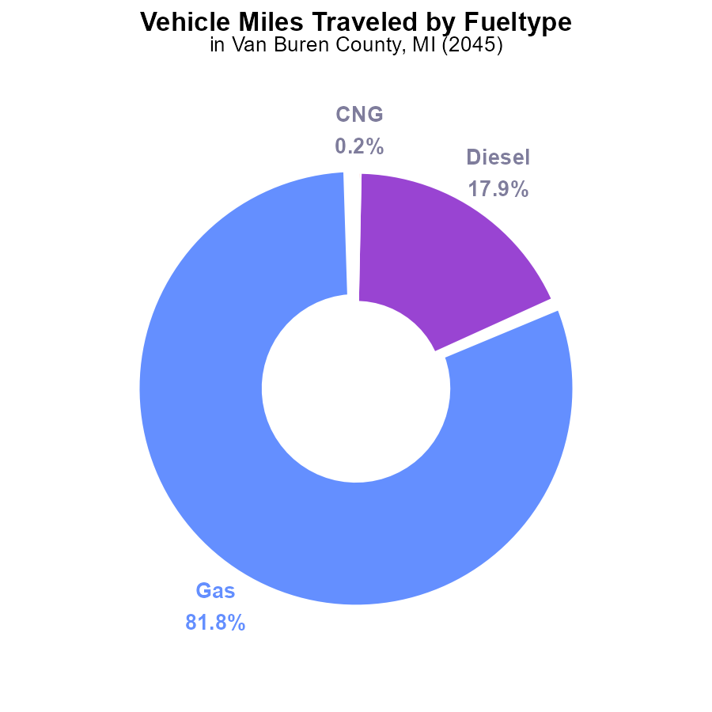

## Findings

* Diesel vehicles contribute 17.9% of CO emissions from vehicle traveled miles.
* Gasoline vehicles are responsible for 81.8% of CO emissions from vehicle traveled miles.
* CNG and Ethanol combined contribute only 0.3% of CO emissions from vehicle miles traveled.

## Recommendations

To decrease CO emissions, it is recommended to incentivize the transition to electric vehicles, improve public transportation, and invest in infrastructure supporting alternative fuel sources.

# Vehicle Starts by Fuel Type

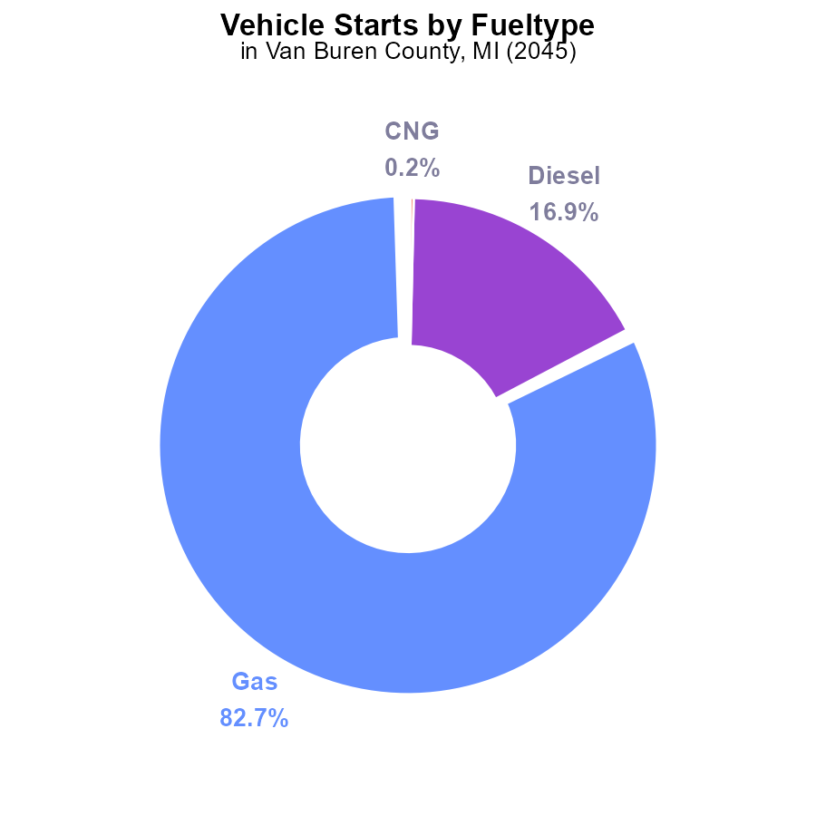

## Findings

* Gasoline vehicles account for 82.7% of CO emissions in Van Buren County.
* Diesel vehicles contribute 16.9% to the total CO emissions.
* Alternative fuel types such as CNG and Ethanol together make up only 0.3% of CO emissions.

## Recommendations

To lower CO emissions, focus on reducing gasoline and diesel vehicle usage through promoting electric and hybrid vehicles. Invest in infrastructure supporting alternative fuels to increase their usage.

# Vehicle Miles Traveled Overall over Time

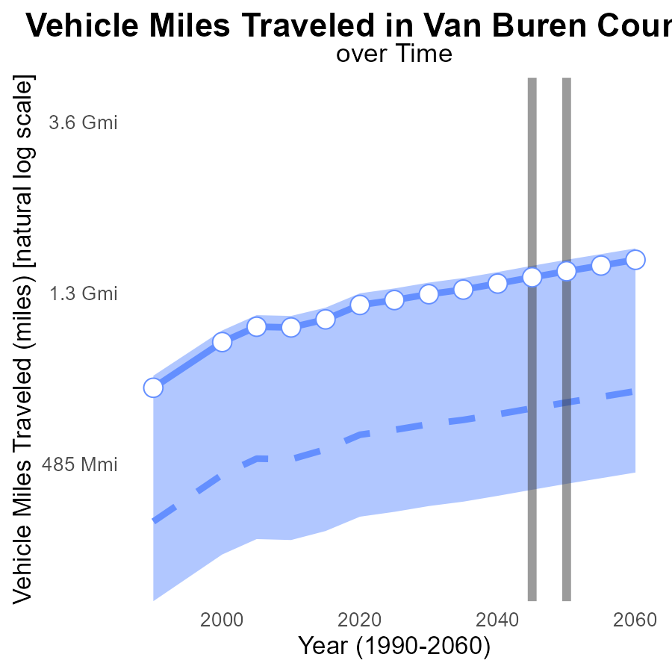

## Findings

* Vehicle miles traveled in Van Buren County are consistently increasing over time.
* The benchmark difference shows Van Buren County's VMT is consistently below the 75th percentile of all areas.
* By 2060, VMT is projected to reach 1.6 billion miles, reflecting an 860.6 million mile increase from the median area.

## Recommendations

To lower emissions, invest in public transportation to reduce individual vehicle usage. Implement bike lanes, carpooling incentives, and telecommuting options. Encourage electric vehicle adoption by expanding charging infrastructure.

# Emissions Rate (per mile) Overall over Time

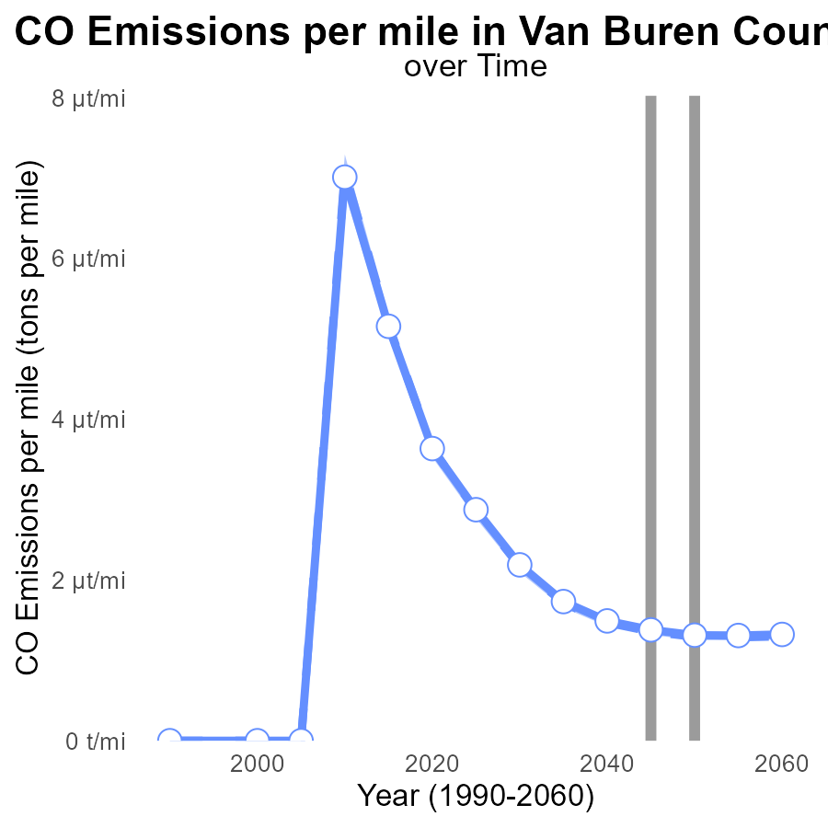

## Findings

* Emissions per mile in Van Buren County are decreasing over time.
* The area is consistently above the median and upper 75th percentile for emissions.
* There has been a gradual improvement in emissions, with a minimal benchmark difference by 2055.

## Recommendations

To further reduce emissions in Van Buren County, policymakers should focus on promoting the adoption of electric vehicles and increasing public transportation options. Implementing stricter emission standards for vehicles can also help in maintaining the downward trend observed over the years.

# Emissions Rate (per vehicle) in My Region

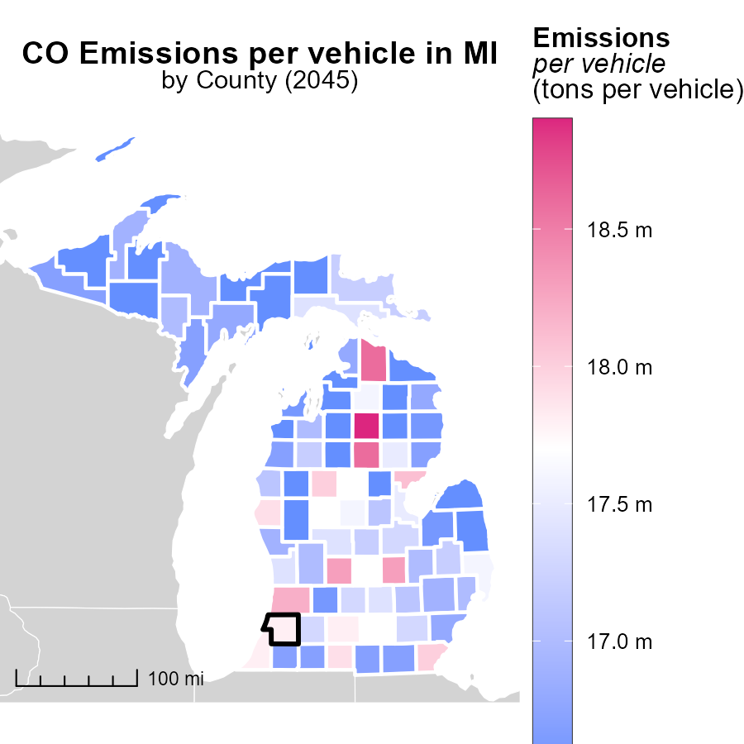

## Findings

* The highest emissions per vehicle were in Crawford County, MI, with 18.9 tons.
* Kent County, MI had median emissions per vehicle at 17.0 tons.
* Schoolcraft County, MI had the lowest emissions per vehicle, with 16.5 tons.

## Recommendations

To reduce emissions, focus on initiatives in counties with higher emissions like Crawford County, MI. Implement policies promoting cleaner transportation methods and incentivize the use of electric vehicles.

# Vehicles Mapped by Area

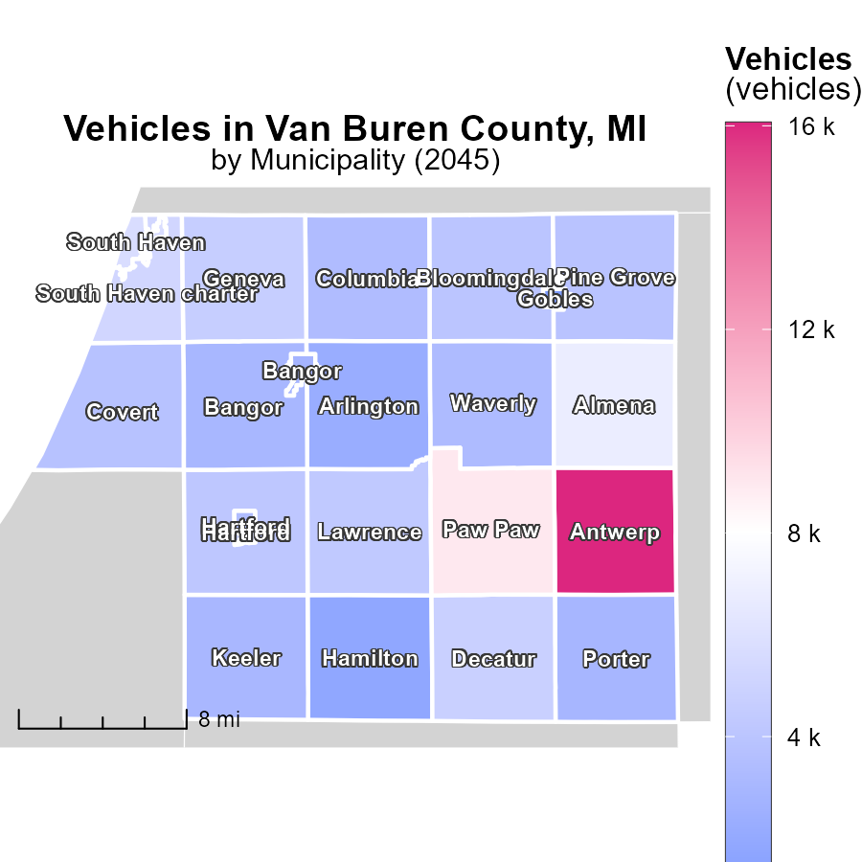

## Findings

* Antwerp, MI has the highest vehicle emissions at 16.1 k
* Covert, MI has median vehicle emissions at 3.8 k
* There are areas in MI with no reported vehicle emissions

## Recommendations

To lower vehicle emissions, focus on high-emitting areas like Antwerp, MI, by introducing stricter emissions regulations and promoting the use of electric vehicles. Conduct further investigations in areas with no reported emissions to ensure accurate data collection.

# Vehicles by Regulatory Class over Time

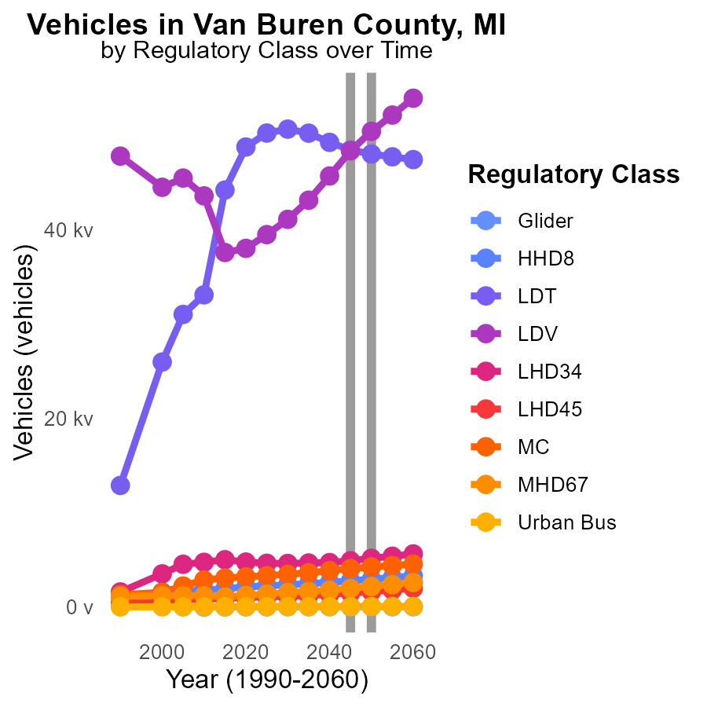

## Findings

* From 2035 to 2055, Glider emissions are decreasing by 6.4%.
* Light-Duty Trucks (LDT) emissions will decrease by 4.6% from 2035 to 2055.
* Urban Bus emissions are projected to decrease by 7.3% from 2035 to 2055.

## Recommendations

To further reduce emissions, incentivize the transition to cleaner fuel alternatives for buses and trucks. Promote the adoption of electric and hybrid vehicles. Implement stricter emissions standards for all vehicle types.

# Vehicles by Fuel Type over Time

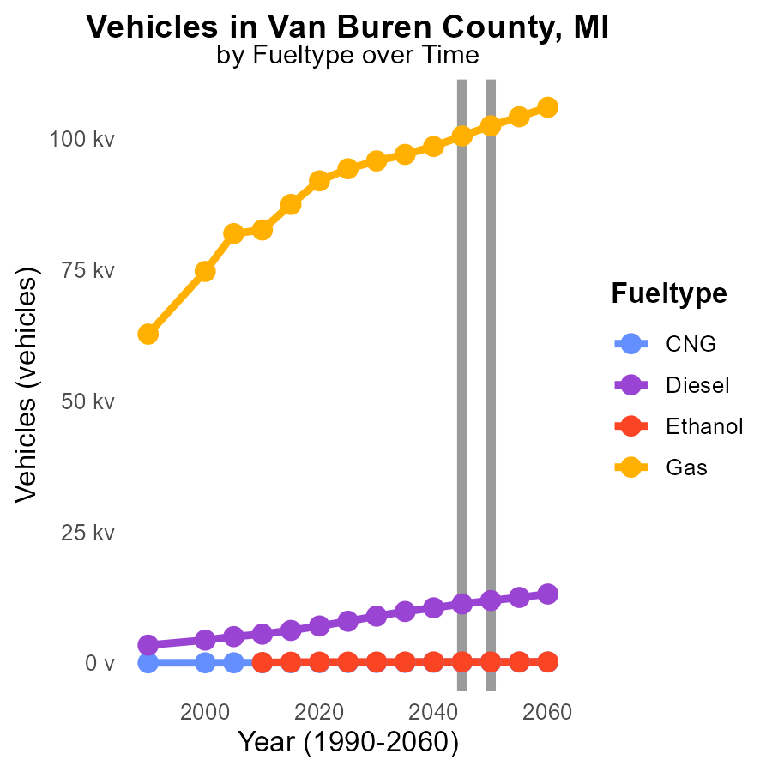

## Findings

* By 2050, CNG emissions are projected to increase by 8.4% compared to 2035 levels.
* Diesel emissions are set to rise by 7.4k (62.2%) from 2035 to 2050.
* Gas emissions are estimated to decrease by 1.8% between 2050 and 2055.

## Recommendations

To lower emissions, promote a shift from diesel to CNG vehicles, incentivize the use of ethanol, and implement stricter regulations on gas emissions by introducing cleaner fuels.

# Areas Ranked by Hotelling (Engines Off)

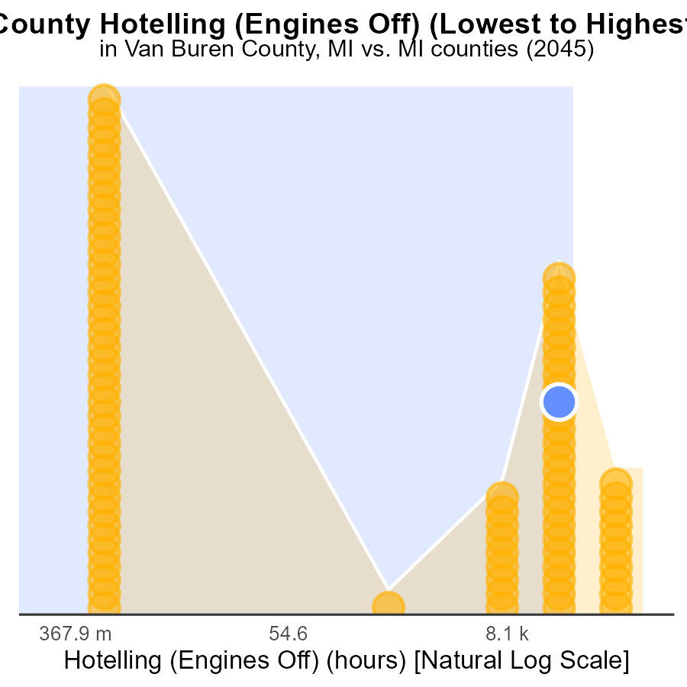

## Findings

* Wayne County has the highest absolute CO emissions with 530.5 k hours.
* Alcona County has the lowest CO emissions with 0 hours.
* Overall, Wayne County ranks 83rd in emissions, reaching 100.0% of the total emissions among counties.

## Recommendations

To lower CO emissions, focus on reducing idling times in Wayne County through awareness campaigns and stricter enforcement of anti-idling policies. Support the implementation of engine-off programs in hotspots like Wayne.

# Areas Ranked by Emissions Rate (per mile)

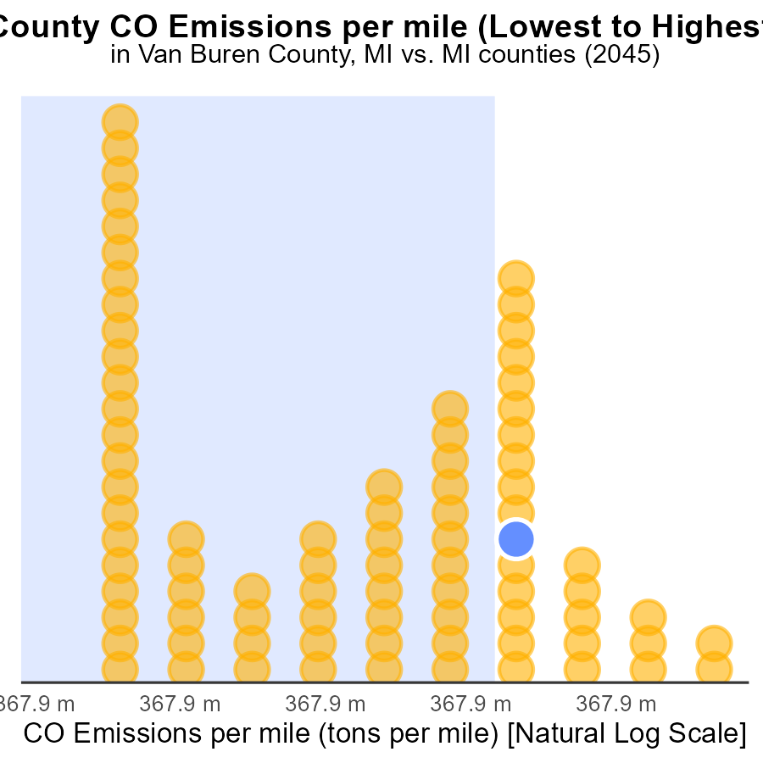

## Findings

* Luce County has the lowest CO emissions per mile at 1.3 tons per mile
* Roscommon County has the highest CO emissions per mile at 1.4 tons per mile
* Overall, counties in this dataset have a range of CO emissions per mile, with most falling within the 1.4 tons per mile range

## Recommendations

To lower emissions, focus on counties with higher emissions like Roscommon. Implement strategies to reduce vehicle miles traveled and promote cleaner transportation options.

# About This Report

Data based on MOVES estimates collected by the Climate Action in Transportation program at Cornell University. Demographic data sourced from the US Census's American Community Survey 5-year estimates. This report was generated with the help of AI.

# References

* U.S. Census Bureau. (2023). American Community Survey 5-year estimates: Detailed tables. Retrieved from https://data.census.gov
* U.S. Environmental Protection Agency. (2024). Motor Vehicle Emission Simulator (MOVES 4.0) [Software]. Retrieved from https://www.epa.gov/moves