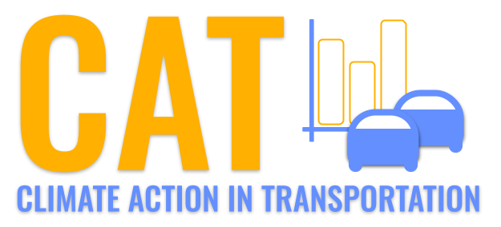 

**PM10 Emissions in Otsego County, 2035**  
Made with CAT VISUALIZER by Gao Labs @ Cornell University.

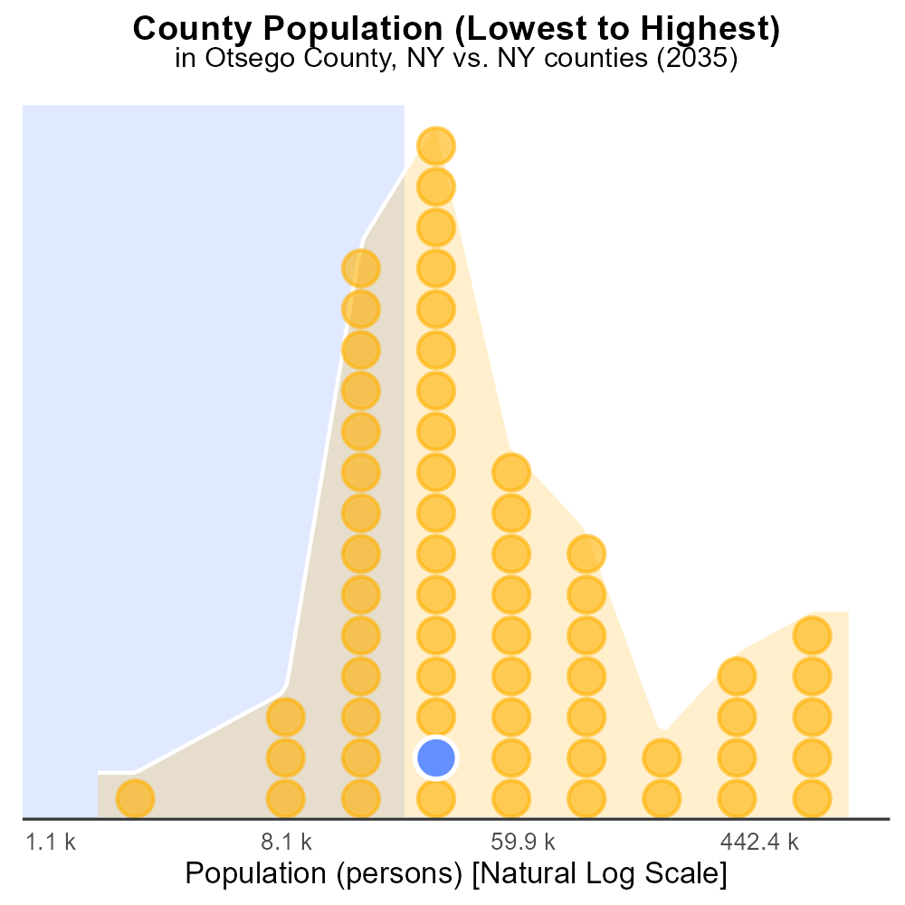

## Keywords

Primary Exhaust; PM10; Total emissions; On-road transportation; Otsego County; 2035

## Highlights

* Study on PM10 emissions from on-road transportation in Otsego County.
* Analysis of primary exhaust sources contributing to PM10 pollution.
* Assessment of total emissions impact on air quality in the region.
* Implications for public health and environmental policies.
* Recommendations for reducing PM10 emissions from transportation.

# Introduction

The following report presents a comprehensive analysis of Primary Exhaust PM10 emissions from on-road transportation in Otsego County, NY, projected for the year 2035. The study focuses on the sources of PM10 pollution originating from vehicular exhaust in the region.

By examining the total emissions of PM10 and their impact on air quality, this report seeks to provide insights into the potential health and environmental consequences in Otsego County. The findings aim to inform policymakers and stakeholders about the urgent need to address the growing issue of PM10 pollution from on-road transportation. Recommendations for mitigation strategies will be discussed to reduce emissions and improve air quality for the well-being of the community.

# Emissions by Regulatory Class

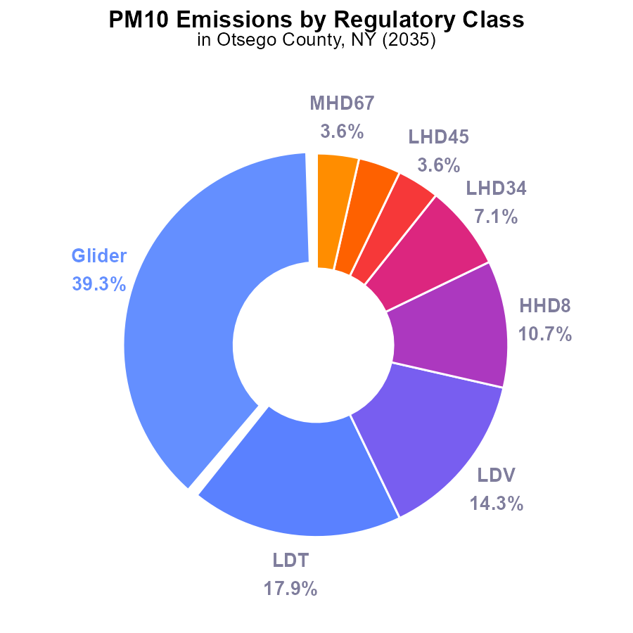

## Findings

* The largest contributor to PM10 emissions in Otsego County in 2035 is Glider at 1.1 tons, representing 39.3%.
* Combined, Light-Duty Trucks (LDT) and Light-Duty Vehicles (LDV) contribute 900.0 tons, accounting for 32.2% of emissions.
* Heavy Heavy-Duty Trucks (HHD8) contribute 300.0 tons, making up 10.7% of the total emissions.

## Recommendations

To reduce PM10 emissions in Otsego County, focus on reducing Glider emissions by optimizing engine efficiency. Encourage the use of cleaner fuels for LDTs and LDVs. Implement stricter emission standards for HHD8 vehicles.

# Emissions Rate (per mile) Overall by Area

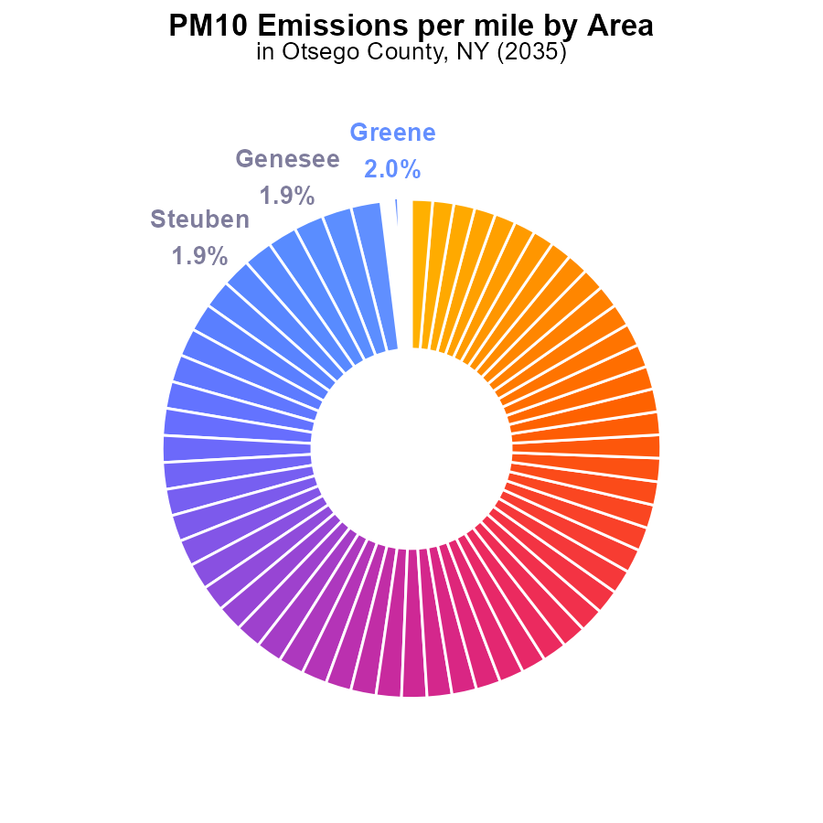

## Findings

* Otsego County has the highest PM10 emissions with 4.2 tons per mile, representing 1.7% of total emissions.
* Counties like Greene, Montgomery, Cortland, and Genesee also contribute significantly, each emitting 4.8 tons per mile, accounting for 2.0% of total emissions.
* The counties with the lowest PM10 emissions per mile are Richmond, Westchester, Suffolk, Rockland, Queens, and New York, each emitting 3.3 tons per mile, representing 1.4% of total emissions.

## Recommendations

To lower PM10 emissions, focus on high-emitting counties like Otsego, implementing stricter vehicle emission regulations and promoting public transport. Encourage more energy-efficient vehicles to reduce emissions.

# Vehicle Starts over Time for Passenger Vehicle Starts

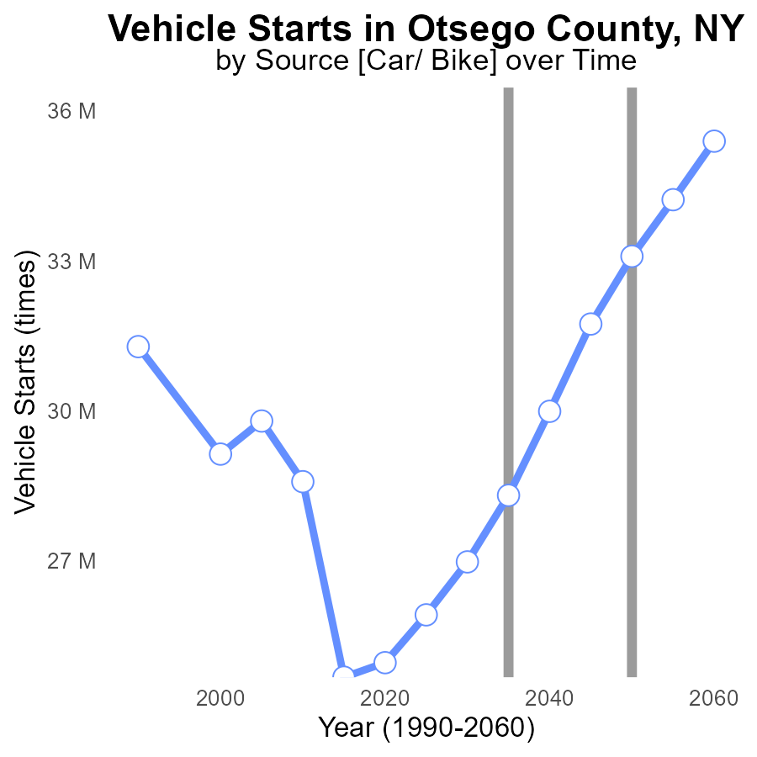

## Findings

* Vehicle starts emissions in Otsego County have generally increased over time.
* PM10 emissions have shown a decrease from 2015 to 2020, briefly increased, and then decreased again.
* By 2050, Otsego County is expected to meet the benchmark for PM10 emissions.

## Recommendations

To lower emissions, consider promoting the use of electric vehicles and improving public transportation to decrease vehicle starts. Implement stricter emission control regulations for industries.

# Vehicle Miles Traveled over Time for Buses

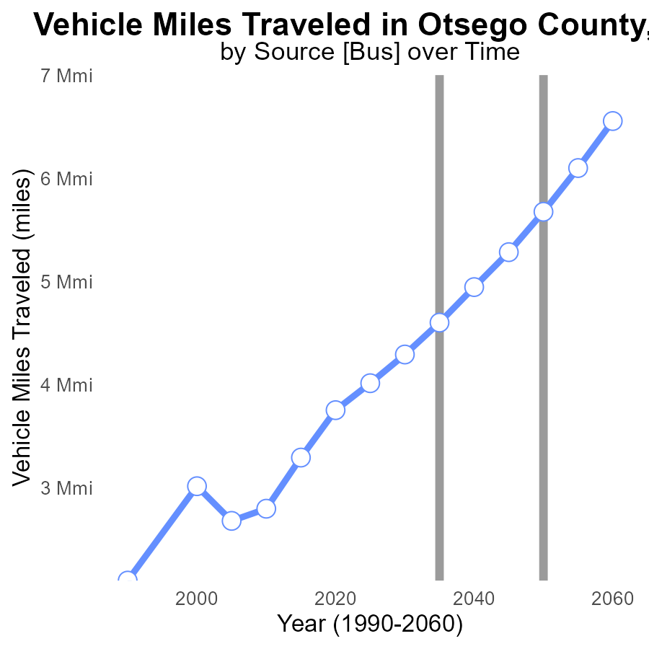

## Findings

* Vehicle Miles Traveled in Otsego County increased from 3.3 M in 2015 to 6.1 M in 2055.
* The benchmark difference decreased over time, with the largest reduction between 2040 and 2050.
* By 2050, Otsego County is expected to have a negative benchmark difference of -424234.7 miles.

## Recommendations

To lower emissions levels, policymakers should focus on implementing strategies to reduce vehicle miles traveled such as promoting public transportation, carpooling, and investing in infrastructure to support walking and biking. Additionally, considering policies that encourage the use of electric vehicles can further contribute to reducing emissions in Otsego County.

# Vehicle Miles Traveled in My Region

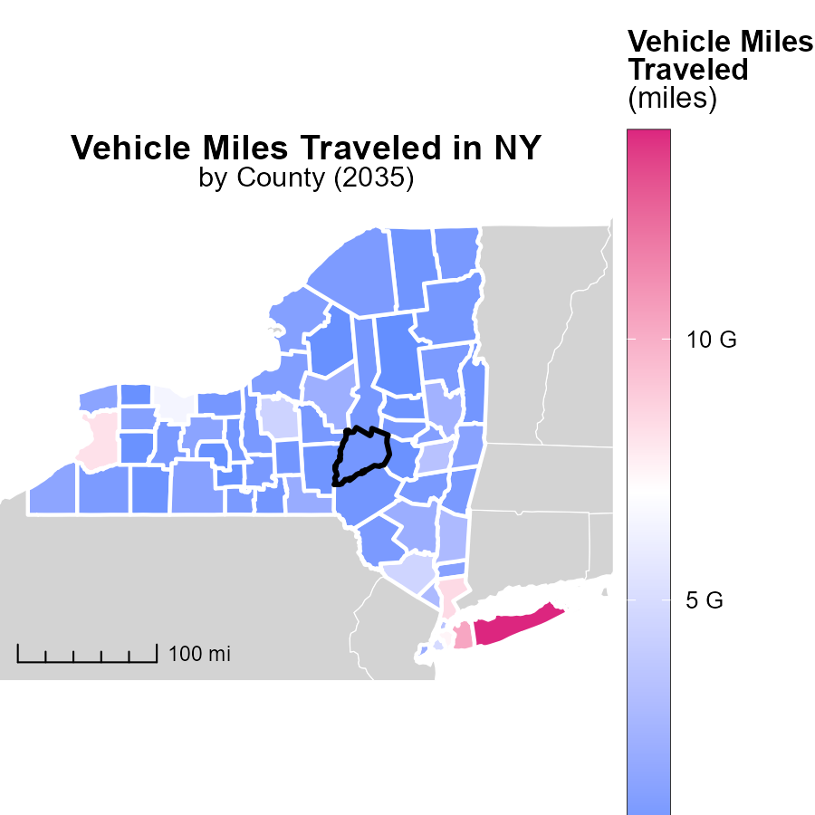

## Findings

* Suffolk County, NY has the highest vehicle miles traveled with 14.0 billion miles.
* Cattaraugus County, NY recorded a median of 937.8 million miles for vehicle miles traveled.
* Hamilton County, NY has the lowest vehicle miles traveled with 163.8 million miles.

## Recommendations

Policymakers should focus on promoting public transportation, implementing carpooling incentives, and investing in infrastructure to reduce vehicle miles traveled and emissions in counties with high numbers.

# Emissions Rate (per mile) Mapped by Area

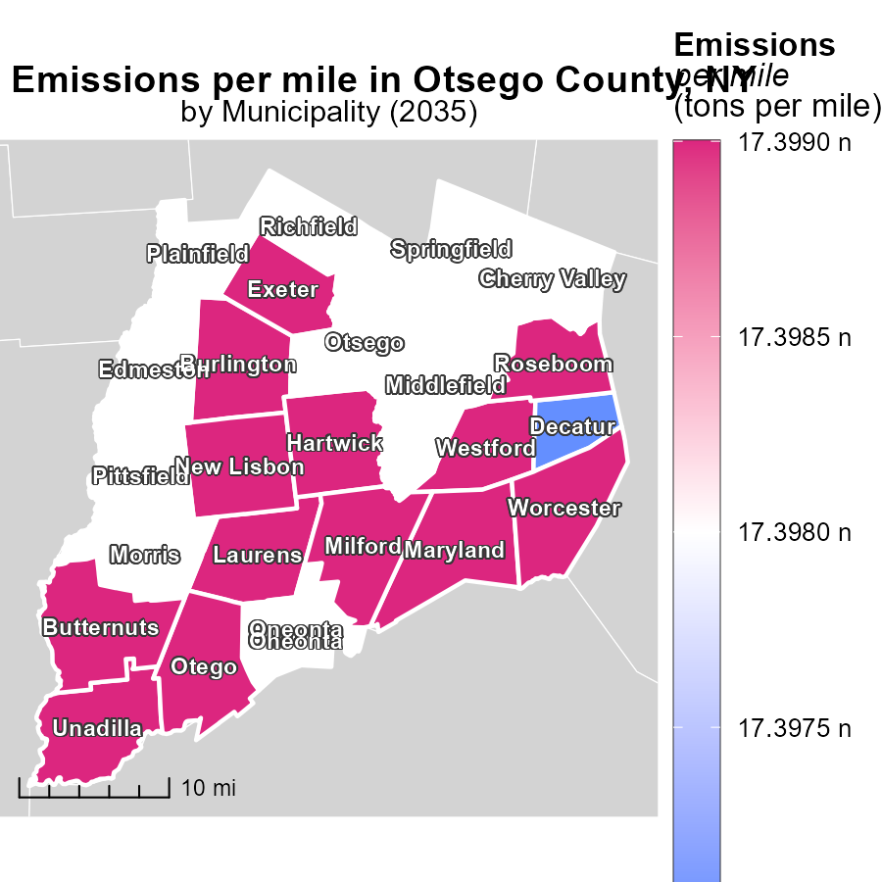

## Findings

* All three cities have the same emissions per mile of 17.4 tons per mile.
* This value is considered high and requires immediate attention.
* There is no variation in emissions per mile among Burlington, Worcester, and Decatur.

## Recommendations

To reduce emissions per mile, cities should focus on promoting the use of public transportation, carpooling, and investing in electric vehicles infrastructure.

# Emissions Rate (per mile) by Area over Time

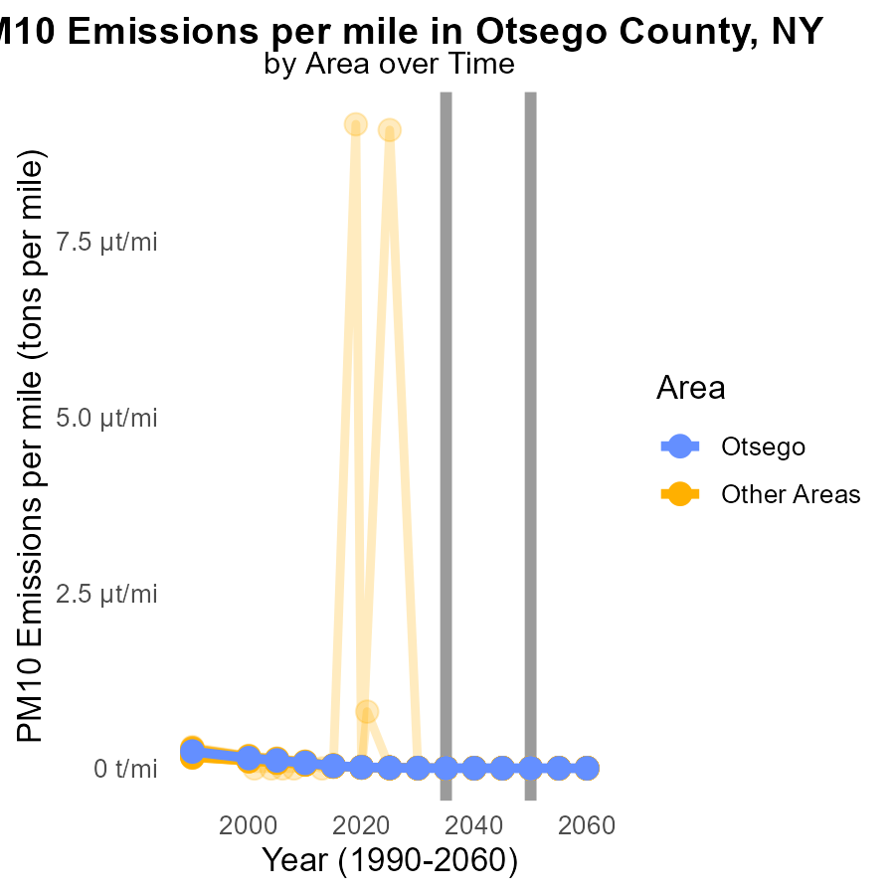

## Findings

* In 2035, the maximum county emitted 4.8 tons of PM10 per mile.
* The target county emitted 4.2 tons of PM10 per mile in 2035.
* The minimum county emitted 3.3 tons of PM10 per mile in 2035.

## Recommendations

To reduce PM10 emissions, focus on targeted counties by promoting cleaner technologies and enforcing stricter emission standards. Encourage the maximum county to implement measures that have been successful in the minimum county.

# Emissions Rate (per vehicle) by Regulatory Class over Time

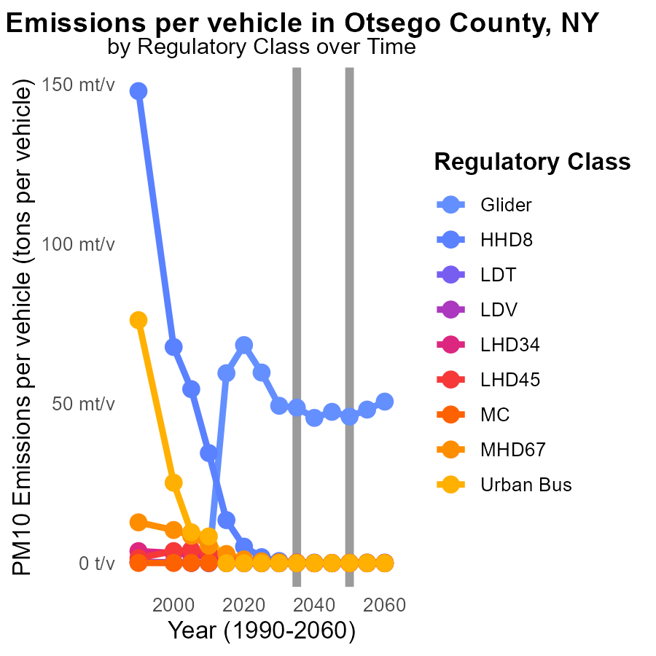

## Findings

* Emissions of Glider vehicles will decrease by an average of 0.0033 tons per vehicle from 2025 to 2045.
* HHD8 vehicles will have a minimal change in emissions over the same period, with an average decrease of 0.0004 tons per vehicle.
* Other vehicle types, such as LDT, LDV, and MC, will maintain relatively stable emission levels with minimal changes.

## Recommendations

To reduce emissions for Glider vehicles further, consider implementing stricter regulations or incentivizing the transition to cleaner alternatives. For vehicle types with stable emission levels, continue monitoring and encourage technological advancements to maintain current low emission rates.

# Areas Ranked by Vehicle Starts

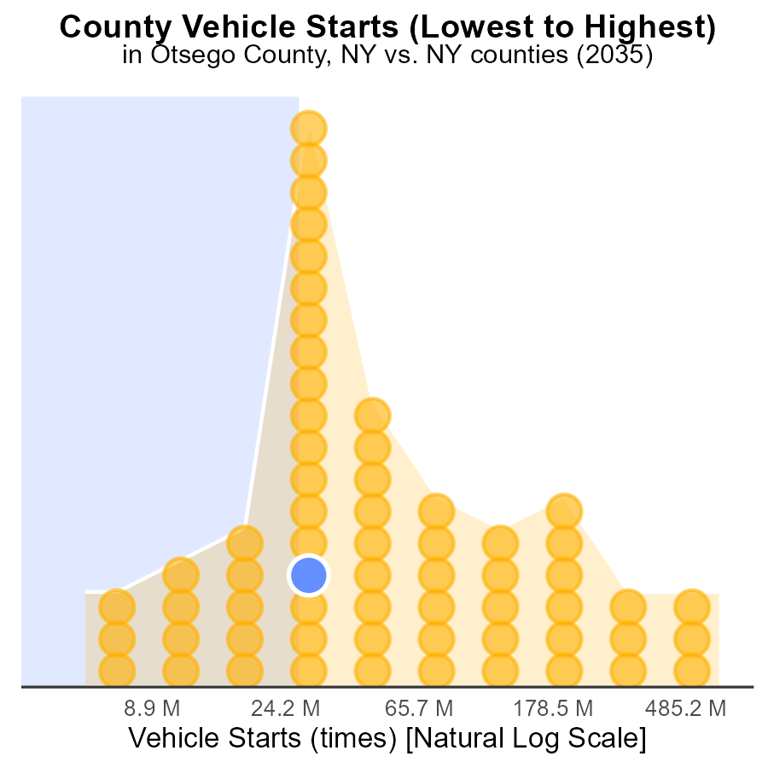

## Findings

* Suffolk county has the highest number of vehicle starts with 1.8 billion, representing 100.0% of the total.
* Hamilton county has the lowest number of vehicle starts with 14.6 million, only accounting for 1.6% of the total.
* The top 3 counties with the highest vehicle starts are Suffolk, Wayne, and Otsego, collectively contributing 78.6% of the total emissions.

## Recommendations

To lower emissions, focus on implementing vehicle start reduction strategies in counties like Suffolk, Wayne, and Otsego. This can include promoting carpooling, improving public transportation, and incentivizing the use of electric vehicles.

# Areas Ranked by Population

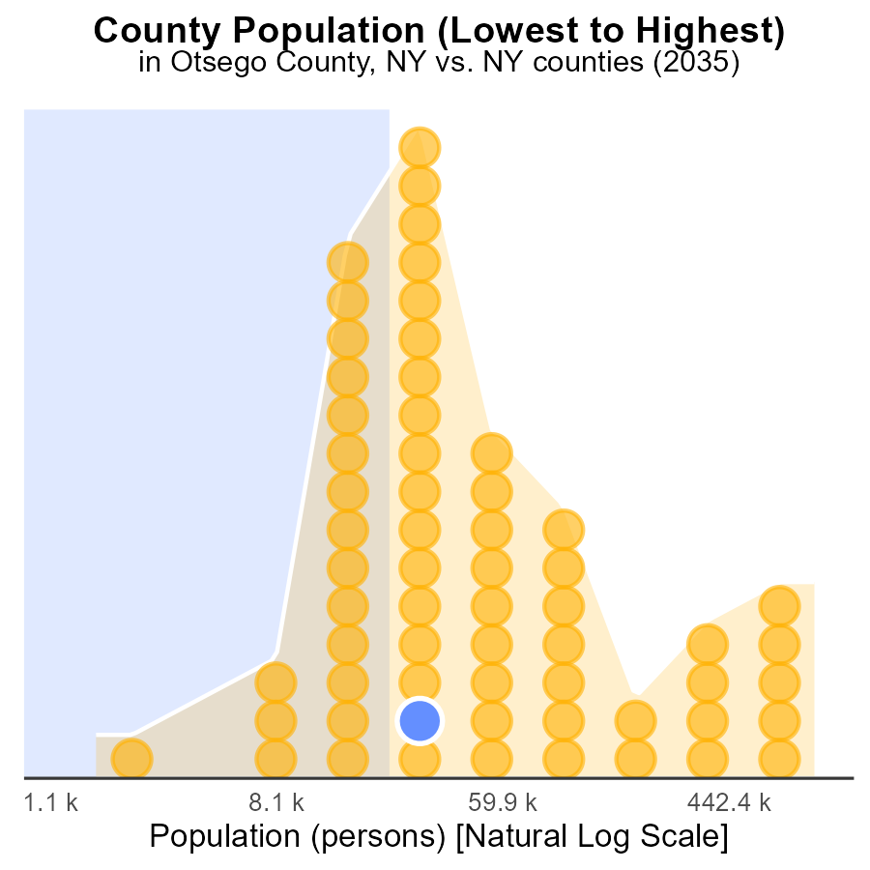

## Findings

* The county with the highest PM10 emissions is Kings with 2.6 million persons, representing 100% of the population.
* The county with the lowest PM10 emissions is Hamilton with 4.5 thousand persons, making up only 1.6% of the population.
* Otsego county falls in the middle with PM10 emissions from a population of 59.6 thousand, accounting for 32.3% of its population.

## Recommendations

To reduce emissions in Kings county, focus on large-scale industrial and transportation sources. In Hamilton county, encourage cleaner energy alternatives for the small population. Otsego should implement stricter regulations on local sources to lower emissions.

# Conclusion

In conclusion, the data for Primary Exhaust PM10 emissions from on-road transportation in Otsego County, NY in 2035 provides valuable insights into the current situation and potential strategies for emission reduction. Glider vehicles emerge as the largest contributor to PM10 emissions, followed by Light-Duty Trucks and Light-Duty Vehicles. Heavy-Duty Trucks also play a significant role in total emissions. To tackle these high-emitting sources, optimizing engine efficiency for Glider vehicles, promoting cleaner fuels for LDTs and LDVs, and implementing stricter emission standards for HHD8 vehicles are recommended.

Moreover, other counties in New York, like Greene, Montgomery, Cortland, and Genesee, also contribute significantly to PM10 emissions per mile. By focusing on implementing stricter vehicle emission regulations and promoting public transportation in these high-emitting counties, overall emissions can be reduced. Additionally, the data highlights the importance of reducing vehicle miles traveled by promoting alternatives such as public transportation, carpooling, and infrastructure improvements. By incorporating these strategies, the target of lowering PM10 emissions in Otsego County and other counties can be achieved by 2050.

# About This Report

Data based on MOVES estimates collected by the Climate Action in Transportation program at Cornell University. Demographic data sourced from the US Census's American Community Survey 5-year estimates. This report was generated with the help of AI.

# References

* U.S. Census Bureau. (2023). American Community Survey 5-year estimates: Detailed tables. Retrieved from https://data.census.gov
* U.S. Environmental Protection Agency. (2024). Motor Vehicle Emission Simulator (MOVES 4.0) [Software]. Retrieved from https://www.epa.gov/moves